PART 1B - Temperature Scaling

The choice of scaling technique will depend on whether the required temperatures are steady-state or transient. At steady-state conditions, the component temperatures do not vary with time (i.e. the components have reached their thermal equilibrium state). In transient conditions, the component temperatures are varying with time.

Steady State Temperature Scaling
For some steady state problems it may be possible to predict component temperatures by direct scaling of engine/rig measurements or previous finite element model predictions.

Temperatures should usually be scaled in relation to 2 engine performance parameters. These will be the inlet and exit temperatures of the appropriate compressor or turbine, or controlling source and sink temperatures.

The main gas path parameters are calculated by the Performance Department at key locations through the engine.

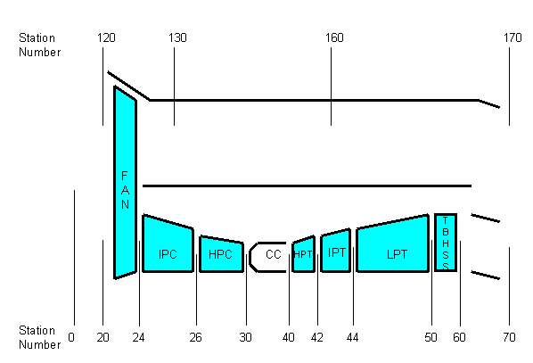
Fig 1.1 – station numbering

For a steady state condition at which a component temperature is known a scaling constant may be determined from the expression:-

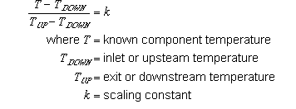

Thus the k-factor can be calculated from a knowledge of the component temperature at a particular upstream and downstream temperature. Using this k-factor, the steady state metal temperature at different values of upstream and downstream temperature can be determined.

This is best illustrated using an example. The metal temperature at the live rim of the HP Compressor stage 6 disc is most influenced by the HP Compressor Inlet and Exit temperatures (T26 and T30).

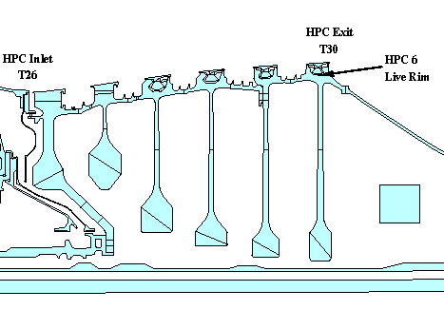
Fig 1.2 – HP compressor example

At a T26 value of 626.8K and a T30 value of 961.0K, the metal temperature (T) at the live rim is 949.8K

Thus the expression for the k factor can be written :

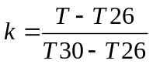 i.e. 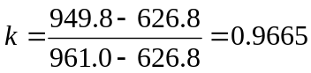

Thus the stabilised metal temperature at the live rim of the disc at a different condition (T26 = 487.1, T30 = 742.1) can be calculated :

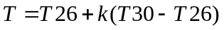

i.e.

K

The actual value of the rim temperature from the finite element model was 734.8K, making a discrepancy of approximately 1K.

There should be some caution, however, as illustrated in the example below.

EXERCISE 1

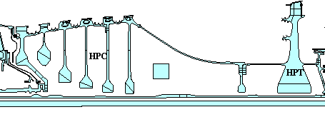
Fig 1.3 – HP compressor/turbine example

Given the information provided in the tables below, calculate :

- the k-factor for each of the three positions based on the Max. take Off Temperatures.
- the steady-state metal temperatures at the cruise condition:

Note that the HP Compressor cob and HP Turbine cob temperatures should be scaled on T26 and T30. The HP Turbine rim temperature should be scaled on T26 and T41.

Main gas path parameters :

 | T26 (K) | T30 (K) | T41 (K)
Max. Take Off | 626.8 | 961.0 | 1804.0
Cruise | 487.1 | 742.1 | 1365.5

Temperatures at Max. Take Off (K)

 | HPC Cob | HPT Cob | HPT Rim
Max. Take Off | 722.0 | 831.0 | 945.1

Transient Temperature Scaling
In general, we are not simply interested in steady-state temperatures, but in transient temperatures through a cycle. Let us consider the simple cycle below which consists of a long (2000 second) idle phase followed by a slam accel (10 seconds in duration) to max take off and then a slam decel back to idle. The cycle ends with a slam accel to a cruise condition.

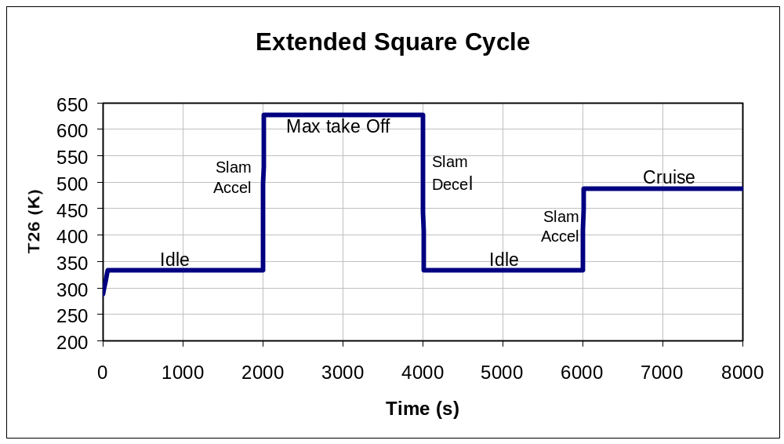
Fig 2.1 – square cycle with cruise point

If we now look at the variation of the component temperatures at the positions on the HP Compressor and Turbine that we have been looking at earlier we get the following responses.

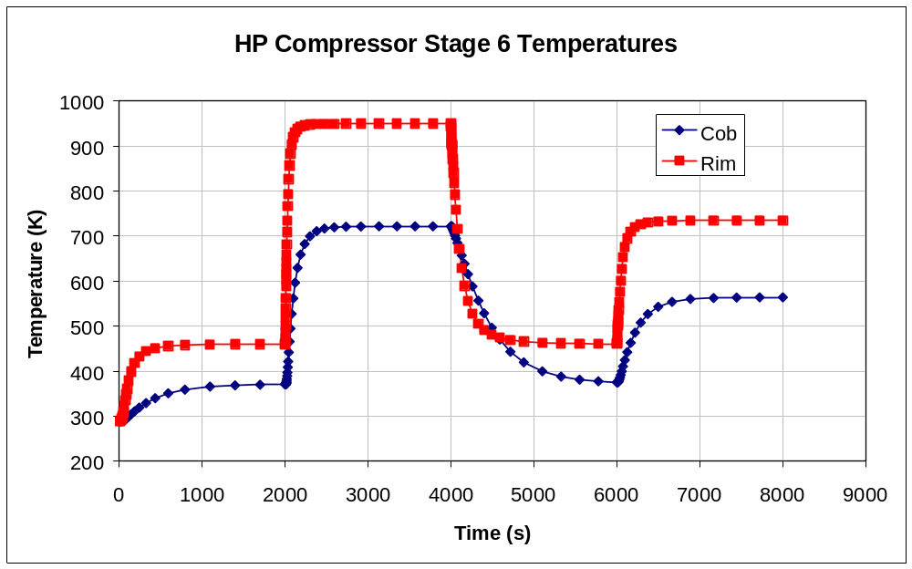
Fig 2.2 – HP compressor stage 6 transient temperatures

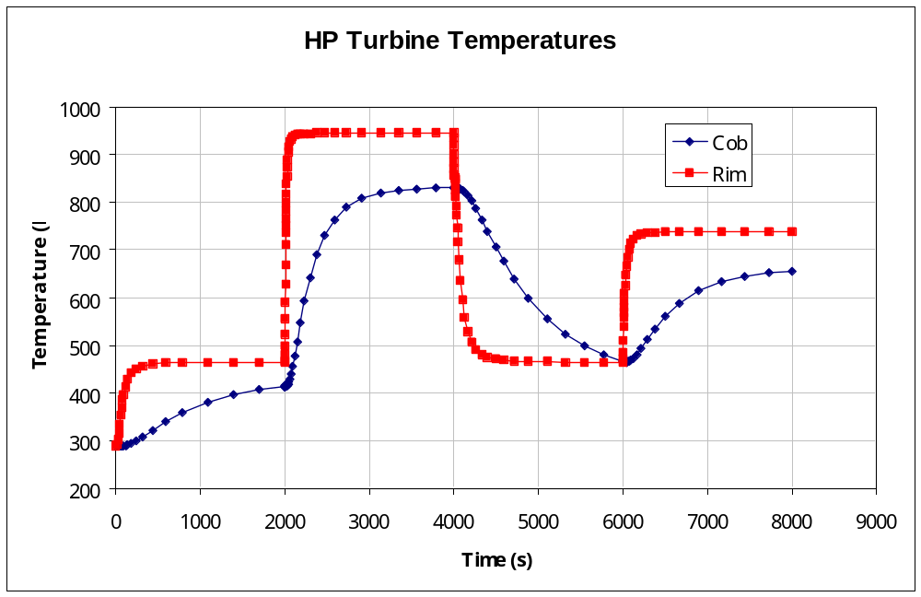
Fig 2.3 – HP turbine transient temperatures

Question 2.1: Why are the responses different ?

Reason 1)

Reason 2)

Reason 3)

Steady State scaling should NOT be used for transient portions of graphs as illustrated on the plot below which shows the true transient response from the Finite Element Model and the predicted temperature using the steady state scaling method.

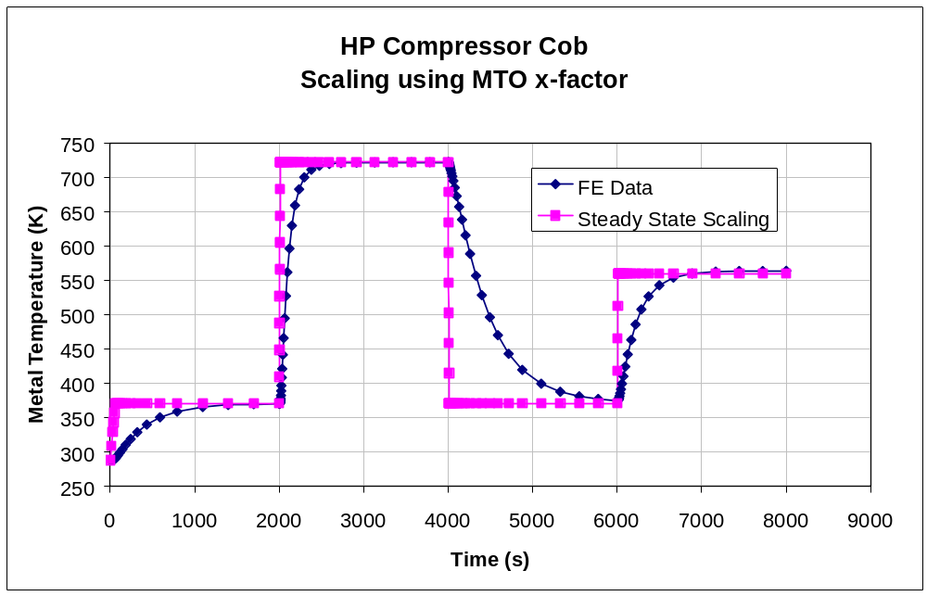
Fig 2.4 – HP compressor transient temperatures and scaling using x-factor (k-factor)

As can be seen, prediction of transient component temperatures using the steady state temperature scaling method can lead to LARGE errors.

Scaling of transient temperatures can be completed using a time-constant approach.

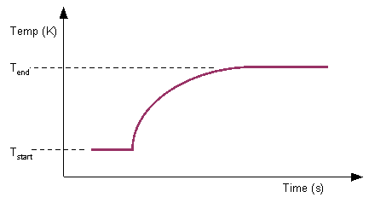
Fig 2.5 – time constant approach

The assumption is that for a given temperature - time response the curve may be represented by an exponential equation of the form:-

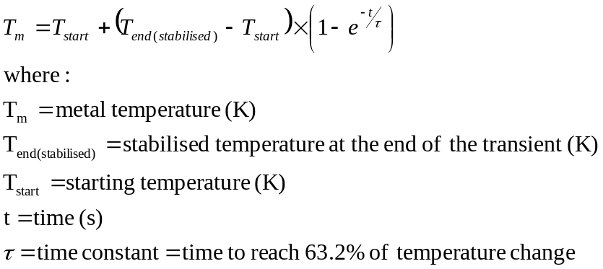

Note that the temperature - time response equation is consistent with the Lumped Capacity Method.

The value of τ, the time constant, varies significantly with engine condition.

Returning to the HP Compressor Cob example, the time constants for the accel (heating) and decel (cooling) portions of the cycle can be calculated.

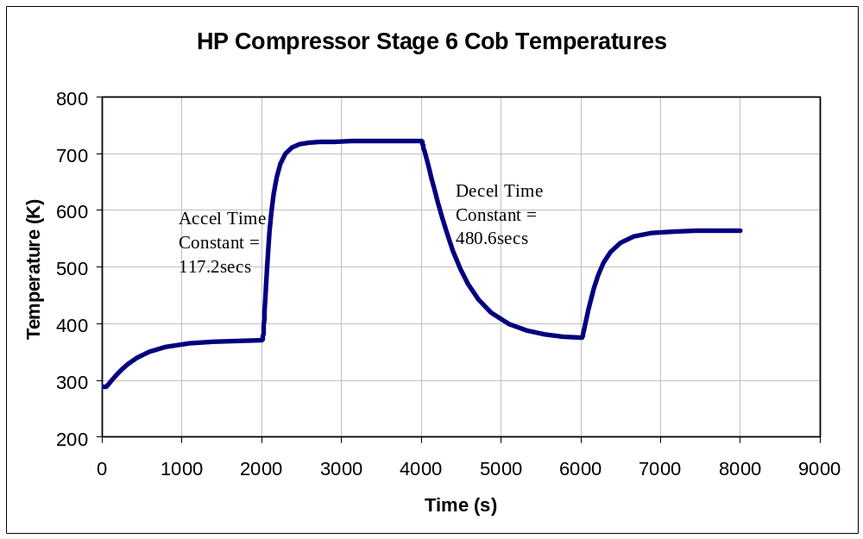
Fig 2.6 – HP compressor time constants

QUESTION 2.2: Why are the time constants different for accel and decel ?

ANSWER :
The exponential equation seen earlier defines the transient temperature throughout the cycle as follows :

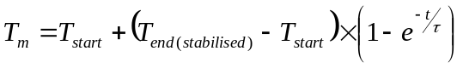

Thus with a knowledge of the starting temperature, the end temperature (i.e. the stabilised component temperature at the new condition), and the time constant, the value of the component temperature (T_{m}) at a time from the start of the transient (t) can be calculated.

This can be seen in the graph below for the HP compressor cob.

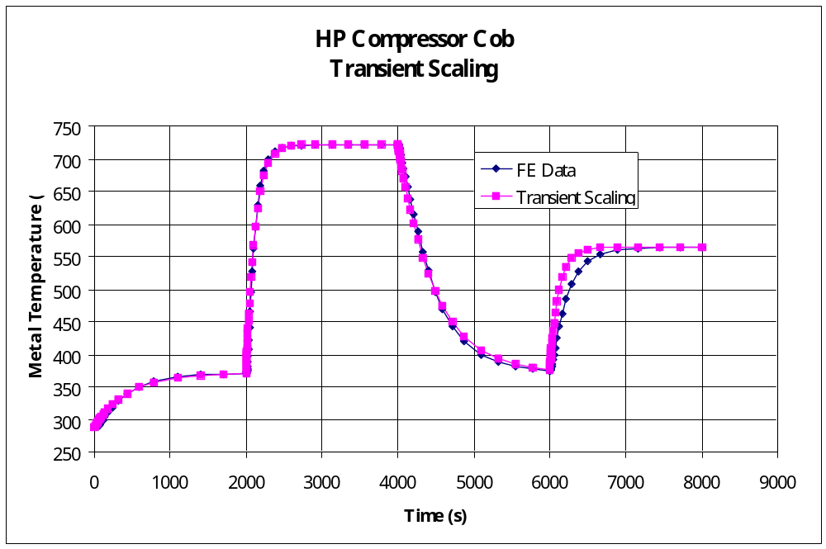
Fig 2.7 – HP compressor transient scaling versus FE solution

This is best illustrated with an example.

EXERCISE 2

For the HP Compressor Live Rim and HP Turbine Cob, perform the following calculations :

1) Calculate the time constants for the slam accel between idle and max take-off using the graph below (Note that the transient begins at 2000 seconds):

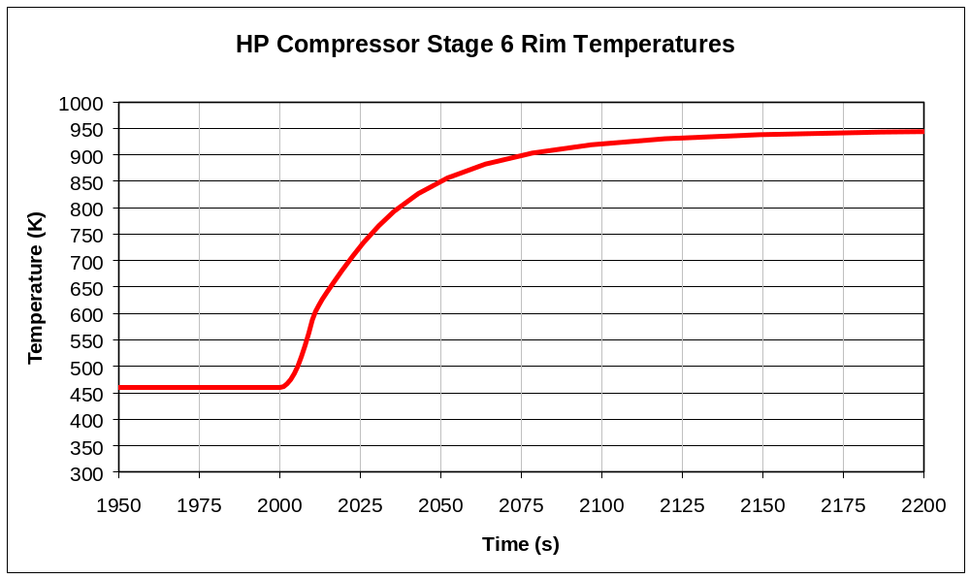
Fig 2.8 – HP compressor stage 6 rim transient temperature (transient starts at 2000s)

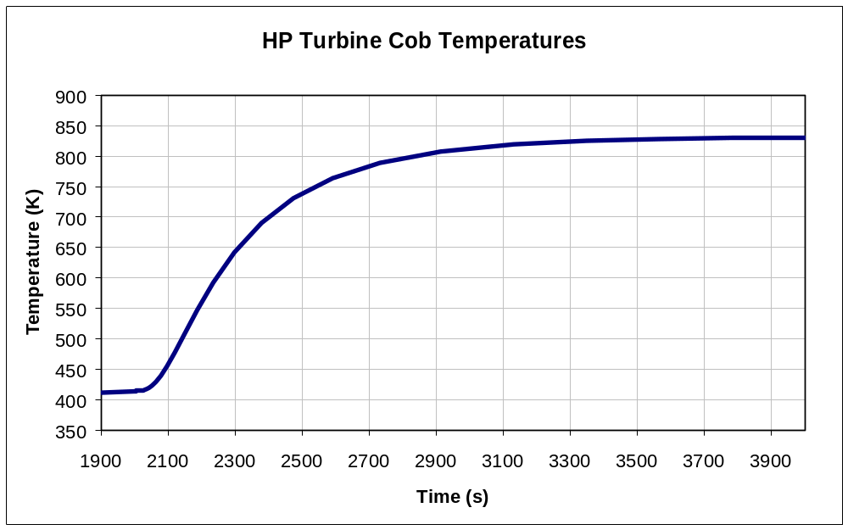
Fig 2.9 – HP turbine cob transient temperature (transient starts at 2000s)

2) Calculate steady state max take-off temperatures for both the rim and the cob using the information in the table below :

 | T26 (K) | T30 (K) | T41 (K)
Max take Off | 626.8 | 961 | 1804

 | HPC Rim | HPT Cob
k-factors | 0.9666 | 0.6101
Scale on | T26 & T30 | T26 & T30

3) Calculate the transient rim and cob temperatures at the times specified and the starting temperatures as in the table below :

 | HPC Rim | HPT Cob
Tstart (K) | 459.8 | 414
t (secs) | 60 | 100

Reminder :

Exercise 1 Solution

K-Factors Note: 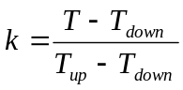

HPC Cob

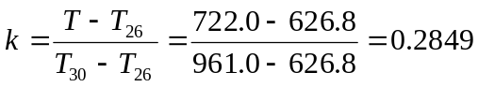

HPT Cob

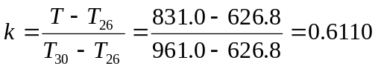

HPT Rim

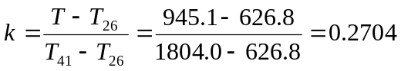

Cruise Temperatures Note: 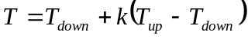

HPC Cob

HPT Cob

HPT Rim

Summary

 | HPC Cob | HPT Cob | HPT Rim
k-factors | 0.2849 | 0.6110 | 0.2704
Cruise Temps (K) | 559.7 | 642.9 | 724.6
Actual FE Temps (K) | 563.9 | 661.7 | 738.3

There are a number of reasons for the discrepancies seen between the scaled values and the actual values calculated by the Finite Element Model :

- The scaling assumes that the relationship between gas path parameters remains constant at each condition (e.g. the relationship between T26 and T41) (See Diagram below)
- The component temperatures are influenced by the mass flows around the component and the heat transfer coefficients. The scaling assumes that relationships between these are preserved between conditions. This is not necessarily so. e.g. At max. take off, the flow under the HP Turbine bore can be over 20% greater (as a percentage of engine core flow) than the bore flow at idle.
- The scaling technique cannot account for step changes that may occur. e.g. opening of a bleed valve or introduction of case cooling flow at some conditions only.

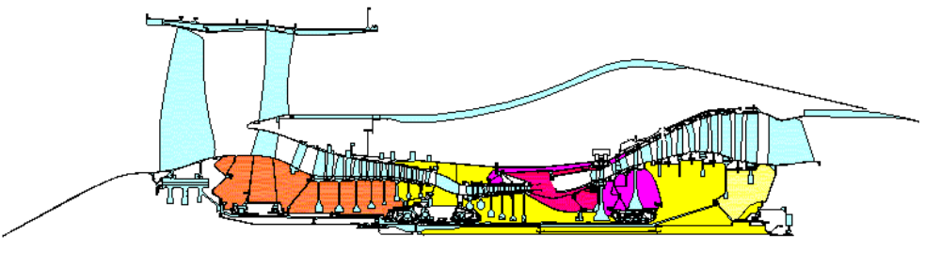
Answer 2.1

There are a number of factors which will affect the transient temperature response at different locations on the component :
- the heat capacity of the material (related to its mass)
- the conductivity of the material (particularly evident for the cob centre temperatures)
- the heat transfer rate at the fluid / component interface

Answer 2.2

The time constant (which is related to the rate of heating or cooling) is influenced by the heat transfer between the fluid and the component. During the accel, heat transfer coefficients are relatively high, but during the decel, the values of htc are lower.

Exercise 2 Solution

HPC Rim

Time Constant Calculation:

From the graph,

T_{start} = 460K, T_{end} = 950K, Thus 63.2% of difference = 776K

776K is reached at time 2026.5 secs (i.e. 26.5 seconds from the start of the transient)

Steady State Calculation:

Transient temperature 60 seconds into the transient:

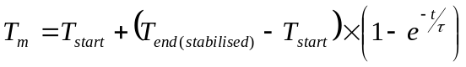
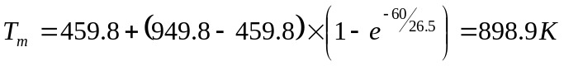

A similar calculation can be performed for the HP turbine cob.

Summary

 | HPC Rim | HPT Cob
Time const (secs) | 26.5 | 366.4
Stabilised max take off temp (K) | 949.8 | 830.7
Transient temp (K) | 898.9 | 513.5
Actual FE temp (K) | 874.3 | 458.1

This can be seen diagramatically for the accel :

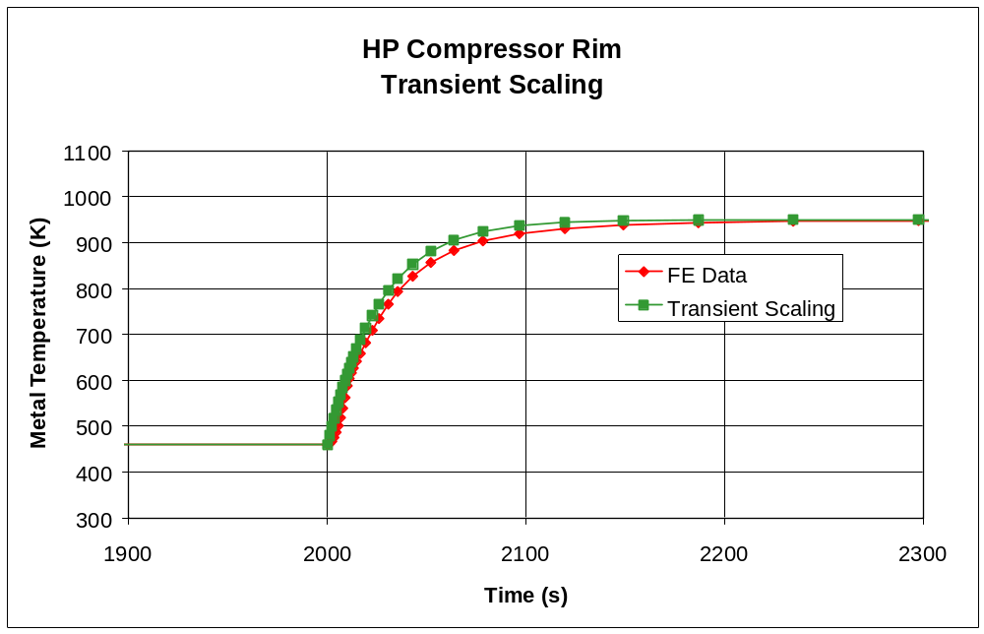
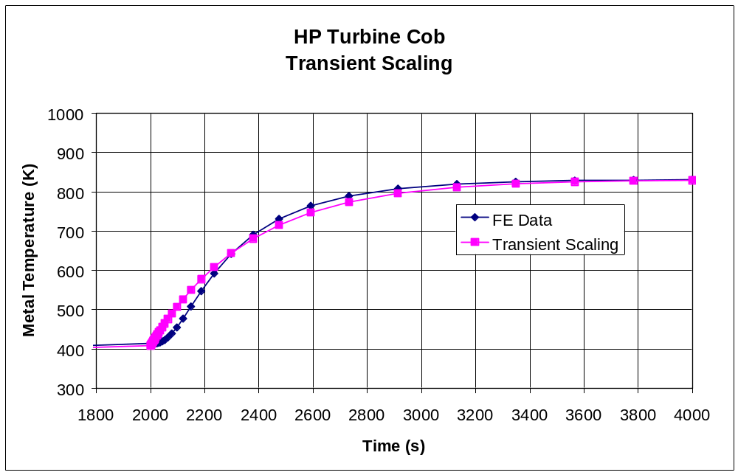

As can be seen, the transient scaling technique works better in some circumstances than others. In general, this approach has more success in compressors than turbines.

In compressors, the metal temperatures are largely dictated by the compressor gas path inlet and exit temperatures. Also, the source of the secondary airflow is closer to the components (less air temperature lag). The discs are also generally less massive than in the turbine.

Turbine discs generally give poorer results from this scaling method. The HP turbine disc metal temperatures in particular are influenced by three separate air systems as well as the annulus temperature. Also the coolant temperatures, particularly around the bore, have a significant lag.

Even in the compressor discs, caution must be used with this technique as can be seen in the diagram below where the time-constant approach has been used to predict temperatures for a slam acceleration to cruise.

