Heat Transfer Fundamentals and Thermo-mechanical Analysis Using SC03

(Course number 50069218)

Introduction

The aim of this course is to provide an understanding of the fundamentals of heat transfer and to apply this to calculate component temperatures. Although many of the practical examples given are from aero engines, the course is relevant to all heat transfer work throughout Rolls-Royce plc.

The majority of thermo-mechanical analysis within Rolls Royce uses the finite element method (mainly SC03). The course is NOT intended to teach the analyst HOW to use SC03 – or other finite element codes – but rather to give that analysts a better understanding of the underlying physical behaviour of the components and surrounding fluids so that thermal boundary conditions can be appropriately defined.

The following courses are available to learn how to use SC03 :

- SC03 introduction and overview (PP22170)
- SC03 thermal analysis (PP22171)

The following interactive training material is also available on the Thermo-mechanics web :

- SC03 2D tutorial for new users
- SC03 3D tutorial for new users
- SC03 general example

Follow the training link from the thermo-mechanics home page (http://www.capability.rolls-royce.com/genthermal/default.htm)

Objectives

By the end of the training the delegate will be able to :

- Describe the 3 modes of heat transfer – conduction, convection and radiation
- Perform hand calculations for the 3 modes of heat transfer
- Describe the various approximate and scaling methods
- Describe the various thermal boundary conditions in SC03
- Appropriately define thermal boundary conditions on an SC03 model to calculate component temperatures

Course Content

The course content is as follows :

- What is thermo-mechanical analysis and why is it performed
- Conduction
- Convection
- Radiation
- Approximate temperature analysis
- Temperature scaling
- Finite element analysis (including thermal boundary conditions)
- Introduction to the Thermo-mechanics web
- Advection and mixing
- Absolute and relative temperatures
- Windage heating
- Practical examples of modelling in SC03
- Thermal model validation
- Displacement analysis

What is thermo-mechanical analysis and why is it performed ?

Thermo-mechanical analysis is the calculation of component temperatures and displacements. There are a large number of different applications of the thermo-mechanical analysis process including :

Component temperature predictions – Used in the selection of the most appropriate materials (e.g. do we need a high temperature capability).

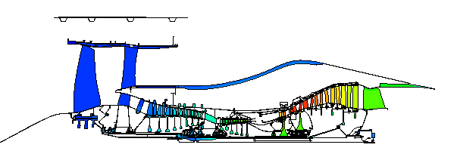

Analysis of component stresses – Component stresses are a function of both the mechanical and thermal loads. As well as affecting the material properties, temperature gradients in a component can result in high thermal stresses. In the Trent 800 HP turbine disc, the thermal gradient accounts for about 50% of the cob centre hoop stress – one of the significant life limiting features.

Temperature 60 secs at max power (450K ΔT)  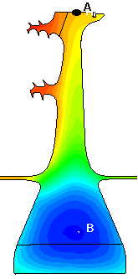 | Hoop stress including thermal stress (cob at 1170Mpa)  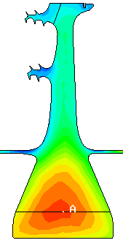 | Hoop stress excluding thermal stress (cob at 607Mpa)  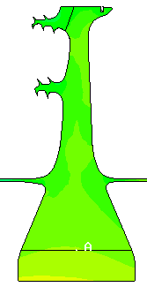

Assembly relative movements – This is required to ensure that there are no fouls anywhere in the flight envelope.

Seal clearance optimisation – Radial and axial clearances of seals and blade tips must be understood and controlled to optimise engine performance and integrity.

For all the above applications, it is relatively easy to produce a prediction. To have confidence in the calculation, the predictions must be validated (i.e. demonstrate by engine measurements that the predictions are accurate).

Thermo-mechanical analysis supports many issues including :

- Integrity
- Lifing
- Cost
- Weight
- Performance

The picture if the ANA Tristar dating from 1976 illustrates the need for thermo-mechanical analysis.

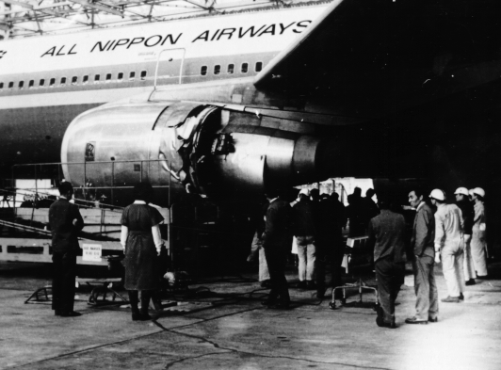

While climbing out of Tokyo on a scheduled flight, this aircraft experienced the failure of an HP turbine disc. The photograph gives some idea of the energy available when a disc fails. The debris cannot be contained in a production aircraft, these people were very lucky, the disc fragments exited on the ‘off’ side of the nacelle, they could have as easily gone through the cabin or the aircraft controls. On investigation this particular incident was traced to a materials defect, rather than poor design, however an inadequate analysis can have the same effect, and ANA do not now buy RR engines.

We also want to choose the most cost-effective materials and we want to control seal clearances in the main annulus and cooling air system to give optimum engine performance/fuel burn.

