PART 2 – Thermo-mechanical Analysis Using SC03

Part 1 has dealt with the fundamentals of heat transfer – conduction, convection and radiation. It has also dealt with various hand calculation and scaling techniques for calculating component temperatures.

Part 2 now goes on to show how the physical mechanisms of heat transfer (conduction, convection and radiation) are applied within SC03.

Contents
1. Units 2
2. Boundary Condition Types 3
2.1. Convecting Zones 3
2.2. Thermal Voids 5
2.3. Thermal Stream 10
2.4. Thermal Duct (2D only) 14
2.5. External Radiation 16
2.6. Internal Radiation 19
2.7. Thermal Contact 21
3. Demonstration of the Thermo-mechanics Web 25
4. What to put in the Panels ? 26
4.1. Fluid Temperatures 26
4.2. Mass Flows and Pressures 26
4.3. Heat Transfer Correlations 28
5. Interdependencies 36
6. Defining the Cycle 38
6.1. Global Control 42
7. Absolute/Relative Temperature 45
8. CFD Analysis 48
8.1. CFD to support a conventional finite element (SC03) analysis 48
8.2. Coupled CFD/FE analyses 49
9. Windage 51
10. Entrainment 53
11. Practical Examples of Modelling in SC03 54
11.1. LP Turbine Assembly 55
11.2. HP Turbine Disc 56
11.3. IP Compressor Assembly 57
11.4. HP Compressor Assembly 58
12. Validation (including Thermal Matching) 59
12.1. Production of a Test Specification 59
12.2. Test Data Reduction 60
12.3. Initial Model Production 60
12.4. Matching Exercise 62
13. Displacements 63

Units

Before describing the various thermal boundary conditions available within SC03 it is worth spending a little time talking about units. There is often confusion concerning the units used within SC03. SC03 uses a fully consistent unit set based on the mm, the Newton and Kelvin as follows.

Quantity | Unit
Geometry, displacements | mm
Rotational speed | rads/sec
Loads, reactions | N
Moments | Nmm
Pressures, tractions | N/mm² (MPa)
Stress, modulus | N/mm² (MPa)
Mass | Mg
Mass density | Mg/mm³
Temperature | C or K
Coeff of thermal expansion | 1/K
Thermal conductivity | mW/mm/K
Specific heat | mJ/Mg/K
Mass flow | Mg/sec
Heat transfer coefficient | mW/mm²/K
Power input | mW
Heat pickup | mW/mm²
Temperature pickup | K/mm
Dynamic viscosity | Nsec/mm²
Gas constant | mJ/Mg/K
Time | sec
Fig 1.1 – table of SC03 units

Note also a second set of units is available. This is an imperial set of units but is NOT currently recommended for thermal analysis.

Boundary Condition Types

Convecting Zones

Of the most commonly used thermal boundary conditions, the convecting zone is perhaps the easiest to describe.

A convecting zone will be used where the fluid temperature distribution is known. This temperature could be a single value or could vary in space and time.


Fig 2.1 – convecting zone boundary condition

Convecting zones are essentially regions of infinite heat capacity. i.e. the fluid temperature specified will not change regardless of the heat transfer between the fluid and the component.

Panel

Inputs for a convecting zone are :

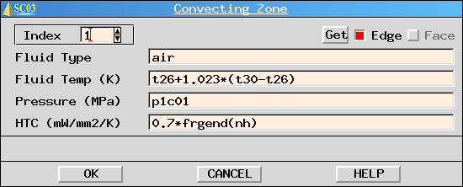
Fig 2.2 – convecting zone panel

Fluid Type – generally air but could be user defined (e.g. oil)

Fluid Temperature – value or expression (can be a function of space and time)

Fluid Pressure – used in the heat transfer coefficient correlation calculation (see below) and used as a pressure load in a thermo-mechanical analysis

Heat Transfer Coefficient – value or expression (SC03 holds a number of standard heat transfer correlations).

Calculation

The heat flux from a convecting zone is simply calculated from :

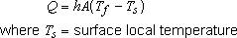

Uses

Bearing chamber internal surfaces commonly use convecting zones (where the oil temperature is often calculated external to SC03 using CZ11 or transient SPAN).

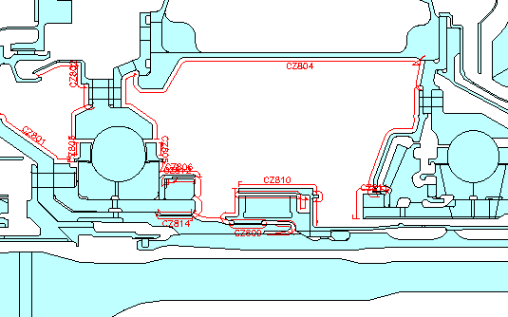
Fig 2.3 – use of convecting zone in an internal gearbox

Often, a convecting zone is used as a direct replacement for prescribed temperature boundary conditions (where the metal temperature distribution is directly specified).

Problems may be encountered when using prescribed temperatures. At the start of the analysis the prescribed temperature must be equal to the initial domain temperature. In addition, if two prescribed temperature boundary conditions have a coincident point (i.e. are adjacent) then the temperatures at that point must be equal (within a tolerance).

The convecting zone air temperature is set to the required metal temperature distribution and a high heat transfer coefficient (htc) is specified (e.g. 5 to 10 mW/mm²K).

Uses for this technique include the gas washed surfaces of aerofoils and regions where a metal temperature distribution is to be imparted from an upstream model.
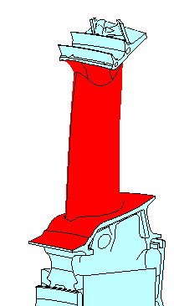 | 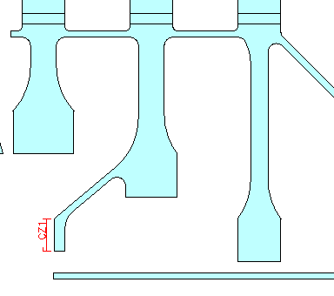
Fig 2.4 – use of convecting zone on an HP turbine blade and on a flange to represent a ‘prescribed temperature’

Thermal Voids

A thermal void is almost the exact opposite of a convecting zone. Whereas a convecting zone can be considered as a region of infinite heat capacity, a thermal void is a region of negligible heat capacity.

A thermal void is used to represent a region that is at a uniform temperature (i.e. the entire void is at a single temperature) and is at instantaneous equilibrium with its surroundings.

The void will essentially be influenced by two heat sources – convection from the surrounding walls, and, if present, an additional power term (generally from a mass flow into the void).
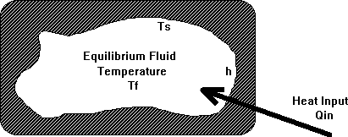
Fig 2.5 – thermal void boundary condition

Panel

Inputs for a thermal void are :

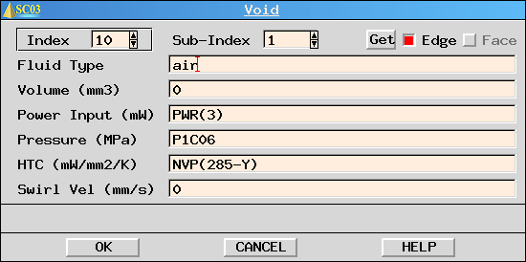
Fig 2.6 – thermal void panel

Fluid Type – generally air but could be user defined (e.g. oil)

Volume - generally, this value will be zero, but where the transient temperature lag that would be associated with the mass of air in the void is significant, a volume can be specified (from which a mass is calculated).

Power Input – an external source of energy into the void (note that this is the total power and is not per unit area)

Fluid Pressure – used in the heat transfer coefficient correlation calculation (see below) and used as a pressure load in a thermo-mechanical analysis

Heat Transfer Coefficient – value or expression (SC03 holds a number of standard heat transfer correlations).

Swirl Velocity - If this field evaluates to non-zero, SC03 will use the absolute total temperature if the domain on which the stream is applied is stationary and the relative total temperature if the domain is rotating. More information later.

Calculation

For the cases where the volume is zero, the assumption of instantaneous equilibrium implies no net heat flux into the void.
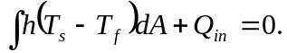
i.e.
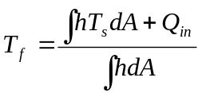

where: A is the surface area, T_{s} and T_{f} are the component and void temperatures respectively

Q_{in} can be a heat input from a thermal stream or duct pwr(i) (note for ducts, a negative sign prefixes the index number).

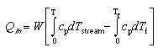
For small changes in temperature, this can be put more simply by ignoring the Cp term :

Q_{in} can also be a heat input from another void pwrv(m,i)

The above calculation is best illustrated with an example.

EXERCISE

Determine the void temperature for each of the two cases :

- no external heat source
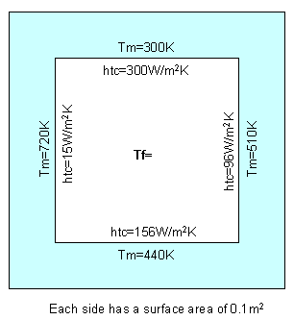

- with external heat source
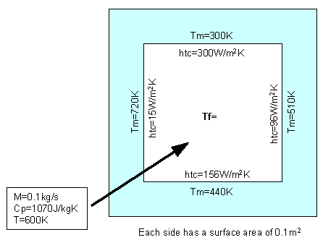
Fig 2.7 – thermal void exercise

Uses

Thermal voids are used in cavities where there is little or no positive through flow (such as ventilation zones around core casings).

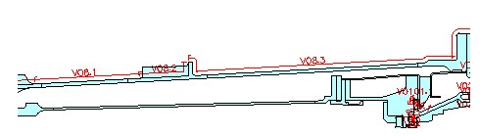
Fig 2.8 – use of thermal void in a ventilation zone

Thermal voids can also be used where flow patterns are unknown, or change with time. | 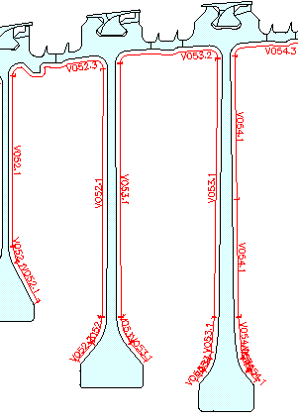  Fig 2.9 – use of thermal void in an HP compressor interdisc cavity

Voids can also be used to effectively restore full or partial conduction between components that have been thermally separated.

If a structural joint has been applied at the interface between two components the conduction path will be removed as a set of dummy nodes are created at the joint. In other models, two components that in reality are in contact, have been separated in the model for some reason.

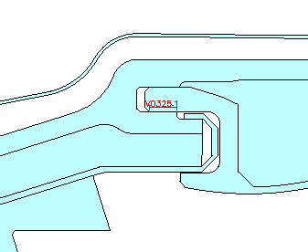 | 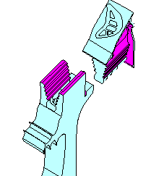
Fig 2.10 – use of thermal void to restore conduction

In both of these cases, by applying a void (same index but different sub-indices) to both the components, full or partial conduction can be restored.
Note 1. The use of thermal voids for restoring the conduction path across joints has now been superseded by the Thermal Contact Boundary Condition.

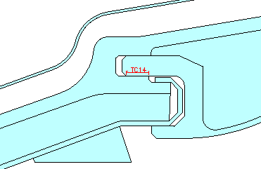
Fig 2.11 – use of thermal contact to restore conduction

Note 2. Since a void can only have a single air temperature, the use of a void in this way may produce some errors if there are large temperature gradients in the two adjacent components at the interface.

Thermal Stream

The thermal stream is the widest used of all the thermal boundary conditions and is used to define a portion of the boundary that has a finite flow of fluid along its length.

A stream has a finite heat capacity. The inlet air temperature of the stream is defined and the variation in fluid temperature along the boundary is calculated with consideration to convection, the heat capacity of the stream and any additional heating (windage etc).

Thus the thermal stream models the heat transfer mechanism known as advection.

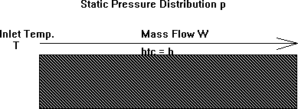

Fig 2.12 – thermal stream boundary condition

Panel

Inputs for a thermal stream are :

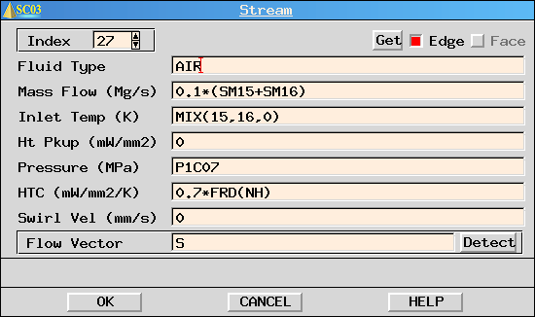
Fig 2.13 – thermal stream panel

Fluid Type – generally air but could be user defined (e.g. oil)

Mass Flow – the mass flow of the stream (refer to SPAN link flows where possible)

Inlet Temperature – defines the STARTING temperature in the stream

Heat Pick-up – defines an additional source of energy along the boundary (generally windage heating)

Fluid Pressure – used in the heat transfer coefficient correlation calculation (see below) and used as a pressure load in a thermo-mechanical analysis

Heat Transfer Coefficient – value or expression (SC03 holds a number of standard heat transfer correlations).

Swirl Velocity - If this field evaluates to non-zero, SC03 will use the absolute total temperature if the domain on which the stream is applied is stationary and the relative total temperature if the domain is rotating. More information later.

Calculation

The temperature pick up along the length of a stream is given by :

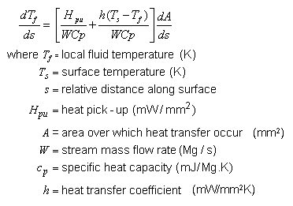

Essentially this states that the temperature pick up along the length of a stream is a function of the convection heat transfer between the component and the fluid and any additional heating effect (e.g. windage heating which will be discussed later).

Mixing

It is possible to mix a number of streams together to produce a mixed out temperature at the inlet to another stream. An enthalpy balance is used to calculate the mixed temperature.
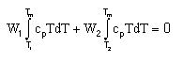
With only small errors, this can be simplified to :

(mCpT)₁ + (mCpT)₂ + (mCpT)₃ … = (mCpT)_{mix}

Uses

Streams are the most commonly used thermal boundary condition and are used to define the heat transfer on boundaries where there is a known, finite mass flow.

Examples include the flows around the IP turbine disc and HPIP support structure and the flows in stator wells and along the gas-washed platforms of the blading in the main annulus.

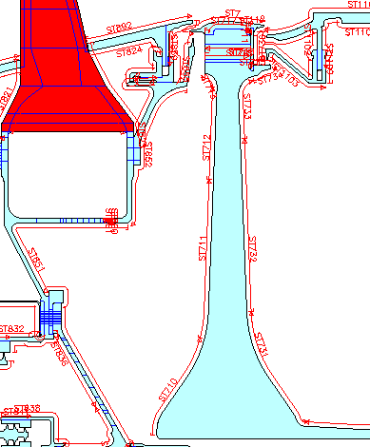
Fig 2.14 use of thermal streams around the IP turbine disc and HPIP
support structure

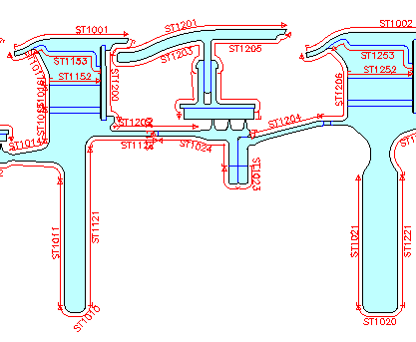
Fig 2.15– use of thermal streams in an LP turbine stator well

Note that when defining a stream with a certain mass flow we are saying that there is perfect mixing of the flow in the boundary layer.

It should be noted that a thermal DUCT should be used if there is a known, finite mass flow AND also interaction between two neighbouring boundaries. This will generally occur if there is only a small gap between two neighbouring components.

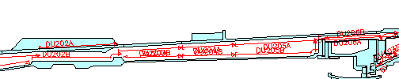
Fig 2.16– use of thermal duct between the COC and CSC

EXERCISE

For the stream SC03 model, modify the stream mass flow and htc to complete the table below:

With the stream htc fixed at 0.2mW/mm²K |  | With the stream mass flow fixed at 0.0001Mg/s
Mass flow (Mg/s) | Stream Exit Temp (K) | htc (mW/mm²K) | Stream Exit Temp (K)
1E-5 |  | 0.01
5E-5 |  | 0.1
1E-4 |  | 0.3
4E-4 |  | 0.6
1E-3 |  | 1.0
1E-2 |  | 3.0

Thermal Duct (2D only)

A thermal duct is identical to a thermal stream in all respects except that two portions of the boundary are defined between which the flow occurs. The assumed flow pattern is constructed by repeatedly finding the shorter of L1 and L2, see figure below, and taking that element next.

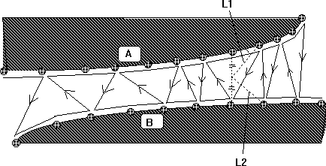

Fig 2.17– thermal duct boundary condition

This means that energy can be exchanged between surfaces A and B and transported via the duct flow. 2 separate streams defined on A and B would have no interaction and there would be no heat transfer between these surfaces.

Thermal ducts are commonly used to represent turbulent flow in small confined passages where there is likely to be heat exchange between the surfaces due to turbulent mixing.

Note that ducts are only used in 2D analysis. In 3D, a duct-style boundary condition is produced by applying the same stream to both components.

Panel

Inputs for a thermal duct are similar to those for stream :

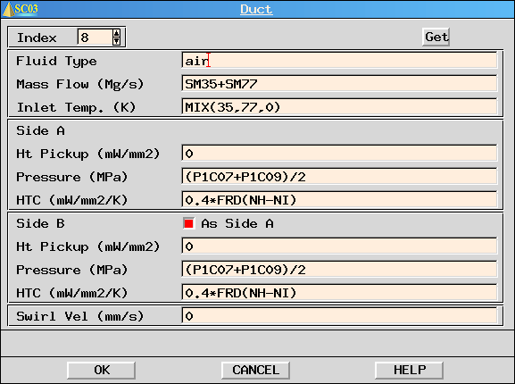
Fig 2.18– thermal duct panel

The only difference is that the pressure, heat pick-up and heat transfer on the two sides of the duct can be different.

Calculation

As for streams

Uses

Ducts are generally used where there is a flow between components separated by only a small distance or flow through holes within a component.

Examples included the annular region between combustion support casings and combustion outer casings, inter-shaft cavities and case cooling flows.

Fig 2.19 - use of thermal duct between the COC and CSC

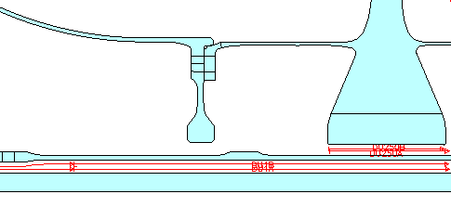
Fig 2.20 - use of thermal duct for intershaft cavities

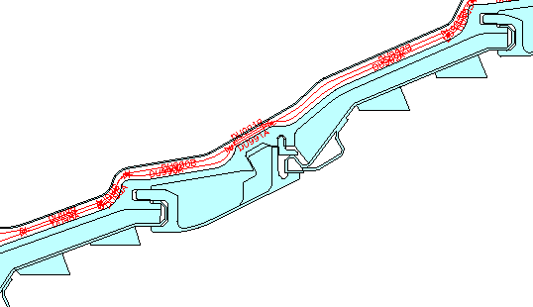
Fig 2.21 - use of thermal duct for LP turbine case cooling flows

External Radiation

External radiation is used to account for radiative heat transfer from a remote source that is not part of the model.

The value of this remote temperature is not influenced by the heat transfer to (or from) it.

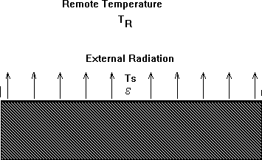

Fig 2.22 – external radiation boundary condition

Panel

Inputs for external radiation are :

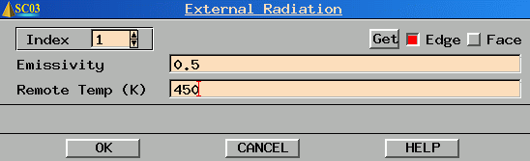
Fig 2.23 – external radiation panel

Emissivity - to define the proportion of black body radiation emitted.

Remote temperature – defines the temperature with which radiation is exchanged.

Calculation

The heat flux is given by the Stefan Boltzmann equation :

Uses

Radiation has most significance in cases where there are large temperature differences between the surface and the surroundings; if the convective heat transfer is relatively low or if there are relatively high surface temperatures. e.g. during engine shutdown (for numerous components) or in turbine casings.

In general, if all the components between which radiation occurs are contained in the model then INTERNAL RADIATION will be defined.
Where one or more of the components are not specified in the model, then EXTERNAL RADIATION will be used.

Examples of this include LP turbine casings where the radiation from the bypass fairing occurs but the fairing itself is not in the model.

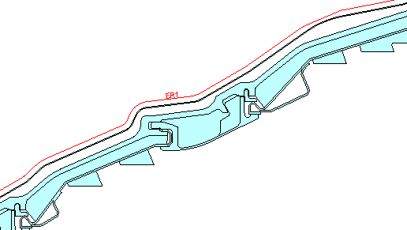
Fig 2.24 – use of external radiation for LP turbine casings

External radiation may also be used on a plane stress 2D model (i.e. not an axisymmetric model). Here all the components are present in the model but the definition of the regions as plane stress makes the automatic calculation of the view factor (which is part of the internal radiation boundary condition) impractical.

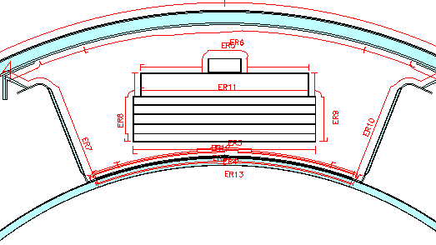
Fig 2.25 – use of external radiation for Electronic Engine Controller (plane stress
model)

Internal Radiation

The internal radiation heat transfer boundary condition is used to define portions of the boundary which are capable of transmitting and receiving radiation from themselves and each other. View factors are calculated automatically.

Radiation has most significance in cases where there are large temperature differences between the surface and the surroundings; if the convective heat transfer is relatively low or if there are relatively high surface temperatures. e.g. during engine shutdown (for numerous components), turbine casings and the LPT disc/TBH cavity.



Fig 2.26 – internal radiation boundary condition

Panel

Inputs for internal radiation are :

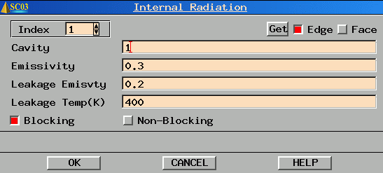
Fig 2.27 – internal radiation panel

Cavity – this is a computational convenience to speed up the view factor calculation. (separate cavities which do not exchange heat with each other should be given different cavity numbers.

Emmisivity - to define the proportion of black body radiation emitted.

Leakage Emissivity and Leakage Temperature define the treatment of heat fluxes that enter or leave the model (acting like external radiation)

Blocking/ Non-Blocking – By default, the boundary condition is set to blocking. By setting this to non-blocking, the boundary to which it is applied will allow radiation to pass through it as part of the view factor calculation.

Calculation

The heat flux is given by the equation :

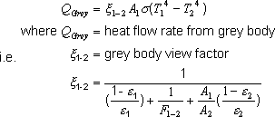

Uses

Internal radiation should be used where there are large temperature differences between component surfaces. The effect of radiation will be more pronounced if convective heat transfer is low.

Examples of internal radiation boundary conditions include turbine casings and the LP turbine disc / Tail Bearing Housing Cavity.

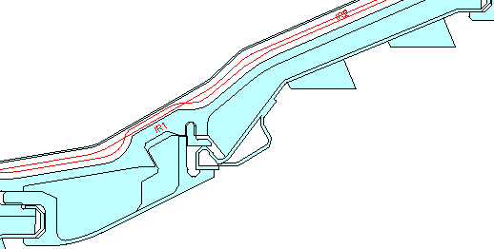
Fig 2.28 – use of internal radiation for the LP turbine casing

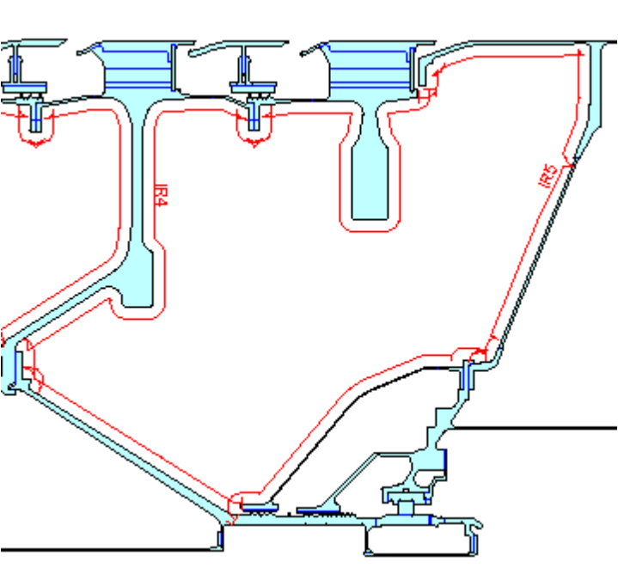
Fig 2.29 – use of internal radiation for the Tail Bearing Housing

Thermal Contact

Thermal contact is used to restore full or partial conduction at an interface. When a joint is defined along an internal line in SC03 it has the effect of removing conduction between the two components. Consider the example below. Components A and B are in contact, an internal line defines the shared edge. Prior to definition of the joint, component A and component B share the same nodes at the internal line. Therefore, heat flux is free to pass between the components.

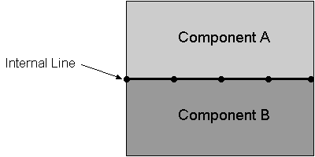

Fig 2.30 – nodes on an internal line between two components

When the joint is applied along the internal line, the nodes at the internal line are effectively separated such that the nodes along the internal line on component A can now act independently from those on component B. Since the nodes now act independently, there is now no information to describe the conduction between the two sets of nodes. The components are effectively thermally separated. If no action is taken, a thermal discontinuity would occur at the joint.

In many instances a restoration of some, or all, of the conduction is required. This has been traditionally done with the use of voids, with a heat transfer chosen to allow the correct heat flux between components. However, this method is not physically representative and may be prone to instability problems (particularly if the void heat transfer coefficient is high). An improvement is to use the Thermal Contact boundary condition.

Panel

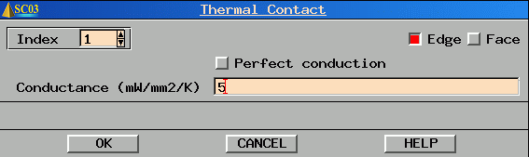
Fig 2.31 – thermal contact panel

Perfect Conduction toggle - If perfect conduction is required, simply select the Perfect conduction toggle. The associated nodes on the edge of the two components will effectively be thermally tied.

Partial conduction - If partial conduction is required, a value (or expression) can be inserted in the Conductance field (with perfect conduction toggled off). Partial conduction is caused by the small-scale irregularities at the interface. This results in local areas of contact with pockets of fluid between.

If a joint is not applied to the interface, the Thermal Contact boundary condition will have no effect as the conduction path is complete.

Calculation

Thermal Conductance is defined by the relationship between flux density across the interface and temperature drop :
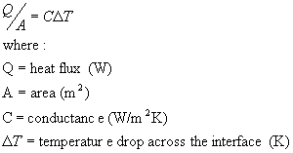

For partial conduction an expression is entered in the appropriate field. Yavanovich suggested that the correlation for the conductance across a rough, conforming contact should be :

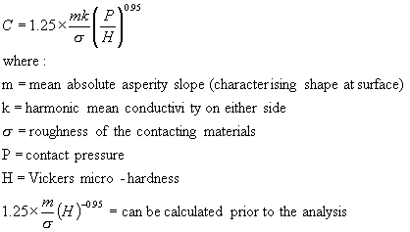

To use the above expression in its entirety, a coupled analysis would have to be performed since the loading of the contact (structural effect) can alter the conductance (thermal effect). To simplify this and allow for thermal contact to be used in ‘Thermal Only’ models the essence of the above expression can be used, rather than the explicit equation itself. The mean absolute asperity slope, roughness of the contacting materials and Vickers microhardness are all effectively constant through the cycle. However it is not easily possible to calculate the value of this constant. The roughness can vary from component to component as can the asperity slope (characterising the shape of the peaks and troughs). This expression is also only valid for the first instance of contact. Plastic deformation under load can change these initial values.

Uses

There are two main uses of thermal contact. The first is to provide full or partial conduction at an interface where a joint has removed the conduction path. The thermal contact boundary condition then restores all or some of the conduction. | Fig 2.32 – use of thermal contact on a birdmouth fixing

The second use is to provide full or partial conduction between two components that should be in contact but are separate in the model (with a small gap between them). An example of this is the interface between turbine disc and blade. The two components are meshed separately and then combined into a single model. Thus there is not a shared face between components. The thermal contact boundary condition provides this. | 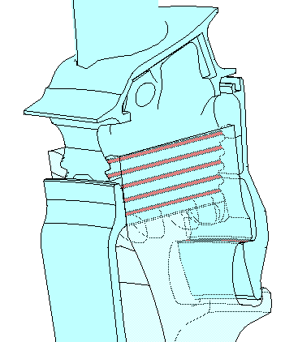  Fig 2.33 – use of thermal contact on a firtree fixing

EXERCISE

For the thermal contact SC03 model, modify the conductance to complete the table below:

Conductance (mW/mm²K) | Metal temperature to left of interface (K) | Metal temperature to right of interface (K)
0
0.1
0.2
0.5
1
2
5
10

 | If you are unsure as to which thermal boundary condition to use, advice is given in the thermo-mechanics web at :  http://www.capability.rolls-royce.com/genthermal/best_practices/temperature/fe/bc_guidance.htm

Also note that for all thermal boundary conditions, care must be taken when applying the boundary condition to an internal line of a 2D model. Double accounting of the wetted area for heat transfer will occur. For more information see :

http://www.capability.rolls-royce.com/genthermal/best_practices/analysis_tools/model_production/general/thickpropcalcs.htm

Demonstration of the Thermo-mechanics Web

The web can be found at :
http://www.capability.rolls-royce.com/genthermal/default.htm

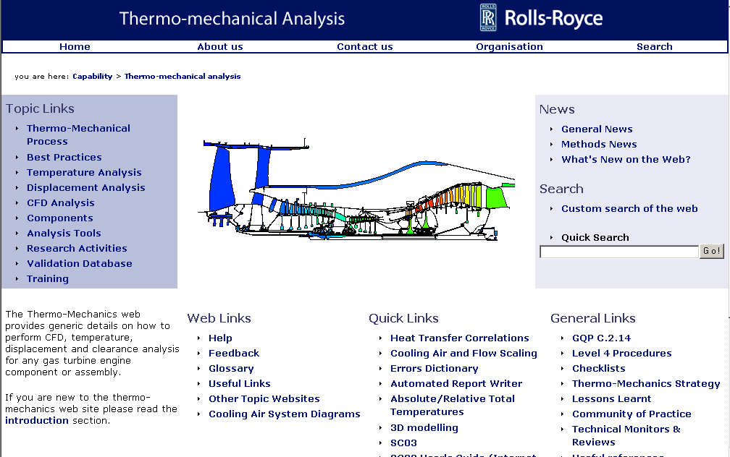
Fig 3.1 – thermo-mechanics home page

What to put in the Panels ?

So far we have looked at the various types of thermal boundary condition. But where does the information come from to put in the panels ?

Fluid Temperatures

Fluid temperatures around the gas washed surfaces in the main annulus (e.g. blade, stator and NGV aerofoils and platforms) are generally obtained from a separate program such as Q263 (RR in-house 2D aerodynamics program) or from a CFD package.

For the secondary air system, fluid temperatures are usually defined at the starting point of a flow system only (generally the main annulus), the subsequent fluid temperature distribution being calculated automatically by the analysis program according to the boundary conditions defined.

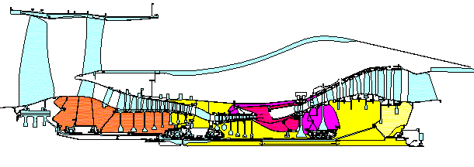
Fig 4.1 – secondary air system

Mass Flows and Pressures

As for temperatures, pressures for the main annulus are usually obtained from a 2D or 3D aerodynamics package. Flows are taken from the performance analysis – i.e. the Basic design document (BDD) described in the scaling section.

For the secondary air system, mass flows and pressures are usually taken from a SPAN model (either full off-design data or scaled design point data) to define flows and pressures for each point in the cycle.

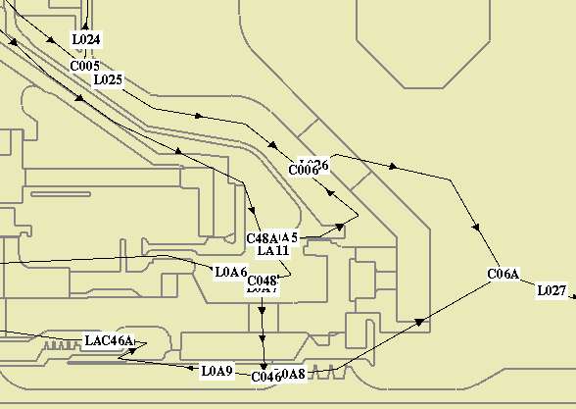
Fig 4.2 – SPAN links and nodes

The thermal boundary conditions can now refer to the link (mass flow) and node (pressure) names from the SPAN model as shown below.

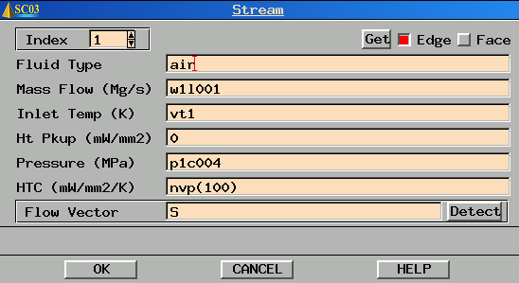
Fig 4.3 – reference to SPAN links and nodes within a stream definition

The values for each of the links and nodes are stored within the SC03 model (see ‘defining the cycle’ later).

Heat Transfer Correlations

There are a number of heat transfer coefficient correlations built into SC03. Rather than calculating the htc’s independently of SC03 and applying the numerical value, SC03 will automatically calculate the value. This speeds up the model preparation time, reduces errors, and allows the model to be independent of the engine cycle (see later).

There are 5 main categories of htc correlation :

- Natural Convection - Plates & Cylinders
- Forced Convection - Duct & Plates
- Forced Convection - Rotating Flow
- Forced Convection - Impingment
- Forced Convection - Labyrinth Seals

The top three of these are the most commonly used.

Note that these correlations have been derived using air. To use them for other fluids such as oil can lead to very strange (and very wrong) results.

Natural Convection – Plates and Cylinders

As mentioned in part 1 of the course, natural convection is driven by buoyancy forces. In addition, it can be shown that natural convection is a function of temperature difference between the fluid and the component.

The non-dimensional term used here is the Grashof number.
It can be shown that the Nusselt number is related to the Grashof number by the relationship :

Nu = f(Gr,Pr)

Note Gr*Pr=Ra (Rayleigh number)

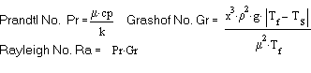
where :

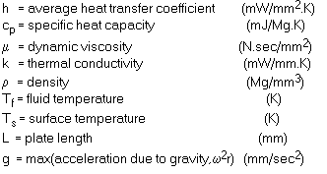
x = characteristic dimension (mm)

The different natural convection htc correlations will use different multipliers, powers and characteristic dimensions, but all are essentially forms of the above equation.

Note for natural convection within rotating components. The gravitational term (g) is replaced with an acceleration term (rω²).

A full listing and description of the heat transfer correlations can be found in the thermo-mechanics web at :
http://www.capability.rolls-royce.com/genthermal/best_practices/temperature/fe/htc/default.htm

Uses

Regions where natural convection occurs include engine core outer casings and interdisc cavities.

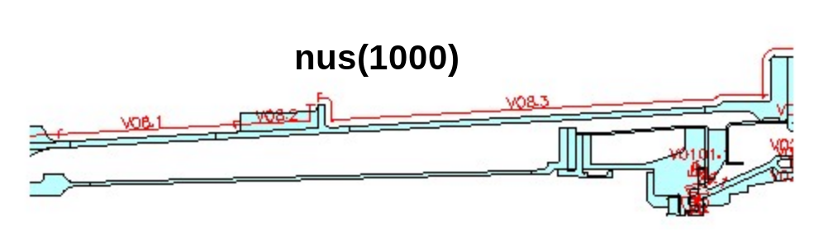
Fig 4.4 – use of natural convection on an engine core outer casing

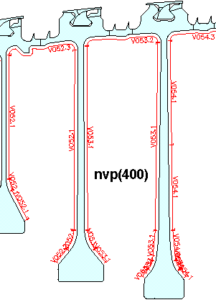
Fig 4.5 – use of natural convection for an interdisc cavity

Forced Convection – Ducts and Plates

As air flows over a plate or through a duct, a boundary layer is set up at the air/solid interface. The characteristics of the boundary layer dictate the heat transfer from the free-stream air to the component surface (represented by the heat transfer coefficient). Remember, the heat flux from the air to the component is given by :

As well as the Nusselt number (which contains the heat transfer coefficient), the key non-dimensional term is the Reynolds number.

Nu=f(Pr,Re)

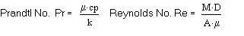
There will be a critical Reynolds number at which the flow goes from laminar to turbulent.

As for the Grashof number in the natural convection case, the Reynolds number requires a characteristic dimension. For plates this will generally be the plate length, for flows in ducts the hydraulic diameter is used :

D_{h}=4A/P

It can be seen that for a pipe of circular cross section, the hydraulic diameter equals the pipe diameter.

The correlations can deal with entry length effects. If the flow goes from a large plenum into the pipe (with sharp corners). there will be an entry length effect as the boundary layer thickness builds up.

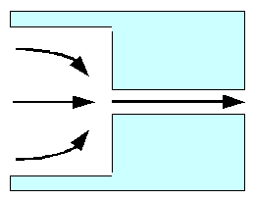
Fig 4.6 – entry length effect

EXERCISE

Using the example from Part 1, vary the entry length in the forced duct correlation. Choose values from 1 to 1000mm. Repeat using FCD and NUN correlations.

Parameter | Value
M (Mg/s) | 2.50E-03
Tf (K) | 700
Tm (K) | 750
A (mm²) | 45100
Dh (mm) | 32
L (mm) | 1 to1000
μ (Nsec/ mm²) | 3.409E-11
μ_{s} (Nsec/ mm²) | 3.568E-11
k (mW/mm) | 5.104E-2
Cp (mJ/MgK) | 1.075E9

Note that the calculation can be performed in SC03 units!

Use the Thermo-mechanics web to find the correlations for both FCD and NUN. Note that both can be calculated using the HT_Calculations facility in SC77.

Uses

Regions where forced convection in ducts and plates occurs include the flow between the combustion outer casing and combustion support casing, flows through drillings and blade platforms. Note that a forced duct correlation does NOT have to be used in conjunction with a Duct boundary condition.
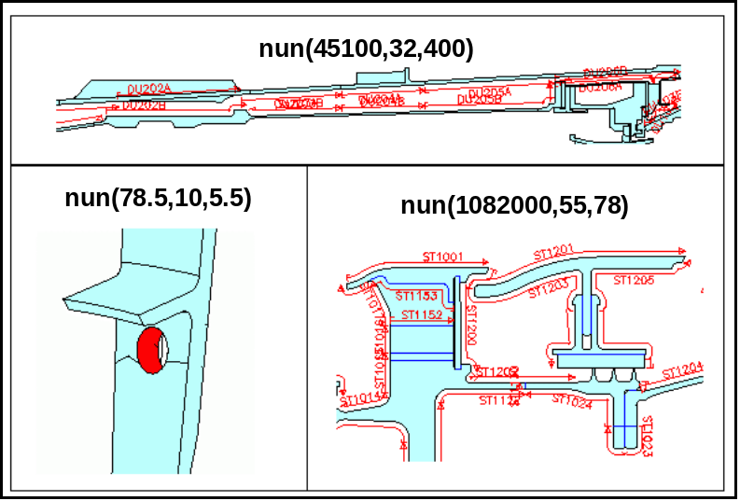
Fig 4.7 – use of forced convection in ducts for (a) the flow between the COC and CSC, (b) flow through a drilling and (c) flows on blade platforms

Forced Convection – Rotating Flow

In many ways, forced convection in rotating systems is similar to that for ducts and plates. Now it is the rotational Reynolds number that dictates the resultant heat transfer coefficient :

Nu = f(Re,Pr)

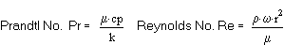

The characteristic dimension is now easier, being the local radius.

Uses

Regions where forced convection in rotating flow occurs includes discs, and static components close to rotating components.

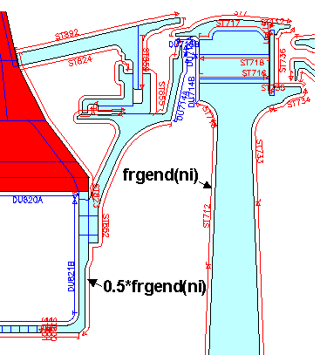
Fig 4.8 – use of forced convection in rotating flows for discs and static
structures next to discs

Thickness Properties and HTC Factoring

Thickness Properties

Many components in the engine are modelled as 2D axisymmetric. This offers significant advantages in boundary condition application, running times and file sizes relative to 3D models. Problems are encountered when 3D features are to be modelled in the 2D axisymmetric model. It must be noted that all we can do is approximate the 3D effect – if detailed component temperatures around the 3D feature are required, a 3D model should be produced.

3D features (in a 2D model) are modelled in SC03 by way of thickness properties. Thickness in SC03 is defined as the amount of material at a given circumference.

Consider 'n' holes on a pitch circle diameter:  Diameter of holes:  D = r_{o}- r_{I}  Pitch circle radius:  r_{m} = (r_{o}+ r_{i})/2  Calculate the actual volume of ‘n’ holes  V_{act} = (π.D²/4).t.n  Calculate the swept volume between r_{o} and r_{i}  V_{swept} = π.(r_{o}²-r_{i}²).t  Calculate the fraction of air  X_{air} = V_{act}/V_{swept}  Hence, calculate the fraction of material  X_{mat} = 1- X_{air}  Thickness property = X_{mat}.2.pi.r_{m} | 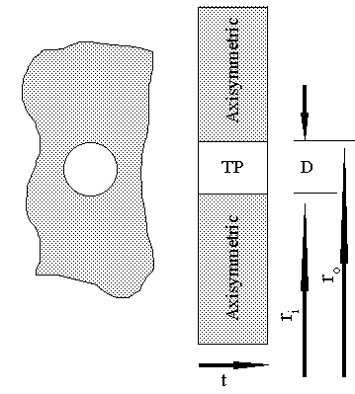  Fig 4.9 – holes on a pitch circle diameter

Note that as long as D<< r_{o} then the error associated with this method of defining the thickness will be small. Where the size of the 3D feature is significant relative to the surrounding geometry then a variable thickness may be required. See:
http://www.capability.rolls-royce.com/genthermal/best_practices/analysis_tools/model_production/general/thickpropcalcs.htm#Variable Thickness (Accurate Method)

HTC Factoring

Care must always be taken when a thermal boundary condition is applied to an internal line.

An internal line will actually have two surfaces associated to it. Thus the total wetted area for heat transfer that SC03 will use will be the area of surface 1 AND the area of surface 2. | 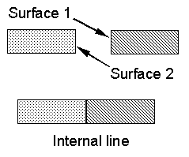  Fig 4.10 – internal lines
We cannot alter the area that SC03 will calculate but we can get SC03 to apply the correct heat flux into the material by applying a ‘geometric factor’. This factor is applied to the standard correlation to compensate for SC03’s interpretation/calculation of the wetted area.

Since Q=hAΔT, altering the ‘h’ value has the same effect as altering the area:

HTC Factor, f = A_{act} / A_{SC03}

Q =h. (A_{act} / A_{SC03}). A_{SC03.}ΔT

Consider the following situation of ‘n’ holes on a pitch circle diameter:  The thickness property has already been calculated to be TP  In the example here, the internal line at radius r_{o} has surface area of :  (2π.r_{o}+TP).t  The same can be said for the inner radius, thus the total wetted area calculated by SC03 is :  A_{SC03}=(2π.r_{o}+TP).t+(2π.r_{i}+TP).t  The actual wetted area for ‘n’ holes on the pitch circle is:  A_{act}=π.D.n.t  HTC Factor, f = A_{act} / A_{SC03} | Fig 4.11 – holes on a pitch circle diameter

EXERCISE

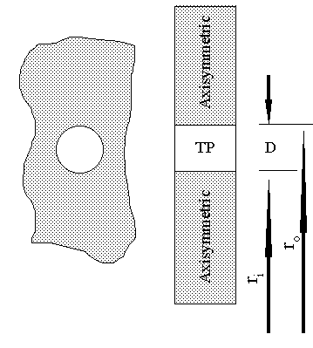  Fig 4.12 – thickness property exercise | Calculate the Thickness Property and ‘geometric’ factor to be applied to the heat transfer coefficient.  Number of holes = 30  r_{o} = 340mm  r_{i} = 320mm

Heat Transfer Coefficient Correlations Listing

http://www.capability.rolls-royce.com/genthermal/best_practices/temperature/fe/htc/htc_correlations.htm

Natural Convection - Plates & Cylinders
Upper Surface of Hot Plates & Lower Surface of Cool Plates (nus)
Lower Surface of Hot Plates & Upper Surface of Cool Plates (nls)
Vertical Plate or Cylinder (nvp)
Horizontal Cylinder (nhc)
Horizontal Cylinder (ncy)
Inner Surface of Compressor Drive Cone (cone)
Forced Convection - Rotating Flow
Turbulent Free Disc (fdf & frd(N))
Laminar Free Disc (fdlam & frlamd(N))
General Free Disc (fdgen & frgend(N))
General Rotating Flow (genrot(a,b,c))
Rotating Drum (drum(Ri,Ro,d))
Forced Convection - Ducts & Plates
Non-rotating duct (fcd, mfcd)
Non-rotating duct (nun, mnun)
Flat Plate (fcp, frp, mfrp)
Forced Convection - Impingement
Single row of Rectangular Slots (imprsl & improw)
Single row of Circular Holes (imprcj(W,d,Xn,x,Zn))
Square array of Circular (impsqr, impsq2)
Forced Convection - Labyrinth Seals
Straight Seals - Stator Surface (lbths)
Straight Seals - Rotor Surface (lbthr)
Stepped Seals - Stator Surface (lbstps)
Stepped Seals - Rotor Surface (lbstpr)

Interdependencies

SC03 allows for interdependencies of mass flows temperatures and pressures between boundary conditions. Version 10 also allows interdependencies of swirl velocity and boundary condition area.

For instance, if stream 5 (with a mass flow of 1kg/s) is mixed with duct 134 (with a mass flow of 0.3 kg/s) to form stream 11, then the mass flow of stream 11 can be defined as (sm5 + dm134) i.e. the sum of the mass flows of stream 5 and duct 134

Similarly, if stream 14 feeds directly into stream 15, then the inlet temperature specified for stream 15 will be st14 i.e. use the exit temperature of stream 14 as the inlet temperature for stream 15.

Again if the pressure of convecting zone 98 is the same as that for void 35 then the pressure in the zone can be defined as vp35 i.e. use the pressure calculated for void 35 for zone 98.

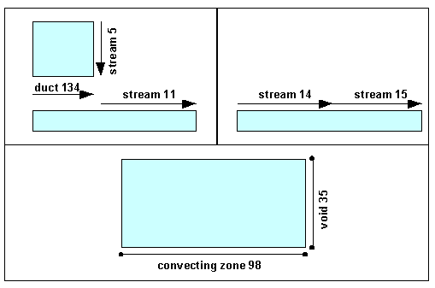
Fig 5.1 – examples of interdependencies

A full list of interdependencies is provided below (where i is the boundary condition index):

ZTi meaning the temperature of convecting zone i
ZPi meaning the pressure of convecting zone i
ZAi meaning the surface area of convecting zone i
VTi meaning the temperature of void i
VPi meaning the pressure of void i
VAi meaning the surface area of void i
VVi meaning the swirl velocity of void i
STi meaning the outlet temperature of stream i
SIi meaning the inlet temperature of stream i
SPi meaning the pressure of stream i
SMi meaning the outlet mass flow in stream i
SOi meaning the outlet metal temperature of stream i
SAi meaning the surface area of stream i
SVi meaning the swirl velocity of stream i
DTi meaning the outlet temperature of duct i
DIi meaning the inlet temperature of duct i
DPi meaning the pressure of duct i
DMi meaning the mass flow in duct i
DAi meaning the surface area of duct i
DVi meaning the swirl velocity of duct i

MIX(i,j) meaning an enthalpy balance between streams (or ducts) i and j
PWR(i) meaning the power of stream (or duct) i
PWRV(massflow,i) meaning the power associated with the temperature of void i and the mass flow specified.

Note that in the above 3 terms, a negative index indicates a duct as opposed to a stream.

Dummy Streams
There is sometimes the requirement to produce a ‘dummy stream’ to allow a particular interdependency to be defined. These streams should be defined on remote geometry (often a dummy block) and generally have the heat transfer coefficient and Heat Pick-up set to 0 so that the stream exit temperature and start temperature are the same.

To mix two stream together in SC03 is relatively straight forwards. The mix function can be used which will perform an enthalpy balance to determine the mixed out temperature.

e.g. T=MIX(123,456)

If, however, there is a flow split such that there is a requirement to mix a proportion of one stream with another stream, then a dummy stream is required to enable the correct mix to be performed.

e.g. To mix half the flow of stream 1 with the total flow of stream 2

Create a new (dummy) stream 3, whereby, the mass flow is 0.5*sm1, and the temperature in st1. All other values in the stream definition should be 0. Since the htc is 0, the exit temperature of stream 3 will be the same as the inlet temperature. Thus stream 3 exists which has half the mass flow of stream 1, but the same temperature. The mix now becomes:

T=MIX(3,2)

EXERCISE

Fill in the gaps in the diagram below :

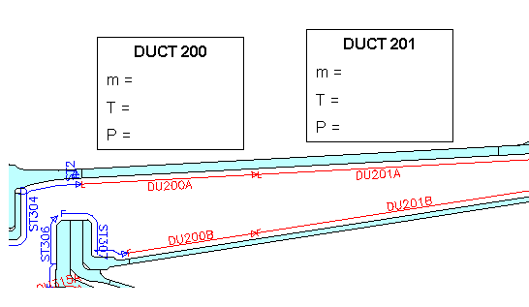
Fig 5.2 – examples of interdependencies

View the general example for more examples of interdependencies.

Defining the Cycle

Temperatures are often required for a number of engine operating cycles and test cycles.

The flight cycle (of which there are many variants) is used to assess component lifing and performance for typical operating conditions.

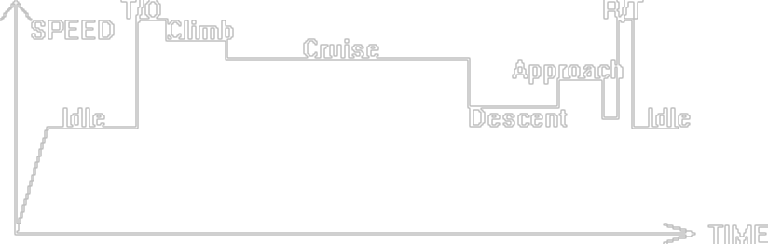

Fig 6.1 – flight cycle

The certification cycle is dependent on the component in question and defined by the certification authorities to establish component integrity at extreme operating conditions.

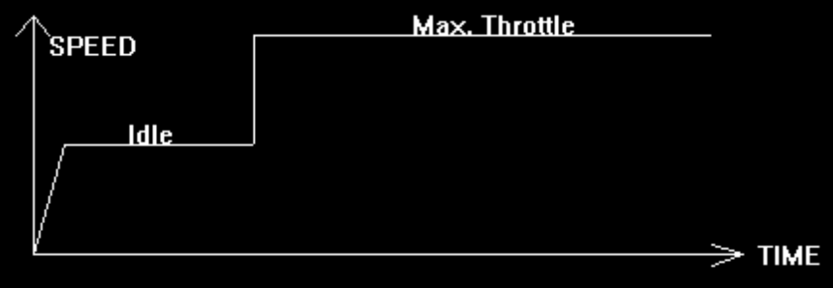

Fig 6.2 – certification cycle

The running-in-handling cycle is engine dependent and designed to 'run-in' a new engine and minimise engine performance deterioration in service.

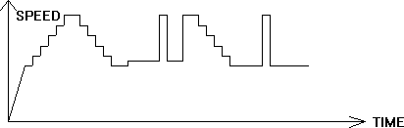

Fig 6.3 – running-in handling cycle

It is recommended that component model validation is based on both square cycle and performance curve data.

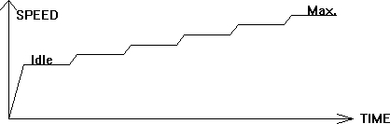

Fig 6.4 – performance curve



Fig 6.5 – square cycle

To have separate models for each of these cases would be very time consuming and cumbersome. Instead, one model is produced to calculate the temperatures (and displacements if required) for all cycles.

The model is made independent of the cycle by relating the boundary conditions to main gas path (or BDD parameters) as opposed to absolute values.

To run different cycles, therefore, the same model is used but simply run to the appropriate BDD parameters (which provides all the main gas path parameters at all key points in the cycle.

As a reminder, the station numbering of the main gas path parameters is as below :

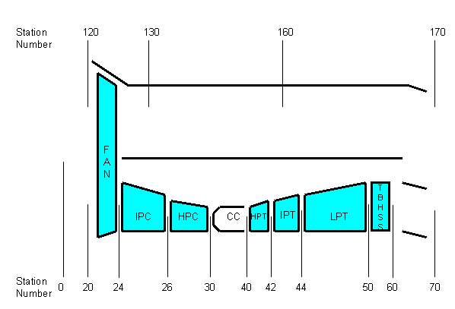
Fig 6.6 – main annulus station numbering

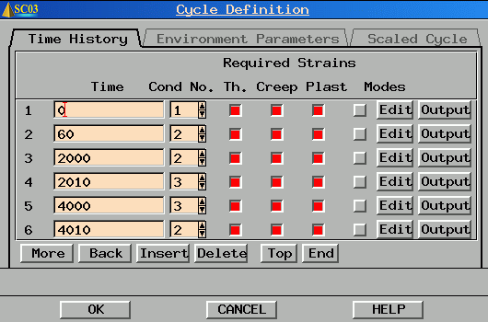
Fig 6.7 – cycle definition within SC03 (time history)

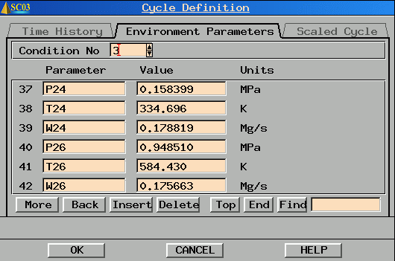
Fig 6.8 – cycle definition within SC03 (main annulus ‘environmental’ parameters)

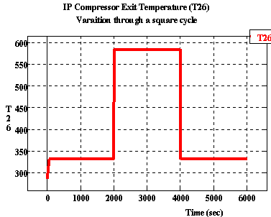
Fig 6.9 – variation of a main annulus parameter (T26) as defined in the panels above

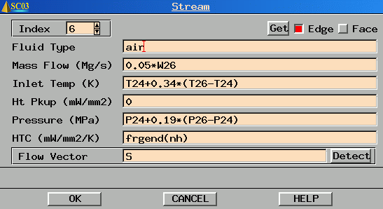
Fig 6.10 – incorporation of cycle definition data within a thermal boundary condition

Global Control

The type of analysis, and information relating to the type of analysis is defined within global control.

Within the main Global Control Panel, the type of analysis (e.g. thermo-mechanical, structural or thermal) can be selected. Note that the default is structural and thus this will need changing for thermal problems.

The Thermal Control button allows further items to be defined.

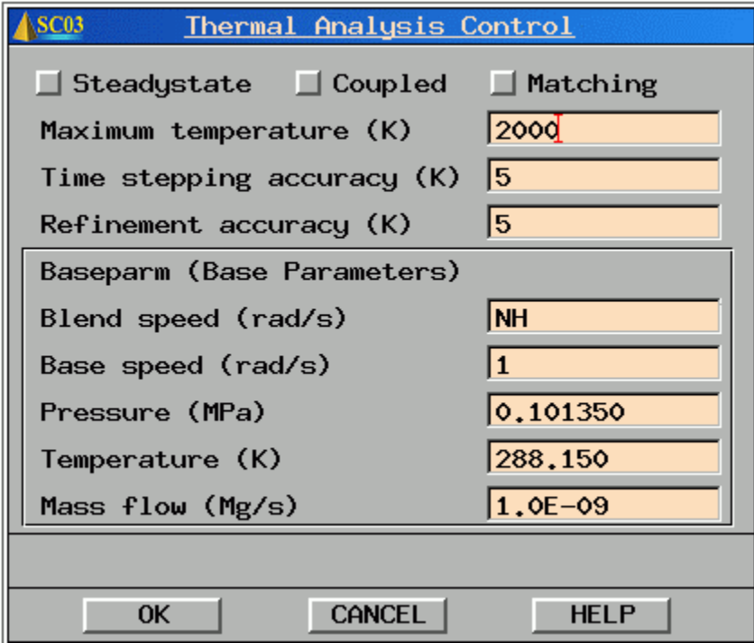
Fig 6.11 – Thermal Analysis Control

Time Stepping Accuracy
The time stepping accuracy is used to control the automatic time stepping. For typical engine compressors or turbines, a value of 5K is recommended for the time stepping accuracy (note that the default in SC03 is 10K).

In a transient analysis, SC03 will perform a number of intermediate analyses (steps) between any two ramps (corner points of the cycle). SC03 will begin by assuming the time step is ¼ of the interval between one ramp and the next.

e.g. if ramp 1 begins at 0 secs and ramp 2 begins at 60 secs, then SC03 will perform calculations at 0,15,30,45 and 60 seconds.

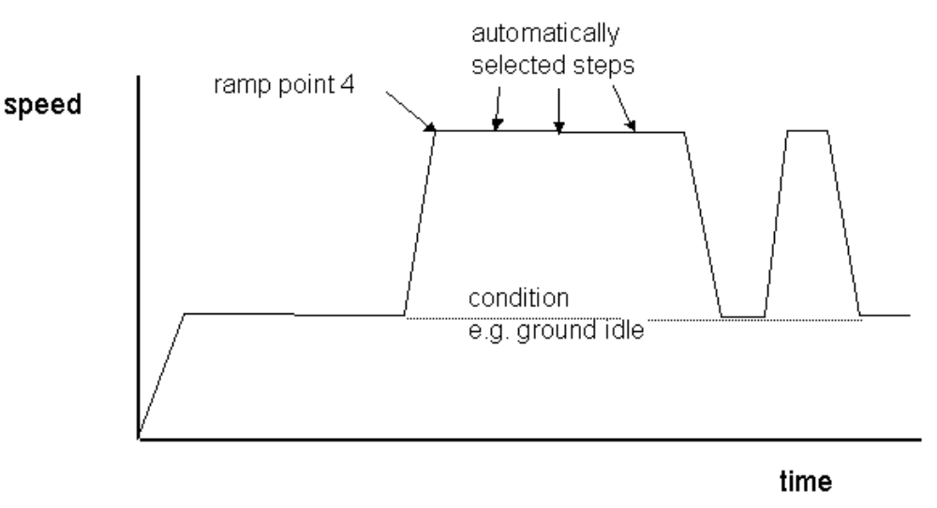Fig 6.12 – Ramp & step numbering

SC03 may reduce the time step for a number of reasons (e.g. too large a temperature change, slow boundary condition iteration). The reason will always be given in the diagnostics file.

To determine whether the temperature change is too large, the following calculation is performed. For each node, SC03 will effectively plot the temperature value for the current step and the previous two steps. It will join the three points both with straight lines and a parabolic curve. If the difference between the two is larger than the user defined time stepping tolerance then the time step is reduced.

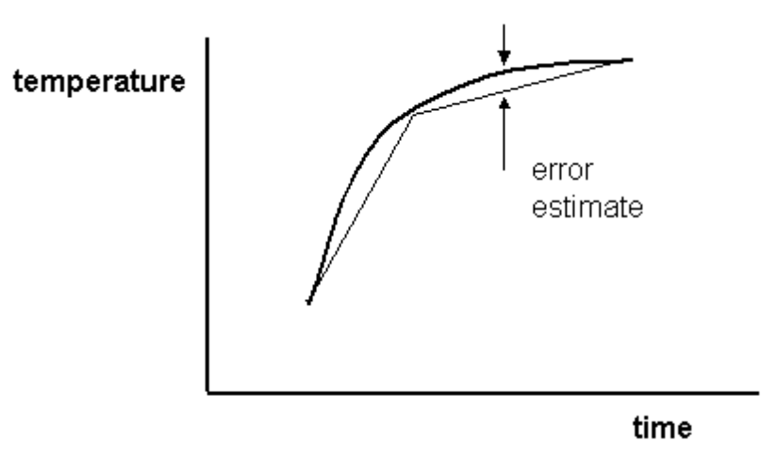
Fig 6.13 – Time stepping accuracy

Refinement Accuracy
The refinement accuracy is used to control mesh refinement. For typical engine compressors or turbines, a value of 5K is recommended for the refinement accuracy (note that the default in SC03 is 10K).

The spatial temperature error estimate is based on temperature gradient.

For simplicity, consider two 6-noded triangular elements. For each element, SC03 will perform the finite element calculations at the Integration Points (or Gauss Points) and not at the node points. Thus for two adjacent elements, each one will extrapolate from the integration points to determine the nodal temperatures. The temperature error is effectively the mismatch in temperature at each node that results from this extrapolation.

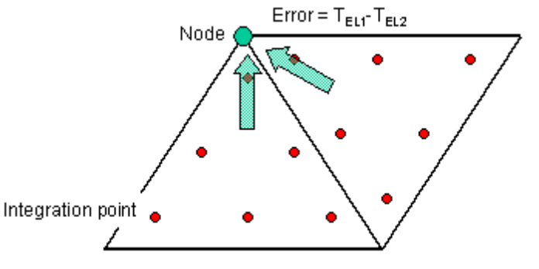
Fig 6.14 – Refinement accuracy

If the temperature error is greater than the user specified refinement accuracy then the automatic mesh refinement (adaption) will be triggered.

Note 1 – only the domains in which elements have failed the temperature accuracy will be refined
Note 2 – the analysis will run through the whole cycle before the mesh is adapted. The analysis will then be automatically re-run with the adapted mesh.

Base Parameters
The base parameter facility enables the user to modify the values of speeds, pressures, temperatures and mass flows during low speed parts of the cycle (most commonly at the start) so as to avoid problems in boundary condition evaluation. The blend speed expression is evaluated and if less than the base speed, the program will not evaluate the boundary condition expressions but set them to the baseparm value.

Thus for a typical starting ramp as shown below, at time 0 where NH is zero, the base parameters are used. At the second step point (time 15), an interpolation will be performed between the boundary conditions evaluated at ramp 2 (time 60s) and the base parameters at ramp 1 (time 0s).

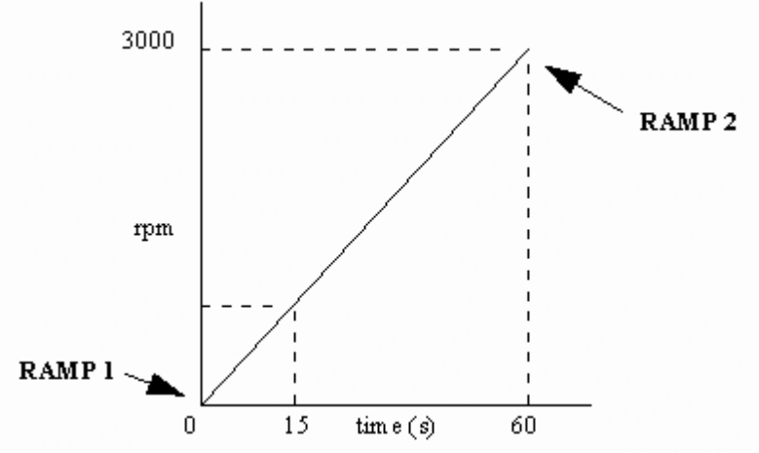
Fig 6.15 – Base Parameter Formulation

Absolute/Relative Temperature

As mentioned before, fluid temperatures are usually defined at the starting point of a flow system only (generally the main annulus), the subsequent fluid temperature distribution being calculated automatically by the analysis program according to the boundary conditions defined.

Main annulus temperatures can usually be assumed to have an instantaneous thermal response and may therefore be specified based on 2 relevant engine performance parameters.

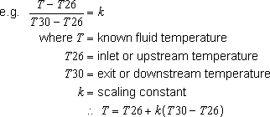

For static components (e.g., casings, stators, NGV's) the temperature at the component surface is the absolute total temperature T_{ABS} BUT for rotating components (e.g., rotor discs and blades) the temperature at the rotor surface is the relative total temperature T_{REL}.

At this point, a small amount of maths is required to highlight the difference between the absolute and relative total temperature.

Specific total enthalpy, h can be defined as
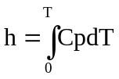
where:
Cp is the specific heat at constant pressure
T is the temperature in question

We can also define the static enthalpy and a velocity term (essentially the contributions of the internal energy and kinetic energy):
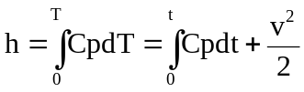
where:
t is the static temperature
v is the velocity

SC03 will use a temperature dependant Cp, but to simplify the following equations, the assumption will be that Cp is constant.

Thus in the absolute frame, and the relative frame of reference, the following equations can be defined:
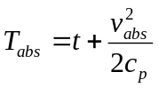 and 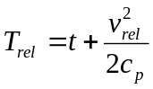
These can be combined to give: 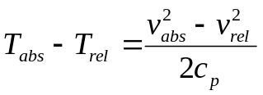
Rearranging (and defining the swirl fraction β=v/rω) gives:
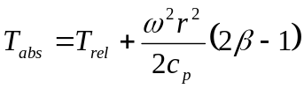 (equ 7.1)
Thus it can be seen that with a knowledge of the absolute total temperature and the swirl fraction, the relative total temperature can be deduced.

For more information see http://www.capability.rolls-royce.com/genthermal/best_practices/analysis_tools/model_production/thermal/absrel.html

While ever the model is simply of a rotating assembly (e.g. HP compressor and turbine) or of a static assembly (e.g. LP turbine casing). Then the choice between absolute total temperature and relative total temperature is straight forward.

Problems may occur, however, when static and rotating components appear in the same model and there is interaction of the air flow between them.

Consider the example below of a rotor-stator cavity (e.g. a stator well cavity).

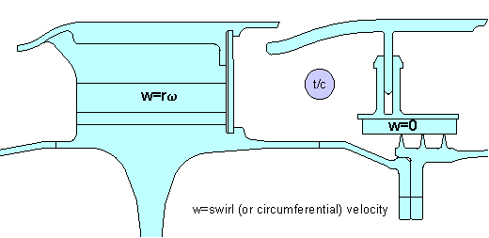
Fig 7.1 – stator well cavity

If a static air thermocouple is placed in the region between the rotor and stator, it will measure the absolute total temperature i.e. the temperature in the stationary frame of reference. It is this fluid temperature that will dictate the heat transfer into the static component.

The relative total temperature i.e. the temperature that the rotor ‘sees’ is NOT the same. It can be calculated from the absolute temperature IF the swirl velocity of the air is known. This is the big problem since it is very difficult to measure this in a real engine situation. More often, the relative total temperature is inferred from an SC03 analysis which is matched to measured metal temperatures (see the validation section later).

EXERCISE

With reference to figure 7.1 above, calculate T_{rel} (i.e. the temperature that the rotor ‘sees’).

You will need to assume the following.

- Disc speed is 700 rad/s
- Bulk air in the cavity is rotating at 0.3xdisc speed
- Temperature reading on the stationary thermocouple is 600K
- Radius of the thermocouple is 400mm
- Cp=1000 J/kg/K
- Radial and axial velocities are negligible

CFD Analysis

The use of computational fluid dynamics (CFD) to support Thermo-mechanical modelling is becoming more widespread. CFD can be used either to:
- support a conventional finite element (SC03) analysis
- be used in a fully coupled FE/CFD analysis

CFD to support a conventional finite element (SC03) analysis

Stand-alone CFD analyses can be used to provide information about the fluid behaviour, which can then be used in the choice of SC03 boundary conditions. It can help to provide information to support:
- choice of boundary condition (stream, duct, void, etc)
- direction of flow (including recirculations)
- mass flow splits
- heat transfer coefficient levels
- windage levels (heat pick-up)

It should be noted that great care should be taken if heat transfer coefficients are to be deduced from the CFD results. The choice of corresponding air temperature is critical and should be consistent with how the fluid is modelled within the SC03 analysis.

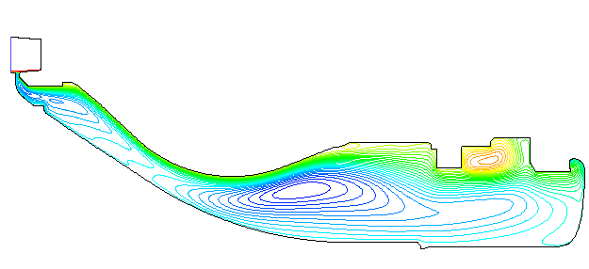
Fig 8.1 – CFD to support a conventional SC03 analysis

CFD can also be used to visualise certain flow phenomena. The simple rotor-stator test case below shows a recirculating region and also highlights the relationship between absolute total temperature, relative total temperature and swirl fraction.

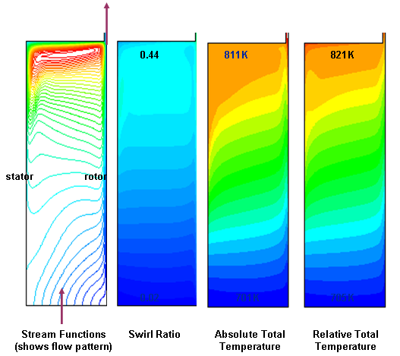
Fig 8.2 – Simple rotor-stator cavity with radial outflow

Coupled CFD/FE analyses

The alternative use of CFD in support of finite element (FE) analyses is to do away with the standard boundary conditions (streams, ducts, etc) and directly pass the heat flux from the CFD model into the FE model. In turn, updated metal temperatures from the FE model can then be passed back to the CFD model. This process continues until converegence is achieved.

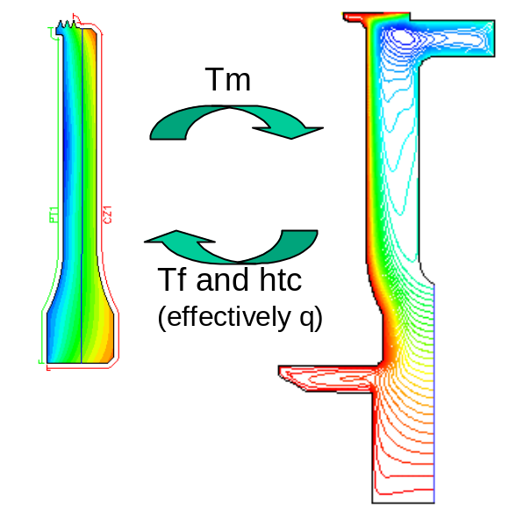
Fig 8.3 – Coupled CFD/FE analysis

In SC03, this process is achieved by use of the plugin SC89. In actual fact, to improve the stability of the process, it is not the heat flux that is passed across but a combination of fluid temperature and htc that combine to give the same heat flux. This information is passed to the SC03 model by way of convecting zones. For more information see the SC89 help page.

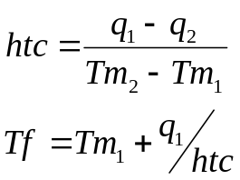

Windage

As a component (e.g. turbine disc) rotates, a velocity profile is created in the boundary layer at its surface.

At the disc surface, the air is rotating at disc speed (the no-slip condition). Outside the boundary layer, the main body of air is rotating at a different speed. The classic case is to assume that the main body of air is infinite and has no rotational component – the free disc. The shearing of the air causes a temperature rise – windage (or frictional) heating.

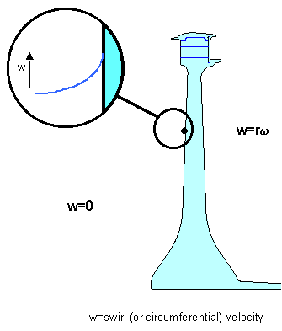
Fig 9.1 – velocity change through the boundary layer

Consider the adiabatic rotor stator cavity below, with rotor torque, T, and stator drag D

the torque balance gives:  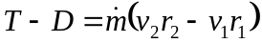  Multiplying by ω to get the rotor work, W:  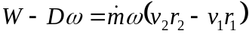 (equ 9.1)  The adiabatic steady flow energy equation, in the absolute frame is:  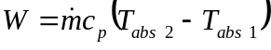 (equ 9.2)  combining (9.1) and (9.2), and using Equ (7.1) to replace Tabs with Trel gives: 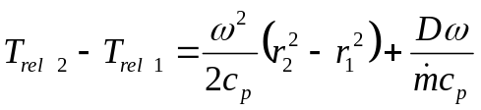 (equ 9.3) | 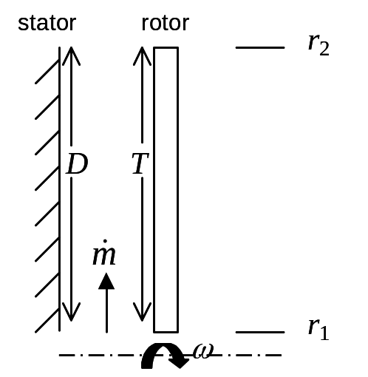
Thus with a knowledge of how the absolute total temperature varies through the cavity (as a result of windage or convection) and how the swirl velocity varies through the cavity, the relative total temperature can be determined.

New Functionality
There is now an additional field in streams, ducts & voids for SWIRL VELOCITY. Note that it is the swirl velocity (in mm/s) relative to ground that is required and not the swirl fraction. This has been chosen to avoid confusion in systems with multiple rotational speeds (e.g. IP/LP turbine cavity).

Any pre-version 9 model that is read into version 9 will have the swirl velocity value set to 0. If the swirl velocity is 0 then the new functionality is not invoked and thus SC03 behaves as for all previous versions. For models where all components are stationary (e.g. casings), it is recommended that the new functionality is not used as it will just add unnecessary complication.

Having a NON-ZERO swirl velocity invokes the new functionality on those streams, ducts and voids where the swirl velocity is non-zero only.

For these thermal boundary conditions, the temperature is assumed to be defined in the absolute frame. Any heat pick-up (windage) applied should be appropriate to that in the absolute frame. No drag term is required since this is taken into account by way of the swirl velocity. SC03 will update the absolute total temperature as it calculates the thermal boundary condition data based on any heat pick-up and/or convection defined. If the component is rotating, SC03 will determine this based on the domain speed. It will then convert the absolute total temperature to a relative based on a knowledge of the swirl velocity at that radius and the local domain speed.

SC03 contains an in built correlation for windage heating which is a function of the rotational speed, the local radius etc.

http://www.capability.rolls-royce.com/genthermal/best_practices/temperature/fe/htc/nfdw.htm

This should be used in conjunction with the advice described in http://www.capability.rolls-royce.com/genthermal/best_practices/analysis_tools/model_production/thermal/absrel.html

EXERCISE

For the windage SC03 model, determine the temperature rise due to windage in each of the two streams. Which stream has the largest temperature rise and why? Vary the stream mass flows and then the disc rotational speed. Which has the greatest effect?

Entrainment

When a disc or cone is rotated, the CF forces induced in the fluid cause it to move radially outwards, which in turn entrains more air to replace it.

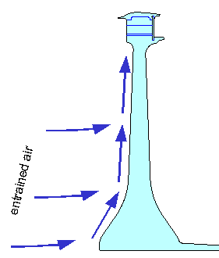
Fig 10.1 – entrainment for a rotating disc

Where the mass flow is radially inwards, this can cause local flow reversals in the flow close to the rotating surface.

In general, the entrained mass flow is cumbersome to calculate, although a particularly simple equation is obtained if 1/7th power law velocity profiles are assumed :

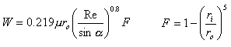
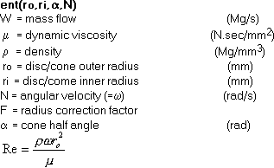

In most cases it is this entrained mass flow that should be used to define the heat capacity of the fluid flowing up the disc face (i.e. the mass flow in the stream)

Practical Examples of Modelling in SC03

EXERCISE

For each of the following cases, choose what type of boundary condition should be applied and what type of heat transfer correlation:

- LP Turbine Assembly
- HP Turbine Disc
- IP Compressor Assembly
- HP Compressor Assembly

LP Turbine Assembly

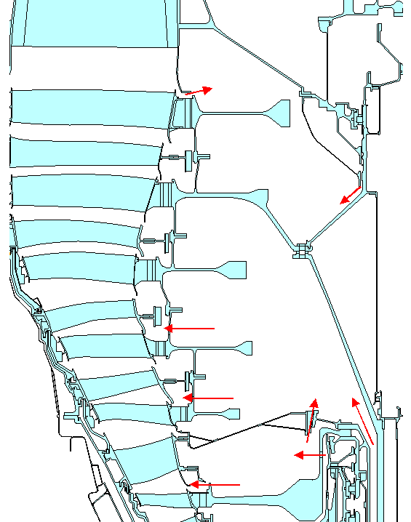

HP Turbine Disc

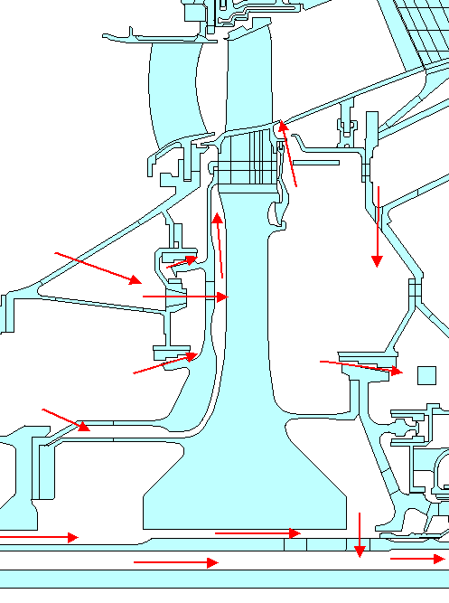

IP Compressor Assembly

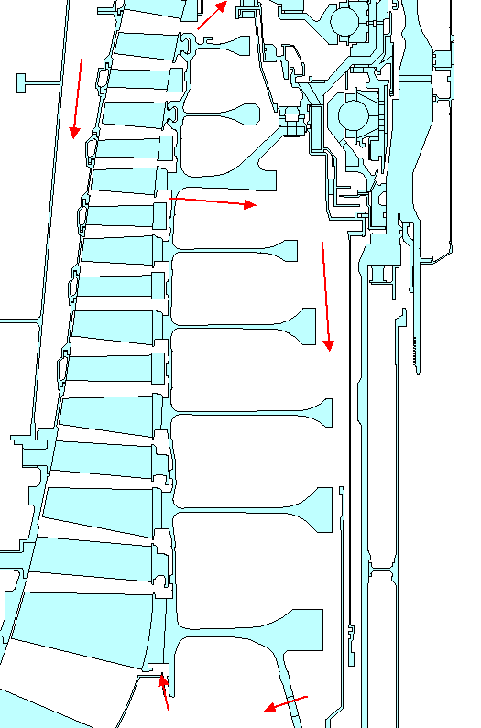

HP Compressor Assembly

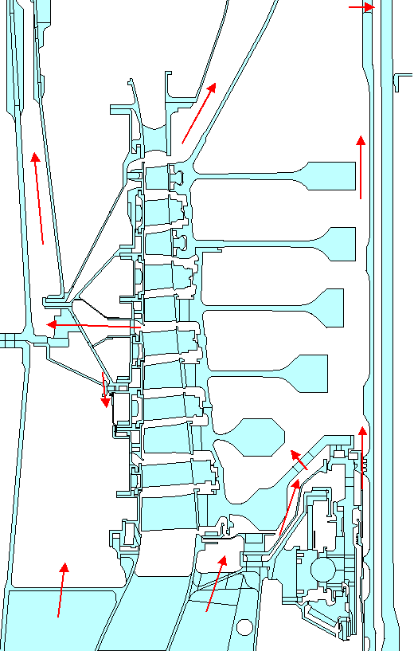

Validation (including Thermal Matching)

By appropriately defining thermal boundary conditions on a model (including choices of the type of boundary condition and heat transfer correlations), the analyst can produce a model and calculate component temperatures. The true test of the quality of such a model, however, is when it is compared to real, measure data. This process is known as validation (or thermal matching). Only when the model has been validated (i.e. a matching exercise successfully performed) can temperature predictions for any cycle be relied upon.

The validation process has 4 main steps :

- Production of a test specification
- Test data reduction
- Initial model production
- Model matching

Production of a Test Specification

The test specification defines what measurements are required (e.g. temperatures, pressures, flows), where they are required and what is the accuracy requirement.

In general, Thermal Systems validation work is based on thermocouple measurements (a scheme is shown below). Other areas such as Turbine Blade Cooling and Combustion use mainly thermal paint data.
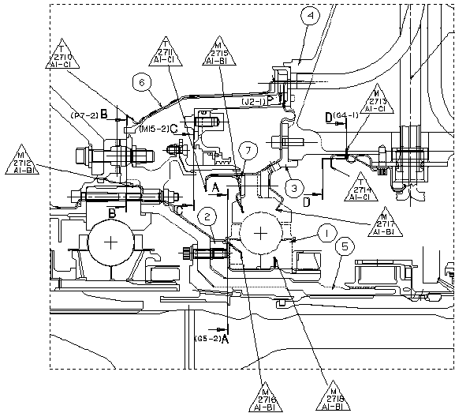
Fig 12.1 – thermocouple specification for an IP bearing
The relative merits of thermocouples and thermal paint measurements are summarised below :

Thermocouples | Thermal Paint
Advantages | Advantages
Accurate (± 1%) | Large areas can be measured
Capable of transient recording | Temperature patterns easily visualised
Can record temperatures for any cycle | Cheap
 | Available early in the development process
Disadvantages | Disadvantages
Intrusive | Inaccurate (± 30K for rotating parts - possible more for static parts - less data for composite)
Discrete | Error (thought to be small) due to temperature gradient through the paint
Prone to failure (either no or false reading) | Limited to a thermal paint cycle
Expensive | Thermal Paint reading requires human judgement
Time consuming to build | Can't use for very high temperatures
Available later in the development process
Telemetry units required for rotating parts

The test specification also defines the type of running (i.e. what cycles are to be run) and where the data is to be stored

Test Data Reduction

After the engine has run, the analyst will look at the raw test data. Potentially rogue data will be challenged. The test data is then reported (including plots of the measured data) and the data is stored securely.

Initial Model Production

The thermal model is set up to reflect the actual test including appropriate geometry (may not be production hardware), secondary air system data and running to the precise engine cycle..

The predicted temperatures are then compared to the measurements. The diagram below shows the measured and predicted temperatures at a particular thermocouple location.

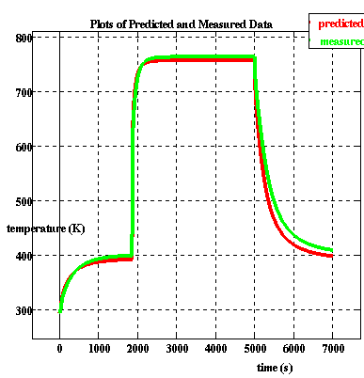
Fig 12.2 – comparison of measured and predicted temperatures

At first glance, the predicted temperatures compare well with the measurements. But look again…. If we now plot the temperature difference between measured and predicted, the true accuracy is revealed !

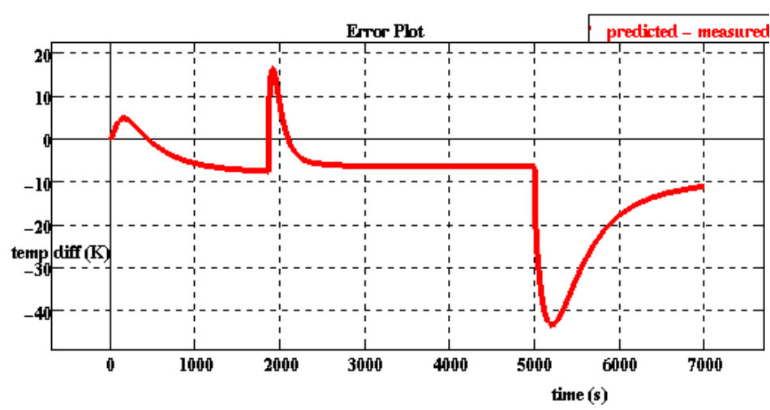
Fig 12.3 – difference between measured and predicted temperatures

There will, in all probability, be differences between predicted and measured temperatures. The process whereby modelling assumptions are refined to gain agreement (to within an acceptable accuracy) between predicted and measured data is known as the Matching Exercise.

Matching Exercise

In the matching exercise, assumptions on type of boundary condition, htc correlations and factors are modified to gain an acceptable match.

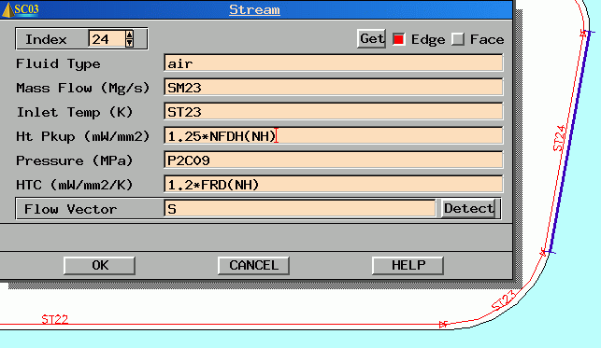
Fig 12.4 – modification of thermal boundary conditions

The general order for matching is :

- Match steady state air temperatures
- Match steady state metal temperatures
- Match transient metal temperatures

Notes

All modifications must be appropriate and justifiable in terms of known heat transfer mechanisms.

In general, for typical engine components a match of ±5K steady state and ±15K transiently would represent an acceptable match. There are however instances where general temperatures are significantly lower (Engine Electronic Controllers, Rigs, etc.) where a smaller tolerance should be applied.

The need for very low or high heat transfer correction factors usually implies the correct correlation is not being used. Factors outside the range of 0.5-2.0 suggest the use of the wrong correlation or incorrect correlation data (e.g. Area, Hydraulic Diameter).

In models where significant temperature differences exist between components (either at steady state or transient conditions), the heat transfer due to radiation should be separated from that due to convection.

Displacements

To calculate displacements (e.g. tip clearances etc), the thermal model should be converted into a thermo-mechanical model. Using the thermal model as a basis, loads and restraints must be applied.

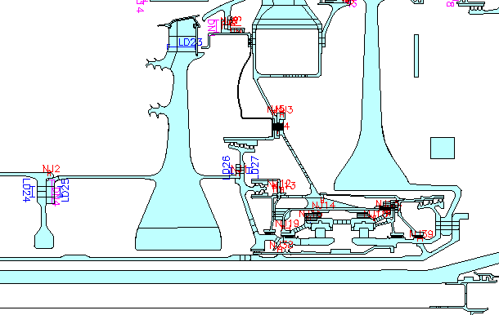
Fig 13.1 – modification of thermal boundary conditions

In general, the thermal boundary conditions that are present on the thermal model should be left untouched. The thermal boundary conditions should already contain accurate definitions for the thermal pressures.

Most often the pressures will be defined as a function of two BDD (main annulus) pressures. Scaling on a single BDD pressure can produce unrealistic pressures at low power cases

Care must be taken so as not to double account pressure loads. When two thermal boundary conditions (say a stream and a void) are both present on a particular geometric entity, and both have a pressure specified (required to calculate the htc) then there will be a double accounting of the pressure load if the model is run thermo-mechanically. The work-around for this is to specify a pressure load with a negative value for the pressure to cancel out the double accounting.

e.g. If both a stream and void are present on an entity and both have P26 specified as the pressure, then define a pressure load over the same entity with Pressure = -P26

In addition, care must be taken when applying pressure loads (either as part of a thermal boundary condition or as a structural pressure load) on 2D domains where a thickness property has been applied. The pressure load will only act on the surface area defined by the thickness and NOT on the full axisymmetric ring. The boundary condition would have to be defined as in the example below.

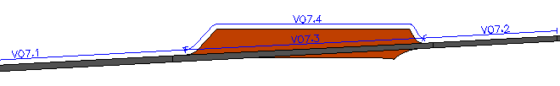
Fig 13.2 – definition of thermal boundary conditions over thickness property regions

If any type of Structural Joint (fixed, sliding, non-linear or open) is applied to the model it will have the effect of removing the conduction path across it. Partial, or full conduction should be restored using the Thermal Contact Option.

Apart from joints, the main structural boundary conditions are loads and restraints. Loads are generally used to apply loading from components not present in the model. Restraints are used to ‘earth’ the model. Care must be taken not to over-restrain or under-restrain the model.

The model can now be run to calculate axisymmetric displacements. However, this may not provide the total displacements. In most instances there are asymmetric effects that must also be considered. Whole engine deflections (obtained from the whole engine structural model) and information from measurements (strip clearances, clearance probe data, x-rays etc.) must be included to calculate the total displacements.

For more information see the Displacements section of the Thermo-mechanics web:

http://www.capability.rolls-royce.com/genthermal/best_practices/displacement/default.htm

