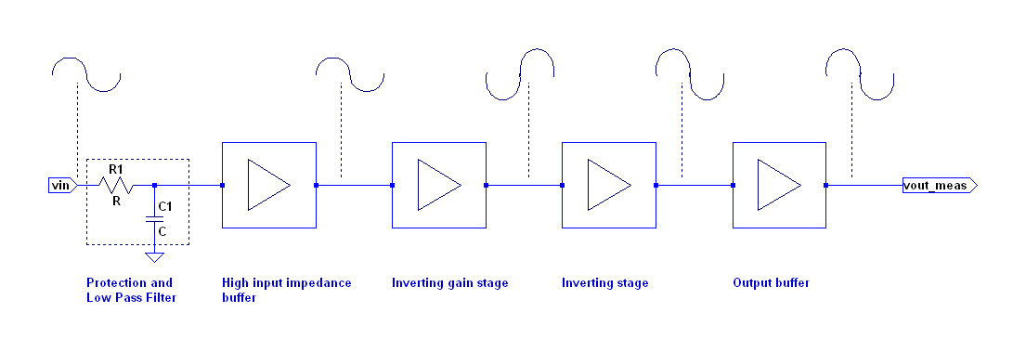Illustration 1: Block schematic
Architecture
- Protection and low pass filter – This block consists of only passive elements which are providing protection against voltage spikes and noise from environment by suppressing high frequency signals. The passive elements in this stage are fairly big and robust in order to dissipate any high energy signal that may come at VIN port.
- High input impedance buffer – provides a unity gain buffering stage that has very high input impedance. Very high input impedance is needed to not compromise the signal coming from VIN port.
- Inverting gain stage – in order to support gain in range from 0.9 to 1.1 an inverting topology was used, therefore after this stage, the signal is either amplified or decreased, but it's phase is reversed.
- Inverting stage – this stage only reverts the signal phase to it's original state. No amplification is done here.
- Output buffer – this stage only buffers the signal. No amplification is done here.

Specification
No | Parameter | Test conditions | Value | Unit
1 | Input impedance | 1Hz - 6kHz | 300k | ohm
2 | Input impedance | 10Hz - 500Hz | 4M | ohm
3 | Output impedance | 50Hz | 145 | ohm
4 | Output impedance | 60Hz | 115 | ohm
5 | Output voltage swing | Rout = 100k | +11 – 11.5 | V
6 | Min gain |  | 0.909 | V/V
7 | Max gain |  | 1.11 | V/V
8 | Low pass filter | 3 dB decrease | 0.72 | Hz
9 | High pass filter | 3 dB decrease | 16k | Hz

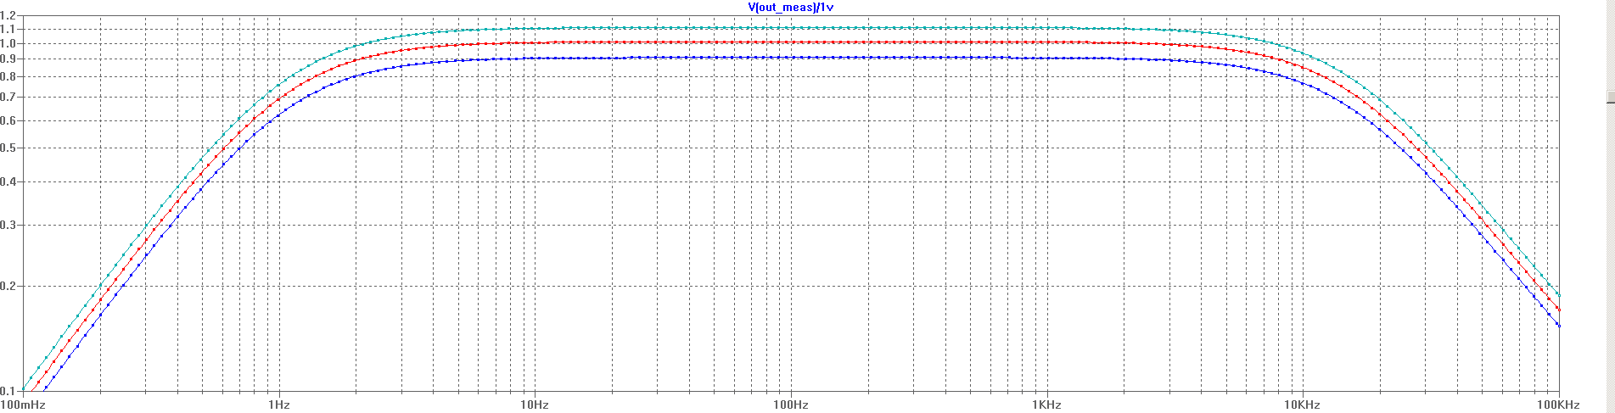Illustration 2: Min and max gains
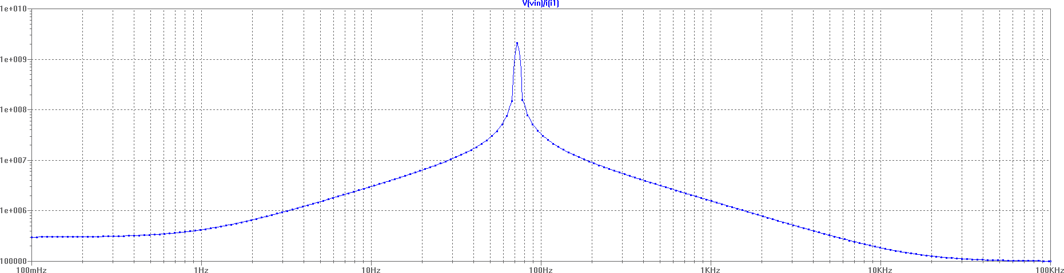Illustration 3: Input impedance
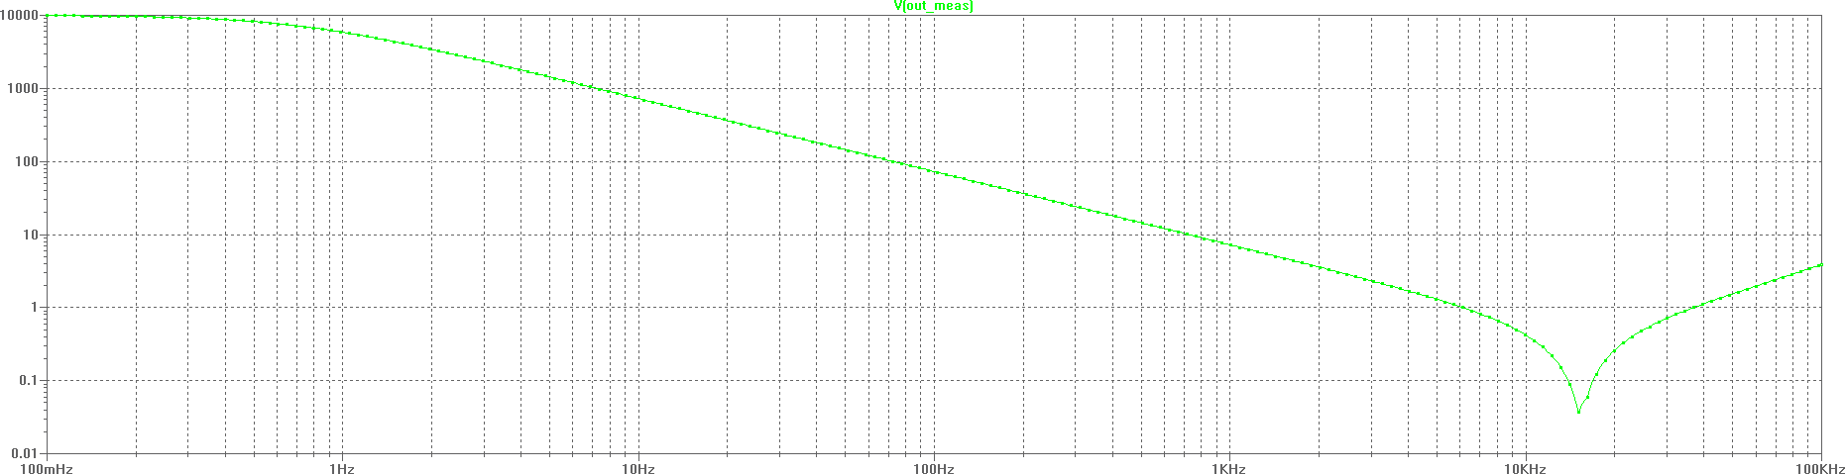Illustration 4: Output impedance
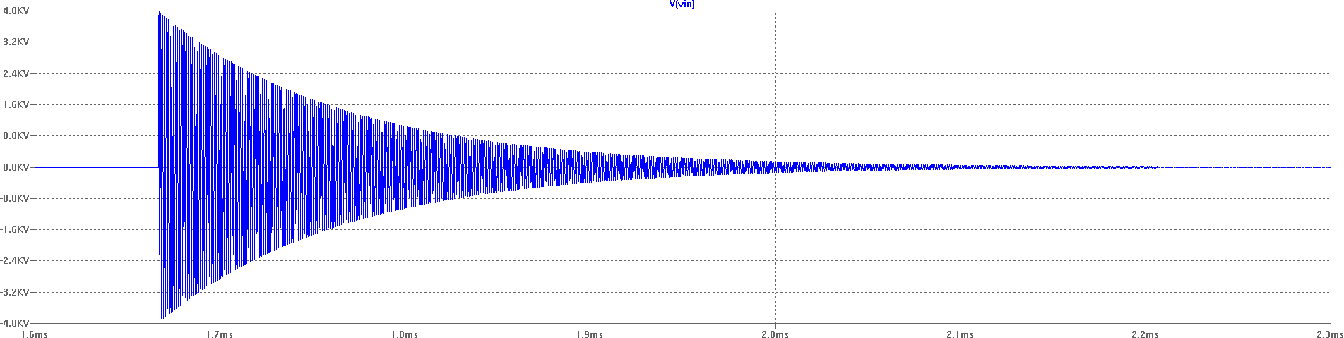Illustration 5: 4kV burst signal shape
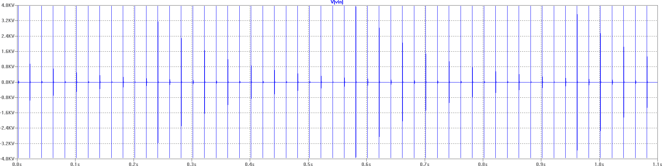Illustration 6: 4kV burst tests (50 cycles)
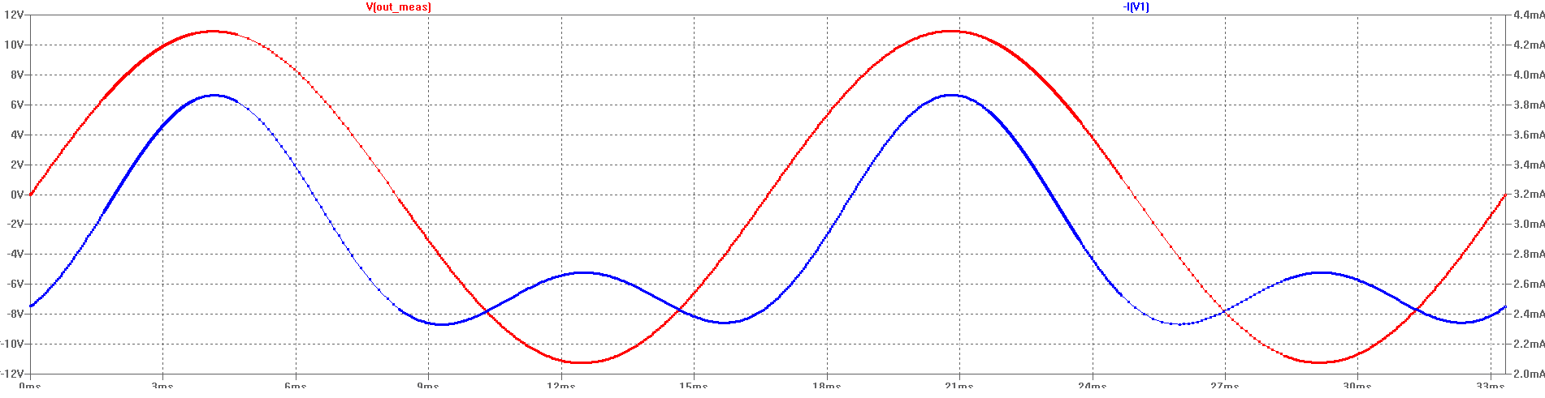Illustration 7: Current consumption with +/-11V input signal
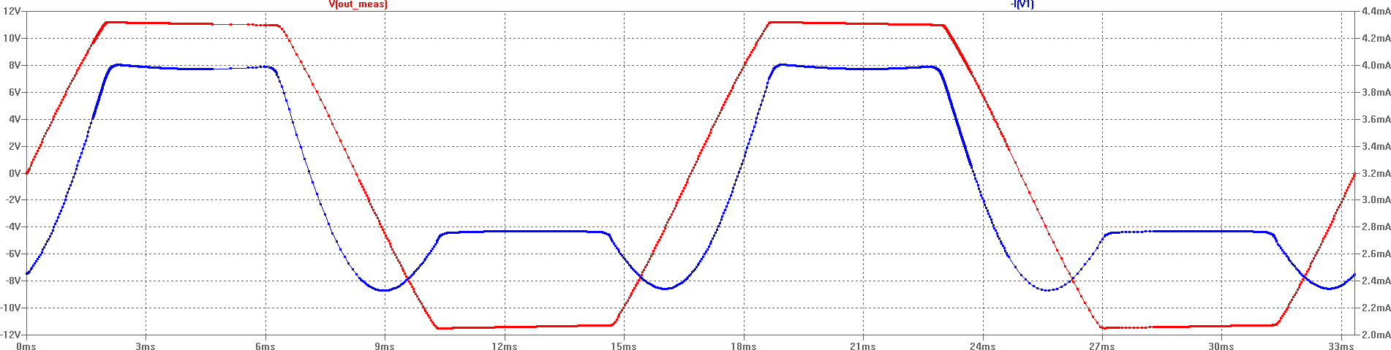Illustration 8: Signal clipping behaviour
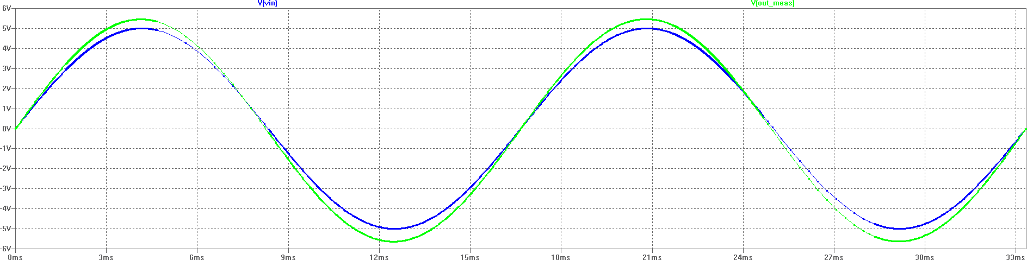Illustration 9: Input and output signal with gain set to 1.1

