Cost-Minimizing Dynamic Migration of Content
Distribution Services into Hybrid Clouds

ABSTRACT:
- The recent advent of cloud computing technologies has enabled agile and scalable resource access for a variety of applications. Content distribution services are a major category of popular Internet applications.
- A growing number of content providers are contemplating a switch to cloud-based services, for better scalability and lower cost. Two key tasks are involved for such a move: to migrate their contents to cloud storage, and to distribute their web service load to cloud-based web services. The main challenge is to make the best use of the cloud as well as their existing on-premise server infrastructure, to serve volatile content requests with service response time guarantee at all times, while incurring the minimum operational cost.
- Cost-minimizing migration of content distribution services into a hybrid cloud infrastructure that spans geographically distributed data centers. A dynamic control algorithm is designed, which optimally places contents and dispatches requests in different data centers to minimize overall operational cost over time, subject to service response time constraints.
- Rigorous analysis shows that the algorithm nicely bounds the response Times
  - We verify the performance of our dynamic algorithm with prototype-based evaluation.

ALGOROTHMS:
- Cost minimization with a dynamic algorithm:
Example:
All I can do is to send any M (1 <= M <= N) of them to the ticket office and get the answer, how much it will cost for these M people.
I also have a limited time, as a train is leaving in some minutes, so the near best solution is good enough for me.

- Uploading & Downloading Algorithms
- Searching Algorithms

KEY POINTS:

- Upload File to CDN
- Upload File to DCN
- Search data to CDN and Download
- If no data in CDN request to DCN
- DCN authenticate to request.
- User downloads the requested item.

EXISTING SYSTEM
private cloud, such that good service response time is guaranteed and only modest operational expenditure is incurred. request routing for traditional CDN , named Iterative Periodic Max- Weight Scheduling with Min-Weight Evictions applications are also considering the cloud-ward move , including content distribution applications . As an important category of popular Internet services, content distribution applications

Existing Algorithm:
- Myopic Scheduling Algorithm

Deadline (Di)
Earliest Start Time
Laxity (Di-ei)
weighted sum of any of the above
For example if the heuristics H(i) = Di, then the schedule is carried out based on the tasks with earlier deadline

PROPOSED SYSTEM:
- While it may not be too difficult to design a simple heuristic, proposing one with guaranteed cost optimality over a long run of the system constitutes an intimidating challenge. Employing Lyapunov optimization techniques, we design a dynamic control algorithm to optimally place contents and dispatch requests in a hybrid cloud infrastructure spanning geo-distributed data centers, which minimizes overall operational cost over time, subject to service response time constraints.
- A growing number of content providers are contemplating a switch to cloud-based services, for better scalability and lower cost. Two key tasks are involved for such a move: to migrate their contents to cloud storage, and to distribute their web service load to cloud-based web services. The main challenge is to make the best use of the cloud as well as their existing on-premise server infrastructure, to serve volatile content requests with service response time guarantee at all times, while incurring the minimum operational cost.

- Rigorous analysis shows that the algorithm nicely bounds the response times within the preset QoS target, and guarantees that the overall cost is within a small constant gap from the optimum achieved by a T-slot lookahead mechanism with known future information. We verify the performance of our dynamic algorithm with prototype-based evaluation. A cloud platform with multiple, distributed data centers is ideal to host such a service, with substantial advantages over a traditional private or public content distribution network (CDN) based solution, in terms of more agility and significant cost reduction with respect to machines, bandwidth, and management

Advantage:
- A cloud platform with multiple distributed data centers is ideal to host such a service, with substantial advantages over a traditional private or public content distribution network
- cost reduction with respect to machines, bandwidth, and management.

SYSTEM ARCHITECTURE:

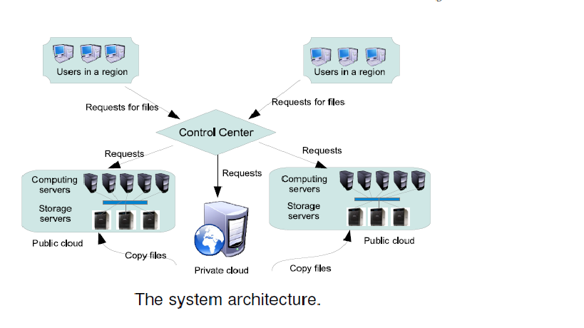

MODULE
- Hybrid Cloud
- File Upload to CDN
- File Upload to DCN
- Search to CDN
- Search to DC
- Cost Chart

Hybrid Cloud:
Infrastructure spanning geo-distributed data centers, which minimizes overall operational, cost over time, subject to service response time constraints. we present a generic optimization framework for dynamic, cost-minimizing migration of content. a hybrid cloud, to dynamically and jointly resolve the optimal content replication and load distribution problems.

File Upload to CDN:
File uploading part Admin can upload the files in Content Distributed Networks. Here used in uploading algorithms.
File Upload to DC:
File uploading part Admin can upload the files in Data Center Network. Here used in same Uploading algorithms
Search to CDN:
User Search Data from Content distributed networks. If the file is found in CDN user can download to low cost, Otherwise user send request to CDN need search item and CDN forward user request to Data center.

Search to DCN:
Data center receive the request and authenticate the particular item, send to CDN and conformation key send to user. User can receive the Key and access the DC searching page. User request item only view in page and also can download only that data can’t search another item.
Cost Charts:
Admin views the cost charts. Charts are Total cost, Download cost, Search cost, Time and EB bill chart. Admin only upload data from CDN & DC.

SYSTEM SPECIFICATION

Hardware Requirements:

- System : Pentium IV 2.4 GHz.
- Hard Disk : 40 GB.
- Floppy Drive : 1.44 Mb.
- Monitor : 14’ Colour Monitor.
- Mouse : Optical Mouse.
- Ram : 512 Mb.

Software Requirements:

- Operating system : Windows 7 Ultimate.
- Coding Language : ASP.Net with C#
- Front-End : Visual Studio 2010 Professional.
- Data Base : SQL Server 2008.

