Vérifications / cas particulier

https://gw.geneanet.org/danielr13?lang=fr&p=pierre&n=nicolas&oc=10
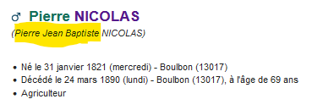
<!-- Portrait -->
<div id="person-title" class="row clearfix">
<div class="columns">
<h1 class="with_tabs name">
<img src="images/male.png" alt="H" title="H">&nbsp;
<a href="danielr13?lang=fr&m=P&v=pierre">Pierre</a>
<a href="danielr13?lang=fr&m=N&v=nicolas">NICOLAS</a>
</h1>
<div class="action-buttons not-printable">

</div>
</div>
</div>
<em>(Pierre Jean Baptiste NICOLAS)</em>
<br><br class="separateur"><br >
<ul>
<li>Né le&nbsp;31&nbsp;janvier&nbsp;1821 (mercredi) - Boulbon (13017)</li>
<li>Décédé le&nbsp;24&nbsp;mars&nbsp;1890 (lundi) - Boulbon (13017),
à l'âge de 69 ans</li>
<li>Agriculteur</li>
</ul>

https://gw.geneanet.org/danielr13?lang=fr&p=marcellin&n=gilles&oc=1
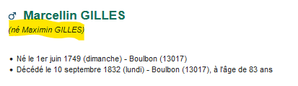
<!-- Portrait -->
<div id="person-title" class="row clearfix">
<div class="columns">
<h1 class="with_tabs name">
<img src="images/male.png" alt="H" title="H">&nbsp;
<a href="danielr13?lang=fr&m=P&v=marcellin">Marcellin</a>
<a href="danielr13?lang=fr&m=N&v=gilles">GILLES</a>
</h1>
<div class="action-buttons not-printable">

</div>
</div>
</div>
<em>(né Maximin GILLES)</em>
<br><br class="separateur"><br >
<ul>
<li>Né le&nbsp;1er&nbsp;juin&nbsp;1749 (dimanche) - Boulbon (13017)</li>
<li>Décédé le&nbsp;10&nbsp;septembre&nbsp;1832 (lundi) - Boulbon (13017),
à l'âge de 83 ans</li>
</ul>

https://gw.geneanet.org/danielr13?lang=fr&p=jean&n=berlandier&oc=24
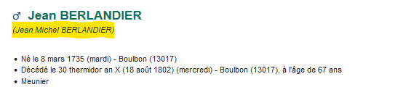
<!-- Portrait -->
<div id="person-title" class="row clearfix">
<div class="columns">
<h1 class="with_tabs name">
<img src="images/male.png" alt="H" title="H">&nbsp;
<a href="danielr13?lang=fr&m=P&v=jean">Jean</a>
<a href="danielr13?lang=fr&m=N&v=berlandier">BERLANDIER</a>
</h1>
<div class="action-buttons not-printable">

</div>
</div>
</div>
<em>(Jean Michel BERLANDIER)</em>
<br><br class="separateur"><br >
<ul>
<li>Né le&nbsp;8&nbsp;mars&nbsp;1735 (mardi) - Boulbon (13017)</li>
<li>Décédé le&nbsp;30&nbsp;thermidor&nbsp;an&nbsp;X (18 août 1802) (mercredi) - Boulbon (13017),
à l'âge de 67 ans</li>
<li>Meunier</li>
</ul>

https://gw.geneanet.org/danielr13?lang=fr&p=magdeleine&n=gilles&oc=1
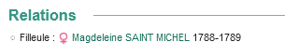
- https://gw.geneanet.org/danielr13?lang=fr&p=magdeleine&n=saint+michel&oc=10
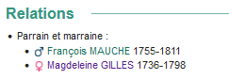

https://gw.geneanet.org/danielr13?lang=fr&p=jean&n=boudoy
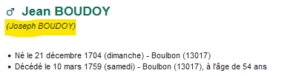

https://gw.geneanet.org/danielr13?lang=fr&p=francois&n=berlandier
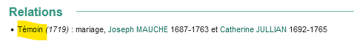

https://gw.geneanet.org/danielr13?lang=fr&p=pierre&n=bard&oc=1
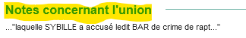

https://gw.geneanet.org/danielr13?lang=fr&p=anne&n=bard&oc=1
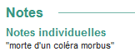

https://gw.geneanet.org/danielr13?lang=fr&p=elizabeth&n=pelenc

https://gw.geneanet.org/danielr13?lang=fr&p=marthe&n=saint+michel&oc=1

https://gw.geneanet.org/danielr13?lang=fr&p=marcellin&n=berlandier
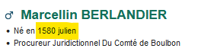

https://gw.geneanet.org/danielr13?lang=fr&p=jean+nicolas&n=durand


https://gw.geneanet.org/danielr13?lang=fr&p=bernard&n=bonnaud


https://gw.geneanet.org/danielr13?lang=fr&p=honnorate&n=vidal
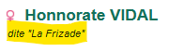

https://gw.geneanet.org/danielr13?lang=fr&p=pierre&n=granier&oc=2


ATTENTION : ANOMALIE :
https://gw.geneanet.org/evechevaleyre?lang=fr&pz=evelyne&nz=cassar&p=domenica&n=chetcuti&oc=3
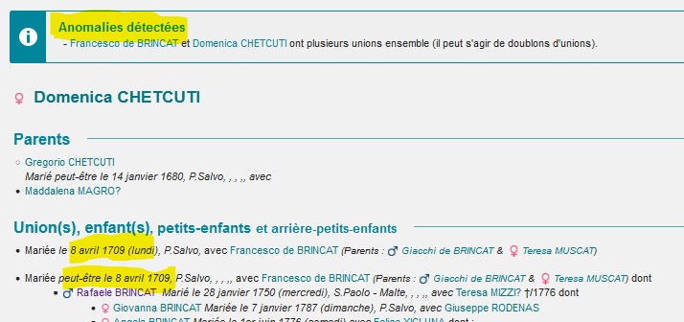
sur fille :
https://gw.geneanet.org/evechevaleyre?lang=fr&pz=evelyne&nz=cassar&p=rafaele&n=brincat
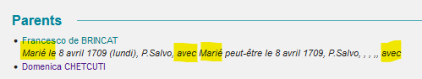

https://gw.geneanet.org/evechevaleyre?lang=fr&pz=evelyne&nz=cassar&p=francesco&n=de+brincat&oc=17
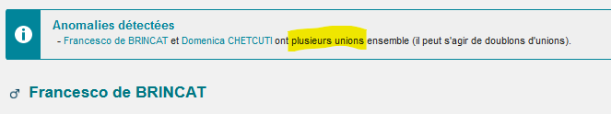

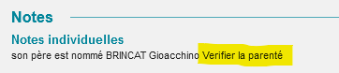

https://gw.geneanet.org/evechevaleyre?lang=fr&pz=evelyne&nz=cassar&p=geronima&n=mifsud&oc=8
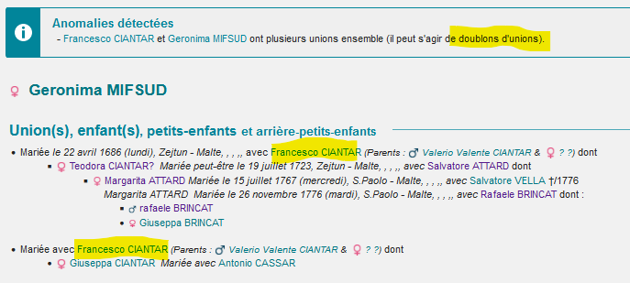
https://gw.geneanet.org/evechevaleyre?lang=fr&pz=evelyne&nz=cassar&p=francesco&n=ciantar
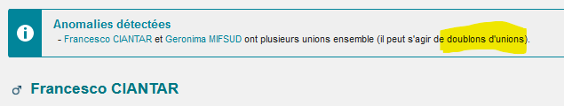

https://gw.geneanet.org/virgile81?lang=fr&pz=mathieu+maurice+andre&nz=nival&ocz=1&p=cosimo&n=libreri


