PJM530 - Project Schedule & Cost Control

MS Project project

Dec 03, 2015

Student ID : 143149

Author : Naveen Rajendrapandian

Professor : Wiselin Mathuram

PJM530 MS Project assignment

1. Project schedule

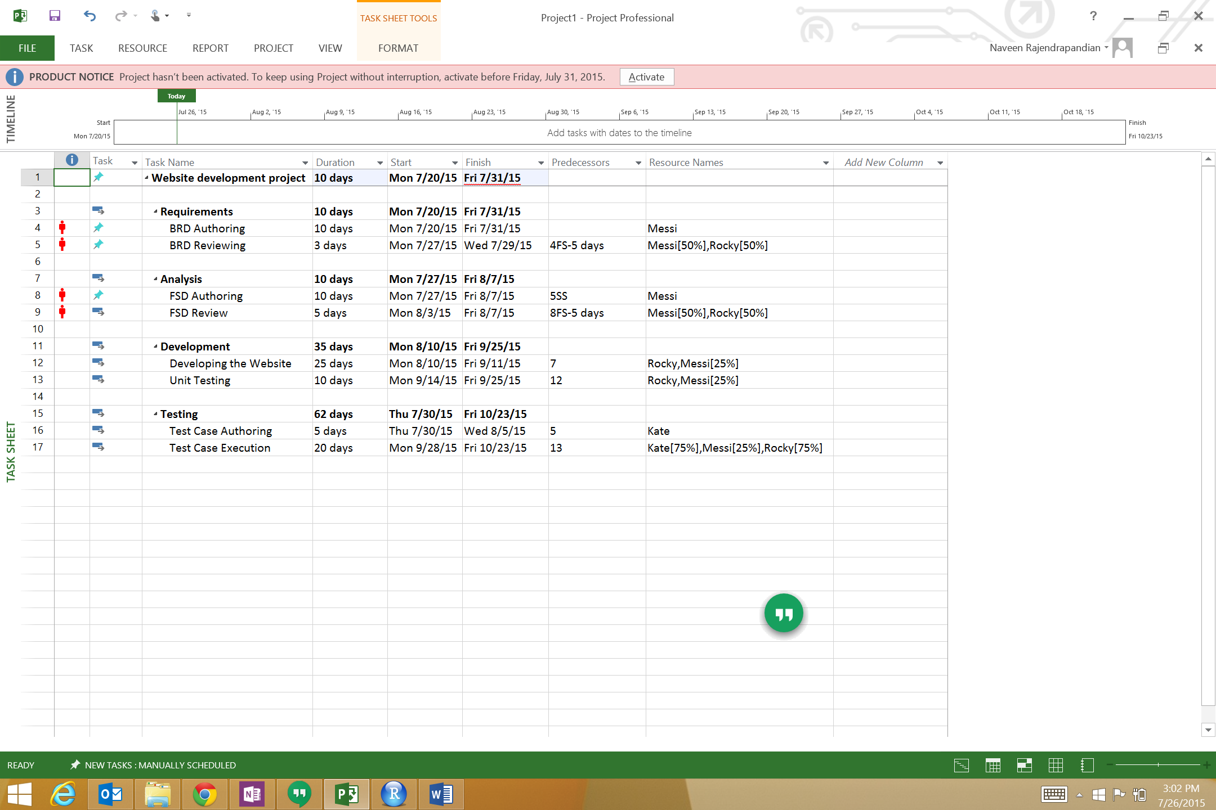

1. Gantt chart

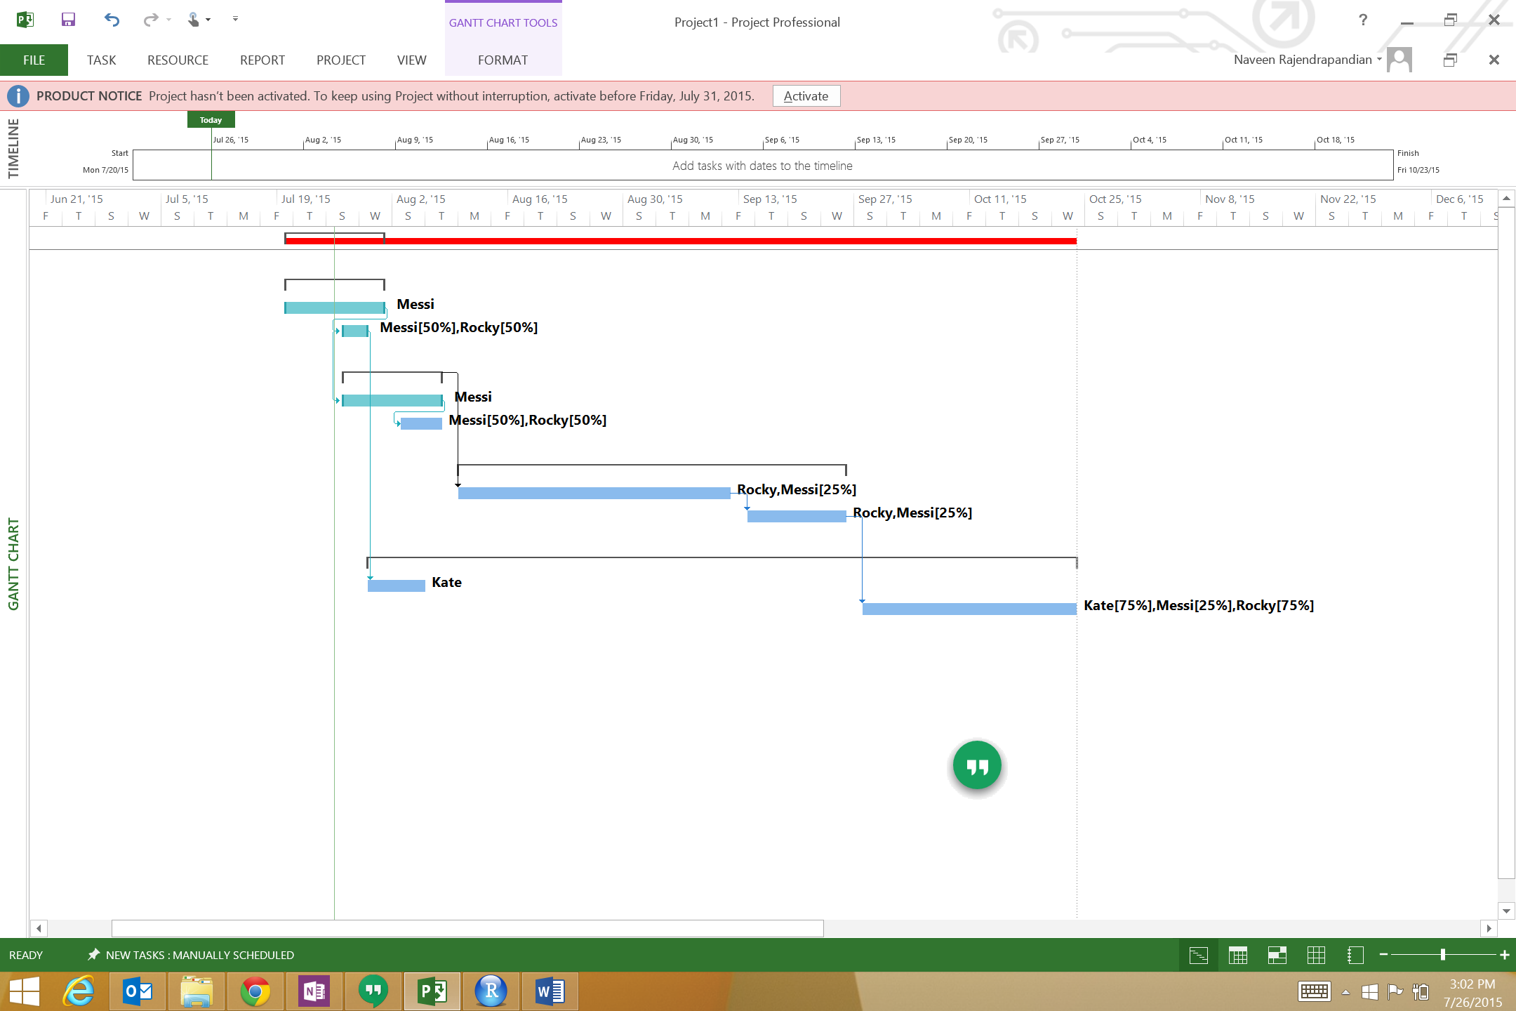

1. Critical path

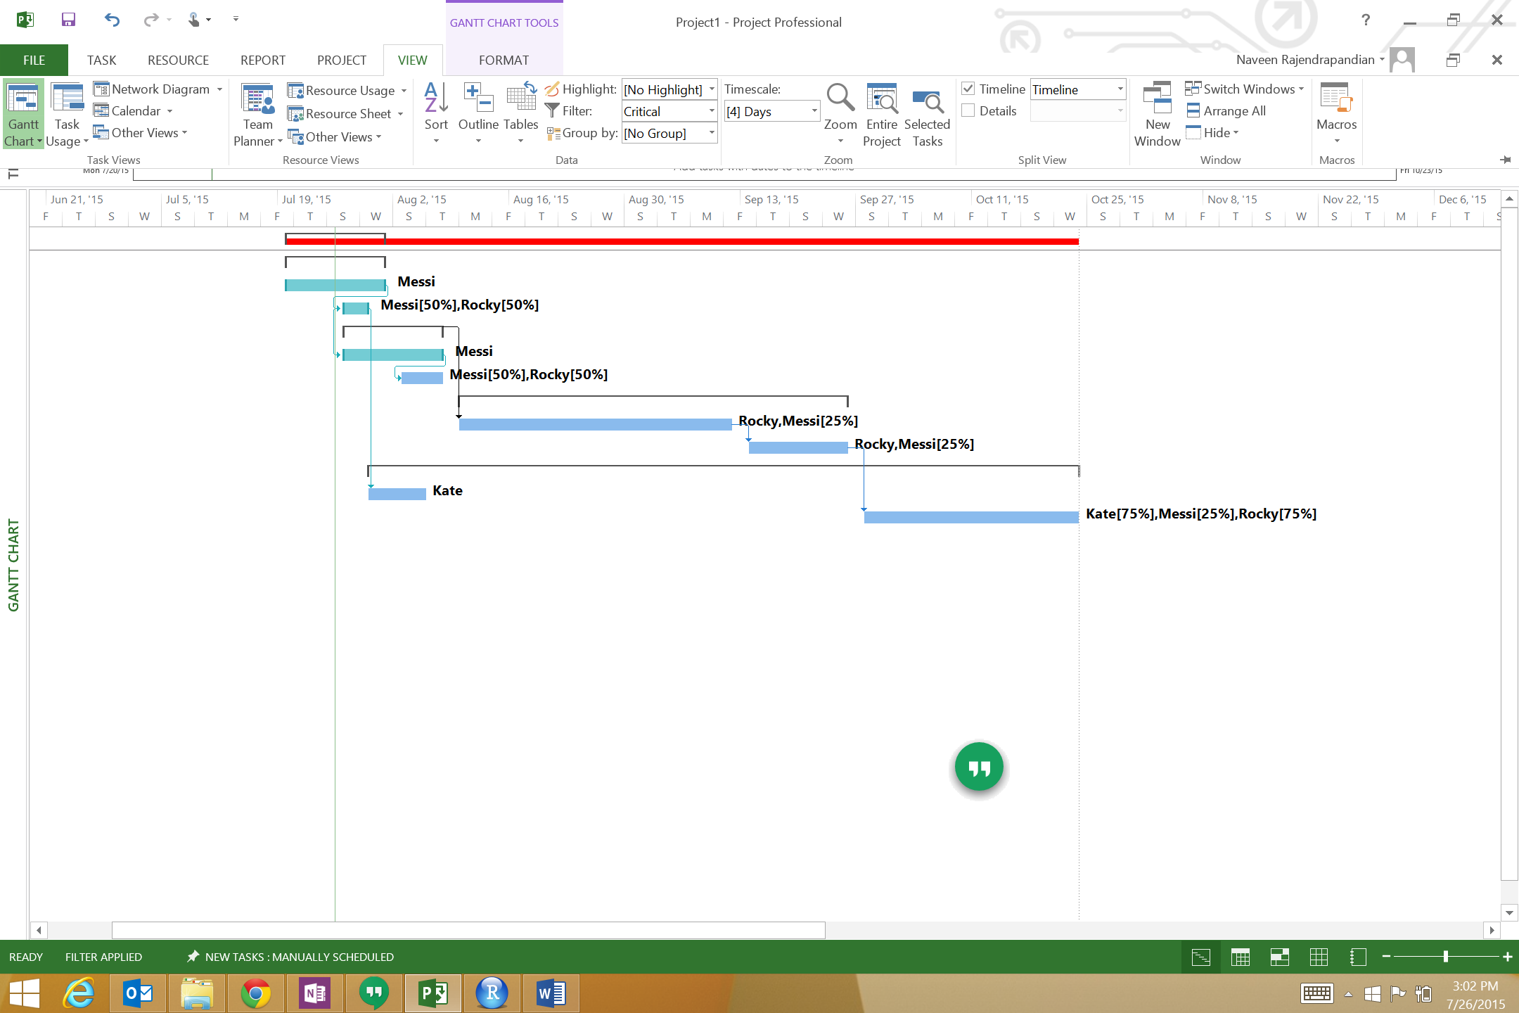

1. Leveling and Auto schedule

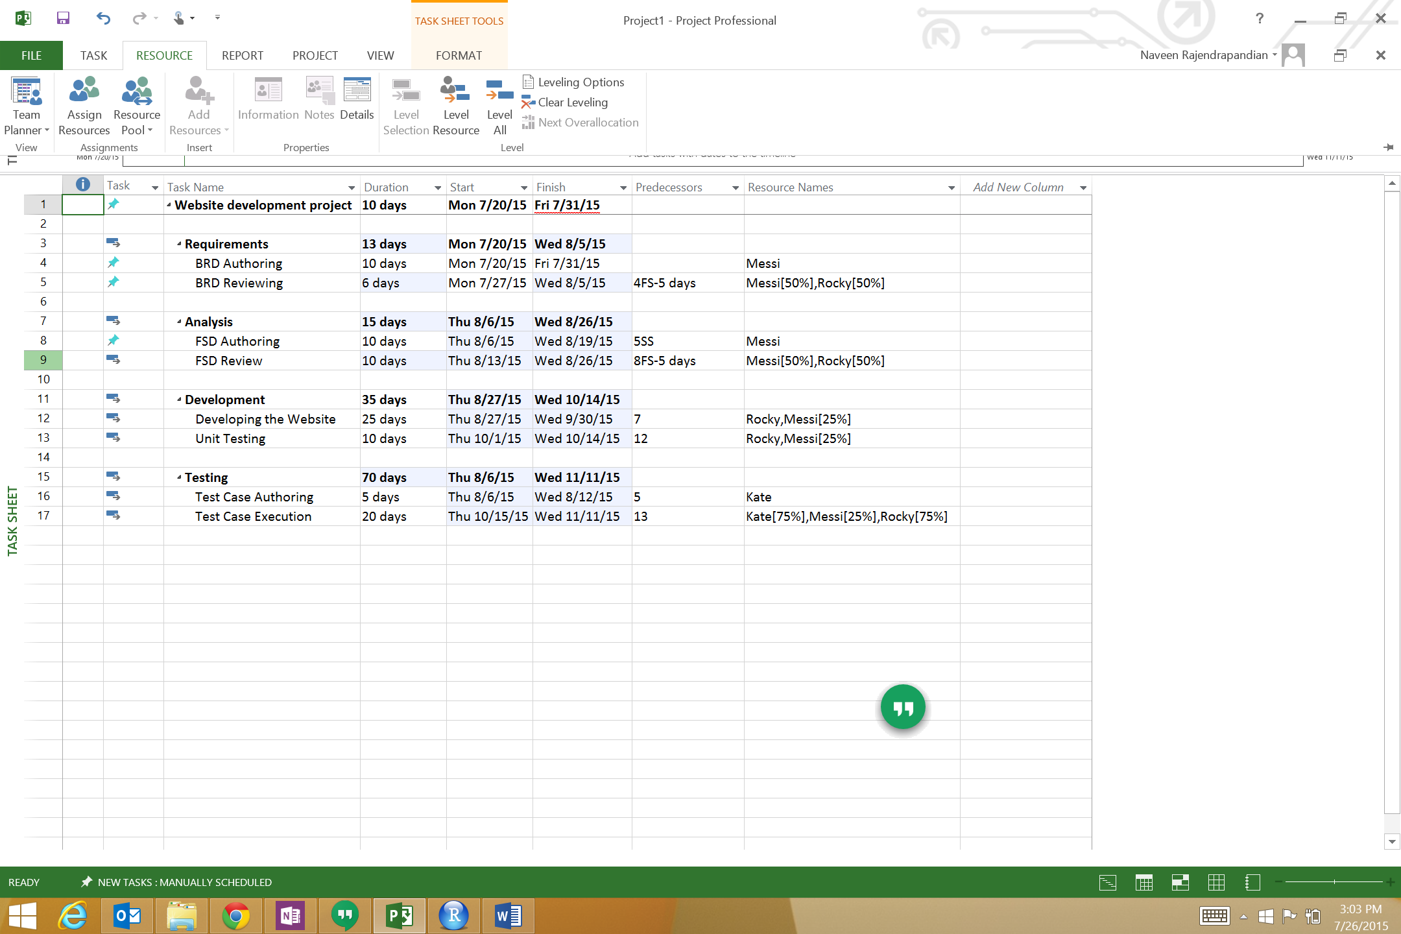

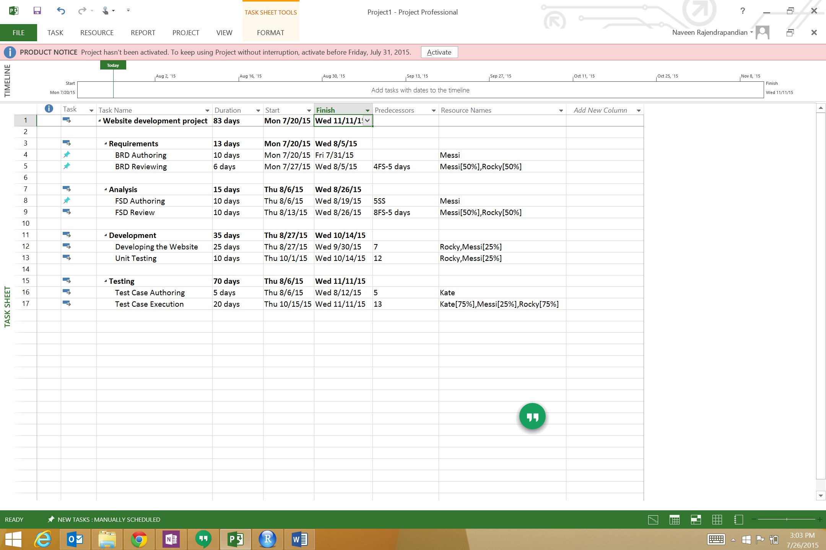

1. Baseline

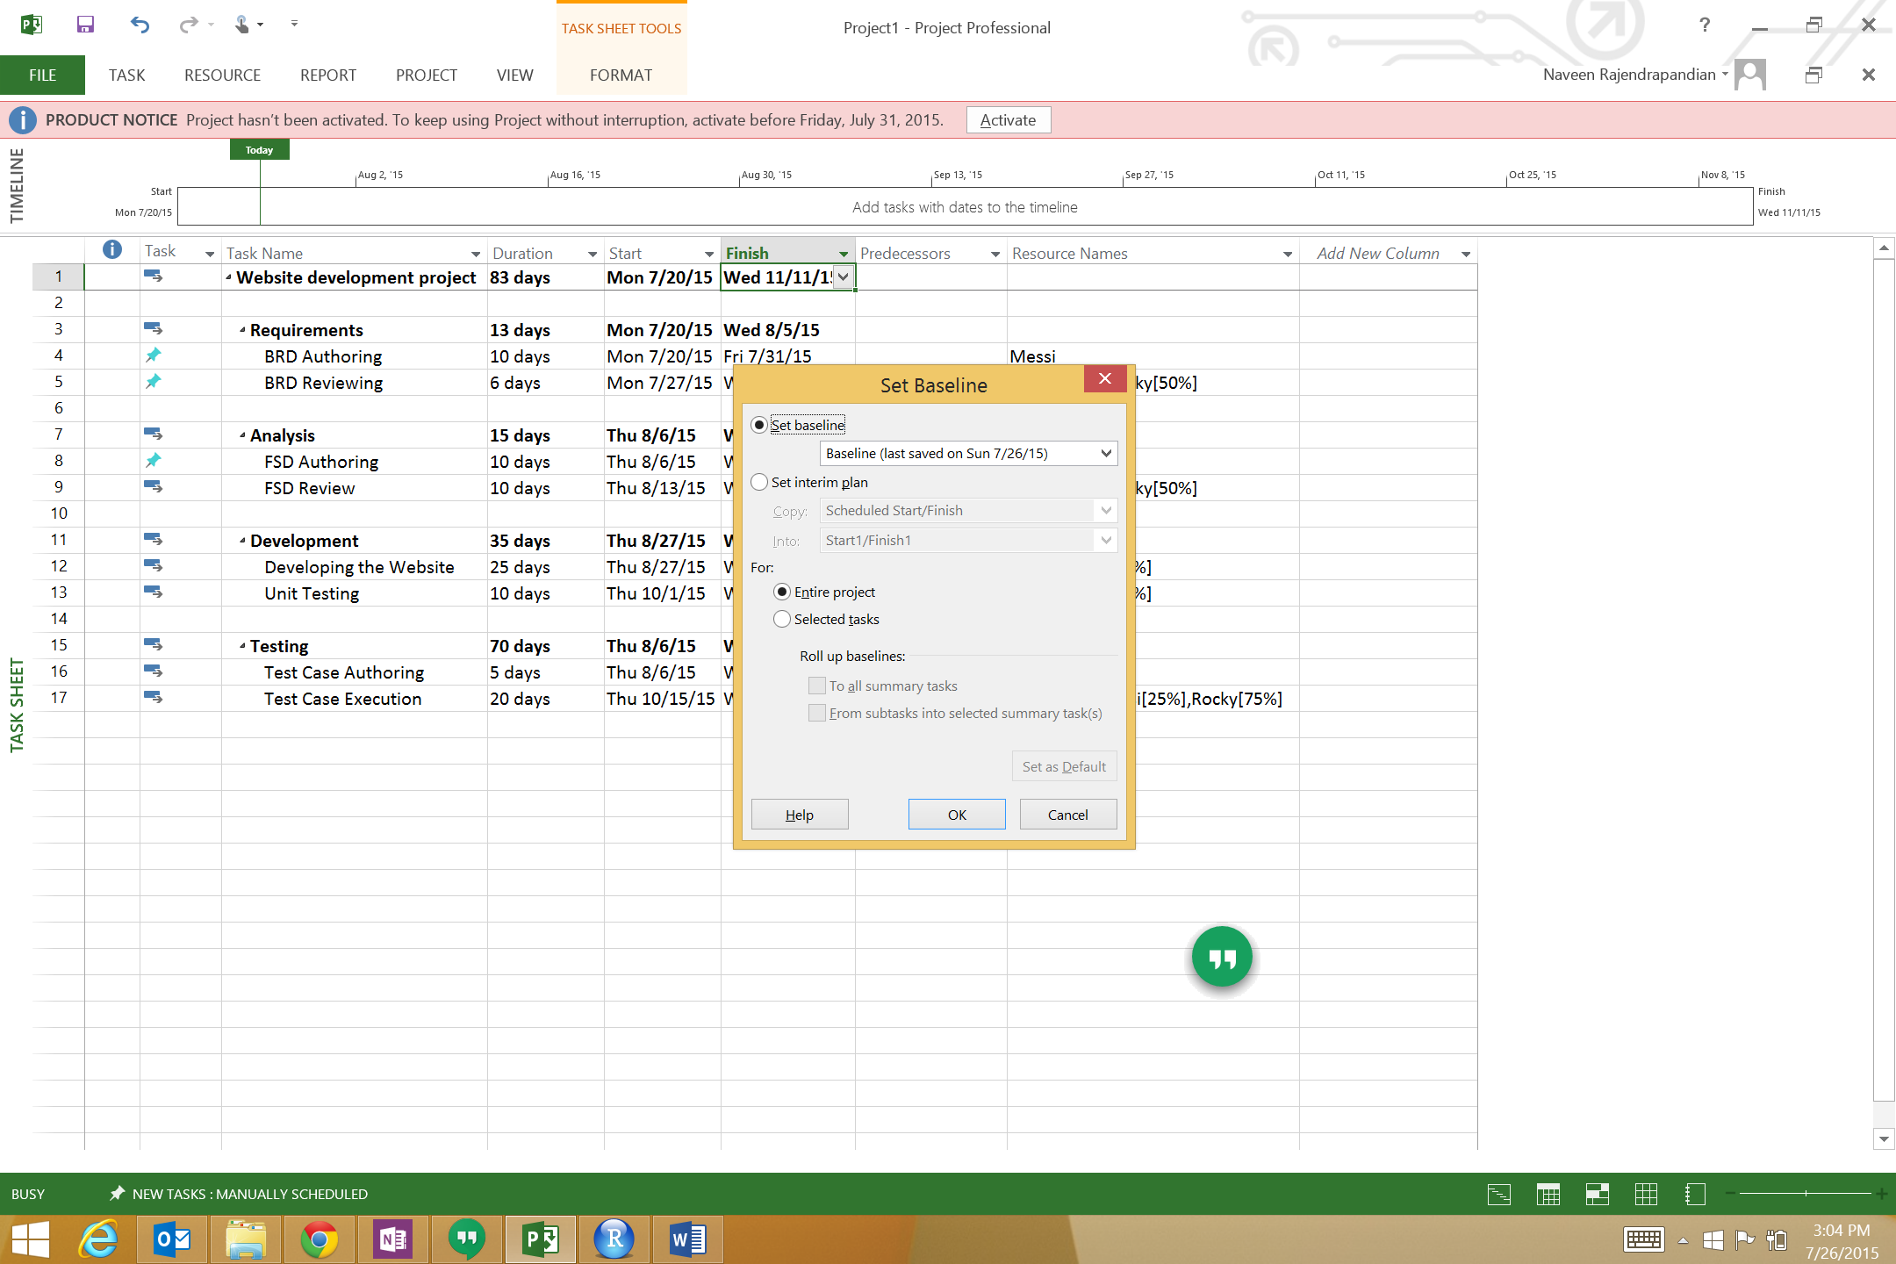

1. Earned Value Cost Indicators

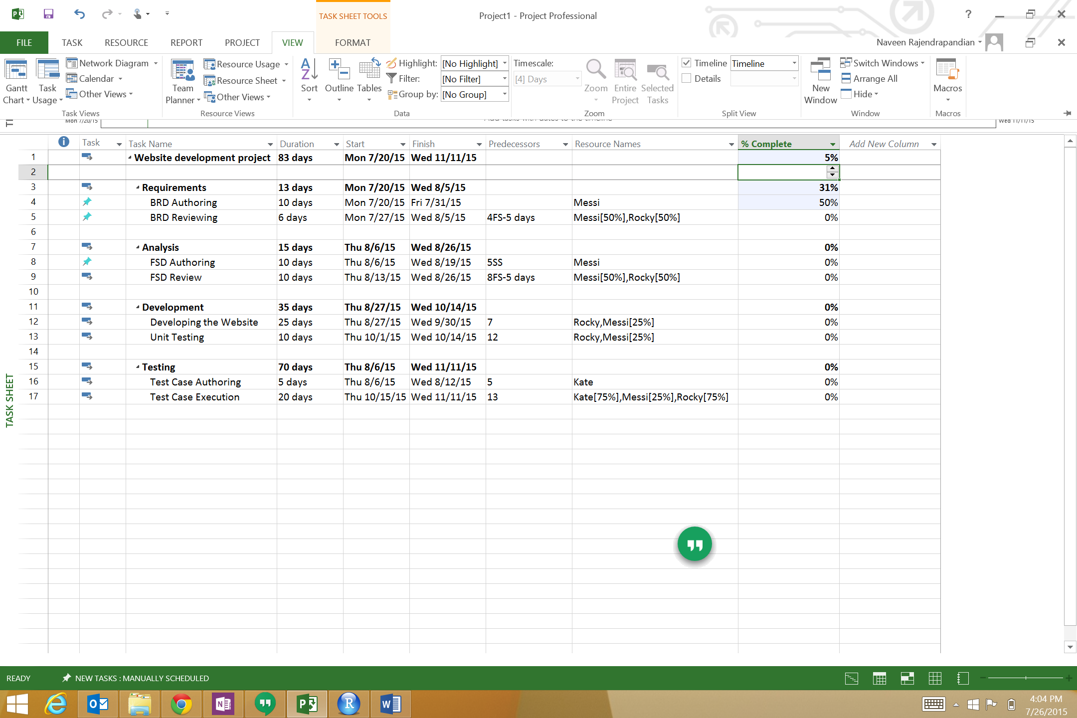

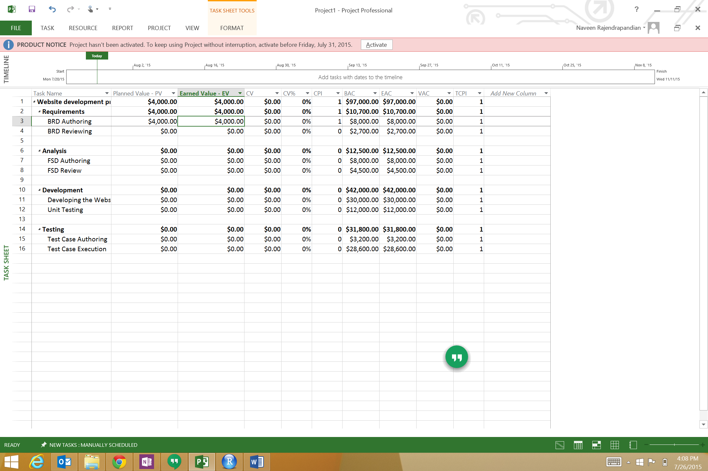

1. Earned Value Schedule Indicators

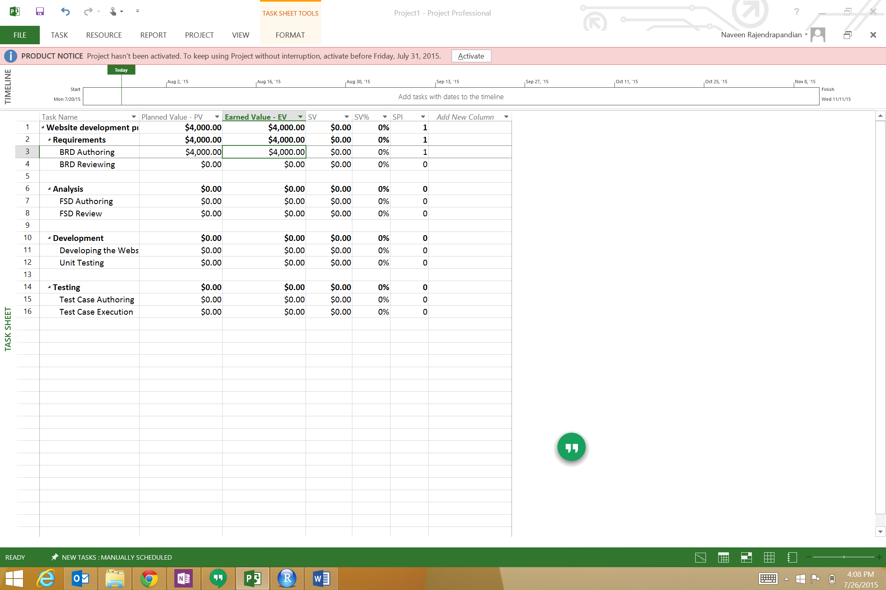

1. Slack

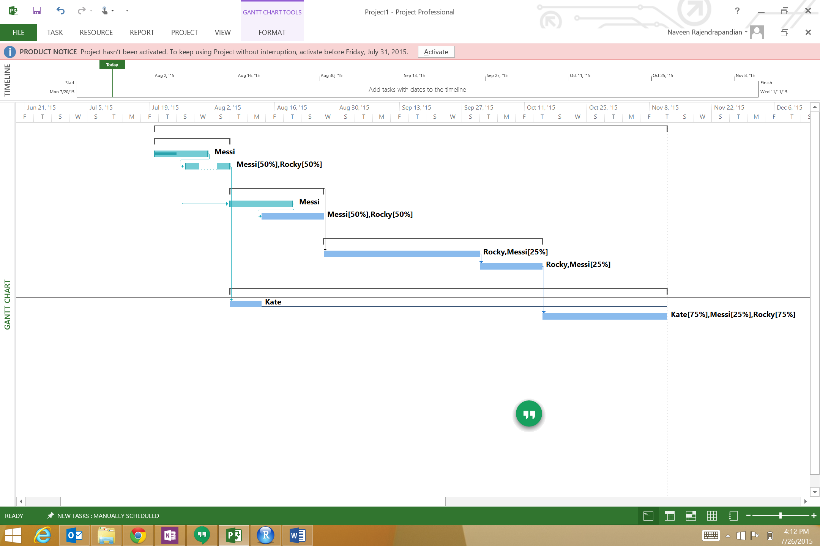

1. Setting Milestone

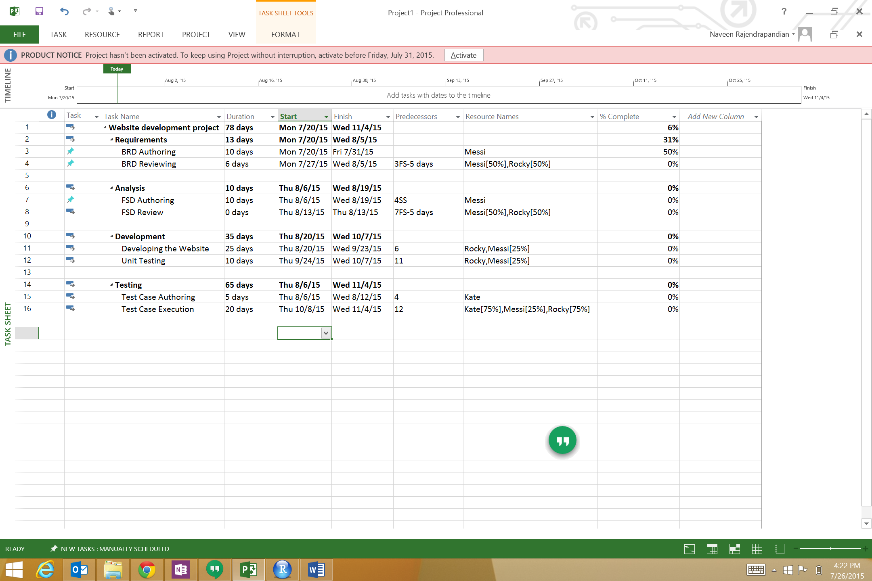

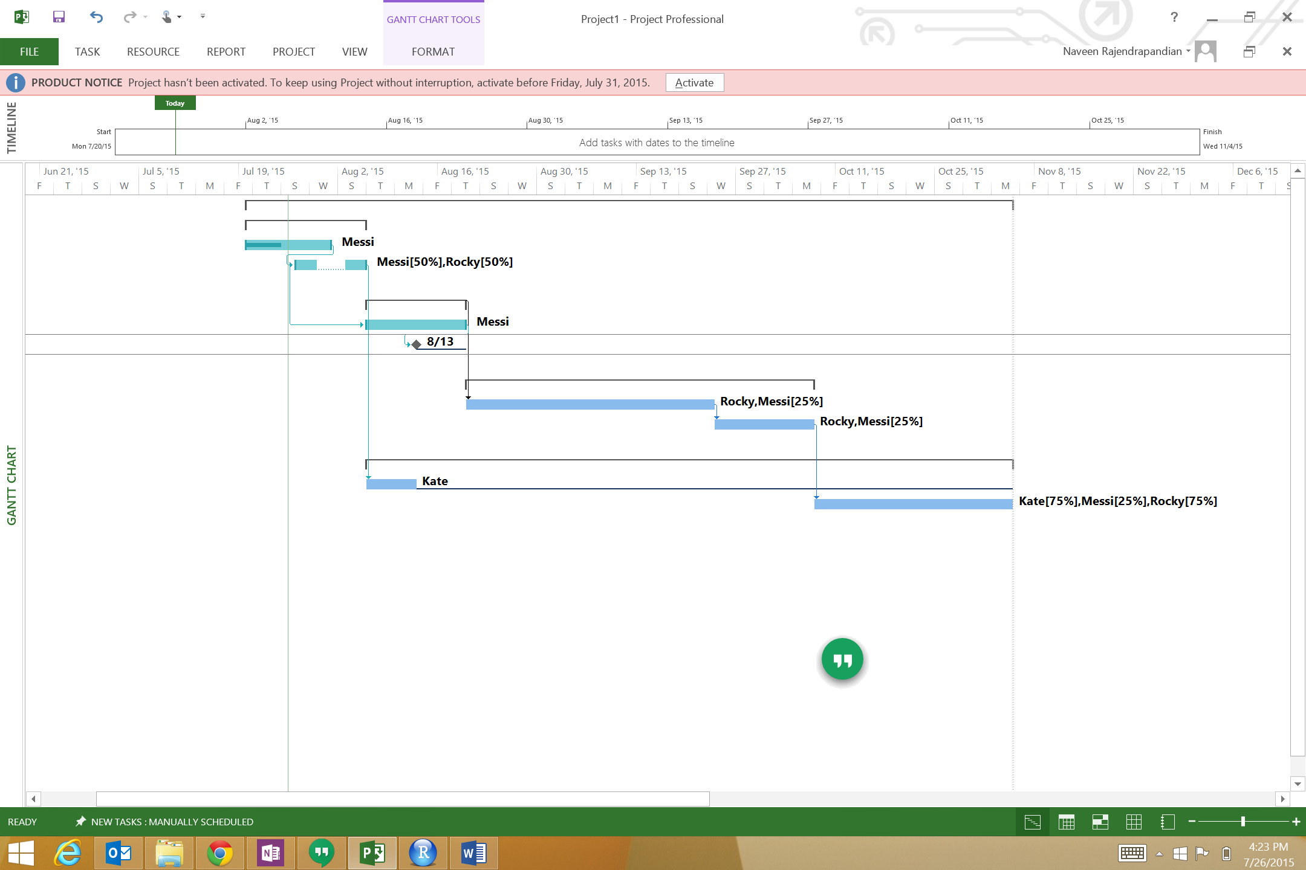

1. Custom report for resource usage

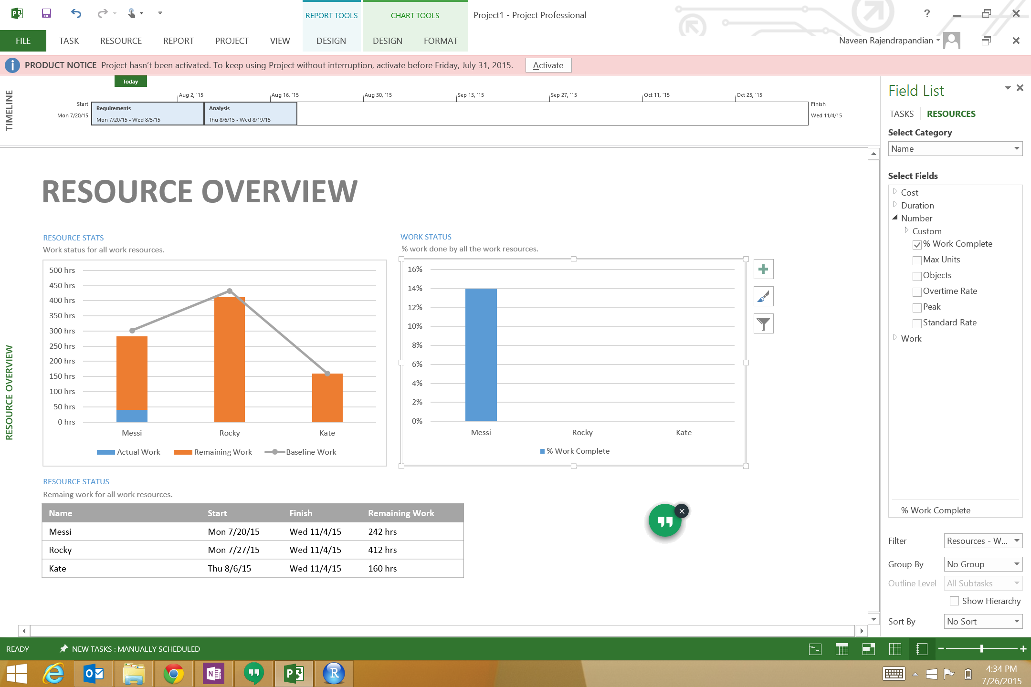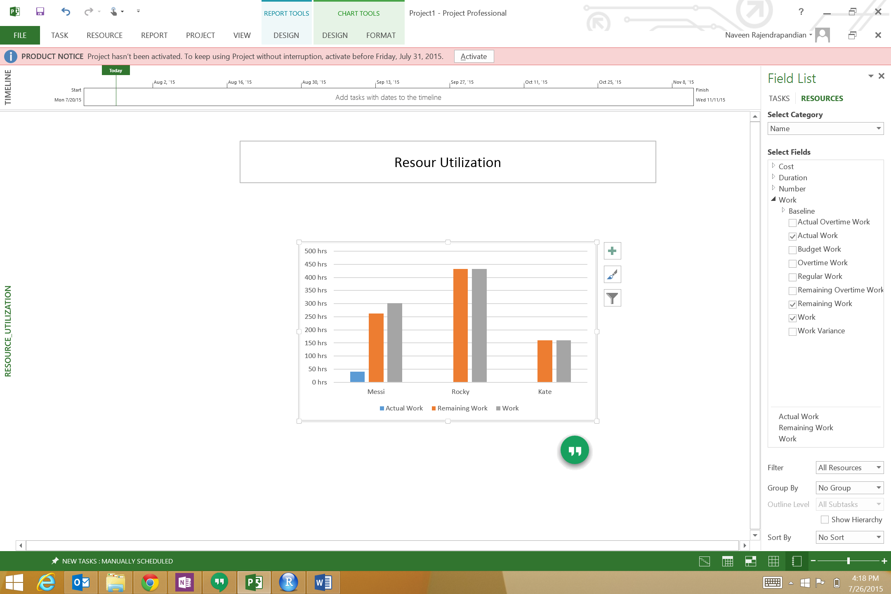

1. Timeline

Start  
Mon 7/20/15

**Requirements**  
Mon 7/20/15 - Wed 8/5/15

**Analysis**  
Thu 8/6/15 - Wed 8/19/15

Jul 26, '15

Aug 2, '15

Aug 9, '15

Aug 16, '15