Ruby on Rails

- Ruby on Rails is extremely productive web-application framework.

- Written in Ruby by David Heinemeier Hansson.

- It includes everything needed to create database-backend web applications according to Model-View-Controller pattern.

- It allows write less code than other languages and frameworks

Ruby on Rails MVC
Like most of the other frameworks, Rails is also based on MVC pattern. It basically works as following:

Requests first come to the controller, controller finds an appropriate view and interacts with model which in turn interacts with database and send response to controller. Then controller gives the output to the view based on the response.

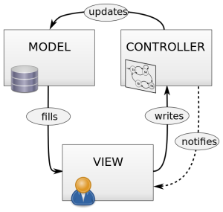

Model
The models are classes in Rails. They interact with database, store data, handles validation, transaction, etc.

This subsystem is implemented in ActiveRecord library. This library provides an interface between database tables and Ruby program code that manipulates database records.

Ruby method names are automatically generated from database tables field names.

View
View represent data in a particular format in an application for the users. It handles HTML, CSS, JavaScript and XML in an application. They do what controller tells them.

This subsystem is implemented in ActionView library. This library is an Embedded Ruby (Erb) based system which define presentation templates for data presentation.

Controller
Controller directs traffic to views and models. It query models for data from the database and display the desired result with the help of view in an application.

This subsystem is implemented in ActionController library. This library is a data broker sitting between ActiveRecord and ActionView.

Don't Repeat Yourself (DRY): DRY is a principle of software development which states that "Every piece of knowledge must have an authoritative, unambiguous, single representation within a system. If same piece of code will not repeat again and again, code will be more maintainable, extensible and less buggy.The principle aims to reduce code repetition as much as possible so that it becomes easy to make any modification in the development cycle

Convention Over Configuration (CoC): It provides different opinions for the best way to do many things in a web application.
Convention over configuration is a simple concept that is primarily used in programming. ... If you follow the established conventions, you can develop a Rails application in much less time and with many fewer lines of code than you would need developing a similar web application in Java, for example.

Ruby on Rails RVM
RVM stands for Ruby Version Manager. It is a command line tool which allows you to easily install, manage and work with different Ruby environments. With RVM, you can easily install different versions of Ruby and easily switch between them.

RVM is maintained by the github community through pull requests sent to the project repository.

Web server
- A web server is a computer that runs websites. It's a computer program that distributes web pages as they are requisitioned.
- The basic objective of the web server is to store, process and deliver web pages to the users.
- This intercommunication is done using Hypertext Transfer Protocol (HTTP). These web pages are mostly static content that includes HTML documents, images, style sheets, test etc.
- Apart from HTTP, a web server also supports SMTP (Simple Mail transfer Protocol) and FTP (File Transfer Protocol) protocol for emailing and for file transfer and storage.

