Data Analysis and Classification of Dry Eye Disease
Christian Ramirez-Flores
Rough Draft

Introduction
Dry Eye Disease is a condition that occurs when the eyes do not produce enough tears or when tears evaporate too quickly. This can lead to symptoms such as irritation, redness, blurred vision, and a persistent feeling of dryness or discomfort. As someone who experiences dry eye disease personally, this topic is especially meaningful to me because it affects everyday activities such as reading, working on a computer, and spending long periods looking at screens. In recent years, more people have begun experiencing dry eye symptoms due to factors such as extended screen time, environmental conditions, aging, and certain health or lifestyle habits. Because these factors are common in daily life, understanding the causes and risk factors of dry eye disease has become an important area of healthcare and research.
This project analyzes a dataset related to dry eye disease in order to explore patterns and relationships between different health and lifestyle variables and the presence of the condition. In addition to exploratory analysis, a Random Forest model will be used for predictive modeling to identify which variable are most important in predicting dry eye disease. Random Forest is a machine learning method that builds multiple decision trees and combines their results to improve prediction accuracy and reduce overfitting. By examining the dataset and interpreting the model result, this project demonstrates how data analysis and machine learning can provide insight into medical conditions and help identify individuals who may be at greater risk for developing dry eye disease.

Public Health Impact
Dry Eye Disease has growing public health impact because it affects a large portion of the population and can significantly reduce quality of lie. People with dry eye disease often experience chronic discomfort, eye fatigue, blurred vision, and difficulty performing everyday activities such as reading, driving, or using digital devices. As screen time increase in work, school, and daily life, more individuals are exposed to risk factors that can worsen dry eye symptoms. If left untreated, the condition can lead to long term irritation, inflammation, and reduced productivity in both academic and workplace settings.
From a public health perspective, understanding and identifying the factors that contribute to dry eye disease can help support early detection and prevention strategies. By analyzing health and lifestyle data, researchers and healthcare professionals can better recognize patterns associated with the condition and develop educational programs or recommendations to reduce risk. Improving awareness of dry eye disease and its causes can help individuals make healthier choices regarding screen use, eye care, and environmental exposure, ultimately reducing the overall burden of the condition on the population.
Data
Filename: Dry_Eye_Dataset.csv
Description: Information on observations made with 26 variables covering demographic, health, lifestyle, and eye-related symptoms.
Dataset Details: 20001 Rows and 27 Columns
Size 1.34MB
Source: https://www.kaggle.com/datasets/dakshnagra/dry-eye-disease/data
Data Analysis & Computation
Data Profiling:
The dataset was inspected by examining the first and last five rows to confirm structure and consistency across entries. The file contains 20,000 rows and 26 columns with no null values and no duplicate records present anywhere in the dataset. Columns span a mix of data types including integers, floats, and strings, with binary Y/N fields making up the majority of categorical variables.
Observations & Data Wrangling:
All 26 Columns are fully usable with no missing data requiring imputation or removal. The Blood Pressure column is stored as a string in systolic/diastolic format (e.g. 137/89) and would need to be split if used in modeling. BMI is not included natively and was derived using Height and Weight columns via the formula **Weight/(Height/100)²**. Age was grouped into three brackets (18-26, 27-35, 36-45) and Screen Time was bucketed into four ranges (0-3h, 3-6h, 6-8h, 8-10h) for chart analysis.
Data Table Schema:
Field | Type | Description
Gender | Categorical (String) | Biological sex of the individual
Age | Integer | Age of the participant in years
Sleep duration | Float | Average number of hours the individual sleeps per night.
Sleep quality | Integer/ Ordinal | Rating of sleep quality, usually on a numerical scale
Stress Level | Integer/ Ordinal | Reported stress level of the individual
Blood pressure | Integer/ Numeric | Measurement of blood pressure indicating cardiovascular health
Heart rate | Integer | Resting heart rate measured in beats per minute
Daily steps | Integer | Average number of steps taken per day
Physical activity | Integer/ Ordinal | Level or frequency of physical activity performed by the individual
Height | Float | Height of the individual, typically measured in centimeters or meters
Weight | Float | Weight of the individual, usually measured in kilograms
Sleep disorder | Categorical | Indicates if the individual has a sleep disorder
Wake up during night | Integer | Number of times the individual wakes up during sleep
Feel sleepy during the day | Integer/ Ordinal | Level of daytime sleepiness experienced
Caffeine consumption | Integer | Amount or frequency of caffeine intake
Alcohol consumption | Integer | Frequency or level of alcohol intake
Smoking | Binary/ Categorical | Indicates whether the individual smokes or not
Medical Issue | Categorical | Indicates if the individual has an underlying medical condition
Ongoing Medication | Categorical | Individuals status of current medication
Smart device before bed | Categorical | Individuals status of smart device before sleeping
Average screen time | Float | Average hours spent looking at digital screens per day
Blue-light filter | Categorical | Indicates if the individual uses a blue-light filter
Discomfort Eyestrain | Categorical | Indicates if the individual has any discomfort from screen usage
Redness in eye | Categorical | Indicates if the individual has redness
Itchiness/Irritation in eye | Categorical | Indicates if the individual has any type of irritation in their eye
Dry Eye Disease | Binary (Target Variable) | Indicates whether the individual has dry eye disease (Yes/No)
BMI | Float | Calculated Field indicating Body Mass Index for the individual.

- Dry Eye Disease (DED) Prevalence

  - Out of 20,000 patients, 13,037 representing 65.2% were diagnosed with Dry Eye Disease, while the remaining 34.8% were unaffected. This chart establishes the baseline prevalence of Dry Eye Disease across the study population, highlighting that the condition affects nearly two-thirds of patients, making it a significant public health concern within this demographic.

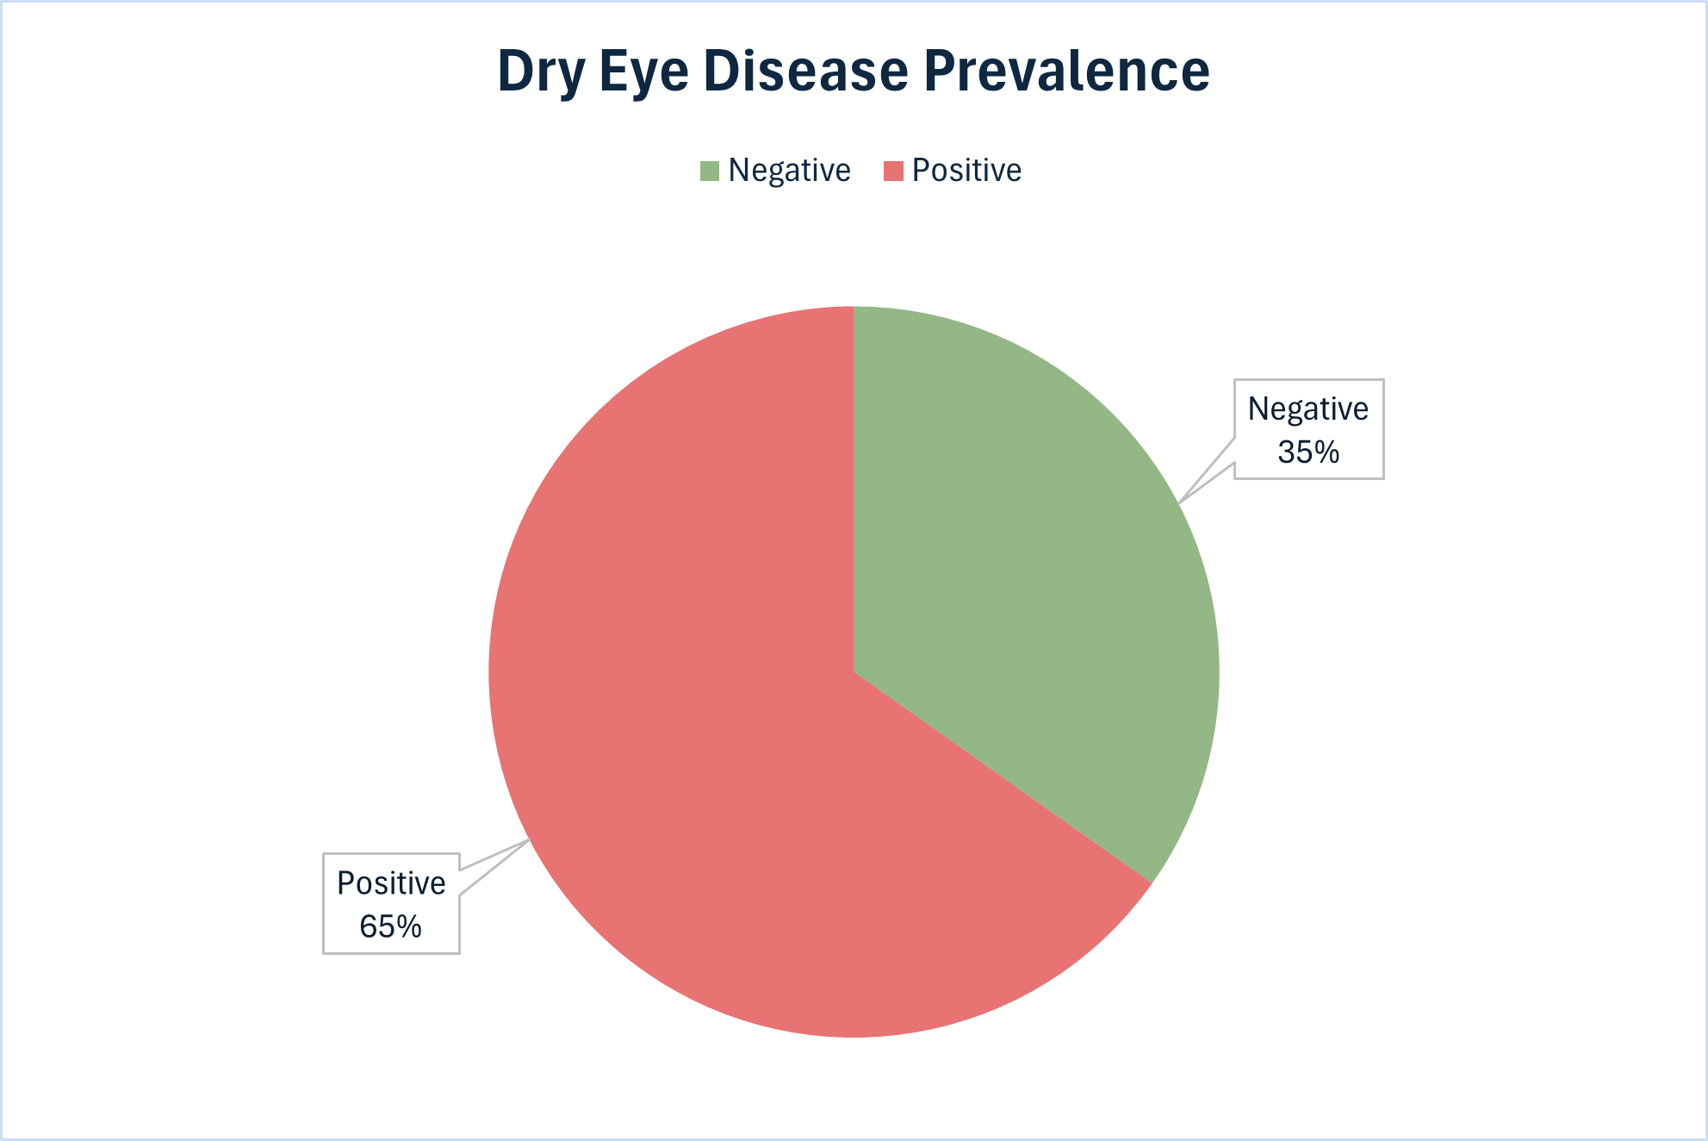

- Dry Eye Disease by Daily Screen Time

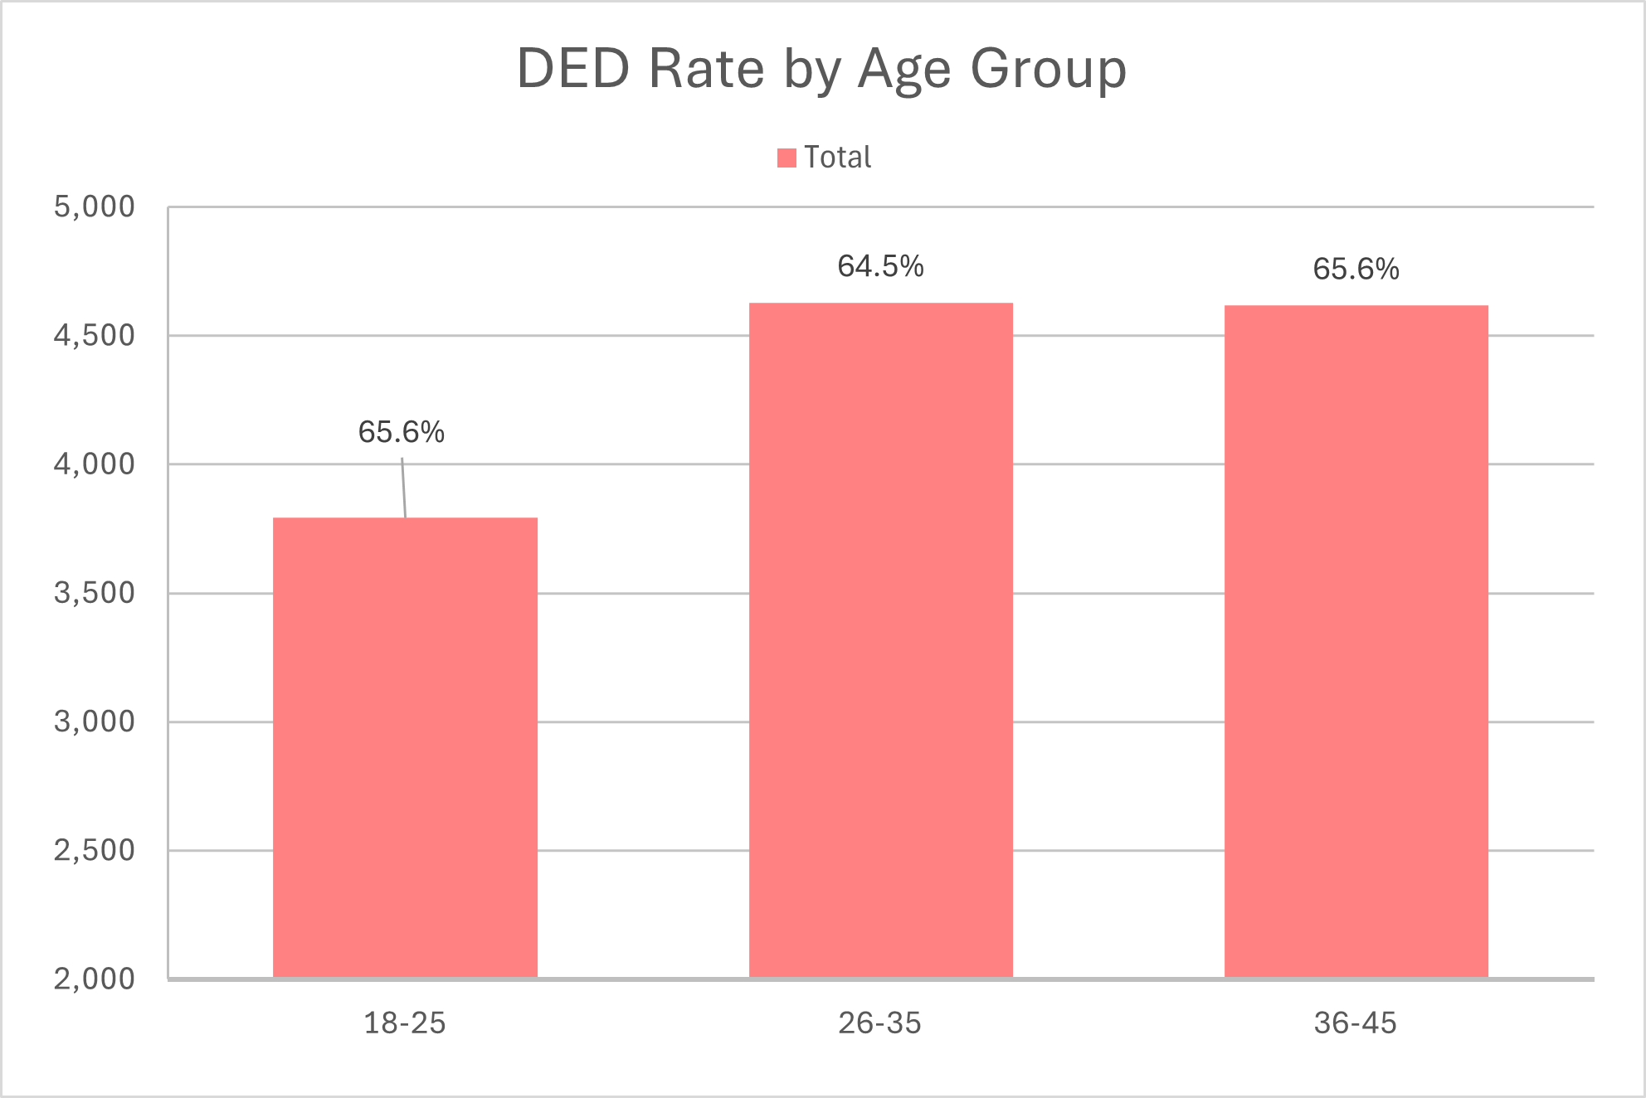
  - Across all screen time ranges, Dry Eye Disease positive cases consistently outnumber negative ones, reinforcing the 65.2% overall diagnosis rate in the dataset. Among positive cases, the 3–6-hour group accounts for the highest count at 4,262 followed closely by the 8–10-hour group at 2,963. On the negative side, the same 3–6-hour range leads at 2374, suggesting this is simply the most populated screen time bracket rather than a lower risk window. Notably, the gap between positive and negative cases widens in the 8–10-hour range, where positive cases (2,963) nearly double the negative count (1,450), pointing to heavier screen usage as a contributing factor in Dry Eye Disease occurrence.

- Dry Eye Disease (DED) Rate by Daily Screen Time

  - Patients with 8-10 hours of daily screen time show the highest DED prevalence at 67.1%, compared to 64.5% in the lowest usage group (0-3 hours). The data shows a clear upward trend as daily screen time increases so does DED risk, supporting the role of prolonged digital device use as a contributing factor to dry eye symptoms.

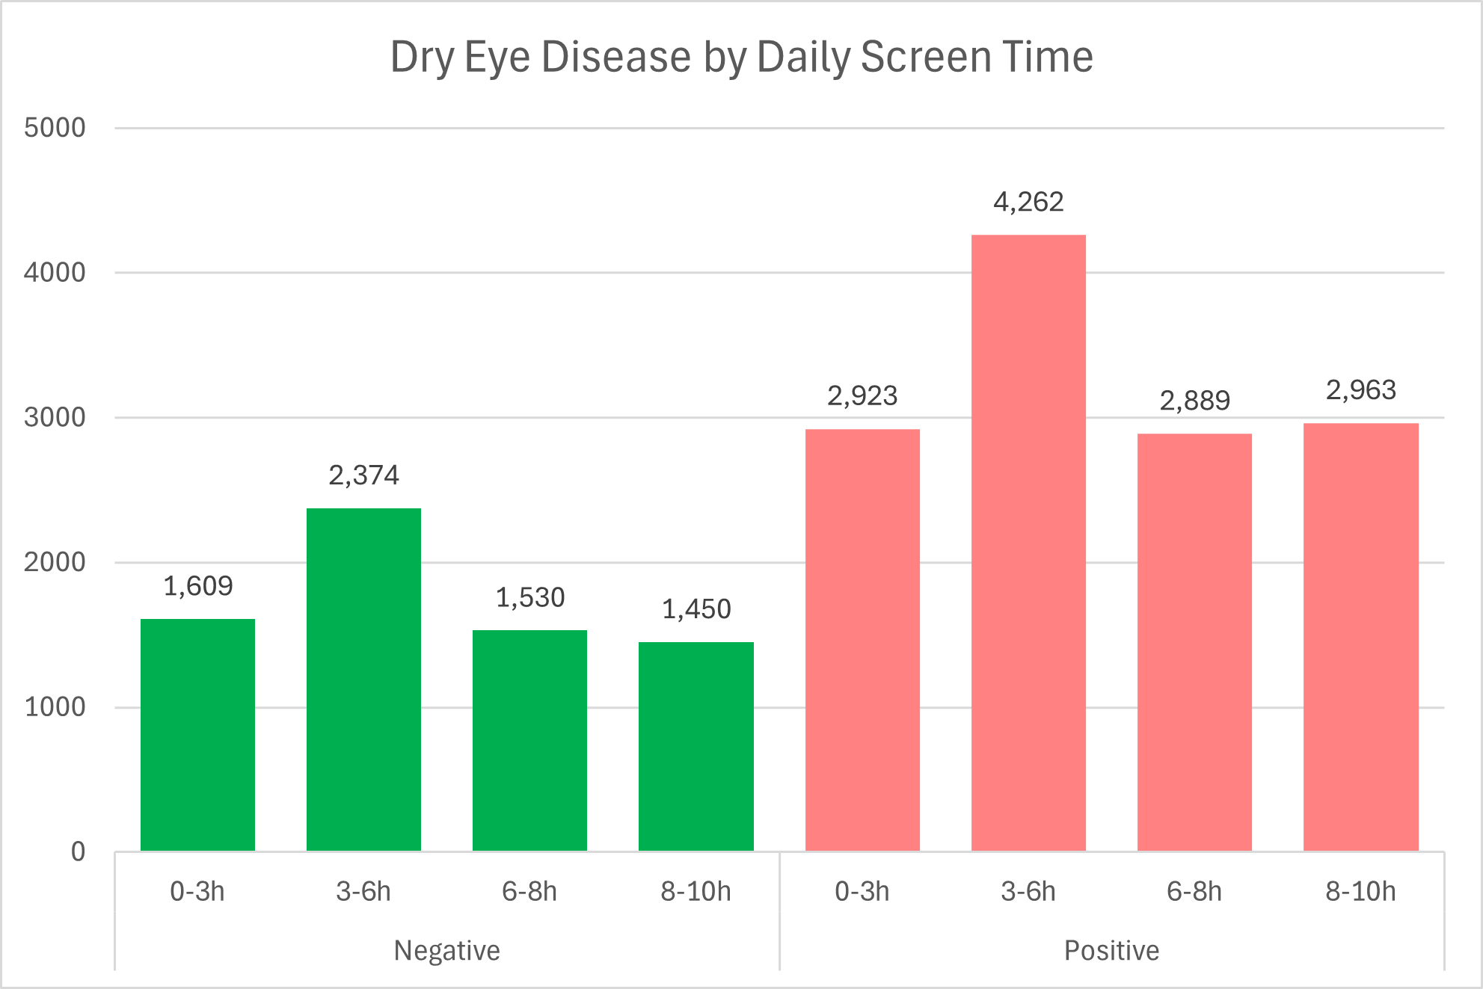

- Prevalence by BMI Category

  - Average BMI values across all age groups fall within the normal to overweight boundary indicating no extreme weight variation in this study population. DED positive patients in the 26-35 age range show the highest average BMI at 25.12, compared to their negative counterparts at 24.99. Across both groups, BMI trends to increase with age, with the 18-26 bracket consistently recording the lowest values. While the differences are marginal, positive cases trend slightly higher in BMI across all three age groups, suggesting a modest association between higher body mass and DED occurrence.

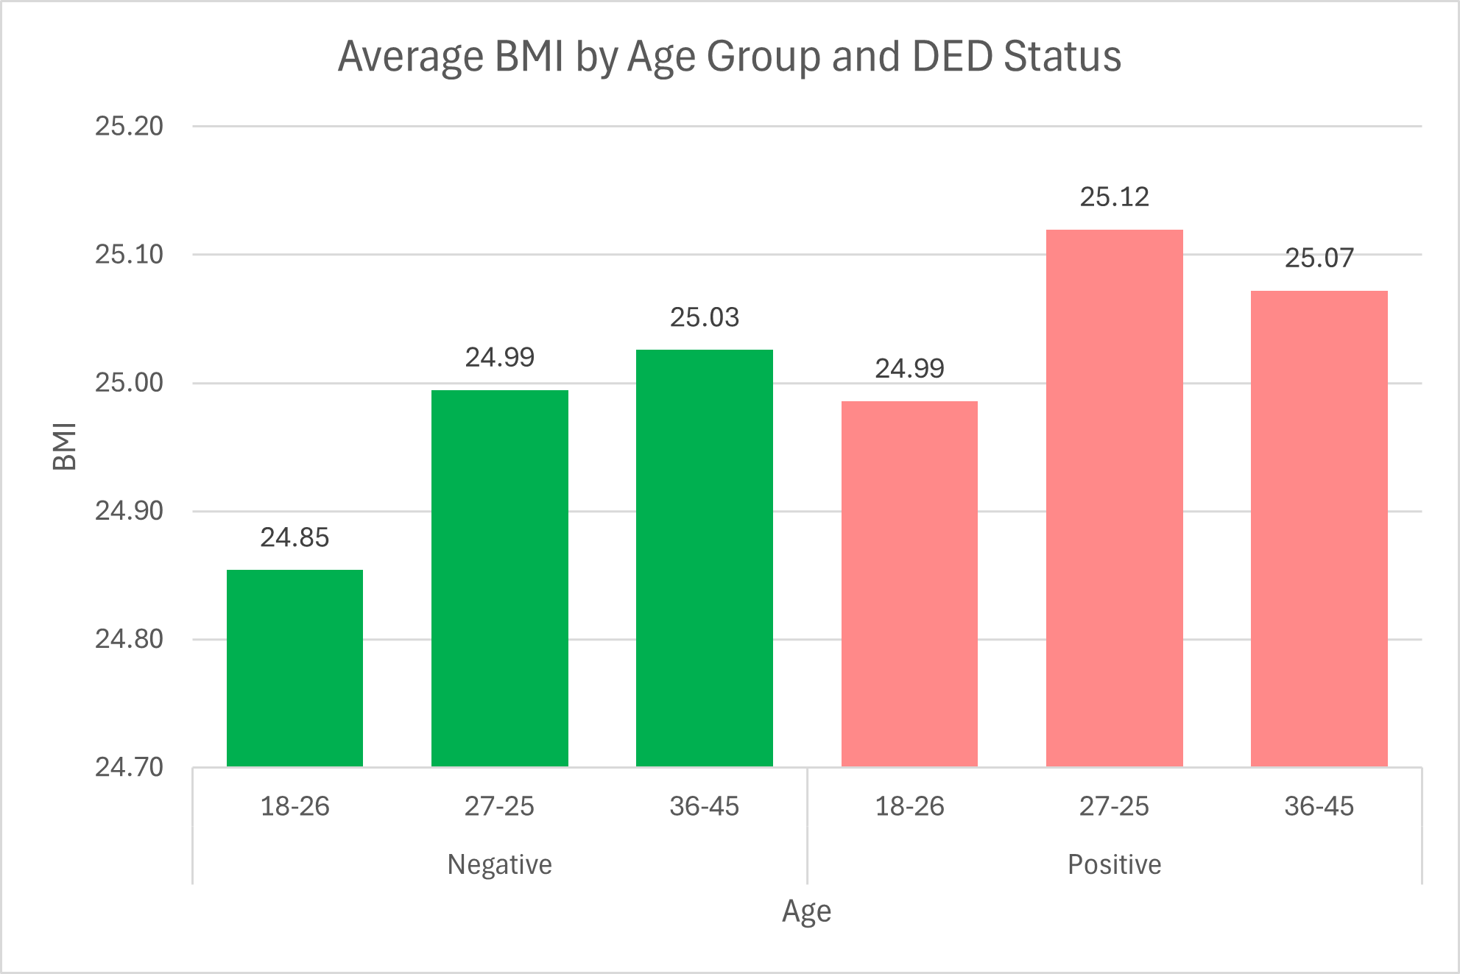

- Prevalence by Stress Level

  - Among DED positive patients, the 36-45 age groups record the highest average stress at 3.025, standing noticeably above the other groups. Negative patients remain tightly clustered between 2.976 and 2.992, showing little variation across age ranges. The most notable contrast appears in the oldest age group, where positive cases average 3.025 compared to 2.976 for negatives, suggesting that stress accumulates as a more significant factor in DED occurrence with age.
