Understanding and Predicting Dry Eye Disease
Christian Ramirez-Flores | March 19, 2026

1. Introduction 2
2. Public Health Impact 2
3. Data Analysis & Computation 2
3.1 Data Profiling 3
3.2 Observations & Data Wrangling 3
3.3 Data Table Schema 3
4. Approach 4
5. Tools 4
6. Exploratory Data Analysis: Dry Eye Disease Prevalence 5
4.1 DED Prevalence in the Sample Population 5
4.2 DED by Age Group 6
4.3 DED Rate by Daily Screen Time 7
4.4 Prevalence by BMI Category 8
4.5 Prevalence by Stress Level 9
7. Predictive Modeling: Random Forest Model 10
8. Model Performance 10
9. Feature Importance Analysis 10
10. Discussion 10
11. Limitations 10
12. Conclusion 10

Introduction
Dry Eye Disease is a condition that occurs when the eyes do not produce enough tears or when tears evaporate too quickly. This can lead to symptoms such as irritation, redness, blurred vision, and a persistent feeling of dryness or discomfort. As someone who experiences dry eye disease personally, this topic is especially meaningful to me because it affects everyday activities such as reading, working on a computer, and spending long periods looking at screens. In recent years, more people have begun experiencing dry eye symptoms due to factors such as extended screen time, environmental conditions, aging, and certain health or lifestyle habits. Because these factors are common in daily life, understanding the causes and risk factors of dry eye disease has become an important area of healthcare and research.
This project analyzes a dataset related to dry eye disease to explore patterns and relationships between different health and lifestyle variables and the presence of the condition. In addition to exploratory analysis, a Random Forest model will be used for predictive modeling to identify which variable are most important in predicting dry eye disease. Random Forest is a machine learning method that builds multiple decision trees and combines their results to improve prediction accuracy and reduce overfitting. By examining the dataset and interpreting the model result, this project demonstrates how data analysis and machine learning can provide insight into medical conditions and help identify individuals who may be at greater risk for developing dry eye disease.

Public Health Impact
Dry Eye Disease has growing public health impact because it affects a large portion of the population and can significantly reduce quality of lie. People with dry eye disease often experience chronic discomfort, eye fatigue, blurred vision, and difficulty performing everyday activities such as reading, driving, or using digital devices. As screen time increase in work, school, and daily life, more individuals are exposed to risk factors that can worsen dry eye symptoms. If left untreated, the condition can lead to long term irritation, inflammation, and reduced productivity in both academic and workplace settings.
From a public health perspective, understanding and identifying the factors that contribute to dry eye disease can help support early detection and prevention strategies. By analyzing health and lifestyle data, researchers and healthcare professionals can better recognize patterns associated with the condition and develop educational programs or recommendations to reduce risk. Improving awareness of dry eye disease and its causes can help individuals make healthier choices regarding screen use, eye care, and environmental exposure, ultimately reducing the overall burden of the condition on the population.

Data Analysis & Computation
Filename: Dry_Eye_Dataset.csv
Description: Information on observations made with 26 variables covering demographic, health, lifestyle, and eye-related symptoms.
Dataset Details: 20001 Rows and 27 Columns
Size 1.34MB
Source: https://www.kaggle.com/datasets/dakshnagra/dry-eye-disease/data

3.1 Data Profiling
The dataset was inspected by examining the first and last five rows to confirm structure and consistency across entries. The file contains 20,000 rows and 26 columns with no null values and no duplicate records present anywhere in the dataset. Columns span a mix of data types including integers, floats, and strings, with binary Y/N fields making up the majority of categorical variables.

3.2 Observations & Data Wrangling
All 26 Columns are fully usable with no missing data requiring imputation or removal. The Blood Pressure column is stored as a string in systolic/diastolic format (e.g. 137/89) and would need to be split if used in modeling. BMI is not included natively and was derived using Height and Weight columns via the formula **Weight/(Height/100) ²**. Age was grouped into three brackets (18-26, 27-35, 36-45) and Screen Time was bucketed into four ranges (0-3h, 3-6h, 6-8h, 8-10h) for chart analysis.

3.3 Data Table Schema
Field | Type | Description
Gender | Categorical (String) | Biological sex of the individual
Age | Integer | Age of the participant in years
Sleep duration | Float | Average number of hours the individual sleeps per night.
Sleep quality | Integer/ Ordinal | Rating of sleep quality, usually on a numerical scale
Stress Level | Integer/ Ordinal | Reported stress level of the individual
Blood pressure | Integer/ Numeric | Measurement of blood pressure indicating cardiovascular health
Heart rate | Integer | Resting heart rate measured in beats per minute
Daily steps | Integer | Average number of steps taken per day
Physical activity | Integer/ Ordinal | Level or frequency of physical activity performed by the individual
Height | Float | Height of the individual, typically measured in centimeters or meters
Weight | Float | Weight of the individual, usually measured in kilograms
Sleep disorder | Categorical | Indicates if the individual has a sleep disorder
Wake up during night | Integer | Number of times the individual wakes up during sleep
Feel sleepy during the day | Integer/ Ordinal | Level of daytime sleepiness experienced
Caffeine consumption | Integer | Amount or frequency of caffeine intake
Alcohol consumption | Integer | Frequency or level of alcohol intake
Smoking | Binary/ Categorical | Indicates whether the individual smokes or not
Medical Issue | Categorical | Indicates if the individual has an underlying medical condition
Ongoing Medication | Categorical | Individuals status of current medication
Smart device before bed | Categorical | Individuals status of smart device before sleeping
Average screen time | Float | Average hours spent looking at digital screens per day
Blue-light filter | Categorical | Indicates if the individual uses a blue-light filter
Discomfort Eyestrain | Categorical | Indicates if the individual has any discomfort from screen usage
Redness in eye | Categorical | Indicates if the individual has redness
Itchiness/Irritation in eye | Categorical | Indicates if the individual has any type of irritation in their eye
Dry Eye Disease | Binary (Target Variable) | Indicates whether the individual has dry eye disease (Yes/No)
BMI | Float | Calculated Field indicating Body Mass Index for the individual.

Approach

This study follows a structured approach combining exploratory data analysis and machine learning to better understand and predict dry eye disease. First, the dataset was examined and cleaned to ensure consistency, with no missing or duplicate values identified. Key variables were analyzed through visualizations to identify patterns and relationships between lifestyle, physiological, and eye-related factors and the presence of dry eye disease. Features such as age, screen time, sleep, BMI, and stress levels were explored to understand their potential influence on the condition. Following this, a Random Forest classification model was implemented to predict dry eye disease and evaluate the relative importance of each variable. The dataset was split into training and testing sets to assess model performance on unseen data. This combined approach allows for both descriptive insights and predictive analysis, providing a more comprehensive understanding of the factors associated with dry eye disease.

Tools

This project used a combination of Microsoft Excel, MATLAB, and Python-based machine learning tools. Microsoft Excel was used for initial inspection of the dataset, summary calculations, and organization of variables. MATLAB was used to create the project’s visualizations for exploratory data analysis, including prevalence and comparison charts. Python was used for predictive modeling, and with Pandas supporting data preparation and Scikit-Learn providing the Random Forest classification model and evaluation metrics. Together, these tools supported both descriptive analysis and machine learning-based prediction of dry eye disease.

6. Exploratory Data Analysis: Dry Eye Disease Prevalence

4.1 DED Prevalence in the Sample Population

Out of 20,000 patients, 13,037 representing 65.2%, were diagnosed with Dry Eye Disease, while the remaining 34.8% were unaffected. This chart establishes the baseline prevalence of Dry Eye Disease across the study population, highlighting that the condition affects nearly two-thirds of patients, making it a significant public health concern within this demographic.

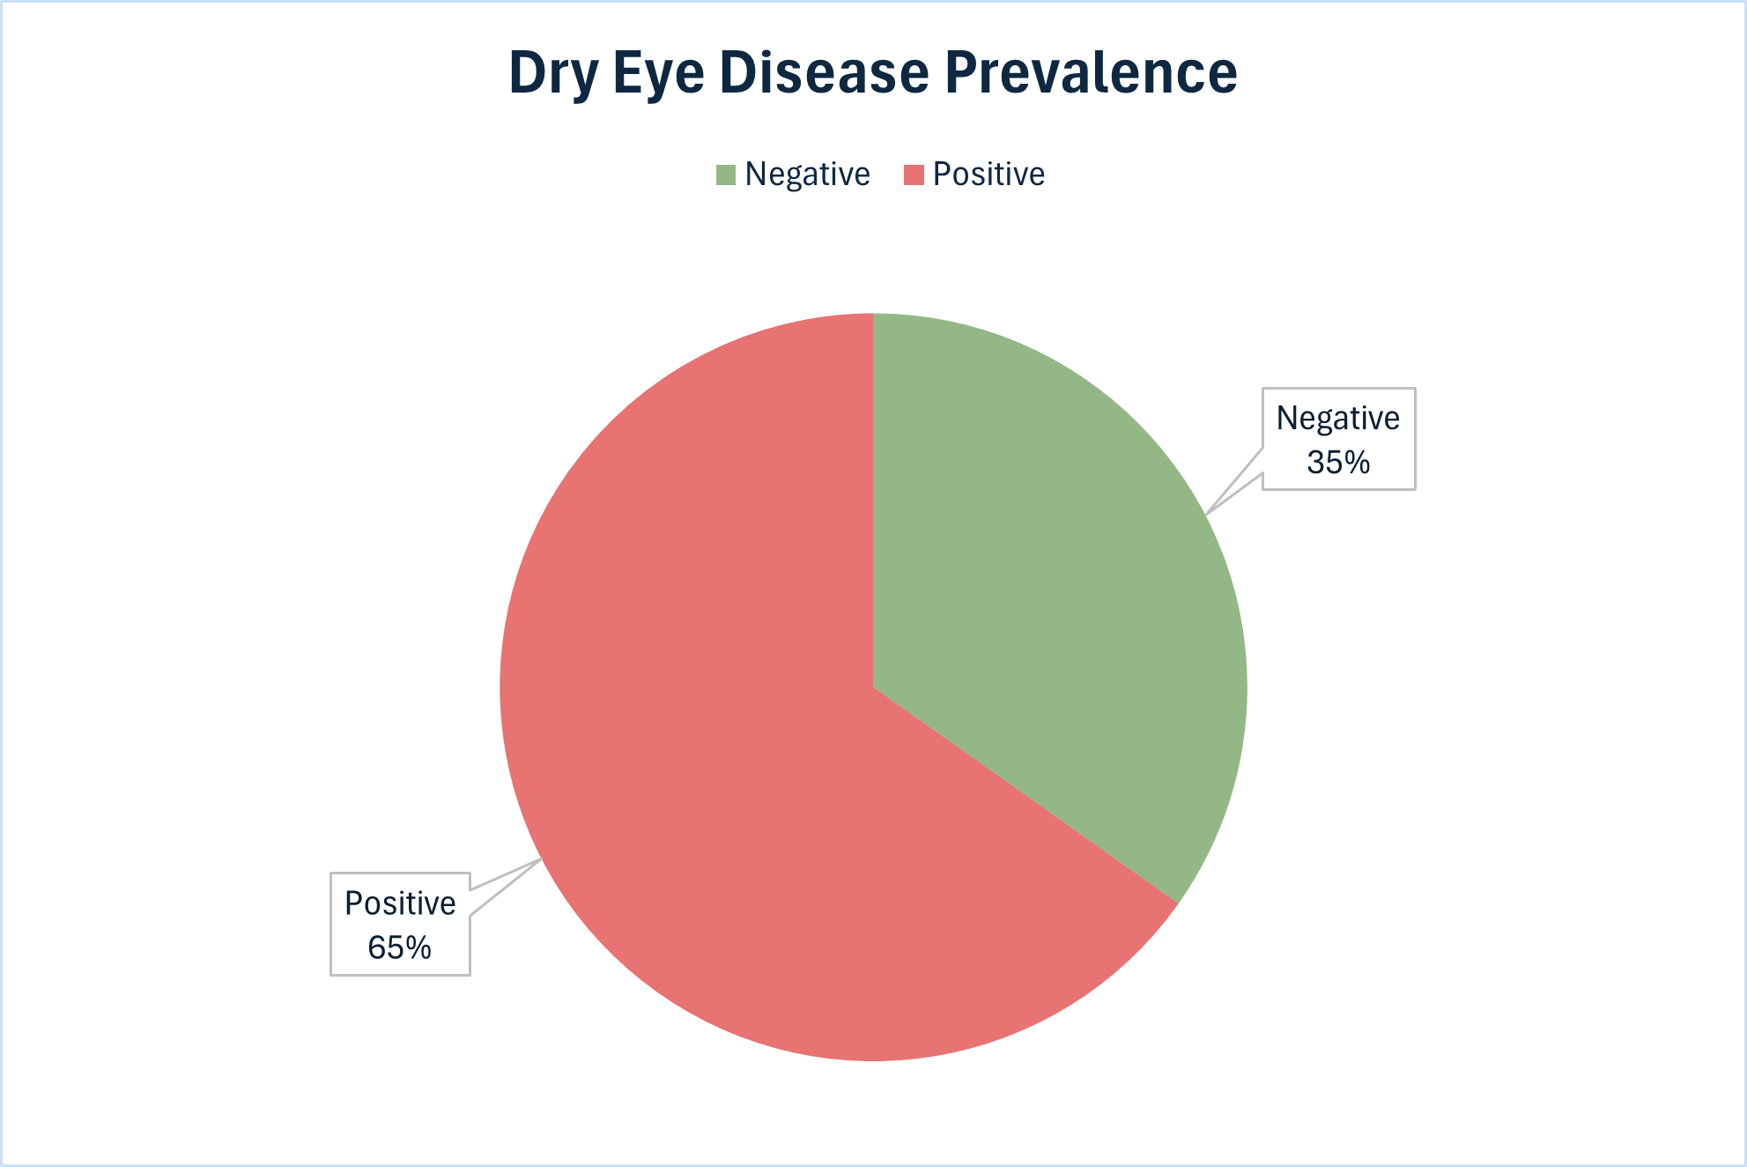

DED by Age Group

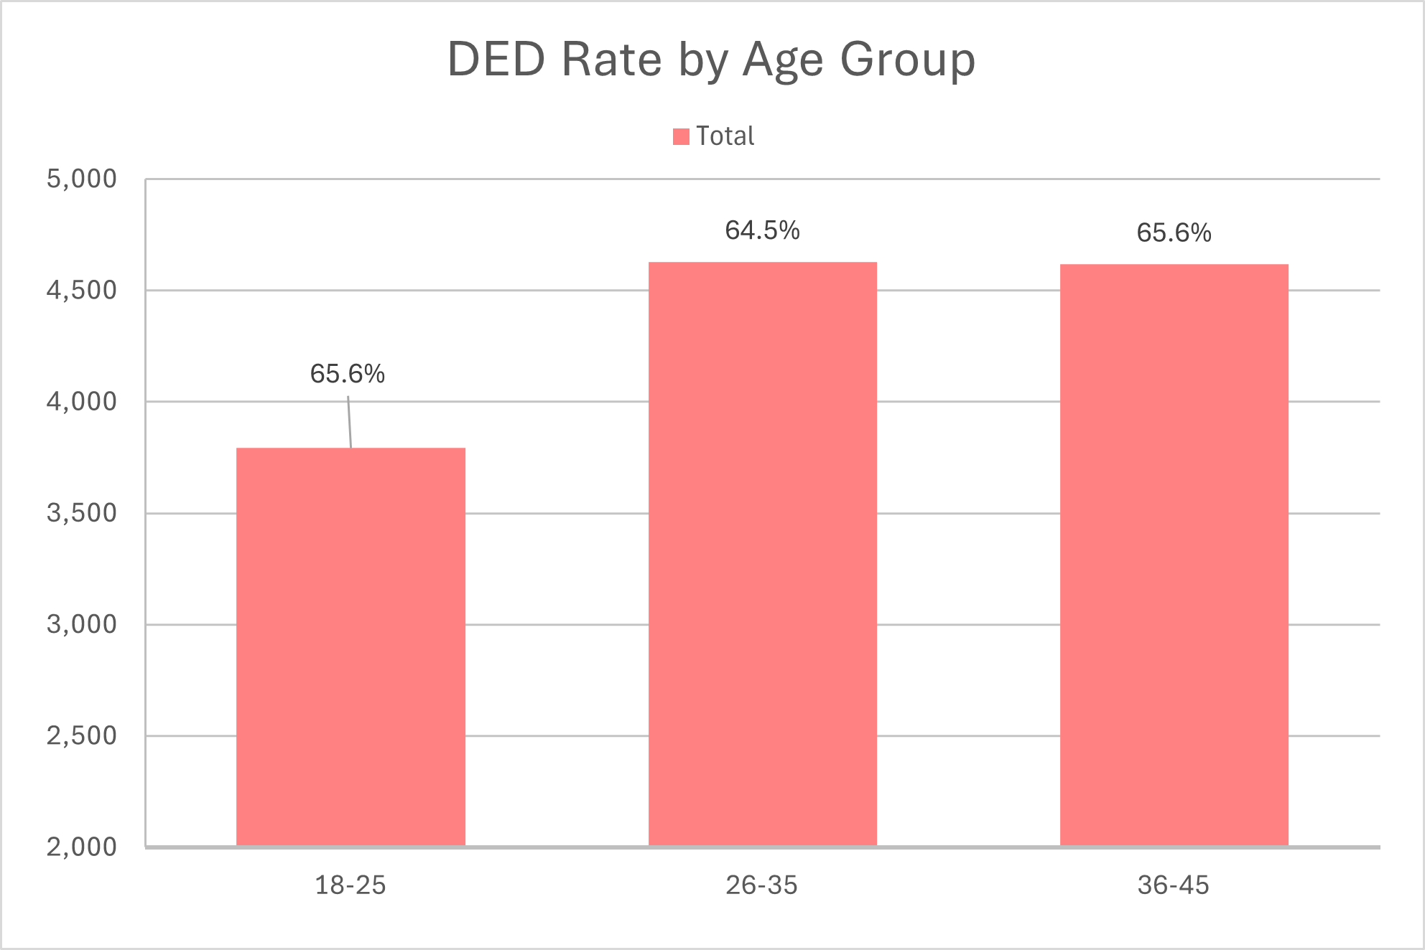
Across all screen time ranges, Dry Eye Disease positive cases consistently outnumber negative ones, reinforcing the 65.2% overall diagnosis rate in the dataset. Among positive cases, the 3–6-hour group accounts for the highest count at 4,262 followed closely by the 8–10-hour group at 2,963. On the negative side, the same 3–6-hour range leads at 2374, suggesting this is simply the most populated screen time bracket rather than a lower risk window. Notably, the gap between positive and negative cases widens in the 8–10-hour range, where positive cases (2,963) nearly double the negative count (1,450), pointing to heavier screen usage as a contributing factor in Dry Eye Disease occurrence.

4.3 DED Rate by Daily Screen Time

Patients with 8-10 hours of daily screen time show the highest DED prevalence at 67.1%, compared to 64.5% in the lowest usage group (0-3 hours). The data shows a clear upward trend as daily screen time increases so does DED risk, supporting the role of prolonged digital device use as a contributing factor to dry eye symptoms.

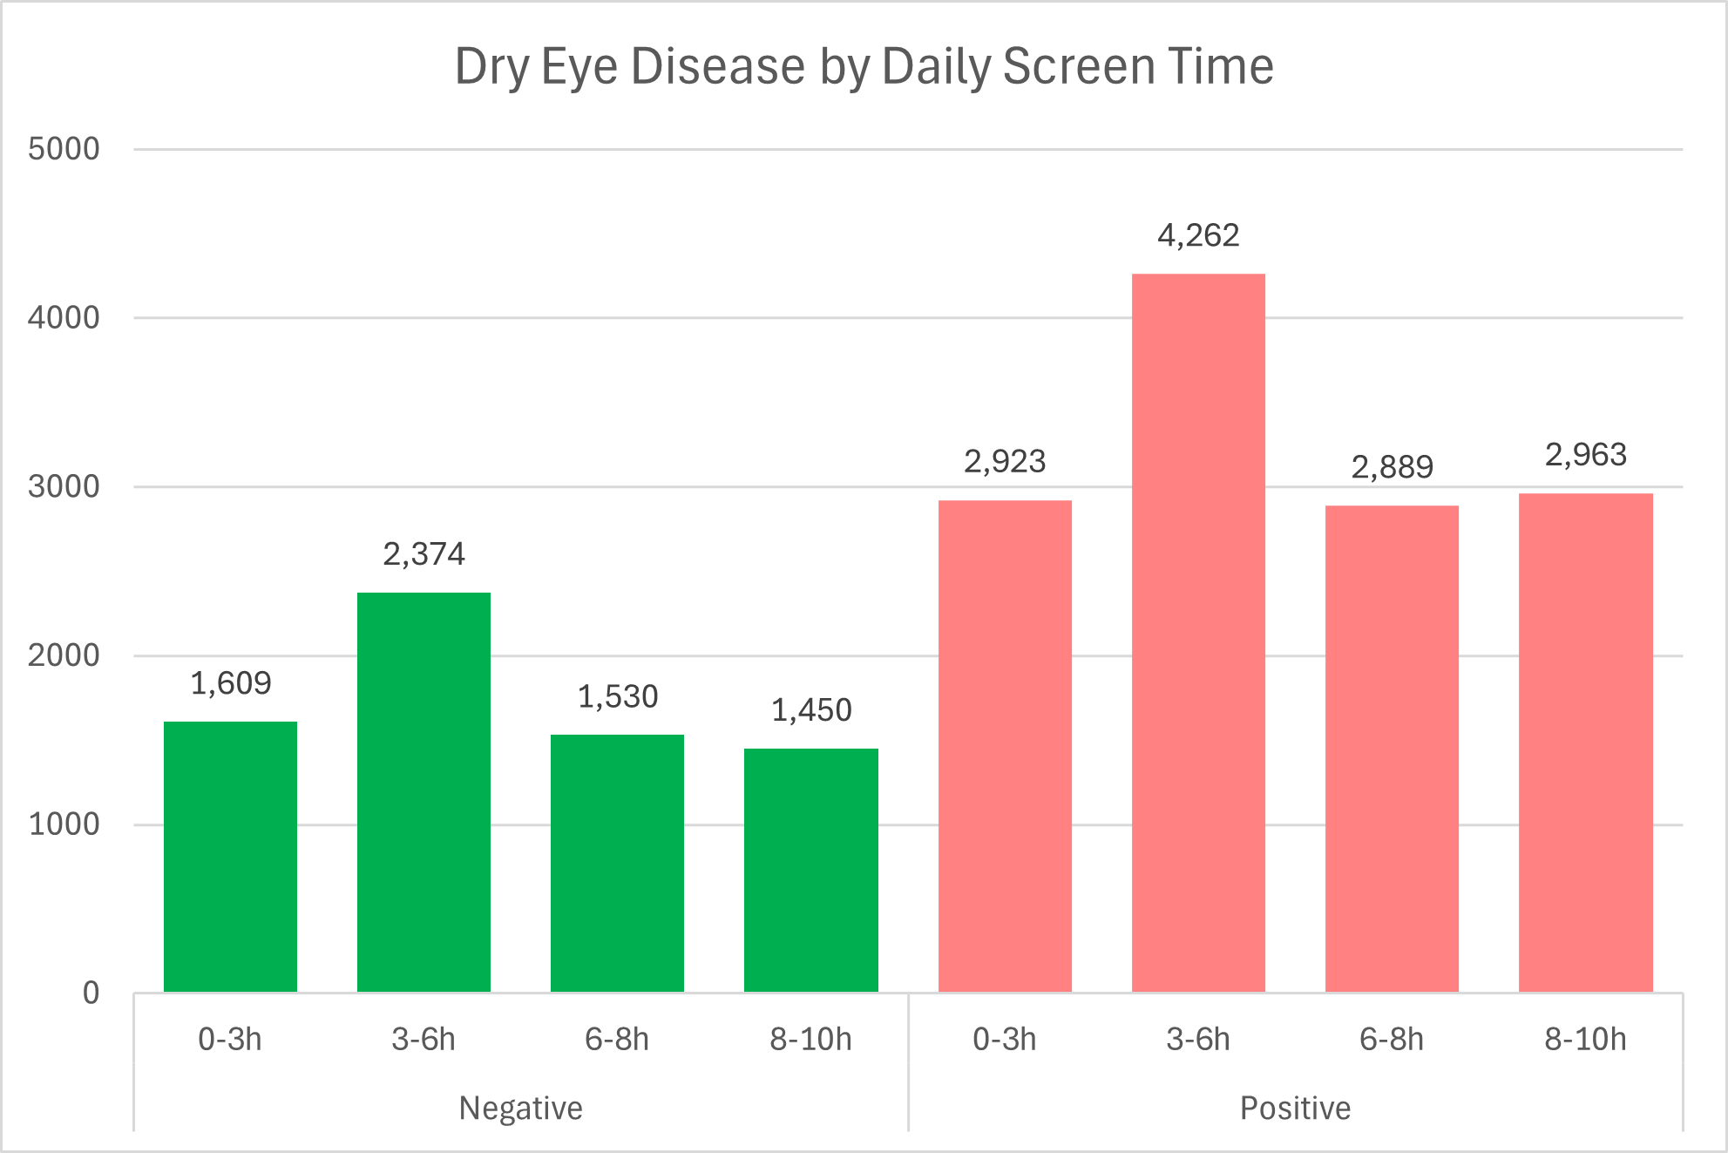

Prevalence by BMI Category

Average BMI values across all age groups fall within the normal to overweight boundary indicating no extreme weight variation in this study population. DED positive patients in the 26-35 age range show the highest average BMI at 25.12, compared to their negative counterparts at 24.99. Across both groups, BMI trends to increase with age, with the 18-26 bracket consistently recording the lowest values. While the differences are marginal, positive cases trend slightly higher in BMI across all three age groups, suggesting a modest association between higher body mass and DED occurrence.

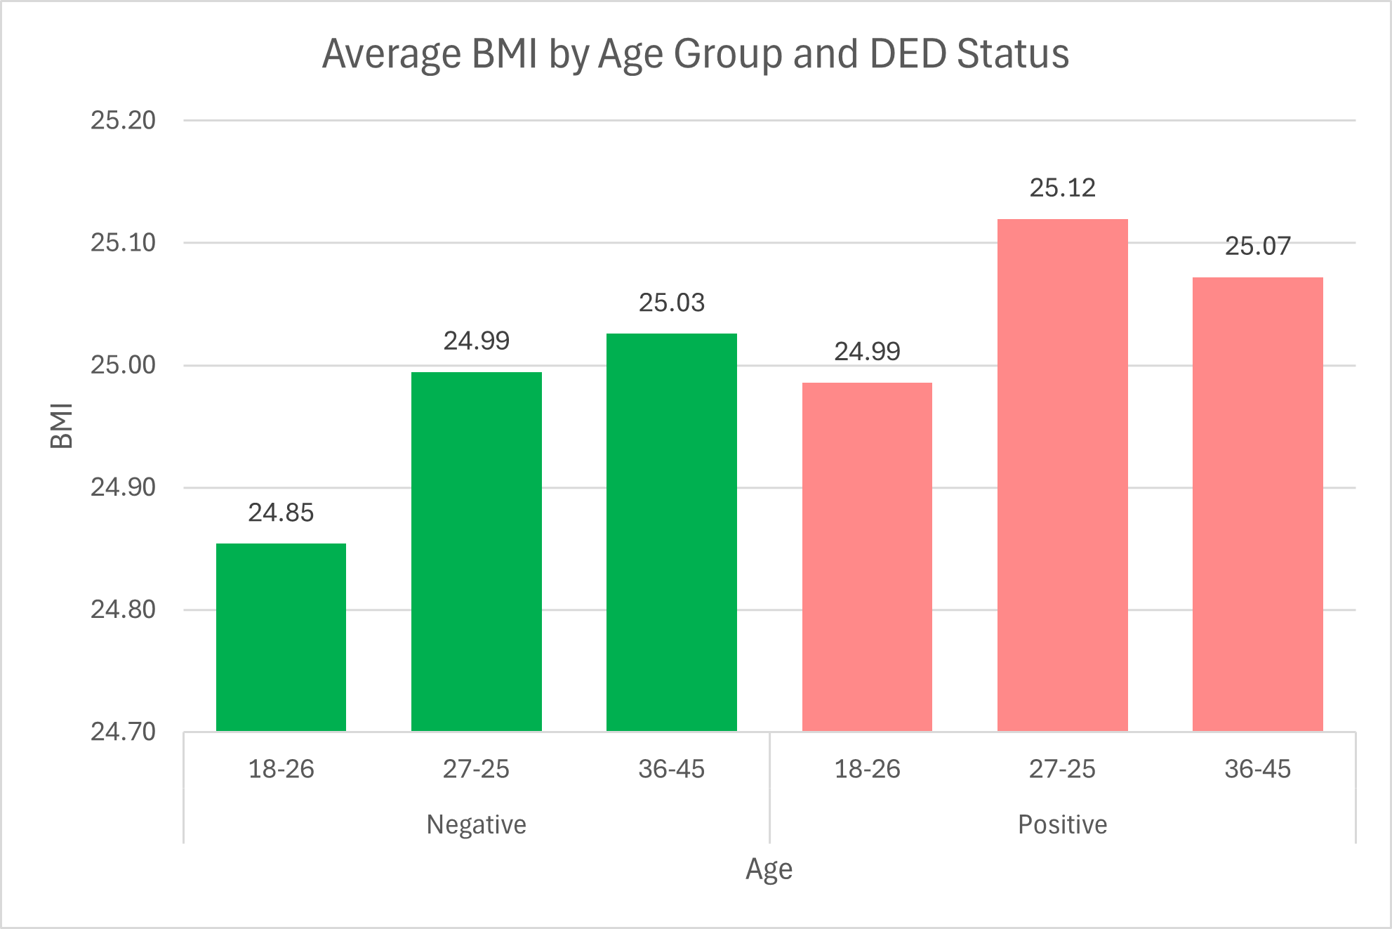

Prevalence by Stress Level

Among DED positive patients, the 36-45 age groups record the highest average stress at 3.025, standing noticeably above the other groups. Negative patients remain tightly clustered between 2.976 and 2.992, showing little variation across age ranges. The most notable contrast appears in the oldest age group, where positive cases average 3.025 compared to 2.976 for negatives, suggesting that stress accumulates as a more significant factor in DED occurrence with age.
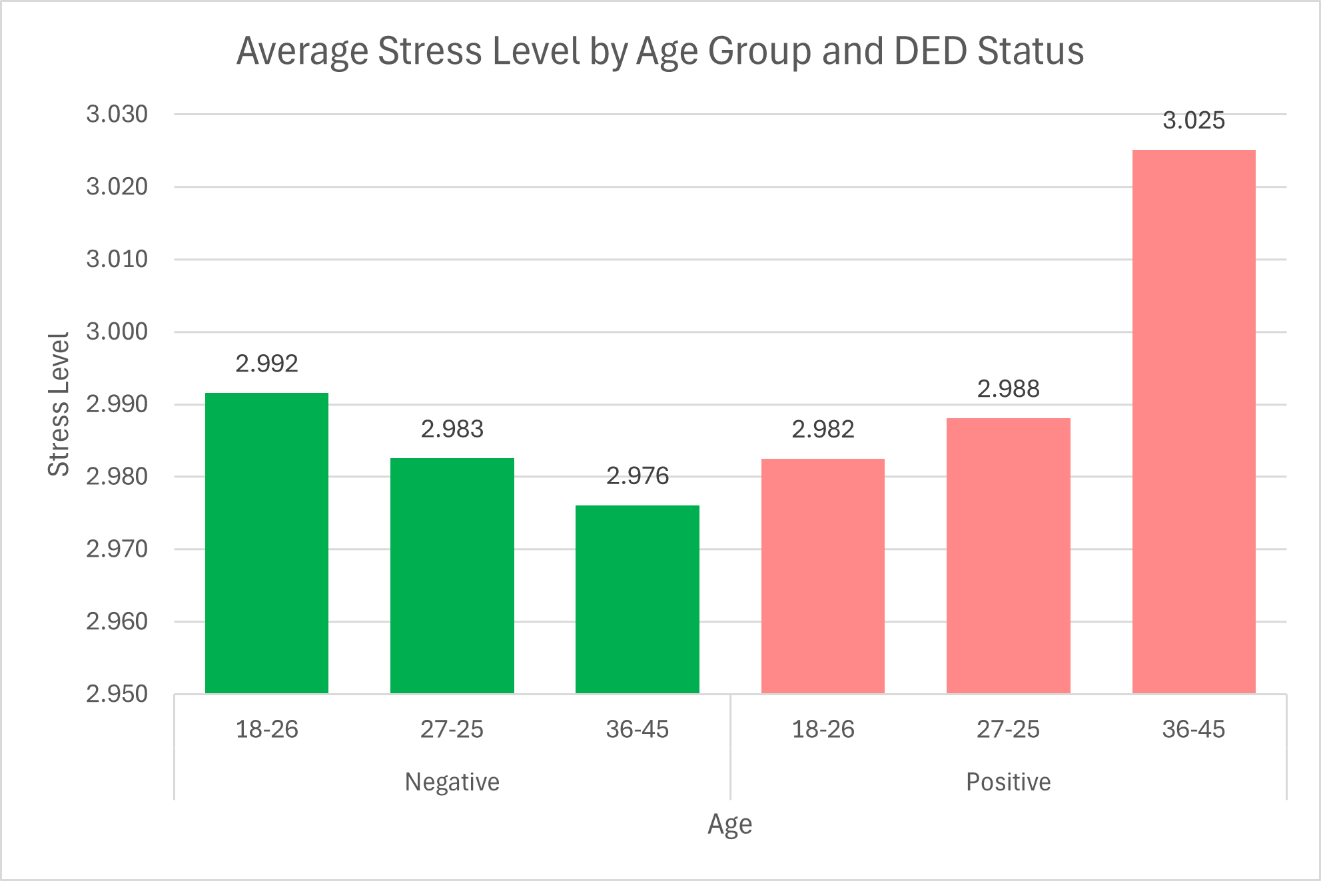

7. Predictive Modeling: Random Forest Model

A Random Forest classification model was implemented to predict the presence of Dry Eye Disease (DED) based on demographic, lifestyle, and physiological variables. Random Forest is an ensemble learning method that constructs multiple decision trees using random subsets of the data and features, then combines their predictions through majority voting. This approach improves predictive accuracy and reduces overfitting compared to a single decision tree.
Prior to modeling, categorical variables were encoded into numerical format to allow compatibility with eh algorithm. The dataset was split into 80% training data (16,000 observations) and 20% testing data (4,000) observations) to evaluate model performance on unseen data. The model was trained using Scikit-learn’s RandomForestClassifier, allowing for efficient handling of mixed feature types and complex relationships between variables.

8. Model Performance
The Random Forest model achieved an overall accuracy of 70.05% indicating that approximately 7 out of 10 predictions were correct on the test dataset.
Confusion Matrix Interpretation
- True Negatives: 338
- False Positive: 1055
- False Negatives: 143
- True Positives: 2464
The model demonstrates strong performance in identifying individuals with Dry Eye Disease, as reflected by a high recall of 0.95 for positive cases. This indicates that the model successfully detects the majority of individuals who have the condition. However, the recall for negative cases is significantly lower (0.24), meaning the model frequency misclassifies healthy individuals as having DED.
Overall, the model tends to favor predicting the presence of dry eye disease, which may be influenced by the higher prevalence of positive cases in the dataset.

9. Feature Importance Analysis
Feature importance was extracted from the Random Forest model to identify which variable contributes most to predicting Dry Eye Disease. These values represent the relative influence of each feature, normalized as percentages.
The top contributing features include:
- Physical Activity (5.9%)
- Average Screen Time (5.8%)
- Sleep duration (5.6%)
- Weight (5.5%)
- Heart Rate (5.4%)
- Age (5.2%)
- Daily Steps (4.9%)
Moderate contributors include stress level and sleep quality, while eye redness showed lower relative influence.
These findings indicate that lifestyle-related factors, particularly screen time, physical activity, and sleep patterns, play a more significant role in predicting dry eye disease than individual symptom indicators alone. It is important to note that feature importance reflects associations within the dataset and does not imply direct causation.
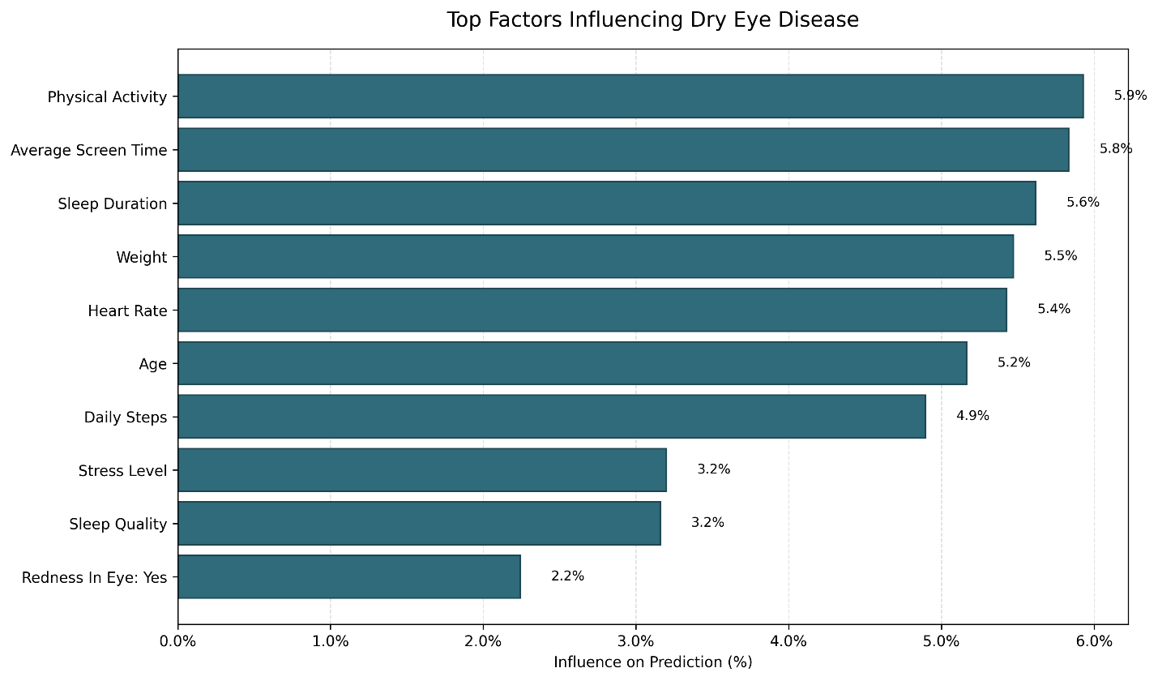

10. Discussion
The results from both exploratory data analysis and machine learning modeling consistently highlight the importance of lifestyle behaviors in relation to Dry Eye Disease. Variables such as screen time, sleep duration, and physical activity appeared as strong contributors across both descriptive analysis and predictive modeling.
The increasing trend of DED prevalence with higher screen time supports existing understanding of digital eye strain and reduced blink rates during prolonged device use. Similarly, sleep-related variables suggest that inadequate rest may contribute to reduced eye recovery and increased irritation.
While physiological factors such as weight and heart rate also contributed to predictions, their influence was less pronounced compared to behavioral factors. This suggests that daily habits may play more direct role in influencing dry eye symptoms within this dataset.

11. Limitations
Several limitations should be considered when interpreting these results. First, the model demonstrates a bias toward predicting Dry Eye Disease, likely due to the higher proportion of positive dases in the dataset. This results in a higher number of false positive and reduced accuracy in identifying healthy individuals.
Second, feature importance values indicate correlation rather than causation, meaning that highly ranked variables may not directly cause the condition but may be associated with other underlying factors.
Additionally, the dataset represents a specific population and may not generalize to broader or clinical population. Further validation using external dataset would be necessary to confirm the model’s applicability.

12. Conclusion
This study demonstrates how data analysis and machine learning can be used to better understand and predict Dry Eye Disease. Through exploratory analysis, key trends were identified linking lifestyle factors such as screen time, sleep, and stress to increased prevalence of the condition.
The Random Forest model further reinforced these findings by identifying similar variables as the most influential predictors. While the model achieved moderate accuracy, it shows strong capability in detecting individuals with Dry Eye Disease, making it a useful tool for identifying potential risk factors.
Overall, the results emphasize the importance of daily habits in eye health and highlight the potential for data-driven approaches to support early detection and prevention strategies.

