**PBJ DOCUMENTATION**

**Ingredients required:**

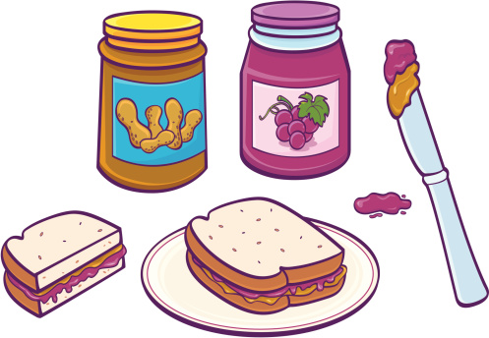

* Bread (two slices for one sandwich)
* Peanut Butter
* Jelly or Jam (any flavor of your choice)
* Optional: Regular butter

**How to make the sandwich:**

**Step 1**: Place the two slices of bread on a flat surface like a cutting board or on a plate.

**Step 2**: If using regular butter, apply a small amount (1/4th teaspoon) of butter using a knife to spread on one slice of the bread. Adding butter to your sandwich enhances the overall flavor of the sandwich. Next, spread a thin layer of peanut butter (add more depending on how much peanut butter you like) on the same slice of bread. Be careful not to add too much peanut butter as this could make the bread a bit moist.

**Step 3**: On the other slice of bread, spread a teaspoon of jelly or jam using a knife.

**Step 4**: Place the slice of the bread with peanut butter on top of the other slice with jam/jelly and gently press them together so as to avoid the jelly from spilling out from the sides of the sandwich.

**Step 5**: Cut the sandwich diagonally from one corner of the bread to the other. This step is optional; however cutting a sandwich diagonally makes it easier to eat

Your PBJ sandwich is ready to devour. ENJOY!!

**Notes:**

* To have a crunchier version of the PBJ, you could also toast the slices of bread and then continue the process from Step 2.
* The commonly used jelly or jam flavors are grape and strawberry. But you can always choose a flavor of your choice and experiment.
* For a healthier version, you can opt for brown bread and a jam or jelly with no added sugar (an organic or homemade version)
* If you find it hard to spread the peanut butter, heat a small amount of peanut butter in the microwave for 10-20 seconds.

Word Count: 322