**RollCall Solutions**

Proposal/Design:-

We will be helping the Master's Program Office (MPO) at Robert H. Smith School of Business to improve their database design. Currently, some faculty take attendance on pen and paper. So we came up with the idea to ease the process of taking attendance. Further, the team decided to make it more efficient by collecting feedback from students after each class and storing them.

We planned to update the attendance process. Currently, students sign the attendance sheets on paper during class sessions.

Mail to MPO (Amy Swann- Director of Business Master's Programs):-

We are planning a new database or incorporating changes into the existing system where a student will mark his presence using an access code provided by the lecturer in class. To avoid proxy cases, we can probably have time limits. For example, the faculty starts this attendance process just before the end of his class session, and students must finish within a minute.

At the same time, we can collect feedback from students. Was the class helpful? Any changes/suggestions for improvement in the future?

What were the reasons for students not attending a particular class? Are there any conflicts with interviews?

Storing these details and then gaining insights will help to improve the services.

We got a confirmation mail to go ahead with the project and to take data from the canvas website.

Data Resources:-

<https://umd.instructure.com/>

https://www.testudo.umd.edu/

https://www.rhsmith.umd.edu/directory

https://www.rhsmith.umd.edu/office-career-services/employers/recruitment/specialty-masters

Tables Description:-

Department:

Identify different departments in the specialty Master’s program at Smith school from the official website.

Student:

We have collected students' information such as UID, name, email, and username from the canvas website.

Faculty:

We identified faculty details such as name and email from the UMD faculty directory.

Course:

We searched it on Testudo to determine which faculty teaches what course.

Work:

This table has details of which faculty are working in which department.

Teach:

This table will have details of which faculty are teaching what course for the students.

Attendance and Review:

We collected data from students for these two tables.

References:-

We referred to class notes, recordings on canvas, and the textbook for building our database model.

Steps to test the project:-

Step1:- Connect to the SQL Server on SQL Server Management Studio.

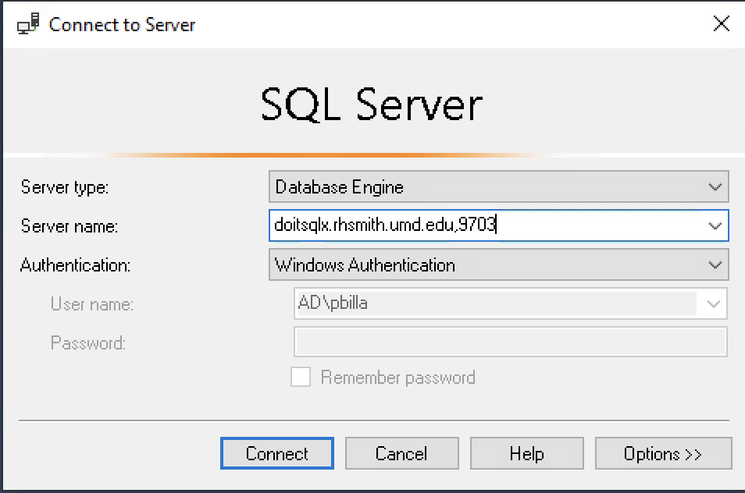

Step2:- After connecting to the server, switch to the database BUDT703_Project_0501_08

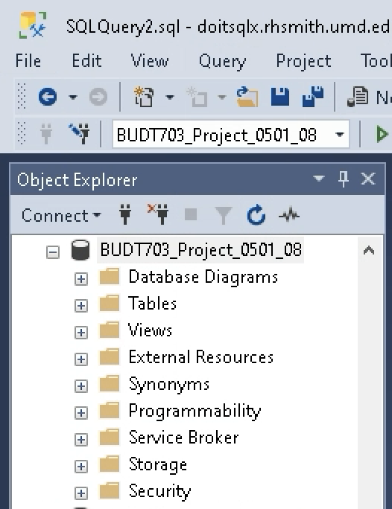

Step3:- After switching the database, open and execute Project_0501_08_Drop.sql

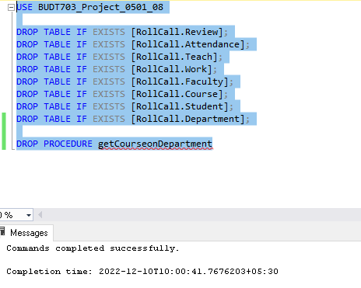

Step4:- Now, open and execute Project_0501_08_Create.sql

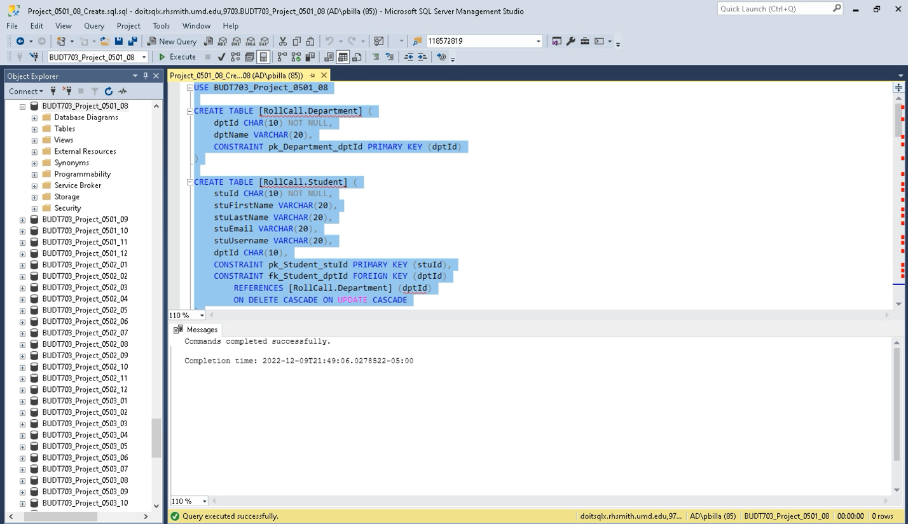

Verify if tables are created:

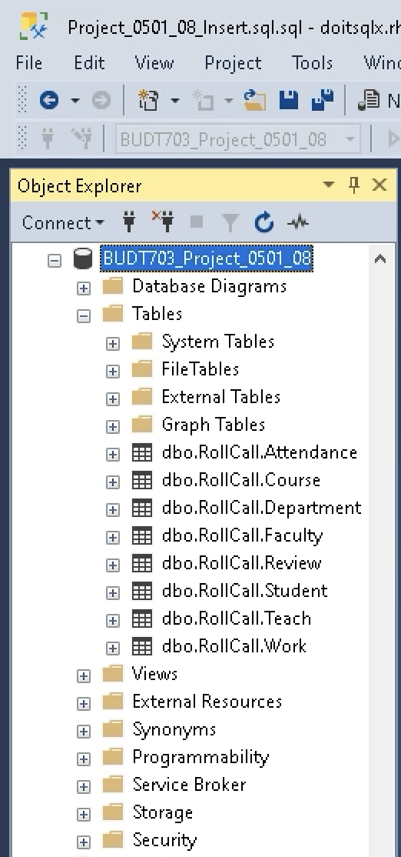

Step5:- After creating the tables, open and execute Project_0501_08_Insert.sql

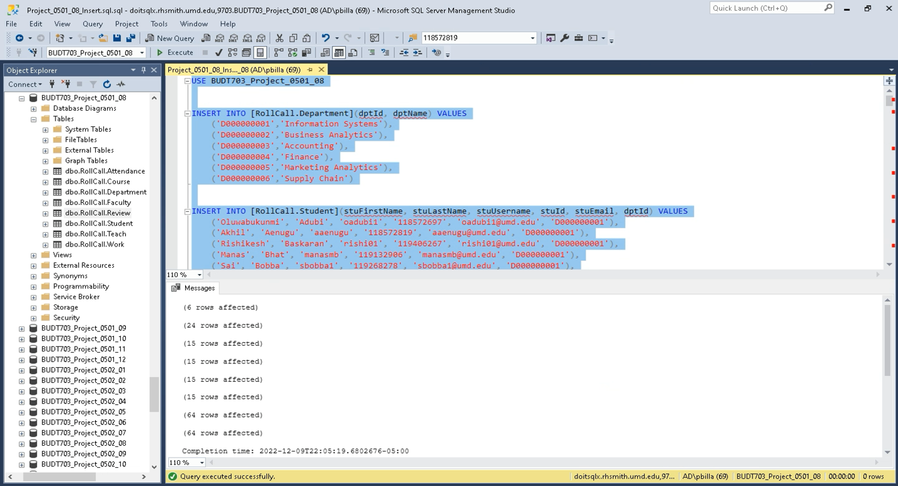

Step6:- Check contents of each table after insertion.

Department:

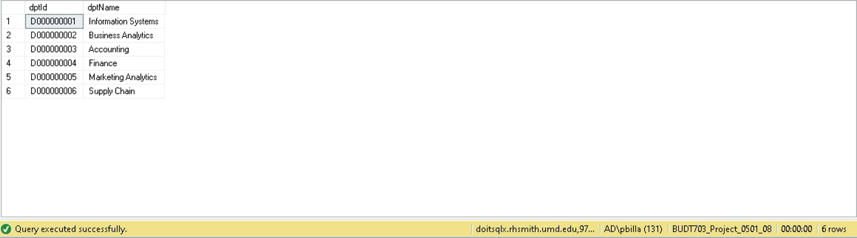

Student:

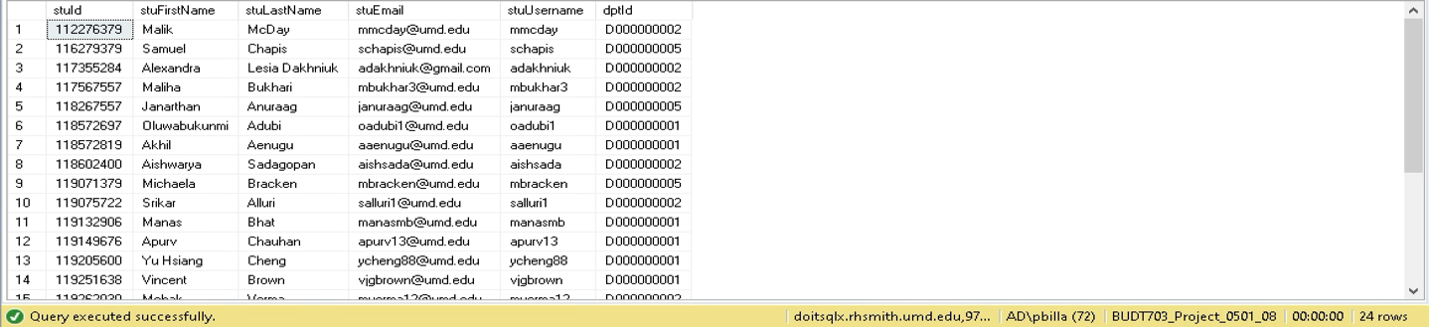

Course:

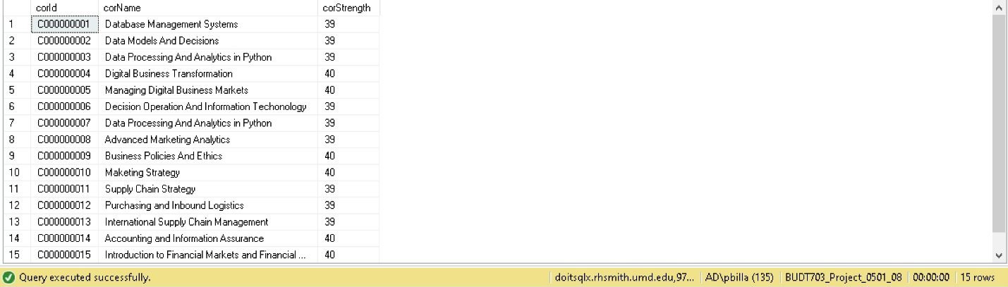

Faculty:

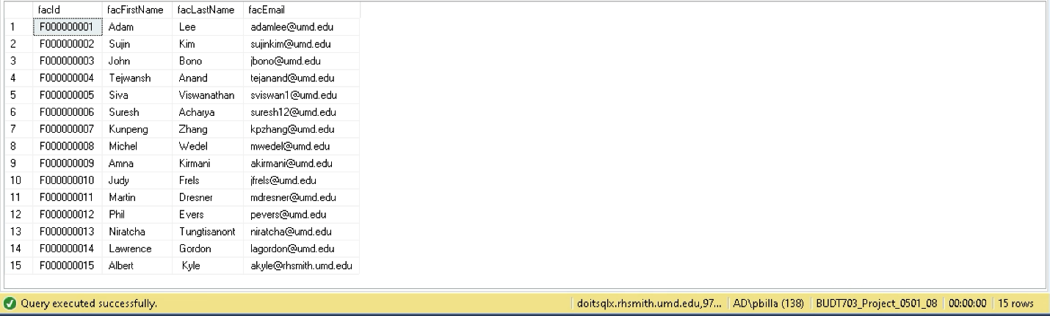

Work:

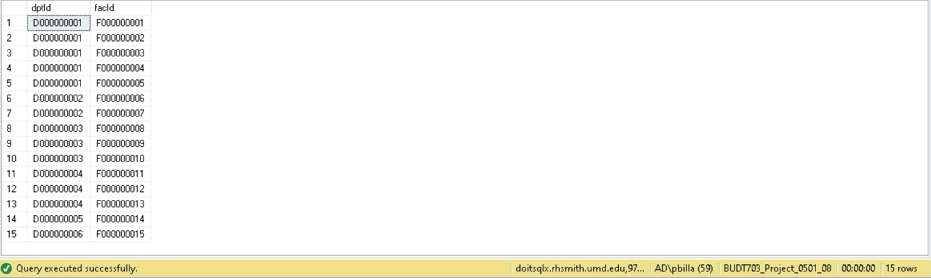

Teach:

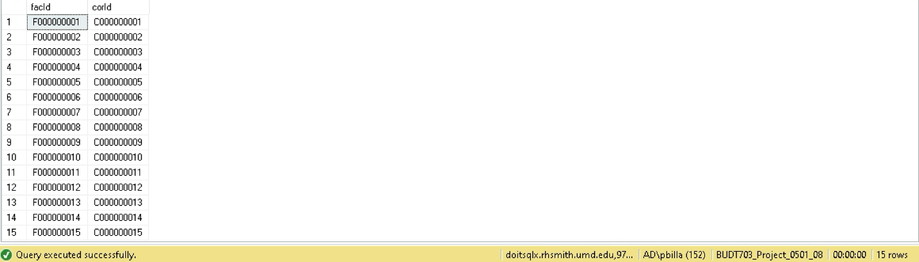

Attendance:

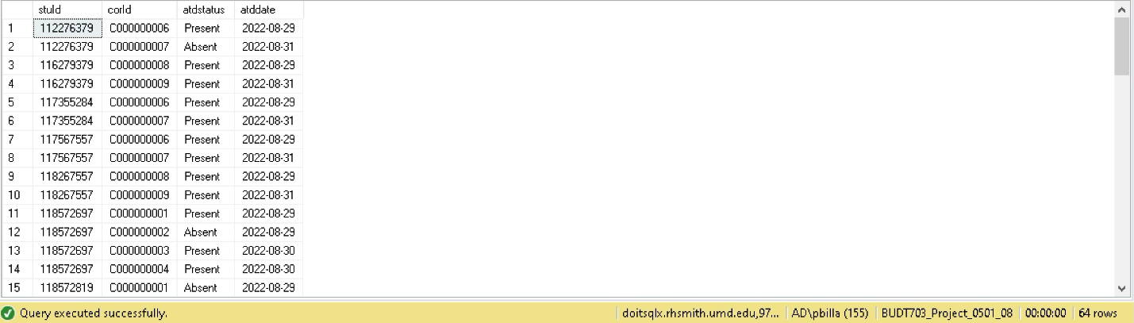

Review:

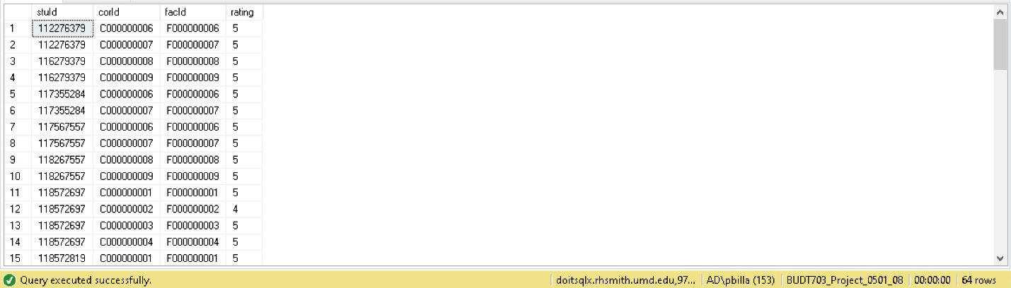

Step7:- After creating tables and inserting data into it, review the database tables and their information before performing the required business transactions.

Business Transaction 1:

To find the list of students who have least regularly attended the courses in each department

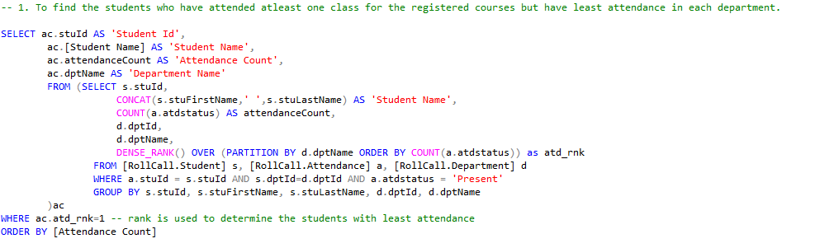

Output:

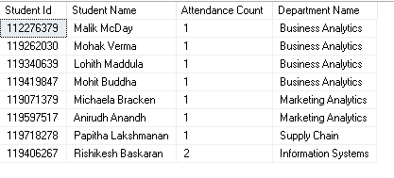

Business Transaction 2:

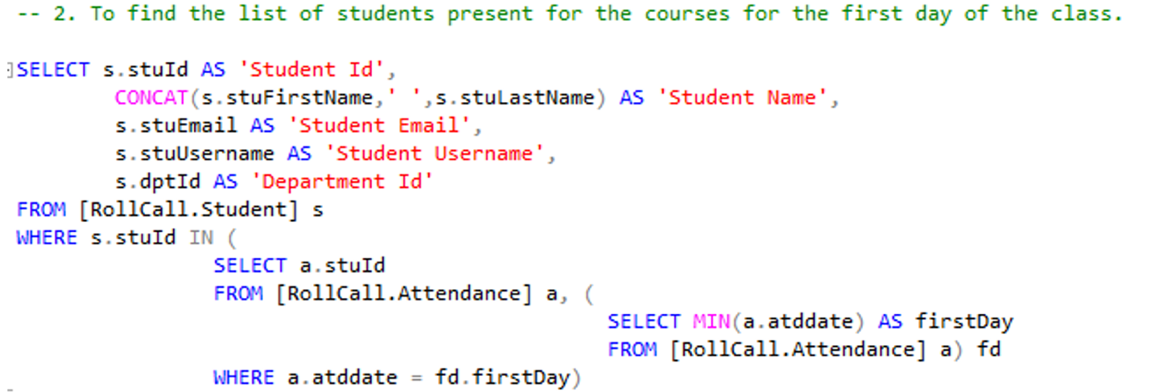

Output:

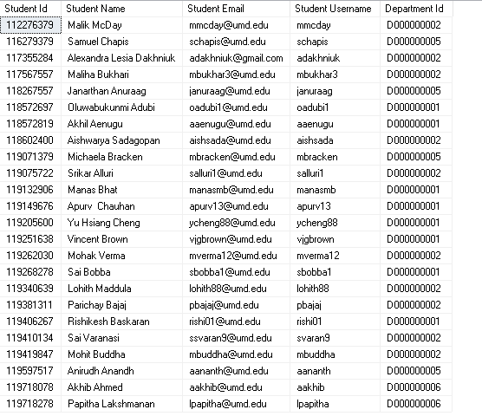

Business Transaction 3:

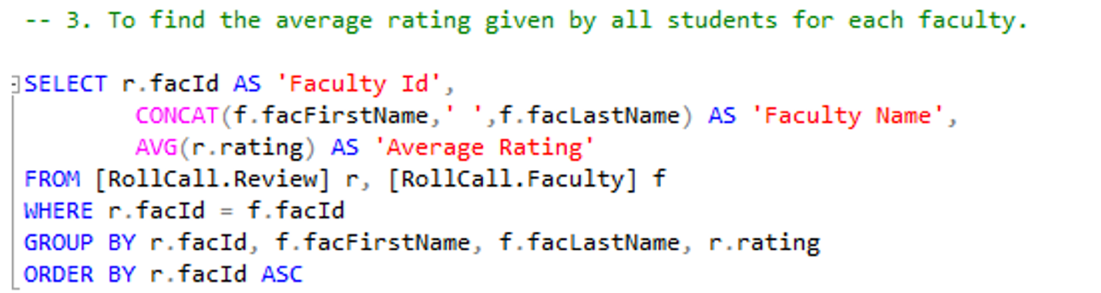

Output:

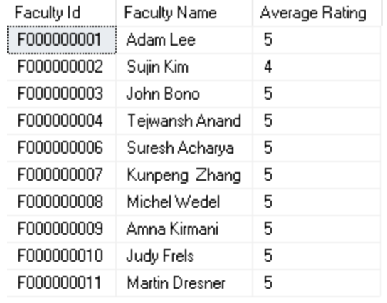

Business Transaction 4:

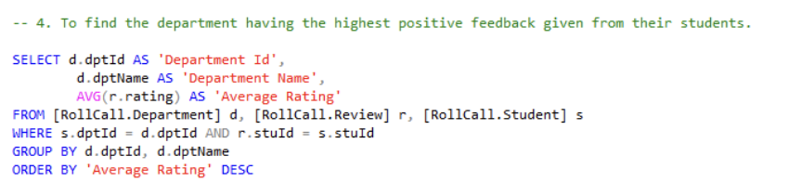

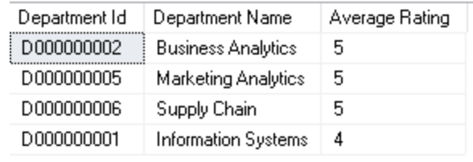

Business Transaction 5:

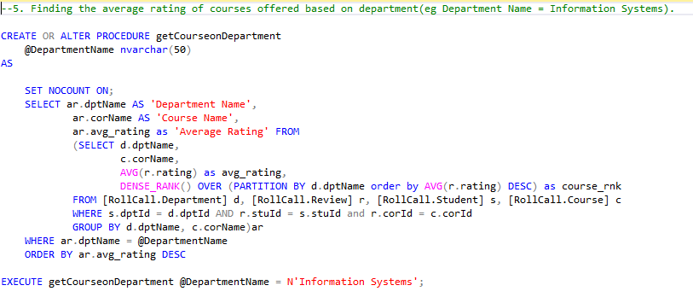

Verify if procedure is created:

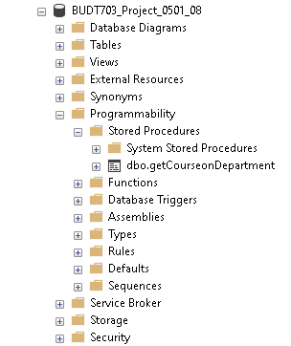

Output:

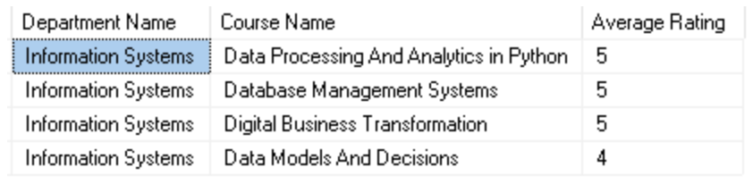

Queries:



Step8:- Lastly, disconnect from the server and close the connection.