Future Path — White Paper 2026
Future Path — Career Guidance System
White Paper — 2026

Empowering UAE Students to Navigate Their Career Future
A science-backed, culturally aligned career guidance platform for secondary school students aged 13–18, designed to convert assessment insight into actionable, nationally relevant career direction.
Publication Date
May 2026
Version
1.1
Classification
Confidential
Future Path © 2026. All rights reserved.
futurepath.ae

Table of Contents
- 1.Executive Summary
- 2.Market Opportunity
- 3.Platform Overview & Revenue Architecture
- 4.Assessment Framework
- 5.Scientific Foundation: The Two Assessment Instruments
- 6.WEF 16 Skills Framework Integration
- 7.Career Matching Methodology
- 8.UAE National Vision Alignment
- 9.Reporting & Platform Outputs
- 10.Privacy, Security & Data Governance
- 11.Conclusion & Partnership Opportunities
- 12.References
Section 1

Executive Summary

Future Path is a UAE-built, science-backed digital career guidance platform for secondary school students aged 13–18 — designed to convert assessment insight into actionable, nationally relevant career direction.
The UAE's national talent pipeline is a strategic imperative. Future Path addresses a critical gap in the secondary education ecosystem: the absence of rigorous, scalable, and culturally contextualized career guidance that connects student identity to economic opportunity.
Unlike generic career tools, Future Path was built from the ground up for the UAE context. It integrates two internationally validated assessment frameworks — Holland's RIASEC model and a Career Values Questionnaire (CVQ) grounded in Schwartz's Theory of Basic Human Values — with UAE curriculum-aligned competency assessment and national vision sector mapping.
The result is a personalized, multi-dimensional career profile that tells students not only which careers suit them, but why — linking their personality, values, academic strengths, and national ambition into a single coherent narrative.

Investment Proposition
- Addressable market: 1.2 million secondary school students across the UAE, with further expansion potential across the GCC and wider MENA region.
- Scalable SaaS architecture: three-tier access model (Free, Premium, School) with recurring institutional revenue and individual subscription income.
- Government alignment: explicitly designed to support UAE Centennial 2071 and We the UAE 2031 — making the platform a natural candidate for public sector endorsement and procurement.
- Evidence-based differentiation built on peer-reviewed assessment science, not proprietary black-box algorithms, ensuring credibility with educators, policymakers, and parents.
- Fully bilingual: the platform is available in both English and Arabic with full RTL layout support, making it accessible to the entire UAE student population regardless of language background.
- Data asset: longitudinal cohort data across Grades 8–12 creates a unique labor market intelligence asset over time.
Section 2

Market Opportunity

The UAE's vision programs — We the UAE 2031 and UAE Centennial 2071 — share a common dependency: a highly skilled, future-ready national workforce. Yet the infrastructure to guide students towards that workforce remains underdeveloped in secondary schools.
Research consistently demonstrates that early career awareness is among the strongest predictors of academic engagement, subject-choice alignment, and long-term career satisfaction. Despite this, formal career guidance in UAE schools is constrained by counsellor capacity, and the tools currently available are typically designed for Western demographic and sectoral contexts that do not reflect UAE labor market realities.

Structural Gaps Future Path Addresses
- No scalable, data-driven guidance tool aligned to the UAE curriculum and national vision sectors
- Absence of psychometrically validated assessments adapted for Arabic-language and Emirati cultural contexts
- Disconnect between student interests and UAE priority economic sectors such as AI, clean energy, and space sciences
- Limited administrative visibility into cohort-level career trends across school populations
- No structured linkage between student assessment data and UAE university or vocational pathway options
Future Path was built by practitioners with direct UAE education experience. It does not adapt a foreign product to fit the UAE; it originates from it.
Section 3

Platform Overview & Revenue Architecture

Future Path is a web-based platform accessible on any device — no app download required. Its three-tier architecture is designed to maximize reach at the free tier while driving conversion and institutional revenue at the premium and school tiers.
Feature | Free Tier | Premium Tier | School Tier
Demographic profiling | ✓ | ✓ | ✓
Interest mapping (8 domains) | ✓ | ✓ | ✓
Subject competency quiz (UAE curriculum) | ✓ | ✓ | ✓
Career recommendations (top matches) | ✓ | ✓ | ✓
Career Personality Assessment (RIASEC) | — | ✓ | ✓
Personal Values Assessment (CVQ) | — | ✓ | ✓
Personalised narrative insights | — | ✓ | ✓
PDF career report download | — | ✓ | ✓
Education pathways (UAE universities) | — | ✓ | ✓
Multi-grade progress tracking | — | — | ✓
School admin dashboard & analytics | — | — | ✓
Bulk student account management | — | — | ✓
CSV & PDF cohort data export | — | — | ✓
Arabic language interface (EN/AR) | ✓ | ✓ | ✓
Guest access is available at the Free tier, allowing students to complete a full assessment without registering. Session results are preserved and can be migrated to a registered account, eliminating friction at the top of the funnel.
The School tier creates a recurring B2B revenue stream through annual license agreements, with per-seat pricing that scales with school enrolment. The Premium tier captures individual families and students not yet reached through institutional channels.
Bilingual platform: Future Path is available in both English and Arabic, with full right-to-left (RTL) layout support. All interface elements, assessment questions, and career descriptions are translated into Arabic, enabling the platform to serve the full spectrum of UAE students and families regardless of language background — a critical differentiator for government procurement and Ministry of Education alignment.
Section 4

Assessment Framework

The Future Path assessment is a five-layer instrument. Each layer contributes a distinct, independently validated dimension of the student's profile. The layers are combined by a configurable scoring engine to generate ranked career recommendations. Premium and School tier users access two additional scientifically validated assessment instruments.
Layer 1 — Interests
8 interest domains
Technology, Creative Arts, Helping Others, Problem Solving, Physical Activities, Research, Leadership, Business & Finance.
Layer 2 — Subject Strengths
UAE Ministry of Education curriculum
Competency quizzes across Mathematics, Science, English, Arabic, Social Studies, and Computer Science — grade-differentiated (Grades 8–12).
Layer 3 — Career Personality (Premium)
RIASEC — 30 items
Maps the student's vocational personality across Holland's six types, producing a three-letter type code.
Layer 4 — Personal Values (Premium)
CVQ — 21 items
Assesses motivational values across seven domains derived from Schwartz's universal values theory.
Layer 5 — Country Aspiration
UAE Vision Alignment
Students select priority sectors aligned to UAE 2030/2071 goals, informing vision weighting in the matching engine.
Section 5

Scientific Foundation: The Two Assessment Instruments

The platform's premium assessment layer rests on two internationally validated assessment frameworks. Each was selected for its empirical rigour, cross-cultural applicability, and alignment with adolescent developmental psychology. Together, they provide a multi-dimensional view of the student that no single instrument can achieve alone.

Career Personality Assessment — RIASEC / Holland Codes
John L. Holland's Theory of Vocational Personalities and Work Environments (Holland, 1959; 1997) is the most empirically supported framework in career psychology. Holland's six vocational types — Realistic, Investigative, Artistic, Social, Enterprising, and Conventional — are embedded in the O*NET occupational database used by labor ministries worldwide and underpin instruments including the Strong Interest Inventory and the Self-Directed Search.
Future Path administers 30 original items (five per type) on a five-point Likert scale. Scores are normalized to a 0–100 scale and the student's top three types form a three-letter Holland Code that is matched against affinity profiles pre-configured for all 36 careers in the platform's catalogue.
Important distinction: Future Path uses the open, peer-reviewed RIASEC academic framework (Holland, 1997) — not the commercially licensed Strong Interest Inventory instrument (CPP Inc.). This avoids licensing constraints while preserving full scientific validity.

The Six Vocational Types
R
Realistic
Hands-on, practical, tools, outdoor work, technical systems. Values tradition and common sense.
I
Investigative
Scientific, analytical, research-driven. Values independence, curiosity, and rigorous inquiry.
A
Artistic
Creative expression, design, storytelling, aesthetics. Values originality and freedom from structure.
S
Social
Helping, teaching, counselling, community service. Values cooperation, empathy, and service to others.
E
Enterprising
Leadership, persuasion, business, entrepreneurship. Values status, influence, and risk-taking.
C
Conventional
Order, data management, systems, accounting. Values accuracy, efficiency, and stability.

Personal Values Assessment — Career Values Questionnaire (CVQ)
The CVQ is grounded in Shalom H. Schwartz's Theory of Basic Human Values (Schwartz, 1992; 2012), the most extensively validated cross-cultural framework for understanding human motivation. Research demonstrates that work values are a significant predictor of career commitment, job satisfaction, and identity development in adolescents (Hirschi, 2010).
The Future Path CVQ measures seven value domains across 21 items. Certain items are reverse-scored to reduce acquiescence bias. Domain scores directly modulate career matching, boosting recommendations aligned with the student's dominant motivational values.

The Seven Value Domains
Items are rated on a five-point scale (1 = Not Like Me to 5 = Very Much Like Me):
Achievement — Success, competence, recognition, ambition
Benevolence — Caring for others, helpfulness, loyalty
Universalism — Fairness, equality, justice, protecting the environment
Self-Direction — Independence, creativity, freedom of thought
Security — Safety, stability, social order, harmony
Power — Authority, wealth, social influence, prestige
Hedonism — Pleasure, enjoyment, self-indulgence
Domain scores are used in career matching to boost careers aligned with the student's dominant values. A student with high Benevolence and Universalism scores will see healthcare, education, and environmental science careers promoted; a student with high Achievement and Power scores will see finance, leadership, and entrepreneurship careers elevated.
Section 6

WEF 16 Skills Framework Integration

The World Economic Forum's New Vision for Education: Unlocking the Potential of Technology (WEF, 2016) and the Future of Jobs Report 2025 define 16 critical skills that will underpin 21st-century employability. Future Path maps all 36 careers in its catalogue against this framework, ensuring that career recommendations explicitly link to future-of-work relevance.
Foundational Literacies (6 skills)
Literacy · Numeracy · Scientific Literacy · ICT Literacy · Financial Literacy · Cultural & Civic Literacy
Competencies (6 skills)
Critical Thinking & Problem Solving · Creativity · Communication · Collaboration · Curiosity · Initiative
Character Qualities (4 skills)
Persistence & Grit · Adaptability · Leadership · Social & Cultural Awareness
Each career in the platform is associated with a weighted set of WEF skill affinities (576 career-skill pairings across 36 careers and 16 skills). Premium users see which WEF skills their recommended careers demand, helping students and parents understand not just what careers suit them, but what skills they will need to develop.
Section 7

Career Matching Methodology

Future Path employs a modular, configurable scoring engine. Each career in the 36-career catalogue receives a composite score based on multiple weighted dimensions. Super administrators can adjust weights per institutional priority; the default configurations are shown below.

Free Tier — Default Scoring Weights
Dimension | Weight | Visual
Subject Competency Match | 35%
Interest Match | 35%
Country Vision Alignment | 30%

Premium Tier — Default Scoring Weights
Dimension | Weight | Visual
RIASEC (Holland Code) | 35%
Subject Competency Match | 20%
Country Vision Alignment | 20%
Personal Values (CVQ) | 25%
Note on weights: In the Premium tier, the Interest Match dimension is replaced by the scientifically validated RIASEC personality assessment, which provides a richer signal. RIASEC leads at 35%, Personal Values (CVQ) at 25%, with Subject Competency and Country Vision Alignment each at 20%. All dimensions sum to 100%. The configurable architecture allows the platform superadmin to tune weights for specific institutional priorities without code changes.

Career Catalogue
The platform currently includes 36 careers spanning the UAE's key economic sectors: Technology & AI, Healthcare, Engineering, Finance, Creative Industries, Education, Environmental Sciences, Business, Legal, and more. Each career entry includes:
- Career description and UAE job market outlook
- Required subject strengths and education pathway
- Holland Code affinity scores (R, I, A, S, E, C)
- WEF skill affinities (weighted relevance across all 16 skills)
- We the UAE 2031 & UAE Centennial 2071 alignment indicators
Section 8

UAE National Vision Alignment

A defining commercial and strategic advantage of Future Path is its explicit, codified integration of UAE national strategic priorities. The platform is not generically global and regionally relabelled — it is structurally built around the UAE's economic transformation agenda.
During the assessment, students are invited to express which sectors of national importance resonate with them. These choices are mapped to the Country Vision Alignment scoring dimension and weighed accordingly in career recommendations. The platform's entire career catalogue is tagged against UAE priority development sectors:

UAE Priority Sectors (We the UAE 2031 & Centennial 2071)
Advanced Technology & AI
Space & Future Sciences
Renewable Energy & Sustainability
Healthcare & Life Sciences
Financial Services & FinTech
Education & Human Capital
Tourism & Hospitality
Advanced Manufacturing
Creative Industries & Media
Food Security & Agriculture
This ensures that student career recommendations are simultaneously personally relevant and economically strategic — directly supporting the UAE's objective of building a skilled, diversified national talent pipeline. It also makes Future Path a natural fit for Ministry of Education procurement, government innovation grants, and national workforce development partnerships.
Section 9

Reporting & Platform Outputs

Student Career Report (Premium)
Premium users receive a personalised PDF career report containing: a ranked list of career matches with match scores, a narrative explaining the student's personality and values profile, UAE university and programme recommendations (sourced from the UAE Commission for Academic Accreditation), and actionable next steps.
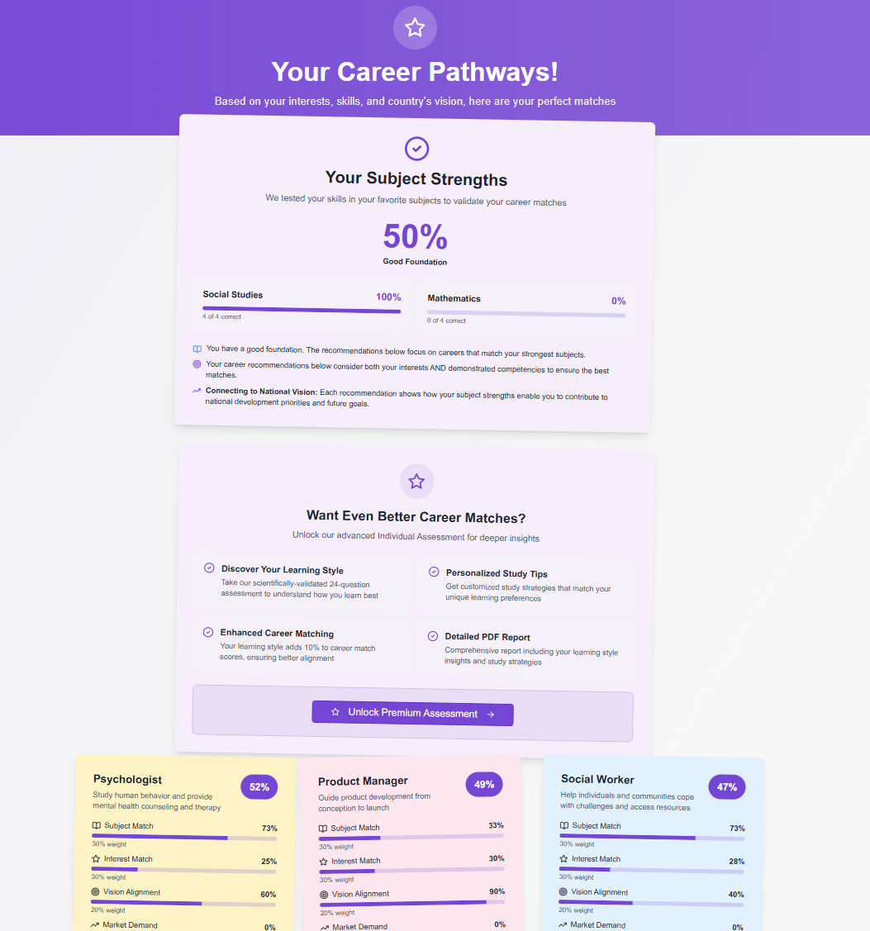
Fig. 1 — The career report page, displaying subject competency scores, ranked career matches with weighted scoring breakdowns, and the premium upgrade pathway for deeper psychometric insights.

Multi-Grade Progress Tracking (School Tier)
School-enrolled students who complete assessments across multiple academic years receive a longitudinal progress view showing how their career preferences and assessment profiles evolve between Grades 8 and 12. This data is uniquely valuable to school counsellors, school leaders, and — in aggregate — to government workforce planners seeking leading indicators of national talent flow.

School Administrator Dashboard
School organization administrators access a secure analytics dashboard providing cohort-level intelligence: top career trends by grade, skill distribution heatmaps, assessment completion rates, and bulk export of student data in CSV and PDF formats for internal reporting and audit compliance.
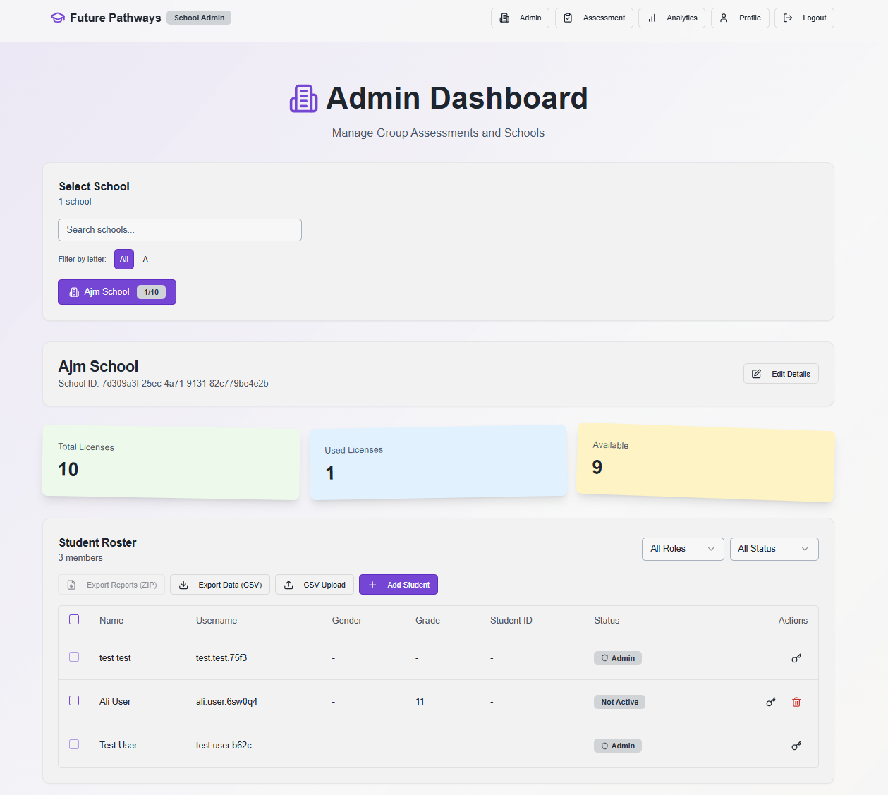
Fig. 2 — The school administrator dashboard, showing license utilisation, the student roster with role and status badges, and bulk export controls for reports and data.

Super Admin Dashboard
The Super Admin layer provides nationwide visibility across all licensed schools — total schools, administrator accounts, student enrolments, and license utilization rates. This tier also enables career catalogue management, scoring configuration, and contribution tracking, making it suitable for district-level or Ministry-level deployment at scale.
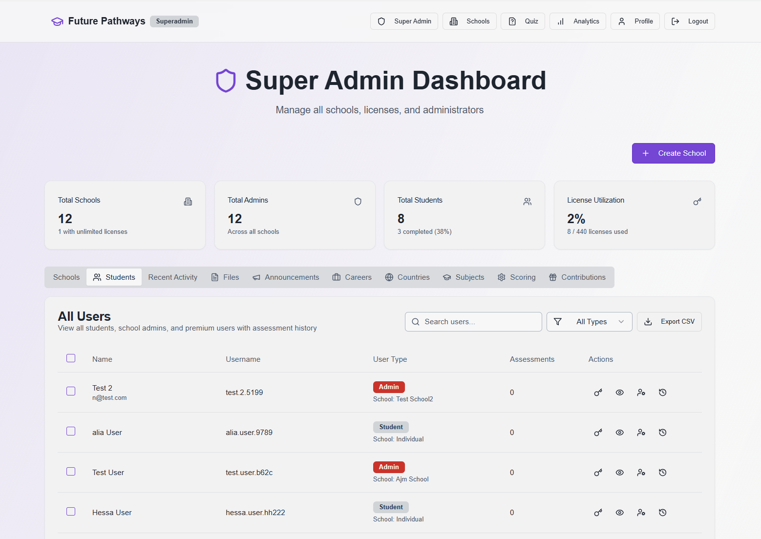
Fig. 3 — The Super Admin dashboard, providing nationwide visibility across all schools with tabs for school management, student roster, career catalogue, scoring configuration, and contribution tracking.
Section 10

Privacy, Security & Data Governance

Future Path is built with data protection as a foundational design principle, in compliance with the UAE Personal Data Protection Law (Federal Decree-Law No. 45 of 2021) and consistent with GDPR-equivalent data rights standards.
- Authentication: Multi-provider OAuth (Google, Microsoft) and email/password with secure hashing. Role-based access control for students, school administrators, and superadmins.
- Session management: PostgreSQL-backed sessions with 24-hour expiry. Cryptographically secure guest tokens for unauthenticated assessments.
- Data minimisation: Only assessment-relevant data is collected. No social media scraping or behavioural tracking beyond platform usage.
- Parental consent: Registration for users under 18 includes consent acknowledgement.
- Data rights: Students and administrators can request full data export or account deletion in compliance with GDPR-equivalent principles.
- Security infrastructure: Helmet security headers, rate limiting, CSRF protection, input sanitisation (DOMPurify), and N+1 query elimination.
- Hosting: PostgreSQL (Neon serverless) with encrypted connections and no unencrypted data at rest.
For institutional partners and government procurement teams: Future Path's privacy architecture is designed for audit readiness from day one, with documented compliance against UAE Federal Decree-Law No. 45 of 2021.
Section 11

Conclusion & Partnership Opportunities

Future Path represents a compelling convergence of market need, scientific rigour, government alignment, and commercial scalability. The UAE secondary education sector is large, underserved in career guidance infrastructure, and directly connected to a government agenda that prioritizes workforce development as a national strategic objective.
The platform is production-ready, multi-tiered, and designed to grow — from individual student subscriptions to institutional school licenses to potential government-wide deployment. Its longitudinal data model creates compounding value over time: each additional year of student assessment data deepens the platform's career intelligence asset and strengthens its differentiation.

Recommended Partnership & Implementation Pathways
- School network partnerships: Engage private school groups and multi-academy operators with the school tier for district-wide license agreements, delivering immediate B2B revenue and rapid scale student data.
- Ministry of Education alignment: Position Future Path as a national career guidance infrastructure tool, eligible for Ministry procurement and integration with UAE curriculum reform initiatives.
- University admissions partnerships: Integrate Future Path career and pathway data with UAE university admissions platforms, creating referral value and cross-institutional data flows.
- Corporate sponsorship: Engage UAE private sector employers in priority vision sectors — particularly Technology, Healthcare, and Financial Services — to sponsor student access in underserved schools.
- GCC regional expansion: Once UAE market penetration is established, the platform architecture supports localization for Saudi Arabia, Qatar, and Bahrain, each with analogous national vision alignment requirements.
Future Path is committed to continuous improvement. The platform's scoring methodology, career catalogue, and assessment instruments are reviewed annually against the latest labor market data, peer-reviewed research, and UAE policy developments.
Section 12

References

- Hirschi, A. (2010). Vocational interests and career goals: Development and relations to personality in middle adolescence. Journal of Vocational Behavior, 76(2), 289–298.
- Holland, J. L. (1959). A theory of vocational choice. Journal of Counseling Psychology, 6(1), 35–45.
- Holland, J. L. (1997). Making vocational choices: A theory of vocational personalities and work environments (3rd ed.). Psychological Assessment Resources.
- Schwartz, S. H. (1992). Universals in the content and structure of values: Theory and empirical tests in 20 countries. Advances in Experimental Social Psychology, 25, 1–65.
- Schwartz, S. H. (2012). An overview of the Schwartz theory of basic values. Online Readings in Psychology and Culture, 2(1).
- UAE Federal Government. (2021). UAE Centennial 2071. https://u.ae/en/about-the-uae/strategies-initiatives-and-awards/federal-governments-strategies-and-plans/uae-centennial-2071
- World Economic Forum. (2016). New Vision for Education: Unlocking the Potential of Technology. WEF.
- World Economic Forum. (2025). Future of Jobs Report 2025. WEF.
Future Path Career Guidance System — White Paper 2026 Confidential · futurepath.ae
Save / Print as PDF

