Future Pathways — White Paper 2026
Future Pathways — Career Guidance System
White Paper — 2026

Empowering UAE Students to Navigate Their Career Future
A science-backed, culturally aligned career guidance platform for secondary school students aged 13–18, designed in support of the UAE's 2030 and 2071 national visions.
Publication Date
May 2026
Version
1.1
Target Audience
Educators, School Leaders, Policy Makers
Classification
Public
Future Pathways © 2026. All rights reserved.
futurepathways.ae

Table of Contents
- 1.Executive Summary
- 2.The Career Guidance Challenge in UAE Schools
- 3.Platform Overview & Tiered Access Model
- 4.Assessment Framework
- 5.The Career Personality Assessment (RIASEC / Holland Codes)
- 6.The Personal Values Assessment (CVQ)
- 7.The WEF 16 Skills Framework Integration
- 8.Career Matching Methodology
- 9.UAE Vision Alignment
- 10.Reporting & Outputs
- 11.Privacy, Security & Data Governance
- 12.Conclusion & Recommendations
- 13.References
Section 1

Executive Summary

Future Pathways is a digital career guidance system purpose-built for secondary school students in the United Arab Emirates. The platform bridges the gap between a student's emerging identity — their interests, values, and academic strengths — and the rapidly changing landscape of careers, nationally and globally.
Unlike generic career quizzes, Future Pathways integrates two internationally validated psychometric instruments into a single, engaging experience: Holland's RIASEC model for career personality, and a Career Values Questionnaire (CVQ) grounded in Schwartz's Theory of Basic Human Values. These instruments are supplemented by a UAE curriculum-aligned subject competency quiz and an interest mapping survey.
The result is a personalised career profile and ranked career recommendations that account for who the student is, how they learn, what they value, what the UAE economy needs, and what the future of work demands — all presented in a student-friendly, visually engaging format.
Key proposition: Future Pathways gives every UAE student — whether using the free tier independently or the premium/school tier through their institution — a rigorous, evidence-based starting point for career exploration that is culturally relevant, fully bilingual (Arabic and English), and future-focused.
Section 2

The Career Guidance Challenge in UAE Schools

The UAE's ambitious national vision programmes — UAE Centennial 2071 and We the UAE 2031 — all depend on a skilled, future-ready national workforce. Yet many secondary school students lack structured, evidence-based guidance to help them translate their interests and strengths into informed career decisions.
Research consistently shows that early career awareness is one of the strongest predictors of academic engagement, subject choice, and ultimate career satisfaction. Despite this, formal career counselling resources in schools are often limited in capacity, and the tools that do exist are typically designed for Western contexts and do not reflect the UAE's unique sectoral priorities, cultural context, or emerging labour market.

Key challenges addressed
- Lack of scalable, data-driven career guidance tools aligned to the UAE curriculum
- Absence of psychometrically validated assessments adapted for adolescent students aged 13–18
- Disconnection between student interests and UAE national priority sectors
- Limited visibility for school administrators into cohort-level career trends
- No structured linkage between assessment data and UAE university/pathway options
Future Pathways is designed as a direct response to these gaps. It is built by practitioners with direct experience in UAE education, grounded in peer-reviewed science, and tailored to the economic and cultural context of the Emirates.
Section 3

Platform Overview & Tiered Access Model

Future Pathways is a web-based platform accessible on any device. It offers three tiers of access, ensuring that students at every level — from those exploring independently at home to those whose school has subscribed — can benefit from career guidance.
Feature | Free Tier | Premium Tier | School Tier
Demographic profiling | ✓ | ✓ | ✓
Interest mapping (8 domains) | ✓ | ✓ | ✓
Subject competency quiz (UAE curriculum) | ✓ | ✓ | ✓
Career recommendations (top matches) | ✓ | ✓ | ✓
Career Personality Assessment (RIASEC) | — | ✓ | ✓
Personal Values Assessment (CVQ) | — | ✓ | ✓
Personalised narrative insights | — | ✓ | ✓
PDF career report download | — | ✓ | ✓
Education pathways (UAE universities) | — | ✓ | ✓
Multi-grade progress tracking | — | — | ✓
School admin dashboard & analytics | — | — | ✓
Bulk student account management | — | — | ✓
CSV & PDF cohort data export | — | — | ✓
Arabic language interface (EN/AR) | ✓ | ✓ | ✓
Guest access is available for the free tier, allowing students to complete an assessment without registering. Results are preserved in the session and can be migrated to a registered account at any point, ensuring no student loses their progress.
Bilingual platform: Future Pathways is available in both English and Arabic. Students can switch languages at any time via a toggle in the navigation header. All interface elements, assessment questions, and career descriptions are fully translated, with right-to-left (RTL) layout applied automatically when Arabic is selected. This makes the platform equally accessible to Arabic-speaking students and families across the UAE.
Section 4

Assessment Framework

The Future Pathways assessment is a five-layer instrument. Each layer contributes a distinct dimension of the student's profile, and the results are combined by the career matching engine to generate ranked career recommendations. The premium and school tiers include two additional scientifically validated instruments — described fully in Sections 5 and 6.
Layer 1 — Interests
8 interest domains
Technology, Creative Arts, Helping Others, Problem Solving, Physical Activities, Research, Leadership, Business & Finance.
Layer 2 — Subject Strengths
UAE Ministry of Education curriculum
Competency quizzes across Mathematics, Science, English, Arabic, Social Studies, and Computer Science — grade-differentiated (Grades 8–12).
Layer 3 — Career Personality (Premium)
RIASEC — 30 items
Maps the student's vocational personality across Holland's six types, producing a three-letter type code.
Layer 4 — Personal Values (Premium)
CVQ — 21 items
Assesses motivational values across seven domains derived from Schwartz's universal values theory.
Layer 5 — Country Aspiration
UAE Vision Alignment
Students select priority sectors aligned to UAE 2030/2071 goals, informing vision weighting in the matching engine.
Section 5

The Career Personality Assessment (RIASEC / Holland Codes)

Theoretical Basis
John L. Holland's Theory of Vocational Personalities and Work Environments (Holland, 1959; 1997) is the most empirically supported framework in career psychology. Holland proposed that both people and work environments can be described using six vocational personality types, commonly arranged in a hexagonal model (the RIASEC hexagon). Career satisfaction and success are strongly predicted by the congruence between a person's type and their occupational environment.
The RIASEC framework underpins numerous well-known instruments (including the Strong Interest Inventory and the Self-Directed Search), and the six types are embedded in the O*NET occupational database used by labour ministries worldwide.

The Six Vocational Types
R
Realistic
Hands-on, practical, tools, outdoor work, technical systems. Values tradition and common sense.
I
Investigative
Scientific, analytical, research-driven. Values independence, curiosity, and rigorous inquiry.
A
Artistic
Creative expression, design, storytelling, aesthetics. Values originality and freedom from structure.
S
Social
Helping, teaching, counselling, community service. Values cooperation, empathy, and service to others.
E
Enterprising
Leadership, persuasion, business, entrepreneurship. Values status, influence, and risk-taking.
C
Conventional
Order, data management, systems, accounting. Values accuracy, efficiency, and stability.

Implementation in Future Pathways
The platform administers 30 original items (5 per type) using a five-point Likert scale. Each type score is normalised to a 0–100 scale. The student's top three types are combined to form a three-letter Holland Code (e.g., "ISA", "ECR") which is matched against the Holland Code affinity scores pre-configured for each of the 36 careers in the platform's catalogue.
Important distinction: Future Pathways uses the academic RIASEC framework (Holland, 1997) — the open, peer-reviewed theory that underpins the career psychology field. This is distinct from the commercially licensed Strong Interest Inventory instrument (CPP Inc.), which builds upon the same underlying theory.
Section 6

The Personal Values Assessment (CVQ)

Theoretical Basis
The Career Values Questionnaire (CVQ) used in Future Pathways is grounded in Shalom H. Schwartz's Theory of Basic Human Values (Schwartz, 1992; 2012), the most widely validated cross-cultural framework for understanding human motivation. Schwartz identified ten universal value types that are hierarchically organised and circumplex in structure — meaning adjacent values are compatible and opposing values are in motivational conflict.
Research consistently demonstrates that work values are a significant predictor of career commitment, job satisfaction, and identity development in adolescents (Hirschi, 2010), making values assessment a powerful complement to interest and personality instruments for a student population.

The Seven Value Domains
The Future Pathways CVQ measures seven value domains across 21 items (3 per domain), rated on a five-point scale (1 = Not Like Me to 5 = Very Much Like Me). Certain items are reverse-scored to reduce acquiescence bias.
Achievement — Success, competence, recognition, ambition
Benevolence — Caring for others, helpfulness, loyalty
Universalism — Fairness, equality, justice, protecting the environment
Self-Direction — Independence, creativity, freedom of thought
Security — Safety, stability, social order, harmony
Power — Authority, wealth, social influence, prestige
Hedonism — Pleasure, enjoyment, self-indulgence
The domain scores are used in career matching to boost careers that align with the student's dominant values. For example, a student with high Benevolence and Universalism scores will see healthcare, education, and environmental science careers promoted in their results.
Section 7

The WEF 16 Skills Framework Integration

The World Economic Forum's New Vision for Education: Unlocking the Potential of Technology (WEF, 2016) and the Future of Jobs Report 2025 define 16 critical skills that will underpin 21st-century employability. Future Pathways maps all 36 careers in its catalogue against this framework, ensuring that career recommendations explicitly link to future-of-work relevance.
Foundational Literacies (6 skills)
Literacy · Numeracy · Scientific Literacy · ICT Literacy · Financial Literacy · Cultural & Civic Literacy
Competencies (6 skills)
Critical Thinking & Problem Solving · Creativity · Communication · Collaboration · Curiosity · Initiative
Character Qualities (4 skills)
Persistence & Grit · Adaptability · Leadership · Social & Cultural Awareness
Each career in the platform is associated with a weighted set of WEF skill affinities (576 career-skill pairings across 36 careers and 16 skills). Premium users see which WEF skills their recommended careers demand, helping students and parents understand not just what careers suit them, but what skills they will need to develop.
Section 8

Career Matching Methodology

Future Pathways uses a modular, configurable scoring engine. Each career in the catalogue receives a composite score based on multiple weighted dimensions. Superadministrators can adjust the weights for each assessment tier; the default configuration is shown below.

Free Tier — Default Scoring Weights
Dimension | Weight | Visual
Subject Competency Match | 35%
Interest Match | 35%
Country Vision Alignment | 30%

Premium Tier — Default Scoring Weights
Dimension | Weight | Visual
RIASEC (Holland Code) | 35%
Subject Competency Match | 20%
Country Vision Alignment | 20%
Personal Values (CVQ) | 25%
Note on weights: In the Premium tier, the Interest Match dimension is replaced by the scientifically validated RIASEC personality assessment, which provides a richer signal. RIASEC leads at 35%, Personal Values (CVQ) at 25%, with Subject Competency and Country Vision Alignment each at 20%. All dimensions sum to 100%. The configurable architecture allows the platform superadmin to tune weights for specific institutional priorities without code changes.

Career Catalogue
The platform currently includes 36 careers spanning the UAE's key economic sectors: Technology & AI, Healthcare, Engineering, Finance, Creative Industries, Education, Environmental Sciences, Business, Legal, and more. Each career entry includes:
- Career description and UAE job market outlook
- Required subject strengths and education pathway
- Holland Code affinity scores (R, I, A, S, E, C)
- WEF skill affinities (weighted relevance across 16 skills)
- UAE Vision 2030/2071 alignment indicators
Section 9

UAE Vision Alignment

A distinguishing feature of Future Pathways is its explicit integration of UAE national strategic priorities. During the assessment, students are invited to express which sectors of national importance resonate with them. These choices are mapped to the platform's Country Vision Alignment scoring dimension.
The platform's career catalogue is tagged against the UAE's priority development sectors, which include:

UAE Priority Sectors (2030 & 2071 Vision)
Advanced Technology & AI
Space & Future Sciences
Renewable Energy & Sustainability
Healthcare & Life Sciences
Financial Services & FinTech
Education & Human Capital
Tourism & Hospitality
Advanced Manufacturing
Creative Industries & Media
Food Security & Agriculture
This ensures that career recommendations are not only personally relevant to the student but also economically relevant to the country — supporting the UAE's strategic objective of developing a skilled, diversified national talent pipeline.
Section 10

Reporting & Outputs

Student Career Report (Premium)
Premium users receive a personalised PDF career report containing: a ranked list of career matches with match scores, a narrative explaining the student's personality and values profile, UAE university and programme recommendations (sourced from the UAE Commission for Academic Accreditation), and actionable next steps.
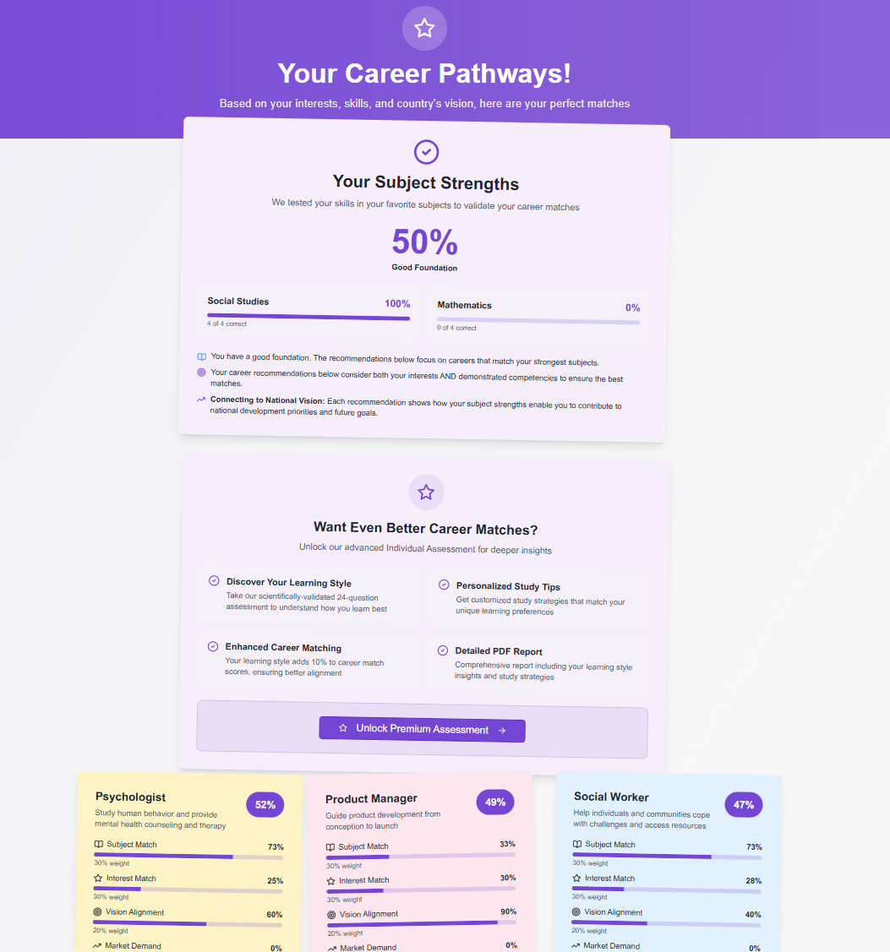
Fig. 1 — The career report page, displaying subject competency scores, ranked career matches with weighted scoring breakdowns, and the premium upgrade pathway for deeper psychometric insights.

Multi-Grade Progress Tracking (School Tier)
For school-enrolled students who complete assessments across multiple academic years, the platform generates a progress view showing how career preferences and psychometric profiles evolve between Grades 8 and 12. This longitudinal view is valuable for school counsellors monitoring student development.
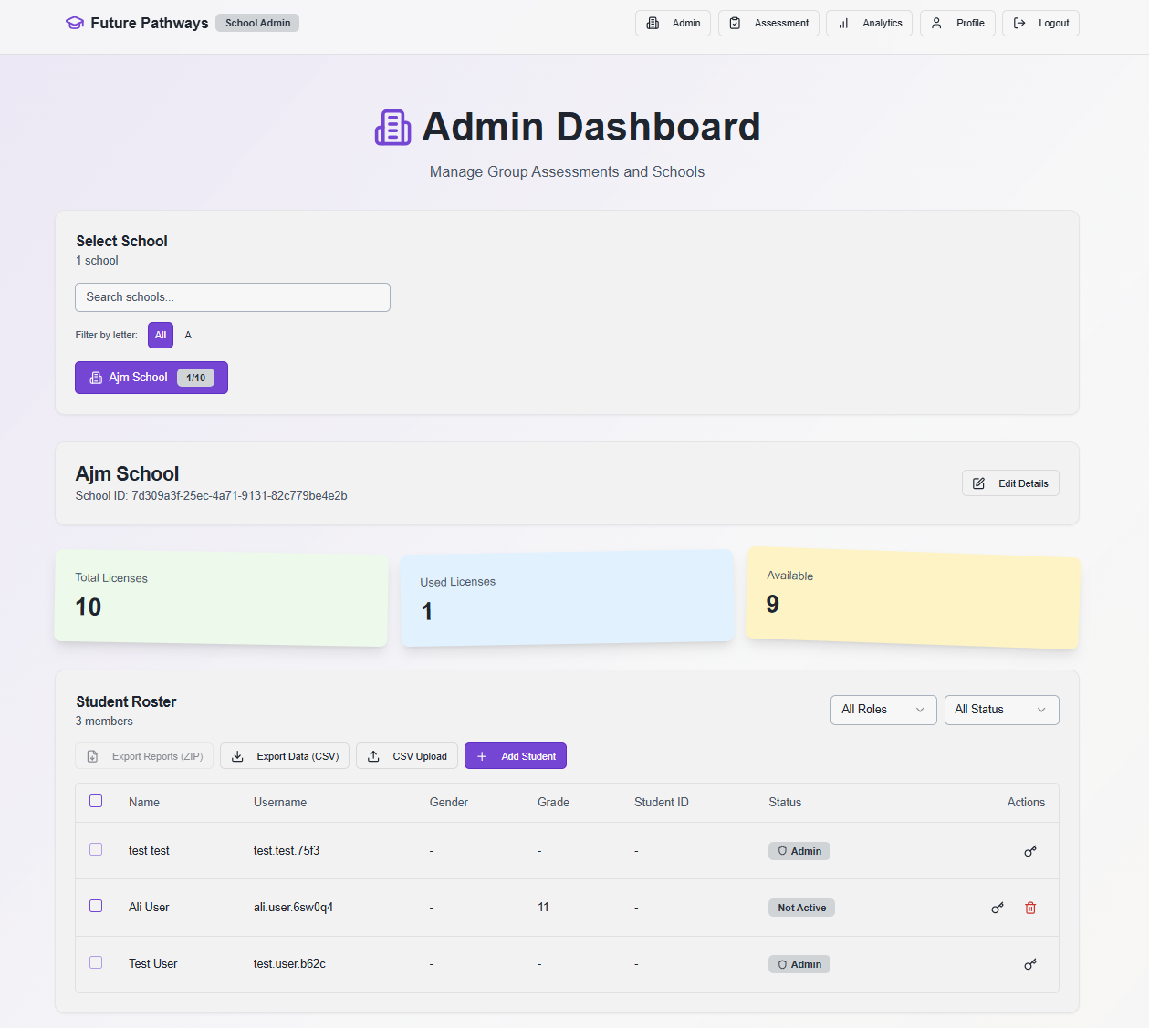
Fig. 2 — The school administrator dashboard, showing license utilisation (10 total / 1 used / 9 available), the student roster with role and status badges, and bulk export controls for reports and data.

School Admin Dashboard
Organisation administrators have access to a secure dashboard providing cohort-level analytics: top career trends by grade, skill distribution heatmaps, assessment completion rates, and the ability to export student data in CSV and PDF formats for reporting and audit purposes.
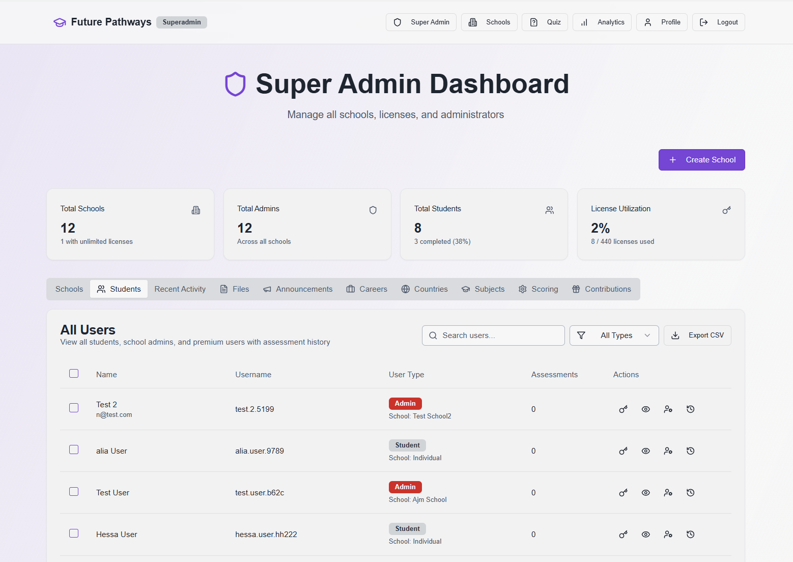
Fig. 3 — The Super Admin dashboard, providing nationwide visibility across all 12 schools, 440 licences, and 8 students, with tabs for school management, student roster, announcements, career catalogue, scoring configuration, and contribution tracking.
Section 11

Privacy, Security & Data Governance

Future Pathways is built with data protection as a foundational design principle, in compliance with applicable data protection frameworks including the UAE Personal Data Protection Law (Federal Decree-Law No. 45 of 2021).
- Authentication: Multi-provider OAuth (Google, Microsoft) and email/password with secure hashing. Role-based access control for students, school administrators, and superadmins.
- Session management: PostgreSQL-backed sessions with 24-hour expiry. Cryptographically secure guest tokens for unauthenticated assessments.
- Data minimisation: Only assessment-relevant data is collected. No social media scraping or behavioural tracking beyond platform usage.
- Parental consent: Registration for users under 18 includes consent acknowledgement.
- Data rights: Students and administrators can request full data export or account deletion in compliance with GDPR-equivalent principles.
- Security infrastructure: Helmet security headers, rate limiting, CSRF protection, input sanitisation (DOMPurify), and N+1 query elimination.
- Hosting: PostgreSQL (Neon serverless) with encrypted connections.
Section 12

Conclusion & Recommendations

Future Pathways represents a significant step forward in evidence-based, culturally aligned career guidance for UAE secondary school students. By combining three internationally validated psychometric instruments with UAE curriculum data, national vision priorities, and WEF future-skills intelligence, the platform delivers a career guidance experience that is simultaneously rigorous and accessible.
The following recommendations are offered to schools and education authorities considering adoption:
- Integrate at Grade 9: Early assessment enables time for reflection, subject selection adjustment, and iterative re-assessment. Grade 9 is the optimal entry point before UAE curriculum tracking decisions are made.
- Repeat annually: Career identity is not fixed in adolescence. Annual re-assessment and the multi-grade progress view give counsellors longitudinal insight into student development.
- Pair with counsellor review: The platform's reports are designed to initiate, not replace, meaningful one-on-one counselling conversations.
- Use cohort analytics: School administrators should use the aggregate dashboard to identify career clusters within their student population and align extracurricular and enrichment programming accordingly.
- Communicate with parents: The PDF report is designed to be shared with parents, making career conversations at home more structured and informed.
Future Pathways is committed to continuous improvement. The platform's scoring methodology, career catalogue, and assessment instruments are reviewed annually against the latest labour market data, psychometric research, and UAE policy developments.
Section 13

References

- Hirschi, A. (2010). Vocational interests and career goals: Development and relations to personality in middle adolescence. Journal of Vocational Behavior, 76(2), 289–298.
- Holland, J. L. (1959). A theory of vocational choice. Journal of Counseling Psychology, 6(1), 35–45.
- Holland, J. L. (1997). Making vocational choices: A theory of vocational personalities and work environments (3rd ed.). Psychological Assessment Resources.
- Schwartz, S. H. (1992). Universals in the content and structure of values: Theory and empirical tests in 20 countries. Advances in Experimental Social Psychology, 25, 1–65.
- Schwartz, S. H. (2012). An overview of the Schwartz theory of basic values. Online Readings in Psychology and Culture, 2(1).
- UAE Federal Government. (2021). UAE Centennial 2071. https://u.ae/en/about-the-uae/strategies-initiatives-and-awards/federal-governments-strategies-and-plans/uae-centennial-2071
- World Economic Forum. (2016). New Vision for Education: Unlocking the Potential of Technology. WEF.
- World Economic Forum. (2025). Future of Jobs Report 2025. WEF.
Future Pathways Career Guidance System — White Paper 2026 Confidential · futurepathways.ae
Save / Print as PDF

