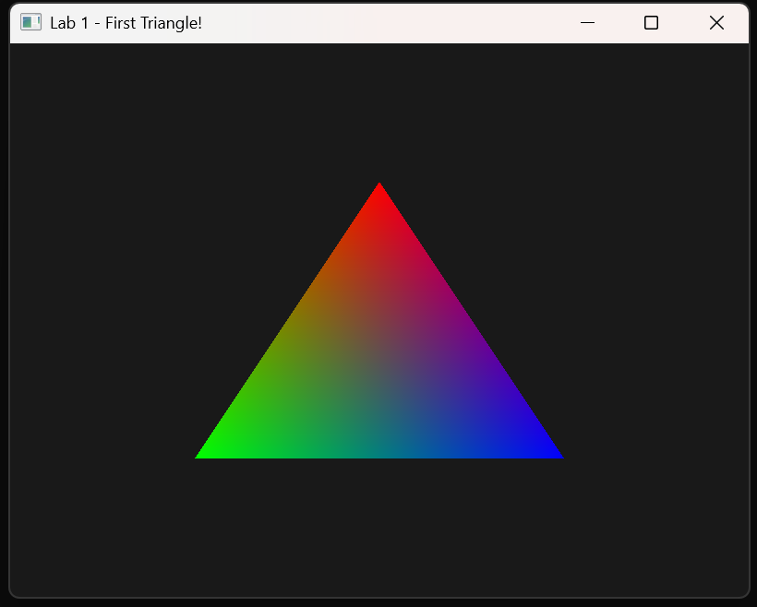
2.1
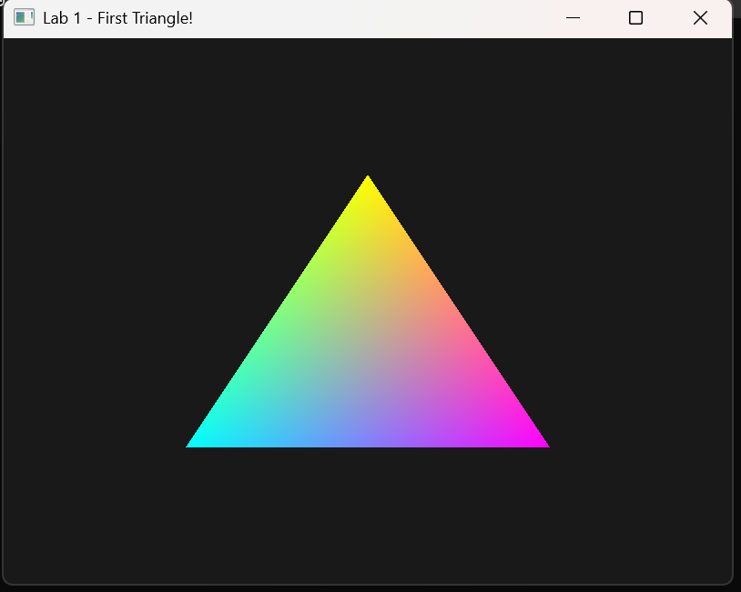
2.2
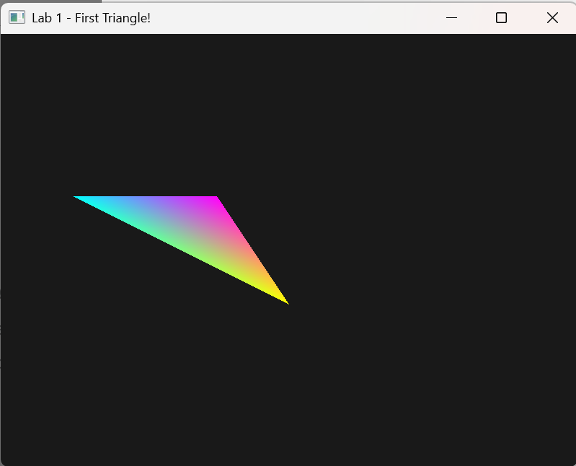

2.3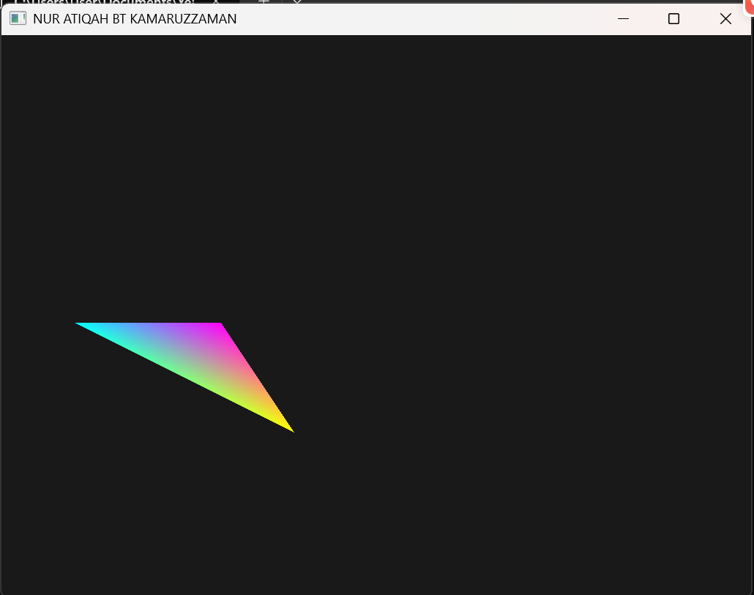
No, the triangle does not change its size when the window is resized because its vertices are defined in normalized device coordinates
2.4
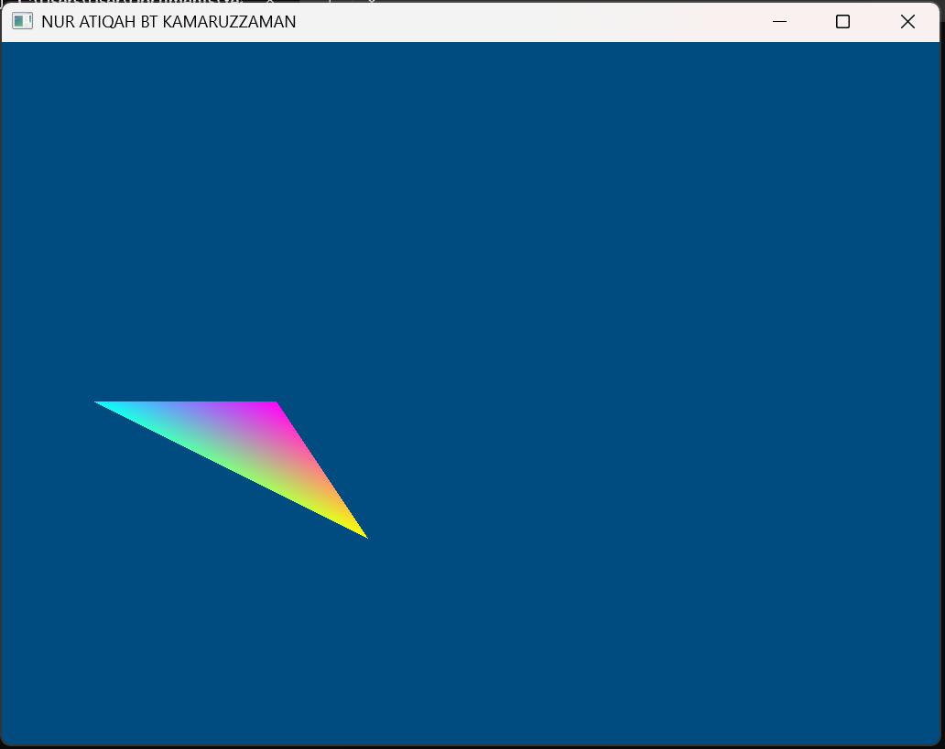
When the alpha value is changed to 0.0f, the background does not become transparent. It remains the same color because alpha blending/transparency is not enabled
