**The National Institute of Engineering**

# [Autonomous Institute, Affiliated to VTU Belgaum]

# Manandavadi Road Mysuru – 570008

# AICTE ACTIVITY POINTS PROJECT REPORT

on

## Helping Local School to achieve Quality Education

## 

## Submitted By

Ravi N (4NI19EE082)

Under The Guidance of

**Ms. Ashwini G**

# Assistant Professor

# Department of Electrical & Electronics Engineering

# The National Institute of Engineering [Autonomous Institute, Affiliated to VTU]

# Manandavadi Road Mysuru – 570008

**The National Institute of Engineering, Mysuru – 08**

**(An Autonomous Institution affiliated under**

**VisvesvarayaTechnological University, Belagavi)**

**Department of Electrical & Electronics Engineering**

# CERTIFICATE

This is to certify that the activity entitled “**Helping Local School to achieve Quality Education**” is a bonafide work carried out by **Ravi N** bearing **USN: 4NI19EE082**, student of **The National Institute of Engineering** in partial fulfillment for the award of **Bachelor of Engineering in Electrical & Electronics Engineering** of the Visvesvaraya Technological University, Belagavi during the year 2022-23. It is certified that all theory/practical/corrections/suggestions indicated for Activity Points have been executed under the directions of **Ms.Ashwini G**. The activity report has been approved as it satisfies the academic requirements in respect of AICTE Activity Points prescribed for the said degree.

**Ms. Ashwini G Dr. Pradeepa H**

Assistant professor Head of the Department

Dept. of Electrical & Electronics Engineering Dept. of Electrical & Electronics Engineering

The National Institute of Engineering, The National Institute of Engineering, Mysuru-570008 Mysuru-570008

**Dr. Rohini Nagapadma**

Principal

The National Institute of Engineering

Mysuru - 570 008

# DECLARATION

We, The students mentioned below activity group of 8th semester B.E. Department of Electrical & Electronics Engineering, The National Institute of Engineering, Mysuru declare that the AICTE Activity Point Programme work entitled **“Helping Local School to achieve Quality Education”** has been duly executed by us under the guidance of **Ms. Ashwini G**, Assistant Professor, Department of Electrical & Electronics Engineering, The National Institute of Engineering, Mysuru. The project report on the same is submitted in partial fulfilment for the award of Bachelor of Engineering in Electrical & Electronics Engineering by Visvesvaraya Technological University during the year 2022-23.

**Date:**

**Place:Mysuru**

**Name of The Student: Ravi N**

**Signature of Student**

## ACKNOWLEDGEMENT

The satisfaction that accompanies the successful completion of the project which would be complete only with the mention of the almighty God and the people who made it possible.

We are grateful to **The National Institute of Engineering Mysuru** for providing us an opportunity to enhance our knowledge through the project.

We express our sincere thanks to **DR. ROHINI NAGAPADMA** Principal, The

National Institute of Engineering for providing us an opportunity and means to present the project.

We are thankful for the headmaster and all teaching and non-teaching staff and students of **Ashoka Puram Government School, Mysore** for giving us this opportunity.

Finally, we would like to thank our family members and friends for standing with us through all times.

Ravi N (4NI19EE082)

**PROJECT DETAILS**

|  |  |
| --- | --- |
| Activity Name | Helping local schools to achieve quality education |
| Project Category as per AICTE | Helping local school achieve good result and enhance their enrolment in higher education |
| Total Activity points earned by this project | 20 points |

## PROJECT PLAN

|  |  |
| --- | --- |
| Phase 1 | Survey on activity requirements, documentation on the survey, approaching the concerned authorities, seeking the permission and approval from the department and the institute |
| Phase 2 | Practical implementation of the project, documentation of progress and reporting the activity. |

**CONTENT**

1.ABSTACT

2.VISION AND MISSION OF THE PROJECT

3.BRIEF INFORMATION OF THE ACTIVITY

4.PROBLEM STATEMENT

5.WHY PRACTICAL EDUCATION IS IMPORTANT

6.BASIC COMPUTER CONCEPT

7.BENEFITES OF STUDY OF CURRENT AFFAIRS

8. APART FROM COURSES UNDER SCIENCE, COMMERCE AND ARTS, THERE IS

ALSO A LIST OF PROFESSIONAL COURSES TO PURSUE AFTER 12TH

9.PHOTOGRAPHS

10.IMPLEMENTATION

11.CONCLUSION

12.PROOF LETTER

# ABSTRACT

The AICTE Activity Points Programme has the focus on applying engineering skills to solve the societal problems existing in India. The project **“Helping Local School to achieve Quality Education”** throws light on possible opportunity for an engineering solution in providing an effective solution for helping local schools to achieve good result and enhance technical education.

# Vision and Mission of the Project

The project aims in building awareness in students of rural schools by interacting with them. The primary concern with this project is that rural school students are not getting enough information and exposure to modern scientific developments, we bridged that gap and created a basic awareness among the students of various classes.

## BRIEF INFORMATION OF THE ACTIVITY

“Engineering is about using science to find creative practical solution” With such an amusing thought this was a massive undertaking by AICTE, assigned to engineering students across Various streams. In order to inculcate the interest about “Science and Technology” in the young minds, we have taken an initiative of “Introducing them to the World of Computer Science and Technology” through this activity. With the authorization of BEO, a group of engineering students were sent to different Government schools in the district to enlighten the young generation about the computer and its application. Thereby helping them in enhancing their enrollment in higher and technical education. Our team was sent to “**Ashoka Puram Government School, Mysore**”.It was a challenge to teach the primary school kids aboutcomputer science and Technology, but within a few days we acclimated to the school environment and students. The children were extremely enthusiastic and showed their thirst for knowledge. We began our journey with the fundamentals of computers, its components, applications, itspros and cons which helped us to recollect our memory. Further we taught them about the shortcut keys of the computer, application software such as MS Paint, MS Word, MS Excel,MS PowerPoint and MS Notepad. We tried to introduce them to the world of the internet. The kids showed great eagerness to learn the new things.

## PROBLEM STATEMENT

Primary education being important for every student, it is not only necessary to learn the theory instead it is also necessary for him/her to learn the practical application of whatever he/she learns. It is also necessary to stay updated, that is, he/she must know about the current affairs to help in raising awareness level and develop themselves an opinion or perspective on worldly affairs. Communication skills are also important for better understanding of people and situations. The problems considered in this project are: Lack of practical education Lack of guidance to improve the communication skills Lack of knowledge regarding current affairs and higher education Quality of Education can be improved to some extent by improving the above three factors within students.

## WHY PRACTICAL EDUCATION IS IMPORTANT

Everyone learns differently, and learning styles can vary from person to person, from visual, to aural, verbal, physical or logical learning styles. But there’s one type of learning that benefits most students, and that’s practical learning. When studying, it’s important to get a hands-on understanding of your subject and how the theory you learn applies to real-life situations. Practical learning allows you to learn quick adaptations needed for daily challenges and scenarios and allows you to get a better understanding of your course topic. Practical learning, as mentioned above, has the unique ability to help students apply their skills in a non-classroom environment. While it’s important to learn the theory of a topic or subject, getting out and applying the theory to a practical situation enables you to build upon existing skills such as problem-solving There are some things that need to be experienced to be understood, and this is true for most subjects. Interactive education in the form of practical learning can strengthen your understanding and comprehension on a subject. While theoretical education utilised textbooks and research papers, practical learning allows you to learn things first hand. This learning is a fundamental part of education and works incredibly well to improve a student’s learning level and understanding. Taking a hands-on approach to learning often results in more ingrained knowledge, with the ability to retain information quickly and for longer periods of time. The reason being that when learning in a theoretical, text-based style, our brains attempt to remember words. However, when learning in a practical environment, we’re remembering actions and scenarios which our brains find easier to retain.

## BASIC COMPUTER CONCEPTS

Computer is an electronic device that stores, retrieves and processes data and can be programmed with instructions. A computer is composed of hardware and software and can exist in a variety of sizes and configurations.

**Hardware and Software:**

The term hardware refers to the physical components of your computer such as the system unit, mouse, keyboard, monitor etc. The software is the instructions that makes the computer work. Software is held either on your computers' hard disk, CD-ROM, DVD or on a diskette (floppy disk) and is loaded (ie, copied) from the disk into the computers RAM (Random Access Memory), as and when required.  **Input Devices of Computer:**

Input devices allow the users to send signals to the computer to perform a certain task. The receiver at this end is the Central Processing Unit (CPU) which then sends the signal to the output devices. Input devices further classify according to modality like visual or audio, discrete or continuous, and is it direct or indirect. Some of the classifications are-

### 1.Keyboard

The most basic input device to enter data on the system or any other device with the help of the keys is a keyboard. They establish a connection with the computer either by wi-fi or by a USB system. There are keys for everything numbers, letters, characters, and functions .

#### 2. Mouse

A hand-supported input device that allows iners to move the cursor on the It works on a flat surface with a wheel between the left and right tions apps touchpad as does the function of a mouse.

#### 3. Joystick

Joystick is a pointing device to move the cursor on the monitor screen bit not the same as a mouse. It has a spherical ball stick-type structure. It can move in all directions and is a computer aid design mainly for gaming purposes.

#### 4. Scanner

A scanner works like a photocopy machine in an input device us make information available on ape from paper. This is mainly to manipulate the information by converting an image digital form and then printing.

#### 5. Microphone

It is an inbuilt voice input device to take in the sound signals and then convert them into digital form. It is a very common device present multimedia presentation and music related applications.

**Output Devices of Computer:**

The output devicestake care of displaying the result after data processing by the input device. It may be in image, graphic, textual or audio form. These devices show the visual elements on the display. The information on the screen is soft copy and some of the important output devicesare

### 1.Monitors

The visual display units are the most important output device responsible for showing the visual made of pixels to the user. The pixels decide the image sharpness.

#### 2. Printers

The primary feature is to print information on paper. Etc

**Benefits of Study of Current Affairs**

The significance of current affairs is undoubtedly different for different people who fall in different age brackets, pursue different objectives and have different interests. However, it can be stated that all social beings are bound to be affected by Current Affairs in more ways than one. Hence, it is advisable that people sit up and take note of this rapidly growing area of study. Current affairs for students For students and aspirants who wish to crack important examinations, current affairs is essential because questions related to currents affairs are compulsorily asked in every competitive exam, whether it is an examination of IAS, bank PO/clerks, PSUs, SSCs or entrance examinations like LLB, MBA, etc. Current affairs for business and service people The people who are involved in services and business, the knowledge of current affairs will further enhance their job prospects. People who work in share market require latest updates of economic events. Knowing market conditions, inflation percentage or bank lending rates will not only help business honchos but also homemakers who can run a home better if she is equipped with the right information. Current Affairs enables an individual to increase his knowledge of the incidents in his immediate environment and the knowledge can be put to numerous usages any place any time.

**Apart from courses under Science, Commerce and Arts, there is also a list of professional courses to pursue after 12th:**

CA- Chartered Accountancy

CS- Company Secretary

Bachelor of Design in Accessory Design, fashion Design, Ceramic Design, Leather

Design, Graphic Design, Industrial Design, Jewellery Design

Bachelor in Foreign Language

Diploma Courses

Advanced Diploma Courses

Certificate Courses

### Engineering

Joint Entrance Examination (JEE) Main

Purpose - For Admission in B. E./B. Tech., B. Arch., B. Planning

Eligibility - Class 12 pass (PCM)

Application mode - Online

### JEE Advanced

Purpose- Admission in UG programmes in IITs

Eligibility - Class 12 Pass (PCM)

Application mode –Online

### BITSAT

Purpose - Admission in Integrated First Degree programmes in BITS Pilani, Goa &

Hyderabad campuses. Eligibility - Class 12 pass (PCM)

Application mode – Online

### Medical

National Eligibility Cum Entrance Test (NEET)

Purpose-Admission to MBBS / BDS

Eligibility-Class 12 (PCB)

Application mode – Online

### Marine, Navy, Defence

Indian Maritime University Common Entrance Test

Purpose - Admission in Diploma in Nautical Science (DNS) leading to BSc. (Nautical Science)

Eligibility - Class 12 (PCM)

Application mode - Online

### Indian Navy B.Tech Entry Scheme

Purpose - Admission in Indian Navy B.Tech course

Eligibility - Class 12 passed

Application mode – Online

### Indian Navy Sailors Recruitment

Purpose - Admission in 24 weeks Basic training at INS Chilka followed by Professional training

Eligibility - Class 12 (Maths and Physics/Chem./Bio/Computer Sc.) Application mode - Online, By Post

### Defence Indian Army Technical Entry Scheme (TES)

Purpose-Technical Entry to Army

Eligibility-Class 12 PCM

Apply-Online

### Fashion & Design

National Institute of Fashion Technology (NIFT) Entrance Test

Purpose-For Admission in Design, Management and Technology for the international fashion business Eligibility- Class 12, 12+, Graduate

Application mode -Online, By Post

### National Institute of Design Admissions

Purpose-Admission to 4 year GDPD & 2.5 Year PGDPD

Eligibility- Class 12, 12+, G Application mode -By Post

### All India Entrance Examination for Design (AIEED)

Purpose-Admission in 4 years UG level programmes in Design

Eligibility-Class 11, 12

Application mode – Online

**Humanity & Social Sciences**

### Banaras Hindu University

Purpose -Admission to Undergraduate courses

Eligibility - Class 12 Application mode - Online

### IIT Madras Humanities and Social Sciences Entrance Examination (HSEE)

Purpose-Admission in integrated Master of Arts (M.A.) programme

Eligibility- Class 12

Application mode – Online

### TISS Bachelors Admission Test (TISS-BAT)

Purpose-Admission in B.A. Social Sciences programme in any of three Campuses i.e.

Tuljapur, Guwahati and Hyderabad

Eligibility- Class 12, 12+

Application mode –Online

### Language

The English and Foreign Languages University Hyderabad Entrance Test PurposeAdmission for BA (Hons.) in English, Arabic, French, German, Russian and Spanish BCJ, B.Ed. (English) Eligibility-Class 12, G, PG Application mode - Online

**Photographs**

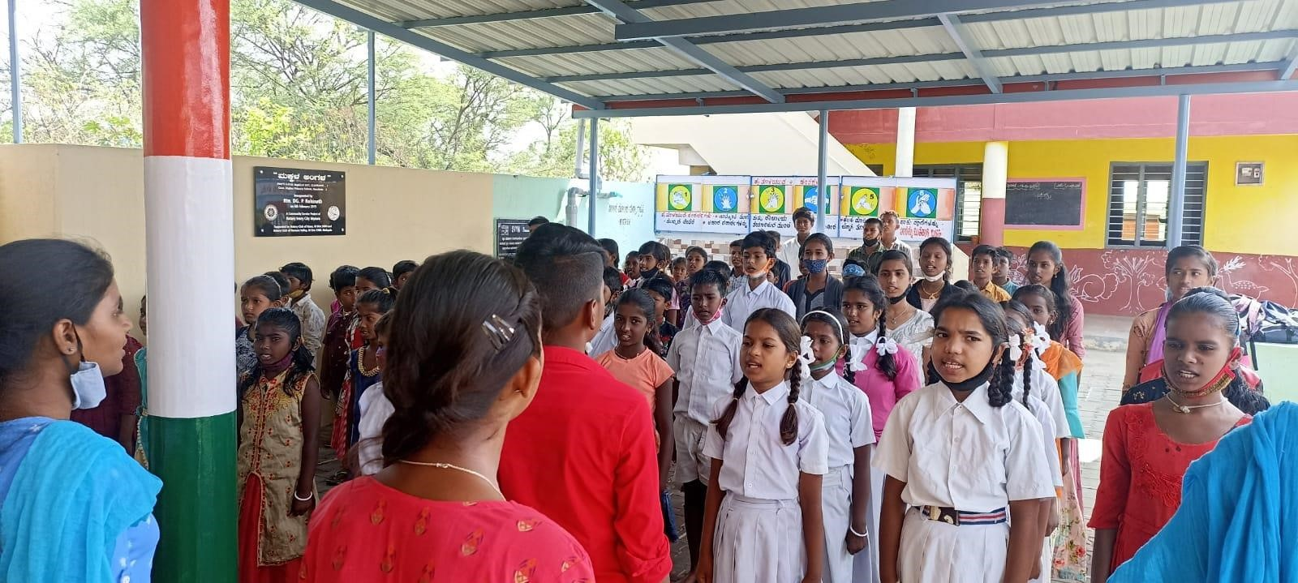

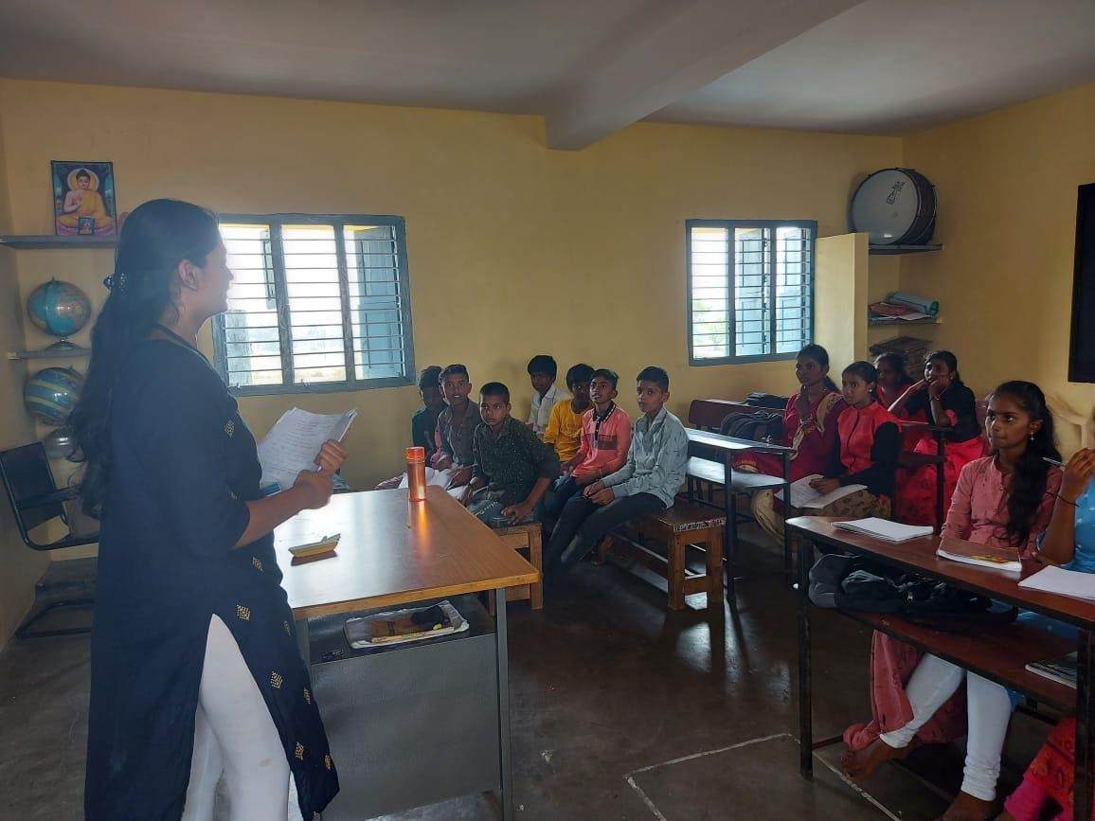

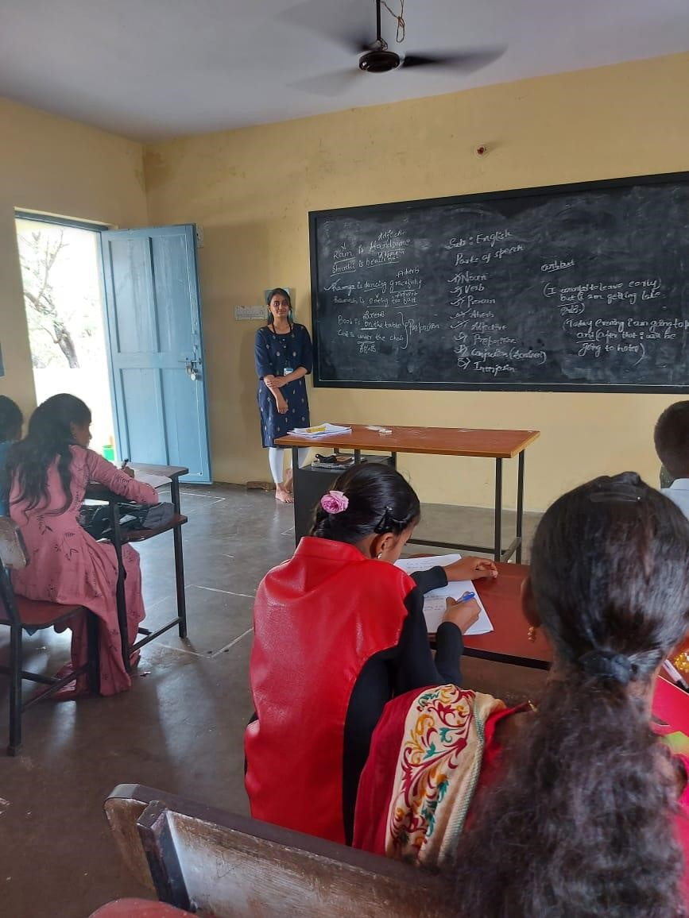

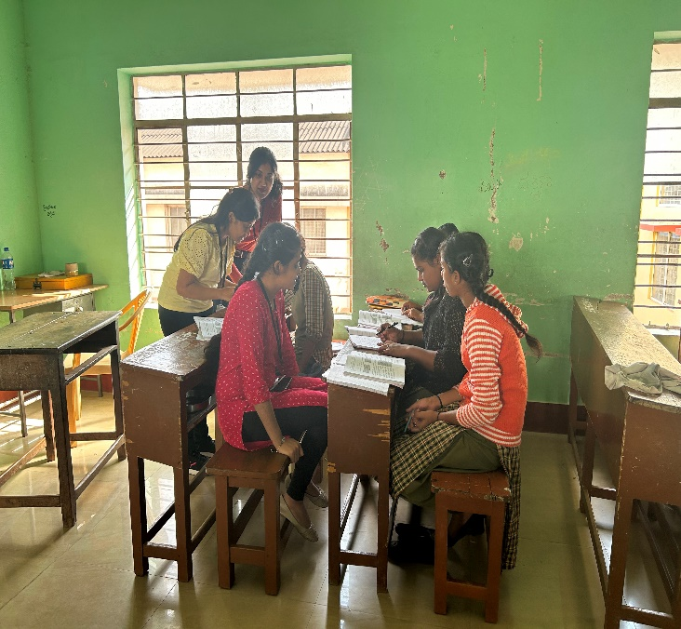

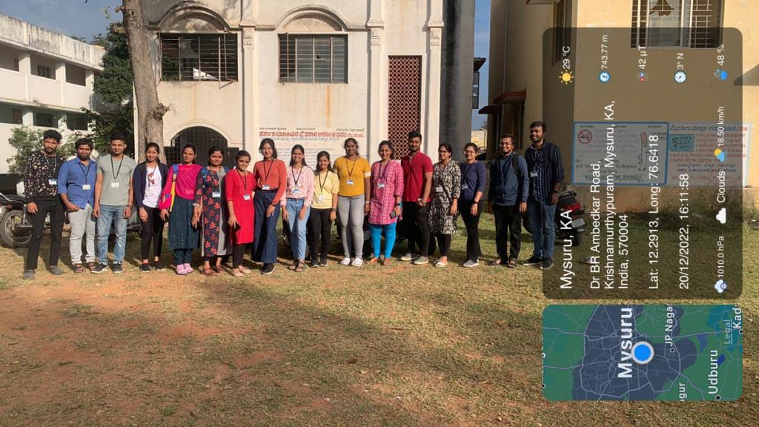

## IMPLEMENTATION

This project involved the students visiting the **Ashoka Puram Government School, Mysore**. The faculty and students were excited on having us. We interacted with the students and understood their interests and the level of understanding they had. Later we engaged in teaching basic Mathematics, basic English, moral value-based stories and basic Computer/Laptop as the School did not have any computer lab facility. The response of the students was very good and we continued this on 15/12/2022 to 30/12/2022. We also interacted with them and showed them some technological developments and the improvement in science and kindled some interest in the field of science.

## CONCLUSION

Through this we successfully educated the students with the importance of practical education, different fields to pursue after the high school and improve their communication skill**.** To teach is to learn as they say, during this activity not only did we realize the difficulties of being a teacher but also discern the significance of education. The environment in the public school was very different as compared to the environment in private school.

We have experienced culture change, adjustments, and new students to handle. The attitudes of the students were also different compared to that of students in the private schools. We were able to face the reality of being a public teacher. We genuinely appreciate all the people we have encountered, especially the students.

We will never forget our experiences. We have learned a lot and we are craving for more wisdom to be bestowed upon us.

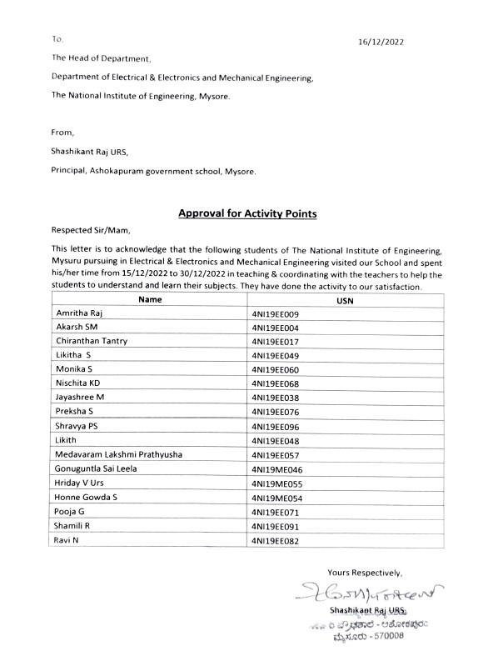**PROOF LETTER**