Kubernetes Course End Project

Kubernetes Course End Project 1
Problem Statement and Motivation 2
Real-time scenario: 2
Assumptions: 2
List of Project tasks: 2
Screenshots 3
Conclusion 4

Problem Statement and Motivation

Real-time scenario:

Karen is a DevOps engineer at a tech startup. Her team has developed a new application using MySQL. Now, it is her task to deploy that application. The company plans to utilize Kubernetes for its robust container orchestration capabilities. Karen must create a Kubernetes dashboard with specific configurations, user roles, storage, service verification, and data management.

Assumptions:

- No Cloud deployment is needed.
- Simplilearn lab environment will be used
- No CI/CD Pipeline is needed
- I will be using WordPress Application with MySQL
- Containers are already available in Docker Hub
- I will be using my git repo to store yaml files and documentation

List of Project tasks:

S. No | Task Description | Status
1 | Set up the cluster in Simplilearn lab environment with 1 master and 3 worker nodes | In Progress/ Completed / Not started
2 | Write/Prepare required yaml files (deployment/service of front end, deployment/service of backend, configmaps, secrets) | In Progress/ Completed / Not started
3 | Setup git repo and push all the yaml files from step 2 | In Progress/ Completed / Not started
4 (optional) | Create a new user, new namespace and apply Role/RoleBinding for the user/namespace | In Progress/ Completed / Not started
5 (optional) | Create a new context and switch to that context for Step 6
6 | Deploy yaml files one by one (for deploy, service, configmaps, secrets, etc) | In Progress/ Completed / Not started
7 | Fix yaml files indentation or syntax errors; Deploy again | In Progress/ Completed / Not started
8 | Verification of K8S objects such as deployment, configmaps, secrets, etc;  Troubleshoot any issues and fix by checking status of the K8S objects using kubectl; log verification. | In Progress/ Completed / Not started
9 | Launch the Ubuntu Desktop on the Lab master node and then verify the application (Wordpress) | In Progress/ Completed / Not started
10 | Validate Application → DB connection and able to setup Wordpress; Login Again to Wordpress | In Progress/ Completed / Not started
11 | Troubleshoot for any issues if Step 9 and 10 are not successful | In Progress/ Completed / Not started
12 | Deploy K8S Dashboard using the documentation we have | In Progress/ Completed / Not started
13 | Update your GitHub repo and push your changes made to yaml files | In Progress/ Completed / Not started
14 | Update this documentation for task status;  Update this documentation with screenshots of your Wordpress app, K8S dashboard, Kubectl commands output (e.g. kubectl get pods/deploy/service, etc) | In Progress/ Completed / Not started
15 | Submit the project documentation (this documentation) to Simplilearn for verification | In Progress/ Completed / Not started

Screenshots
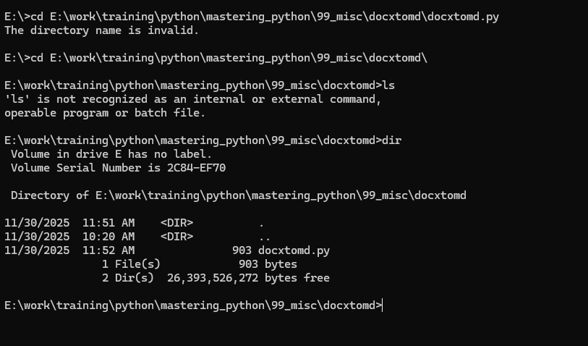

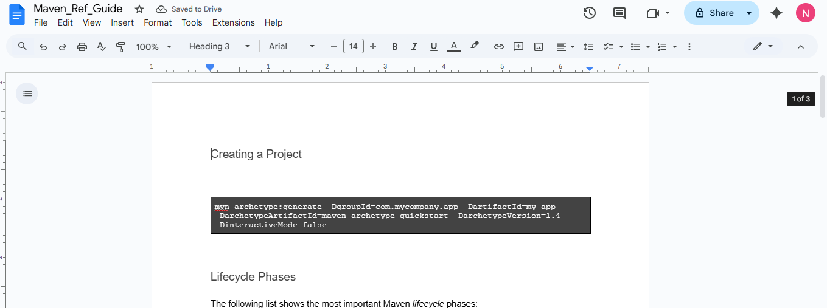

Conclusion

Followed the lesson references and lab documentation to implement the above given problem statement and applied all my K8S learnings.

