W04: Final Project - Proposal

# Overview

## Purpose

The CFA (College For All) project’s purpose is to standardize college applications in the Democratic Republic of the Congo by making life easier for both local colleges and prospective students. The system will increase the reach and accessibility of local schools during the admission period. Knowing that colleges are overcrowded every year during the admission period, it will make life easier for distant and international students and save them from wasting their energy, time and resources with in-person visits to campuses.

## Audience

Our audience is made of higher education schools and prospective students who intend to study in the DR Congo.

# Major Functions

The application builds up on more than one form and meets the complexity corresponding the time available between now and the end of the block. It includes a combination of static and dynamically generated markup, and uses animation.

Here are some ideas on projected features that match the course’s requirements:

* Landing Page
* Login page
* User Dashboard
* User Profile
* Application form
* Admin/College Dashboard (for applications validation)
* 3rd party APIs for local weather and map
* Confirmation page
* 404 page

**Datasource**

* + college-admission-drc.json

# Initial Module list

* HTML: index.html, login.html, student-dashboard.html, application.html, confirmation.html, college-dashboard.html.
* CSS: main.css, form.css, student.css, college.css
* JS: main.js, student.js, college.js

# Palette

**Primary (for Business name, icon, main titles, and buttons)**

|  |  |
| --- | --- |
| HEX: | # 19475C |
| RGB: | 35 99 128 |
| CMYK: | 73 23 0 50 |
| Pantone: | 18-4225 |

**Secondary Color (for Slogan, subtitles)**

|  |  |
| --- | --- |
| HEX: | #00d1cd |
| RGB: | 0 209 205 |
| CMYK: | 100 0 2 18 |
| Pantone: | 14-5420 |

**Accent 1 (for Foreground text)**

|  |  |
| --- | --- |
| HEX: | #f0eefc |
| RGB: | 255 255 255 |
| CMYK: | 0 0 0 0 |
| Pantone: | 11-0601 |

**Accent 2 (for Background Elements such as paragraphs and warning boxes)**

|  |  |
| --- | --- |
| HEX: | #444444 |
| RGB: | 68 68 68 |
| CMYK: | 0 0 0 73 |
| Pantone: | 19-0201 |

Palette’s Link : <https://coolors.co/236380-00d1cd-f0eefc-444444>

**Fonts**

|  |  |  |
| --- | --- | --- |
| **Category** | **Name** | **Use** |
| Primary | Arizonia | Business Name and slogan |
| Secondary | Open Sans | Titles and Subtitles |
| General Text’s Font Family | 'Trebuchet MS', 'Lucida Sans Unicode', 'Lucida Grande', 'Lucida Sans', Arial, sans-serif | Paragraphs |

**Logo - Business Name - Slogan**



**Trello Board**

<https://trello.com/b/j0O0uDw2/wdd330-final-project-college-for-all-cfa>

**Schedule**

|  |  |
| --- | --- |
| Week | Deliverable |
| W05 | * Review the project proposal * Complete project design, including framework for mobile and desk top devices * Create all necessary pages * Add relevant style |
| W06 | * Complete form validation * Add data source * Run unit |
| W07 | * Wrap up project * Run final tests * Prepare README file * Launch the application |

**Framework**

## Mobile

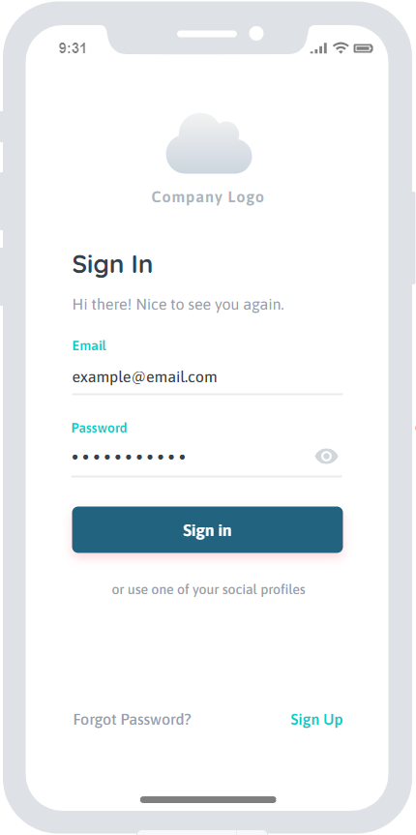 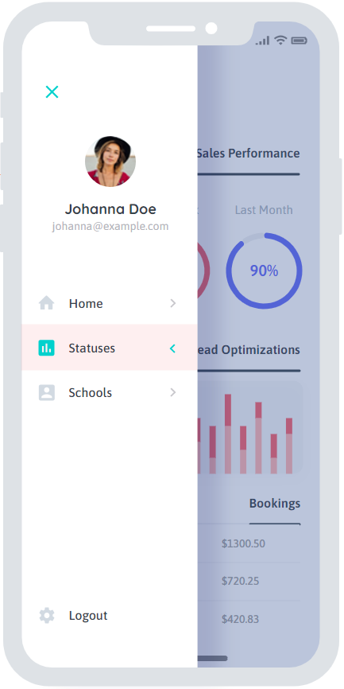 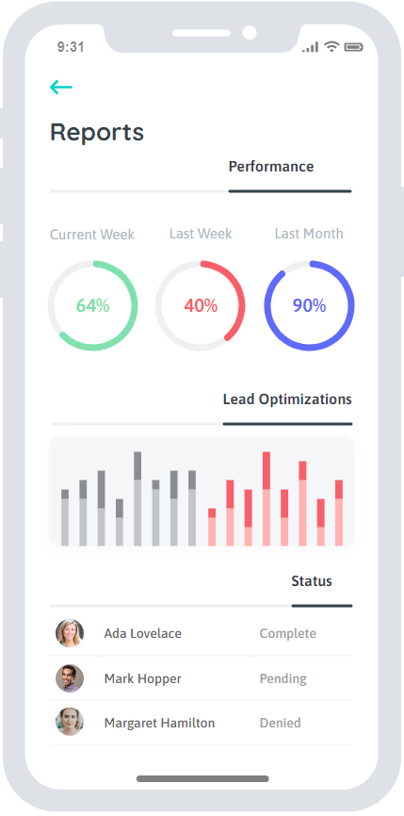 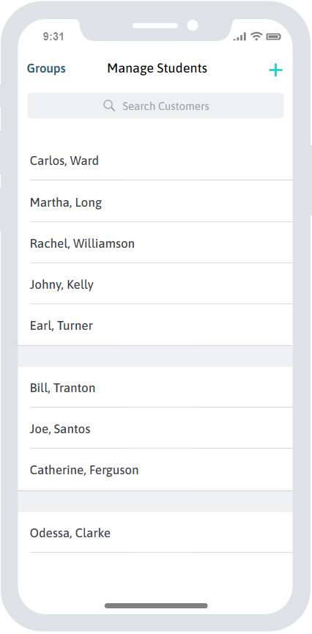

## Desktop

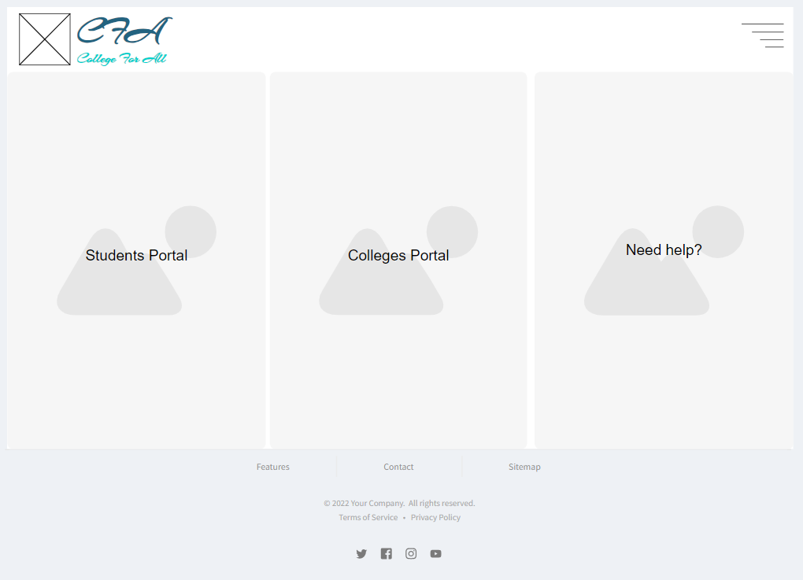

*Landing page*

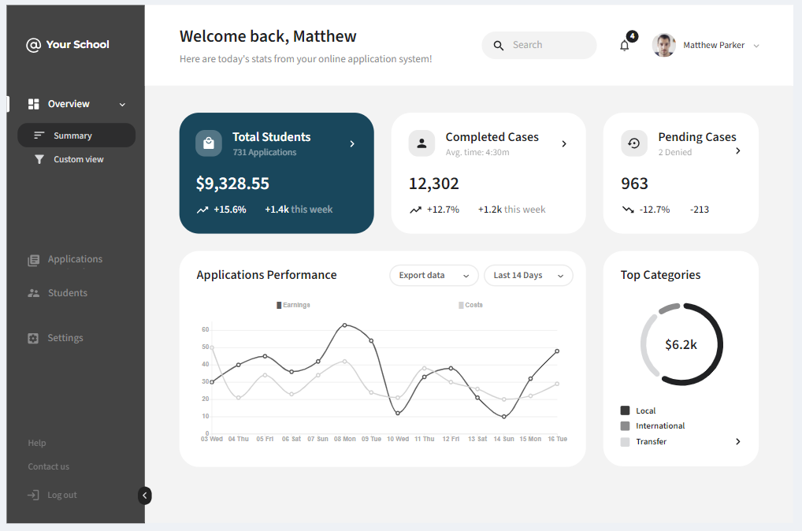

*College Admin Dashboard*