|  |  |  |
| --- | --- | --- |
|  | **Rochester Institute of Technology**  **Golisano College of Computing and Information Sciences**  **School of Interactive Games and Media**  **2145 Golisano Hall – (585) 475-7680** |  |

**Data Structures & Algorithms for Games & Simulation II**

**IGME 309**

**Second exam – Practical (version C)**

I’ve included a solution under the _Binary folder. Please take a look at that before continuing reading this document. You are NOT allowed to use any previous code for reference.

Right out of the box you will begin with this:

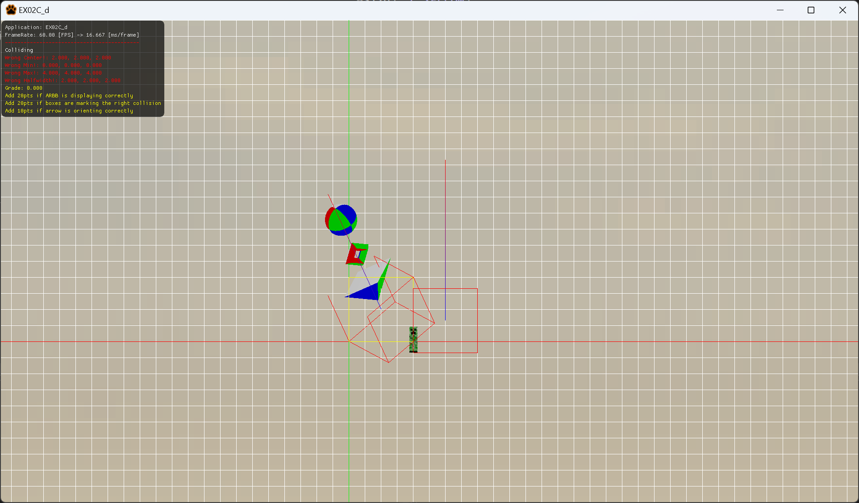

You are working on calculating collision detection of any object loaded. This scene contains only 2 objects, one of them is made out of 3 shapes, a sphere, a torus and a cone, the other, is a Creeper. You should calculate the Rigid Body for the objects and initialize the values in the constructor, as well as making a box around the AABB that is oriented to the world no matter what orientation it has (ARBB). You are also required to check if the objects are colliding among themselves using the Axis Realigned Bounding Box method. Last, you will orient the “arrow” displayed as a line that changes from blue to red. This line grows from the center of the object upwards (in their local space). You then need to orient the directional vector that orients that line in the Update method.

A complete solution will look like this:

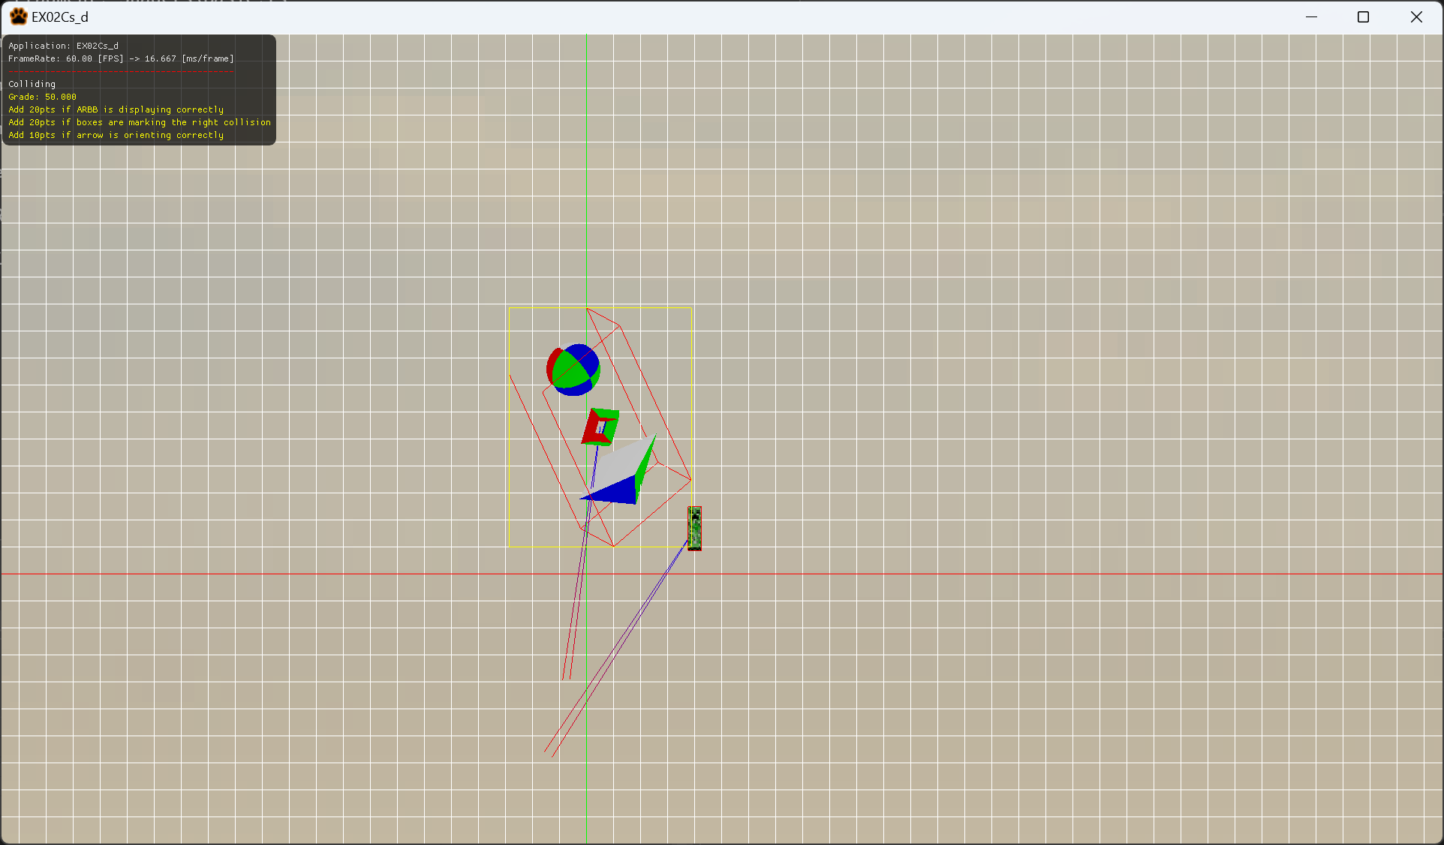

A successful submission would look like this

50% of your grade will come from calculating the correct values for the variables:

Center, Min, Max, Halfwidth

20% of your grade will come from displaying the ARBB correctly (in yellow in the above image.

20% for using the ARBB as a test for collision with both objects

10% for making the arrow rotate.

Please take a look at the solution provided in the _Binary folder (2nd reminder)

***Submit to the dropbox labeled Exam 2 –Practical***

The required submission asks only for a single unzipped file containing your MyRigidBody.cpp, not the whole solution, it should be no larger than 20kb. In the case you are also modifying any other file for helper function purposes, you need to submit those files as well in a zipped file.

After you submit your file, it is your responsibility to download your submission and make sure it is what you worked on and not the starter code, **it has happened to other students before, do not let it happen to you.**

TLDR:

Please take a look at the solution provided in the _Binary folder and replicate it (3rd reminder)

Only submit your MyRigidbody.cpp file once you are done (UNZIPPED)