Exercise 4: Threads

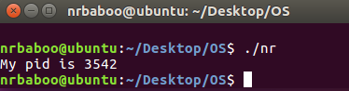
1.1 Ans

3.1 Ans
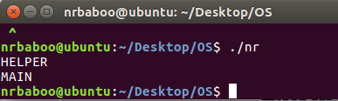

How can we modify the code above to always print out "HELPER" followed by "MAIN"?

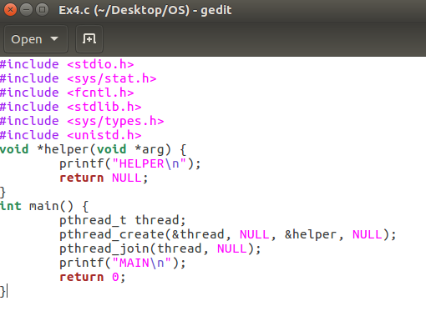

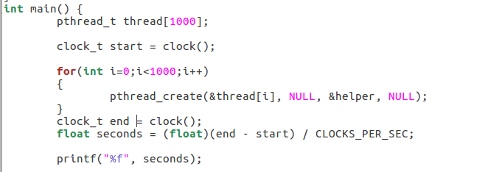
3.2 Ans

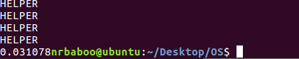

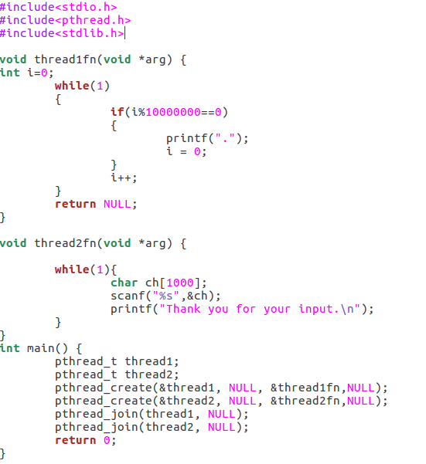
3.3 Ans

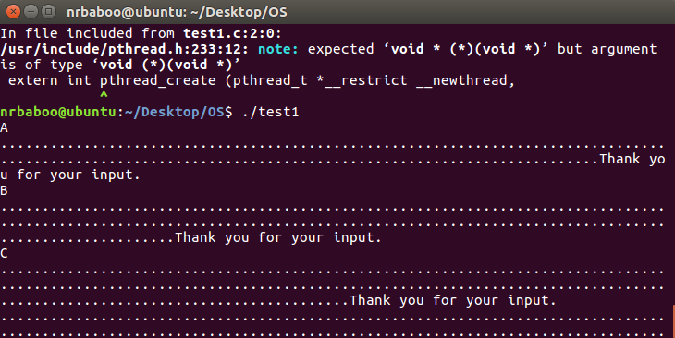
3.4 Ans

#include <stdio.h>
#include <stdlib.h>
#include <sys/time.h>
#include <pthread.h>

int size, num_threads;
double **matrix1, **matrix2, **matrix3;

double ** allocate_matrix( int size )
{
/* Allocate 'size' * 'size' doubles contiguously. */
double * vals = (double *) malloc( size * size * sizeof(double) );

/* Allocate array of double* with size 'size' */
double ** ptrs = (double **) malloc( size * sizeof(double*) );

int i;
for (i = 0; i < size; ++i) {
ptrs[ i ] = &vals[ i * size ];
}

return ptrs;
}

void init_matrix( double **matrix, int size )
{
int i, j;

for (i = 0; i < size; ++i) {
for (j = 0; j < size; ++j) {
matrix[ i ][ j ] = 1.0;
}
}
}

void print_matrix( double **matrix, int size )
{
int i, j;

for (i = 0; i < size; ++i) {
for (j = 0; j < size-1; ++j) {
printf( "%lf, ", matrix[ i ][ j ] );
}
printf( "%lf", matrix[ i ][ j ] );
putchar( '\n' );
}
}

/**
* Thread routine.
* Each thread works on a portion of the 'matrix1'.
* The start and end of the portion depend on the 'arg' which
* is the ID assigned to threads sequentially.
*/
void * worker( void *arg )
{
int i, j, k, tid, portion_size, row_start, row_end;
double sum;

tid = *(int *)(arg); // get the thread ID assigned sequentially.
portion_size = size / num_threads;
row_start = tid * portion_size;
row_end = (tid+1) * portion_size;

for (i = row_start; i < row_end; ++i) { // hold row index of 'matrix1'
for (j = 0; j < size; ++j) { // hold column index of 'matrix2'
sum = 0; // hold value of a cell
/* one pass to sum the multiplications of corresponding cells
in the row vector and column vector. */
for (k = 0; k < size; ++k) {
sum += matrix1[ i ][ k ] * matrix2[ k ][ j ];
}
matrix3[ i ][ j ] = sum;
}
}
}

int main( int argc, char *argv[] )
{
int i;
double sum = 0;
struct timeval tstart, tend;
double exectime;
pthread_t * threads;

if (argc != 3) {
fprintf( stderr, "%s <matrix size> <number of threads>\n", argv[0], argv[1] );
return -1;
}

size = atoi( argv[1] );
num_threads = atoi( argv[2] );

if ( size % num_threads != 0 ) {
fprintf( stderr, "size %d must be a multiple of num of threads %d\n",
size, num_threads );
return -1;
}

threads = (pthread_t *) malloc( num_threads * sizeof(pthread_t) );

matrix1 = allocate_matrix( size );
matrix2 = allocate_matrix( size );
matrix3 = allocate_matrix( size );

init_matrix( matrix1, size );
init_matrix( matrix2, size );

if ( size <= 10 ) {
printf( "Matrix 1:\n" );
print_matrix( matrix1, size );
printf( "Matrix 2:\n" );
print_matrix( matrix2, size );
}
gettimeofday( &tstart, NULL );
for ( i = 0; i < num_threads; ++i ) {
int *tid;
tid = (int *) malloc( sizeof(int) );
*tid = i;
pthread_create( &threads[i], NULL, worker, (void *)tid );
}

for ( i = 0; i < num_threads; ++i ) {
pthread_join( threads[i], NULL );
}
gettimeofday( &tend, NULL );

if ( size <= 10 ) {
printf( "Matrix 3:\n" );
print_matrix( matrix3, size );
}
exectime = (tend.tv_sec - tstart.tv_sec) * 1000.0; // sec to ms
exectime += (tend.tv_usec - tstart.tv_usec) / 1000.0; // us to ms

printf( "Number of MPI ranks: 0\tNumber of threads: %d\tExecution time:%.3lf sec\n",
num_threads, exectime/1000.0);
return 0;
}

This figure show that the result of multiplication matrix size 5x5
