NRC HTML5 Whiteboard



Author: Jason Hines

Revision: 77

Architecture 4
Features 5
Example Usage 6
API 7
Init(params) 7
setTool(tool) 8
setFillStyle(fill, alpha) 8
setStrokeStyle(stroke, alpha) 8
setLineWidth(width) 8
setFontFamily(font) 9
setFontSize(size) 9
setFontStyle(fill, alpha) 9
setFontAlign(align) 9
toggleBold() 9
toggleItalic() 9
toggleUnderline() 10
remove() 10
clear() 10
getCanvasOrigin() 10
toggleGrid() 10
setGridWidth(width) 10
undo() 11
redo() 11
sendToBack() 11
sendToFront() 11
convertToPNG() 11
copy() 11
paste() 11
addImage(url, offset_x, offset_y) 12
chat(msg) 12
setMousePosition(x, y) 12
resetCanvasPosition() 12
Synchronization/Socket Protocol 13
JOIN 13
CHAT 13
PROPCHANGE 13
UPROPCHANGE 13
CREATE 13
UCREATE 13
SELECT 14
DESELECT 14
REMOVE 14
UREMOVE 14
CLEAR 14
SEND-BACK 14
USEND-BACK 14
SEND-FRONT 14
USEND-FRONT 14
SEND-FRONT-ADJUST 14
DISCONNECT 15
IDENTIFY 15
Deployment 17
Demo 17
Production 17
Libraries 18

Architecture
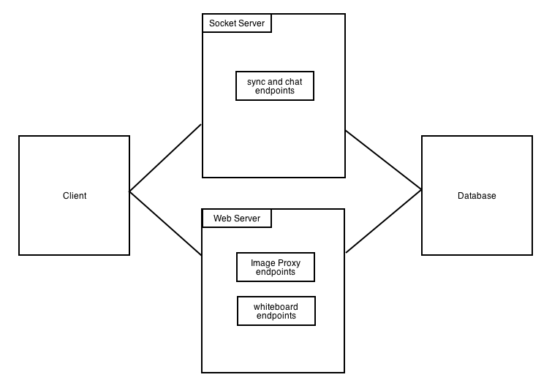
*This is a typical architecture. Actual implementation may vary.

Image proxying endpoints are required because a canvas element is considered “tainted” if it contains images from a domain different than that of the host. Due to browser security restrictions a tainted canvas cannot be converted to an image. Therefore, the images are proxied and either stored in the database or returned as an encoded string. Typically, images available online are simply converted to a base64 representation and returned, while images uploaded from the desktop are stored on the host.

Features
- Standard shapes/objects
  - Rectangle
  - Ellipse
  - Triangle
  - Right Triangle
  - Line
  - Text Box
  - Brush
  - Polygon
  - Image
- Drag and drop image from desktop (chrome)
- Drag and drop image from website (chrome)
- Copy/paste
- Delete
- Clear all
- Convert to PNG
- Undo/Redo
- Inline text editing for Text Box objects
  - Bold
  - Italic
  - Underline
  - Left/center/right align
- Send to Back
- Send to Front
- Grid
  - Auto snap to grid
- Collaborative
- Chat
- Supports alpha transparency

Example Usage
Include the libraries:

Initialize the canvas:

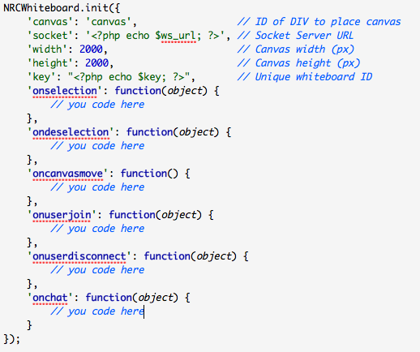

*This usage does not implement a control panel. You are responsible for that.

You can use the API without a socket server. However, the state of the board will not be saved and there is no real-time collaboration and chat functionality.

API

Init(params)

Initialize the whiteboard

Params: object format:
Required params:
canvas: string, ID of a div in which to place a canvas
width: Integer, width, in pixels, of canvas
height: Integer, height in pixels, of canvas
key: string, a unique identifier of the whiteboard

Optional params:
socket: string, The socket server URL
onselection: callback function, receives one parameter:
ShapeObject
ondeselection: callback function, receives one parameter:
ShapeObject
oncanvasmove: callback function
onuserjoin: callback function, receives one parameter:
{
name: <string>,
color: <string>,
slot: <integer>, // unique ID for user-wb combo
owner: <bool>
}
onuserdisconnect: callback function, receives one parameter:
{
slot: <integer>
}
onchat: callback function, receives one parameter:
{
name: <string>,
color: <string>,
slot: <integer>,
msg: <string>
}

setTool(tool)

Set the current tool to interact with the whiteboard.

tool: Required, one of:
NRCWhiteboard.TOOL_SELECT
NRCWhiteboard.TOOL_RECT
NRCWhiteboard.TOOL_ELLIPSE
NRCWhiteboard.TOOL_TRIANGLE
NRCWhiteboard.TOOL_RTRIANGLE
NRCWhiteboard.TOOL_LINE
NRCWhiteboard.TOOL_TEXT
NRCWhiteboard.TOOL_BRUSH
NRCWhiteboard.TOOL_HAND
NRCWhiteboard.TOOL_UNDO
NRCWhiteboard.TOOL_REDO
NRCWhiteboard.TOOL_POLY

setFillStyle(fill, alpha)

Set the current fill color.

Fill: Required, hexadecimal color value with leading ‘#’.
Alpha: Required, float between 0 and 1.

setStrokeStyle(stroke, alpha)

Set the current stroke/line color.

Stroke: Required, hexadecimal color value with leading ‘#’.
Alpha: Required, float between 0 and 1.

setLineWidth(width)

Set the current line stroke/line width.

Width: Required, an integer value. Suggested to use multiples of 2.

setFontFamily(font)

Set the current font family.

Font: Required, string name of font. E.g., ‘helvetica’.

setFontSize(size)

Set the current font size.

Size: required, integer value. Size in pixels.

setFontStyle(fill, alpha)

Set the current font style.

Fill: Required, hexadecimal color value with leading ‘#’.
Alpha: Required, float between 0 and 1.

setFontAlign(align)

Set the current text align.

Align: required, string, one of ‘left’, ‘center’, ‘right’.

toggleBold()

Set/Unset bold font style.

toggleItalic()

Set/Unset italic font style.

toggleUnderline()

Set/Unset underline font style.

remove()

Remove the currently selected item from the whiteboard.

clear()

Remove all items from the whiteboard.

getCanvasOrigin()

Get the current canvas origin.

Returns {x:<integer>, y:<integer>}.

toggleGrid()

Turn the canvas grid on and off.

setGridWidth(width)

Set the spacing of the grid lines.

Width: Required, integer, pixel value. Less than 10 is not recommended.

undo()

Undo the last action.

redo()

Redo the last action, if possible.

sendToBack()

Send the currently selected item to the back

sendToFront()

Send the currently selected item to the front.

convertToPNG()

Save the current canvas to a PNG.

Returns a data URL.

copy()

Copy the currently selected item.

paste()

Paste the currently copied item.

addImage(url, offset_x, offset_y)

Add an image to the canvas.

url: Required, a URL of the image to add. A local URL is required if you wish to use the convertToPNG method.
offset_x: Optional, a pixel value to displace the position of insertion.
offset_y: Optional, a pixel value to displace the position of insertion.

chat(msg)

Send a chat message.

msg: Required, string message.

setMousePosition(x, y)

Set the current mouse position on the canvas. Useful when inserting images.

x: required, integer pixel position from top left.
y: Required, integer pixel position from top left.

resetCanvasPosition()

Return a re-positioned canvas to original position.

Synchronization/Socket Protocol
The following messages are sent from client to socket server. Leading ‘U’ indicates undo. Unless stated otherwise, the server broadcasts the same message format, but always appends the ‘slot’ key-value to the message. ‘obj’ is a JSON serialization of a ShapeObject.

JOIN
{type: ‘JOIN’, msg:<string>}

The typical flow for responding to a JOIN request is as follows:

Server sends {type: ‘JOINED’, slot: <int id>} to requester and broadcasts the same message with type JOIN.

The server then sends the existing objects to the requester using a special type of ‘JCREATE’. E.g., {type:’JCREATE’, obj: <ShapeObject>, slot: <int id>}

The server then broadcasts the JOIN to the other clients. E.g., {type: ‘JOIN’, name:<user name>, slot: <int id>}

CHAT
{type: ‘CHAT’, msg: <string>}

PROPCHANGE
{type: ‘PROPCHANGE’, obj: <ShapeObject>}

UPROPCHANGE
{type: ‘UPROPCHANGE’, obj: <ShapeObject>}

CREATE
{type: ‘CREATE’, obj: <ShapeObject>}

UCREATE
{type: ‘UCREATE’, obj: <ShapeObject>}

SELECT
{type: ‘SELECT’, obj: <ShapeObject>}

DESELECT
{type: ‘DSELECT’, obj: <ShapeObject>}

REMOVE
{type: ‘REMOVE’, obj: <ShapeObject>}

UREMOVE
{type: ‘UREMOVE’, obj: <ShapeObject>}

CLEAR
{type: ‘CLEAR’, obj: <ShapeObject>}

SEND-BACK
{type: ‘SEND-BACK’, obj: <ShapeObject>}

USEND-BACK
{type: ‘USEND-BACK’, obj: <ShapeObject>}

SEND-FRONT
{type: ‘SEND-FRONT’, obj: <ShapeObject>}

USEND-FRONT
{type: ‘USEND-FRONT’, obj: <ShapeObject>}

SEND-FRONT-ADJUST
{type: ‘SEND-FRONT-ADJUST’, obj: <ShapeObject>}

DISCONNECT
The client does not have an explicit disconnect event. However, when the server detects that the socket is dead, it will broadcast:

{type: ’DISCONNECT’, slot:<int id>}

IDENTIFY
{type:’IDENTIFY’, msg:’<new name>’}

Collaborating clients will fire onuserjoin callback.

ShapeObject

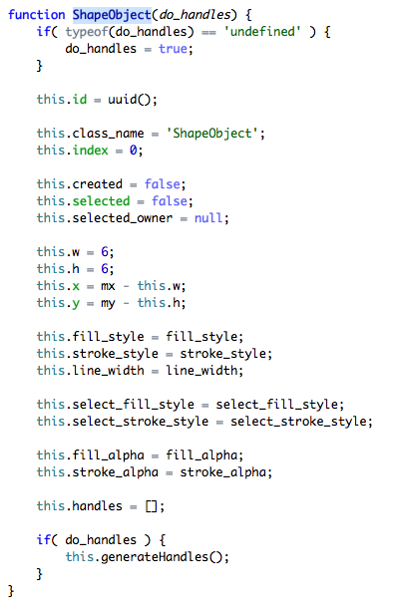

Deployment

Demo
Follow the following steps to deploy the demo whiteboard environment (Note that the demo environment is not recommended for production, it is just an example of how to interact with the API). The demo file structure is a basic CodeIgniter project.

See section Libraries for required libraries.

- Check out the source code from SVN and place the folder (htmlwhiteboard) in a Web accessible path.

https://iitfrdsvn01.iit.nrc.ca/viewvc/htmlwhiteboard/?root=synergic3

- See the README for an example Apache configuration.

- Create a database to hold the tables required.

- Adjust the ‘base_url’ and ‘ws_url’ (web socket url) configuration in application/config.php and the database configuration in application/database.php. Also set the database parameters correctly in server/app.js.

- Run the server. E.g., node server/app.js

- Visit http://<base_url> and click the ‘create new’ button

Production

How you deploy in production is up to you. All you need is the node server and the client Javascript libraries. See the Example section for an example. If you wish to implement the server in another platform, that is possible. The demo server is not configured for production.

See:

server/app.js

application/static/js/nrcwhiteboard.js

Libraries

Name | Use | License | Constraints | Strategy
jQuery | Demo interface control panel. Not part of Whiteboard API. | MIT
jPicker | Demo interface control panel. Not part of Whiteboard API. | MIT
socket.io | Emulating socket communication for Whiteboard collaboration and syncing. | MIT
node.js | Demo server for handling socket communication. Not part of Whiteboard API. Demo server implements Whiteboard logic. | MIT
Sequelize | Used in demo server to communicate with MySQL. Easy to read ORM. Not required. | MIT
CodeIgniter | Demo endpoints for expected callbacks for the Whiteboard API. Not required. | Apache/BSD Style

*Not listed: PHP, JS, HTML, Apache, MySQL.

