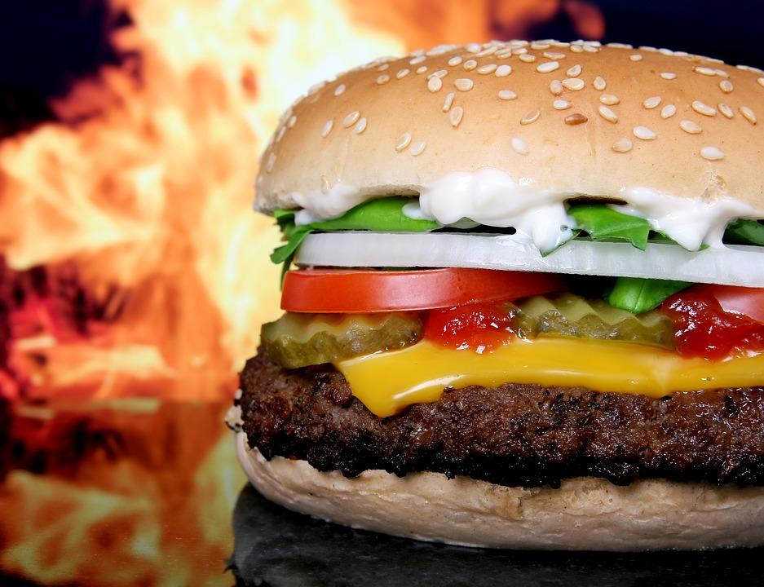
Cheeseburger, Mediations from https://pixabay.com/en/abstract-barbecue-barbeque-bbq-1238247/ CC0 Public Domain

Instructions: You may print and hand write your answers to the following questions. This will be how you will be completing this part on the actual AP Exam. To submit if you hand write, you will need to take an image or scan and submit. For this practice, you may also enter your answers directly into this document, save and submit

A local fast-food restaurant sells both individual items from its menu and value-meals (VM), which include several items from the menu. For example, a customer may make individual purchases like this
Menu item | Cost
Single burger | $1.50
Double burger | $2.50
French Fries (Sm & Lg) | $0.60 - $1.00
Dessert Pie | $0.75
Soft drinks (S, M, L) | $1.00 - $1.50

Or the customer may purchase a value-meal such as this:

Single-Burger Value Meal
Single Burger | $1.50
Small French Fries | $0.60
Apple Pie | $0.75
Medium soft drink | $1.25
Total | $4.10

In this example, as is often the case, the price of the value-meal is discounted, that is, it is less than the total price of the individual menu items.

The company is developing a computer programs to help it manage its menu. Individual menu items are represented by the Itemclass, which is a subclass of the Product class.

public class Product
{
String upc;
double price;
String name;
/* returns a String that uniquely identifies this Product */
public String getUPC()
{
return upc;
}
/* returns this item’s name */
public String getName()
{
return name;
}

/* returns this item’s price in dollars */
public double getPrice()
{
return price;
}

/* constructor and other methods not shown */
}

public class Item extends Product
{
/*constructor, methods, and instance variables not shown */
}

Value-meals are represented by this class, which is also a subclass of Product:

public class Value-meal extends Product
{
ArrayList<MItem> items;
public ArrayList<MItem> getItems();

/* returns the total price of its items */
public double total()
{
/*you will implement this in part (a) */
}

/* constructor and other methods now shown */
}

- The total method of Value-meal returns the sum of the prices of its items. For example, if a value-meal contains a single burger ($1.50), small French fries ($0.60), pie ($0.75), and a medium drink ($1.25), the cost would be $4.10:

$1.50 + $0.60 + $0.75 + $1.25 = $4.10

Complete the following definition for the total method of Value-meal:

public class Value-meal extends Product
{
private ArrayList<MItem> items;
/* constructor not shown */
public double total()
{

for (int count = 0; count < items.size(); count++)
{
double total += items.getPrice();
}

return total;

}
/* other methods not shown */
}
- The restaurant policy is to price value-meals at a discount of 20%, rounded up to the nearest 10 cents then increase by $0.09. For example, if the total price of the value-meal’s items is $4.10, then the price of the value-meal is calculated as follows
  - $4.10 discounted by 20% = $3.28
  - $3.28 rounded up to the nearest dime = $3.30
  - $3.30 + $0.09 = $ 3.39

This amount $3.39 is called the discounted price. Complete the following definition for the static method calcVMPrice that inputs a Value-meal and returns its discounted price. (Note that the static method roundToNearestDimeUp is provided for your use.)

public class VM extends Product
{
/* constructor and instance variables not shown */

public static double calcVMPrice ( VM burger)
{

double newPrice = 0;
newPrice = (burger.getPrice * .8);
newPrice = roundToNearestDimeUp(newPrice);
newPrice = newPrice + .09;
return newPrice;

}

public static double roundToNearestDimeUp (double d)
{
double dInDimes = 10 * d;
if (dInDimes – (int)dInDimes == 0)
return d;

return (int) ( dInDimes + 1) / 10.0;
}

/*other methods not shown */
}
- Each week, the value-meal that has the highest prices is highlighted on the company’s menu. Complete the following definitions for the static highestPricedVM method that inputs an ArrayList of VMs and returns the Value-meal with the highest price.

public class VM extends Product

{
/*constructor and instance variables not shown */

public static VM highestPricedVM (ArrayList<VM>burger)
{
int indexOfHighest = 0;
double priceOfHighest = 0;

for(int count = 0; count < burger.size(); count++)
{

if (burger.get(count).getPrice() > priceOfHighest)
{
indexOfHighest = count;
burger.get(count).getPrice = priceOfHighest;
}
}

return burger.get(indexOfHighest);

}
/* other methods not shown */
}

