ICH-CAHPS Disposition Processing

Dana Petersen, 14 March 2016

The CAHPS Preprocessing step in Form Gen runs sp_fg_CAHPSPreprocessing in QP_Prod.

That proc executes two stored procedures in QP_Prod:



The CAHPS Preprocessing step in the Catalyst nightly ETL runs csp_CAHPSProcesses in NRC_Datamart_ETL.

That proc executes several stored procedures in QP_Prod:

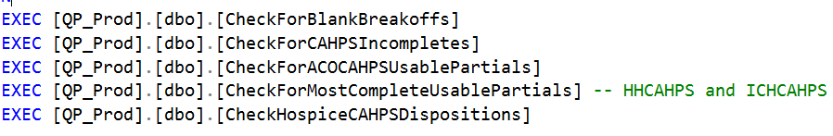

# Check for CAHPS Incompletes

* Find all records for returned CAHPS surveys in the Catalyst ETL Queue (ICH & others)
* Execute QFResponseCount to get a count of distinct question cores with non-missing responses (responseval >= 0) from QuestionResult2, then QuestionResult
* Insert a record into QP_Prod DispositionLog with disposition_id 25 (Blank First Survey) of the response count = 0 and the mailing step name is ‘1st survey’
* Insert a record into QP_Prod DispositionLog with disposition_id 26 (Blank Second Survey) of the response count = 0 and the mailing step name is ‘2nd survey’
* Decide if this return should be ETL’d
  + If there are no future mailings (record in ScheduledMailing w/ NULL SentMail_id)
  + If all mail steps are accounted for (all steps have datReturned, datUnusedReturn, or datUndeliverable populated)
* Check for any other QuestionForm records for the samplepops that can be ETL’d where UnusedReturn_id = 5 (Partial return, not used for now)
  + Take the return with the highest response count
  + If response counts are > 0 and are the same, take the first one
  + If response counts are 0 (blank surveys) for both, take the last one
* If we’re ETL’ing today’s return, change the UnusedReturn_id to 6 (Partial return, fate decided) for the return that is not being ETL’d
* If we’re not ETL’ing today’s return:
  + Move its results to QuestionResult2 and change it to an unused return w/ UnusedReturn_id = 6. This should remove from the Catalyst ETL Queue via a trigger, according to the comments.