ECE 403 Andrew Bossert

Budget Proposal and Gantt Chart Christopher Jorden-Denny

Nicolette Lippert

Summary of Direction

The main goal of our project is to answer the question is transmembrane potential affected by exposure to radio frequencies. In order to test this we need a way to measure transmembrane potential. Because of the unknown nature of the results of this project we have elected to study two methods of membrane potential measurement. The first method is dielectric spectroscopy, which essentially turns a solutions of suspended cells into a dielectric and studies the frequency response of the system to determine the membrane potential. The setup we have choose to accomplish this is shown below.

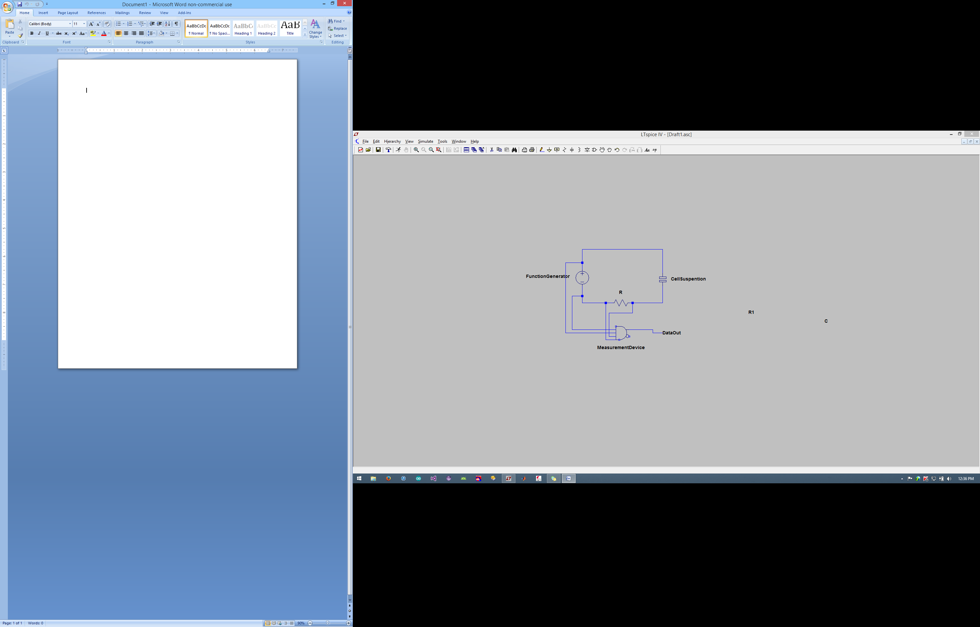

We will be provided a function generator that can produce frequencies in the radio range. We will also be provided cells by our adviser. We were advised to place $150 in the budget for these cells in case this was needed. We will have to build an apparatus to hold the solution and a measurement device. As seen in the budget list we will use the ATMEGA32U4TQFP in order to record these measurements. However some signal processing is needed before the data reaches the micro in which that will have to be build by us. After consulting Jeff a 3D printed "holder" will need to be constructed in order to hold the plates that create a capacitor with the cell suspension as a dielectric.

The second method being sought after is a direct probing of individual cells. Dr. Nawarathna will be able to provide pipettes to be used as probes, however there we will need to create an apparatus to hold the probes and also an electrical circuit to detect when the pipette has entered the cell. The device to hold the pipettes will involve 3D printing and the circuit will be a combination of what we will have already created for the dielectric spectroscopy method.