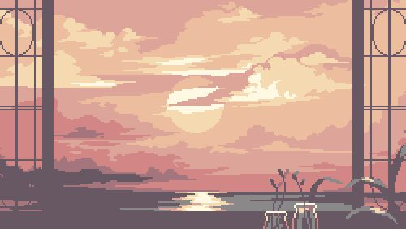
+---++++
Happy
Shy
Tired
Best part of today was:
Early wake up and see sun raised that’s the best part of my day that I want always happen like a don’t having a problem because he gave me a peaceful mind and positive mind to became me happen every morning .
Something I will do starting today that is better than yesterday:
Don’t stay stuck , Starting today I’ll will be trying something new or trying something different today.
Something I’m looking forward tomorrow is:
New learning ,new experience and new opportunities. I don’t know what more the new day will be bring that’s why I need planning to be prepared for other days unexpected event.
Feelings that I felt during the day:
MY DAILY JOURNAL
Everything that happened today

