**Prerequisites for NRG Automation**

**Installation:**

Install JDK 1.8  
Install Eclipse IDE/IntelliJ Idea  
Set Up Environment Variables for the JDK 1.8, bin folder  
Install Cucumber, Naturals plugin  
Install TestNG plugin

**Folder Structure:**

**Directories and Packages Hierarchy**

The source directory mainly contains packages to distinguish test methods, page objects and common utilities. All other resources such as driver exe files, test data source will be placed inside the resource director. Maven POM XML, and configuration properties are placed at the root of the project directory.

|  |  |
| --- | --- |
| **Directory/File** | **Description** |
| *src/test/java/pages* | Java package that holds page objects and page methods |
| *src/test/java/tests* | Java package that holds Java class files grouped under functionality, which has TestNG test methods annotated with @Test |
| *src/test/java/Utilities* | A collection of Java class files which provide features for reading data from external files, generating test reports etc. |
| *pom.xml* | Maven POM file that maintains the dependencies and helps in build process |
| *test-output/TestSummaryReport.html* | HTML report that has details on recent automated test execution |
| *history* | The directory where history of previous execution report will be maintained |
| *configurations.properties* | Any test parameters can be configured if it needs to be. This is required only if we have to override any existing configurations |

**How to import the Project:**  
1.Click on File  
2.Open Projects from File System  
3.Click on Directory  
4.Select Folder from the local  
5.Click on Finish Button

**How to Run the Cucumber Project:**  
1. Navigate to src/test/java

2. Pick the Scenario Tag Name from Test Scenario Mapping Sheet Update the Scenario Tag name under tags in Test Runner  
3.Right Click on the Test Runner file and Run as Junit Test

**Test Scenario Mapping:**

Using this file you can easily get Scenario Tag names of various Test Scenarios



**Test Data Prerequisites**

**Refresh 01/Refresh 02**

Pick Siebel Customer ID and Siebel Contract ID from Renewal Customer and Update it to Siebel Customer ID column and Siebel Contract ID column for Amendment Add/Delete Sheets

1. Query for the contract number in Siebel 'Contracts' tab.

2. In the sub-tabs, select 'Add/Delete Amendments

3. Pick Product ID from More Info Section and Update it to Product ID column in Amendment sheet

|  |  |
| --- | --- |
| REQUEST TYPE | Select ADD if you are requesting a site to be added to your contract.  Select DELETE if you are requesting a site be deleted from your contract. |
| ESI ID | In ERCOT, the Electric Service Identifier ID#, which is assigned by the TDSP, is the basic identifier for each point of electricity delivery.  The ESI ID is used in the registration and settlement systems managed by ERCOT. |
| SERVICE LOCATION NAME | The specific name the location goes by. In addition to the company name listed on your contract, you can specify this location name, which will also appear on your electricity invoice to help you identify this location from others. If you do not need a specific location name to appear on your electricity invoice, you may leave this field blank. |
| METER STREET ADDRESS | The physical address where the meter is installed or will be installed. This address must match TDSP and ERCOT records. |
| CITY | The city where the meter is installed or will be installed. |
| STATE | The State where the meter is installed or will be installed. |
| ZIP CODE | The zip code where the meter is installed or will be installed. |
| REQUESTED REMOVAL DATE | The "Requested Removal Date" is the date you are requesting the meter to be de-energized and/or removed. |
| IS THIS A "MOVE IN" OR "SWITCH"? | Specify one.  A "Move In" is either a brand new meter, one you are taking ownership of for the first time, or a meter that is not currently flowing power.  A "Switch" is when you already have service, but you are switching from your current retail provider to Reliant. |
| REQUESTED SWITCH DATE or MOVE IN DATE | If this is a SWITCH, this is the date you prefer to have your service switched from your current Retail Electric Provider to Reliant If this is a MOVE IN, this is the date you are requesting the meter to be to be installed and energized, and/or the date you plan to move in. |
| IS THE PREMISE INSIDE OR OUTSIDE OF CITY LIMITS? | This designation determines the GRT, Gross Receipts Tax, for billing purposes.  GRT is paid by Reliant based on gross receipts from retail sales of electricity and related charges where the Delivery Point is located inside an incorporated city or town.  The rates vary based on the city/town population |

**Amendment-Attachment-Add**:



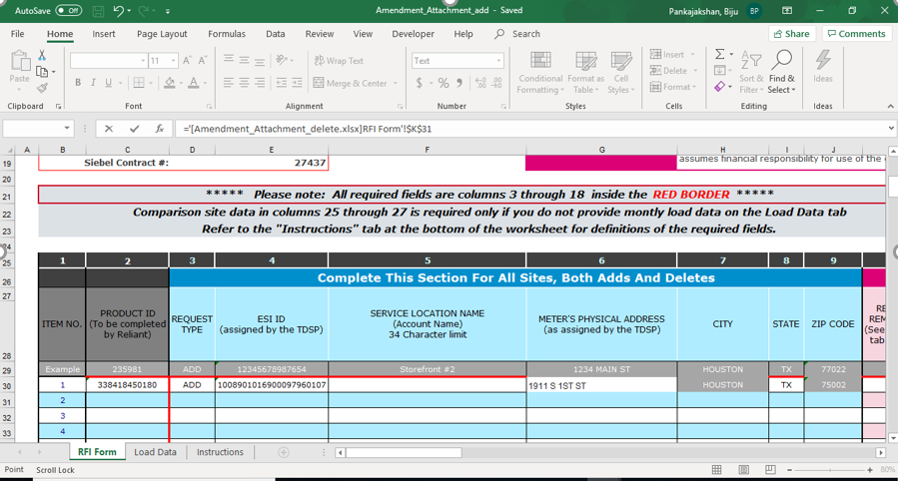

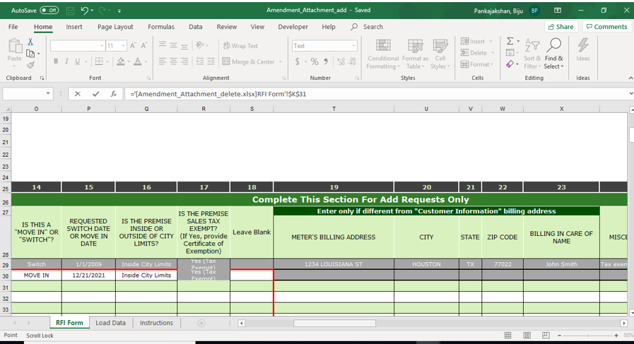

**Amendment-Attachment-Delete**:



