


Technical Safety Concept Lane Assistance
Document Version: 2.0
Version 1.0, Released on 2018-04-28

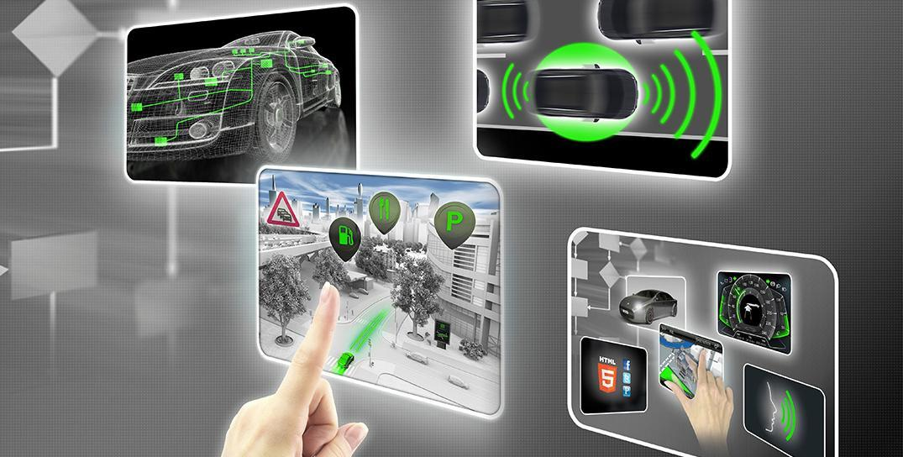

Document history
Date | Version | Editor | Description
04/28/2018 | 1.0 | Ninad Ghike | Initial Creation
05/15/2018 | 2.0 | Ninad Ghike | Update safe state

Table of Contents
Document history
Table of Contents
Purpose of the Technical Safety Concept
Inputs to the Technical Safety Concept
Functional Safety Requirements
Refined System Architecture from Functional Safety Concept
Functional overview of architecture elements
Technical Safety Concept
Technical Safety Requirements
Refinement of the System Architecture
Allocation of Technical Safety Requirements to Architecture Elements
Warning and Degradation Concept

Purpose of the Technical Safety Concept
Technical Safety Concept (TSC) is part of the product development phase. Though it looks similar to Functional Safety Concept but it is more concrete and goes into the technical details of the item’s technology. TSC often define the signal flow and covers the general hardware and software requirements without going into the specific details.

Inputs to the Technical Safety Concept

Functional Safety Requirements
ID | Functional Safety Requirement | ASIL | Fault Tolerant Time Interval | Safe State
Functional  Safety  Requirement  01-01 | The lane keeping item shall ensure that the lane departure oscillating torque amplitude is below Max_Torque_Amplitude | C | 50 msec | LDW will set the oscillating torque amplitude to 0
Functional  Safety  Requirement  01-02 | The lane keeping item shall ensure that the lane departure oscillating torque frequency is below Max_Torque_Frequency | C | 50 msec | LDW will set the oscillating torque amplitude to 0
Functional  Safety  Requirement  02-01 | The lane keeping item shall ensure that the lane keeping assistance torque is applied for only Max_Duration | B | 500 msec | LDW will set the oscillating torque amplitude to 0

Refined System Architecture from Functional Safety Concept
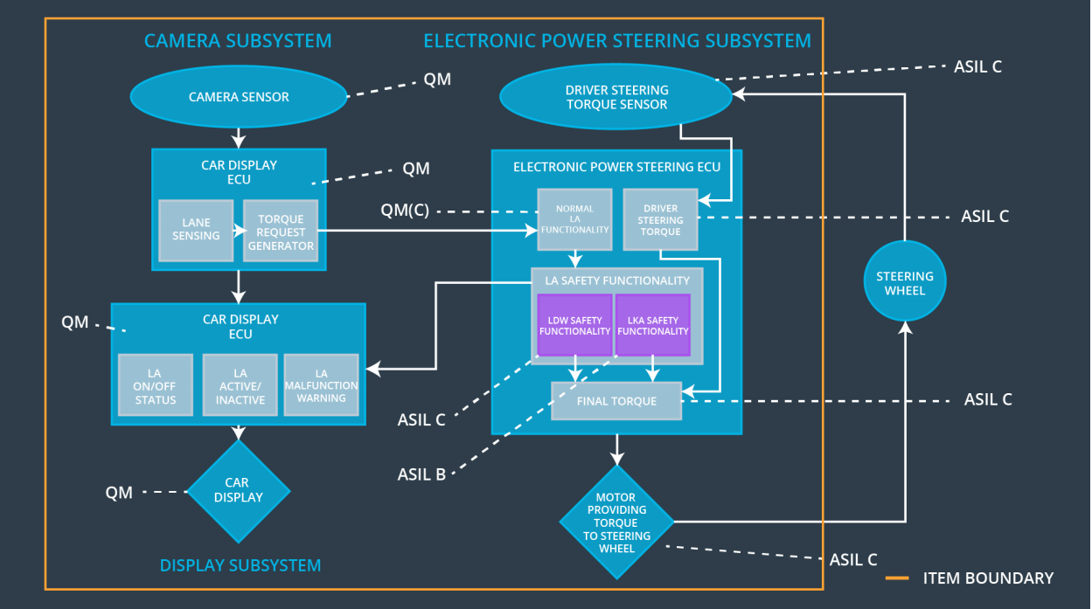
Figure 1

Functional overview of architecture elements
Element | Description
Camera Sensor | The Camera Sensor reads in images from the road
Camera Sensor ECU - Lane Sensing | The Camera Sensor ECU - Lane Sensing defines lane departure
Camera Sensor ECU - Torque request generator | The Camera Sensor ECU - Torque request generator sends torque request to EPS ECU
Car Display | Takes the input from car display ECU and displays on/off warning sign as well as any malfunction occurred.
Car Display ECU - Lane Assistance On/Off Status | Shows light on and off for LA symbol if driver turn LAS on and off.
Car Display ECU - Lane Assistant Active/Inactive | Shows light on and off for LA symbol if LDW or LKS activated or deactivated.
Car Display ECU - Lane Assistance malfunction warning | The Car Display ECU - LA malfunction warning controls a warning light that tells the driver if the LA has a malfunction
Driver Steering Torque Sensor | The Driver Steering Torque Sensor measures steering torque provided by the driver
Electronic Power Steering (EPS) ECU - Driver Steering Torque | The EPS ECU - Driver Steering Torque receives a signal from Driver Steering Torque Sensor, processes and sends steering torque provided by the driver to EPS ECU - Final Torque
EPS ECU - Normal Lane Assistance Functionality | The EPS ECU - Normal LA Functionality processes and sends request satisfying normal functionality
EPS ECU - Lane Departure Warning Safety Functionality | The EPS ECU - LDW Safety Functionality processes and checks that vibrational request not above limits
EPS ECU - Lane Keeping Assistant Safety Functionality | The EPS ECU - EPS ECU - LKA Safety Functionality processes and checks that torque request not above limits
EPS ECU - Final Torque | Sends the final required torque value to the motor.
Motor | Takes the input from EPS ECU and applies the torque to the steering wheel.

Technical Safety Concept

Technical Safety Requirements
Lane Departure Warning (LDW) Requirements:
Functional Safety Requirement 01-01 with its associated system elements
(derived in the functional safety concept)
ID | Functional Safety Requirement | Electronic Power Steering ECU | Camera ECU | Car Display ECU
Functional  Safety  Requirement  01-01 | The lane keeping item shall ensure that the lane departure oscillating torque amplitude is below Max_Torque_Amplitude | X

Technical Safety Requirements related to Functional Safety Requirement 01-01 are:
ID | Technical Safety Requirement | ASIL | Fault Tolerant Time Interval | Architecture Allocation | Safe State
Technical  Safety  Requirement  01 | The LDW safety component shall ensure that the amplitude of the 'LDW_Torque_Request' sent to the 'Final electronic power steering Torque' component is below 'Max_Torque_Amplitude. | C | 50 msec | LDW Safety Functionality | LDW will set the oscillating torque amplitude to 0
Technical  Safety  Requirement  02 | The 'LDW Safety' software block shall send a signal to the car display ECU to turn on a warning light as soon as the LDW function deactivates the LDW feature. | C | 50 msec | LDW Safety Functionality | LDW will set the oscillating torque amplitude to 0
Technical  Safety  Requirement  03 | The LDW function shall deactivate the LDW feature and the 'LDW_Torque_Request' shall be set to zero as soon as a failure is detected. | C | 50 msec | LDW Safety Functionality | LDW will set the oscillating torque amplitude to 0
Technical  Safety  Requirement  04 | The system shall check for the timeouts of ‘LDW_Torque_Request’ Signal | C | 50 msec | Data Transmission integrity check | LDW will set the oscillating torque amplitude to 0
Technical  Safety  Requirement  05 | The system shall perform memory check of the EPS ECU at bootup to look for memory related faults. | A | Ignition Cycle | Safety Startup | LDW will set the oscillating torque amplitude to 0

Functional Safety Requirement 01-02 with its associated system elements
(derived in the functional safety concept)
ID | Functional Safety Requirement | Electronic Power Steering ECU | Camera ECU | Car Display ECU
Functional  Safety  Requirement  01-02 | The lane keeping item shall ensure that the lane departure oscillating torque frequency is below Max_Torque_Frequency | X

Technical Safety Requirements related to Functional Safety Requirement 01-02 are:
ID | Technical Safety Requirement | ASIL | Fault Tolerant Time Interval | Architecture Allocation | Safe State
Technical  Safety  Requirement  01-02-01 | The LDW safety component shall ensure that the frequency of the “LDW_Torque_Request” sent to the “EPS ECU - Final Torque” component is below Max_Torque_Frequency | C | 50 ms | LDW Safety block | LDW torque request shall be set to zero
Technical  Safety  Requirement  01-02-02 | As soon as the LDW function deactivates the LDW feature, the “LDW Safety” software block shall send a signal to the car display ECU to turn on a warning light | C | 50 ms | LDW Safety block | LDW torque request shall be set to zero
Technical  Safety  Requirement  01-02-03 | As soon as a failure is detected by the LDW function, it shall deactivate the LDW feature and the “LDW_Torque_Request” shall be set to zero | C | 50 ms | LDW Safety block | LDW torque request shall be set to zero
Technical  Safety  Requirement  01-02-04 | The validity and integrity of the data transmission for “LDW_Torque_Request” signal shall be ensured | C | 50 ms | Data Transmission Integrity Check block | LDW torque request shall be set to zero
Technical  Safety  Requirement  01-02-05 | Memory test shall be conducted at start up of the EPS ECU to check for any faults in memory | A | ignition cycle | Safety Startup Memory Test block | LDW torque request shall be set to zero

Lane Keeping Assistance (LKA) Requirements:

Functional Safety Requirement 02-1 with its associated system elements
(derived in the functional safety concept)

ID | Functional Safety Requirement | Electronic Power Steering ECU | Camera ECU | Car Display ECU
Functional  Safety  Requirement  02-01 | The lane keeping item shall ensure that the lane keeping assistance torque is applied for only Max_Duration | X

Technical Safety Requirements related to Functional Safety Requirement 02-01 are:
ID | Technical Safety Requirement | ASIL | Fault Tolerant Time Interval | Allocation to Architecture | Safe State
Technical  Safety  Requirement  02-01-01 | The LKA safety component shall ensure that the torque request of the “LKA_Torque_Request” sent to the 'EPS ECU - Final Torque' component is applied for only Max_Duration | B | 500 ms | LKA Safety block | LKA torque request shall be set to zero
Technical  Safety  Requirement  02-01-02 | As soon as the LKA function deactivates the LKA feature, the “LKA Safety” software block shall send a signal to the car display ECU to turn on a warning light | B | 500 ms | LKA Safety block | LKA torque request shall be set to zero
Technical  Safety  Requirement  02-01-03 | As soon as a failure is detected by the LKA function, it shall deactivate the LKA feature and the “LKA_Torque_Request” shall be set to zero | B | 500 ms | LKA Safety block | LKA torque request shall be set to zero
Technical  Safety  Requirement  02-01-04 | The validity and integrity of the data transmission for “LKA_Torque_Request” signal shall be ensured | B | 500 ms | Data Transmission Integrity Check block | LKA torque request shall be set to zero
Technical  Safety  Requirement  02-01-05 | Memory test shall be conducted at start up of the EPS ECU to check for any faults in memory | A | ignition cycle | Safety Startup Memory Test block | LKA torque request shall be set to zero

Lane Keeping Assistance (LKA) Verification and Validation Acceptance Criteria:

[OPTIONAL: For each technical safety requirement, identify both the verification and validation acceptance criteria. “Validation” asks whether or not you chose the appropriate parameters. “Verification” involves testing to make sure the vehicle behaves as expected when the parameter value is crossed. There is not necessarily one right answer. Look at your verification and validation acceptance criteria from the functional safety concept for inspiration.]

Refinement of the System Architecture

Allocation of Technical Safety Requirements to Architecture Elements
For Lane Assistance system, which includes LDW and LKA, all technical safety requirements are allocated to the Electronic Power Steering ECU.

Warning and Degradation Concept
ID | Degradation Mode | Trigger for Degradation Mode | Safe State invoked? | Driver Warning
WDC-01 | Vibrational torque request received by the Electronic Power Steering ECU is very high | Vibrational torque request is higher than MAX_Torque_Amplitude or MAX_Torque_Frequency | Yes | Display a malfunction warning light on the driver dashboard
WDC-02 | Duration of the  LKA torque request received by the electronic power steering ECU is long | Duration of torque request is more than Max_Duration | Yes | Display a malfunction warning light on the driver dashboard

