Team: Twenty-Hats

Nathan Graham
Daniel Moore
Eric Laib
Kyle Johnson

End of Second Iteration Deliverables

Completed user stories on Pivotal Tracker.

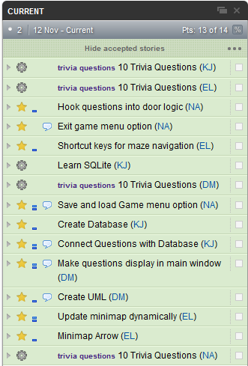

Proof of GitHub use.

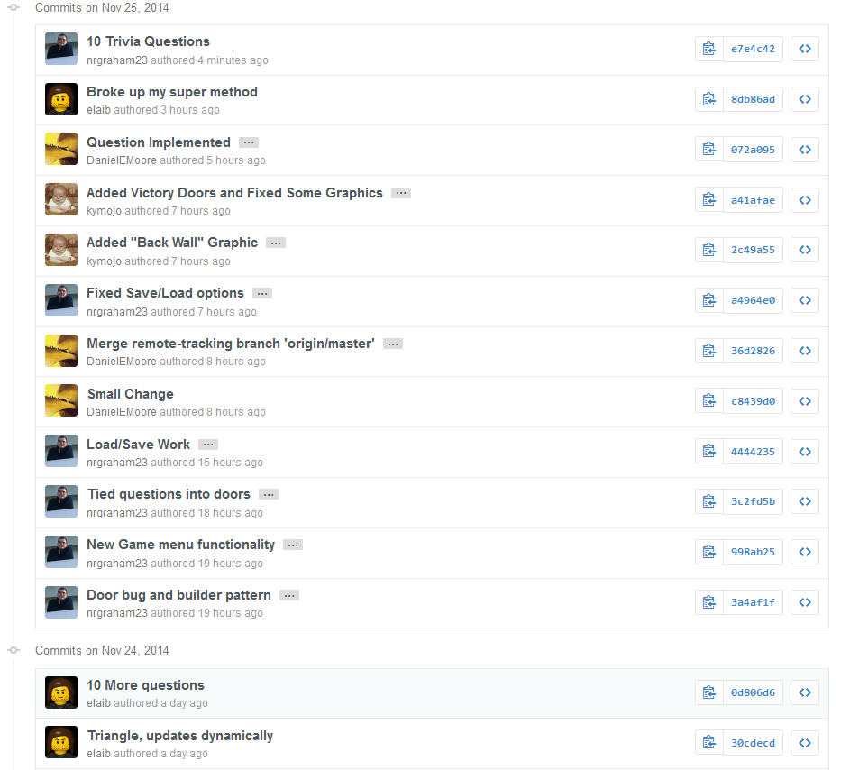
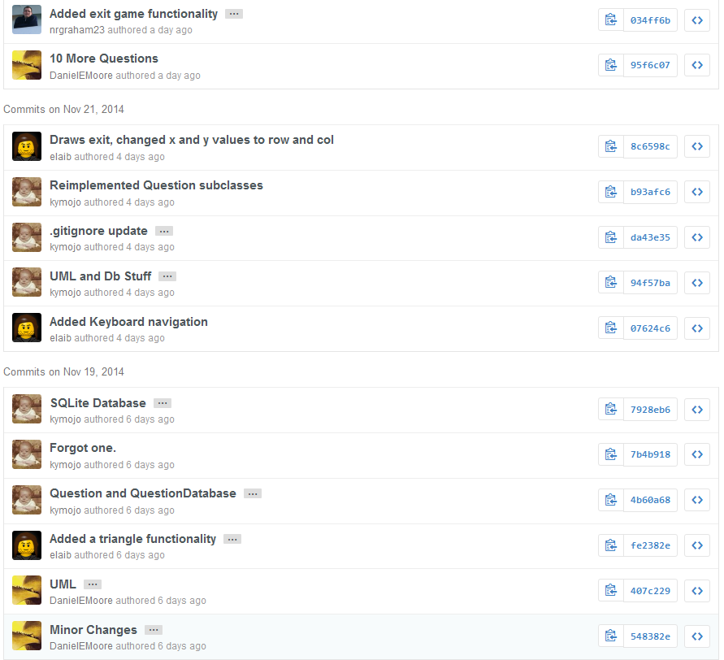

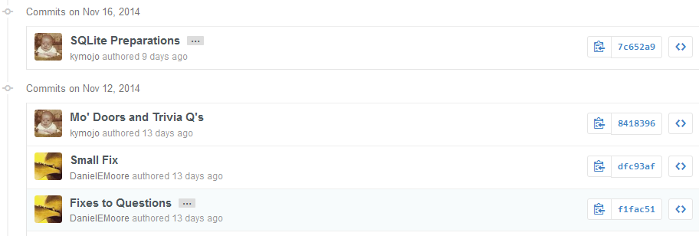

Commits
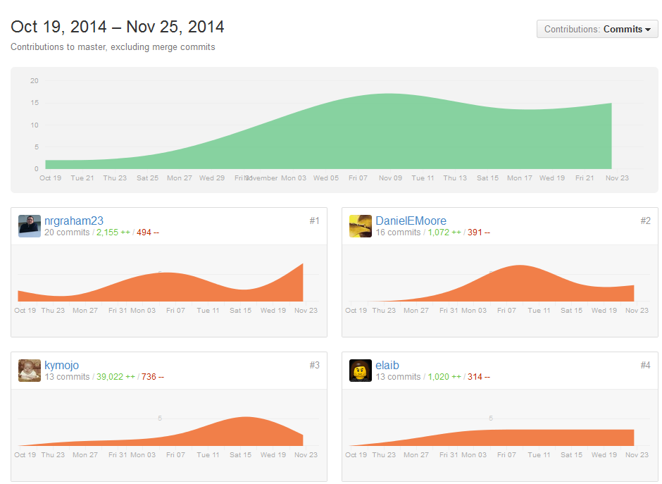

Project functionality:

New functionality for this iteration includes a dynamically updating mini-map
as displayed below.
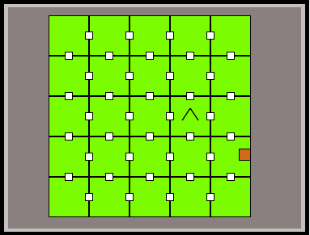

Question Display

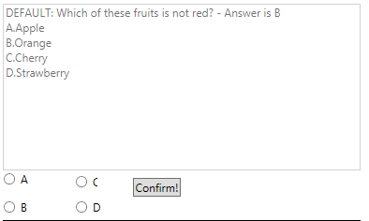

Save Game Window

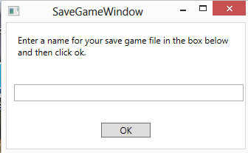

The file saved within the project structure

Game Before Save
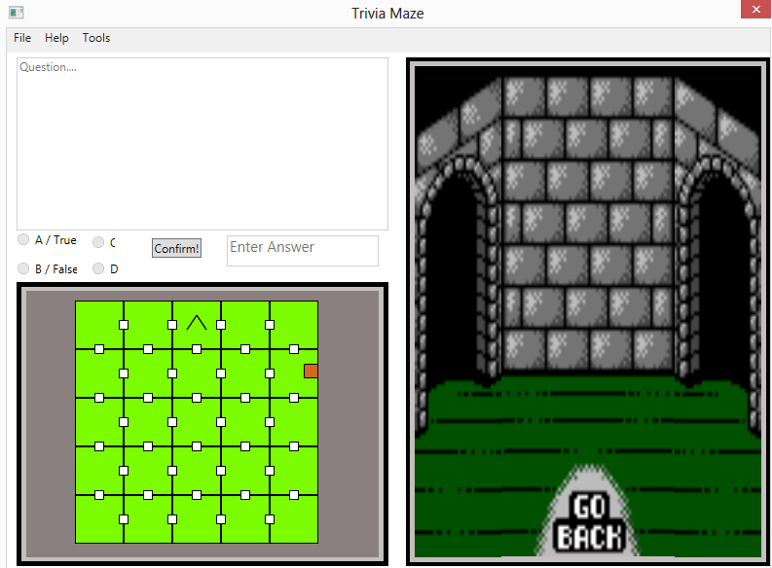

Load Game Window

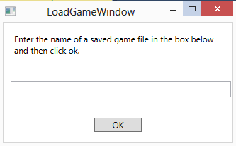

Game after load (Note: it appears we have a bug with the arrow not printing in the
mini-map)

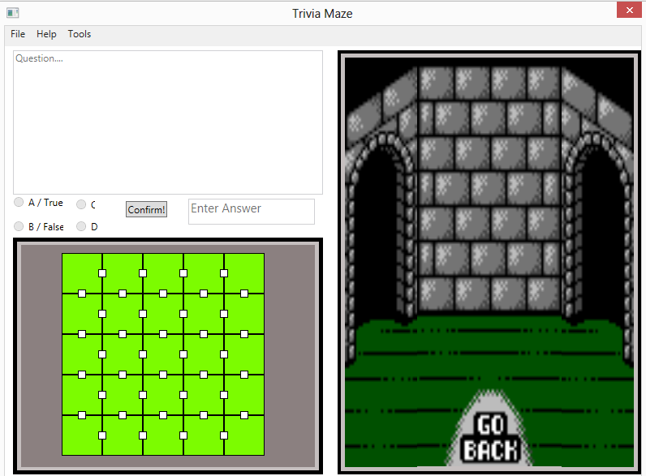

The database is now setup, however there is no visible functionality
associated with it at the moment.

Project UML

Note: The UML got locked to one of our team members so I had to draw in a
composition arrow using paint.

