Team: Twenty-Hats

Nathan Graham
Daniel Moore
Eric Laib
Kyle Johnson

End of First Iteration Deliverables

Completed user stories on Pivotal Tracker.

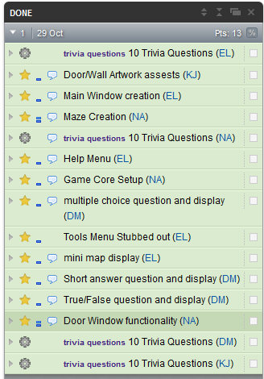

Proof of GitHub use.

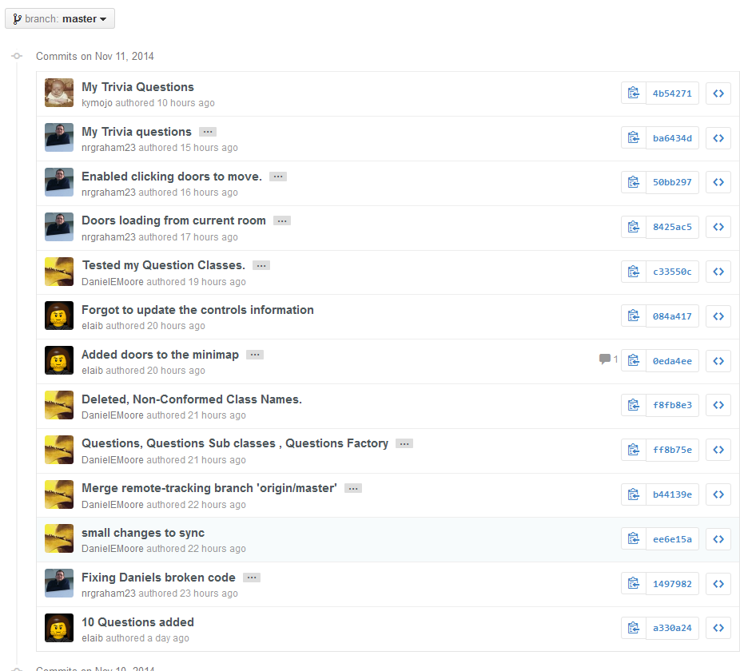
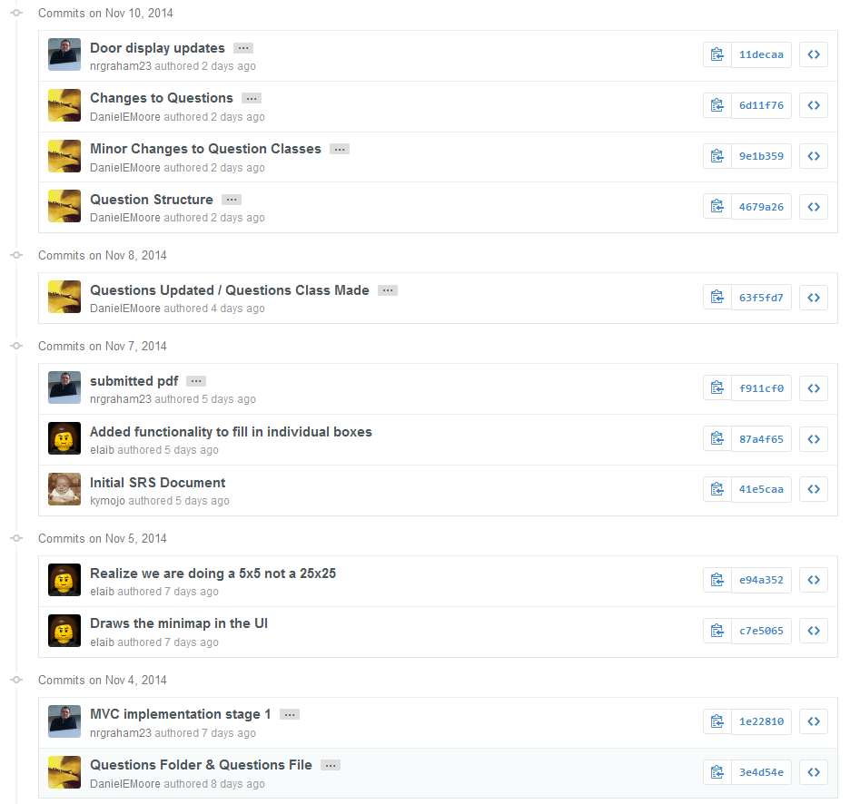

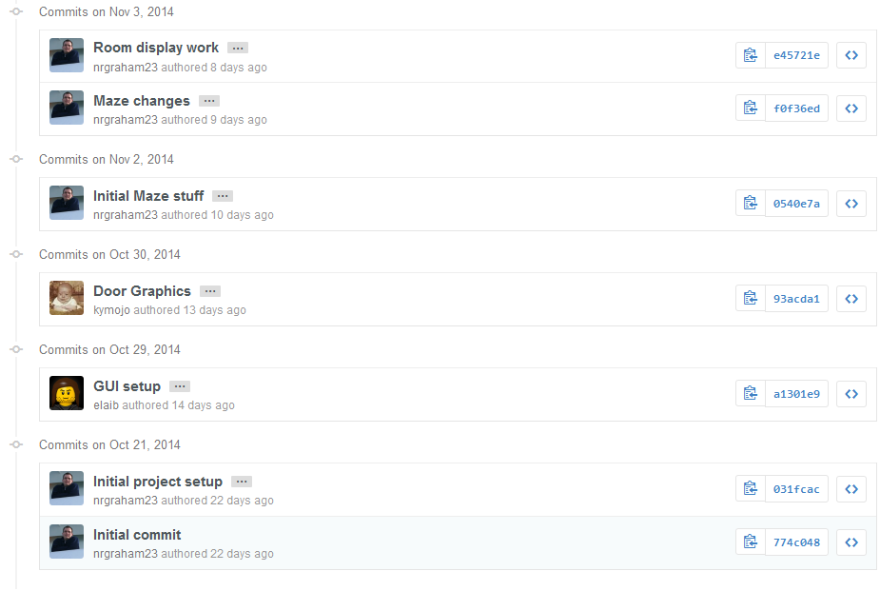

Note: It may appear that kymojo (kyle) and elaib (Eric) did very little, however
Kyle spent a good chunk of time working on the artwork for our doors, and Eric spent
a good deal of time working with getting the mini-map to function correctly.
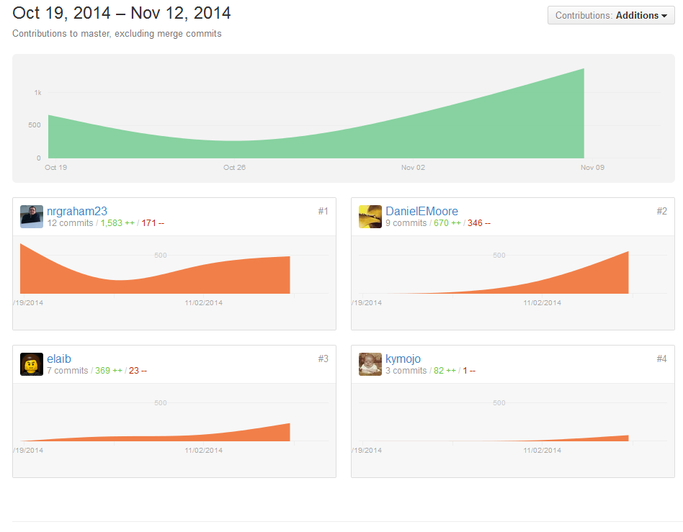

Project functionality:

Main Window showing the operational doors and an example of how the mini-map may
appear for a solved maze.
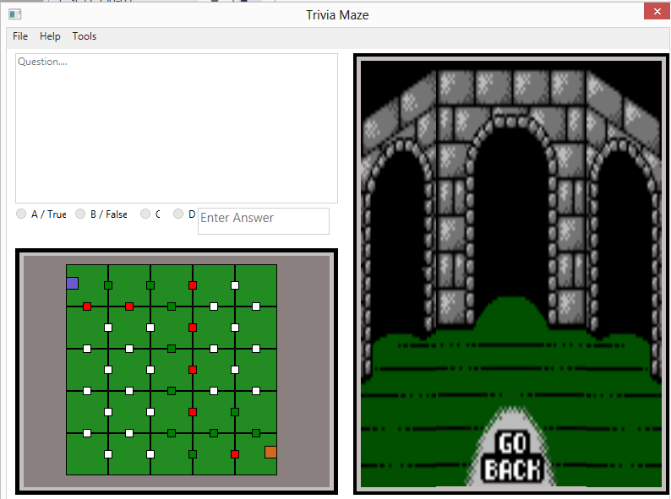
About menu
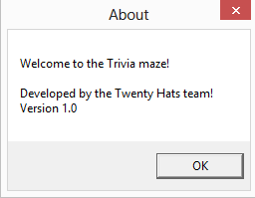

Controls Menu
