Nathan Graham
Daniel Moore
Eric Laib
Kyle Johnson

Pivotal Tracker Screen-shots

Pivotal Tracker completed stories

Iteration 1
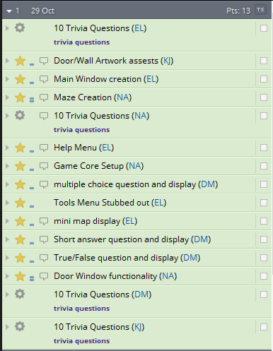

Iteration 2
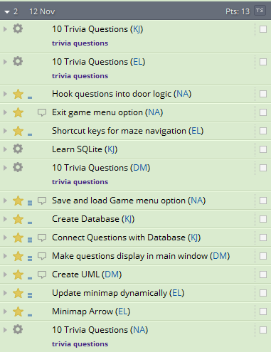

Iteration 3
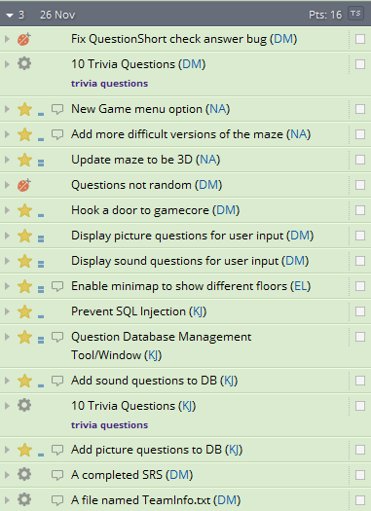

Iteration 4
Technically there was no iteration 4, however some final chores we had
on Pivotal Tracker were counted as part of a fourth iteration.
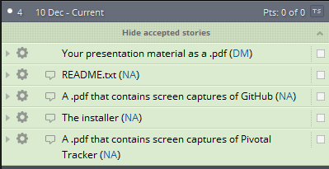

We pushed hard at the end and completed all stories we had planned for our project.
Therefore, there were no stories left in the ice box or uncompleted.

