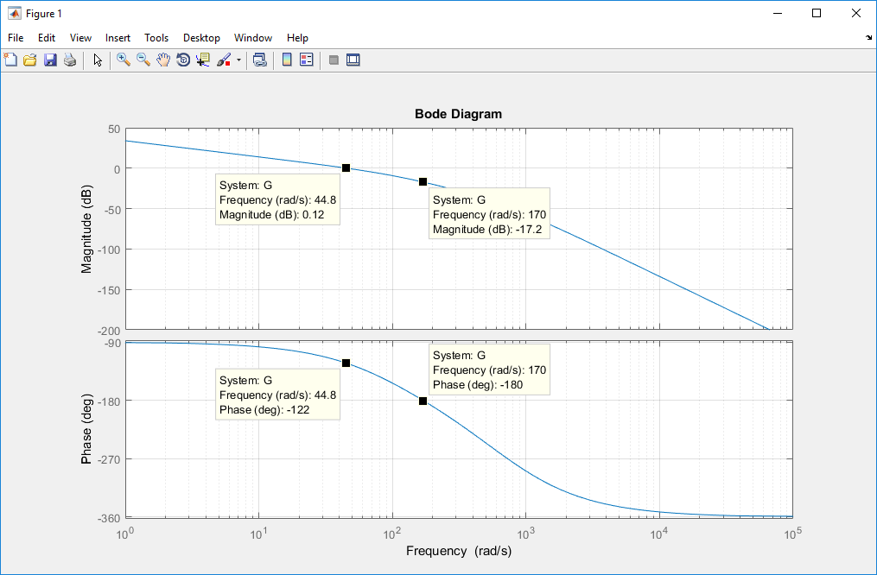  
**Figure 1**: Bode plot required for Part A

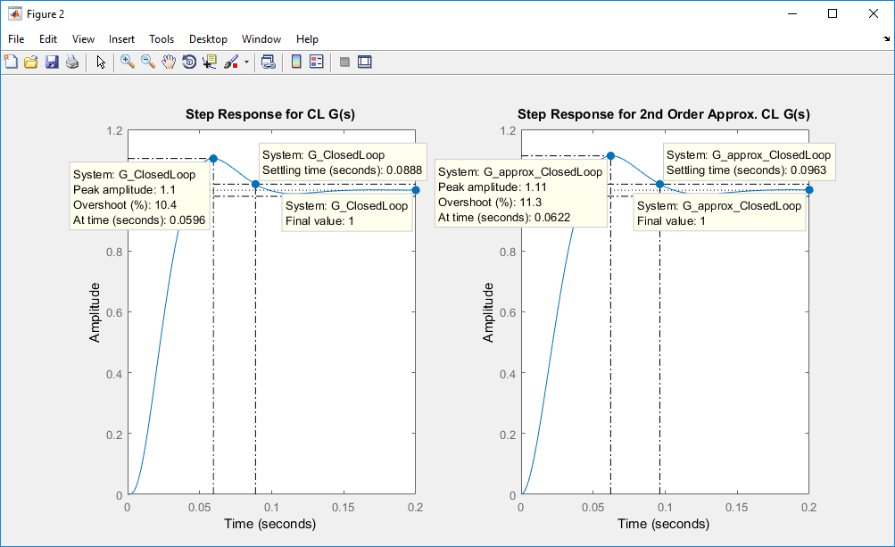  
**Figure 2**: MATLAB verification for Part C, comparing actual step response and second-order   
 approximated step response