Extraction Scoring System

Illustration (Example)
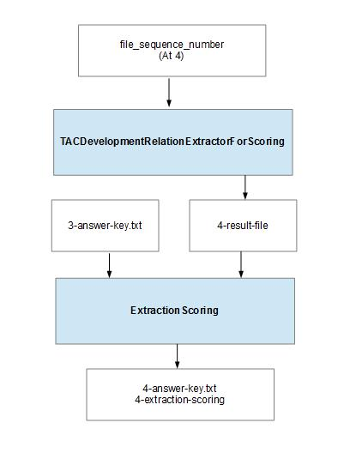
1. Inputs

1. file of extractions to score
2. file of answer key extractions

2. Outputs

1. scoring report
2. file with answer key and extractions-not-found-in-answer-key-which-need-to-be-tagged

3. Arguments

1. (optional) arg(0) can be an integer, to specify the sequence-number which is used to determine the input files to read and the file names used for output files

4. How to Run

0. edit ImplicitRelationExtractor/src/main/resources/extraction-scoring.conf
to point to your desired input and output files
1. cd ImplicitRelationExtractor
2. sbt
3. sbt> runMain testers.ExtractionScoring

5. Assumptions

1. Input Files:

1. Ignored Lines:
-input lines which don't start with an integer are ignored;
e.g.,a header line of column names can be included and will be ignored

2. Sequence Number:
-file_sequence_number is the prefix for the input extractions-file, and the output scoring report and the output answer-key-with-new-extractions-file

-(file_sequence_number – 1) is the prefix for the input answer-key

Relation Extraction and Extraction Scoring System

1. How to Run

0. edit tac-extractor-for-scoring.conf and extraction-scoring.conf
1. cd ImplicitRelationExtractor
2. sbt
3. sbt> runMain tac.TACDevelopmentRelationExtractorAndScoring

