Nathan West

Yonathan Mekonnen

Derrick Adjei

Project 1 Report

09/15/18

**Scenario A:** For this scenario, only the height of males and females were considered. A normal distribution scatter plot was created using Python. The male heights were centered around the average male height (5.9), with a standard deviation of 0.1. The female heights were centered around the average female height (5.4), with a standard deviation of 0.1. The resulting graph is shown below (Figure 1).

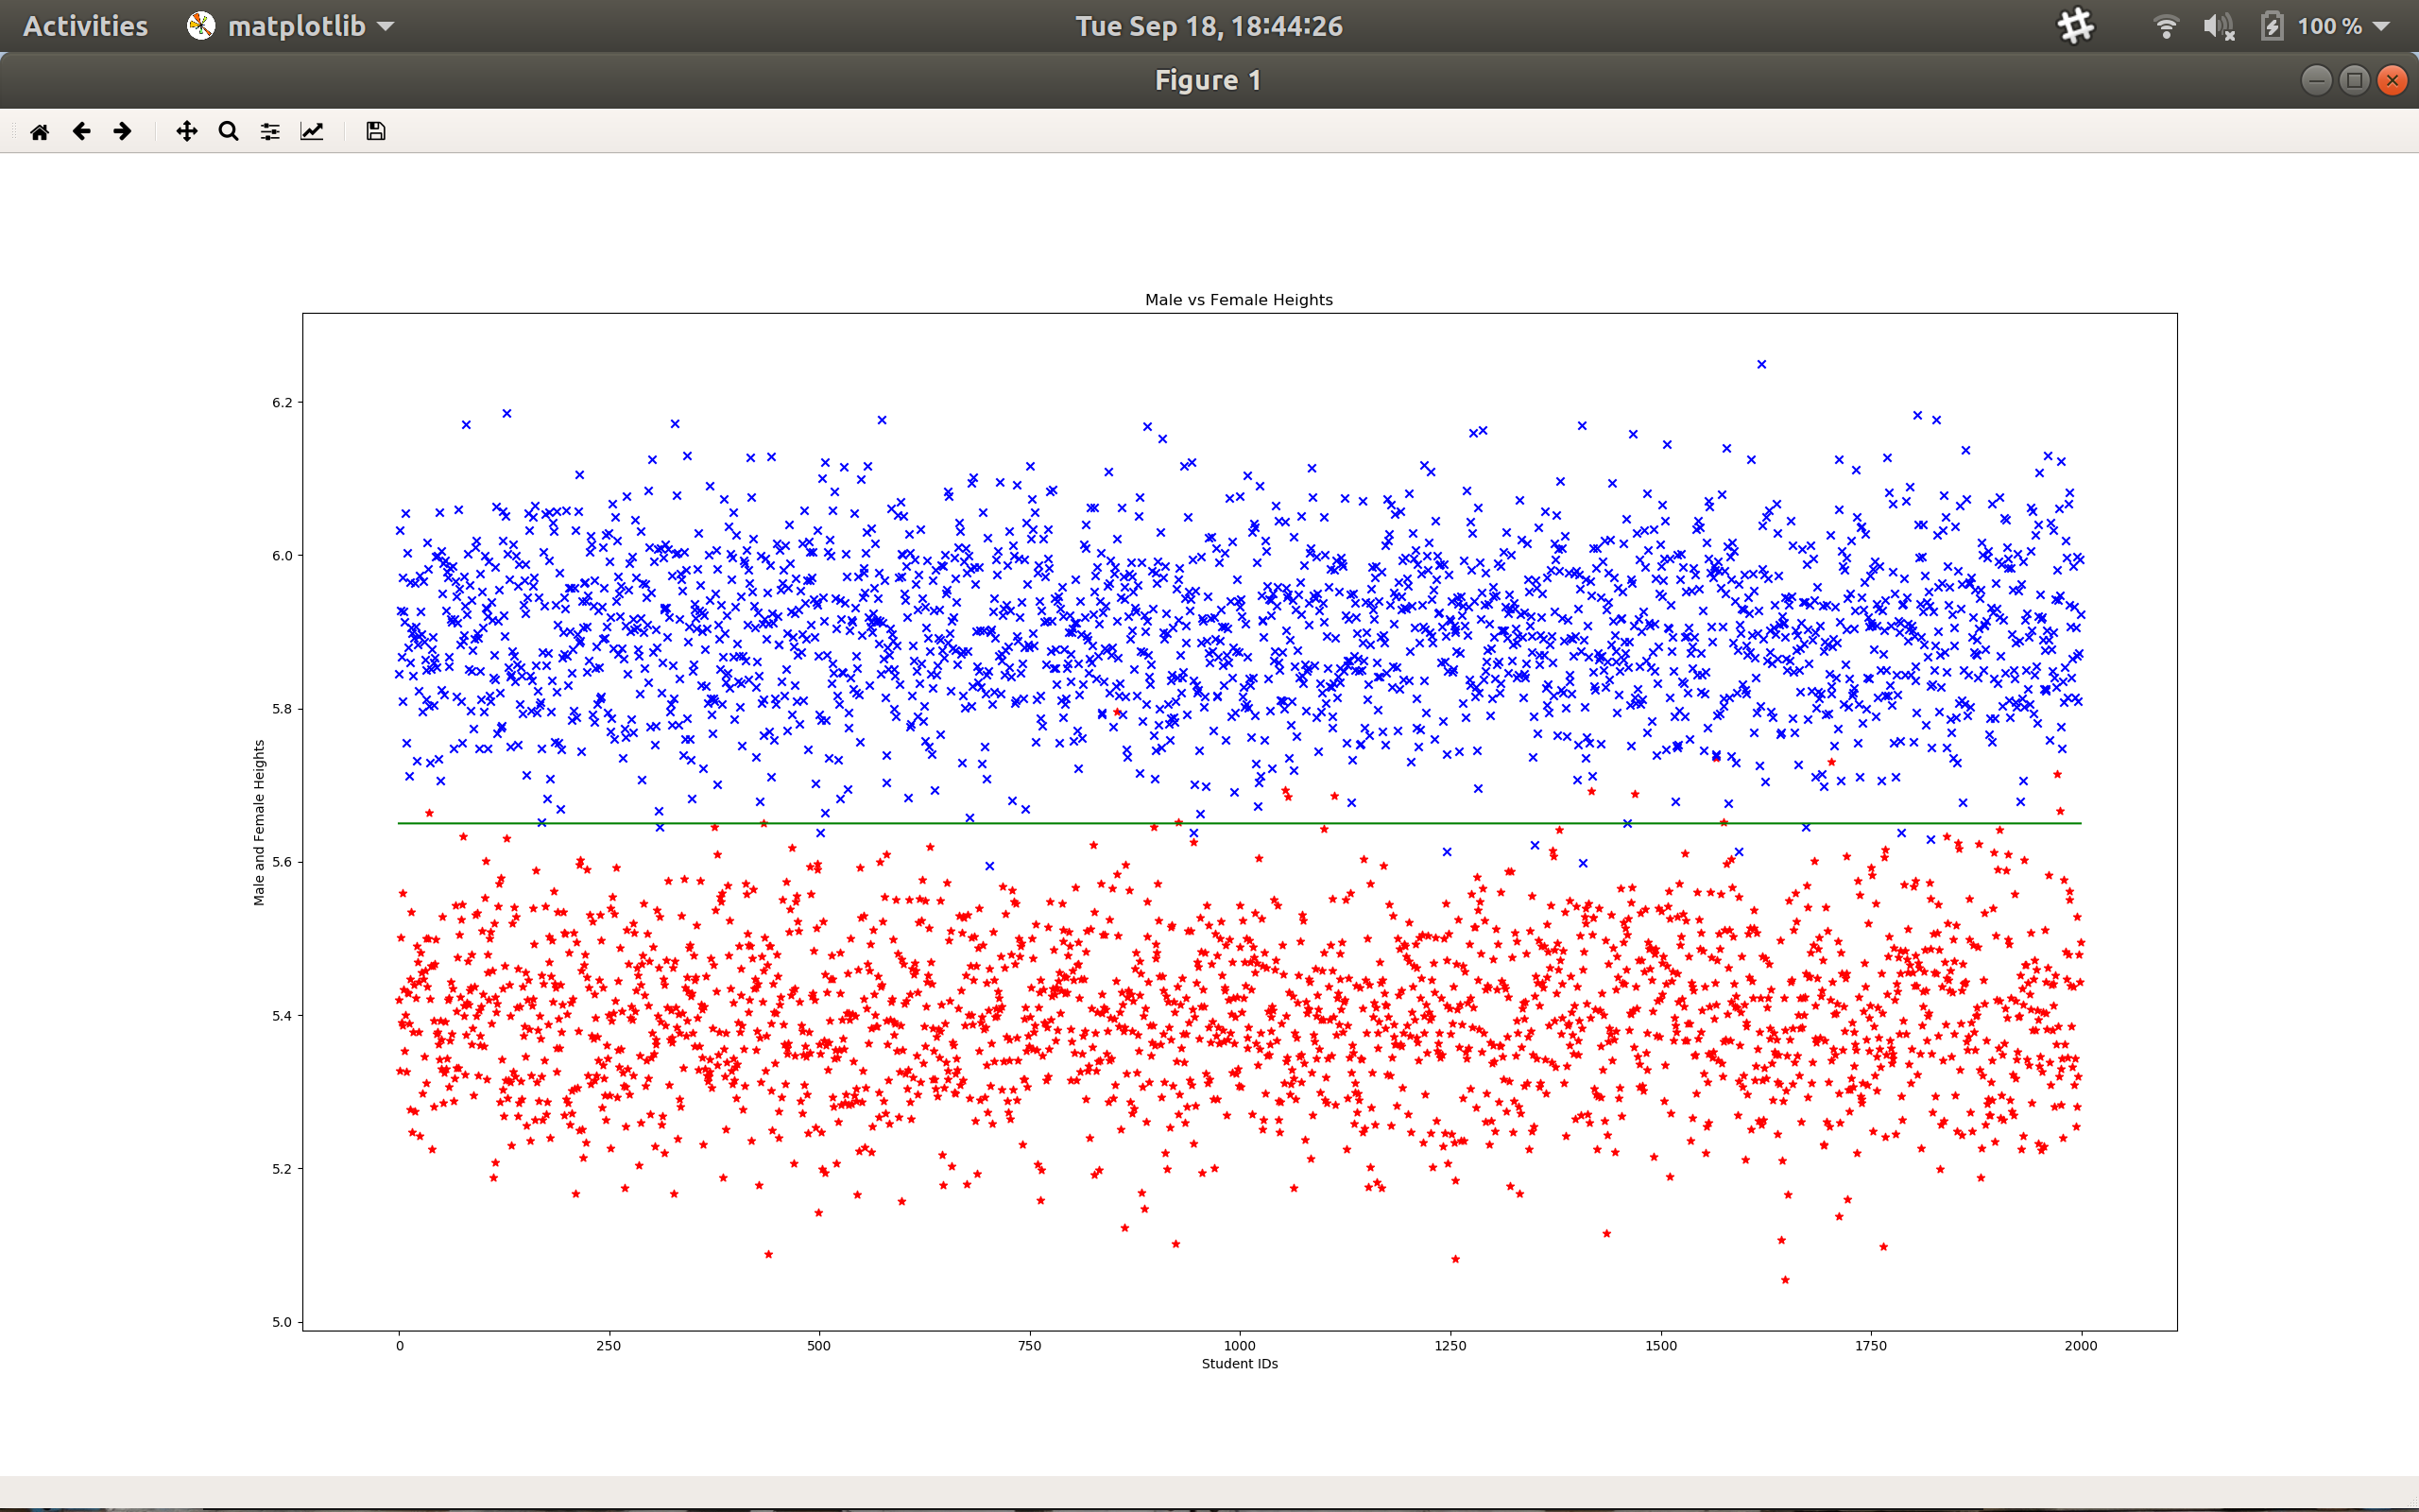

Figure 1 shows a normal distribution of male and female heights. The blue color represents a male student while the red color represents a female student. The green line represents the line of separation, which is defined as y = 2000(0) + 5.65 or y = 5.65. The neuron will fire if the sample is above or below the line. The accuracy and error rate of this sample is discussed below.

**Scenario B:** For this scenario, both the weights and heights of males and females were considered. A normal distribution scatter plot was created using Python. The male weights are centered around the average male weight (195.7) with a standard deviation of 20. The male heights are centered around the average male height (5.9) with a standard deviation of 0.1. The female weights were centered around the average female weight (168.5) with a standard deviation of 20. The female heights are centered around the average female height (5.4) with a standard deviation of 0.1. The resulting graph is shown below (Figure 2).

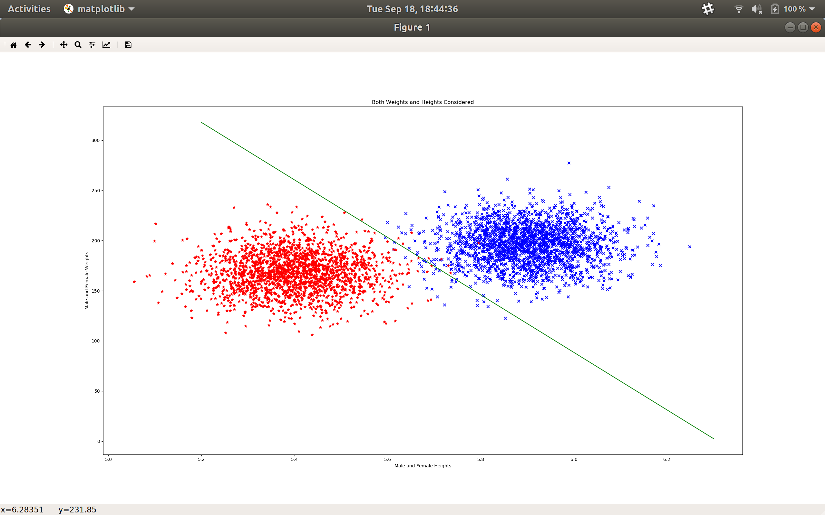

Figure 2 shows the normal distribution of male and female heights and weights. The blue color represents male students, while the red color represents female students. The green line represents the line of separation which is defined as y = -28.65x + 375. The accuracy and error rate is discussed below.