  June 5th, 2018 | Prineha Narang  Assistant Professor of Computational Materials Science  304 Pierce Hall  29 Oxford St., Cambridge MA 02138  Phone: (617) 496-4710  Email: prineha@seas.harvard.edu
Prof. Michael Thoennessen
Editor in Chief, Physical Review Letters.

Dear Prof. Michael Thoennesen,

For these reasons, we believe that this Letter is well suited to the broad and interdisciplinary readership of Physical Review Letters and very timely. Enclosed is a list of prominent scientists, both theorists and experimentalists, across relevant fields of quantum optics and ab-initio QED that we recommend as potential reviewers.
Please feel free to contact me at prineha@seas.harvard.edu with any additional questions.
Yours Sincerely,
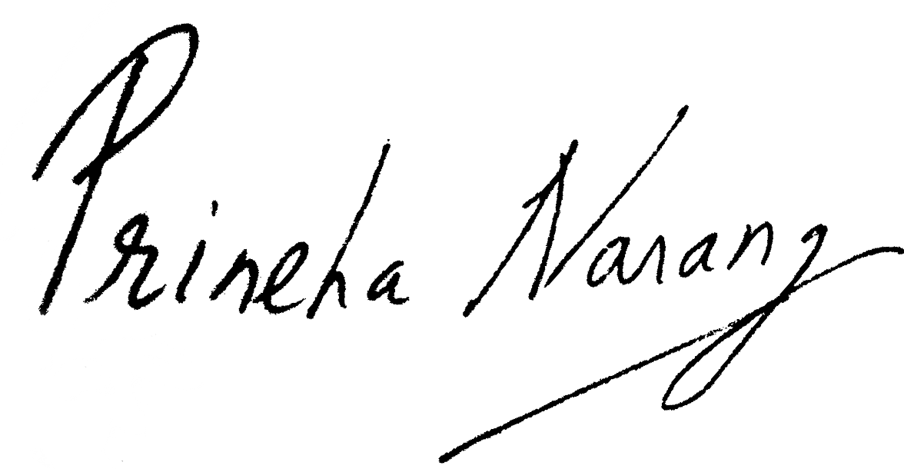
Professor Prineha Narang.
Suggested Reviewers & Reviewer Context:
- Professor Jeremy J. Baumberg, Professor of Nanoscience at the University of Cambridge, Email: jjb12@cam.ac.uk (Picoscale Quantum Optics and Light-matter Interactions)
- Professor Angel Rubio, Director, Max Planck Institute for the Structure and Dynamics of Matter. Email: angel.rubio@mpsd.mpg.de (Ab initio Methods for Microscopic Dynamics in Optical Materials and Quantum Chemistry)
- Professor Owen Miller, Professor of Applied Physics, Yale University, Email: owen.miller@yale.edu (Computational approaches to Light-Matter interactions)
- Professor Aashish Clerk, Institute of Molecular Engineering, University of Chicago, Email: aaclerk@uchicago.edu (Quantum Systems)
- Dr. Claudiu Genes, Max Planck Institute for the Science of Light, Erlangen, Email: claudiu.genes@mpl.mpg.de (Quantum Optics)
- Professor Sir John Pendry, Faculty of Natural Sciences, Department of Physics, Imperial College, London, Email: j.pendry@imperial.ac.uk (Nonlinear Optics and Photonics)
- Professor Alejandro Rodriguez, Department of Electrical Engineering, Princeton University, Email: arod@princeton.edu (Casimir and van der Waals forces)
- Professor Francis C. Spano, Department of Chemistry, Temple University University, Email: spano@temple.edu (Strong vibrational light-matter coupling)
- Prof. Gil Refael, Department of Physics, Mathematics and Astronomy, California Institute of Technology, Email: refael@caltech.edu (Condensed Matter Physics)

