  November 9th, 2018 | Prineha Narang  Assistant Professor of Computational Materials Science  304 Pierce Hall  29 Oxford St., Cambridge MA 02138  Phone: (617) 496-4710  Email: prineha@seas.harvard.edu
Dr. Michael Thoennessen
Editor in Chief, Physical Review Letters,
American Physical Society,
1 Research Road, Ridge, NY 11961.

Dear Dr. Thoennessen,

We hereby submit our manuscript entitled ‘Variational theory of non-relativistic quantum electrodynamics’ by Rivera et al. for consideration as a Letter.

The ability to achieve ultra-strong coupling between light and matter promises to bring about new concepts for manipulating light at the atomic-scale and, simultaneously, provides fundamentally new insight into quantum electrodynamics (QED). It also necessitates new and quantitative theories of QED phenomena in complex electronic and photonic systems. In this work, we introduce a new paradigm to determine from first principles the dynamics of any system of coupled light and matter in the non-perturbative regime of QED. Our paper establishes for the first time an explicit set of equations that determines ground-state, excited-state, and real-space properties of an arbitrary multi-electron system interacting with quantized electromagnetic fields in arbitrary photonic structures and in three dimensions. Importantly, we find that despite these equations being variational in origin, these equations give an extremely accurate (> 99%) and semi-analytical account of ground- and excited- state energies in the multi-mode Rabi model, which despite being a very actively studied and highly general model in quantum optics, has no analytical solution.

Interestingly, our general theory reveals unexpected fundamental physics even in this well-studied model, including screening effects that saturate light-matter coupling in the non-perturbative regime, and blue-shift effects that suppress resonances between photons and electrons. The variational theory advanced in this manuscript also constitutes the first non-perturbative theory of Lamb shifts felt by atoms interacting with quantized electromagnetic fields in photonic structures. The essential new physics in this non-perturbative theory is that instead of the energy shift of atomic levels being a result of virtual emission and re-absorption of photons of the bare nanophotonic structure, it results from virtual emission and re-absorption of ‘photonic quasiparticles’ whose properties are influenced by the emitter itself. This theory reproduces extremely well the energy spectrum of the Rabi model in non-perturbative QED.

Our results represent an important and general advance in physics for many reasons: 1) Solutions to problems in quantum electrodynamics in the non-perturbative regime are essentially non-existent in the literature. 2) An explicit method to accurately solve such problems are of utmost importance in context of recent experimental advances, and our theory provides just that. 3) Finally, we expect these equations, being highly general, will provide a new starting point for many researchers analyzing any coupled light-matter system in the newly developing field of ab initio quantum optics and electrodynamics. We thus expect many additional fundamental contributions to quantum optics and electrodynamics to be derived from this work.

We expect our results will be of great interest to scientists across a broad spectrum of physics including those who study quantum optics, superconducting circuits, cavity QED, chemistry in the strong-coupling regime, condensed matter physics, and first-principles approaches to strongly coupled quantum field theories. For these reasons, we believe that this timely Letter is well suited to the broad and interdisciplinary readership of Physical Review Letters. Please feel free to contact me at prineha@seas.harvard.edu with any additional questions.

Yours Sincerely,
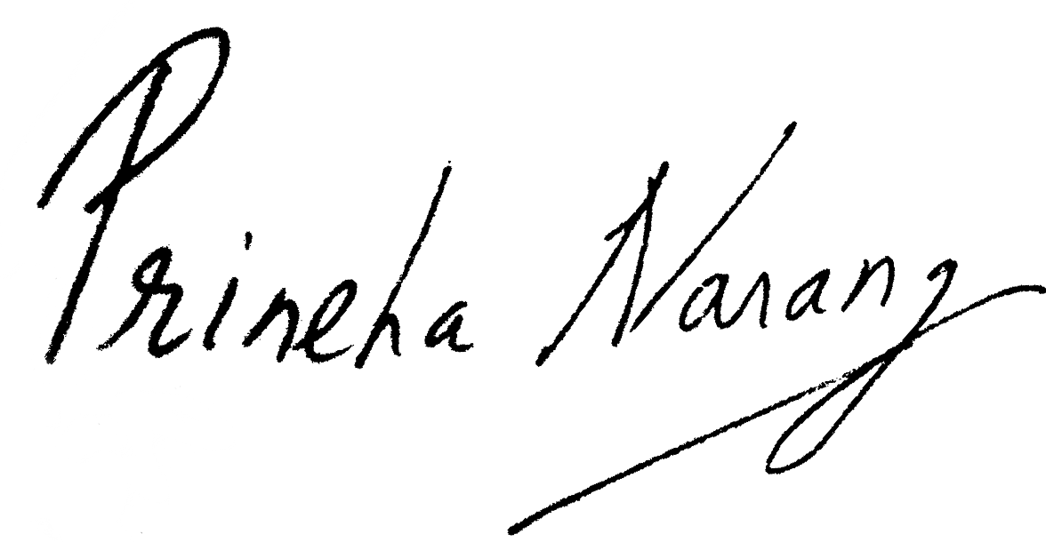
Professor Prineha Narang.
Enclosed is a list of prominent scientists, both theorists and experimentalists, across relevant fields of quantum optics, atomic, molecular, and optical (AMO) physics, condensed matter physics and ab initio QED that we recommend as potential reviewers.

Suggested Reviewers & Reviewer Context:
- Professor Jeremy J. Baumberg, Professor of Nanoscience at the University of Cambridge, Email: jjb12@cam.ac.uk (Picoscale Quantum Optics and Light-matter Interactions)
- Professor Angel Rubio, Director, Max Planck Institute for the Structure and Dynamics of Matter. Email: angel.rubio@mpsd.mpg.de (Ab initio Methods for Microscopic Dynamics in Optical Materials and Quantum Chemistry)
- Professor Aashish Clerk, Institute of Molecular Engineering, University of Chicago, Email: aaclerk@uchicago.edu (Quantum Systems)
- Dr. Claudiu Genes, Max Planck Institute for the Science of Light, Erlangen, Email: claudiu.genes@mpl.mpg.de (Quantum Optics)
- Professor Sir John Pendry, Faculty of Natural Sciences, Department of Physics, Imperial College, London, Email: j.pendry@imperial.ac.uk (Nonlinear Optics and Photonics)
- Professor Francis C. Spano, Department of Chemistry, Temple University University, Email: spano@temple.edu (Strong vibrational light-matter coupling)
- Professor Gil Refael, Department of Physics, Mathematics and Astronomy, California Institute of Technology, Email: refael@caltech.edu (Condensed Matter Physics)

