**Variability of Hydraulic Properties and Hydrophobicity in a Coarse-Textured** **Inceptisol Cultivated with Maize in the Mediterranean Area of Chile**

**Nicolás Riveras1,2,*, Carla Silva1, Osvaldo Salazar1, Thomas Scholten2, Steffen Seitz2, Oscar Seguel1**

1 Universidad de Chile, Departamento de Ingeniería y Suelos, Facultad de Ciencias Agronómicas, Av. Santa Rosa 11315, La Pintana, Santiago, Chile

2 University of Tübingen, Department of Geosciences, Soil Science and Geomorphology, Rümelinstrasse 19–23, 72070 Tübingen, Germany

*Corresponding author (nicolas-andres.riveras-munoz@uni-tuebingen.de)

# Abstract

The O'Higgins Region, in central Chile, concentrates 40% of the country's maize production, mainly under intensive tillage. This has generated soil physical degradation modifying water movement on it, which vary even in short distances. In this study we wanted to evaluate the spatial variability of different physical and hydraulic properties and its relations of an Inceptisol under agricultural use. The study was conducted on a farm in central Chile, in a fallow-maize rotation under conventional tillage. Penetration resistance (PR) was measured using systematic sampling, defining areas of high and low PR, where soil samples were collected in-the-wheel-track (IT) and out-of-the-wheel-track (OT); and on Topsoil and Subsoil, establishing four treatments: IT-Topsoil, IT-Subsoil, OT-Topsoil, and OT-Subsoil. Organic matter (OM), texture, bulk density (BD), hydraulic conductivity (K) and hydrophobicity (R) were measured. The soil order was Inceptisol with sandy-loam texture. PR ranged from 0.2 to 2 MPa on topsoil and 0.6 to 2.4 MPa in subsoil, and OM content was higher with low PR. K varied from 0.6 to 18 cm h-1, being greater in depth, as tillage disturbs the topsoil stabi-lized during the season. A linear relationship was found between K and R, explaining differences between high and low PR sites

**Keywords:** soil physical functioning, hydraulic conductivity, conventional tillage, penetration resistance, hydrophobicity.

# Introduction

One of the main economic activities in Central Chile is agriculture, with maize production at the first position with 78% of the total crop surface and indicating O’Higgins Region as the largest agricultural planting area at national level {ODEPA, 2013 #75}. The average regional yield of 117 qqm ha-1 is above the national average of 106 qqm ha-1, but below the potential yield of 220 qqm ha-1that {Pioneer, 2012 #78@@author-year} has reported.

While Chile shares mostly cloudless skies during the growing season with the other Mediterranean regions, it has two advantages for maize production: (i) the cooling influence of the Humboldt Current that flows north along the western coast of South America providing cool temperatures in summer and encouraging the accumulation of biomass and (ii) in most of the world, maize is grown as a rainfed crop, while in Chile and some other very limited regions it is irrigated, resulting in yields far above the world average and making difficult an straightforward comparisons with other regions {Fischer, 2014 #89}.

Despite the very favorable conditions, the gap with the potential yield indicates the presence of limitations. In this sense, {Taylor, 1991 #65@@author-year}, point out root decreases and soil compaction as one of the main issues affecting the yield of maize, while {Hamza, 2005 #29@@author-year} attribute hydraulic properties, such as reduction in infiltration and available water, as determining factors in crop yield and root growth. In this regard, maize farmers associated to the Cooperativa Campesina Intercomunal de Peumo (COOPEUMO), in the context of a Clean Production Agreement (CPA), indicated the presence of compaction and surface runoff problems, likely related to long-term monoculture and intensive tillage {Salazar, 2013 #73}.

Tillage represents one of the most influential disturbances of the soil surface, resulting in changes of varying intensity for different soil properties {Seitz, 2020 #61}. Even if general physical restrictions generated by over-tillage are well studied, their characterization and applied assessment is difficult due to their unknown spatial distribution and high variability {Hausherr Lüder, 2019 #31}. Soil mechanical and hydraulic processes are interrelated and affect each other. Therefore, when the soil structure and pore distribution are modified, water retention and hydraulic conductivity (K) should change {Seguel, 2020 #60}. The magnitude of these changes depends on external factors such as: (i) the duration and frequency of the tillage operations; and (ii) the compaction produced by the transit of agricultural machinery and/or animal trampling {Nissen, 2006 #43}.

Sandy alluvial soils have a high K at low pressures (close to saturation), due to their greater amount of macropores (> 10μm), provided by the space between the coarse particles. However, when the pores are quickly depleted, they are filled with air, which results in a sharp decrease in the water conduction, reflected in low values of unsaturated hydraulic conductivity (Kns) {Warrick, 2001 #71}.

A widely spread and sustainable way to avoid those harmful effects on the soil in the agricultural production is the organic matter addition. Organic matter stabilizes the contact points between soil particles through cementing and the hydrophobic effect, which prevents solutes from being dissolved by water. {Piccolo, 1999 #53}, and being the main structuring agent in the case of coarse texture dominated soils {Urbanek, 2007 #67}.

However, due to the physico-chemical characteristics of certain organic compounds that coat the solid particles and have a hydrophobic effect, it can result in a reduction of the wetting rate and water repellency in the soil {Hallett, 2007 #25}. {Cuevas Becerra, 2006 #14@@author-year} describes this phenomenon, as a process of high relevance since its existence is associated to preferential flows and surface runoff.

Finally, it has to be considered that excessive tillage and incorporation of organic waste into cereal production systems leads to compaction problems that can hinder the capacity of fluid transmission in the soil {Horton, 1994 #38}. Additionally with changes in local hydrology, related to the effect of hydrophobicity and the destruction of the porous system by farming, where its distribution and variability are unknown {Buczko, 2006 #93}, we hypothesized that in a coarse textured soil under a long-term tillage and maize monoculture the spatial distribution of the hydraulic properties is associated with the state of compaction and hydrophobicity of the soil. The aims of the study were (i) to spatially quantify the state of soil compaction (inside and outside of the tire track as well as at the topsoil and subsoil) through properties of physical functionality in areas of high and low mechanical resistance and (ii) evaluate the hydraulic conductivity and hydrophobicity depending on the spatial variability of the soil and its dependence on soil compaction, for a coarse textured soil under a long-term tillage and maize monoculture.

# Materials and Methods

## Site Description

The study was carried out during the 2013-2014 season on a 2.9 ha site belonging to an associate of the Cooperativa Campesina Intercomunal de Peumo (COOPEUMO), located at San Luis in the Central Valley of Chile, O'Higgins Region, Commune of Pichidegua (Figure 1). The soil was classified as Typic Haploxerepts (Inceptisols after US Soil Taxonomy) on alluvial terraces {CIREN, 1996 #13} with textural classes varying from mainly loam at the surface to sand at 30 cm depth. Top soil (0 - 15 cm) is charaterised by neutral soil pH (pH = 6.93), low OM content (OM = 1.47%), non-saline (EC = 1.59 dS m-1) and low cation exchange capacity (CEC = 9.65 cmol(+) kg-1) accoriding to {Salazar, 2014 #81@@author-year}. At the study site, long-term tillage and maize monoculture has been carried out (> 15 yr), when maize is cultivated between the months of September and March, while the rest of the year the soil is fallow.

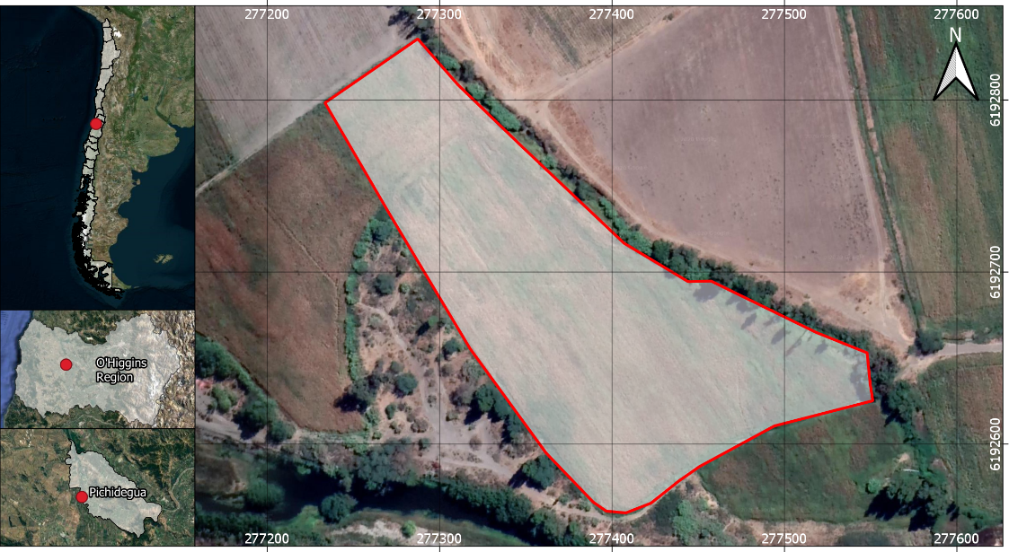

**Figure 1.** Location map of San Luis (277399 E- 6192699 S), experimental site (Google Earth, datum WSG 1984).

The Commune of Pichidegua is under a semi-arid Mediterranean climate. It has an average annual air temperature of 14.6°C, a monthly maximum of 26.3°C in the month of January and a monthly minimum of 6.1°C in August. Precipitations are concentrated from May to October and border an annual average of 550 mm, with a potential evapotranspiration of 940 mm year-1 {Uribe, 2012 #68}.

Maize production is conducted under furrow irrigation with traditional tillage management, as described by and {Salazar, 2017 #83@@author-year}. Soil preparation with a disc plough is carried out immediately after the harvest or before planting, with the number of tractor passes varying from 5 to 8 times, using the same routes, making it possible to identify areas where the machinery transited, directly in-the-wheel-track (WT) and outside-the-wheel-track (OWT). Stubble and plant residues from the previous season are consumed by cattle through direct grazing and the remnant is incorporated to the soil.

## Study Design

In November 2013, with the maize crop in the eighth leaf, an initial diagnosis of the state of compaction of the study site was realized. Soil penetration resistance (PR) was measured identifying areas of high and low PR (according to the 0-5 cm layer). In each zone, four experimental units of 1 m2 each were delimited randomly.Within each experimental unit, the area relative to the passage of machinery was identified, designating the in-the-wheel-track (WT) and outside-the-wheel-track (OWT) treatments. Moreover, due to repeated handling over several seasons, based on visual characteristics and mechanical resistance, it was possible to identify the limit of the plow layer (approximately 30 cm), using this criteria to separate in topsoil and subsoil layers. From the combination of the tire tracks of the machinery and the limit of the arable layer, 4 treatments were established: T1: OWT-Topsoil; T2: OWT-Subsoil; T3: WT-Topsoil; T4: WT-Subsoil. Hydraulic conductivity was measured in both PR zones and all four treatments with 4 replicates each (n = 32). Undisturbed soil samples from the topsoil and subsoil layers were taken in cylinders 5 cm high and 5.9 cm in diameter for the determination of hydrophobicity. Disturbed soil samples were collected at depths of 0 – 10 cm and 30 – 40 cm.

## Soil Property Measurements

Soil compaction was characterized as the spatial variability of penetration resistance (PR) with a Penetrologger (Eijkelkamp, Giesbeek, The Netherlands), with measurements distribuited in a regular grid of 30 m x 30 m. All the measurements were taken in the same position of the furrow, avoiding the tractor's tireprint, to prevent distortions of the values. The device was equipped with a GPS and data storage memory, allowing to spatially locate the evaluated points.

Considering that mechanical loads exert their greatest effect in the topsoil layer, PR mean values from 0-5 cm were interpolated by kriging, generating a spatial distribution map of PR. The measurement was performed 2 days after an irrigation, with a water content close to field capacity and a penetration down to 80 cm depth. The results where used to identify two areas with different penetration resistance (high and low).

Texture was measured according to the Bouyoucos hydrometer method and the bulk density (BD) by the cylinder method {Sandoval, 2012 #55}, while the content of organic matter (OM) was determined by the calcination method {Sadzawka, 2004 #54}.

Unsaturated hydraulic conductivity (Kns) measurements were conducted in the field between April and May 2014 and prior to farmers soil preparation for the next season. It was measured with mini disk infiltrometers (Decagon Devices, Pullman, WA, USA). A fine sand layer was added to ensure the contact of the porous plate to the ground. The infiltrated water was measured every 30 secons for a period of 10 minutes, for 1, 2, 4 and 6 hPa of soil water pressure. The obtained data was procecced by the method of {Zhang, 1997 #72@@author-year} to determine Kns as function of the applied soil water pressure, defined as:

|  |  |
| --- | --- |
|  | (Eq. 1) |

where C1 corresponds to curvature of the parabola at pressures of 1, 2, 4 and 6 hPa, obtained from a quadratic regression between the accumulated infiltration and the root of time, and A is the factor of van Genuchten {Carsel, 1988 #10} and depends of soil texture and the sorption.

With the distribution of Kns as a function of the supplied pressure, linear adjustments were made to extrapolate the saturated hydraulic conductivity (Ks) to zero pressure.

Hydrophobicity was evaluated by the repellency index (R) according to the methodology described by {Tillman, 1989 #66@@author-year}. A self-made sorptivity equipment device based on the specifications of {Leeds-Harrison, 1994 #45@@author-year}. The device consists of a network of 4 mm capillaries that conduct the liquid from a container to an air-dry soil sample in close contact via a sponge, setting at the end a negative pressure (h) of 1 cm of water column or -1 hPa, which causes a suction that makes the liquid flow through the capillary. The amount of liquid held in the sample and the capillary system is registered with a precision balance, and from the ratio of water and ethanol 95% was obtained the R index.

First the test was performed infiltrating water, then the sample was air dried and finally the ethanol infiltration test was repeated. The infiltration of each liquid was measured every 15 seconds, until 75 seconds, and from the density of each liquid, the final infiltration volume was determined. With the data recorded, the volume of water was plotted as a function of time, obtaining the liquid flow rate. From this, we estimated the sorptivity in water and ethanol considering a capillary of 4 mm diameter, factor b = 0.55 and f = 1.0 according to the proposed by {Hallett, 1999 #27@@author-year}, determining the index R by Equation 2:

R = 1.95 * (Se/Sw) (Eq. 2)

where Se corresponds to sorptivity in ethanol, Sw to sorptivity in water and 1.95 is due to the constant that considers the properties of water and ethanol (viscosity, surface tension).

Soils were considered hydrophobic, if R was greater than 1.95 and hydrophilic, if it was less than 1.95 {Tillman, 1989 #66}.

## Statistical Analysis

First, a penetration resistance (PR) map was generated to determine the distribution of this property in the study site. For this, a linear interpolation with kriging was made with the software Surfer 10. Areas of high PR and low PR where identified and used as blocking criteria.

A randomized complete block design (RCBD) was established, using areas with high and low PR as blocking criteria. In each block, a 2-factorial treatment was applied, from the combination of (i) two relative positions to the tractor's track (in-the-wheel-track (WT) and outside-the-wheel-track (OWT)) and (ii) two relative positions to the plowable layer (topsoil and subsoil) with a total of 4 treatments (see above). Four repetitions of each treatment where randomly distributed in each block.

To determine the treatment effect, an ANOVA was conducted with a confidence level of 95% using the Infostat software {Di Rienzo, 2005 #77}. In case of significant differences, the treatments were analyzed with the test of multiple comparisons of the Least Significant Difference (LSD) (α ≤ 0,05). Results of hydraulic conductivity (K) were determined based on a linear regression of Kns by the supplied tension (1, 2, 4 and 6 hPa). Then the regression coeficients where compared through a t-test, comparing pairs with the slopes and intercepts of the linear model. Moreover, a General Mixed Linear Model (MLGM) was performed with the whole set of data (Kns for four repetitions at four soil water pressure stages, n = 16) and normalized distributions, when data did not show normal distribution and therefore the assumptions for errors were not fulfilled {Badiella, 2011 #5}. Because both approaches gave comparable results, the first statistical analysis is presented as representative of the Kns, but MLGM was used to determine the confidence intervals for intercepts (95%), equivalent to K saturated.

Dependence between variables was explored through stepwise regression using the *stats* package of R 3.5.3. Model selection was made based on simplicity, Akaike Information Criterion (AIC) and avoiding collinearity between variables.

Finally, a correlation analysis was performed between the variables hydrophobicity (R index) and saturated hydraulic conductivity (Ks), to determine if the water repellency alters the water flow in the soil. For this, a logarithmic adjustment of the variable K was performed as a function of the R index, achieving an adjustment with a significance of 95%.

# Results and Discussion

## State of Soil Compaction and Related Physical Soil Properties

**Penetration Resistance (PR).** The knowledge of the spatial distribution of soil penetration resistance is useful to identify compacted areas. With this problem stated, management measures can be generated to minimize negative effects, such as decreasing crop yields or the risk of erosion due to increased surface runoff {Usowicz, 2009 #69}. According to this, the identification of the variability of the soil mechanical resistance allowed to determine two zones: one high and one low PR (values from depth colums of 0 – 5 cm). Accordingly, we then performed evaluations of the other soil properties for each zone separately, to obtain homogeneous treatments and to decrease the variability between the samples.

The depth trend of PR can be clearly distinguished between high and low zone (Figure 2). The area of high PR is a consequence of repeated traffic at the site associated with the field entrance. This continuous traffic has caused a deterioration of the soil structure and the porous system {Strudley, 2008 #63} with a reorganization of the particles, generating a plow pan to 30 cm depth approximately. As for the area of low PR, this presents lower values on the surface, but in depth it is constantly increasing, even surpassing the values of the zone of high PR. A similar process of particle rearrangement would occur in this zone, but the development of the plow pan would be at a greater depth (40 cm) and with a greater intensity.

|  |
| --- |
|  |

**Figure 2.** Average areas of high (blue) and low (green) PR, defined in the 0 – 5 cm soil layer.

The areas of high and low PR can be clearly identified on the spatial distribution map of the PR obtained in the field (Figure 3). The constant increase of the PR in depth in areas of low PR is a consequence of the overlying soil mass, since it constitutes a normal load towards subsurface layers, generating accumulations of pressures as the depth increases {Schäffer, 2010 #56}. The alteration of this tendency can be due to the stratification product of the pedogenesis or to processes of compaction as result of mechanization {Horn, 2007 #37}. Even if PR does not exceed 8000 kPa, it is considered as being at a very high level according to {Schoeneberger, 2012 #57@@author-year}.

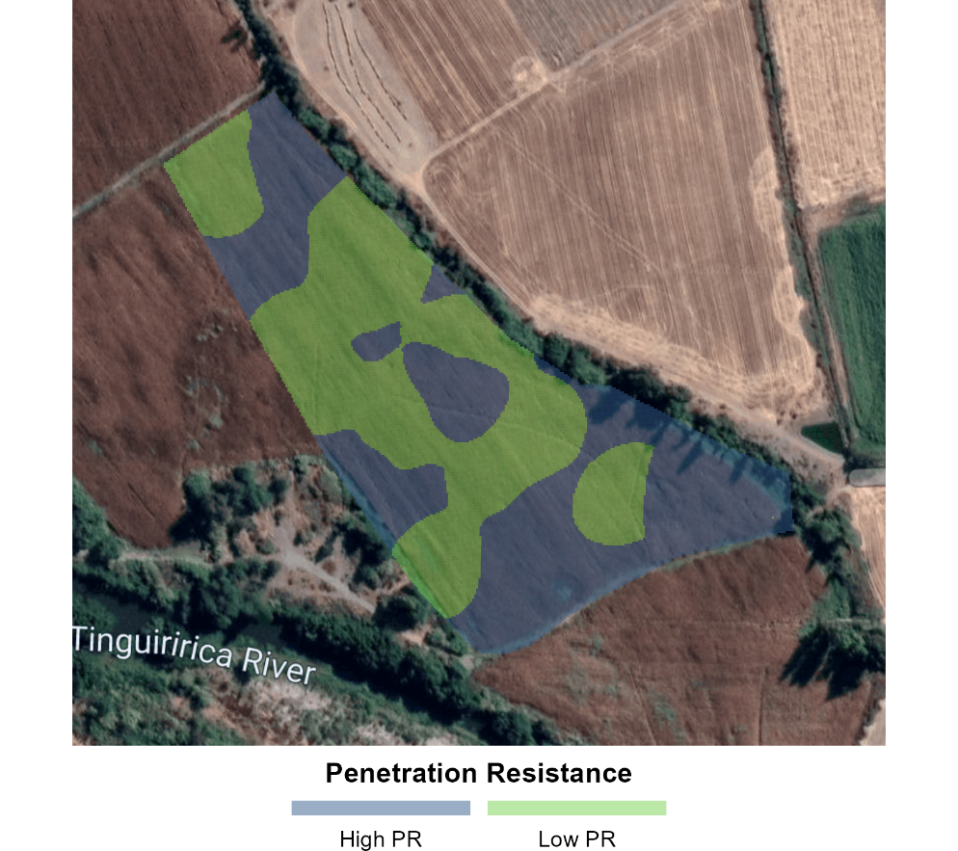

**Figure 3.** Spatial distribution of PR (0 – 5 cm) at the study site. Areas of high PR (blue) and low PR (green).

High PR zone (Figure 3) corresponds to the entry of the field, which presents higher values of penetration resistance, given the greater traffic frequency resulting from the maneuvers of seasonal work. On the other hand, the area of low PR, presents values related to lower exposure to traffic. Furthermore, the natural variability within the textural classes of the soil is intervening in the response to compaction processes (cf. {Horn, 2003 #34@@author-year}; see below).

It is known that the effect of the number of tractor passages is cumulative and that the PR increases with the intensity of the traffic {Nissen, 2006 #43}. This was evaluated by {Usowicz, 2009 #69@@author-year}, who determined that the maximum effect occurs between the first and third passage of the tractor at a depth range of 0 to 60 cm and that this effect decreases to a greater depth. Thus, consequences are manifested predominantly near the soil surface. In addition, {Horn, 2009 #35@@author-year} showed that tires with a load of 3.3 Mg exert an average normal stress of approximately 50 kPa to the 40 cm depth layer and increasing this load to 6.5 Mg leads to tensions of more then 100 kPa even down to 60 cm depth. The same authors clarified that a loamy soil presents a greater sensitivity to the external loads than a sandy or clayey soil due to differences in the pore size distribution.

The effects on root growth as result of increased mechanical strength were studied by {Taylor, 1991 #65}, who determined a linear decrease in root elongation with PR values higher than 500 kPa. On the other hand, {Pérez, 2010 #52@@author-year} consider that root growth equals zero with a soil penetration resistance of approximately 5000 kPa and, in the specific case of the maize crop, {Hadas, 1997 #24@@author-year} reported no root growth values in a range of 1600 to 3700 kPa. {Feldman, 1994 #21@@author-year} indicates that the typical rooting depth of maize varies between 150 and 180 cm, depending on the textural class of the soil. This finding indicates that at the sites of low PR, the rooting of maize will be affected under 40 cm of depth (Figure 2), resulting in low exploration of the plant roots and reduction and heterogeneity of the maize yields at the study site.

**Texture.** The texture influences the mechanical behavior and ease of soil tillage, the amount of water and air it can hold and the speed with which water penetrates and circulates in it {FAO, 2009 #20}. The particle size is determined by the parent material and the pedogenesis, and accordingly affect erosion processes including other properties such as structure, porosity and consistency. The granulometric analysis of the soil allowed defining a class of sandy loam texture (SL) for all the study factors, with an average percentage of clay of 7.4% (Table 1). This result allows inferences regarding the structure and stability of the aggregates. It is known that soils dominated by sand tend to have a weak structure grade, while clay soils have more stable aggregates, characterizing a more complex structure {Warrick, 2001 #71}. This is explained by the electrochemical loads of the fine particles, which bind with cementing agents such as organic matter, maintaining the bonds and increasing the effective stress {Horn, 1994 #36}. Finally, there is a direct relationship between the flows in the profile. Well-structured soils will have continuous pores, favoring the flow of water and gas exchange, while soils with weak structure, such as sands, show water flow in the discontinuous space between particles {Hillel, 1980 #32}. Accordingly, soil compressibility, which corresponds to the proportion of a soil mass decreasing its volume when supporting a load, will be lower in coarse soils {Horn, 1994 #36}.

**Table 1.** Granulometry at the soil surface (0-10 cm) and below the plow horizon (30-40 cm) for each area of the study site, in-the-wheel-track (WT) and outside-the-wheel-track (OWT). Mean ± SD.

|  |  |  |  |  |  |  |  |
| --- | --- | --- | --- | --- | --- | --- | --- |
| Zone | Treat. | Position | Depth | Texturea | | | Textural class |
| Sand | Silt | Clay |
|  |  |  | ------------(%)----------- | | | (USDA)b |
| High  PR | T1 | OWT | Topsoil | 57.6 ± 2.2 | 34.9 ± 1.9 | 7.5 ± 1.8 | SL |
| T2 | OWT | Subsoil | 64.7 ± 2.1 | 28.8 ± 17.2 | 6.5 ± 3.9 | SL |
| T3 | WT | Topsoil | 57.0 ± 5.6 | 35.9 ± 10.2 | 7.2 ± 2.2 | SL |
| T4 | WT | Subsoil | 64.6 ±15.9 | 30.5 ± 9.2 | 4.9 ± 0.6 | SL |
|  |  |  |  | 61.0 ± 4.3 ***a*** | 32.5 ±3.4 ***a*** | 6.5 ± 1.1 ***b*** | SL |
| Low  PR | T1 | OWT | Topsiol | 51.8 ± 5.1 | 40.4 ± 2.9 | 7.9 ± 2.7 | SL |
| T2 | OWT | Subsoil | 57.0 ± 7.9 | 35.2 ± 6.1 | 7.8 ± 2.1 | SL |
| T3 | WT | Topsoil | 50.5 ± 2.1 | 40.4 ± 2.8 | 9.2 ± 1.3 | SL |
| T4 | WT | Subsoil | 55.2 ± 4.9 | 36.4 ± 4.3 | 8.4 ± 0.9 | SL |
|  |  |  |  | 53.6 ± 3.0 ***b*** | 38.1 ± 2.7 ***a*** | 8.3 ± 0.6 ***a*** | SL |

a Different letters between averages of high and low PR areas for the same particle size denote statistically significant differences (p <0.05).

bSL: Sandy loam.

There was a trend of increasing sand content and decreasing silt content with depth. In addition, there were differences for clay and sand between the high and low PR areas (Table 1). The high PR area presented a higher average value of sand and lower average value of clay than the zone of low PR. Even so, within each analyzed area there is a high textural homogeneity, which allows to compare the treatments as result of management.

Particle size distribution is largely explained by the natural distribution of this property within the soil and is not expected to show great variability. Changes of this property are expected as result of long-term processes, like selective erosion or in-situ weathering. Nevertheless, the local increase of the clay content affects other properties like water retention or organic matter content, that directly affect the mechanical and hydraulic behavior of the soil.

**Bulk Density (BD).** Due to the tillage practices at this study site, BD is a property that varies within the same season {Osunbitan, 2005 #49}. These variations reflect changes in soil structure, which are closely related to total porosity, the latter being highly sensitive to the content of organic matter (OM) and to the management {Horn, 1994 #36}. This occurs because any load applied to the soil surface is transmitted in three dimensions through the solid, liquid and gaseous phases. If the air permeability is high enough to allow the immediate deformation of the air-filled pores, soil settlement will primarily affect the flow of water {Horn, 2003 #34}.

Thus, in sectors in-the-wheel-track (WT), higher BD values are expected compared to areas outside-the-wheel-track (OWT); results that could not be observed in every case in the presented study (Figure 4). In addition, the values of BD in both sampling areas do not present great variability, so there are no differences attributable to the treatments in the areas of high and low PR. {Sandoval, 2012 #55@@author-year} indicated for a sandy loam textural class, values of BD ranging from 1.4 to 1.8 Mg m-3; these values were low in relation to what was expected. On the other hand, it is necessary to consider that sand has a lower compressibility compared to clay soils when subjected to external loads {Horn, 1994 #36}, so that depending on their shape, size and mixture they can maintain their values relatively stable in front of these mechanical load events {Blume, 2010 #7}.

|  |
| --- |
|  |

**Figure 4.** Bulk density (BD) depending on the treatments of the study. Average ± standard deviation values. There were no statistically significant differences(*p*> 0,05).

Although the area of high PR presented lower values of BD at the position inside the track, this tendency would not correspond to the expected values due to exposure to strong pressures caused by the passage of machinery in the area under the wheel track. This may be related to the plowing that loosens the soil, inverting and releasing compacted areas. For the case of the high PR site, having a higher sand content, the first pass of the machinery generates its final settlement {Horn, 2003 #34}. Preventing the subsequent rearrangement of particles; while outside-the-wheel-track (OWT), the particles continue to settle with the successive cycles of wetting and drying generated by the irrigations {Seguel, 2006 #58}. The low PR area, as expected, showed lower values of BD outside the track compared to inside the track. However, these values were measured approximately 6 months after tillage, so they were probably higher than those recorded immediately after soil preparation. In this regard, {Osunbitan, 2005 #49@@author-year} reported constant BD increases in different tillage systems after soil preparation, reaching values up to 55% higher after a few weeks.

Finally, to reduce the effect of the pressure exerted by the constant use of machinery for tillage, {Horn, 2009 #35@@author-year} recommend that this must be adjusted to the load capacity of soil and that the wheel load does not exceeds 3.3 Mg, a condition that is generally fulfilled in maize production systems in Chile.

**Soil Organic Matter (OM).** Soil organic matter has been applied as a wide term to describe all materials of biological origin in the soil {Stolt, 2010 #62}. From the point of view of carbon fluxes, agriculture is defined as the anthropic manipulation of carbon through the absorption, fixation, emission and transfer of C between the different deposits {Lal, 2004 #40}, and its main effect is the emission of CO2 into the atmosphere due to the microbiological combustion of the OM, together with the stratification of organic waste by tillage systems {Franzluebbers, 2002 #22}. However, the long-term incorporation of organic matter to the soil reduces erosion and air pollution by stabilising the structure and improving the mechanical and hydraulical behaviour to disturbances {Lal, 2004 #40}. I this study, OM contents differed between the treatments in different PR zones (Figure 5).

|  |
| --- |
|  |

**Figure 5.** Organic matter content (OM in %) as a function of position and depth. Average ± standard deviation values. In each zone, there were no statistically significant differences (*p*> 0.05) between treatments.

At the study site, practices of incorporation of crop residues are frequently carried out, and mechanical work has replaced the burning of stubble. However, in the present study, the recorded contents of OM did not show great variability among treatments and presented levels which are considered as low (<2.5%), with poor biological and physical condition for soils of central Chile according to {Ortega, 1999 #76@@author-year}. Despite of this, the values are within the ranges expected for Inceptisols {Lal, 2004 #40}, which indicates that repeated handling has not diminished this property at the time of the study.

When comparing high and low PR areas, the high PR sector showed a lower level of OM of 1.78 ± 0.48% , than the low PR area with 2.23 ± 0.30% (α ≤ 0,05). The low PR area had in average 0.45% more OM than the high PR site, which is equivalent to approximately 22 Mg ha-1 organic C between 0 - 40 cm depth. This finding indicates that there is a loss of OM affecting the fertility and erodibility of the soil, and different results were obtained even with similar soil management.

## Hydraulic Functionality of the Soil

**Unsaturated Hydraulic Conductivity (Kns).** The average results obtained in the field, showed that the Kns was greater in the subsoil than in the topsoil, since in depth there is an increased content of sand (Table 1). In addition, at the time of taking the measurements, the formation of a laminar layer of fine particles that sealed the soil against the entry of water was observed on the surface. This was probably due to a dispersion process due to low soil stability in water. In addition, plowing contributes to a complete homogenization of the Ap horizon, increasing the total porosity of the porous system but not the continuity {Dörner, 2011 #18}, altering the continuity with subsurface macroporosity {Dexter, 2004 #15}.

|  |
| --- |
|  |

**Figure 6.** Unsaturated hydraulic conductivity (Kns) measured in the soil at pressures of 1, 2, 4 and 6 hPa. Figure (A) corresponds to the High PR area and (B) to the Low PR zone. The legend applies to both figures. Note the scale change of the Y axis.

{Casanova, 2000 #11@@author-year} proposed to describe the behavior of the Kns as function of the water pressure, an adjustment with two straight lines; a line describing the behavior close to the minimum size of mesopores and another line describing the behavior close to saturation, associated to macropores, the latter being more pronounced in clay soils. In the present study, given the textural class of the soil and the low water supply pressures, the behavior within the first section of rectilinear nature (Figure 6) was considered, which allows to extrapolate the saturated hydraulic conductivity (Ks) to the value of zero pressure by linear adjustment (Table 2).

**Table 2.** Equations of unsaturated hydraulic conductivity (Kns) as a function of the supply pressure (hPa) for a linear model from the averages of the replicates. Different letters denote statistically significant differences (*p* <0.05) according to *t*-test.

|  |  |  |  |  |  |  |
| --- | --- | --- | --- | --- | --- | --- |
| **Zone** | **Treat.** | **Position** | **Depth.** | **K** | **P- Value** | ***t*-test** |
|  |  |  |  | **(cm min-1)** |  |  |
| High | T1 | OWT | Topsoil | T1= -0,017x + 0,145 | 0,1459 | ab |
| PR | T2 | OWT | Subsoil | T2= -0,027x + 0,218 | 0,0065 | a |
|  | T3 | WT | Topsoil | T3= -0,011x + 0,083 | 0,0003 | b |
|  | T4 | WT | Subsoil | T4= -0,017x + 0,171 | 0,1693 | ab |
| Low | T1 | OWT | Topsoil | T1= -0,007x + 0,055 | 0,0409 | ab |
| PR | T2 | OWT | Subsoil | T2= -0,007x + 0,062 | 0,0007 | a |
|  | T3 | WT | Topsoil | T3= -0,004x + 0,043 | 0,1329 | b |
|  | T4 | WT | Subsoil | T4= -0,006x + 0,060 | 0,0323 | ab |

The linear regression coeficients (Table 2) of the relation between soil water pressure and unsaturated hydraulic conductivity (Figure 6) presents a negative slope indicating an inverse relation between those variables. However, due to the high variability, not all cases fit well to the rectilinear model. The slope and the intercept are greater in the outside-the-wheel-track (OWT) zone than in-the-wheel-track (WT) at the same depth, more notoriously in the high PR zone. The saturated hydraulic conductivity can be obtained from the extrapolation of soil water pressure to 0 hPa. It maintains higher values in the subsoil for the WT condition, statistically validated by t-tests. This reflects a primary effect of compaction by tillage and due to machinery transit. In this regard, {Seguel, 2020 #60@@author-year} indicate that when comparing the effect of ploughing on K, it presents an effect that is prolonged throughout the season, while the effect of machinery passage is not significant in the same season and requires repeated passes to affect K, as occurs in no-tillage systems.

**Saturated hydraulic conductivity (Ks).** As expected, the Ks presented values that increased in depth, given the increase in both the content and the size of the sands (Table 3). The Ks collected data show the same effect on the in-the-wheel-track (WT) and outside-the-wheel-track (OWT) conditions and also between areas of high and low PR, which would result from a structural deterioration due to excess of tillage.

**Table 3.** Saturated hydraulic conductivity (mean, upper limit and lower limit derived by MGLM) as a function of depth in high and low PR areas and for samples under the track and outside the tractor track.

|  |  |  |  |
| --- | --- | --- | --- |
| **Ks (cm min-1)** | | | |
| Position | Depth (cm) | High PR (UL;LL) | Low PR (UL;LL) |
| WT | Topsoil | 0.083 (-0.021; 0.191) | 0.043 (-0.028; 0.116) |
| Subsoil | 0.171 (0.069; 0.281) | 0.060 (0.031; 0.092) |
| OWT | Topsoil | 0.144 (0.073; 0.224) | 0.055 (0.005; 0.107) |
| Subsoil | 0.218 (0.117; 0.329) | 0.061 (-0.009; 0.135) |

The high homogeneity between the two zones and treatments could be due to seasonal plowing management. This is valid as proposed by {Bhattacharyya, 2006 #6@@author-year}, who concluded that the conventional tillage systems cause a rupture of the compacted areas generating an increase of the total porosity of the soil, but a decrease of the amount of macropores, besides its stability and continuity in comparison to the systems of no-tillage. This could explain that the results obtained for both high and low PR areas generally classify as high Ks soils, since they are within the range of 0.06 to 0.6 cm min -1. In terms of its permeability, the study site rates as moderately fast, according to {Schoeneberger, 2012 #57@@author-year}. These results agree with previous studies that have been carried out in the same site, where it has been determined that the soils show a moderate to very fast Ks {Fuentes, 2014 #23}.

The confidence intervals showed a great dispersion (Table 4. Consequently, the Ks values behave independently of the positions and depths at which they were measured (Table 3). The obtained variability of K in time and space is in the expected range. This property varies considerably under conventional tillage, due to the ploughing of the soil, which coincides with the maximum value of K, and decreases during the growing season due to the settlement of the soil particles and formation of structure {Alletto, 2009 #2}. In this sense, {Strudley, 2008 #63@@author-year} recommend performing temporary/annual measurement campaigns to clarify short-term behaviors, since there are multiple factors that influence and determine the behavior of soil hydraulic conductivity (such as tillage, soil compaction, irrigation, waste management, crop type, climate, soil texture and organic matter content, topography, biotic activity, etc.).

**Water Repellency Index (R).** Based on a previous diagnosis {Salazar, 2013 #73} and because water repellency tends to increase in coarse-textured soils {Harper, 2000 #30}, it was expected to find this phenomenon at the study site.Nevertheless, treatments did not show water repellency or hydrophobicity (Table 4), except treatment 3 of the low PR area, with a R value slightly higher than 2. However, there were no differences (*p* > 0.05) between treatments or between high and low PR areas.

The values of R were considered low {Hallett, 2007 #25}, related to poor water stability of the aggregates. Together with the silt content (30-40%, Table 1), it could indicate a tendency to the formation of superficial crusts by a dispersion of aggregates when rapidly wetting {Chenu, 2000 #12}. This finding can be explained with the fact that a low repellency is necessary to ensure good stability against wetting events {Hallett, 2001 #28}, or otherwise, it can cause an increased runoff that can lead to erosion processes and finally a decrease in maize yields.

In the case of excessive repellency or heterogeneous distribution of hydrophobicity, a change in the hydraulic characteristics of the soils would have been expected, leading to the appearance of preferential flows. {Fuentes, 2014 #23@@author-year} studied the preferential flow of soluble nitrogen forms in the soil at the same study site, demonstrating that the movement of this element is intrinsically related to that of water and the considerable presence of textural porosity, which is abundant in the soils coarse texture. In this regard, these authors detected preferential flows, not necessarily attributed to phenomena of hydrophobicity, but also implying an environmental risk due to the potential of contamination of underground water.

**Table 4.** Repellency index (R, dimensionless) obtained by the method proposed by {Tillman, 1989 #66@@author-year} in air-dried samples.

|  |  |  |  |  |
| --- | --- | --- | --- | --- |
| **Zone** | **Treat.** | **Position** | **Depth.** | **R-Index** |
|  |  |  | **(cm)** |  |
| High | T1 | OWT | Topsoil | 1.33 (± 0.37) |
| PR | T2 | OWT | Subsoil | 1.57 (± 0.38) |
|  | T3 | WT | Topsoil | 1.64 (± 0.42) |
|  | T4 | WT | Subsoil | 1.39 (± 0.40) |
| Low | T1 | OWT | Topsoil | 1.70 (± 0.63) |
| PR | T2 | OWT | Subsoil | 1.58 (± 0.69) |
|  | T3 | WT | Topsoil | 2.02 (± 0.70) |
|  | T4 | WT | Subsoil | 1.70 (± 0.26) |

When exploring the dependence of R with the other properties analysed, the step-wise regression in both directions indicates clays as the best predictor (R = 8.809 * clay + 0.9503), with statistical significance for this linear model analysed according to ANOVA. The direct relationship of these properties is in contrary to findings of {Urbanek, 2007 #67@@author-year}, indicating that in coarse textured soils, R tends to be greater. This could eventually be explained by the greater reactivity of clays that retain organic substances. However, OM did not present any kind of correlation or dependence with the other analyzed properties, which could lead to the fact that the cause of this correlation is due to internal characteristics or mineralogy of the clays present in the site, which should be addressed in future studies.

## Correlation between Hydraulic Conductivity (K) and Hydrophobicity (R)

The dependence of Ks with respect to the independent variable R (Figure 7) was evaluated. It is known that C content in soils correlates positively with hydraulic conductivity, because it improves the soil structure {Pathak, 2011 #51}. However, the presence of hydrophobic substances in soils can considerably reduce the infiltration processes and, depending on the magnitude of the repellency, surface runoff processes can be accelerated. Moreover, it was found that even the growth of the plants can be affected by changed surface water flows {Seguel, 2013 #59}.

|  |
| --- |
|  |

**Figure 7.** Hydraulic conductivity (Log K) as a function of the repellency index (R).

Although the OM contents of the study site are not high (Figure 5), their presence may be interfering with water repellency, since this is a phenomenon that is related to the specific surface occupied by the coating of the particles. Coarse texture classes will be more affected by hydrophobicity than fine texture classes {Harper, 2000 #30}.

In soils dominated by sands, as in the present study, with a lower specific surface than in soils dominated by clay, the generation of a hydrophobic surface will have an impact on a greater proportion of particles than for a soil of fine texture, where the contact surface is up to three times greater {Hallett, 2007 #25}. The correlation between both properties was determined using the mean values of the replicates of each of the treatments of both zones (high and low P). There is an inverse linear dependence between these variables (Figure 7). In addition, it is observed that the zone of low PR presents the highest values of water repellency, a condition that would explain the lower values of K with respect to the site of high PR.

It is possible that the laboratory method used to determine the presence of hydrophobicity has not been sufficiently sensitive, so initially the R index did not explain the problems associated with the inflow of water into the profile. However, even when the R index detected a hydrophilic condition of the study soil, small variations have a direct effect on the Ks, indicating that there would be particle dispersion processes due to high wettability. In other words, at the high PR site the effect of the higher sand content would be dominating in relation to the low PR site.

In a context of climate change, with longer periods of drought, it becomes vital to clarify the implications that management has, especially in a resource as closely linked to climate as the soil. In this sense, it becomes relevant to evaluate the critical value of R (> 1.95) for specific local conditions and its temporal distribution along the season, to reduce environmental degradation processes and improve conditions for maize cultivation, making optimal use of soil and water.

# Conclusions

For an Inceptisol in central Chile under traditional intensive tillage, the mechanical effect of machinery traffic evaluated as penetration resistance (PR) in-the-wheel-track (WT) and outside-the-wheel-track (OWT) is not reflected in the same season. It shows a homogeneous distribution, possibly mitigated by annual tillage. However, a deep hardening was observed, reflected as an increase in bulk density and penetration resistance of the soil. This directly affects soil functionality, limiting the ability of the roots to reach water and nutrients, reducing maize yields, but this effect could be eliminated through deep ploughing. It is particularly noteworthy, how the distribution of PR is associated to the clay content of the soil, possibly associated with the higher water and nutrient retention capacity that these particles have, which favors a mayor accumulation of organic matter.

When analyzing soil functionality through hydraulic properties, evaluated as hydraulic conductivity (K) and soil water repellency (R) and associated with the movement of water in the soil, it shows homogeneous values for the different treatments. However, the trend indicates a reduction in K in the low PR zone, which can be explained by the higher clay content. When exploring the distribution in depth, there is an increase in K the subsoil, which can be attributed to the destruction of the coarse porosity generated by the tillage in the topsoil, not being affected in the subsoil. The effect of the passage of machinery (OWT/WT) is likewise the mechanical properties, explained by the uniform alteration of the structures generated by tillage.

Findings on water repellency (R) indicated that there is no hydrophobicity at the study site. This result contrasts with the observed correlation between hydraulic conductivity and the R index. This may be due to the sensitivity of the method used, which was not high enough to determine a sufficiant degree of soil hydrophobicity. This could be explained by the presence of surface runoff and the problems of water infiltration in the profile identified by farmers. It might be interesting to study this phenomenon more thoroughly and to conduct measurements better distributed throughout the season. Moreover, R shows a dependency with the clay content, not associated with OM or other texture fractions, which could be explained by internal characteristics or mineralogy of the clays present in the site. This result should be addressed in future studies.

**Data Availability**

The data presented in this study and the code to reproduce the figures are openly available in FigShare at https://doi.org/, reference number 10.6084/m9.figshare.20533005.

**Acknowledgments**

The authors thank the Departamento de Ingeniería y Suelos of the Universidad de Chile and the Cooperativa Intercomunal Campesina de Peumo (COOPEUMO) for supporting this study. This research was partially funded by FONDECYT de Iniciación 2011 grant no. 11110464.

**Conflict of Interest**

The authors declare that they have no conflict of interest.

# References