CSIT 598 Machine Learning

Assignment 1
  - Neeraj Singh
  - CWID - 50161746

Introduction
This report compares required machine learning classifiers on MNIST dataset and analyzes accuracy-versus-compute trade-offs.

Methodology
Dataset: MNIST (70,000 grayscale images, 10-digit classes).
Split: 50,000 train / 10,000 validation / 10,000 test.
Preprocessing: normalized and standardized feature views as required by model families.
Evaluation metrics: accuracy, macro precision, macro recall, macro F1, train time, prediction time.

Decision Tree Classifier
- Implemented a Decision Tree classifier and tuned its hyperparameters.
- Best parameters: criterion = entropy, max_depth = 15, min_samples_split = 2.
- Test performance: Accuracy = 0.8808, Precision (macro) = 0.8794, Recall (macro) = 0.8790, F1 (macro) = 0.8791.
- Runtime: Training = 6.3512 s, Prediction = 0.0128 s.

Naive Bayes Classifier
- Implemented both GaussianNB and MultinomialNB and compared them on MNIST.
- GaussianNB results: Accuracy = 0.5359, Precision (macro) = 0.6691, Recall (macro) = 0.5283, F1 (macro) = 0.4754, Train = 0.0908 s, Predict = 0.0423 s.
- MultinomialNB results: Accuracy = 0.8307, Precision (macro) = 0.8364, Recall (macro) = 0.8275, F1 (macro) = 0.8290, Train = 0.0178 s, Predict = 0.0204 s.
- Best MultinomialNB setting: alpha = 0.1.
- Observation: MultinomialNB outperformed GaussianNB by +0.2948 accuracy.

Support Vector Machine (SVM)
- Implemented SVM with linear and RBF kernels and compared their performance.
- Linear SVM (best C = 0.1): Accuracy = 0.9347, Precision (macro) = 0.9342, Recall (macro) = 0.9337, F1 (macro) = 0.9338, Train = 112.9181 s, Predict = 10.2167 s.
- RBF SVM (best C = 10.0, gamma = scale): Accuracy = 0.9588, Precision (macro) = 0.9593, Recall (macro) = 0.9584, F1 (macro) = 0.9587, Train = 80.9955 s, Predict = 61.8280 s.
- Observation: RBF improved accuracy by +0.0241 compared with Linear SVM.

k-Nearest Neighbors (k-NN)
- I implemented k-NN and tested k values: [1, 3, 5, 7, 9, 11, 15, 20].
- Optimal k from validation performance: k = 3 (validation accuracy = 0.9500).
- Final test performance (k = 3): Accuracy = 0.9483, Precision (macro) = 0.9487, Recall (macro) = 0.9476, F1 (macro) = 0.9478.
- Runtime: Training = 0.0250 s, Prediction = 2.3708 s.

Ensemble Methods
- I implemented all required ensemble methods and compared them.
- Bagging: Accuracy = 0.9487, F1 (macro) = 0.9481, Train = 35.0081 s, Predict = 0.2016 s.
- Random Forest: Accuracy = 0.9687, F1 (macro) = 0.9684, Train = 5.8230 s, Predict = 0.0668 s.
- AdaBoost: Accuracy = 0.8324, F1 (macro) = 0.8319, Train = 118.3886 s, Predict = 0.1475 s.
- XGBoost: Accuracy = 0.9695, F1 (macro) = 0.9693, Train = 192.5334 s, Predict = 0.0869 s.
- Observation: XGBoost achieved the highest accuracy, while Random Forest gave nearly similar accuracy with much lower training time.

Comparative Results
Model | Accuracy | PrecisionMacro | RecallMacro | F1Macro | TrainTimeSec | PredTimeSec | Rank
xgboost | 0.9695 | 0.9693 | 0.9692 | 0.9693 | 192.53 | 0.09 | 1
random_forest | 0.9687 | 0.9685 | 0.9684 | 0.9684 | 5.82 | 0.07 | 2
SVM_RBF | 0.9588 | 0.9593 | 0.9584 | 0.9587 | 81.00 | 61.83 | 3
bagging | 0.9487 | 0.9483 | 0.9481 | 0.9481 | 35.01 | 0.20 | 4
KNN | 0.9483 | 0.9487 | 0.9476 | 0.9478 | 0.03 | 2.37 | 5
SVM_Linear | 0.9347 | 0.9342 | 0.9337 | 0.9338 | 112.92 | 10.22 | 6
DecisionTree | 0.8808 | 0.8794 | 0.8790 | 0.8791 | 6.35 | 0.01 | 7
adaboost | 0.8324 | 0.8351 | 0.8309 | 0.8319 | 118.39 | 0.15 | 8
MultinomialNB | 0.8307 | 0.8364 | 0.8275 | 0.8290 | 0.02 | 0.02 | 9
GaussianNB | 0.5359 | 0.6691 | 0.5283 | 0.4754 | 0.09 | 0.04 | 10

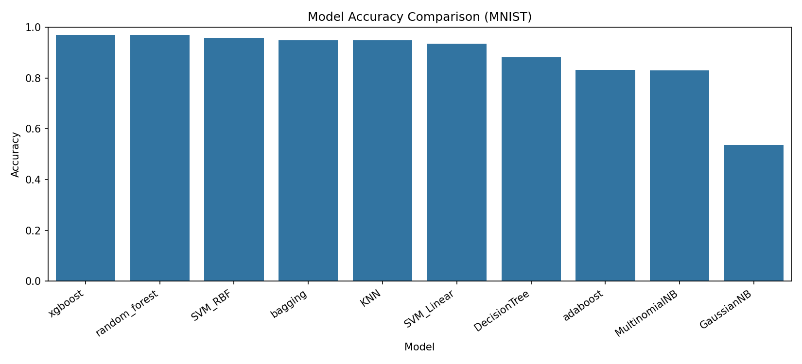
Figure 1. Accuracy comparison across models.
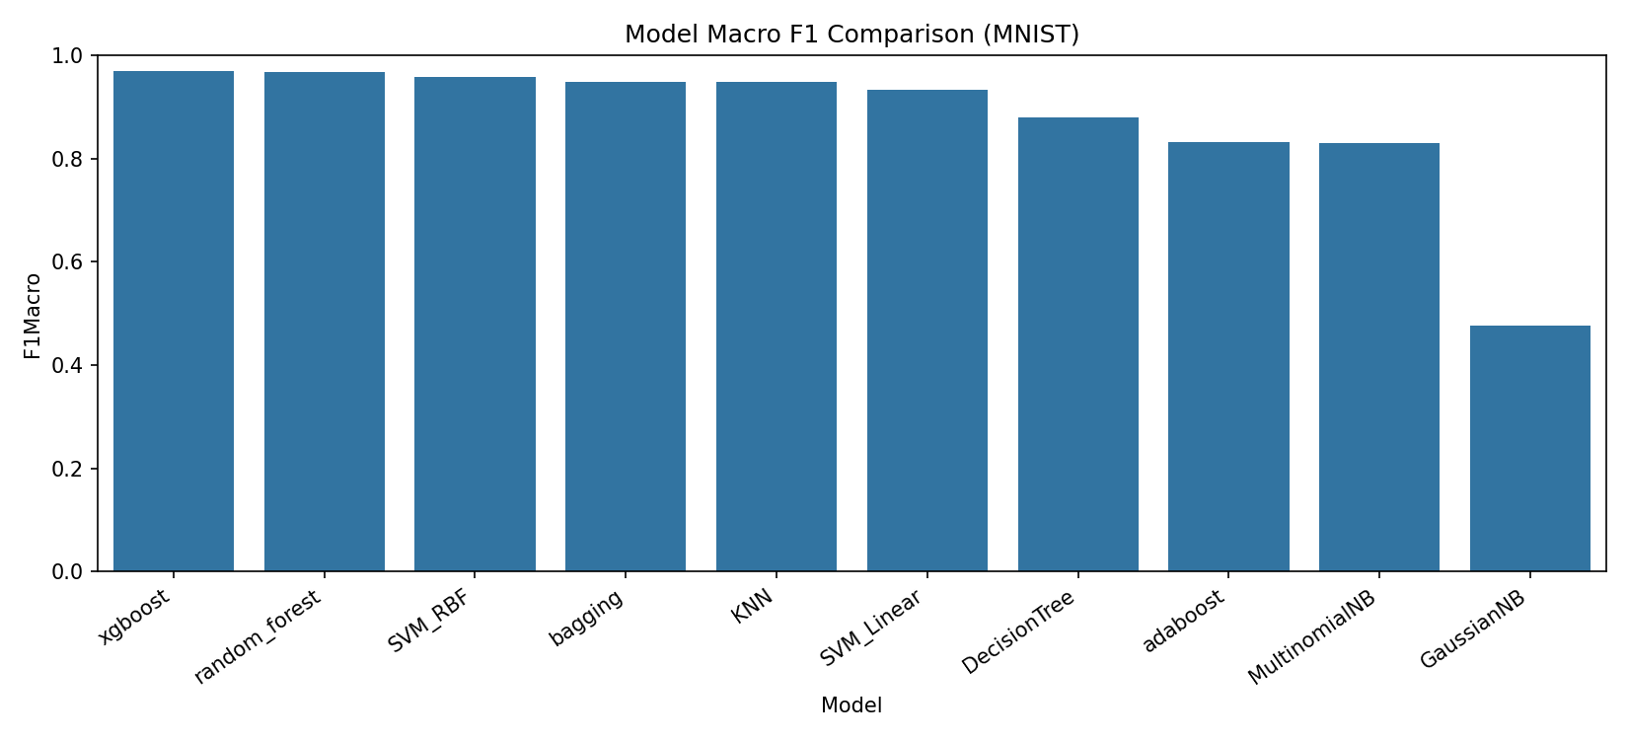
Figure 2. Macro F1 comparison across models.

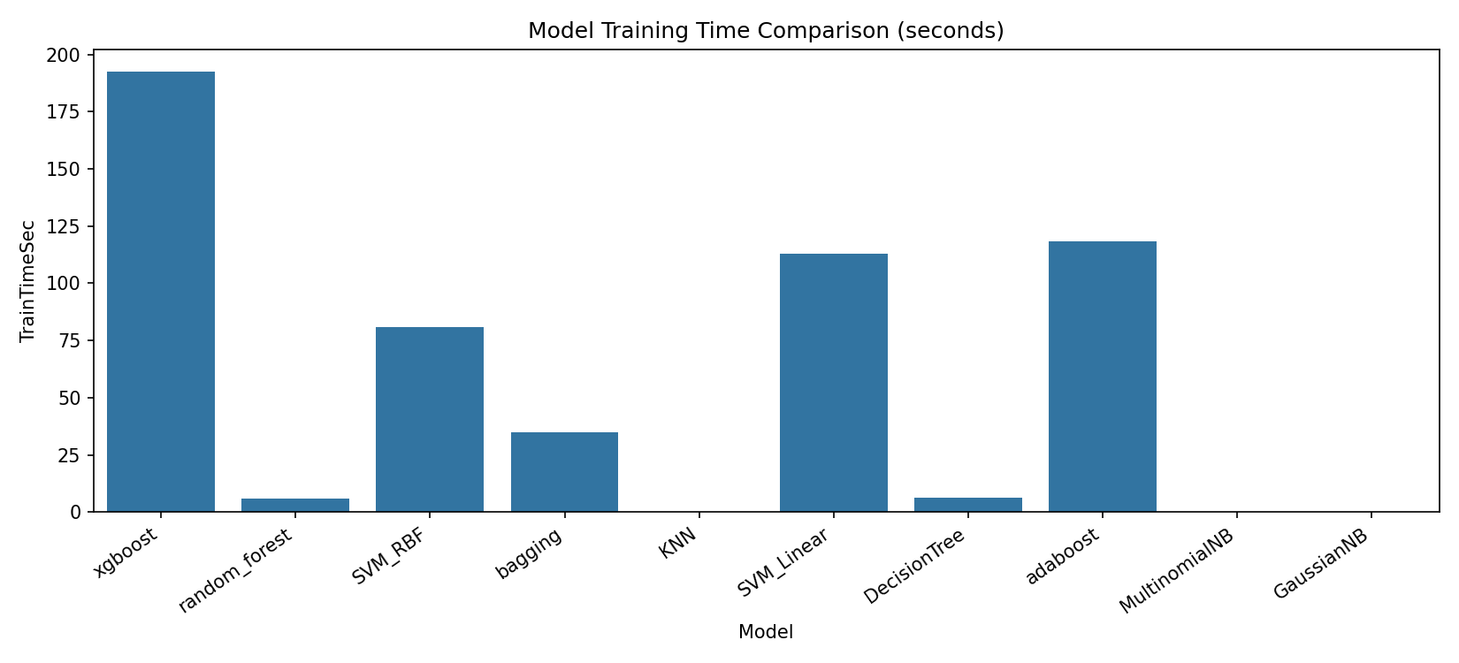
Figure 3. Training time comparison across models.

Findings
Best-performing model by accuracy: xgboost (0.9695).
Fastest training model: MultinomialNB (0.0178 sec).
Top-accuracy models in this run are ensemble/tree-boosting methods, with xgboost ranked first.
Low-latency training methods (e.g., Naive Bayes) provide speed advantages at lower predictive performance.

Conclusion
In this experiment, XGBoost achieved the best overall performance on MNIST with an accuracy of 0.9695 (macro F1 = 0.9693), followed very closely by Random Forest (accuracy = 0.9687) and SVM with RBF kernel (accuracy = 0.9588).
k-NN also performed strongly (accuracy = 0.9483), while Decision Tree gave moderate performance (accuracy = 0.8808).
Among probabilistic models, Multinomial Naive Bayes (accuracy = 0.8307) significantly outperformed Gaussian Naive Bayes (accuracy = 0.5359), showing that feature-distribution assumptions matter for this dataset.
In terms of computational trade-offs, Multinomial Naive Bayes was the fastest to train (0.0178 s), whereas higher-performing ensemble methods required more computation (e.g., XGBoost training time = 192.5334 s).
Overall, the results show a clear trade-off: methods with the highest predictive accuracy generally require greater training time, so model choice should depend on whether priority is maximum accuracy or computational efficiency.

