CSIT-598: Machine Learning

Assignment 2
  - Neeraj Kumar Singh
  - CWID – 50161746

Multiple-Choice Questions
- (b)
- (b)
- (b)
- (c)
- (c)
- (c)
- (b)
- (c)
- (b)
- (b)
- (c)
- (a)
- (c)
- (b)
- (c)
- (b)
- (b)
- (b)
- (c)
- (b)
- (c)
- (b)
- (c)
- (c)
- (b)
- (b)
- (b)
- (b)
- (c)
- (b)
- (c)
- (b)
- (b)
- (a)
- (b)
- (a)
- (b)
- (b)
- (b)
- (b)

Calculation Questions

Question 1 (Ensemble Learning)
Consider $N$ independent random variables $\begin{aligned}X_{1},X_{2},...,X_{N}\end{aligned}$, each following a normal distribution with mean $\begin{aligned}μ\end{aligned}$ and variance $\begin{aligned}σ^{2}\end{aligned}$, i.e., $\begin{aligned}X_{i}∼N(µ,σ^{2})\end{aligned}$. Define the averaged decision variable as:
$$\begin{aligned}\overline{X}=\frac{1}{N}\sum_{i=1}^{N}{X_{i}}\end{aligned}$$
(a) Show that the mean of the averaged decision variable $\overline{X}$ is $μ$.
(b) Show that the variance of $\overline{X}$ is $\begin{aligned}\frac{σ^{2}}{N}\end{aligned}$.
(c) Based on derivation from (a) and (b), discuss how to reduce variance in ensemble learning (hint: consider base models as a form of random variables).

Answer 1
We are given:
- $X_{1},X_{2},...,X_{N}$are independent random variables
- Each follow:
  - $\begin{aligned}X_{i}∼N(µ,σ^{2})\end{aligned}$ , hence Expected value $\begin{aligned}E[X_{i}]=μ\end{aligned}$ and $\begin{aligned}Var(X_{i})=σ^{2}\end{aligned}$

The averaged variable is:
$$\begin{aligned}\overline{X}=\frac{1}{N}\sum_{i=1}^{N}{X_{i}}\end{aligned}$$
(a) Taking expectation of $\begin{aligned}\overline{X}\end{aligned}$
$$\begin{aligned}E[\overline{X}]=E\left[\frac{1}{N}\sum_{i=1}^{N}{X_{i}}\right]\end{aligned}$$
Use linearity of expectation
Expectation is linear, meaning: $\begin{aligned}E[aX+bY]=aE[X]+bE[Y]\end{aligned}$
So, we can move constants outside:
$$\begin{aligned}E[\overline{X}]=\frac{1}{N}E\left[\sum_{i=1}^{N}{X_{i}}\right]\end{aligned}$$
Split expectation across sum
$$\begin{aligned}E[\overline{X}]=\frac{1}{N}\sum_{i=1}^{N}{E[}X_{i}]\end{aligned}$$
Substitute $\begin{aligned}E[X_{i}]=μ\end{aligned}$
$$\begin{aligned}E[\overline{X}]=\frac{1}{N}\sum_{i=1}^{N}{μ}\end{aligned}$$
Since there are N terms:
$$\begin{aligned}\sum_{i=1}^{N}{μ=Nμ}\end{aligned}$$
Simplifying

$$\begin{aligned}E[\overline{X}]=\frac{1}{N}(Nμ)\end{aligned}$$
$$\begin{aligned}E[\overline{X}]=μ\end{aligned}$$
(b) Starting with variance of $\begin{aligned}\overline{X}\end{aligned}$
$$\begin{aligned}Var(\overline{X})=Var\left(\frac{1}{N}\sum_{i=1}^{N}{X_{i}}\right)\end{aligned}$$
Using variance scaling rule
If $a$ is constant: $\begin{aligned}Var(aX)=a^{2}Var(X)\end{aligned}$
So:
$$\begin{aligned}Var(\overline{X})=\frac{1}{N^{2}}Var\left(\sum_{i=1}^{N}{X_{i}}\right)\end{aligned}$$
Use independence property
Since $\begin{aligned}X_{1},...,X_{N}\end{aligned}$ are independent:
$$\begin{aligned}Var(X+Y)=Var(X)+Var(Y)\end{aligned}$$
Thus:
$$\begin{aligned}Var\left(\sum_{i=1}^{N}{X_{i}}\right)=\sum_{i=1}^{N}{Var(}X_{i})\end{aligned}$$
Substitute $\begin{aligned}Var(X_{i})=σ^{2}\end{aligned}$

$$\begin{aligned}Var\left(\sum_{i=1}^{N}{X_{i}}\right)=Nσ^{2}\end{aligned}$$
Substituting back

$$\begin{aligned}Var(\overline{X})=\frac{1}{N^{2}}(Nσ^{2})\end{aligned}$$
Simplifying
$$\begin{aligned}Var(\overline{X})=\frac{σ^{2}}{N}\end{aligned}$$
(c) In ensemble learning (like Bagging or Random Forests), we treat individual base models as the random variables $X_{1},X_{2},...,X_{N}$. Each model is a "learner" that makes a prediction.
Based on the mathematical derivation in part (b), we can reduce the overall variance of the ensemble in two primary ways:
Increase the number of models ($N$): As shown by the formula $\begin{aligned}Var(\overline{X})=\frac{σ^{2}}{N}\end{aligned}$ , the total variance is inversely proportional to the number of models. By increasing $N$ (adding more decision trees to a forest, for example), the ensemble's prediction becomes more stable and less sensitive to the noise of any single model.
Ensure Independence (Reduce Correlation): The derivation in (b) assumes the models are independent. In reality, if models are highly correlated (they all make the same mistakes), the variance does not drop as quickly. This is why techniques like feature bagging (used in Random Forests) are essential, they force the models to be diverse, making them behave more like independent random variables and significantly lowering the ensemble variance.

Question 2(Decision Tree)
Consider the following dataset for a binary classification problem where the target variable is “Play Tennis” (Yes or No), and there are two features: “Outlook” and “Temperature.”
Outlook | Temperature | Play Tennis
Sunny | Hot | No
Sunny | Cool | Yes
Overcast | Cool | Yes
Rainy | Hot | Yes
Rainy | Cool | No
Sunny | Hot | No
Overcast | Hot | Yes

Answer 2
(a) Compute the entropy of the target variable “Play Tennis.”
Let E() is the entropy function , and
$E\left(PlayTenis\right)=-\sum{{Probability}_{x} × \log_{2}{{Probability}_{x }}}$, where x is a binary class ‘Yes’ or ‘No’
Count(Yes) = 4, Count(No) = 3, total = 7
$${Probability}_{Yes} = \frac{4}{7}$$
$${Probability}_{No} = \frac{3}{7}$$

$$E\left(PlayTenis\right)=-\frac{4}{7}×\log_{2}{\frac{4}{7}}-\frac{3}{7}×\log_{2}{\frac{3}{7} = 0.985}$$

(b) Calculate the information gain for the feature “Outlook.”
$${Information Gain}_{Outlook}=E\left(PlayTenis\right)- E\left(Outlook\right) Eq1$$

Considering root node as Outlook
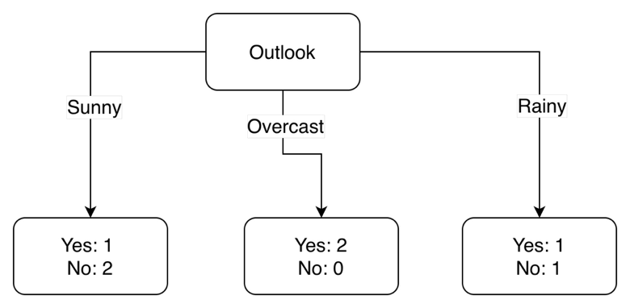
$$E\left(PlayTenis\right)=0.985. from question\left(a\right)$$
$$E\left(Outlook\right)=\sum{\frac{S_{v}}{S}×E\left(S_{v}\right)}, where S_{v} is subset for Outlook$$
$$E\left(Sunny\right)=-\frac{1}{3}×\log_{2}{\frac{1}{3}}-\frac{2}{3}×\log_{2}{\frac{2}{3} = 0.918}$$
$$E\left(Overcast\right)=-\frac{2}{2}×\log_{2}{\frac{2}{2}}-\frac{0}{2}×\log_{2}{\frac{0}{2} = 0}$$
$$E\left(Rainy\right)=-\frac{1}{2}×\log_{2}{\frac{1}{2}}-\frac{1}{2}×\log_{2}{\frac{1}{2} = 1}$$
$$\frac{S_{sunny}}{S} = \frac{3}{7} , \frac{S_{overcast}}{S} = \frac{2}{7} , \frac{S_{rainy}}{S} = \frac{2}{7}$$
$$E\left(Outlook\right) = \frac{3}{7}×0.918 +\frac{2}{7}×0 +\frac{2}{7}×1=0.679$$
$${Information Gain}_{Outlook}= 0.985 - 0.679=0.306, from Eq 1$$

(c) Show which feature should be used as the root node based on information gain.
From question (b) we derived , ${Information Gain}_{Outlook}=0.306$
Now we can find the Information gain of Temperature attribute , and compare both,
the attribute that has more information gain can be used as root node.
$${Information Gain}_{Temperature}=E\left(PlayTenis\right)- E\left(Temperature\right) Eq2$$
considering Temperature attribute as the root node.
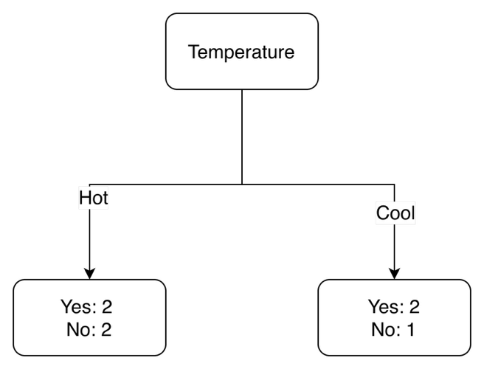
$$E\left(PlayTenis\right)=0.985 from question\left(a\right)$$
$$E\left(Temperature\right)=\sum{\frac{S_{v}}{S}×E\left(S_{v}\right)}, where S_{v} is subset for Temperature$$
$$E\left(Hot\right)=-\frac{2}{4}×\log_{2}{\frac{2}{4}}-\frac{2}{4}×\log_{2}{\frac{2}{4} = 1}$$
$$E\left(Cool\right)=-\frac{2}{3}×\log_{2}{\frac{2}{3}}-\frac{1}{3}×\log_{2}{\frac{1}{3} = 0}.918$$
$$\frac{S_{Hot}}{S} = \frac{4}{7} , \frac{S_{Cool}}{S} = \frac{3}{7}$$
$$E\left(Temperature\right) = \frac{4}{7}×1 +\frac{3}{7}×0.918 =0.965$$
$${Information Gain}_{Temperature}= 0.985 -0.965 from Eq 2$$
$$= 0.020$$
Since, ${Information Gain}_{Outlook} >$ ${Information Gain}_{Temperature}$
Outlook attribute can be used as root node of the decision tree.

(d) Create a simple decision tree based on your results.
Based on the above results we are using Outlook attribute as root node while constructing the decision tree . Temperature attribute can be used as child node of outlook attribute.
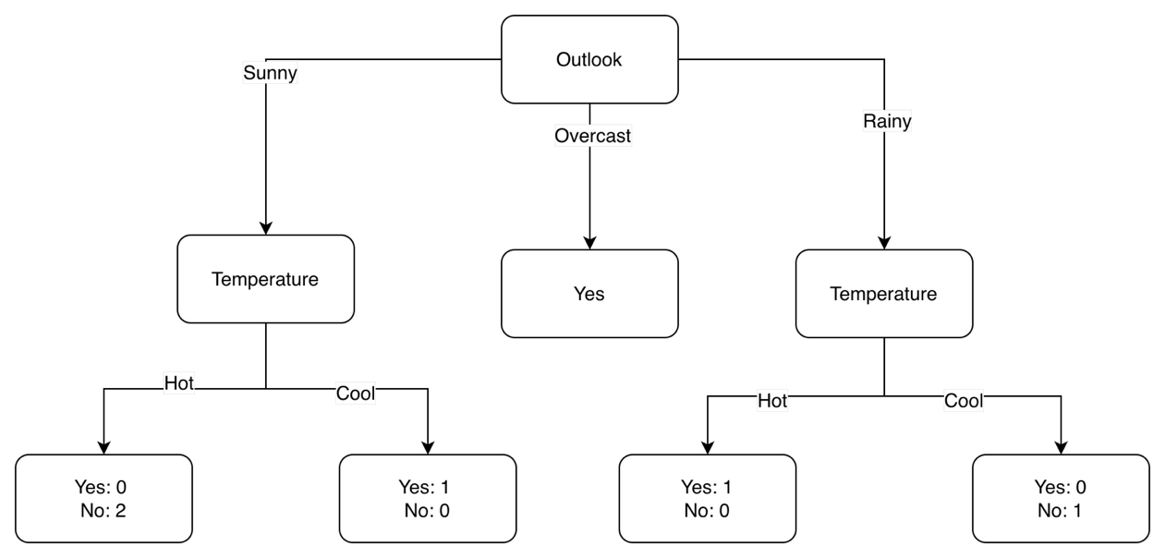
Since all the child nodes of Temperature attribute have either Yes or No as 0 occurrences(pure), similarly the case for outlook = overcast , Yes occurs 2 times , but No occurs 0 time, hence all these nodes will act as leaf nodes ,the decision tree can be further simplified as shown below.
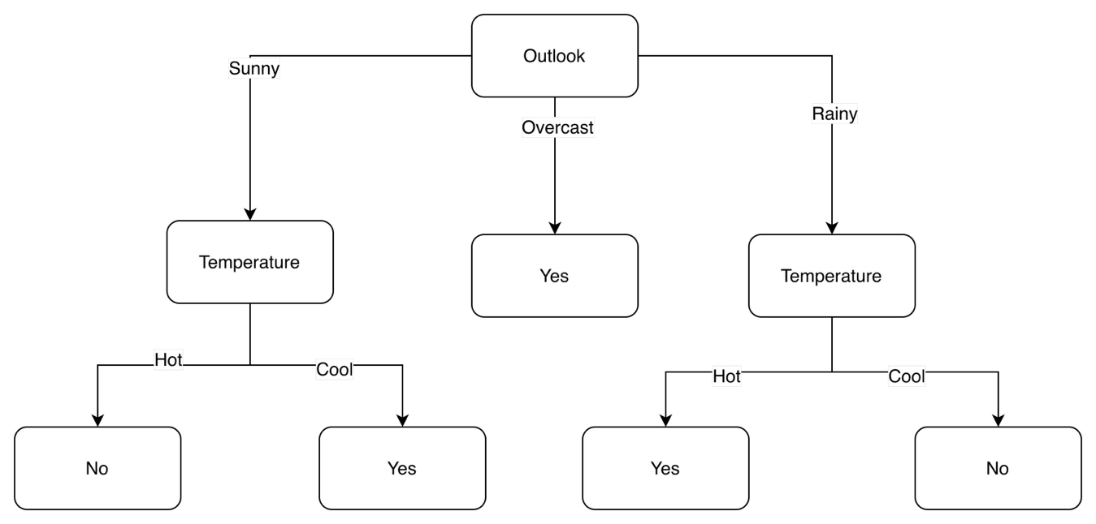

Question 3(KNN)
You are given the following dataset, where each point has two features: $X_{1}$ and $X_{2}$, and a binary target class (A or B):
Point | $$X_{1}$$ | $$X_{2}$$ | Class
$$P_{1}$$ | 1 | 1 | A
$$P_{2}$$ | 2 | 2 | A
$$P_{3}$$ | 3 | 3 | B
$$P_{4}$$ | 6 | 5 | B
$$P_{5}$$ | 7 | 6 | B

A new data point $\begin{aligned}P_{new}\end{aligned}$= (3,4) arrives. Use the k-Nearest Neighbors algorithm with k = 3 to
classify this new data point.

Answer 3
Step 1 : Find the distance from the points to the new point , here we will be using the Euclidean Distance . Euclidean Distance between two points is given by , $\begin{aligned}d\end{aligned}$
$\begin{aligned} d_{P_{1},P_{2}}\end{aligned} = \begin{aligned}\sqrt{(x_{1}-x_{2})^{2}+(y_{1}-y_{2})^{2}}\end{aligned}$, here $x$ and $y$ are the two features
$$\begin{aligned}d_{P_{1},P_{new}}=\sqrt{{\left(x_{P_{1}} − x_{P_{new}}\right)}^{2}+{\left(y_{P_{1}} − y_{P_{new}}\right)}^{2}}\end{aligned} \begin{aligned}=\sqrt{{\left(1 − 3\right)}^{2}+{\left(1 − 4\right)}^{2}}=\end{aligned} \sqrt{4 + 9}=\sqrt{13}=3.605$$
$$\begin{aligned}d_{P_{2},P_{new}}=\sqrt{{\left(x_{P_{2}} − x_{P_{new}}\right)}^{2}+{\left(y_{P_{2}} − y_{P_{new}}\right)}^{2}}\end{aligned} \begin{aligned}=\sqrt{{\left(2 − 3\right)}^{2}+{\left(2 − 4\right)}^{2}}=\end{aligned} \sqrt{1 + 4}=\sqrt{5}=2.236$$
$$\begin{aligned}d_{P_{3},P_{new}}=\sqrt{{\left(x_{P_{3}} − x_{P_{new}}\right)}^{2}+{\left(y_{P_{3}} − y_{P_{new}}\right)}^{2}}\end{aligned} \begin{aligned}=\sqrt{{\left(3 − 3\right)}^{2}+{\left(3 − 4\right)}^{2}}=\end{aligned} \sqrt{0 + 1}=\sqrt{1}=1$$
$$\begin{aligned}d_{P_{4},P_{new}}=\sqrt{{\left(x_{P_{4}} − x_{P_{new}}\right)}^{2}+{\left(y_{P_{4}} − y_{P_{new}}\right)}^{2}}\end{aligned} \begin{aligned}=\sqrt{{\left(6 − 3\right)}^{2}+{\left(5 − 4\right)}^{2}}=\end{aligned} \sqrt{9 + 1}=\sqrt{10}=3.162$$
$$\begin{aligned}d_{P_{5},P_{new}}=\sqrt{{\left(x_{P_{5}} − x_{P_{new}}\right)}^{2}+{\left(y_{P_{5}} − y_{P_{new}}\right)}^{2}}\end{aligned} \begin{aligned}=\sqrt{{\left(7 − 3\right)}^{2}+{\left(6 − 4\right)}^{2}}=\end{aligned} \sqrt{16 + 4}=\sqrt{20}=4.472$$

Point | $$X_{1}$$ | $$X_{2}$$ | Class | Distance to $P_{new}$
$$P_{1}$$ | 1 | 1 | A | 3.605
$$P_{2}$$ | 2 | 2 | A | 2.236
$$P_{3}$$ | 3 | 3 | B | 1
$$P_{4}$$ | 6 | 5 | B | 3.162
$$P_{5}$$ | 7 | 6 | B | 4.472

Step 2: We sort the points with respect to Distance to $P_{new}$ in ascending order, and assign rank to them , such that lower rank is closes to $P_{new}$.
Point | $$X_{1}$$ | $$X_{2}$$ | Class | Distance to $P_{new}$ | Rank
$$P_{3}$$ | 3 | 3 | B | 1 | 1
$$P_{2}$$ | 2 | 2 | A | 2.236 | 2
$$P_{4}$$ | 6 | 5 | B | 3.162 | 3
$$P_{1}$$ | 1 | 1 | A | 3.605 | 4
$$P_{5}$$ | 7 | 6 | B | 4.472 | 5

Step 3: Now since k =3 , we consider top 3 rank points , which are $P_{3}$, $P_{2}$ and $P_{4}$ , having rank 1, 2 and 3 respectively. Among these three points we find the majority class label and that label becomes our target label for the new point.
Since $P_{3}$, $P_{2}$ and $P_{4}$ have class B, A and B respectively , B is the majority class . Hence the point $\begin{aligned}P_{new}\end{aligned}$= (3,4) will be classified in class B.

Question 4(K-Means)
You are given the following dataset with two features, $x_{1}$ and $x_{2}$, representing the coordinates of points in a 2D space. Your task is to perform K-means clustering with K = 2 clusters:
$$x_{1}$$ | $$x_{2}$$ | points
2 | 3 | $$P_{1}$$
3 | 3 | $$P_{2}$$
6 | 8 | $$P_{3}$$
8 | 8 | $$P_{4}$$

(a) Assume initial centers are $P_{2}$ and $P_{3}$. Find the two clusters.
(b) Recompute the centers for the two clusters, based on which find the new two clusters.

Answer 4
a) Since initial centers are $P_{2}$ and $P_{3}$ , we will find the distance from each point to the centers and compare them, the point closer to a center will belong to that cluster.
Let $C_{2}$ and $C_{3}$ be clusters for centers $P_{2}$ and $P_{3}$ respectively.
Calculating distances from each point to $P_{2}$ and $P_{3}$ , using Euclidean Distance ,
$\begin{aligned} d_{P_{1},P_{2}}\end{aligned} = \begin{aligned}\sqrt{(x_{1}-x_{2})^{2}+(y_{1}-y_{2})^{2}}\end{aligned}$
$$\begin{aligned} d_{P_{1},P_{2}}\end{aligned} = \begin{aligned}\sqrt{(2-3)^{2}+(3-3)^{2} } = 1\end{aligned}$$
$$\begin{aligned} d_{P_{1},P_{3}}\end{aligned} = \begin{aligned}\sqrt{(2-6)^{2}+(3-8)^{2} } = \sqrt{4^{2}+5^{2}}=6.403\end{aligned}$$
$$\begin{aligned} d_{P_{2},P_{2}}\end{aligned} = 0$$
$$\begin{aligned} d_{P_{2},P_{3}}\end{aligned} = \begin{aligned}\sqrt{(6-3)^{2}+(8-3)^{2} } = \sqrt{3^{2}+5^{2}}=5.83\end{aligned}$$
$$\begin{aligned} d_{P_{3},P_{2}}\end{aligned} = \begin{aligned}\sqrt{(6-3)^{2}+(8-3)^{2} } = \sqrt{3^{2}+5^{2}}=5.83\end{aligned}$$
$$\begin{aligned} d_{P_{3},P_{3}}\end{aligned} = \begin{aligned}0\end{aligned}$$
$$\begin{aligned} d_{P_{4},P_{2}}\end{aligned} = \begin{aligned}\sqrt{(8-3)^{2}+(8-3)^{2} } = \sqrt{5^{2}+5^{2}} = 7.07 \end{aligned}$$
$$\begin{aligned} d_{P_{4},P_{3}}\end{aligned} = \begin{aligned}\sqrt{(8-6)^{2}+(8-8)^{2} } = \sqrt{2^{2}+0}=2\end{aligned}$$

$$x_{1}$$ | $$x_{2}$$ | points | $${Distance_P}_{2}$$ | $${Distance_P}_{3}$$ | Cluster
2 | 3 | $$P_{1}$$ | 1 | 6.40312424 | $$C_{2}$$
3 | 3 | $$P_{2}$$ | 0 | 5.83095189 | $$C_{2}$$
6 | 8 | $$P_{3}$$ | 5.83095189 | 0 | $$C_{3}$$
8 | 8 | $$P_{4}$$ | 7.07106781 | 2 | $$C_{3}$$

As shown in the table , since $P_{1}$ is close to $P_{2}$ , it’s grouped in cluster $C_{2}$ along with $P_{2}$, similarly $P_{3}$ and $P_{4}$ belong to cluster $C_{3}$.
b) Recomputing the centers
let $P_{2}^{`}$ be the centroid of cluster $C_{2}$ , which is given by the mean of points $P_{1}$ and $P_{2}$
and $P_{3}^{`}$ be the centroid of cluster $C_{3}$ , which is given by the mean of points $P_{3}$ and $P_{4}$
$P_{2}^{`}=\left(\frac{2+3}{2}, \frac{3+3}{2}\right)= (2.5, 3)$
$P_{3}^{`}=\left(\frac{6+8}{2}, \frac{8+8}{2}\right)= (7, 8)$
Calculating distances from each point to $P_{2}^{`}$ and $P_{3}^{`}$ , using Euclidean Distance ,
$$\begin{aligned} d_{P_{1},P_{2}^{`}}\end{aligned} = \begin{aligned}\sqrt{(2-2.5)^{2}+(3-3)^{2} } = \sqrt{{0.5}^{2}}=0.5\end{aligned}$$
$$\begin{aligned} d_{P_{1},P_{3}^{`}}\end{aligned} = \begin{aligned}\sqrt{(2-7)^{2}+(3-8)^{2} } = \sqrt{5^{2}+5^{2}}=7.07\end{aligned}$$
$$\begin{aligned} d_{P_{2},P_{2}^{`}}\end{aligned} = \begin{aligned}\sqrt{(3-2.5)^{2}+(3-3)^{2} } = \sqrt{{0.5}^{2}+0}=0.5\end{aligned}$$
$$\begin{aligned} d_{P_{2},P_{3}^{`}}\end{aligned} = \begin{aligned}\sqrt{(3-7)^{2}+(3-8)^{2} } = \sqrt{4^{2}+5^{2}}=6.40\end{aligned}$$
$$\begin{aligned} d_{P_{3},P_{2}^{`}}\end{aligned} = \begin{aligned}\sqrt{(6-2.5)^{2}+(8-3)^{2} } = \sqrt{{3.5}^{2}+5^{2}}=6.10\end{aligned}$$
$$\begin{aligned} d_{P_{3},P_{3}^{`}}\end{aligned} = \begin{aligned}\begin{aligned}\sqrt{(6-7)^{2}+(8-8)^{2} } = \sqrt{1^{2}+0}=1\end{aligned}\end{aligned}$$
$$\begin{aligned} d_{P_{4},P_{2}^{`}}\end{aligned} = \begin{aligned}\sqrt{(8-2.5)^{2}+(8-3)^{2} } = \sqrt{{5.5}^{2}+5^{2}} = 7.43\end{aligned}$$
$$\begin{aligned} d_{P_{4},P_{3}^{`}}\end{aligned} = \begin{aligned}\sqrt{(8-7)^{2}+(8-8)^{2} } = \sqrt{1^{2}+0}=1\end{aligned}$$

$$x_{1}$$ | $$x_{2}$$ | points | ${Distance_P}_{2}^{`}$ | $${Distance_P}_{3}^{`}$$ | cluster
2 | 3 | p1 | 0.5 | 7.07106781 | $$C_{2}$$
3 | 3 | p2 | 0.5 | 6.40312424 | $$C_{2}$$
6 | 8 | p3 | 6.10327781 | 1 | $$C_{3}$$
8 | 8 | p4 | 7.43303437 | 1 | $$C_{3}$$

As shown in the table based on the new distances, we see clusters for each point are not changed, but the centroids of clusters $C_{2}$ and $C_{3}$ are now changed to points $P_{2}^{`}$ (2.5, 3) and $P_{3}^{`}$(7,8) .
Here since clusters have not changed for each point, we can stop the process of clustering.

Question 5(Linear Regression)
You are given the following three data points: (1,1), (2,3), and (3,3). Your task is to fit a line y= mx+ b using the least squares method.
(a) Calculate the slope m and the intercept b.
(b) Calculate the least squared error.
Note: round a decimal number to two decimal places.

Answer 5
Linear Regression using Least Squares Method
Given data points: (1,1), (2,3), (3,3)
Fit a line of the form: y = mx + b
Step 1: Create Calculation Table
x | y | x² | xy
1 | 1 | 1 | 1
2 | 3 | 4 | 6
3 | 3 | 9 | 9
$\sum{x}$= 6
$\sum{y}$ = 7
$\sum{x^{2}}$ = 14
$\sum{xy}$ = 16
n = 3
Step 2: Calculate Slope (m)
$Formula : m = \begin{aligned}\frac{N\sum_{i=1}^{N}{x_{i}}y_{i}-\sum_{i=1}^{N}{x_{i}}\sum_{i=1}^{N}{y_{i}}}{N\sum_{i=1}^{N}{x_{i}^{2}}-(\sum_{i=1}^{N}{x_{i}})^{2}}\end{aligned}$
$$m = \frac{(3×16 -6 ×7)}{(3×14 - 6^{2})}$$
m = (48 − 42) / (42 − 36)
m = 6 / 6
m = 1.00
Step 3: Calculate Intercept (b)
Formula: b = $\begin{aligned}\frac{\sum_{i=1}^{N}{y_{i}}-m\sum_{i=1}^{N}{x_{i}}}{N}\end{aligned}$
b = (7 − 1×6) / 3
b = 1 / 3
b = 0.33
Step 4: Regression Line
y = x + 0.33
Step 5: Predicted Values
x | Actual y | Predicted ŷ
1 | 1 | 1.33
2 | 3 | 2.33
3 | 3 | 3.33
Step 6: Squared Errors
(1 − 1.33)² = 0.11
(3 − 2.33)² = 0.45
(3 − 3.33)² = 0.11
Step 7: Least Squared Error
LSE = 0.11 + 0.45 + 0.11 = 0.67
Final Answer
Slope (m) = 1.00
Intercept (b) = 0.33
Least Squared Error = 0.67

Bonus Question
Given a set of N data points $\begin{aligned}(x_{1},y_{1}),(x_{2},y_{2}),...,(x_{N},y_{N})\end{aligned},$where each point consists of a predictor value $\begin{aligned}x_{i}\end{aligned}$ and an output value $\begin{aligned}y_{i}\end{aligned}$, the goal is to find the equation of the best-fit line y= mx+ b that minimizes the sum of squared errors (SSE). Show how the formulas for the slope m and the intercept b can be derived using the method of least squares, where:
$$\begin{aligned}m=\frac{N\sum_{i=1}^{N}{x_{i}}y_{i}-\sum_{i=1}^{N}{x_{i}}\sum_{i=1}^{N}{y_{i}}}{N\sum_{i=1}^{N}{x_{i}^{2}}-(\sum_{i=1}^{N}{x_{i}})^{2}},\end{aligned}$$
$$\begin{aligned}b=\frac{\sum_{i=1}^{N}{y_{i}}-m\sum_{i=1}^{N}{x_{i}}}{N}\end{aligned}$$

Answer
