

Terminal Operation System

Sparcs N4 Version 2.1

IT Operations Procedures

Table of Contents
1. Sign-off 4
2. Revision History 5
3. Document Purpose 8
4. System Data Flow Diagram 9
5. Description of the Application 11
5.1. Current Terminal Operation System 12
5.2. Future 14
6. Application/Instance Setup Procedures 16
6.1. Environment Details 16
6.2. Web Server Setup 16
6.3. Unix Setup 17
6.4. Database Setup 20
6.5. Tomcat Setup 24
6.6. WebLogic Setup 41
7. Application Start/Stop Instructions 57
7.1. Tomcat 58
7.2. Weblogic 58
8. Configuration Files 59
9. Dependencies 60
10. Jobs, Schedule and Messages/Alerts 62
11. Health Checks 68
12. Exception Handling 71
13. Users 72
14. Alarming Requirements 74
14.1. Process Name 75
14.2. System 75
14.3. Error Log 77
14.4. Log Message 77
14.5. Description 78
14.6. Action 78
14.7. Additional Notes 78
15. DASD Purge 81
16. List of All Data Files and Their Definitions 81
17. Maintenance Windows 81
18. Reports/Output 82
19. Support Escalation Process and Contact Details 83
20. Post Production Monitoring and Metrics 84
21. Manual Test Procedures 84
22. Application Interface Dependencies 85
23. Roles and Responsibilities 85
24. Appendix 86
24.1. XPS Server Setup 86

- Sign-off
Use the following matrix for obtaining sign-off on each document. Insert the role name in the table below for each person responsible for sign-off on this particular template, and indicate in this section of the template exactly what the sign-off represents.
Name | Role | Date | Signature
 | Development Manager
 | Production Operations Sr. Mgr.

- Revision History
For each revision of a document, please log the major changes made for that version.
Document Revision History
Date | Version | Page(s) | Change Control # (optional) | Description | Author(s)
08.17.11 | 1.0 | 43 |  | Added N42.1 Snx Mailbox function | Glenn Raposo
08.22.11 | 1.0 | 43 |  | Added Snx mailbox Producer & consumer server addresses | Glenn Raposo
08.23.11 | 1.0 | 14 |  | Added Env Detail Grid | Glenn Raposo
08.23.11 | 1.0 | 28 |  | Updated/Corrected tomcat install steps 18,19,20, 26 | Glenn Raposo
08.24.11 | 1.0 | 30 |  | Corrected Step25 the catalina.sh directory | Glenn Raposo
08.24.11 | 1.0 | 30 |  | Add jar to tomcat classpath step26 | Glenn Raposo
08.26.11 | 1.0 | 14 |  | Updated QA VIP in the Env Grid | Glenn Raposo
09.13.11 | 1.0 | 17 |  | Open Firewall rules for QA for web services to talk | Glenn Raposo
09.15.11 | 1.0 | 22 |  | Update/Correct Instruction for Tomcat application server setup config section 6.5.2 | Glenn Raposo
09.19.11 | 1.0 | 22 |  | Update Shutdown script and Sever.xml path | Glenn Raposo
09.19.11 | 1.0 | 49,50 |  | Added MNS SAF agents | Glenn Raposo
09.21.11 | 1.0 | 34 |  | Added Weblogic JMS setup instructions | Glenn Raposo
09.22.11 | 1.0 |  |  | Removed ActiveMQ setup | Glenn Raposo
09.22.11 | 1.0 | 34 |  | Update Shutdown Script for node1 | Glenn Raposo
09.24.11 | 1.0 | 15 |  | Added Preprod XPS Ports | Glenn Raposo
09.27.11 | 1.0 | 34 |  | Update scripts to reflect home/tomcat/tomcat as its root folder | Glenn Raposo
09.27.11 | 1.0 | 34 |  | Removed <cluster> element as it has been commented in QA server.xml on each node. | Glenn Raposo
09.27.11 | 1.0 | 34 |  | Added configuration server.xml for node3 and node4 | Glenn Raposo
10.04.11 | 1.0 | 32 |  | Updated scripts for all 4 nodes as per Preprod setup | Glenn Raposo
10.04.11 | 1.0 | 82 |  | Update XPS config | Paul Schroeder
10.04.11 | 1.0 | 82 |  | Corrected webserver IP and Server names | Glenn Raposo
10.04.11 | 1.0 | 35 |  | Set Jida and weblogic jar file in classpath | Glenn Raposo
10.25.11 | 1.0 | 35 |  | Updated Snxmail box Prod proxy id’s | Glenn Raposo
10.27.11 | 1.0 | 15,16 |  | Update SSL direct web server URL | Glenn Raposo
10.27.11 | 1.0 | 38 |  | Added jxl-2.6.jar to the list of custom jars | Glenn Raposo
10.27.11 | 1.0 | 38,39 |  | Open Firewall rules from Application sever to Printers | Glenn Raposo
10.31.11 | 1.0 | 38 |  | Added navis-apex.log messages to be alerted on | Glenn Raposo
11.30.11 | 1.0 | 91,92 |  | WhereNet MTS-N4 Integration | Glenn Raposo
12.14.11 | 1.0 | 15 |  | Removed VIP in Dev and QA | Glenn Raposo
02.22.12 | 1.0 |  |  | Added user on TosMns on WLS-MNS for the TOS->MNS saf agent to work. | Glenn Raposo
10.15.2012 | 1.0 | 52,53 |  | Added FTP Mappings for stowplan file (from GEMS), brds file (from FACTS) and DCM File (from SSAT) | Raghu Pattangi
12.13.2012 | 1.0 | 24,25 |  | Added JNDI to connect to GEMS | Raghu Pattangi
03.20.2013 | 1.0 | 54,55 |  | Added a new section with “FTP locations for GUM New vessel process:” which has subdirectories added to the existing dcm and rds ftp locations for GUM new vessel development. | Raghu Pattangi
- Document Purpose
The purpose of this document is to provide a reference point for the Operations group to maintain the Terminal Operation System.

- System Data Flow Diagram
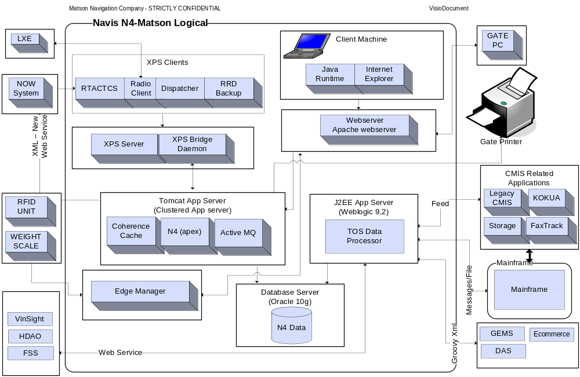
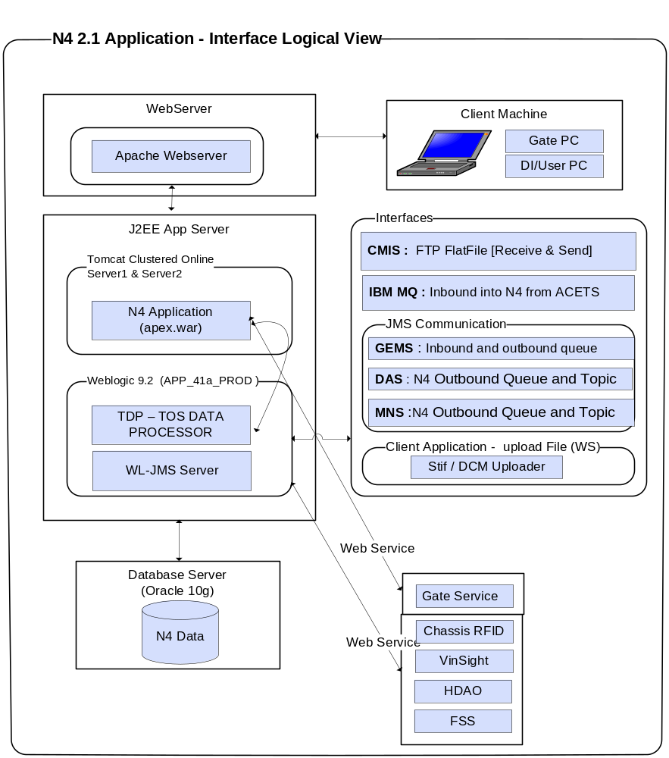

TOS Prod System Env
MATCAMUPA
41
128
.
167
.
130
.
100
10
.
201
.
1
.
18
MATCAMUPA
42
128
.
167
.
130
.
101
10
.
201
.
1
.
21
ADM
_
41
_
PROD
APP
_
41
a
_
PROD
TDP
APP
_
42
a
_
PROD
JMS
-
DQ
Application Servers
CLUSTER APP
1
JMS
-
DQ
WL
9
.
2
Tomcat Online Server Cluster
APP
2
Tomcat
N
4 2
.
1
Node
3
N
4 2
.
1
Node
4
Tomcat
N
4 2
.
1
Node
1
N
4 2
.
1
Node
2
ActiveMQ
FWD msg to Active JMS Listener
Local JMS Posting
ActiveMQ
Local JMS Posting

- Description of the Application
Additional documentation can be found on the WIKI, in the TOS category.
  - Current Terminal Operation System
Matson uses a legacy Terminal Operation System known as CMIS in Honolulu at the Sand Island and Pier 29 ports.
Container Management Information System (CMIS) was developed in 1988 using Borland’s Paradox for DOS. Paradox is a flat file database with relational capabilities which are not really utilized by the CMIS application. Instead logic is implemented using the Paradox Application Language (PAL) to manage data and enforce rules within the application.
The CMIS data model centers around two tables, the container table and the OUTQUE table. The container table represents active containers present at the port at anytime. A transaction to load/discharge a container to/from a vessel, send it out of the gate or even just to edit its status is immediately reflected in the container table. The OUTQUE is a workflow table that records instructions from these transactions for processing by backend processes that translate these instructions according to the business rules and propagate them to other tables for reporting, KOKUA (customer) and audit history. Applications like Storage & Detention, Chassis License, Faxtrack and KOKUA use these tables directly. The information may propagate to third party vendors like Young Brothers to complete the route for Matson. Other sub-systems also feed from CMIS and this is not a conclusive list.
SPARCS is a software product provided by the software provider, Navis. While the main function of CMIS is to handle the gate and corrective, administrative actions, the main function of SPARCS is the yard and vessel automation. SPARCS today integrates with NOW and as well LXE’s in the yard to perform transactions such as loading and unloading containers from the ship.
When a vessel leaves a west coast port, destined to Hawaii, a CMIS module called “New Vessel” is initiated with the following four main inputs:
- RDS (from FACTS)
- Stow Plan (from ACETS)
- STIF File (Mainsail or SPARCS)
- Dangerous Cargo Manifest a.k.a. DCM (Mainsail or CMIS)

Output from this process is delivered to SPARCS today. This input to SPARCS allows for planning.

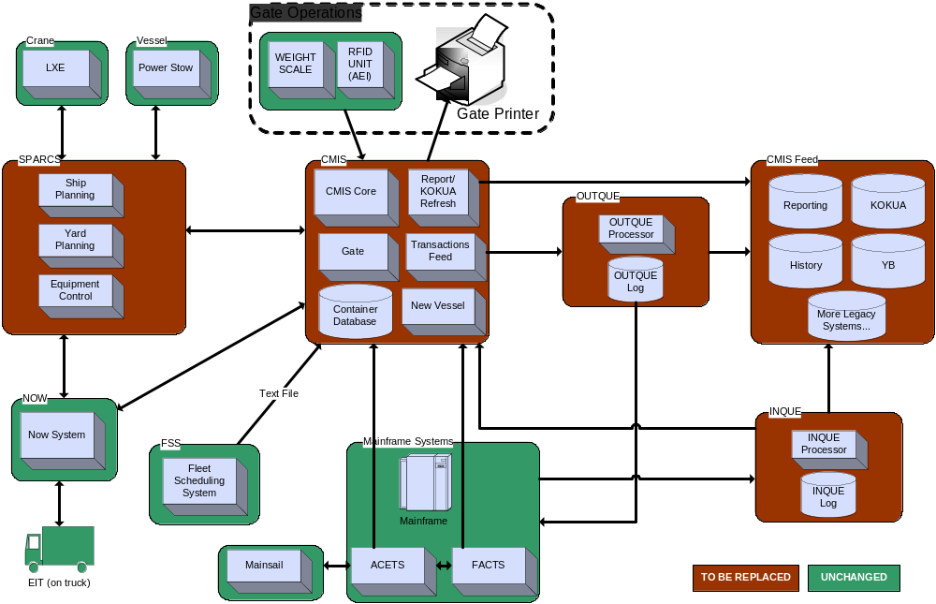
  - Future
The objective of this project is to replace CMIS with a new Terminal Operating System (N4 from Navis) which is based on distributed architecture with a Web-based front end, Application Tier and Relational Database. The introduction of N4 will require a SPARCS upgrade that will include a new server, referred to as XPS. The project will also require new Matson integration software. This integration software will allow communication between N4/SPARCS and ACETS/FACTS/Fleet Scheduling System and other internal Matson systems. The integration software will run on our target architecture, utilizing common components.
Eliminating CMIS completely will not happen during the first deployment. Until all components of CMIS can be replaced, there will be a legacy version of CMIS running. For example, when N4 is deployed to Sand Island, CMIS will still be used by other neighbor islands. Kokua, reports, and other sub-systems will remain in legacy CMIS until they are replaced.
One of the external interfaces is the State of Hawaii’s Department of Agriculture (HDOA). The HDOA requires a manifest from Matson for vessel’s arriving in Hawaii. This requirement stems from recent laws within the state regarding invasive species. Matson accomplishes this with an automatic feed from TDP to the HDOA using web services.

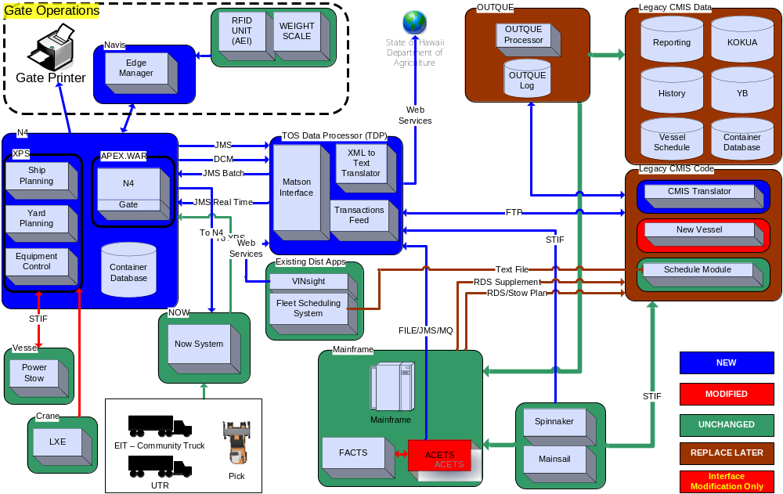
http://wiki.matson.com/index.php?title=Image:Terminal_Operating_System_Future_State_Overview.png
- Application/Instance Setup Procedures
  - Environment Details
 | DEV | QA | PREPROD | PROD
App Server | 10.3.4.179 | 10.201.0.14 | 10.201.2.29, 10.201.2.27 | 10.201.1.21, 10.201.1.18
Web Server | 10.3.4.179 | 10.201.0.14 | 10.201.2.4, 10.201.2.4 | 10.201.0.4, 10.201.0.5
Port | 80 | 80 | 80,443 | 80,443
<DOMAIN_HOME> | /home/apache/tomcat | /home/tomcat/tomcat | /home/tomcat/tomcat | /home/tomcat/tomcat
Console URL | http://10.3.4.179:9282/apex/apex.jnlp http://10.3.4.179:9284/apex/apex.jnlp | http://10.201.0.14:9282/apex/apex.jnlp http://10.201.0.14:9284/apex/apex.jnlp | http://10.201.2.27:9282/apex/apex.jnlp http://10.201.2.27:9284/apex/apex.jnlp http://10.201.2.29:9286/apex/apex.jnlp http://10.201.2.29:9288/apex/apex.jnlp | http://10.201.1.18:9282/apex/apex.jnlp http://10.201.1.18:9284/apex/apex.jnlp http://10.201.1.21:9286/apex/apex.jnlp http://10.201.1.21:9288/apex/apex.jnlp
Webserver Direct URL |  |  | https://10.201.2.38/apex/apex.jnlp https://10.201.2.39/apex/apex.jnlp | https://10.201.0.18/apex/apex.jnlp https://10.201.0.19/apex/apex.jnlp
Server Names | OHQUDD02 | matcamuqa35 | matcvauaw37,matcvauaw38, matcvauaw14, matcvauaw15 | matcamupa41, matcamupa42, matcamupw01, matcamupw02
<CLUSTER_ADDRESS> | 224.3.3.2 | 224.3.3.3 | Well known addresses | Well known addresses
Deploy Directory | home/ tomcat/tomcat/webapps | home/ tomcat/tomcat/webapps | home/ tomcat/tomcat/webapps | home/ tomcat/tomcat/webapps
<TOS_DB> | 10.3.4.180 | 10.201.1.8 | 10.201.2.56 | 10.201.1.33
<TOS_DB_USERS> | TOSMGR2, TOSCUSTMMGR2 | TOSMGR2, TOSCUSTMMGR2 | TOSMGR2, TOSCUSTMMGR2 | TOSMGR, TOSCUSTMMGR
<TOS_DB_SID> | TOSD01 (details in sec 6.4) | MATQ03 (details in sec 6.4) | MATA03X86 (details in sec 6.4) | MATP03X86 (details in sec 6.4)
Application URL | http://tos2.dev.matson.com/apex/apex.jnlp | http://tos2.qa.matson.com/apex/apex.jnlp | http://tos2.preprod.matson.com/apex/apex.jnlp | http://tos.matson.com/apex/apex.jnlp
Coherence ports | 15153,15154 | 15153,15154 | 15152,15153 [available 15151, 15154,15155] | 15152,15153 [available 15151, 15154,15155]
Tomcat nodes | node1,node2 | node1,node2 | node1,node2,node3,node4 | node1,node2,node3,node4

  - Web Server Setup
Navis SN4 is a web application and there are two other web applications in tos.ear. We need to config web server for the URLs.

    - The application will be a Matson distributed application with a provided security layer that includes SSL. No other communication to the outside network using EDI or similar will be required.
    - The application may be available to people outside of Matson network. There are outside users from Pacific Transporation Lines and Norton Lilly that will use the application. These users will be able to access the application through SSL and with valid credentials.

Apache Webserver

Installed version 2.2.21 since http port 80 & https port 443 is used by Iplanet webserver.
The web server will be installed on other ports and Infra is going to create virtual IP.
Infra to assign DNS names with tos2.matson.com in DEV, QA and Preprod

Use the following VIP addresses have been setup in DEV, QA to support TOS2.1.
Preprod and PROD we are using SSL
Environment | IP Address
Dev | 10.3.4.194
QA | 10.201.0.30
Preprod | https://10.201.2.38/apex/apex.jnlp
Preprod | https://10.201.2.39/apex/apex.jnlp
Prod | https://10.201.0.18/apex/apex.jnlp
Prod | https://10.201.0.19/apex/apex.jnlp

  - Unix Setup
On the physical box running the WebLogic software there are some setup items required.
- Log file directories need to be created and read/writable by the user that starts the WebLogic process.
  - /home/logs/applogs/TOS
  - /home/logs/applogs/cas
  - /home/logs/applogs/TOS/ftp

Files in /home/logs/applogs/cas need to be deleted so they don’t take up to much space. Delete all the .TXT files older than 30 days using a cron job.

- On the Unix server, make sure the following line is in the /etc/hosts file and the “localhost” is assigned to only one IP address.
  - “127.0.0.1 localhost”
- On the Unix server, copy the “navis-license.xml” file to the DOMAIN_HOME directory (typically /home/weblogic/bea921/user_projects/domains/MATSON). This file is the same in all environments and exists today in DEV.
- The infrastructure team should allow outbound traffic from the Application servers for the below Webservice connectivity.

4.1 - TOS -> HDOA
Environment | Matson Originating IP Address | HDOA IP Address | HDOA Port | WSDL
DEV | 10.3.4.179 | 64.129.8.55 | 20100
QA | 10.201.0.14 | 64.129.8.55 | 20100
PRE-PROD | 10.201.2.59 | 64.129.8.55 | 20100
PRODUCTION | 10.201.1.7 | 64.129.8.55 | 20200

4.2 - FSS SetUp (FSS -> N4)
Environment | TOS Originating IP Address | FSS IP Address | FSS Port | WSDL
DEV | 10.3.4.179 | 10.8.7.145 | 8001 | http://10.8.7.145:8001/fssWS/ScheduleWS?WSDL
QA | 10.201.0.14 | 10.201.0.6 | 8001 | http://10.201.0.6:8001/fssWS/ScheduleWS?WSDL
PRE-PROD | 10.201.2.59 | 10.201.2.6 | 8001 | http://10.201.2.6:8001/fssWS/ScheduleWS?WSDL
PRODUCTION (proxy ID=106) | 10.201.1.7 | 10.201.1.4 | 8001 | http://10.201.1.4:8001/fssWS/ScheduleWS?WSDL

4.3. ChassisRFID Setup (N4 -> NOW)
The infrastructure team should allow outbound traffic from WebLogic TOS servers to NOW Server.
Environment | TOS Originating IP Address | NOW IP Address | NOW Port | WSDL
DEV | 10.3.4.179 | 192.168.170.244 | 9301 | http://192.168.170.244:9301/?wsdl
QA | 10.201.0.14 | 192.168.170.244 | 9301 | http://192.168.170.244:9301/?wsdl
PRE-PROD | 10.201.2.59 | 192.168.170.244 | 9301 | http://192.168.170.244:9301/?wsdl
PRODUCTION | 10.201.1.7 | 192.168.170.248 | 9301 | http://192.168.170.248:9301/?wsdl

4.4. Gate service Setup (N4 -> NOW)
The infrastructure team should allow outbound traffic from WebLogic TOS servers to NOW Server.
Environment | TOS Originating IP Address | NOW IP Address | NOW Port | WSDL
DEV | 10.3.4.179 | 192.168.170.244 | 10060 | http://192.168.170.244:10060/.wsdl
QA | 10.201.0.14 | 192.168.170.244 | 10060 | http://192.168.170.244:10060/.wsdl
PRE-PROD | 10.201.2.27  10.201.2.29 | 192.168.170.244 | 10060 | http://192.168.170.244:10060/.wsdl
PRODUCTION | 10.201.1.18  10.201.1.21 | 192.168.170.248 | 10060 | http://192.168.170.248:10060/.wsdl
4.5. TOS2.1 ChassisRFID Setup (N4 -> NOW)
The infrastructure team should allow outbound traffic from WebLogic TOS servers to NOW Server.
Environment | TOS Originating IP Address | NOW IP Address | NOW Port | WSDL
DEV | 10.3.4.194 | 192.168.170.244 | 9301 | http://192.168.170.244:9301/?wsdl
QA | 10.201.0.30 | 192.168.170.244 | 9301 | http://192.168.170.244:9301/?wsdl
PRE-PROD | -- | 192.168.170.244 | 9301 | http://192.168.170.244:9301/?wsdl
PRODUCTION | 10.201.1.7 | 192.168.170.248 | 9301 | http://192.168.170.248:9301/?wsdl

4.6. TOS2.1 Gate service Setup (N4 -> NOW)
The infrastructure team should allow outbound traffic from WebLogic TOS servers to NOW Server.
Environment | TOS Originating IP Address | NOW IP Address | NOW Port | WSDL
DEV | 10.3.4.194 | 192.168.170.244 | 10060 | http://192.168.170.244:10060/.wsdl
QA | 10.201.0.30 | 192.168.170.244 | 10060 | http://192.168.170.244:10060/.wsdl
PRE-PROD | -- | 192.168.170.244 | 10060 | http://192.168.170.244:10060/.wsdl
PRODUCTION | 10.201.1.18  10.201.1.21 | 192.168.170.248 | 10060 | http://192.168.170.248:10060/.wsdl

5. Configure server host file with entries:
5.1 Configure /etc/host with mapping for weblogic1, weblogic 2, weblogic 3
Add this line to the /etc/host:
Environment | Line
DEV | 10.8.7.145 unx08d1s weblogic1 weblogic2 weblogic3
QA | 10.201.0.6 matcamuqa08 weblogic1 weblogic2 weblogic3
PREPROD | 10.201.2.6 matcvauaa16 weblogic1 weblogic2 weblogic3
PROD | 10.201.1.4 matcamupa03 weblogic1 weblogic2 weblogic3

5.2 Configure /etc/host with mapping for tosJmsServer
Listen Address Config change on WL-Admin Server1 & 2 for node2 Jms server issue:

Environment | Line
DEV | 10.3.4.179 ohquda02 tosJmsServer
QA | 10.201.0.14 matcamuqa35 tosJmsServer
PREPROD | 10.201.2.27 matcvauaa37 tosJmsServer
PROD | 10.201.1.18 matcamupa41 tosJmsServer

  - Database Setup
Database setup is to be implemented on both Tomcat Application server and On weblogic10 Application server
    - Database setup for the TOSMGR schema is required before deploying the Navis, apex.war file. The database team simply needs to setup the schema and users. The application will access the database through the “jdbc.ds.apex.nontx” data source.
    - Database setup and population of the tables is needed before deploying the TOS Data Processor application. The database schema is TOSCSTMMGR which will be accessed through WebLogic data source TOS_CSTM_DS. The DBA will setup TOSCSTMMGR and TOSCSTMUSER users in the schema and associated tables. Initialization scripts should be run – see the appendix.
    - Database setup for CAS ref data for the TosDataProcessors FTP functions that uses the casftp.jar file [jdbc.ds.cas.nontx]
    - Database setup for CAS Vessel Itinerary Component that sis used by the TosDataProcessor for its FSS function that uses data source [jdbc.ds.itin.nontx].

Data Source Setup
** All passwords provided by the DBA team.
1. Data Source for Navis, APEX.WAR deployment.
Data Source Name | jdbc.ds.apex.nontx
JNDI Name | jdbc/apexDS
Target | Cluster
Test Connections on Reserve | True
Maximum Capacity | 65
Development Environment
URL | jdbc:oracle:thin:@10.3.4.180:1521:tosd01
Driver | oracle.jdbc.OracleDriver
Properties | user=tosmgr
QA Environment
URL | jdbc:oracle:thin:@10.201.1.8:1521:MATQ03
Driver | oracle.jdbc.OracleDriver
Properties | user=tosmgr
PreProduction Environment
URL | jdbc:oracle:thin:@10.201.2.56:1521: MATA03X86
Driver | Oracle.jdbc.OracleDriver
Properties | user=tosmgr
Production Environment
URL | jdbc:oracle:thin:@10.201.1.33:1521: MATP03X86
Driver | oracle.jdbc.OracleDriver
Properties | user=tosmgr

Data Source for the TOS Data Processor, TOS.EAR deployment.
Data Source Name | jdbc.ds.tdp.nontx
JNDI Name | jdbc.ds.tdp.nontx
Target | Managed Server 1 (SVR1)
Test Connections on Reserve | True
Development Environment
URL | jdbc:bea:oracle:@10.3.4.180
Driver | weblogic.jdbcx.oracle.OracleDataSource
Properties | user=TOSCSTMUSER  portNumber=1521  SID=TOSD01  serverName=10.3.4.180
QA Environment
URL | jdbc:bea:oracle:@ 10.201.1.8
Driver | weblogic.jdbcx.oracle.OracleDataSource
Properties | user=TOSCSTMUSER  portNumber=1521  SID=MATQ03  serverName=10.201.1.8
Pre-Production Environment
URL | jdbc:bea:oracle:@10.201.2.15
Driver | weblogic.jdbcx.oracle.OracleDataSource
Properties | user=TOSCSTMUSER  portNumber=1521  SID=MATA03X86  serverName=10.201.2.56
Production Environment
URL | jdbc:bea:oracle:@10.201.1.9
Driver | weblogic.jdbcx.oracle.OracleDataSource
Properties | user=TOSCSTMUSER  portNumber=1521  SID=MATP03X86  serverName=10.201.1.33

3. Data Source for CAS deployment.
Data Source Name | jdbc.ds.cas.nontx
JNDI Name | jdbc.CASRefDataSource  jdbc.ds.com.matson.cas.nontx  jdbc.ds.CASRefDataSource.nontx
Target | Managed Server 1 (SVR1)
Test Connections on Reserve | True
Development Environment
URL | jdbc:oracle:thin:@10.3.4.93:1521:MATD01OK
Driver | weblogic.jdbcx.oracle.OracleDataSource
Properties | user=casuser  portNumber=1521  SID=MATD01OK  serverName=10.3.4.93
QA Environment
URL | jdbc:oracle:thin:@10.201.1.15:1523:MATQ01
Driver | weblogic.jdbcx.oracle.OracleDataSource
Properties | user=casuser  portNumber=1523  SID=MATQ01  serverName=10.201.1.15
Pre-Production Environment
URL | jdbc:oracle:thin:@10.201.2.42:1521:MATA01
Driver | weblogic.jdbcx.oracle.OracleDataSource
Properties | user=casuser  portNumber=1521  SID=MATA01  serverName=10.201.2.42
Production Environment
URL | jdbc:oracle:thin:@10.201.1.26:1521:MATP01
Driver | weblogic.jdbcx.oracle.OracleDataSource
Properties | user=casuser  portNumber=1521  SID=MATP01  serverName=10.201.1.26
4. Data Source for CAS Vessel Itinerary Component.
Data Source Name | jdbc.ds.itin.nontx
JNDI Name | jdbc.ds.itin.nontx
Target | Managed Server 1 (SVR1)
Test Connections on Reserve | True
Development Environment
URL | jdbc:oracle:thin:@10.8.7.32:1521:MATD01PH
Driver | oracle.jdbc.OracleDriver
Properties | user=vcscuser
QA Environment
URL | jdbc:oracle:thin:@10.201.1.15:1523:MATQ01
Driver | oracle.jdbc.OracleDriver
Properties | user=vcscuser
Pre-Production Environment
URL | jdbc:oracle:thin:@10.201.2.42:1521:MATA01
Driver | oracle.jdbc.OracleDriver
Properties | user=vcscuser
Production Environment
URL | jdbc:oracle:thin:@10.201.1.126:1521:MATP01
Driver | oracle.jdbc.OracleDriver
Properties | user=vcscuser

5. Data source to access GEMS API.
Data Source Name | gemsDS
JNDI Name | gemsDS
Test Connections on Reserve | True
Development Environment
Target | SVR1_AO2_DEV
URL | jdbc:oracle:thin:@ 10.3.4.180:1521:MATD04
Driver | oracle.jdbc.OracleDriver
Properties | user=gemuser
QA Environment
Target | APP_35a_QA
URL | jdbc:oracle:thin:@ 10.201.1.8:1531:MATQ04
Driver | Oracle.jdbc.OracleDriver
Properties | user=gemuser
Pre-Production Environment
Target | APP_37a_PRE
URL | jdbc:oracle:thin:@ 10.201.2.42:1531:MATA04
Driver | Oracle.jdbc.OracleDriver
Properties | user=gemuser
Production Environment
Target | APP_41a_PROD
URL | jdbc:oracle:thin:@10.201.1.34:1531:MATP04
Driver | Oracle.jdbc.OracleDriver
Properties | user=gemuser

  - Tomcat Setup
According to the architecture specification, each environment will consist of two managed servers in a cluster and an administration server. The Navis application is called N4 and the deployment artifact is “apex.war”. This deployment should be targeted to the cluster.

SOE - \\mnc03p0s\ITServices\_NonEnterpriseProjects\TOS 2.1\Arch_Docs\D2.34SystOpEnv_TOS_UPGRADE_v4.0.doc

6.5.1 Apache Webserver

Installed version 2.2.21 in each environment

For DEV and QA since http port 80 & https port 443 is used by Iplanet webserver.
The web server will be installed on other ports and Infra is going to create virtual IP.
Infra configured DNS names to tos2.matson.com in DEV, QA
DEV - http://tos2.dev.matson.com/apex/apex.jnlp
QA - http://tos2.qa.matson.com/apex/apex.jnlp

For Preprod and Prod we are going to Shutdown the Iplanet webserver use that configuration for the apache webserver.

Apache Webserver Install instruction for TOS application

- Download "httpd-2.2.21.tar.gz" from apache website
- Unzip in where you want to install.
bash-3.00#gunzip httpd-2.2.21.tar.gz
- Untar the file which you got from Step 2. This will create "httpd-2.2.21" folder
bash-3.00#tar -xvf httpd-2.2.21.tar .

Now you need to login as "root" and run rest of the commands.

- Change folder to "httpd-2.2.21" and run following “configure” command (prefix is where you want to install apache)
Note : You need "make" and "gcc" in your path.
bash-3.00# ./configure --prefix=/home/apache/httpd

- Then run "make" to build the installation files.
bash-3.00# make

- Last step will be "install". Run "make install" to install.
bash-3.00# make install

Now you are done with Webserver install. Below is how you configure mod_jk which you need for communication with Tomcat.

- Download and install mod_jk from apache website. Then copy downloaded "mod_jk.so" to module folder under httpd. Then edit "httpd.conf" file in conf folder to include following line.
LoadModule jk_module modules/mod_jk.so

Next is to configure load balancing with two Tomcat nodes.

- Crete worker.properties file in “conf” folder which include Tomcat information.

Here is the one from DEV.

bash-3.00# cat workers.properties
worker.list=loadbalancer,jkstatus,tomcat1
worker.jkstatus.type=status

worker.loadbalancer.type=lb
worker.loadbalancer.balance_workers=tomcat1,tomcat2 (these names should match with Tomcat “jvmRoute” parameter in Tomcat server.xml)
worker.loadbalancer.sticky_session=true

worker.tomcat1.port=9582
worker.tomcat1.host=10.3.4.194
worker.tomcat1.type=ajp13
worker.tomcat1.lbfactor=2 (This mean serve 2 request before move to other node)
worker.tomcat1.retries=1

worker.tomcat2.port=9584
worker.tomcat2.host=10.3.4.194
worker.tomcat2.type=ajp13
worker.tomcat2.lbfactor=1 (This mean serve 1 request before move to other node)
worker.tomcat2.retries=1

- Update httpd.conf with jk_module info.

<IfModule jk_module>
JkWorkersFile conf/workers.properties (This is the worker file name)
JkLogFile logs/jk.log
JkLogLevel info
JkOptions +ForwardKeySize +ForwardURICompat -ForwardDirectories
JkMount /apex/* loadbalancer (Means forward /apex/ requests according to worker.properties file )
JkMount /jkstatus/* jkstatus
</IfModule>

Restart httd after changes.

6.5.2 Tomcat Application Server

Navis provided Sun Solaris OS specific install instructions and configuration.

Prerequisite Database step: to minimize N4 Application Startup Time
Run below two create index queries before starting up the tomcat running application as this would reduce startup time.
The below queries could take upto 2hrs based on the size of production tables.

create index SRV_EVENT_APP_CLS_GKEY on srv_event(APPLIED_TO_CLASS, APPLIED_TO_GKEY);
create index SRV_EVENT_CLS_APP_GKEY on srv_event(APPLIED_TO_GKEY,APPLIED_TO_CLASS);

QA and DEV have a 2 node setup as per below specification.
Prod and Preprod have a 4 node setup as per below specification.

TOMCAT Install instruction for N4 application

1. Unzip SPARCS.N4_2.1.4.1 -> Folder SPARCS.N4_2.1.4.1 is created (from Navis)
- Get tomcat.zip from SPARCS.N4_2.1.4.1 folder
- Unzip tomcat.zip -> Folder tomcat is created (/home/apache/tomcat)
- copy ojdbc6.jar to tomcat/lib (download from Oracle)
- For Node1, under “/home/tomcat /tomcat/instances/node1“ create a bin directory
- In the node1/bin directory, create file setENV.sh, startup.sh and shutdown.sh that reads like this:
SET ENVIROMENT.SH NODE1
#!/bin/sh
CATALINA_BASE="/home/tomcat/tomcat/instances/node1"
CATALINA_HOME="/home/tomcat/tomcat"
JAVA_HOME="/home/tomcat/jdk"
PATH="/home/tomcat//jdk/bin:$PATH"
CATALINA_PID=$CATALINA_BASE/logs/catalina.pid
JIDA_HOME="/home/opnetadmin/Panorama6/Panorama/hedzup/mn"
JIDA_INSTANCE="TomCatNode1"
LD_LIBRARY_PATH=/home/opnetadmin/Panorama6/Panorama/hedzup/mn/lib:$LD_LIBRARY_PATH

JAVA_OPTS=""
export JAVA_OPTS
export CATALINA_BASE
export CATALINA_PID
export CATALINA_HOME
export JAVA_HOME
export PATH
export JIDA_INSTANCE
export JIDA_HOME
export LD_LIBRARY_PATH

JAVA_OPTS="$JAVA_OPTS -Xms512m -Xmx1024m -XX:MaxPermSize=256m -Dtangosol.coherence.mode=prod -Dtangosol.coherence.localport=8088 -Dtangosol.coherence.localhost=10.201.2.27 -Dpanorama.home=$JIDA_HOME -Dpanorama.jida.instance=$JIDA_INSTANCE -Dfile.encoding=UTF8 -Djava.security.auth.login.config=/home/tomcat/tomcat/instances/node1/conf -Djava.io.tmpdir=/home/tomcat/tomcat/instances/node1/temp -Djava.util.logging.manager=org.apache.juli.classLoaderlogManager -XX:+UseConcMarkSweepGC -XX:+HeapDumpOnOutOfMemoryError -XX:HeapDumpPath=/home/tomcat/tomcat/instances/node1/logs -XX:ErrorFile=/home/tomcat/tomcat/instances/node1/logs/hs_err_pid%p.log -Denvironment.container.identity=node1 -Dtangosol.coherence.override=file:/home/tomcat/tomcat/webapps/apex/tangosol-coherence-override-prod.xml"
export JAVA_OPTS
STARTUP SCRIPT NODE1
#!/bin/sh

NODE_HOME="/home/tomcat/tomcat/instances/node1"

. ${NODE_HOME}/bin/setENV.sh $*

echo "${CATALINA_BASE}"
echo "${CATALINA_HOME}"
echo "${JAVA_HOME}"
echo "${PATH}"
/home/tomcat/tomcat/bin/startup.sh
SHUTDOWN SCRIPT - $HOME/INSTANCE/NODE1/BIN
#!/bin/sh

NODE_HOME="/home/tomcat/tomcat/instances/node1"

. ${NODE_HOME}/bin/setENV.sh $*

echo "${CATALINA_BASE}"
echo "${CATALINA_HOME}"
echo "${JAVA_HOME}"
echo "${PATH}"

echo "Creating lockfile on /home/tomcat/lockfiles/lockfile-node1"
touch /home/tomcat/lockfiles/lockfile-node1 && chmod 664 /home/tomcat/lockfiles/lockfile-node1

echo "Shutting down node1 - wait 30 seconds before force shutdown"
echo "set in /home/tomcat/tomcat/bin/shutdown.sh"

# Path to tomcat pid file.
CATALINA_PID="${NODE_HOME}/logs/catalina.pid"
export CATALINA_PID
/home/tomcat/tomcat/bin/shutdown.sh stop

SHUTDOWN SCRIPT - $HOME/BIN
added ‘60 –force’ to stop command in the shutdown.sh in $HOME/bin

PRG="$0"

while [ -h "$PRG" ] ; do
ls=`ls -ld "$PRG"`
link=`expr "$ls" : '.*-> \(.*\)$'`
if expr "$link" : '/.*' > /dev/null; then
PRG="$link"
else
PRG=`dirname "$PRG"`/"$link"
fi
done

PRGDIR=`dirname "$PRG"`
EXECUTABLE=catalina.sh

# Check that target executable exists
if [ ! -x "$PRGDIR"/"$EXECUTABLE" ]; then
echo "Cannot find $PRGDIR/$EXECUTABLE"
echo "This file is needed to run this program"
exit 1
fi

exec "$PRGDIR"/"$EXECUTABLE" stop 60 -force "$@"

- In the node2/bin directory, also create file setENV.sh, startup.sh and shutdown.sh that reads like this:
SET ENVIROMENT.SH NODE2
#!/bin/sh

CATALINA_BASE="/home/tomcat/tomcat/instances/node2"
CATALINA_HOME="/home/tomcat/tomcat"
#JAVA_HOME="/home/weblogic/bea103/jdk"
JAVA_HOME="/home/tomcat/jdk"
#PATH="/home/weblogic/bea103/jdk/bin:$PATH"
PATH="/home/tomcat//jdk/bin:$PATH"
CATALINA_PID=$CATALINA_BASE/logs/catalina.pid
JIDA_HOME="/home/opnetadmin/Panorama6/Panorama/hedzup/mn"
JIDA_INSTANCE="TomCatNode2"
LD_LIBRARY_PATH=/home/opnetadmin/Panorama6/Panorama/hedzup/mn/lib:$LD_LIBRARY_PATH

JAVA_OPTS=""
export JAVA_OPTS

export CATALINA_BASE
export CATALINA_PID
export CATALINA_HOME
export JAVA_HOME
export PATH
export JIDA_INSTANCE
export JIDA_HOME
export LD_LIBRARY_PATH

JAVA_OPTS="$JAVA_OPTS -Xms512m -Xmx1024m -XX:MaxPermSize=256m -Dtangosol.coherence.mode=prod -Dtangosol.coherence.localport=8089 -Dtangosol.coherence.localhost=10.201.2.27 -Dtangosol.coherence.extend.enabled=true -Dtangosol.coherence.extend.port=15152 -Dtangosol.coherence.extend.address=10.201.2.27 -Dtangosol.coherence.extend.localhost=10.201.2.27 -Dpanorama.home=$JIDA_HOME -Dpanorama.jida.instance=$JIDA_INSTANCE -Dfile.encoding=UTF8 -Djava.security.auth.login.config=/home/tomcat/tomcat/instances/node2/conf -Djava.io.tmpdir=/home/tomcat/tomcat/instances/node2/temp -Djava.util.logging.manager=org.apache.juli.classLoaderlogManager -XX:+UseConcMarkSweepGC -XX:+HeapDumpOnOutOfMemoryError -XX:HeapDumpPath=/home/tomcat/tomcat/instances/node2/logs -XX:ErrorFile=/home/tomcat/tomcat/instances/node2/logs/hs_err_pid%p.log -Denvironment.container.identity=node2 -Dtangosol.coherence.override=file:/home/tomcat/tomcat/webapps/apex/tangosol-coherence-override-prod.xml"
export JAVA_OPTS
STARTUP SCRIPT NODE2
#!/bin/sh

NODE_HOME="/home/tomcat/tomcat/instances/node2"

. ${NODE_HOME}/bin/setENV.sh $*

echo "${CATALINA_BASE}"
echo "${CATALINA_HOME}"
echo "${JAVA_HOME}"
echo "${PATH}"

/home/tomcat/tomcat/bin/startup.sh
SHUTDOWN SCRIPT NODE2
#!/bin/sh

NODE_HOME="/home/tomcat/tomcat/instances/node2"

. ${NODE_HOME}/bin/setENV.sh $*

echo "${CATALINA_BASE}"
echo "${CATALINA_HOME}"
echo "${JAVA_HOME}"
echo "${PATH}"

echo "Shutting down node1 - wait 30 seconds before force shutdown"
echo "set in /home/tomcat/tomcat/bin/shutdown.sh"

# Path to tomcat pid file.
CATALINA_PID="${NODE_HOME}/logs/catalina.pid"
export CATALINA_PID
/home/tomcat/tomcat/bin/shutdown.sh stop
SET ENVIROMENT.SH NODE3
#!/bin/sh

CATALINA_BASE="/home/tomcat/tomcat/instances/node3"
CATALINA_HOME="/home/tomcat/tomcat"
#JAVA_HOME="/home/weblogic/bea103/jdk"
JAVA_HOME="/home/tomcat/jdk"
#PATH="/home/weblogic/bea103/jdk/bin:$PATH"
PATH="/home/tomcat//jdk/bin:$PATH"
CATALINA_PID=$CATALINA_BASE/logs/catalina.pid
JIDA_HOME="/home/opnetadmin/Panorama6/Panorama/hedzup/mn"
JIDA_INSTANCE="TomCatNode3"
LD_LIBRARY_PATH=/home/opnetadmin/Panorama6/Panorama/hedzup/mn/lib:$LD_LIBRARY_PATH

JAVA_OPTS=""
export JAVA_OPTS

export CATALINA_BASE
export CATALINA_PID
export CATALINA_HOME
export JAVA_HOME
export PATH
export JIDA_INSTANCE
export JIDA_HOME
export LD_LIBRARY_PATH

JAVA_OPTS="$JAVA_OPTS -Xms512m -Xmx1024m -XX:MaxPermSize=256m -Dtangosol.coherence.mode=prod -Dtangosol.coherence.localport=8088 -Dtangosol.coherence.localhost=10.201.2.29 -Dtangosol.coherence.extend.enabled=true -Dtangosol.coherence.extend.port=15153 -Dtangosol.coherence.extend.address=10.201.2.29 -Dtangosol.coherence.extend.localhost=10.201.2.29 -Dpanorama.home=$JIDA_HOME -Dpanorama.jida.instance=$JIDA_INSTANCE -Dfile.encoding=UTF8 -Djava.security.auth.login.config=/home/tomcat/tomcat/instances/node3/conf -Djava.io.tmpdir=/home/tomcat/tomcat/instances/node3/temp -Djava.util.logging.manager=org.apache.juli.classLoaderlogManager -XX:+UseConcMarkSweepGC -XX:+HeapDumpOnOutOfMemoryError -XX:HeapDumpPath=/home/tomcat/tomcat/instances/node3/logs -XX:ErrorFile=/home/tomcat/tomcat/instances/node3/logs/hs_err_pid%p.log -Denvironment.container.identity=node3 -Dtangosol.coherence.override=file:/home/tomcat/tomcat/webapps/apex/tangosol-coherence-override-prod.xml"
export JAVA_OPTS
STARTUP SCRIPT NODE3
#!/bin/sh

NODE_HOME="/home/tomcat/tomcat/instances/node3"

. ${NODE_HOME}/bin/setENV.sh $*

echo "${CATALINA_BASE}"
echo "${CATALINA_HOME}"
echo "${JAVA_HOME}"
echo "${PATH}"
/home/tomcat/tomcat/bin/startup.sh
SHUTDOWN SCRIPT NODE3
#!/bin/sh
NODE_HOME="/home/tomcat/tomcat/instances/node3"

. ${NODE_HOME}/bin/setENV.sh $*

echo "${CATALINA_BASE}"
echo "${CATALINA_HOME}"
echo "${JAVA_HOME}"
echo "${PATH}"

echo "Creating lockfile on /home/tomcat/lockfiles/lockfile-node3"
touch /home/tomcat/lockfiles/lockfile-node3 && chmod 664 /home/tomcat/lockfiles/lockfile-node3

echo "Shutting down node3 - wait 30 seconds before force shutdown"
echo "set in /home/tomcat/tomcat/bin/shutdown.sh"

# Path to tomcat pid file.
CATALINA_PID="${NODE_HOME}/logs/catalina.pid"
export CATALINA_PID
/home/tomcat/tomcat/bin/shutdown.sh stop
SET ENVIROMENT.SH NODE4
#!/bin/sh

CATALINA_BASE="/home/tomcat/tomcat/instances/node4"
CATALINA_HOME="/home/tomcat/tomcat"
JAVA_HOME="/home/tomcat/jdk"
PATH="/home/tomcat//jdk/bin:$PATH"
CATALINA_PID=$CATALINA_BASE/logs/catalina.pid
JIDA_HOME="/home/opnetadmin/Panorama6/Panorama/hedzup/mn"
JIDA_INSTANCE="TomCatNode4"
LD_LIBRARY_PATH=/home/opnetadmin/Panorama6/Panorama/hedzup/mn/lib:$LD_LIBRARY_PATH
JAVA_OPTS=""
export JAVA_OPTS
export CATALINA_BASE
export CATALINA_PID
export CATALINA_HOME
export JAVA_HOME
export PATH
export JIDA_INSTANCE
export JIDA_HOME
export LD_LIBRARY_PATH

JAVA_OPTS="$JAVA_OPTS -Xms1024m -Xmx1024m -XX:MaxPermSize=256m -Dtangosol.coherence.mode=prod -Dtangosol.coherence.localport=8089 -Dtangosol.coherence.localhost=10.201.2.29 -Dpanorama.home=$JIDA_HOME -Dpanorama.jida.instance=$JIDA_INSTANCE -Dfile.encoding=UTF8 -Djava.security.auth.login.config=/home/tomcat/tomcat/instances/node4/conf -Djava.io.tmpdir=/home/tomcat/tomcat/instances/node4/temp -Djava.util.logging.manager=org.apache.juli.classLoaderlogManager -XX:+UseConcMarkSweepGC -XX:+HeapDumpOnOutOfMemoryError -XX:HeapDumpPath=/home/tomcat/tomcat/instances/node4/logs -XX:ErrorFile=/home/tomcat/tomcat/instances/node4/logs/hs_err_pid%p.log -Denvironment.container.identity=node4 -Dtangosol.coherence.override=file:/home/tomcat/tomcat/webapps/apex/tangosol-coherence-override-prod.xml"

export JAVA_OPTS
STARTUP SCRIPT NODE4
#!/bin/sh

NODE_HOME="/home/tomcat/tomcat/instances/node4"

. ${NODE_HOME}/bin/setENV.sh $*

echo "${CATALINA_BASE}"
echo "${CATALINA_HOME}"
echo "${JAVA_HOME}"
echo "${PATH}"
/home/tomcat/tomcat/bin/startup.sh
SHUTDOWN SCRIPT NODE4
#!/bin/sh

NODE_HOME="/home/tomcat/tomcat/instances/node4"

. ${NODE_HOME}/bin/setENV.sh $*

echo "${CATALINA_BASE}"
echo "${CATALINA_HOME}"
echo "${JAVA_HOME}"
echo "${PATH}"
echo "Shutting down node4 - wait 30 seconds before force shutdown"
echo "set in /home/tomcat/tomcat/bin/shutdown.sh"
# Path to tomcat pid file.
CATALINA_PID="${NODE_HOME}/logs/catalina.pid"
export CATALINA_PID
/home/tomcat/tomcat/bin/shutdown.sh stop
- Create the logs, temp and work directories under /home/apache/tomcat/instances/node1
- Create folder structure /home/apache/tomcat/conf/Catalina/localhost/
- Copy the apex.xml from DEV path /home/apache/tomcat/conf/Catalina/localhost/ to QA, PP, PROD and Change Database configure as per Enviromnet specific DB values.
- Setup datasource but Copy apex.xml to .../node1/conf /Catalina/localhost and .../node2/conf /Catalina/localhost
In Prod datasource setting remain to current prod users and ONLY in DEV, QA, PP using TOSMGR2 and TOSCSTMMGR2 user
- Edit “server.xml” file with proper port numbers
Here the ports I used in DEV

variable | DEV | QA | PP | PROD
${IP} [In connector element] | 10.3.4.194 | 10.201.0.30 | 10.201.2.27 10.201.2.29 in its respecting config file | 10.201.1.18 and 10.201.1.21 in its respective config file

Node1 - ‘path’ /home/tomcat/tomcat/instances/node1/conf
<Server port="9202" shutdown="SHUTDOWN">
Non-SSL
<Connector address=${IP} port="9282" protocol="HTTP/1.1"
connectionTimeout="20000" redirectPort="9482" />

<Connector executor="tomcatThreadPool" port="9282" protocol="HTTP/1.1"
connectionTimeout="20000" redirectPort="9482" />

<Connector port="9582" protocol="AJP/1.3" redirectPort="9482" />
<!-- Keep unique “jvmRoute” parameter in server.xml for each Node. You for webserver configuration. -->
<Engine name="Catalina" defaultHost="localhost" jvmRoute="tomcat1">

Node2 - ‘path’ /home/tomcat/tomcat/instances/node2/conf
<Server port="9204" shutdown="SHUTDOWN">
Non-SSL
<Connector address=${IP} " port="9284" protocol="HTTP/1.1"
connectionTimeout="20000" redirectPort="9482" />
<Connector executor="tomcatThreadPool" port="9284" protocol="HTTP/1.1"
connectionTimeout="20000" redirectPort="9484" />
<Connector port="9584" protocol="AJP/1.3" redirectPort="9484" />
<!-- Keep unique “jvmRoute” parameter in server.xml for each Node. You for webserver configuration. -->
<Engine name="Catalina" defaultHost="localhost" jvmRoute="tomcat2">

Node3 - ‘path’ /home/tomcat/tomcat/instances/node3/conf
<Server port="9206" shutdown="SHUTDOWN">
Non-SSL
<Connector address=${IP} " port="9286" protocol="HTTP/1.1"
connectionTimeout="20000" redirectPort="9482" />
<Connector executor="tomcatThreadPool" port="9286" protocol="HTTP/1.1"
connectionTimeout="20000" redirectPort="9484" />
<Connector port="9584" protocol="AJP/1.3" redirectPort="9484" />
<!-- Keep unique “jvmRoute” parameter in server.xml for each Node. You for webserver configuration. -->
<Engine name="Catalina" defaultHost="localhost" jvmRoute="tomcat3">

Node4 - ‘path’ /home/tomcat/tomcat/instances/node4/conf
<Server port="9208" shutdown="SHUTDOWN">
Non-SSL
<Connector address=${IP} " port="9288" protocol="HTTP/1.1"
connectionTimeout="20000" redirectPort="9482" />
<Connector executor="tomcatThreadPool" port="9288" protocol="HTTP/1.1"
connectionTimeout="20000" redirectPort="9484" />
<Connector port="9584" protocol="AJP/1.3" redirectPort="9484" />
<!-- (don’t need jvmroute this tag as its not an online server) -->

- Repeat for your other nodes (node2) from step 5 for as many tomcat instances as you need.
- Set the memory and PermGen setting (Green) in “catalina.sh” file in /home/tomcat/tomcat/bin . This is not in each “Node” level.

if [ -z "$LOGGING_MANAGER" ]; then
JAVA_OPTS="$JAVA_OPTS -Djava.util.logging.manager=org.apache.juli.ClassLoaderLogManager"
else
JAVA_OPTS="$JAVA_OPTS $LOGGING_MANAGER"
fi

JAVA_OPTS="$JAVA_OPTS -Xms512m -Xmx1024m -XX:MaxPermSize=256m"

- create folder under root user /home/tomcat/tomcat/shared/lib add jar file (chassrfid.jar, nowsolclient.jar, jxl-2.6.jar) from dev/QA.
copy jars to tomcat /home/tomcat/tomcat/webapps/apex/WEB_INF/lib calsspath. So each tomcat node instance has visibility to these jars.

- Set Jida and weblogic jar in Catalina.sh -Djava.endorsed.dirs="$JAVA_ENDORSED_DIRS" -classpath "/home/apache/custWLN4jar/weblogic.jar:$CLASSPATH:/home/opnetadmin/Panorama6/Panorama/hedzup/mn/lib/awapp/JIDAapp.jar" \
- Started the each Node instance by executing the startup.sh script in Node level. Ex: /home/tomcat/tomcat/instances/node1/bin
- Reviewed the navis-apex.log file and made sure all the cache population was complete.
- Try accessing N4 from each node.
DEV : Port is HTTP/1.1 port.
http://10.3.4.194:9282/apex/apex.jnlp
http://10.3.4.194:9284/apex/apex.jnlp

20. Csc create alerts on these messages in the navis-apex.logs.
Local member left the cluster
MuleWorkManager is stopped
JMSClientExceptions
org.mule.providers.ConnectException
PollArray window size has grown

21. TOS2.1 Application Printer Functionality change: Till TOS1.6.X version the Printer or any hardware device connected to the local client local installed printer/hardware(printer client installed on that machine) but in TOS2.1 navis has changed the architecture to make the call from the Application sever directly to the Printer (hardware device) and not use the local installed client. This is the reason we need these IP:PORT opened from the application server to the Gate and user Printers
Hardware ID | Location | IP Address:Port
GATE1PTR | PRINTER IN SI GATE LANE 1 | 10.7.10.114:9100
GATE2PTR | PRINTER IN SI GATE LANE 2 | 10.7.10.115:9100
GATE3-4 | PRINTER IN SI GATE LANE 3 & LANE 4 - CONNECTED TO TRUE PRINTER AT GATE | 10.7.10.117:9100
GATE3PTR | PRINTER IN SI GATE LANE 3 | 10.7.10.118:9100
GATE4PTR | PRINTER IN SI GATE LANE 4 | 10.7.10.116:9100
GATE5PTR | PRINTER IN SI GATE LANE 5 | 10.7.10.120:9100
GATE6PTR | PRINTER IN SI GATE LANE 6 | 10.7.10.119:9100
HON2PQ10 | DATA INTEGRITY TO RE-PRINT GATE TRANS | 10.7.10.34:9100
HONPQ102 | TOWER 3 ISD | 10.7.10.3:9100
HONPQ104 | TOWER 4 BY SECRETARY | 10.7.10.1:9100
HONPQ119 | TOWER 2 BY JOCE | 10.7.10.98:9100
HONPQ122 | TOWER 5 BY GAIL | 10.7.10.111:9100
IG PTR | IT1 | 172.16.200.51:9100
OG PTR | IT2 | 172.16.200.50:9100
P2 PTR | PRINTER AT PIER 2 GATE | 10.6.2.162:9100
PHX_GEN | PHX 6TH FLOOR GENERAL | 10.8.6.18:9100

Currently the Shut down script is not gracefully shutting down the tomcat instance and leave a process still running
/usr/ucb/ps -auxwww|grep node1 -> Kill -9 ProcessId
/usr/ucb/ps -auxwww|grep node2 -> Kill -9 ProcessId

Data Source Setup: Create DS entries in apex.xml under (/home/apache/tomcat/instances/node1/conf/Catalina/localhost/apex.xml) on each server node with detail for the above database setup section (6.3)
N4 groovy uses the Tos Ref data to lookup environment specific details example: gate webservice URL, now webservice url, gems queue for post messages direct to gems bypassing TDP.
Data Source Name
APEX | jdbc.ds.apex.nontx
TOS REF DATA | jdbc.ds.tdp.nontx

Adding Edge manager Users in Tomcat –
Edge manager users have the same ID and password and no group required. This change has been made to separate Edge manager gate workflows to each gate.
Added user to /home/tomcat/tomcat/conf/tomcat-users.xml
<user username="EDMLane1" password="EDMLane1" roles="tomcat"/>
<user username="EDMLane2" password="EDMLane2" roles="tomcat"/>
<user username="EDMLane3" password="EDMLane3" roles="tomcat"/>
<user username="EDMLane4" password="EDMLane4" roles="tomcat"/>
<user username="EDMLane5" password="EDMLane5" roles="tomcat"/>
<user username="EDMLane6" password="EDMLane6" roles="tomcat"/>
<user username="EMSecurityIn" password="EMSecurityIn" roles="tomcat"/>
<user username="EMSecurityOut" password="EMSecurityOut" roles="tomcat"/>

6.5.3 - JMS Setup – As per Team discussion ActiveMq cannot be used as the JMS messaging Broker for TOS2.1 Upgrade.
In Dev we have Tomcat talking to the existing WL-JMS queue setup. To establish this we had configure tomcat (n4) info below.

- Create folder custWLN4jar out of the tomcat root in dev /home/tomcat/custWLN4jar
- From dev path(/home/apache/custWLN4jar)pick up navis changes custom weblogic jar file and copy it to the above folder
- Map weblogic.jar file to classpath in root user bin/catalina.sh in dev /home/tomcat/tomcat/bin
- Update below line of code by adding in the jar file (in Dev - /home/tomcat/tomcat/bin/catalina.sh)
-Djava.endorsed.dirs="$JAVA_ENDORSED_DIRS" -classpath "/home/tomcat/custWLN4jar/weblogic.jar:$CLASSPATH:/home/opnetadmin/Panorama6/Panorama/hedzup/mn/lib/awapp/JIDAapp.jar" \

  - WebLogic Setup
According to the architecture specification, each environment will consist of two managed servers in a cluster and an administration server.
A Matson application called TOS Data Processor is integration software used to communicate between the new N4 system and legacy applications. The deployment artifact is called “tos.ear” and should be deployed to a single managed server [DEV= SVR1_A02_DEV, QA= APP_35a_QA, PP= APP_37a_PRE, PROD= APP_41a_PROD].
Domain Configuration Changes
Ensure that the server’s listen address is not set (left blank). You can see this on the WebLogic Admin Console:
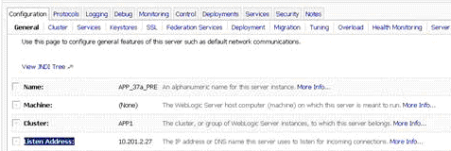

Data Source Setup: create DS entries on WL-application server with detail for the above database setup section (6.3)
i. TOSDataProcessor uses the apex database to make a few lookup queries related to function FSS, Checkdigit, and couple other.
ii. TOSDataProcessor uses the TOS ref Data database to lookup environment specific details.
iii. TOSDataProcessor uses the CAS ref Data database to lookup FTP addresses and for FTP authentication.
Iv. TOSDataProcessor uses the CAS vessel itinerary Database to lookup FSS related details.
Data Source Name
APEX | jdbc.ds.apex.nontx
TOS REF DATA | jdbc.ds.tdp.nontx
CAS REF DATA | jdbc.ds.cas.nontx
CAS VESSEL ITINERARY | jdbc.ds.itin.nontx

Startup Script Changes
Put MQ jars files in classpath of WebLogic.
PATH="${PATH}${PATHSEP}/opt/mqm/java/bin${PATHSEP}${DOMAIN_HOME}/lib"

CLASSPATH="${CLASSPATH}${CLASSPATHSEP}${MEDREC_WEBLOGIC_CLASSPATH}"
CLASSPATH="${CLASSPATH}${CLASSPATHSEP}${DOMAIN_HOME}/lib/com.ibm.mq.jar"
CLASSPATH="${CLASSPATH}${CLASSPATHSEP}${DOMAIN_HOME}/lib/com.ibm.mqjms.jar"
CLASSPATH="${CLASSPATH}${CLASSPATHSEP}${DOMAIN_HOME}/lib/providerutil.jar"

Additional Startup script specific details to follow in the section as we progress. (Memory setting changes)
FTP Setup
TOS application will also use a few FTP servers/sites for file transfer to/from other systems. CAS FTP component is used for this purpose. To setup the FTP sites the infrastructure team will need to logon: http://10.xx.xxx.xxxx:8001/CasFtpAdminWeb/login_pages/login.jsp

FTP setup details include a CAS Proxy ID to be setup by the infrastructure team.

1. CSC Setup
The Matson standard FTP servers are located at CSC. A number of FTP items are required all for the distributed application called TOS Data Processor.

Infra – need the yellow highlighted sections completed.

Description | FTP Server | FTP Username | Proxy ID | Remote Directory
DCM Upload  CSC  When a vessel departs from HON, a user in the N4 system will run a report that generates a DCM report. This report is saved on the user’s local file system. A web interface within TDP allows the user to put the file on the standard CSC FTP server. Later TDP will read the file and send a subsequent email and file to a HON local FTP server.  Late DCM files from the west coast will be emailed the SN4 support team. A web interface within TDP allows the user to put the file on the standard CSC FTP server. Later TDP will read the file and send JMS messages to N4.  READ & WRITE ACCESS REQUIRED. | DEV: UNX08D1S (10.8.7.145)  QA: matcamuqa08 (10.201.0.6)  PP: matcvauaw14 (10.201.2.4), matcvauaw14 (10.201.2.5)  PROD: matcamupw01 (10.201.0.4), matcamupw02 (10.201.0.5) | DEV: bea  QA: tosftp  PP: tosftp  PROD: tosftp | DEV: 103  QA: 504  PP: ??  PROD: ?? | DEV: /export/home/bea/TOS/ftp/DCM/out  QA: ~/DCM/out  PP: ~/DCM/out  PROD: ~/DCM/out
STIF Into HON  CSC  When a vessel departs, destined for HON, an email is sent to the SN4 support team. The file is stored on the local file system. Then a web interface provided by TDP is used to send the file to the standard CSC FTP server. TDP later reads this same file from the standard CSC FTP server, manipulates the data and sends messages to N4 via JMS.  READ & WRITE ACCESS REQUIRED. | DEV: UNX08D1S (10.8.7.145)  QA: matcamuqa08 (10.201.0.6)  PP: matcvauaw14 (10.201.2.4), matcvauaw14 (10.201.2.5)  PROD: matcamupw01 (10.201.0.4), matcamupw02 (10.201.0.5) | DEV: bea  QA: tosftp  PP: tosftp  PROD: tosftp | DEV: 101  QA: 501  PP: ??  PROD: ?? | DEV: /export/home/bea/TOS/ftp/vesFiles  QA: ~/vesFiles  PP: ~/vesFiles  PROD: ~/vesFiles

2. HONWPA14 Setup
FTP users and directories are required on the new server (HONWPA14). This setup should be mirrored to the backup server (HONWDA06).

TOS Data Processor
From the distributed applications environment (TDP) point of view:
Infra – need the yellow highlighted sections completed.

Description | FTP Server | FTP Username | Proxy ID | FTP Remote Directory | FTP Mapped Directory
CMIS to N4 Feeds  The vessel schedule, the supplemental process, and new vessel file output from CMIS are stored in the new HONO FTP server and read by TDP. The data is then sent from TDP to N4 using JMS.  READ ACCESS REQUIRED. | DEV: HONWPA14 (10.7.11.142)  QA: HONWPA14 (10.7.11.142)  PP: HONWPA14 (10.7.11.142)  PROD: HONWPA14 (10.7.11.142) | DEV: tdptest  QA: tdptest  PP: tdptest  PROD: tdp | DEV: ??  QA: ??  PP: ??  NV PROD: 104  SUPP PROD: 105 | DEV: /ftp/test/newves  QA: /ftp/test/newves  PP: /ftp/test/newves  PROD: /ftp/newves | DEV: ??  QA: ??  PP: ??  PROD: ??
N4 Events to CMIS  HON  Events in N4 will be sent through JMS to TDP. TDP will manipulate the formatting and FTP the file to a HON local FTP server for CMIS to pick up.  WRITE ACCESS REQUIRED. | DEV: HONWPA14 (10.7.11.142)  QA: HONWPA14 (10.7.11.142)  PP: HONWPA14 (10.7.11.142)  PROD: HONWPA14 (10.7.11.142) | DEV: tdptest  QA: tdptest  PP: tdptest  PROD: tdp | DEV: ??  QA: ??  PP: ??  PROD: 103 | DEV: /ftp/test/n4events  QA: /ftp/test/n4events  PP: /ftp/test/n4events  PROD: /ftp/n4events | DEV: I:  (Netware, /hon2/vol1/wrkgroup/tos/jmsdev)  QA: I:  (Netware, /hon2/vol1/wrkgroup/tos/jmsdev)  PP: I:  (Netware, /hon2/vol1/wrkgroup/tos/jmsdev)  PROD: J:  (Netware, /hon2/vol1/wrkgroup/tos/jmsprod)
GUAM to N4 Feeds  Cmis GUAM(GVPQ) actions that were previously sent by the Pipeline upto Acets is being replaced. NOW cmis HON actions are bundled and stored by cmis in a new HON FTP area to be read by TDP The data is then sent from TDP to N4 using JMS.  This replaces the pipeline  cmis->pipeline-> Acets  Communication with Cmis->TDP->Gems  READ ACCESS REQUIRED. | DEV: (10.7.11.148)  QA: (10.7.11.148)  PP: (10.7.11.148)  PROD: (10.7.11.149) | DEV: pipegumdev  QA: ??  PP: ??  PROD: ?? | DEV: ??  QA: 911  PP: 1167  PROD: 605 | DEV: /ftp/test/GUMPIPE/OUTQUE  QA: /ftp/test/GUMPIPE /OUTQUE  PP: /ftp/test/GUMPIPE /OUTQUE  PROD: /ftp/GUMPIPE /OUTQUE | Dev: HON2\VOL1:WRKGROUP\TOS\JMSDEV\GUMPIPE\  QA: HON2\VOL1:WRKGROUP\TOS\JMSQA\GUMPIPE\  PP : HON2\VOL1:WRKGROUP\TOS\JMSPPD\GUMPIPE\  Prod : HON2\VOL1:WRKGROUP\TOS\JMSPROD\GUMPIPE\
HON to N4 Feeds  Cmis HON actions that were previously sent by the Pipeline upto Acets is being replaced. NOW cmis HON actions are bundled and stored by cmis in a new HON FTP area to be read by TDP The data is then sent from TDP to N4 using JMS.  This replaces the pipeline  cmis->pipeline-> Acets  Communication with Cmis->TDP->Gems  READ ACCESS REQUIRED. | DEV: (10.7.11.148)  QA: (10.7.11.148)  PP: (10.7.11.148)  PROD: (10.7.11.149) | DEV: pipehondev  QA: ??  PP: ??  PROD: ?? | DEV: ??  QA: 910  PP: 1168  PROD: 604 | DEV:/ftp/test/HONPIPE /OUTQUE  QA: /ftp/test/HONPIPE /OUTQUE  PP: /ftp/test/HONPIPE /OUTQUE  PROD: /ftp/HONPIPE /OUTQUE | Dev: HON2\VOL1:WRKGROUP\TOS\JMSDEV\HONPIPE\  QA : HON2\VOL1:WRKGROUP\TOS\JMSQA\HONPIPE\  PP : HON2\VOL1:WRKGROUP\TOS\JMSPPD\HONPIPE\  Prod : HON2\VOL1:WRKGROUP\TOS\JMSPROD\HONPIPE\

CMIS
The setup should be similar to the existing CMIS FTP server (10.7.11.1), where files are FTP’d in and mapped to a directory in NETWARE that paradox has access to read the files and vice versa. IPX will need to be installed on HONWPA14.

Paul Kau – Byron will need the setup so he can read/write to the new FTP server from CMIS, similar to 10.7.11.1.

Netware mappings needed on HONWPA14 for CMIS:

Description | Remote Directory
CMIS to N4 Feeds  The vessel schedule and new vessel file output from CMIS are stored in the new HONO FTP server and read by TDP. The data is then sent from TDP to N4 using JMS.  WRITE ACCESS REQUIRED. | DEV: ??  QA: ??  PP: ??  PROD: ??  Byron to fill in…
N4 Events to CMIS  HON  Events in N4 will be sent through JMS to TDP. TDP will manipulate the formatting and FTP the file to a HON local FTP server for CMIS to pick up.  READ ACCESS REQUIRED. | DEV: I:  (Netware, /hon2/vol1/wrkgroup/tos/jmsdev)  QA: I:  (Netware, /hon2/vol1/wrkgroup/tos/jmsdev)  PP: I:  (Netware, /hon2/vol1/wrkgroup/tos/jmsdev)  PROD: J:  (Netware, /hon2/vol1/wrkgroup/tos/jmsprod)

Tier II/III FTP Server Setup
There is a tier III production application, called HAZMAT, supported by John Petterson that currently receives a feed from CMIS. With the new terminal operating system, this DCM file will come from N4, not from CMIS any longer. Today, the production box where HAZMAT runs is 10.3.4.65. By the time that the new TOS goes live, this will have been switched over to the tier III DB servers. Therefore, this documentation uses the tier III DB servers.

Infra – create needed CAS FTP proxy IDs

Description | FTP Server | FTP Username | Password | Proxy ID | Remote Directory
DCM Out/Publish  HON  When a vessel departs from HON, a user in the N4 system will run a report that generates a DCM report. This report is saved on the user’s local file system. A web interface within TDP allows the user to put the file on the standard CSC FTP server. Later TDP will read the file and send a subsequent email and file to a HON local FTP server. This file is read by the HAZ Viewer on the vessels. Finally, another copy is sent to the Tier III DB server to be read by the HAZMAT application.  WRITE ACCESS REQUIRED. | DEV: ohqwdc02 (128.242.122.110)  QA: ohqwdc02 (128.242.122.110)  PP: ohqwdc02 (128.242.122.110)  PROD: OHQWPC11 (128.242.122.109) | DEV: tdptest  QA: tdptest  PP: tdptest  PROD: tdp | DEV: dcmPUTTER  QA: dcmPUTTER  PP: dcmPUTTER  PROD: dcmPUTTER | DEV: ??  QA: ??  PP: ??  PROD: ?? | DEV: ~  QA: ~  PP: ~  PROD: ~
DCM Out/Publish  Tier III  When a vessel departs from HON, a user in the N4 system will run a report that generates a DCM report. This report is saved on the user’s local file system. A web interface within TDP allows the user to put the file on the standard CSC FTP server. Later TDP will read the file and send a subsequent email and file to a HON local FTP server. This file is read by the HAZ Viewer on the vessels. Finally, another copy is sent to the Tier III DB server to be read by the HAZMAT application.  READ ACCESS REQUIRED. | DEV: ohqwdc02 (128.242.122.110)  QA: ohqwdc02 (128.242.122.110)  PP: ohqwdc02 (128.242.122.110)  PROD: OHQWPC11 (128.242.122.109) | DEV: HAZUSERDEV  QA: HAZUSERQA  PP: HAZUSER  PROD: HAZUSER | DEV: ??  QA: ??  PP: ??  PROD: ?? | N/A | DEV: ~  QA: ~  PP: ~  PROD: ~
DCM Out/Publish  HON  When a vessel departs from HON, a user in the N4 system will run a report that generates a DCM report. This report is saved on the user’s local file system. A web interface within TDP allows the user to put the file on the standard CSC FTP server. Later TDP will read the file and send a subsequent email and file to a HON local FTP server. This file is read by the HAZ Viewer on the vessels. Finally, another copy is sent to the Tier III DB server to be read by the HAZMAT application.  WRITE ACCESS REQUIRED. | DEV: ohqwdc02 (128.242.122.110)  QA: ohqwdc02 (128.242.122.110)  PP: ohqwdc02 (128.242.122.110)  PROD: OHQWPC11 (128.242.122.109) | DEV: tdptest  QA: tdptest  PP: tdptest  PROD: tdp | DEV: dcmPUTTER  QA: dcmPUTTER  PP: dcmPUTTER  PROD: dcmPUTTER | DEV: ??  QA: ??  PP: ??  PROD: ?? | DEV: DCM/out/<VES>  QA: DCM/out/<VES>  PP: DCM/out/<VES>  PROD: DCM/out/<VES>
DCM Out/Publish  HON  When a vessel departs from HON, a user in the N4 system will run a report that generates a DCM report. This report is saved on the user’s local file system. A web interface within TDP allows the user to put the file on the standard CSC FTP server. Later TDP will read the file and send a subsequent email and file to a HON local FTP server. This file is read by the HAZ Viewer on the vessels. Finally, another copy is sent to the Tier III DB server to be read by the HAZMAT application.  READ ACCESS REQUIRED. | DEV: HONWPA14 (10.7.11.142)  QA: HONWPA14 (10.7.11.142)  PP: HONWPA14 (10.7.11.142)  PROD: HONWPA14 (10.7.11.142) | DEV: vessel  QA: vessel  PP: vessel  PROD: vessel | DEV: dcmGETTER  QA: dcmGETTER  PP: dcmGETTER  PROD: dcmGETTER | N/A | DEV: DCM/out/<VES>  QA: DCM/out/<VES>  PP: DCM/out/<VES>  PROD: DCM/out/<VES>

After the Proxy IDs are created by the infrastructure team, the IDs should be sent to the support team so they can be added to the reference data for that environment. As each proxy ID is created, the FTP connections should be tested to make sure network paths and firewalls are configured correctly.
HAZMAT is a downstream consumer of the data. TOS is not at all dependent on HAZMAT. See attached email, the HAZMAT application may be retired soon.
GUAM GATE TRANSACTION to GEMS: “Port Authority of Guam” to send us a delimetered flat file with gate transaction via FTP. We already have processor in place(production) that reads cmis files from Ftp areas and post transaction to Gems. We are going the same route and would use the TosDataProcessor to lookup the FTP file process them and post transaction to Gems.

- Message to be formatted to same layout and Field as N4 messages (Prod : Groovy xml already existing layout)
- This Groovy xml is currently posted to gems for all events from N4 today in Production.
- Message to be posted the N4-Gems Queue (Prod : Already existing queue)
- No work on the Gems Interface as we are posting the transaction in the same N4 groovy format
- In the Future this interface would be replaced by EDI

Description | FTP Server | FTP Username | Password | Proxy ID | Remote Directory
Guam Gate transaction to Gems  Current Matson Guam Office Process:  1. Matson collects Gate Transaction hard copy printout receipts from the “Port of Guam office” twice a day (afternoon and day end)  2. These gate transaction receipts are brought back to the Matson office and are manually entered into Gems to update the information on the unit.  3. All this data entry is being done manually by the Guam office staff and they have approach us(Hon Team) to automate the process.  Future: Port of Guam planning to setup EDI communication to Gems Or a Matson system that would update gems. But as we don’t know when in the near future this would be implemented.  WRITE ACCESS REQUIRED. | Dev: 10.8.7.145  QA: 10.201.0.6  PreProd: 10.201.2.4, 10.201.2.5  Prod: 10.201.0.4, 10.201.0.5 | Dev: paog  QA: paog  PreProd: paog  Prod: paog | Dev:  QA:  PreProd:  Prod: | Dev:  QA:  PreProd: 1451, 1452  Prod: 854,855 | Dev:  QA:  PreProd: home dir of user  Prod: home dir of user
DCM File to Ftp area Via Excel Spreadsheet (macro): We have created a spreadsheet that will FTP a text file up to the directory listed below (Very similiar to the HazCreator process that China uses) and then TOS will grab the file and process it. Data Intregrity can at times enter hundreds of Hazardous items and this new spreadsheet will allow them to perform this process much faster and minimize risk of losing data entry. Once data entry is complete, when prompted, the sheet will automatically post a .txt file via FTP and TDP(Tos data processor) application deployed in the TOS WL-domain running on matcamupa41 is polling this area for files and picks, reads, create xml for N4 application and post to xml(snx) to N4 queue.
There are three flavors of DCM files that are posted to this region (1 & 2 are existing flavors that are current processed in Prod adding flavor 3)
1. DCM File drop by salt lake (vesvoy.CSV) using Dcm Uploader UI. This sends out emails to Vessel DCM group
2. Last DCM file dropped by DI users (vesvoy_LT.TXT) using Dcm Uploader UI. This Update’s N4 with Update HAZ item posted as SNX
3. NOW ADDING - Haz Insert DCM file dropped by DI user to update Hazardous Item on Container (vesvoy_TimeStamp_INS.TXT) using the HAZ spreadsheet. This Update’s N4 with Update HAZ item posted as SNX
Request to setup:
1. Create FTP userId(tdphazprod) and Password to ftp to directory (/home/tdphazprod/DCM/in) on server(10.201.0.4)
2. Require userId(tdphazprod) and Password to FTP from HazCreator(an excelSheet template used to enter hazardous items for
the Outbound vessel and it ftp’s a csv flat file using VBA macro code from the client desktop machine to ftp area on the server)
3. Require CAS FTP proxy ID for the above configuration (item1#)
4. Restricted Ftp access for below listed HON DI user’s Pc’s to FTP area listed in Item1# (prod area below in red)
Env | TDP Proxy ID | Server | Directory | User | Password
DEV | 102 | 10.8.7.145 | /export/home/bea/TOS/ftp/DCM/in | bea | eaGle!
PROD | 904 | 10.201.0.4 | /home/tdphazprod/DCM/in | honhazpd | --------

Restricted FTP access IP: as per Infra Need to create new user who is able to write files to the destination folder which is restricted by IP address. We would have to add all the DI user IP address as they are the ones whole are going to use this functionality.
DI Pc | 10.7.8.64 | 10.7.8.65 | 10.7.8.66 | 10.7.8.67 | 10.7.8.68
 | 10.7.8.69 | 10.7.8.70

FTP Locations for TDP New vessel process:
Currently, the input files (stowplan –from GEMS, brds – from FACTS, DCM- from SSAT) for the new vessel process are copied to CMIS servers in HON and CMIS new vessel process reads from these locations. New vessel process is being migrated to TDP. For this we need to use the tier 1 FTP servers.
- GEMS/FACTS will write the files into these FTP locations from where TDP reads these for new vessel processing.
- DCM file is sent over email from SSAT and TDP will copy the email attachment to the FTP location and reads during new vessel processing.
- Once the new vessel processing is done, these input files will be archived to the “archive” folder mentioned in the below request and gets deleted from the input’ folder.
The below are the FTP details required for TDP new vessel process. All these folders required read/write/delete access.The below are the FTP details required for TDP new vessel process. All these folders required read/write/delete access.
Environ  ment | Description | Source IP | FTP  Server | FTP  Username | FTP  Proxy ID | Remote Directory
QA | GEMS-N4 feed: GEMS will FTP the stowplan file to this location for TDP to pick it up and process during new vessel process | 10.201.0.14 | matcamuqa08 (10.201.0.6) | tdpstow |  | /export/home/tdpstow/stowplan/input
QA | RDS-N4 feed (FACTS): RDS will FTP the BRDS files to this location for TDP to pick it up and process during new vessel process | 10.201.0.14 | matcamuqa08 (10.201.0.6) | tdpdcm |  | /export/home/tdpdcm/dcm/input
QA | This is to copy the DCM file received from Load Port (SSAT) for the new vessel process. | 10.201.0.14 | matcamuqa08 (10.201.0.6) | tdprds |  | /export/home/tdprds/rds/input
QA | GEMS-N4 feed: GEMS will FTP the stowplan file to this location for TDP to pick it up and process during new vessel process | 10.201.0.14 | matcamuqa08 (10.201.0.6) | tdpstow |  | /export/home/tdpstow/stowplan/archive
QA | RDS-N4 feed (FACTS): RDS will FTP the BRDS files to this location for TDP to pick it up and process during new vessel process | 10.201.0.14 | matcamuqa08 (10.201.0.6) | tdpdcm |  | /export/home/tdpdcm/dcm/archive
QA | This is to copy the DCM file received from Load Port (SSAT) for the new vessel process. | 10.201.0.14 | matcamuqa08 (10.201.0.6) | tdprds |  | /export/home/tdprds/rds/archive
PER PROD | GEMS-N4 feed: GEMS will FTP the stowplan file to this location for TDP to pick it up and process during new vessel process | matcvauaa37 (10.201.2.27) | matcvauaw14 (10.201.2.4) | tdpstow |  | /export/home/tdpstow/stowplan/input
PER PROD | RDS-N4 feed (FACTS): RDS will FTP the BRDS files to this location for TDP to pick it up and process during new vessel process | matcvauaa37 (10.201.2.27) | matcvauaw14 (10.201.2.4) | tdpdcm |  | /export/home/tdpdcm/dcm/input
PER PROD | This is to copy the DCM file received from Load Port (SSAT) for the new vessel process. | matcvauaa37 (10.201.2.27) | matcvauaw14 (10.201.2.4) | tdprds |  | /export/home/tdprds/rds/input
PER PROD | GEMS-N4 feed: GEMS will FTP the stowplan file to this location for TDP to pick it up and process during new vessel process | matcvauaa37 (10.201.2.27) | matcvauaw14 (10.201.2.4) | tdpstow |  | /export/home/tdpstow/stowplan/archive
PER PROD | RDS-N4 feed (FACTS): RDS will FTP the BRDS files to this location for TDP to pick it up and process during new vessel process | matcvauaa37 (10.201.2.27) | matcvauaw14 (10.201.2.4) | tdpdcm |  | /export/home/tdpdcm/dcm/archive
PER PROD | This is to copy the DCM file received from Load Port (SSAT) for the new vessel process. | matcvauaa37 (10.201.2.27) | matcvauaw14 (10.201.2.4) | tdprds |  | /export/home/tdprds/rds/archive
PROD | GEMS-N4 feed: GEMS will FTP the stowplan file to this location for TDP to pick it up and process during new vessel process | matcamupa41 (10.201.1.18) | matcamupw01 (10.201.0.4) | tdpstow |  | /export/home/tdpstow/stowplan/input
PROD | RDS-N4 feed (FACTS): RDS will FTP the BRDS files to this location for TDP to pick it up and process during new vessel process | matcamupa41 (10.201.1.18) | matcamupw01 (10.201.0.4) | tdpdcm |  | /export/home/tdpdcm/dcm/input
PROD | This is to copy the DCM file received from Load Port (SSAT) for the new vessel process. | matcamupa41 (10.201.1.18) | matcamupw01 (10.201.0.4) | tdprds |  | /export/home/tdprds/rds/input
PROD | GEMS-N4 feed: GEMS will FTP the stowplan file to this location for TDP to pick it up and process during new vessel process | matcamupa41 (10.201.1.18) | matcamupw01 (10.201.0.4) | tdpstow |  | /export/home/tdpstow/stowplan/archive
PROD | RDS-N4 feed (FACTS): RDS will FTP the BRDS files to this location for TDP to pick it up and process during new vessel process | matcamupa41 (10.201.1.18) | matcamupw01 (10.201.0.4) | tdpdcm |  | /export/home/tdpdcm/dcm/archive
PROD | This is to copy the DCM file received from Load Port (SSAT) for the new vessel process. | matcamupa41 (10.201.1.18) | matcamupw01 (10.201.0.4) | tdprds |  | /export/home/tdprds/rds/archive

After the Proxy IDs are created by the infrastructure team, the IDs should be sent to the support team so they can be added to the reference data for that environment. As each proxy ID is created, the FTP connections should be tested to make sure network paths and firewalls are configured correctly.
FTP locations for GUM New vessel process:
We are not creating new proxies for GUM new vessel process. Instead we are trying to create sub directories in the existing ftp locations. The sub directories are in bold in the below list.
PER PROD | RDS-N4 feed (FACTS): RDS will FTP the GUM BRDS files to this location for TDP to pick it up and process during GUM new vessel process | matcvauaa37 (10.201.2.27) | matcvauaw14 (10.201.2.4) | tdprds |  | /home/tdprds/rds/input/gumrds
PER PROD | RDS-N4 feed (FACTS): TDP GUM new vessel process will archive the file from the above location to this location once the GUM new vessel process is completed. | matcvauaa37 (10.201.2.27) | matcvauaw14 (10.201.2.4) | tdprds |  | /home/tdprds/rds/archive/gumrds
PER PROD | This is to copy the DCM file received from Load Port (SSAT) for the new vessel process which will be copied to this sub directory | matcvauaa37 (10.201.2.27) | matcvauaw14 (10.201.2.4) | tdpdcm |  | /home/tdpdcm/dcm/input/gumdcm
PER PROD | TDP GUM new vessel process will archive the file from the above location to this location once the GUM new vessel process is completed. | matcvauaa37 (10.201.2.27) | matcvauaw14 (10.201.2.4) | tdpdcm |  | /home/tdpdcm/dcm/archive/gumdcm
PROD | RDS-N4 feed (FACTS): RDS will FTP the GUM BRDS files to this location for TDP to pick it up and process during GUM new vessel process | matcvauaa37 (10.201.1.18) | matcvauaw14 (10.201.0.4) | tdprds |  | /home/tdprds/rds/input/gumrds
PROD | RDS-N4 feed (FACTS): TDP GUM new vessel process will archive the file from the above location to this location once the GUM new vessel process is completed. | matcvauaa37 (10.201.1.18) | matcvauaw14 (10.201.0.4) | tdprds |  | /home/tdprds/rds/archive/gumrds
PROD | This is to copy the DCM file received from Load Port (SSAT) for the new vessel process which will be copied to this sub directory | matcvauaa37 (10.201.1.18) | matcvauaw14 (10.201.0.4) | tdpdcm |  | /home/tdpdcm/dcm/input/gumdcm
PROD | TDP GUM new vessel process will archive the file from the above location to this location once the GUM new vessel process is completed. | matcvauaa37 (10.201.1.18) | matcvauaw14 (10.201.0.4) | tdpdcm |  | /home/tdpdcm/dcm/archive/gumdcm

N42.1 SNX MAILBOX : Batch Processing for new vessel feed, neighboring island vessel feed, supplemental vessel feed and stow file vessel feed ] The new N4 2.1 batch processing function in dev. For us to set this up we would need ftp server areas created on each environment.

Currently we are using Jms to post SNX messages into N4 with the batch processing function we would need to write the entire SNX file out to an ftp server area and setup N4 2.1 to poll and read from the ftp server. TDP will writing the entire snx xml file out to the ftp server area using the cas proxy Id’s that infra provides. The UserId and password is required to setup the N4 UI batch function.

The below ftp areas are already in use by the TOS application for the DCM and Stif process. I was thinking that we can use the same areas and create these new directories under this root.

Producer Server : TDP(TosDataProcess a matson application) that is deployed on the Application Server in each environment will create the xml to be ftp’ed
Consumer Server : N4 application server running on node (PP-10.201.2.29, Prod-10.201.1.21)
FTP Server Area : Area on Server where the batch file is going to be posted and consumed.
Folders : Individual folders for each batch process(batch file)
Cas Proxy Id : For TDP(TosDataProcess a matson application) that is deployed on the Application Server to use these cas proxy’s to Ftp files
User Id & Passwd : For TOS2.1 to setup SnxMailBox(ftp mailbox) configuration in the application using the UI

Env | Dev | QA | PP | PROD
Producer Server [TDP application] | 10.3.4.179 | 10.201.0.14 | 10.201.2.27 | 10.201.1.18
Consumer Server [TOS 2.1 app] | 10.3.4.179 | 10.201.0.14 | 10.201.2.29 | 10.201.1.21
FTP Server area | 10.8.7.145/export/home/bea/TOS/ftp | 10.201.0.6/home/tosftp | 10.201.2.4/home/tosftp | 10.201.0.4/home/tdpprod
Folders
  newves | nlt | supp | stif
  newves | nlt | supp | stif
  newves | nlt | supp | stif
  newves | nlt | supp | stif
Cas Proxy Id
  2601 | 2602 | 2603 | 2604
  -- | -- | -- | --
  1701 | 1702 | 1703 | 1704
  1055 | 1056 | 1055 | 1055
User Id & Passwords | Tdp Username: tdpsnxdev  Password: d3v$nxpassword  N4 Username: n4snxdev  Password: n4$nxpassword | WE DIDN’T SETUP | Required till FTP user home folder | Required till FTP user home folder

As per specs in PP and Prod the batch processing is reserved to be setup on tomcat instance node4(sever2)

MQ Setup
The Infrastructure team will need to set up the remote MQ for sending MQ messages to the mainframe and the local MQ for receiving messages from the mainframe and the TOS.SVRCON channel.
Production
MQ_CHANNEL = TOS.SVRCON
MQ_HOSTNAME = 10.201.1.4 (MATCAMUPA03)
MQ_QUEUE_MGR_NAME = SUNPROD1
MQ_QUEUE_NAME = ACETS.TOS.N4.FORMATTED

PreProd - Pointing TO F: Region
MQ_CHANNEL = TOS.SVRCON
MQ_HOSTNAME = 10.201.2.6 (MATCVAUAA16)
MQ_QUEUE_MGR_NAME = SUNDEV1
MQ_QUEUE_NAME = ACETS.TOS.N4.FORMATTED.QL

QA – Pointing to E: Region
MQ_CHANNEL TOS.SVRCON
MQ_HOSTNAME 10.201.0.6 (MATCAMUQA08)
MQ_QUEUE_MGR_NAME SUNDEV2
MQ_QUEUE_NAME ACETS.TOS.N4.FORMATTED.QL

DEV
MQ_HOSTNAME = 10.8.7.145
MQ_CHANNEL = CUSTOMS.SVRCON (UNX01D1S)
MQ_QUEUE_MGR_NAME = UNXDEV1
MQ_QUEUE_NAME = ACETS.TOS.N4.FORMATTED

JMS Setup
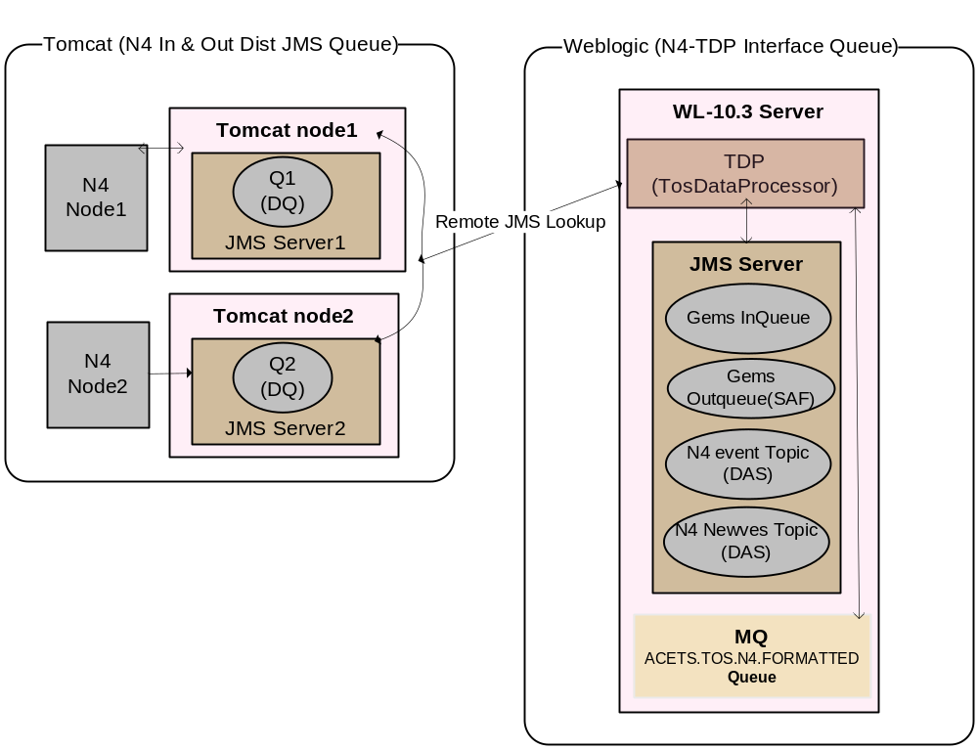
Tomcat
Active MQ MOM to be configured with the Tomcat Application Server.
Distributed Queues Inbound and Outbound out of N4 configured on Tomcat
Specific Configuration Detail to follow as we progress.
Weblogic
N4- TDP interface Queues & Topics that communicate with Gems, Das configured on the WL domain.
Deploy resource adapters from WebLogic console: jms-notran-adp, jms-xa-adp

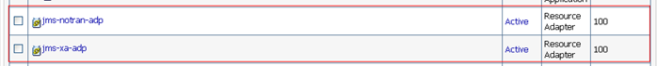

JMS Configuration
BROWN - New Config
BLUE - Which App Server
JMS Queue
Name | Type | JNDI name | Subdeployment | Targets | APP SERVER
jms.conn.tdp.udq | Connection Factory | jms.conn.tdp.udq | Default Targetting | APP1 | Tomcat
jms.distqueue.tdp.N4QueueIn | Uniform Distributed Queue | jms.distqueue.tdp.N4QueueIn | tdp_sub_udq | jms.server.tdp,jms.server2.tdp | Tomcat
jms.distqueue.tdp.N4QueueInBT | Uniform Distributed Queue | jms.distqueue.tdp.N4QueueInBT | tdp_sub_udq | jms.server.tdp,jms.server2.tdp | Tomcat
jms.distqueue.tdp.N4QueueInHIL | Uniform Distributed Queue | jms.distqueue.tdp.N4QueueInHIL | tdp_sub_udq | jms.server.tdp,jms.server2.tdp | Tomcat
jms.distqueue.tdp.N4QueueInKAH | Uniform Distributed Queue | jms.distqueue.tdp.N4QueueInKAH | tdp_sub_udq | jms.server.tdp,jms.server2.tdp | Tomcat
jms.distqueue.tdp.N4QueueInKHI | Uniform Distributed Queue | jms.distqueue.tdp.N4QueueInKHI | tdp_sub_udq | jms.server.tdp,jms.server2.tdp | Tomcat
jms.distqueue.tdp.N4QueueInLNI | Uniform Distributed Queue | jms.distqueue.tdp.N4QueueInLNI | tdp_sub_udq | jms.server.tdp,jms.server2.tdp | Tomcat
jms.distqueue.tdp.N4QueueInMOL | Uniform Distributed Queue | jms.distqueue.tdp.N4QueueInMOL | tdp_sub_udq | jms.server.tdp,jms.server2.tdp | Tomcat
jms.distqueue.tdp.N4QueueInNAW | Uniform Distributed Queue | jms.distqueue.tdp.N4QueueInNAW | tdp_sub_udq | jms.server.tdp,jms.server2.tdp | Tomcat
jms.distqueue.tdp.N4QueueOut | Uniform Distributed Queue | jms.distqueue.tdp.N4QueueOut | tdp_sub_udq | jms.server.tdp,jms.server2.tdp | Tomcat
gems.tos.n4.formatted | Queue | gems.tos.n4.formatted | TOSsubDeployment | jms.server.tdp | Weblogic10
jms.conn.tdp.TOSfactory | Connection Factory | jms/WLQueueConnectionFactory | TOSsubDeployment | jms.server.tdp | Weblogic10
jms.topic.tdp.n4 | Topic | jms.topic.tdp.n4 | TOSsubDeployment | jms.server.tdp | weblogic10
jms.topic.tdp.newVessel | Topic | jms.topic.tdp.newVessel | TOSsubDeployment | jms.server.tdp | weblogic10
n4.gems.cf  n4.gems.saf.error  n4.gems.saf.imported  n4.gems.saf.remote.context | SAF - Connection Factory, Error Handler, Context, Importer |  | n4.gems.sd | n4.gems.saf.agent
n4.mns.cf  n4.mns.saf.error  n4.mns.saf.imported  n4.mns.saf.remote.context | SAF - Connection Factory, Error Handler, Context, Importer |  | n4.mns.sd | n4.mns.saf.agent
n4.mns.nvi.cf  n4.mns.nvi.saf.error  n4.mns.nvi.saf.imported  n4.mns.nvi.saf.remote.context | SAF - Connection Factory, Error Handler, Context, Importer |  | n4.mns.nvi.sd | n4.mns.nvi.saf.agent
Protocol Channel
Name | Protocol | Enable | Listen Address | Listen Port | APP SERVER
TDP_JMS_CHANNEL | t3 | true | localhost | 9321 | Tomcat
TDP_JMS_CHANNEL | t3 | true | localhost | 9321 | Tomcat
Persistance store
Name | Type | Target | APP SERVER
jms.store.tdp | FileStore | APP_41a_PROD | Tomcat
jms.store.node2.tdp | FileStore | APP_42a_PROD | Tomcat
n4.gems.persistent.store | FileStore | APP_41a_PROD | weblogic10
n4.mns.nvi.persistent.store | FileStore | APP_41a_PROD
n4.mns.persistent.store | FileStore | APP_41a_PROD
jms.store.tos.tdp | FileStore | BATCH SERVER | weblogic10
Jms Server
Name | Persistence Store | Target | APP SERVER
jms.server.tdp | jms.store.tdp | APP_41a_PROD | Tomcat
jms.server2.tdp | jms.store.node2.tdp | APP_42a_PROD | Tomcat
jms.server.tos.tdp | jms.store.wl.tdp | BATCH SERVER | Weblogic10
Jms Module
Name | Type | APP SERVER
jms.module.tdp | system | Tomcat
jms.module.tos.tdp | system | Weblogic10
SAF Agent
Name | Agent Type | Persistence Store | Server | APP SERVER
n4.gems.saf.agent | Sending-only | n4.gems.persistent.store | APP_41a_PROD | Weblogic10
n4.mns.nvi.saf.agent | Sending-only | n4.mns.nvi.persistent.store | APP_41a_PROD
n4.mns.saf.agent | Sending-only | n4.mns.persistent.store | APP_41a_PROD
JMS - Subdeploymetns
Name | Resource | Target | APP SERVER
tdp_sub_udq | All Distributed queues | jms.server.tdp,jms.server2.tdp | Tomcat
n4.gems.sd | n4.gems.saf.imported | n4.gems.saf.agent | Weblogic10
TOSsubDeployment |  | jms.server.tdp | Webloigc10
n4.mns.sd | n4.mns.cf, n4.mns.saf.imported | n4.mns.saf.agent
n4.mns.nvi.sd | n4.mns.nvi.cf, n4.mns.nvi.saf.imported | n4.mns.nvi.saf.agent

- Application Start/Stop Instructions
See the appendix for details about XPS.
  - Tomcat
When the deployment artifact is copied to the deploy directory (WAR file), the permissions should include the executable attribute set to true.
N4
The deployment artifact for Navis N4 is called apex.war. This WAR is deployed to the cluster. The start up/shut down procedure must be to stop/start the Tomcat servers. The redeploy process does not work. The administration server is not required to be shutdown, but can be without harm. No special coordination with the external servers is required (e.g. XPS or Edge manager). However, after a restart, someone from the support team should verify that everything working.
When there is a release from Navis and the version number on the apex.war is incremented a more specific deployment process should follow. Additional Setup & Install instructions to follow in this section
1. WL Admin, un-install application apex.war
2. WL Admin, stop all Tomcat servers (admin and two managed servers)
3. WL Admin, clear stage directory on both physical servers:
PhysicalServer1:
PhysicalServer2:
4. WL Admin, copy new WAR file to TOS Tomcat Environment Servers (PhysicalServer1 & PhysicalServer2)
5. WL Admin, start the admin server and the first managed server
6. WL Admin, install (target the cluster) and deploy application apex.war
7. WL Admin, once the apex.war application is in ACTIVE state (this may take awhile), restart managed server 2

  - Weblogic
When the deployment artifact is copied to the deploy directory (EARfile), the permissions should include the executable attribute set to true.

Tos Data Processor
The deployment artifact for the TOS Data Processor is called tos.ear. This application is deployed on 1 managed server in each environment [DEV= SVR1_DEV2, QA= SVR2_GEMS_QA, PP=SVR3_GEMS_PRE, PROD= SVR3_GEMS_PROD ]. The application can be stopped and started from the Weblogic console at any time without any dependencies or special checkout required. The redeploy process does work for this application.

- Configuration Files
None – All configuration information for N4 and TOS Data Processor is kept in the database.
- Dependencies
As described in Section 4, Data Flow Diagram, the application has the following dependencies:
Dependency | Description | Modules
Mainframe | The mainframe sends ACETS and FACTS updates to N4 using MQ. If the communication between the application and MQ is disconnected for any reason messages should queue and be processed when the connection is restored.  The normal mainframe outage times are acceptable for availability SLA’s for TOS. Messages are coming from the Mainframe to TOS and not the other way. If the mainframe is down, then there are no pending transactions to be processed. | All
Gems | Gems has replaced the ACETS mainframe system and now Transaction that we were receiving from ACETS is coming down to TOS via the Gems Interface | N4
CMIS | N4 sends messages to CMIS for event notification and receives updates from CMIS for Vessel Schedule and New Vessel process. Tos Data Processor connects to a FTP server in Honolulu to send messages to CMIS. The FTP process uses CAS FTP. | ALL
EMAIL Server | Responsible for the transmission and delivery of N4 events.  The production SMTP server should have Tier I availability to support the TOS environment. | N4
Edge Manager | Edge Manager sends information from a trucks RFIDs and the gate scale to N4.  The availability for the edge manager is the same as N4 itself, Tier I. However, if the edge manager is unavailable, the work around is for the clerk to do manual data entry. This is acceptable for a number of hours. | N4
NOW | NOW sends position information from the EIT to XPS.  NOW availability is nearly 24x7 with no downtime. This product will give the terminal the required automation to work and plan the vessel and yard. Without it, the terminal will come to a standstill. | XPS
LXE | The LXEs are used in the yard to perform transactions that are sent to the XPS. | XPS
XPS | This is a set of servers on or near the terminal, one for each facility. This server is used by the SPARCS client and for vessel and yard automation. There is no direct dependency on XPS for N4. However, XPS will not be able to start up if N4 is not alive first. Also, XPS will need N4 to be alive to persist data. If during the N4 outage, XPS were to also crash data would be lost.  XPS availability is nearly 24x7 with no downtime. This product will give the terminal the required automation to work and plan the vessel and yard. Without it, the terminal will come to a standstill.  XPS requires N4 to be up to start. This is because XPS does not have a database, it uses the N4 database. However, it can survive an N4 outage because they both use coherence cache. Therefore, yes – it is true that XPS will not come up without N4 alive. However, it can stay up without N4. If XPS crashes while N4 is down, we must wait for N4 to be alive to continue. | N4
Oracle | The N4 application is dependent on the database. Specifically, APEX.WAR needs MATP03 and TOS.EAR needs MATP03 and MATP01. If there is an outage of just MATP01, TOS.EAR will continue to work, some FTP files will queue and be delivered once MATP01 returns. | N4, TDP

- Jobs, Schedule and Messages/Alerts
Job Name | Frequency / Timing | Success/Fail Message | Purpose
New Vessel | File created at each vessel sailing destined for the port of HON.  Checking for the presence of the file happens every 12 minutes. | If the TOS Data Processor is unable to parse the file from the FTP server, a failure email is sent to the SN4 support team.  If Navis N4 rejects a transaction, a failure email is sent to the SN4 support team. | A process in paradox collects inputs from various sources and creates a stow plan. This stow plan is input to Navis N4. After the stow plan is created in a comma separated value text file, it is stored on an FTP server locally in HON. The TOS Data Processor will pick up the file, manipulate the data and send it to Navis N4 via JMS. The CMIS process to create the stow plan happens every time a vessel sails destined for the port of HON. TOS Data Processor will look for the presence of this file every 12 minutes and send the updates to Navis N4 immediately.  At the end of the process, which is one day after sailing, the manifest is sent to the HDOA via web services for imports to Hawaii (not barges).  Timing: The manifest should arrive at the state 48 hours before arrival in Hawaii. This gives a normal sailing a 24 hour window to create and send the manifest.  Impact: The impact of delaying this process past vessel arrival means that availability notices could be delayed. The inspector must be scheduled and if the list of holds is delayed, the inspector might be late by a day.  Workaround: Today, Matson sends a hard copy report to the State. It is acceptable to use this process if the automated version is unable to complete.
All monitoring is done by the SN4 support team. No requirements from the operations team or CSC.
Late DCM | A west coast port may send an updated DCM file. If this happens it is emailed to the HON data integrity team.  The HON data integrity team will then manually upload the file to the TOS Data Processor through a web interface. The uploaded file is stored in the standard CSC FTP server.  TOS Data Processor will check for the presence of the file on the FTP server every 4 minutes. | If the TOS Data Processor is unable to parse the file from the FTP server, a failure email is sent to the SN4 support team.  If Navis N4 rejects a transaction, a failure email is sent to the SN4 support team. | If the west coast finds that they missed some hazardous reporting, they will email a new DCM file. The SN4 support team will put this file on the local HON FTP server. The TOS Data Processor will grab and parse this file from the HON FTP server. TDP will convert the text to XML and send the message to Navis N4 via JMS.
All monitoring is done by the SN4 support team. No requirements from the operations team or CSC.
Vessel Schedule | File created at each Fleet Scheduling System publish.  Checking for the presence of the file happens every 10 minutes. | If the TOS Data Processor is unable to parse the file from the FTP server, a failure email is sent to the SN4 support team.  If Navis N4 rejects a transaction, a failure email is sent to the SN4 support team. | Each time the Fleet Scheduling System performs a publish, a portion of the schedule is serialized and sent to an FTP server. This file is read by a paradox process that loads the necessary data into CMIS. The same CMIS process will then create a new file and store it on a local HON FTP server. The TOS Data Processor will read this file, change the format and send JMS messages to Navis N4.
All monitoring is done by the SN4 support team. No requirements from the operations team or CSC.
DCM from Navis N4 | File created at each vessel sailing from the port of HON.  The HON data integrity team will then manually upload the file to the TOS Data Processor through a web interface. The uploaded file is stored in the standard CSC FTP server.  TOS Data Processor will check for the presence of the file on the FTP server every 4 minutes. | If the TOS Data Processor is unable to parse the file from the FTP server, a failure email is sent to the SN4 support team.  If the destination FTP is unavailable, a failure email is sent to the SN4 support team.  If the process is unable to successfully send an email to the distribution list, an error is logged and another email is attempted to the SN4 support team. | When a vessel sails from the port of HON, a Navis N4 user runs a report that generates a dangerous cargo manifest file. This file is saved locally on the user machine. Then the user initiates a process that places the file on the common CSC standard FTP server. Every 4 minutes, the TOS Data Processor will look for this file. When found, it will grab the file, parse it, and send the results to an email distribution list, place a copy on a HONO FTP server and on the Tier II/III FTP server for the HAZMAT application to pick up.
All monitoring is done by the SN4 support team. No requirements from the operations team or CSC.
STIF to Navis N4 | File created at each vessel sailing destined for the port of HON and emailed to the SN4 support team.  The SN4 support team will then manually upload the file to the TOS Data Processor through a web interface. The uploaded file is stored in the standard CSC FTP server.  TOS Data Processor will check for the presence of the file on the FTP server every 4 minutes. | If the TOS Data Processor is unable to parse the file from the FTP server, a failure email is sent to the SN4 support team.  If Navis N4 rejects a transaction, a failure email is sent to the SN4 support team. | When a vessel sails destined for the port of HON, a STIF file is produced from the origin port and emailed to a number of recipients. The SN4 support team receives the email and moves the STIF file to the CSC standard FTP server.  The TOS Data Processor checks for the presence of this file on the CSC standard FTP server. When found, grabs the file and parses it, finally sending messages to Navis N4. These messages instruct Navis N4 to create new units that are inbound to the port.
All monitoring is done by the SN4 support team. No requirements from the operations team or CSC.
GUAM PIPELINE  (VPU & VPS) | File created by Cmis for Guam Discharge and Load action |  | Load and Discharge Guam messages that are now read by TDP and posted to the Gems Queue. These messages are posted by Guam Sparcs to Cmis. Cmis creats a Flat file and drops it into an FTP area. TosDataProcessor picks this file formats it into a Groovy xml and Post the file to the Gems Queue
All monitoring is done by the SN4 support team. No requirements from the operations team or CSC.
HON PIPELINE (BDC & NIT) | File created by Cmis for NIS Detention |  | HON NIS messages that are now read by TDP and posted to the Gems Queue. These messages are posted by HON Cmis for NIS Island YB containers that were outgated from the SI yard. Cmis creates a Flat file and drops it into an FTP area. TosDataProcessor picks this file formats it into a Groovy xml and Post the file to the Gems Queue
All monitoring is done by the SN4 support team. No requirements from the operations team or CSC.
Navis N4 Events to CMIS Translator | JMS messages from Navis N4 are sent to the TOS Data Processor. TDP will collect this data, change the format and send the file to an FTP server.  The file is sent to the FTP server every 600 seconds or every 20 transactions, whichever comes first. | If the TOS Data Processor is unable to send the file to the FTP server, a failure email is sent to the SN4 support team. | As events occur in Navis N4, they are communicated to the TOS Data Processor using JMS. The TOS Data Processor will capture these XML messages coming via JMS and transform them into text files. The text files are then sent on to the CMIS translator via FTP to an FTP server in HON.
All monitoring is done by the SN4 support team. No requirements from the operations team or CSC.
ACETS/FACTS Mainframe updates to Navis N4. | These messages are sent in real time. The queue structure allows for messages to sit and build up if needed in the event that one system is down. | If the TOS Data Processor has any problems connecting to either the JMS queue or MQ, an email is sent to the SN4 support team. | Equipment and booking updates sourced at the mainframe are packaged up in MQ messages and sent to an MQ destination. The TOS Data Processor reads the messages from MQ, converts the message format and sends them to Navis N4 on a JMS queue.
All monitoring is done by the SN4 support team. No requirements from the operations team or CSC.
- Health Checks
  - The link below should return a login page. Replace the IP in the URL with the appropriate IP for the environment for which the health check is performed.
http://10.3.4.179/apex
  - Log in to the SPARCS N4 web user interface. Switch to “Administration”, the choose “System” and finally “Cluster Management”. The resulting tab should look similar to the screen below. One “N4” entry for each managed server in the Tomcat cluster. They should all read “ACTIVE.” The journal size should be zero.
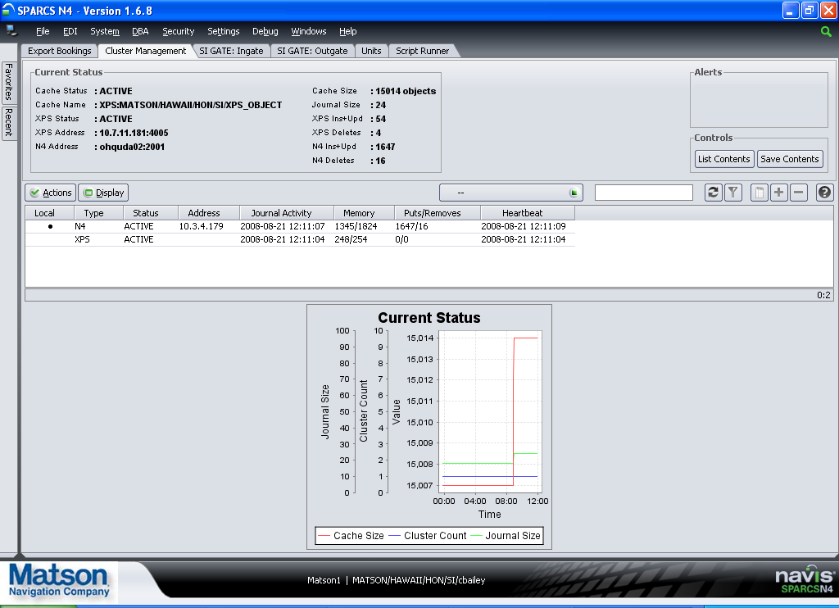
  - The SPARCS N4 thick client has box in the upper right corner that will flash red during a communication problem. Users may report a “flashing red status box.” Below is a screenshot of the SPARCS client. The box in the upper left corner is where the flashing red would take place.
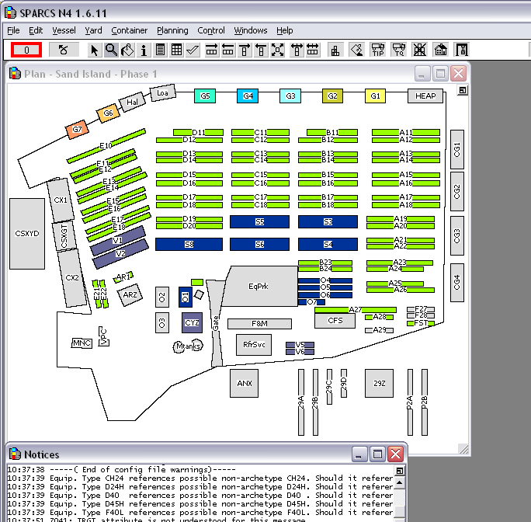
- Exception Handling
Log files created in the /home/logs/applogs/TOS and /home/logs/applogs/cas directories may contain exceptions. These exceptions need to be handled by the SN4 support team. No exceptions are expected.
For each failure, an email from the TOS Data Processor will be sent to the support team. Failures from Navis N4 are sent via JMS to the TOS Data Processor to allow for all emails to originate from the same place.

- Users
- Matson Navigation Company; Salt Lake City, Utah; Planners: Will use both the SPARCS N4 web client and the SPARCS N4 thick client.
- Matson Navigation Company; Phoenix, Arizona; Customer Service Representatives: Will use the SPARCS N4 web client.
- Matson Navigation Company; Honolulu, Hawaii; Terminal Operations: Will use both the SPARCS N4 web client and the SPARCS N4 thick client.
- Matson Terminals; Honolulu, Hawaii; Clerks; Will use the SPARCS N4 web client.
- Clients and Agents for Matson; Honolulu, Hawaii; Pacific Transport Lines, Maersk and Norton Lilly, etc.: Will use the SPARCS N4 web client.

The Honolulu Gate & Customer Support department; Customer service staff in Phoenix, Vessel Planners in Salt Lake City; and gate, F&M, container ops, process team, container yard, freight processing, claims, sales, and accounting in Honolulu are all users of the system.
User Acceptance Testing Participants – A sample of the users involved:
Tester | Role | UAT Location
Gail Anonsen | Subject Matter Export/UAT Lead | HON
Jocelyn Chagami | SPARCS Expert | HON
Linda Chong | Lead Tester – Gate, Customer Support, Container Yard | HON
Joanne Mahuka | Lead Tester – Gate, CS, CY | HON
Iwalani Maner | Tester – Gate, CS, CY | HON
Carol Hamasaki | Tester - Gate, CS, CY | HON
Cathy Kanehiro | Tester - Gate, CS, CY | HON
Mila Aglanao | Tester - Gate, CS, CY | HON
Greta Gainey | Tester - Gate, CS, CY | HON
Walter Harada  Michael Kikuta  Derwin Gealon  Ikaika Gueco | Tester – Process Team | HON
Elizabeth Turner Keiko Tanada  Jessica Bailey | Tester – Customer Svc | PNX
Robert Potter  Brian Robb | Tester – Vessel Planning | HON
Vern Ramie  Linda Takase  Kristi Moriyasu | Tester – Container Ops | HON
Judy Sakoda  Pearl Alonzo Oshita  Kent Takazawa | Tester - Accounting | HON
Kenneth Ocreto  Tisa Wilson | Tester - CVS | HON
Linda Oba | Tester – Auto Lot | HON
John Robinette | Tester - Claims | HON
Leimomi Tagawa  JoJo Kaea | Tester – F&M | HON
Dorothy Cooper | Tester – Freight Processing | HON
Paul McCully  Bryan Gomes | Tester - Sales | HON
Bill Pirtle  Letricia Linborg-Naehu  Didi Kapua | Tester – Pacific Transfer | HON
Mari Tani (Norton Lilly)  Julio Torres (Maersk) | Tester - Client | HON

- Alarming Requirements
Exceptions in the application will be visible in the application log files:
/home/logs/applogs/TOS/*-navis-apex.log
/home/logs/applogs/TOS/TosDataProcessor.log

Unexpected exceptions will be sent via email to the support group. The environment and Server are listed in the subject line. An example message follows:

From: 1SN4Supt@matson.com [mailto:1SN4Supt@matson.com]
Sent: Thursday, February 26, 2009 2:13 PM
To: 1SN4 Support at Matson
Subject: [APP_37A_PRE] ACETS Error Message

[Customer Groovy Code generated an exception: ERR_GVY_BDA_003. Unit: MATU2516157 Booking Num dismatch: N4 num=3625431 BDA num=8631306.]<?xml version="1.0" encoding="UTF-8"?><argo:snx xmlns:argo="http://www.navis.com/argo" xmlns:xsi="http://www.w3.org/2001/XMLSchema-instance" xsi:schemaLocation="http://www.navis.com/argo snx.xsd"><groovy class-location="database" class-name="GvyInjAbda"><parameters><parameter id="recorder" value="$SDEV41" /><parameter id="sealNum" value="610914" /><parameter id="commodity" value="NEW MACHINERY" /><parameter id="vesvoy" value="RJP339" /><parameter id="consigneeName" value="ROYAL HAWAIIAN MOVERS INC" /><parameter id="shipperId" value="0017006310" /><parameter id="equipment-id" value="MATU2516157" /><parameter id="temp" value="" /><parameter id="shipperName" value="APPROVED FORWARDERS OF HAWAII" /><parameter id="bookingNum" value="8631306" /><parameter id="destPort" value="HON" /><parameter id="loadPort" value="LAX" /><parameter id="dischargePort" value="HON" /><parameter id="consigneeId" value="0000008812" /></parameters></groovy></argo:snx>

Process/Job Name
System | Tomcat, WebLogic, Oracle
Error Log | /home/logs/applogs/TOS/*-navis-apex.log  /home/logs/applogs/TOS/TosDataProcessor.log
Log Message | Java Exceptions
Description
Action | Support team to address after email is received. Some discretion as to urgency can be deemed from the particular message.
Additional Notes

  - Process Name
WebLogic and deployments within WebLogic – looking for any Java Exceptions as well as memory and CPU constraints.

  - System

14.2.1 Tomcat

Development
ohquda02 - 10.3.4.179
DEV Console
N4 Console Client

QA
matcamuqa35 - 10.201.0.14
QA Console

PreProduction
matcvauaa37 - 10.201.2.27
matcvauaa38 - 10.201.2.29
PreProd Console

Production
matcamupa41 - 10.201.1.18
matcamupa42 - 10.201.1.21
Production Console

    - Weblogic

Development
- ohquda02 - 10.3.4.179
DEV Console

QA
- matcamuqa35 - 10.201.0.14
QA Console

PreProduction
matcvauaa18 -10.201.2.59
PreProd Console

Production
- matcamupa06 – 10.201.1.7
Production Console

Database
- DEV, OHQUDD02 (10.3.4.180)
- QA, MATUQD09 (10.201.1.8)
- PRE, MATCVAUAD50 (10.201.2.56)

PreProd backup db - MATCVAUAD51(10.201.2.48)
- Production, MATCAMUPD48 (10.201.1.33)

Prod backup db-MATCAMUPD49(10.201.1.32)

  - Error Log
/home/logs/applogs/TOS/*-navis-apex.log
/home/logs/applogs/TOS/TosDataProcessor.log

  - Log Message
An example exception in the log file follows:
2008-09-11 18:05:53,655 ERROR [[ACTIVE] ExecuteThread: '1' for queue: 'weblogic.kernel.Default (self-tuning)'] [Message
CollectorImpl:87] ( ) UNCAUGHT EXCEPTION: class java.lang.NullPointerException: null
java.lang.NullPointerException (compact stack trace follows)
com.navis.road.business.model.CachedScanKey.getXpsCacheKey(CachedScanKey.java:37)
com.navis.road.business.model.CachedScan.store(CachedScan.java:103)
com.navis.road.business.apihandler.BaseScanHandler.storeScan(BaseScanHandler.java:358)
com.navis.road.business.apihandler.BaseScanHandler.storeScan(BaseScanHandler.java:349)
com.navis.road.business.apihandler.BaseScanHandler.storeScans(BaseScanHandler.java:133)
com.navis.road.business.apihandler.RecordScanHandler.execute(RecordScanHandler.java:43)
com.navis.road.webservice.GateWebservice.processUpdate(GateWebservice.java:75)
com.navis.argo.webservice.ArgoWebServices$1.doInTransaction(ArgoWebServices.java:260)
com.navis.framework.persistence.hibernate.PersistenceTemplate.invoke(PersistenceTemplate.java:114)
com.navis.argo.webservice.ArgoWebServices.genericInvoke(ArgoWebServices.java:256)
com.navis.argo.webservice.ArgoWebServices.genericInvoke(ArgoWebServices.java:71)
java.lang.NullPointerException
at com.navis.road.business.model.CachedScanKey.getXpsCacheKey(CachedScanKey.java:37)
at com.navis.road.business.model.CachedScan.store(CachedScan.java:103)
at com.navis.road.business.apihandler.BaseScanHandler.storeScan(BaseScanHandler.java:358)
at com.navis.road.business.apihandler.BaseScanHandler.storeScan(BaseScanHandler.java:349)
at com.navis.road.business.apihandler.BaseScanHandler.storeScans(BaseScanHandler.java:133)
at com.navis.road.business.apihandler.RecordScanHandler.execute(RecordScanHandler.java:43)

  - Description
These error messages are delivered to the SN4 support team via email and must be addressed on a case-by-case basis to determine details.

  - Action
- All exceptions are first triaged by the support team before the operations team is required.

  - Additional Notes

Functional SLA’s
A number of business functions that will be preformed by this solution have performance requirements.

Gate Functions:
- RFID scans and the scale reads should appear on the gate screen by the time the truck arrives at the window.
- The time the trucker spends at the gate working with the clerk should remain unchanged from the CMIS processing of today. This is variable based on the transaction type (receive empty, receive export, dray in, etc.).
- Container Movement Clerks frequently used screens should have sub-second response:
- Lookup a container
- History
- Release container to second trucker
- Add Hold
- Release Hold
- Printing at the gate should be instantaneous.

NOW:
- Position updates from NOW should appear in N4 < 2 seconds
- EIT Updates should be posted to NOW < 5 seconds

SPARCS:
- Planners open a vessel, using the SPARCS client < 7 minutes. Today there is a workaround: remote desktop into the terminal server. This workaround will be available in the new solution as well.

Vessel Ops:
- LXE transactions should post to XPS < 5 seconds

Interfaces:
- FSS publish to N4 < 10 minutes
- The new vessel process from CMIS to N4 < 15 minutes
- VST sail flag sent from N4 to ACETS (through CMIS) < 5 minutes
- HDOA needs the manifest one day prior to arrival in HON (process SLA)

Disaster Recovery
- XPS part of the TOS environment should be available during the DR Test window.
N4 Disaster scenario | Expected result based on current architecture | Desired Result
1. A member of the WebLogic cluster goes down and another member survives. | At least one member of the cache cluster survives. XPS and N4 can still communicate. No interruption to XPS. | Same as expected. If the first managed server is the one that went down, restarting the mule (button inside in N4 client) is necessary by the development team. Restart procedure is documented here.
2. An outage at CSC in Cambridge. | XPS will stay alive, but without communication to N4. Transactions are allowed in XPS and queue up in the bridge extend. Once N4 is restored transactions recorded in XPS are sent from the bridge extend to N4 and persisted to the database. | Same as expected for a reasonably long outage.
3. A partial outage at CSC in Cambridge pulls down all WebLogic servers. (Add in normal software maintenance for WebLogic and Solaris, etc.) | XPS will stay alive, but without communication to N4. Transactions are allowed in XPS and queue up in the bridge extend. Once N4 is restored transactions recorded in XPS are sent from the bridge extend to N4 and persisted to the database. | Same as expected for a reasonably long outage.
4. A partial outage at CSC in Cambridge pulls down the Oracle database. | XPS and N4 will both stay alive. N4 will lose communication to the database. N4 will stay alive but throw persistence errors. N4 client users will not be able to continue working. Transactions are allowed in XPS. These transactions will be sent to N4 and sit and wait in the coherence cache. When the database returns, transactions from XPS queued up will be replayed in order. | Same as expected.
5. A network interruption between Hawaii and CSC. | XPS will queue up transactions and replay them to N4 when connection is restored. | Same as expected for a reasonably long outage.
6. COMBO: In the scenarios above that require the bridge extend to queue transactions (2, 3, and 5), the XPS server crashes. | XPS transactions queued up in the bridge extend will be lost. | We would like to see these XPS transactions that are queued in the bridge extend to be persisted to local disk or similar. When the XPS server is restored, read the transactions from the persistent store and replay them to N4. Until we have this fix from Navis, the data must be re-entered by the users for all lost data.
* Our testing reveals that a reasonably long outage is greater than 8 hours. We have not reached an upper limit on time yet, during testing.

XPS Disaster scenario | Expected result based on current architecture | Desired Result
The facility XPS server crashes. | Changes in N4 will be saved and delivered to XPS when it returns. | Same as expected.
The facility XPS server crashes and cannot recover. Switch to the XPS backup server. | Changes in N4 will be saved and delivered to XPS when it returns. | Same as expected.

- DASD Purge
N4 archives automatically. TDP does not save transactional data.

- List of All Data Files and Their Definitions
All data is stored in the database. Data integration is passed through JMS messages or via FTP. These files/messages hold transactional data and are deleted once processed. See sections above for more details on specific files, folders, and FTP details.
- Maintenance Windows
Day | Time Frame | Description
Tuesday | 9 PM MST (Phoenix) | Normal CSC deployment window.
Sunday | 11 AM MST (Phoenix) | Normal CSC deployment window.
Sunday | 0200 – 1300 PST | Normal MF maintenance window.

The TOS Data Processor deployments can occur during any normal maintenance window without the need for any user coordination. The Navis N4 deployments must be coordinated with the HON terminal to limit down time to the gate operations. After stabilization we expect these deployments to be very limited (around two per year).
During a maintenance window that would include MATP01, all jobs continue to run as normal without interruption with the exception of some FTP files that may be delayed.; however, the recovery is automatic. Simply notifying CMIS that events will not flow for sometime is enough.

- Reports/Output
16 reports are user requested in real time. These can be found in the N4 application on the reports tab. Automated output follows:
Name | Frequency | Description
Cargo Manifest Email | As needed. | As cargo status is updated or changed, an automatic email is sent to alert employees of the changes.

- Support Escalation Process and Contact Details
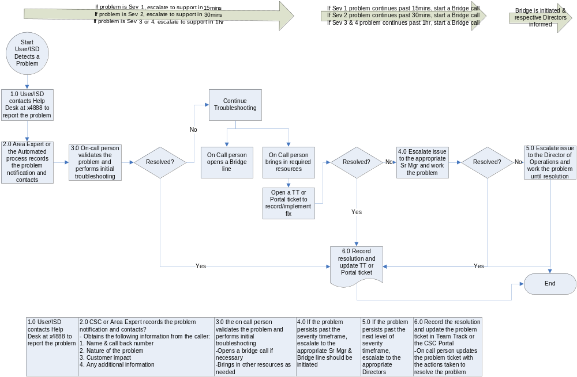

Contact Details
Level | Name | 1° Number | 2°Number | Email | Time Zone | Notes
1 | SN4 Support Team | X8382 |  | 1TOSDevTeamHon@matson.com | HST | Honolulu support team – currently supporting CMIS.
3 | Jocelyn Chagami | (808) 848-8317 | (808) 479-6320 | jchagami@matson.com | MST | Development Team Manager

The support team phone number (x8368) automatically rolls between support team members, from cell phone to cell phone. The secondary levels should be used in emergency cases only.

- Post Production Monitoring and Metrics
No planned performance monitoring; may be requested and added as needed – see the architecture specification document for a list of SLA’s for parts of this application.

- Manual Test Procedures
The test procedure is documented and stored here:
N4 Gates and other Functional areas test docs to be added
- Application Interface Dependencies
1=Webservice 2=N4Bridge 3=FTP 4=MQ 5=JMS 6=DB 7=EDI 8=IP/PORT | intefaces To --> | TOS (Apex) | TOS (TDP) | Cmis | Gems | Das | MQ(FACTS) | Vinsight | HDOA | FSS | NOW | XPS | DCM/STIF(client UI) | Gum Out Queue | Hon Out Queue | XPS RTACTCS
Source Application -->
TOS (Apex) |  |  |  |  | 5 |  |  |  |  |  | 1 | 2
TOS (TDP) |  |  |  | 3 | 5 | 5 |  | 1 | 1 | 1 | 1 |  | 1 | 3 | 3
Cmis
Gems |  |  | 5 | 3
Das
MQ(FACTS) |  |  | 4
Vinsight |  |  | 1
HDOA |  |  | 1
FSS |  |  | 1
NOW |  | 1 | 1 |  |  |  |  |  |  |  |  |  |  |  |  | 8
XPS |  | 2
DCM/STIF
Gum Out Queue
Hon Out Queue
XPS RTACTCS |  |  |  |  |  |  |  |  |  |  | 8

- Roles and Responsibilities
 | IT Ops | DBA | ESS | SN4 Support Team
Web Server | P
Application Server | P
Oracle |  | P
Client Machines (Internet Explorer, Java, SPARCS Clients) |  |  | P
XPS Server |  |  | S | P
XPS Clients |  |  | S | P
Edge Manager |  | S | S | P
NOW Server |  |  | S | P
LXE |  |  |  | P
EIT |  |  |  | P
RFID Readers |  |  | P
Weight Scale |  |  | P

- Appendix
  - XPS Server Setup
XPS Server Install and Startup
http://wiki.matson.com/index.php?title=XPS_Upgrade
Bridged Setup (Bridge/Bin/Bridgedw.exe)
Java Options:
-Dfile.encoding=UTF-8
-XX:+UseConcMarkSweepGC
-XX:+HeapDumpOnOutOfMemoryError
-XX:HeapDumpPath=D:\Navis\bridged\logs\
-XX:ErrorFile=D:\Navis\bridged\logs\hs_err_pid%p.log
-Dtangosol.coherence.mode=prod
-Dtangosol.coherence.override=D:\Navis\conf\tangosol-coherence-override-prod.xml
-Dtangosol.coherence.cacheconfig=D:\Navis\bridged\classes\coherence-cache-config-ext-client.xml
-Dtangosol.coherence.extend.address.1=[Proxy_Address_1]
-Dtangosol.coherence.extend.port.1=[Proxy_Port_1]
-Dtangosol.coherence.extend.address.2=[Proxy_Address_2]
-Dtangosol.coherence.extend.port.2=[Proxy_Port_2]

StartUp Options:
-start
-f
D:\Navis\conf\n4_settings_prod.xml
-c
-e

Bridged/Classes
COHERENCE-CACHE-CONFIG-EXT-CLIENT
<?xml version="1.0"?>
<!DOCTYPE cache-config SYSTEM "cache-config.dtd">
<!--
For use by the BridgeDaemon when in the extend mode.
-->
<cache-config>

<caching-scheme-mapping>

<!-- The yard's OBJECTS, JOURNAL, PARTICPANT, MISC caches are scope-prefixed with XPS:OPR/FCY/CPX/YRD/ -->
<cache-mapping>
<cache-name>XPS*</cache-name>
<scheme-name>extend-dist</scheme-name>
</cache-mapping>

<!-- The global network node cache is ARGO:NETWORK_NODES. Must also share across the Extend connection. -->
<cache-mapping>
<cache-name>ARGO:*</cache-name>
<scheme-name>extend-dist</scheme-name>
</cache-mapping>

</caching-scheme-mapping>

<caching-schemes>

<remote-cache-scheme>
<scheme-name>extend-dist</scheme-name>
<service-name>ExtendTcpCacheService</service-name>
<initiator-config>
<tcp-initiator>
<remote-addresses>
<!--
TODO: How to handle 'undefined' socket-address?
-->
<socket-address>
<address system-property="tangosol.coherence.extend.address.1">NODE2 IP</address>
<port system-property="tangosol.coherence.extend.port.1">15152</port>
</socket-address>
<socket-address>
<address system-property="tangosol.coherence.extend.address.2">NODE3 IP</address>
<port system-property="tangosol.coherence.extend.port.2">15153</port>
</socket-address>
</remote-addresses>
<connect-timeout system-property="tangosol.coherence.extend.connect.timeout">180s</connect-timeout>
</tcp-initiator>
<outgoing-message-handler>
<request-timeout system-property="tangosol.coherence.extend.request.timeout">190s</request-timeout>
</outgoing-message-handler>
</initiator-config>
</remote-cache-scheme>

</caching-schemes>

</cache-config>

TANGOSOL-COHERENCE-OVERRIDE-PROD
<?xml version='1.0'?>
<!DOCTYPE coherence PUBLIC
"-//Oracle Corporation//DTD Oracle Coherence 3.3//EN"
"http://www.tangosol.com/dtd/coherence_3_3.dtd">

<!--
This operational configuration override file is intended to be set up for use with Coherence in
a production mode. You will need to change it according to your environment.
-->
<coherence xml-override="/tangosol-coherence-override.xml">
<cluster-config>
<unicast-listener>
<!--
well-known-addresses:
Note: Specifying one or more "well known" addresses (WKA) will disable
all multicast communication. In this case, for a member to join the cluster
it will either have to be a WKA or there will have to be at least one WKA
member running.
-->
<well-known-addresses>
<socket-address id="1">
<address system-property="tangosol.coherence.wka1"></address>
<port system-property="tangosol.coherence.wka1.port"></port>
</socket-address>
<socket-address id="2">
<address system-property="tangosol.coherence.wka2"></address>
<port system-property="tangosol.coherence.wka2.port"></port>
</socket-address>
<socket-address id="3">
<address system-property="tangosol.coherence.wka3"></address>
<port system-property="tangosol.coherence.wka3.port"></port>
</socket-address>
<socket-address id="4">
<address system-property="tangosol.coherence.wka4"></address>
<port system-property="tangosol.coherence.wka4.port"></port>
</socket-address>
<socket-address id="5">
<address system-property="tangosol.coherence.wka5"></address>
<port system-property="tangosol.coherence.wka5.port"></port>
</socket-address>
</well-known-addresses>
<!--
address:
Note: The "localhost" setting may not work on systems that define
localhost as the loopback address; in that case, specify the machine
name or the specific IP address.
-->
<address system-property="tangosol.coherence.localhost">XPS SERVER IP ADDRESS</address>
<port system-property="tangosol.coherence.localport">8088</port>
<port-auto-adjust system-property="tangosol.coherence.localport.adjust">true</port-auto-adjust>

<packet-buffer>
<maximum-packets>1428</maximum-packets>
</packet-buffer>
<priority>8</priority>
</unicast-listener>
<packet-publisher>
<packet-delivery>
<timeout-milliseconds>30000</timeout-milliseconds>
</packet-delivery>
</packet-publisher>
</cluster-config>
<logging-config>
<severity-level system-property="tangosol.coherence.log.level">3</severity-level>
<character-limit system-property="tangosol.coherence.log.limit">0</character-limit>
</logging-config>
</coherence>

Navis/Conf
TANGOSOL-COHERENCE-OVERRIDE-PROD
<?xml version='1.0'?>
<!DOCTYPE coherence PUBLIC
"-//Oracle Corporation//DTD Oracle Coherence 3.3//EN"
"http://www.tangosol.com/dtd/coherence_3_3.dtd">

<!--
This operational configuration override file is intended to be set up for use with Coherence in
a production mode. You will need to change it according to your environment.
-->
<coherence xml-override="/tangosol-coherence-override.xml">
<cluster-config>
<unicast-listener>
<!--
well-known-addresses:
Note: Specifying one or more "well known" addresses (WKA) will disable
all multicast communication. In this case, for a member to join the cluster
it will either have to be a WKA or there will have to be at least one WKA
member running.
-->
<well-known-addresses>
<socket-address id="1">
<address system-property="tangosol.coherence.wka1"></address>
<port system-property="tangosol.coherence.wka1.port"></port>
</socket-address>
<socket-address id="2">
<address system-property="tangosol.coherence.wka2"></address>
<port system-property="tangosol.coherence.wka2.port"></port>
</socket-address>
<socket-address id="3">
<address system-property="tangosol.coherence.wka3"></address>
<port system-property="tangosol.coherence.wka3.port"></port>
</socket-address>
<socket-address id="4">
<address system-property="tangosol.coherence.wka4"></address>
<port system-property="tangosol.coherence.wka4.port"></port>
</socket-address>
<socket-address id="5">
<address system-property="tangosol.coherence.wka5"></address>
<port system-property="tangosol.coherence.wka5.port"></port>
</socket-address>
</well-known-addresses>
<!--
address:
Note: The "localhost" setting may not work on systems that define
localhost as the loopback address; in that case, specify the machine
name or the specific IP address.
-->
<address system-property="tangosol.coherence.localhost">XPS Server IP Address</address>
<port system-property="tangosol.coherence.localport">8088</port>
<port-auto-adjust system-property="tangosol.coherence.localport.adjust">true</port-auto-adjust>

<packet-buffer>
<maximum-packets>1428</maximum-packets>
</packet-buffer>
<priority>8</priority>
</unicast-listener>
<packet-publisher>
<packet-delivery>
<timeout-milliseconds>30000</timeout-milliseconds>
</packet-delivery>
</packet-publisher>
</cluster-config>
<logging-config>
<severity-level system-property="tangosol.coherence.log.level">3</severity-level>
<character-limit system-property="tangosol.coherence.log.limit">0</character-limit>
</logging-config>
</coherence>

Wherenet MTS Integration
The Navis N4 2.1 as the ability to integrate with Navis Wherenet MTS to provide container tracking events. This is important for Matson in that it allows Wherenet container tags to be associated with Matson containers in the shared tag database. In most cases, this associate is already in the system. But as new tags are placed, there is no associate until the container passes through either a Matson or SSAT reader and this information is interfaced back to WhereNet MTS. In future this integration will allow containers to be tracked within the yard.
Today Navis provides either a local directory or an FTP interface to retrieve man very small container event files. Rather than incur the FTP overhead, we are implementing an NFS share from the WhereNet server in Honolulu to a second N4 server shared disk area similar to the one described above. In this way the WhereNet MTS system will be able to pull frequently (1 to 5 minute intervals) and pick up the numerous small event files as if they are on local disk.
Pre Production Implementation Specifics
NFS share at \\10.201.2.71\share\tos21\preprod\mts is to be used by all 4 N4 instances to write files to be consumed by WhereNet MTS servers HONVDA08 and HONVDA09 in Honolulu. The path used by N4 is /home/tomcat/tomcat/mts and is mounted as U: drive from the windows servers. The MTS Draymangate service requires that the drive be mounted pre-authentication as system level security context. Our current implementation will use a Microsoft (sysinternals) utility psexec to mount the drive letter on server startup to map the drive letter. The UID/GID for the mount are set via registry to match tomcat UID/GID on CSC Unix server.

Production Implementation Specifics
NFS share at \\10.201.2.??\share\tos21\prod\mts is to be used by all 4 N4 instances to write files to be consumed by WhereNet MTS servers HONWPA08 and HONWPA09 in Honolulu. The path used by N4 is /home/tomcat/tomcat/mts and is mounted as U: drive from the windows servers. The MTS Draymangate service requires that the drive be mounted pre-authentication as system level security context. Our current implementation will use a Microsoft (sysinternals) utility psexec to mount the drive letter on server startup to map the drive letter. The UID/GID for the mounts are set via registry to match tomcat UID/GID on CSC Unix server.
Disaster Recovery Implementation Specifics
Two NFS shares for use by DR are as follows:
\\10.201.2.71\share\tos21\prod\config
\\10.201.2.71\share\tos21\prod\mts

