Untitled

Group 3

2/18/2021

## R Markdown

This is an R Markdown document. Markdown is a simple formatting syntax for authoring HTML, PDF, and MS Word documents. For more details on using R Markdown see <http://rmarkdown.rstudio.com>.

When you click the Knit button a document will be generated that includes both content as well as the output of any embedded R code chunks within the document. You can embed an R code chunk like this:

summary(cars)

## speed dist   
## Min. : 4.0 Min. : 2.00   
## 1st Qu.:12.0 1st Qu.: 26.00   
## Median :15.0 Median : 36.00   
## Mean :15.4 Mean : 42.98   
## 3rd Qu.:19.0 3rd Qu.: 56.00   
## Max. :25.0 Max. :120.00

## Including Plots

You can also embed plots, for example:

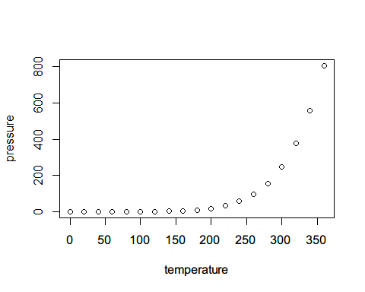

Note that the echo = FALSE parameter was added to the code chunk to prevent printing of the R code that generated the plot.

Plain text

End a line with two spaces to start a new paragraph.

italics and italics

bold and bold

superscript2

strikethrough

link

# Header 1

## Header 2

### Header 3

#### Header 4

##### Header 5

###### Header 6

endash: –

emdash: —

ellipsis: …

inline equation: $A=π*r^{2}$

image:

horizontal rule (or slide break): ***

block quote * unordered list * item 2 + sub-item 1 + sub-item 2

1. ordered list
2. item 2

* sub-item 1
* sub-item 2

|  |  |
| --- | --- |
| Table Header | Second Header |
| Table Cell | Cell 2 |
| Cell 3 | Cell 4 |