GLay[Temporary Name] Brief Description
Gang Su, Mentored by Allan Kuchinsky, Scooter Morris and David J. States

Motivation: Cytoscape is a comprehensive software foundation for visualizing and analysis of various scaled biological networks. The major objective of this Google Summer of Code project is to develop a plugin for Cytoscape, integrating community detection algorithms into this platform to provide interactive and flexible clustering functions and optimize visualization for large networks with the clustering data. We have three specific aims:
- Implement community detection algorithms into the plugin. Provide an interface for the user to execute the clustering algorithm; fast select/activate/browse clusters.
- Re-layout the network with the clustering data. Nodes belong to the same cluster should be agglomerated together and separated apart from the other clusters. Clusters should have the ability to be expanded/collapsed for the ease of user focus on a specific subset of the network.
- This plugin should be able to cooperate with other plugins, such MIMi and MCode to enhance usage potential.

Background: Community structure detection is to find clusters in a network that maximizes intra-cluster edge density and minimizes inter-cluster edge density. When applied to biological interaction networks, community structure detection algorithms are able to recover structures like protein complexes, biological pathways or molecule co-compartmentation. For more information about community structure and related research, please refer to [1].

Cytoscape is an active open-source software foundation built on Java for visualization of biological interaction networks. For more information about cytoscape, please refer to [2].

Plugin Description: The current alpha build of the plugin require Cytoscape 2.6.1 and MetaNodePlugin2 from Scooter Morris to function. This plugin could take the active network in the cytoscape viewport as the input, perform either Fast-Greedy algorithm or modified Fast-Greedy algorithm with consolidation ratio. The user may also to cast force-directed layout globally or cast force-directed layout on top of cluster metaNodes for better visualization of large networks. The clusters can be expanded/collapsed by metaNodePlugin2 and browsed in the provided cluster navigation panel; the cluster members can be fast selected/activated/deactivated/zoomed in/out from the provided tool-cons. A screenshot below explains some of the functions. When the clusters are activated, the visual style is changed instead of selection so that the user could still maintain the current selection from other operations or plugins.
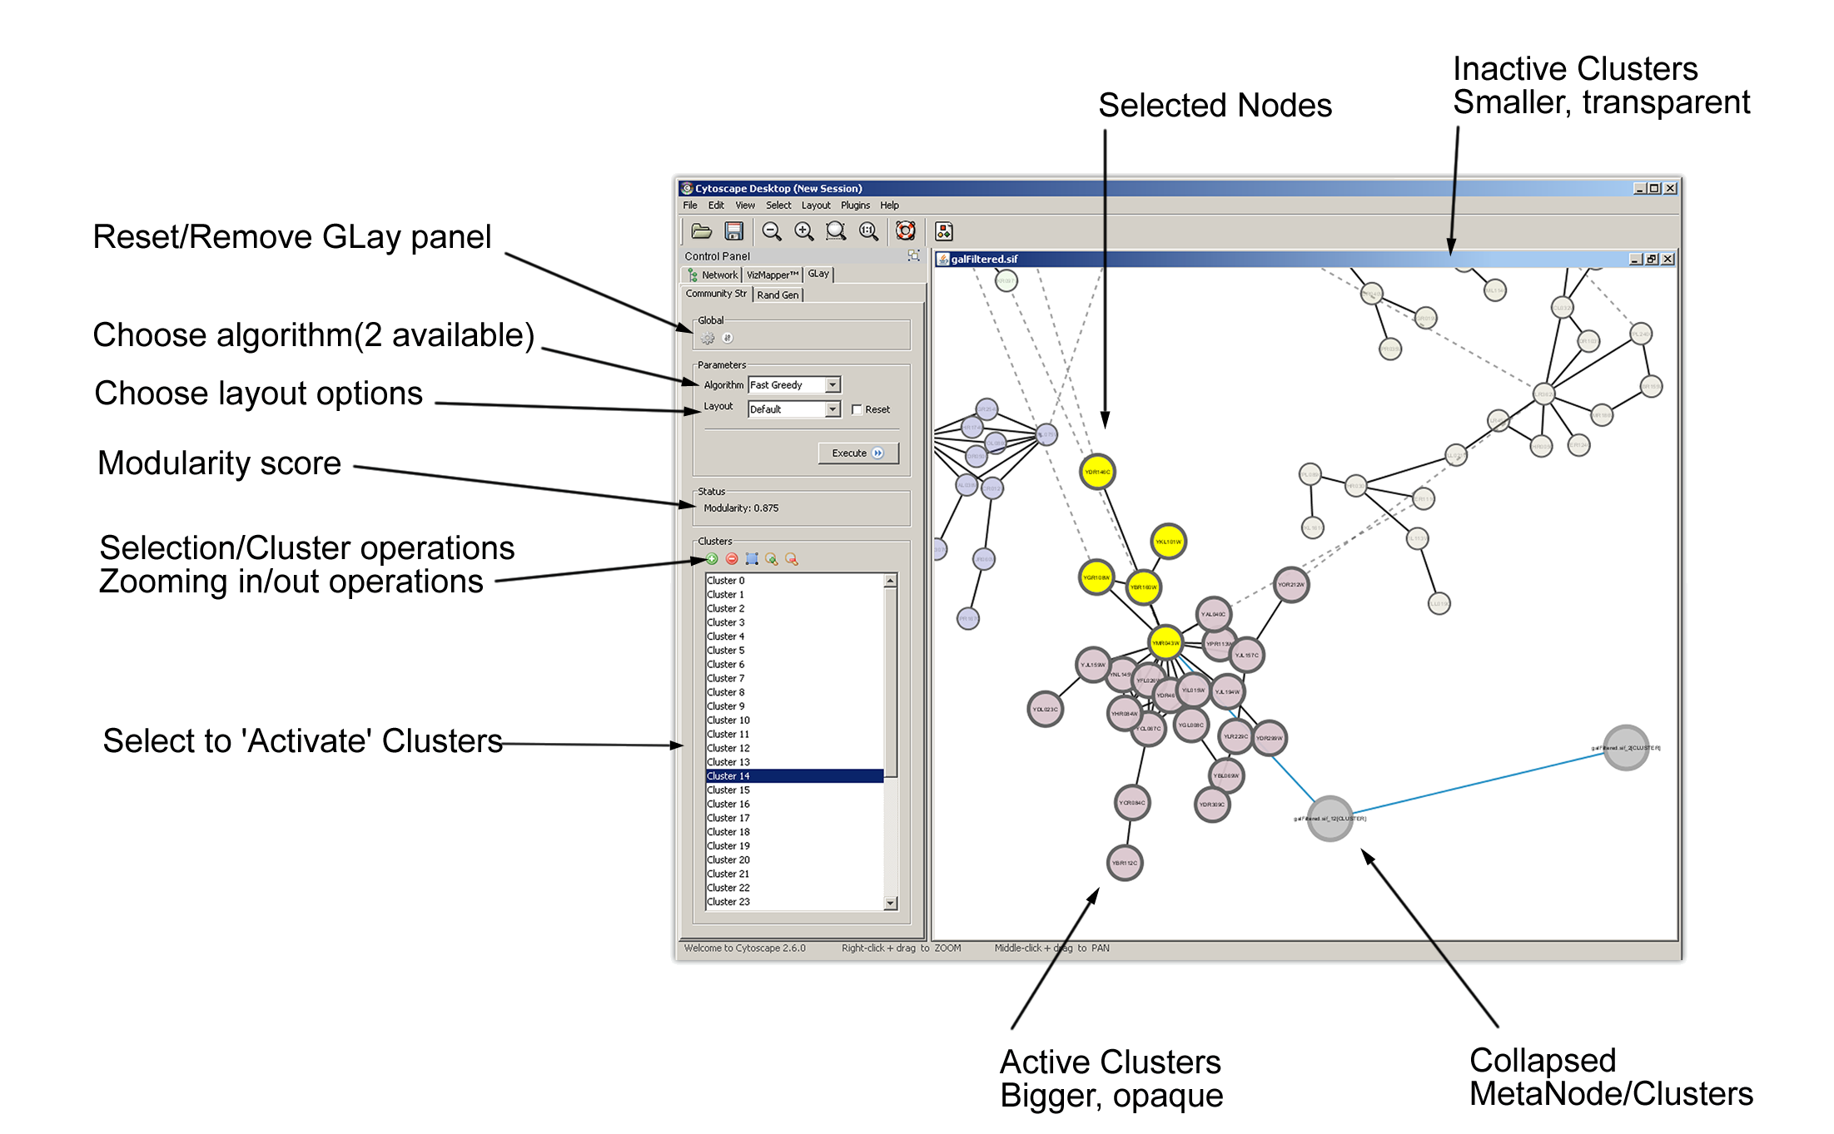

References:
[1] http://www-personal.umich.edu/~mejn/pubs.html
[2] http://cytoscape.org/

P.S.
The screencast will be updated pretty soon.

