## Experiment 6 - Write an application that draws basic graphical primitives on the screen

**FingerPath.java**

package com.example.mypaint; import android.graphics.Path; public class FingerPath {

public int color; public boolean emboss; public boolean blur; public int strokeWidth; public Path path;

public FingerPath(int color, boolean emboss, boolean blur, int strokeWidth, Path path) {

this.color = color; this.emboss = emboss; this.blur = blur; this.strokeWidth = strokeWidth; this.path = path;

}

}

## PaintView.java

package com.example.mypaint;

import android.content.Context; import android.graphics.Bitmap;

import android.graphics.BlurMaskFilter; import android.graphics.Canvas;

import android.graphics.Color;

import android.graphics.EmbossMaskFilter; import android.graphics.MaskFilter; import android.graphics.Paint;

import android.graphics.Path; import android.util.AttributeSet; import android.util.DisplayMetrics; import android.view.MotionEvent; import android.view.View;

import java.util.ArrayList;

public class PaintView extends View {

public static int *BRUSH_SIZE* = 20;

public static final int *DEFAULT_COLOR* = Color.*BLUE* ; public static final int *DEFAULT_BG_COLOR* = Color.*WHITE*; private static final float *TOUCH_TOLERANCE* = 4;

private float mX, mY; private Path mPath; private Paint mPaint;

private java.util.ArrayList<FingerPath> paths = new ArrayList<>(); private int currentColor;

private int backgroundColor = *DEFAULT_BG_COLOR*; private int strokeWidth;

private boolean emboss; private boolean blur;

private android.graphics.MaskFilter mEmboss; private MaskFilter mBlur;

private Bitmap mBitmap; private Canvas mCanvas;

private Paint mBitmapPaint = new Paint(Paint.*DITHER_FLAG*);

public PaintView(Context context) { this(context, null);

}

public PaintView(Context context, AttributeSet attrs) { super(context, attrs);

mPaint = new Paint(); mPaint.setAntiAlias(true); mPaint.setDither(true); mPaint.setColor(*DEFAULT_COLOR*); mPaint.setStyle(Paint.Style.*STROKE*); mPaint.setStrokeJoin(Paint.Join.*ROUND*); mPaint.setStrokeCap(Paint.Cap.*ROUND*); mPaint.setXfermode(null); mPaint.setAlpha(0xff);

mEmboss = new EmbossMaskFilter(new float[] {1, 1, 1}, 0.4f, 6, 3.5f); mBlur = new BlurMaskFilter(5, BlurMaskFilter.Blur.*NORMAL*) ;

}

public void init(DisplayMetrics metrics) { int height = metrics.heightPixels;

int width = metrics.widthPixels;

mBitmap = Bitmap.*createBitmap*(width, height, Bitmap.Config.*ARGB_8888*); mCanvas = new Canvas(mBitmap);

currentColor = *DEFAULT_COLOR*; strokeWidth = *BRUSH_SIZE*;

}

public void normal() { emboss = false; blur = false;

}

public void emboss() { emboss = true; blur = false;

}

public void blur() { emboss = false; blur = true;

}

public void clear() {

backgroundColor = *DEFAULT_BG_COLOR*; paths.clear();

normal(); invalidate();

}

@Override

protected void onDraw(Canvas canvas) {

canvas.save(); mCanvas.drawColor(backgroundColor);

for (FingerPath fp : paths) { mPaint.setColor(fp.color); mPaint.setStrokeWidth(fp.strokeWidth); mPaint.setMaskFilter(null);

if (fp.emboss) mPaint.setMaskFilter(mEmboss);

else if (fp.blur) mPaint.setMaskFilter(mBlur);

mCanvas.drawPath(fp.path, mPaint);

}

canvas.drawBitmap(mBitmap, 0, 0, mBitmapPaint); canvas.restore();

}

private void touchStart(float x, float y) { mPath = new Path();

FingerPath fp = new FingerPath(currentColor, emboss, blur, strokeWidth,

mPath);

}

paths.add(fp);

mPath.reset(); mPath.moveTo(x, y); mX = x;

mY = y;

private void touchMove(float x, float y) {

float dx = Math.*abs*(x - mX); float dy = Math.*abs*(y - mY);

if (dx >= *TOUCH_TOLERANCE* || dy >= *TOUCH_TOLERANCE*)

{

mPath.quadTo(mX, mY, (x + mX) / 2, (y + mY) / 2); mX = x;

mY = y;

}

}

private void touchUp() { mPath.lineTo(mX, mY);

}

@Override

public boolean dispatchTouchEvent(MotionEvent event) { float x = event.getX();

float y = event.getY();

switch(event.getAction()) {

case MotionEvent.*ACTION_DOWN* : touchStart(x, y); invalidate();

break;

case MotionEvent.*ACTION_MOVE* : touchMove(x, y); invalidate();

break;

case MotionEvent.*ACTION_UP* : touchUp();

invalidate(); break;

}

return true;

}

}

**main.xml**

*<?*xml version="1.0" encoding="utf-8"*?>*

<menu xmlns:android="<http://schemas.android.com/apk/res/android>" xmlns:app="<http://schemas.android.com/apk/res-auto>" >

<item

android:id="@+id/normal" app:showAsAction="never" android:title="Normal"

/>

<item

android:id="@+id/emboss" app:showAsAction="never" android:title="Emboss"

/>

<item

android:id="@+id/blur" app:showAsAction="never" android:title="Blur"

/>

<item

android:id="@+id/clear" app:showAsAction="never" android:title="Clear"

/>

</menu>

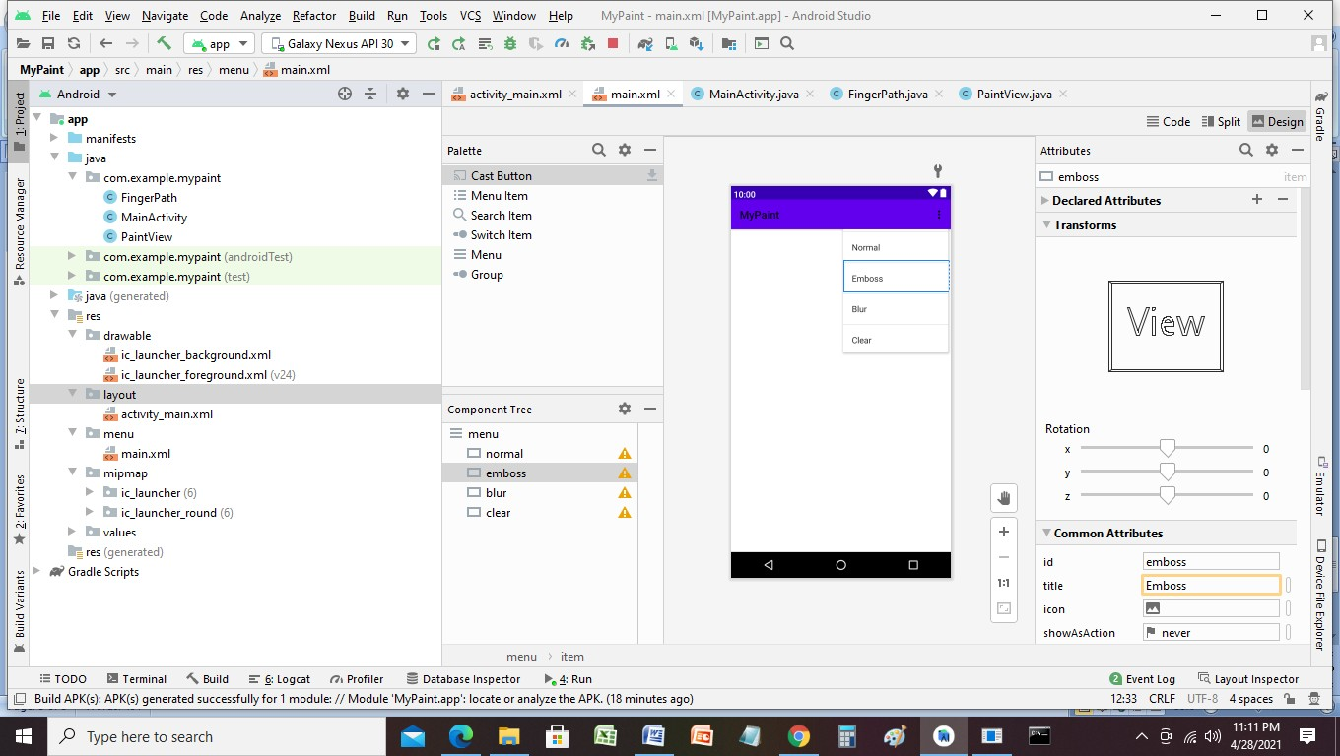

# activity_main.xml

*<?*xml version="1.0" encoding="utf-8"*?>*

<RelativeLayout xmlns:android="<http://schemas.android.com/apk/res/android>" xmlns:tools="<http://schemas.android.com/tools>" android:id="@+id/activity_main"

android:layout_width="match_parent" android:layout_height="match_parent" tools:context=".MainActivity">

<com.example.mypaint.PaintView android:id="@+id/paintView" android:layout_width="wrap_content" android:layout_height="wrap_content" />

</RelativeLayout>

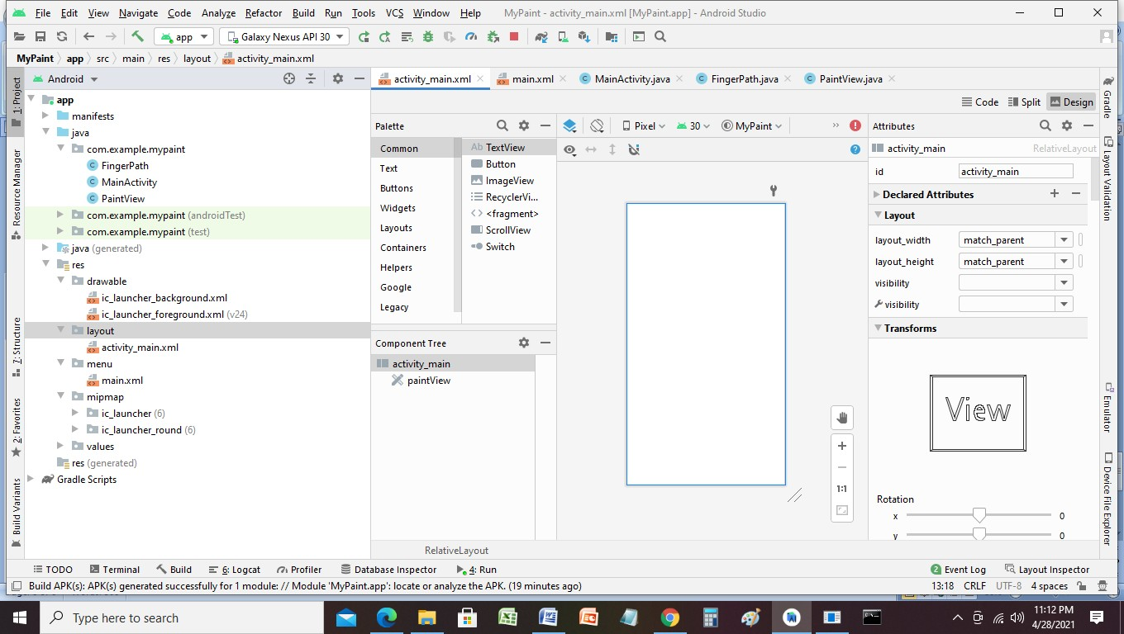

# MainActivity.java

package com.example.mypaint;

import android.annotation.SuppressLint; import android.os.Bundle;

import android.util.DisplayMetrics; import android.view.Menu;

import android.view.MenuInflater; import android.view.MenuItem;

import androidx.appcompat.app.AppCompatActivity; public class MainActivity extends AppCompatActivity {

private PaintView paintView;

@Override

protected void onCreate(Bundle savedInstanceState) { super.onCreate(savedInstanceState); setContentView(R.layout.*activity_main*);

paintView = (PaintView) findViewById(R.id.*paintView*); DisplayMetrics metrics = new DisplayMetrics(); getWindowManager().getDefaultDisplay().getMetrics(metrics); paintView.init(metrics);

}

@Override

public boolean onCreateOptionsMenu(Menu menu) { MenuInflater menuInflater = getMenuInflater(); menuInflater.inflate(R.menu.*main*, menu); return super.onCreateOptionsMenu(menu);

}

@SuppressLint("NonConstantResourceId") @Override

public boolean onOptionsItemSelected(MenuItem item) { switch(item.getItemId()) {

case R.id.*normal*: paintView.normal();

return true; case R.id.*emboss*:

paintView.emboss(); return true;

case R.id.*blur*: paintView.blur(); return true;

case R.id.*clear*: paintView.clear(); return true;

}

return super.onOptionsItemSelected(item);

}

}

