**I .ចក្ខុវិស័យ**

ជំរុញការភ្ជាប់ហេដ្ធារចនាសម្ព័ន​ និងការផ្តល់សេវា លើវិស័យប្រៃសណីយ៏ និងទូរគមនាគមន៏ ព្រមទាំងបច្ចេកវិទ្យាគមនាមន៏ និងព័ត៏មាន នៅគ្រប់ទីក្លែងទាំងអស់ក្នុងប្រទេសកម្ពុជា នៅក្នុងតំបន់ និងពិភពលោក ប្រកបដោយគុណភាព និងភាពស័ក្តិសិទ្ធិ ដើម្បីចូលរូមជំរុញ ការអភិវឧ្ឍសង្គម កំណើនសេដ្ធកិច្ច និងការកាត់បន្ថយភាពក្រីក្រ៕

**II. Web Development Technology**

**HTML :**

* **What is HTML?**
* **HTML** is a **markup** language for **describing** web documents (web pages).
* HTML stands for **H**yper **T**ext **M**arkup **L**anguage
* A markup language is a set of **markup tags**
* HTML documents are described by **HTML tags**
* Each HTML tag **describes** different document content
* **HTML**គឺជា Technology មួយដែលវាគ្រាន់តែអាចអោយយើងធ្វើការរៀបចំ Web side​​ មួយអោយលេចចេញជារូបរាង រឺ​ គ្រោងរបស់ Web side​ ដូចជា Header, Content, Footer ជាដើម។HTML មិនមានសមត្ថភាពក្នុងការរចនា ​​wed side អោយមានភាពស្រស់ស្អាត រឺ ធ្វើអោយមានភាពទាក់ទាញឡើយ។**HTML** មិនមាន សមត្ថភាពក្នុងការរៀបចំ លាយពណ៌ ដាក់រូបភាព លេង Style ផ្សេងៗឡើយ។ប្រសិនបើយើងចង់រចនាធ្វើអោយ web side​ របស់យើងមានភាពស្រស់ស្អាត និង លេចធ្លោរនោះគឺយើងចាំបាច់ត្រូវតែប្រើប្រាស់ CSS Style ទើបបាន។

**CSS :**

* **CSS** គឺជា Technology មួយដែលវាគឺជាអ្នករៀបចំ web side អោយកាន់តែមានភាពស្រស់ស្អាត លេចធ្លោ និង មានភាពទាន់សម័យ។វាមានសមត្ថភាពអាចអោយយើងត្វើការរៀបចំតុបតែង web side អោយមានភាពស្រស់ស្អាតគួរអោយចង់មើល។ម្យ៉ាងទៀតយើងអាចធ្វើការងារជាច្រើនជាមួយ **CSS**​ ដូចជា លាយពណ៌ ដាក់រូបភាព​ ព្រមទាំងអាចអោយយើងលេង **Style** បានច្រើនទៅតាមអ្វីដែលយើងចង់បាន។គួរបញ្ជាក់ផងដែរថា **CSS** គឺ អាចជួយយើងបានច្រើនក្នុងការធ្វើអោយ web side មានភាពទាក់ទាញ មានតែ **CSS**​ ទេទើបអាចជួយយើងក្នុងការរចនា web side បាន។
* **+What is CSS?**
* **CSS** stands for **C**ascading **S**tyle **S**heets
* CSS describes **how HTML elements are to be displayed on screen, paper, or in other media**
* CSS **saves a lot of work**. It can control the layout of multiple web pages all at once
* External stylesheets are stored in **CSS files**
* **CSS** is a stylesheet language that describes the presentation of an HTML (or XML) document.
* CSS describes how elements must be rendered on screen, on paper, or in other media.
* This tutorial will teach you CSS from basic to advanced.
* **+Why Use CSS?**
* **CSS** is used to define styles for your web pages, including the design, layout and variations in display for different devices and screen sizes.

#### **III .Site Map**

1. Home
2. About MPTC
   1. Minister
   2. Ministry in Brief
   3. Ministry Leadership
   4. Ministry Structure
   5. Activities
   6. International Cooperation
   7. Provincial Offices
3. Laws & Regulations
   1. Laws
   2. Royal decrees
   3. Sub-decrees
   4. Circulations
   5. Prakas
   6. Instructions
   7. Decisions
   8. Guideline
4. Publications
   1. Policies
   2. Seminar
   3. Training Documents
5. News
   1. New Technology
   2. Operator
6. Fact Sheet

**Conclusion**

ដោយសារតែការកើនឡើងនូវបណ្តាញទូទាំងពិភពលោកក្រុមហ៊ុនជាច្រើនបានបង្កើតគេហទំព័រផ្ទាល់របស់ខ្លួនដើម្បីផ្សព្វផ្សាយផលិតផលឬសេ​​វាកម្មរបស់ពួកគេ។ ព័តមាននេះថាក្រុមហ៊ុននេះបានបង្កើតគឺអាចចូលដំណើរការបានដើម្បីឱ្យប្រជាជនកាន់តែច្រើនចាប់តាំងពីការតភ្ជាប់អ៊ីធឺណិតដោយឥតគិតថ្លៃគឺអាចរកបានជាសាធារណៈ។ ដូច្នេះវាមានការប្រកួតប្រជែងស្វិតស្វាញរវាងក្រុមហ៊ុនសម្រាប់ការជូនដំណឹងដល់សាធារណៈជនអំពីផលិតផលរបស់ខ្លួនផ្ទាល់។ នៅក្នុងគោលបំណងដើម្បីទទួលបានការយកចិត្តទុកដាក់ជាសាធារណៈតាមរយៈទំព័របណ្តាញរបស់ក្រុមហ៊ុននេះវាជាការសំខាន់ណាស់ក្នុងការរចនាវែបសាយគួរឱ្យទាក់ទាញនិងងាយស្រួលក្នុងការប្រើ។

ដើម្បីរៀបចំតំបន់នោះគឺជាការទាក់ទាញនិងងាយស្រួលក្នុងការប្រើបណ្តាញមួយដែលតម្រូវឱ្យមានអង្គការមួយចំនួន។ មានបន្សំផ្សេងគ្នាជាច្រើននៃការរចនាទំព័របណ្ដាញអ្នកអភិវឌ្ឍន៍អាចជ្រើសដើម្បីប្រើសម្រាប់តំបន់បណ្ដាញរបស់ពួកគេ។ ទោះជាយ៉ាងណាវានឹងមានការរចនាដែលជាការកាន់តែសមស្របសម្រាប់ក្រុមគោលដៅនៃទស្សនិកជនមួយ។ ដូច្នេះមុនពេលដំណើរការនៃការរចនា, អ្នកអភិវឌ្ឍន៍មានការយល់ពីតម្រូវការរបស់ទស្សនិកជនរបស់ខ្លួនដើម្បីជ្រើសជម្រើសល្អបំផុតនៃការរចនា។

នៅក្នុងរបាយការណ៍នៃការប្រើប្រាស់មានប្រសិទ្ធិភាពនៃប្រភេទផ្សេងគ្នានៃប្លង់ទំព័របណ្ដាញនេះយើងបានពិភាក្សាអំពីអ្វីដែលកំណត់ធាតុជាមូលដ្ឋាននៃការរចនាទំព័រមួយល្អ។ ធាតុជាមូលដ្ឋានរួមមានការផ្ទុយប៍ន, អង្គការអត្ថបទ, ការជ្រើសរើសពុម្ពអក្សររចនាប័ទ្មនៃទំព័រទំហំទំព័រក្រាហ្វិកដែលត្រូវបានប្រើ, និងស្ថិរភាព។ ទាំងអស់នៃធាតុទាំងនេះមានសារៈសំខាន់ខ្លាំងណាស់ក្នុងការរចនានៃទំព័របណ្ដាញនេះ។ ដូច្នេះអ្នកអភិវឌ្ឍន៍ត្រូវតែមានការយល់ព្រមលើបញ្ហាខាងលើទាំងអស់មុនពេលចាប់ផ្ដើមការរចនា។

**+Website Interface**

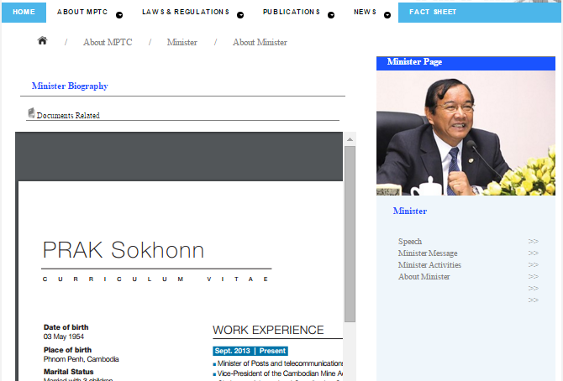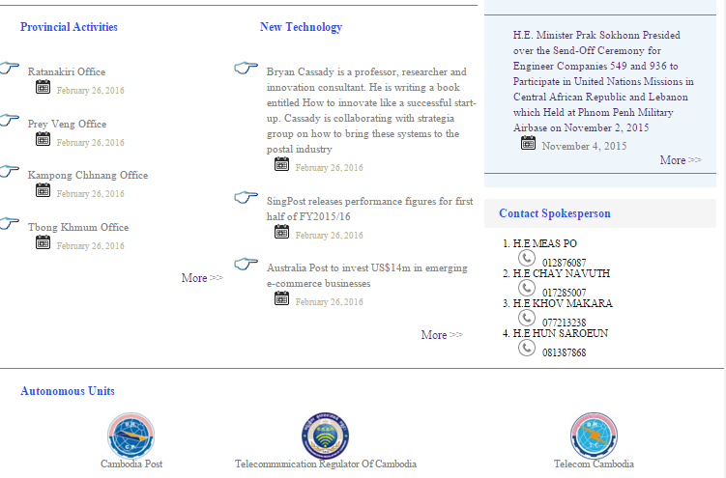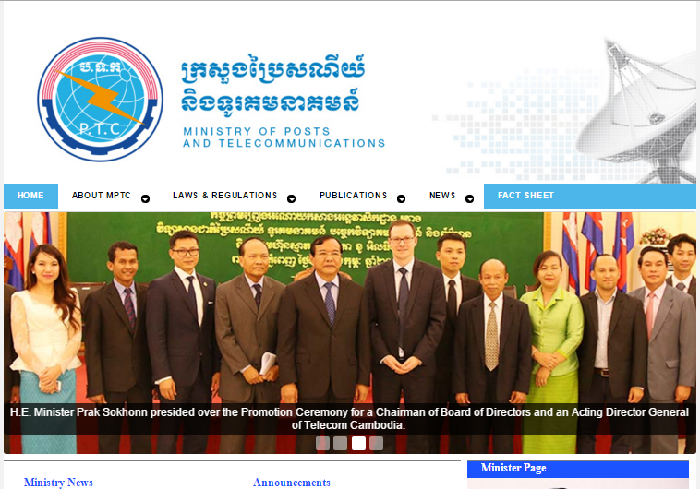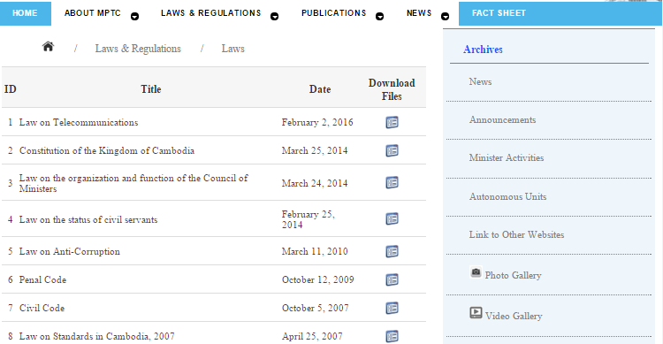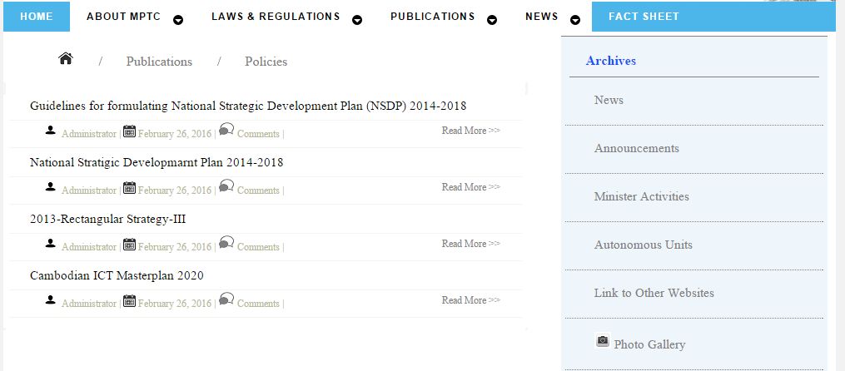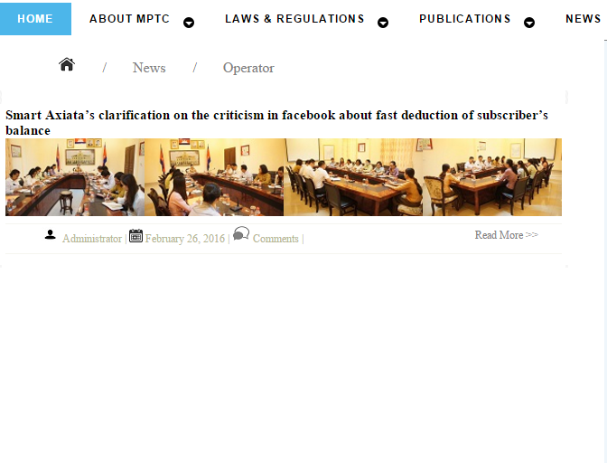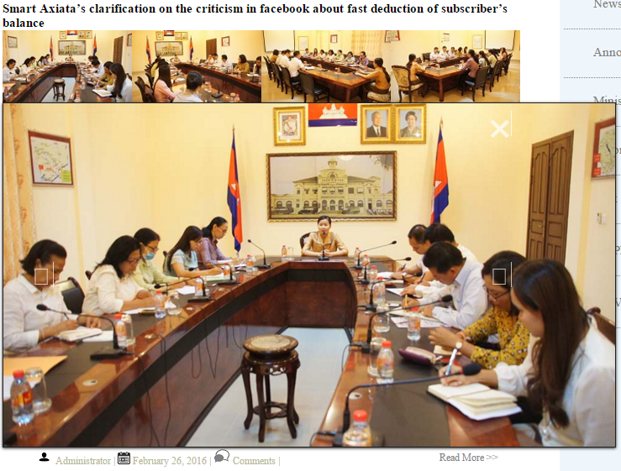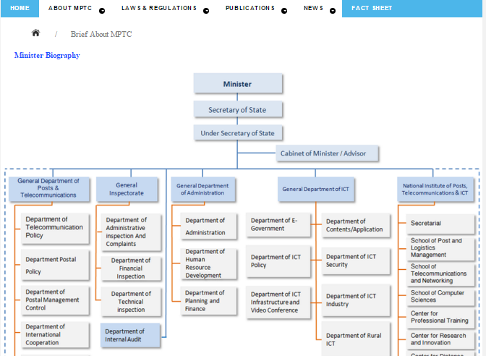

+Code Selection

**-CSS:**

body{

background-color: #f2f2f2;

margin: 0;

padding: 0;

font-family: 'Roboto-Thin';

}

.parag{

padding: 20px;

font-size: 14;

color: gray;

}

#logo1{

float: left;

padding: 0px 50px 0px 140px;

text-align: center;

font-size: 14;

color: gray;

}

#logo2{

float: left;

padding: 0px 50px 0px 50px;

text-align: center;

font-size: 14;

color: gray;

}

#logo3{

float: left;

padding: 0px 50px 0px 140px;

text-align: center;

font-size: 14;

color: gray;

}

#parag1{

line-height:150%;

font-size: 14;

color: gray;

padding-bottom:15px;

}

#videogallery img{

float: left;

width:350px;

padding: 0px 20px 0px 20px;

margin: 0;

}

#photogallery img{

width:600px;

padding: 0px 20px 0px 20px;

margin: 0;

}

#contentwrapper, #rightpanel, #leftpanel,#photogallery, #footer, #videogallery, #proact, #newtech, #autonomousunits{

border-top: 1px solid gray;}

#mainwrapper{

background-color: white;

min-height: 100%;

width: 1000px;

margin: 0 auto;

}

#header{

}

.container{

margin-bottom: 10px;

}

#leftpanel{

width: 330px;

height: 500px;

float: left;

}

#contentwrapper{

width:330px;

height: 500px;

float: left;

}

#rightpanel {

background-color:#EFF6FB;

margin-right: 10px;

width: 320px;

height: 1825px;

float: right;

}

.tittelname2{

margin-top:16px;

padding: 10px;

padding-left: 20px;

font-weight: 700;

color: #1a53ff;

background-color:F5F5F5;

border-radius: 4px;

}

.listphone{

list-style-image: url('../images/phone.png') ;

}

#contactlist{

font-size:14;

border-bottom: 1px gray;

}

#Contact{

float: right;

margin-right: 10px;

width: 320px;

}

#righttitle{

height:24px;

background-color: #1a53ff;

}

.MinisterPage{

padding: 15px;

padding-left: 20px;

font-weight: 700;

color: white;

}

.MinisterPage:hover{

text-decoration: underline;

}

#pic1 img{

width:320px;

}

#photogallery{

float: left;

height: 670px;

width: 660px;

}

#videogallery{

float: left;

height: 400px;

width: 660px;

}

#proact,newtech{

width: 330px;

height: 500px;

float: left;

}

#newtech{

width: 330px;

height: 500px;

float: left;

}

#autonomousunits{

height: 150px;

clear: both;

width: 1000px;

}

#footer{

background-color: #3385ff;

height: 150px;

clear: both;

width: 1000px;

}

#footer1{

text-align: center;

font-size: 11;

padding-top:80px;

color: white;

}

#footermenu a{

padding-right: 50px;

padding-left: 50px;

border-right: 1px solid white;

color: white;

}

#footermenu a:hover{

color: #d9d9d9;

}

#footermenu li{

text-align: center;

display: inline;

font-family: 'PT Sans', sans-serif;

}

.tittelname{

margin: 10px;

padding: 10px;

padding-left: 20px;

font-weight: 700;

color: #1a53ff;

}

#rightpanel ul li{

line-height:150%;

list-style-type:none;

padding-right:30px;

font-size: 15;

color: gray;

}

.listborder{

border-bottom: 1px solid gray;

padding-bottom:10px;

}

.sentance{

font-size: 15;

line-height:150%;

color: gray;

word-wrap: break-word;

}

.more{

padding-right:20px;

float: right;

}

.more:hover{

color: #b8b894;

}

a{

text-decoration: none;

}

.listnew{

list-style-image: url('../images/ulist1.png') ;

}

.listdate{

list-style-image: url('../images/ulist2.png') ;

color: #b8b894;

}

.listnew li ul li{

padding-bottom: 10px;

font-size:12;

}

.sentance2:hover{

color: #668cff;

}

.sentance:hover{

color: #668cff;

}

.listnew li{

line-height:150%;

font-size:15;

}

#cssmenu {

z-index:99;

background: #4cb6ea;

margin: 0;

width: auto;

padding: 0;

line-height: 0.5;

display: block;

position: relative;

font-family: 'PT Sans', sans-serif;

margin-bottom: 5px;

}

#cssmenu ul {

list-style: none;

margin: 0;

padding: 0;

display: block;

}

#cssmenu ul:after,

#cssmenu:after {

content: " ";

display: block;

font-size: 0;

height: 0;

clear: both;

visibility: hidden;

}

#cssmenu ul li {

margin: 0;

padding: 0;

display: block;

position: relative;

}

#cssmenu ul li a {

text-decoration: none;

display: block;

margin: 0;

-webkit-transition: color .2s ease;

-moz-transition: color .2s ease;

-ms-transition: color .2s ease;

-o-transition: color .2s ease;

transition: color .2s ease;

-webkit-box-sizing: border-box;

-moz-box-sizing: border-box;

box-sizing: border-box;

}

#cssmenu ul li ul {

position: absolute;

left: -9999px;

top: auto;

}

#cssmenu ul li ul li {

max-height: 0;

position: absolute;

-webkit-transition: max-height 0.4s ease-out;

-moz-transition: max-height 0.4s ease-out;

-ms-transition: max-height 0.4s ease-out;

-o-transition: max-height 0.4s ease-out;

transition: max-height 0.4s ease-out;

background: #ffffff;

}

#cssmenu ul li ul li.has-sub:after {

display: block;

position: absolute;

content: "";

height: 10px;

width: 10px;

border-radius: 5px;

background: #000000;

z-index: 1;

top: 13px;

right: 15px;

}

#cssmenu.align-right ul li ul li.has-sub:after {

right: auto;

left: 15px;

}

#cssmenu ul li ul li.has-sub:before {

display: block;

position: absolute;

content: "";

height: 0;

width: 0;

border: 3px solid transparent;

border-left-color: #ffffff;

z-index: 2;

top: 15px;

right: 15px;

}

#cssmenu.align-right ul li ul li.has-sub:before {

right: auto;

left: 15px;

border-left-color: transparent;

border-right-color: #ffffff;

}

#cssmenu ul li ul li a {

font-size: 12px;

font-weight: 400;

text-transform: none;

color: #000000;

letter-spacing: 0;

display: block;

width: 170px;

padding: 11px 10px 11px 20px;

}

#cssmenu ul li ul li:hover > a,

#cssmenu ul li ul li.active > a {

color: #4cb6ea;

}

#cssmenu ul li ul li:hover:after,

#cssmenu ul li ul li.active:after {

background: #4cb6ea;

}

#cssmenu ul li ul li:hover > ul {

left: 100%;

top: 0;

}

#cssmenu ul li ul li:hover > ul > li {

max-height: 72px;

position: relative;

}

#cssmenu > ul > li {

float: left;

}

#cssmenu.align-center > ul > li {

float: none;

display: inline-block;

}

#cssmenu.align-center > ul {

text-align: center;

}

#cssmenu.align-center ul ul {

text-align: left;

}

#cssmenu.align-right > ul {

float: right;

}

#cssmenu.align-right > ul > li:hover > ul {

left: auto;

right: 0;

}

#cssmenu.align-right ul ul li:hover > ul {

right: 100%;

left: auto;

}

#cssmenu.align-right ul ul li a {

text-align: right;

}

#cssmenu > ul > li:after {

content: "";

display: block;

position: absolute;

width: 100%;

height: 0;

top: 0;

z-index: 0;

background: #ffffff;

-webkit-transition: height .2s;

-moz-transition: height .2s;

-ms-transition: height .2s;

-o-transition: height .2s;

transition: height .2s;

}

#cssmenu > ul > li.has-sub > a {

padding-right: 40px;

}

#cssmenu > ul > li.has-sub > a:after {

display: block;

content: "";

background: #ffffff;

height: 12px;

width: 12px;

position: absolute;

border-radius: 13px;

right: 14px;

top: 16px;

}

#cssmenu > ul > li.has-sub > a:before {

display: block;

content: "";

border: 4px solid transparent;

border-top-color: #4cb6ea;

z-index: 2;

height: 0;

width: 0;

position: absolute;

right: 16px;

top: 21px;

}

#cssmenu > ul > li > a {

color: #ffffff;

padding: 15px 20px;

font-weight: 700;

letter-spacing: 1px;

text-transform: uppercase;

font-size: 12px;

z-index: 2;

position: relative;

}

#cssmenu > ul > li:hover:after,

#cssmenu > ul > li.active:after {

height: 100%;

}

#cssmenu > ul > li:hover > a,

#cssmenu > ul > li.active > a {

color: #000000;

}

#cssmenu > ul > li:hover > a:after,

#cssmenu > ul > li.active > a:after {

background: #000000;

}

#cssmenu > ul > li:hover > a:before,

#cssmenu > ul > li.active > a:before {

border-top-color: #ffffff;

}

#cssmenu > ul > li:hover > ul {

left: 0;

}

#cssmenu > ul > li:hover > ul > li {

max-height: 72px;

position: relative;

}

#cssmenu #menu-button {

display: none;

}

#cssmenu > ul > li > a {

display: block;

}

#cssmenu > ul > li {

width: auto;

}

#cssmenu > ul > li > ul {

width: 170px;

display: block;

}

#cssmenu > ul > li > ul > li {

width: 170px;

display: block;

}

@media all and (max-width: 800px), only screen and (-webkit-min-device-pixel-ratio: 2) and (max-width: 1024px), only screen and (min--moz-device-pixel-ratio: 2) and (max-width: 1024px), only screen and (-o-min-device-pixel-ratio: 2/1) and (max-width: 1024px), only screen and (min-device-pixel-ratio: 2) and (max-width: 1024px), only screen and (min-resolution: 192dpi) and (max-width: 1024px), only screen and (min-resolution: 2dppx) and (max-width: 1024px) {

#cssmenu > ul {

max-height: 0;

overflow: hidden;

-webkit-transition: max-height 0.35s ease-out;

-moz-transition: max-height 0.35s ease-out;

-ms-transition: max-height 0.35s ease-out;

-o-transition: max-height 0.35s ease-out;

transition: max-height 0.35s ease-out;

}

#cssmenu > ul > li > ul {

width: 100%;

display: block;

}

#cssmenu.align-right ul li a {

text-align: left;

}

#cssmenu > ul > li > ul > li {

width: 100%;

display: block;

}

#cssmenu.align-right ul ul li a {

text-align: left;

}

#cssmenu > ul > li > ul > li > a {

width: 100%;

display: block;

}

#cssmenu ul li ul li a {

width: 100%;

}

#cssmenu.align-center > ul {

text-align: left;

}

#cssmenu.align-center > ul > li {

display: block;

}

#cssmenu > ul.open {

max-height: 1000px;

border-top: 1px solid rgba(110, 110, 110, 0.25);

}

#cssmenu ul {

width: 100%;

}

#cssmenu ul > li {

float: none;

width: 100%;

}

#cssmenu ul li a {

-webkit-box-sizing: border-box;

-moz-box-sizing: border-box;

box-sizing: border-box;

width: 100%;

padding: 12px 20px;

}

#cssmenu ul > li:after {

display: none;

}

#cssmenu ul li.has-sub > a:after,

#cssmenu ul li.has-sub > a:before,

#cssmenu ul li ul li.has-sub:after,

#cssmenu ul li ul li.has-sub:before {

display: none;

}

#cssmenu ul li ul,

#cssmenu ul li ul li ul,

#cssmenu ul li ul li:hover > ul,

#cssmenu.align-right ul li ul,

#cssmenu.align-right ul li ul li ul,

#cssmenu.align-right ul li ul li:hover > ul {

left: 0;

position: relative;

right: auto;

}

#cssmenu ul li ul li,

#cssmenu ul li:hover > ul > li {

max-height: 999px;

position: relative;

background: none;

}

#cssmenu ul li ul li a {

padding: 8px 20px 8px 35px;

color: #ffffff;

}

#cssmenu ul li ul ul li a {

padding: 8px 20px 8px 50px;

}

#cssmenu ul li ul li:hover > a {

color: #000000;

}

#cssmenu #menu-button {

display: block;

-webkit-box-sizing: border-box;

-moz-box-sizing: border-box;

box-sizing: border-box;

width: 100%;

padding: 15px 20px;

text-transform: uppercase;

font-weight: 700;

font-size: 12px;

letter-spacing: 1px;

color: #ffffff;

cursor: pointer;

}

#cssmenu #menu-button:after {

display: block;

content: '';

position: absolute;

height: 3px;

width: 22px;

border-top: 2px solid #ffffff;

border-bottom: 2px solid #ffffff;

right: 20px;

top: 16px;

}

#cssmenu #menu-button:before {

display: block;

content: '';

position: absolute;

height: 3px;

width: 22px;

border-top: 2px solid #ffffff;

right: 20px;

top: 26px;

}

}

-CSS: SuperBox

.superbox-active

{

word-spacing: 0;

letter-spacing: 0;

font-size: 0;

}

.superbox-active *

{

-webkit-box-sizing:border-box;

-moz-box-sizing:border-box;

box-sizing:border-box;

word-spacing: normal;

letter-spacing: normal;

font-size: 16px;

}

.superbox-active .superbox-list

{

display:inline-block;

width:12.5%;

zoom:1;

vertical-align: bottom;

}

.superbox-active .superbox-list img

{

width:100%;

vertical-align:bottom;

cursor:pointer;

}

.superbox-active .superbox-list img:hover

{

opacity:.8;

}

.superbox-active .superbox-show

{

position:relative;

display:none;

float:left;

padding:0;

width:50%;

background:#333;

box-shadow:inset 0 1px 5px #111;

text-align:center;

}

.superbox-active .superbox-show img.superbox-current-img

{

width:auto;

height:100%;

border:1px solid #222;

box-shadow:0 1px 4px #222;

opacity:0;

}

.superbox-active .superbox-close,

.superbox-active .superbox-prev,

.superbox-active .superbox-next

{

position:absolute;

width:30px;

height:30px;

color: #fff;

text-decoration: none;

opacity:0;

cursor:pointer;

}

.superbox-active .superbox-close

{

top: 10px;

right: 10px;

}

.superbox-active .superbox-prev,

.superbox-active .superbox-next

{

top:50%;

margin-top: -15px;

}

.superbox-active .superbox-prev

{

left:10px;

}

.superbox-active .superbox-next

{

right:10px;

}

.superbox-active .superbox-show > a > i

{

font-size: 30px;

}

.superbox-active .superbox-close:hover,

.superbox-active .superbox-prev:hover,

.superbox-active .superbox-next:hover

{

text-decoration:none;

opacity:1 ! important;

}

.superbox-active .superbox-float

{

float:left;

}

/*

* Resonsive Rules

*/

.superbox-active .superbox-2

{

width:50%;

}

.superbox-active .superbox-4

{

width:25%;

}

.superbox-active .superbox-6

{

width:16.667%;

}

.superbox-active .superbox-8

{

width:12.5%;

}

/*

* Font icons

*/

@font-face {

font-family: 'SuperBoxIcons';

src: url('font/superboxicons.eot?6890439');

src: url('font/superboxicons.eot?6890439#iefix') format('embedded-opentype'),

url('font/superboxicons.woff?6890439') format('woff'),

url('font/superboxicons.ttf?6890439') format('truetype'),

url('font/superboxicons.svg?6890439#superboxicons') format('svg');

font-weight: normal;

font-style: normal;

}

/* Font Awesome styles

------------------------------------------------------- */

.superbox-active [class^="icon-"],

.superbox-active [class*=" icon-"] {

font-family: SuperBoxIcons;

font-weight: normal;

font-style: normal;

text-decoration: inherit;

-webkit-font-smoothing: antialiased;

}

.superbox-active [class^="icon-"]:before,

.superbox-active [class*=" icon-"]:before {

font-family: inherit;

font-weight: inherit;

font-style: inherit;

text-decoration: inherit;

display: inline-block;

speak: none;

}

/* makes sure icons active on rollover in links */

.superbox-active a [class^="icon-"],

.superbox-active a [class*=" icon-"] {

display: inline-block;

}

.superbox-active .icon-remove-sign:before { content: "\2716"; }

.superbox-active .icon-circle-arrow-left:before { content: "\e4a1"; }

.superbox-active .icon-circle-arrow-right:before { content: "\e4a2"; }

**-HTML: homepage**

<html>

<head>

<link rel="stylesheet" type="text/css" href="css/style.css" />

<script src="js/script.js"></script>

<link rel="stylesheet" href="css/my-slider.css"/>

<script src="js/ism-2.1.js"></script>

<meta charset="utf-8"/>

</head>

<body>

<div id="mainwrapper">

<div id="header">

<div>

<img src="images/header.jpg" />

</div>

</div>

<div id='cssmenu'>

<ul>

<li><a href='index.html'><span>Home</span></a></li>

<li class='active has-sub'><a href='#'><span>About MPTC</span></a>

<ul>

<li class='last'><a href='page1/minister.html'><span>Minister</span></a>

</li>

<li class='last'><a href='page1/Brief About MPTC​.html'><span>Ministry in Brief</span></a>

</li>

<li class='last'><a href='page1/Ministry Structure​.html'><span>Ministry Structure</span></a>

</li>

<li class='last'><a href='page2/Ministry Leaders​.html'><span>Ministry Leadership</span></a>

</li>

<li class='last'><a href='#'><span>Activities</span></a>

</li>

<li class='last'><a href='#'><span>International Cooperation</span></a>

</li>

<li class='last'><a href='#'><span>Provincial Offices</span></a>

</li>

</ul>

</li>

<li class='active has-sub'><a href='#'><span>Laws & Regulations</span></a>

<ul>

<li class='last'><a href='page1/Laws.html'><span>Laws</span></a>

</li>

<li class='last'><a href='page1/Royal decrees.html'><span>Royal decrees</span></a>

</li>

<li class='last'><a href='page1/Sub-decrees.html'><span>Sub-decrees</span></a>

</li>

<li class='last'><a href='#'><span>Circulations</span></a>

</li>

<li class='last'><a href='#'><span>Prakas</span></a>

</li>

<li class='last'><a href='#'><span>Decisions</span></a>

</li>

<li class='last'><a href='#'><span>Instructions</span></a>

</li>

<li class='last'><a href='#'><span>Guideline</span></a>

</li>

</ul>

</li>

<li class='active has-sub'><a href='#'><span>Publications</span></a>

<ul>

<li class='last'><a href='page1/Policies.html'><span>Policies</span></a>

</li>

<li class='last'><a href='page1/Training Documents.html'><span>Training Documents</span></a>

</li>

<li class='last'><a href='#'><span>Seminar</span></a>

</li>

</ul>

</li>

<li class='active has-sub'><a href='#'><span>News</span></a>

<ul>

<li class='last'><a href='page1/New Technology.html'><span>New Technology</span></a>

</li>

<li class='last'><a href='page1/Operator.html'><span>Operator</span></a>

</li>

</ul>

</li>

<li class='last'><a href='page1/Fact Sheet.html'><span>Fact Sheet</span></a></li>

</ul>

</div>

<div class='container'>

<div class="ism-slider" data-play_type="loop" id="my-slider">

<ol>

<li>

<img src="images/slides/_u/1457195575983_382183.jpg">

<div class="ism-caption ism-caption-0">H.E Minister Prak Sokhonn Led Cambodian Delegates to Attend the Mobile World Congress “GSMA’s Ministerial Program” in Barcelona, Spain.​</div>

</li>

<li>

<img src="images/slides/_u/1457195576005_695491.jpg">

<div class="ism-caption ism-caption-0">A Signing Ceremony of Memorandum of Understanding and Agreement on Dormitory Donation between the National Institute of Posts, Telecommunication </div>

</li>

<li>

<img src="images/slides/_u/1457195576055_965544.jpg">

<div class="ism-caption ism-caption-0">H.E. Minister Prak Sokhonn presided over the Promotion Ceremony for a Chairman of Board of Directors and an Acting Director General of Telecom Cambodia. ​</div>

</li>

<li>

<img src="images/slides/_u/1457195576809_853832.jpg">

<div class="ism-caption ism-caption-0">H.E. Minister Prak Sokhonn Paid a Visit to Battalion 413 on February 14, 2016.</div>

</li>

</ol>

</div>

</div>

<div id="leftpanel">

<div class="tittelname">

Ministry News

</div>

<div>

<ul class="listnew">

<li><a href='page1/news 1.html'><span class="sentance">H.E. Prak Channoy, Secretary of State of MPTC Chaired a Preparatory Meeting for the 105th Anniversary of the International Women’s Day 2016.</span></a>

<ul class="listdate">

<li>February 26, 2016</li>

</ul>

</li>

<li><a href='page1/news 1.html'><span class="sentance">Ministry of Posts and Telecommunications in Cooperation with the Internet Corporation for Assigned Names and Numbers (ICANN) Conducted the Second Workshop on Khmer Script Root Zone LGR.</span></a>

<ul class="listdate">

<li>February 26, 2016</li>

</ul>

</li>

<li><a href='page1/news 1.html'><span class="sentance">A Consultation Meeting with Private Sectors on the Draft of Sub-Decree on Organization and Function of Telecommunication Regulator of Cambodia.</span></a>

<ul class="listdate">

<li>February 26, 2016</li>

</ul>

</li>

<ul>

</div>

<div><a href='#'><span class="more">More >></span></a></div>

</div>

<div id="contentwrapper">

<div class="tittelname">

Announcements

</div>

<div>

<ul class="listnew">

<li><a href='page1/news 1.html'><span class="sentance">Announcement for Australia Awards Cambodia and New Zealand ASEAN Scholarship Awards, Master’s Degree and Ph.D. Academic Year 2017.</span></a>

<ul class="listdate">

<li>February 26, 2016</li>

</ul>

</li>

<li><a href='page1/news 1.html'><span class="sentance">Clarification of H.E. Minister Prak Sokhonn on Replacement of Board of Directors’ (BoD) Chairman and Director General of Telecom Cambodia</span></a>

<ul class="listdate">

<li>February 26, 2016</li>

</ul>

</li>

<li><a href='page1/news 1.html'><span class="sentance">Announcement: H.E. Minister Prak Sokhonn Led Cambodian Delegates to Attend the Mobile World Congress “GSMA’s Ministerial Program” in Barcelona, Spain</span></a>

<ul class="listdate">

<li>February 26, 2016</li>

</ul>

</li>

<ul>

<div><a href='page1/news 1.html'><span class="more">More >></span></a></div>

</div>

</div>

<div id="rightpanel">

<div id="righttitle">

<a href='#'><span class="MinisterPage">Minister Page</span></a>

</div>

<div id="pic1"> <img src="images/minister.jpg" /> </div>

<div class="listborder"><ul>

<li>

<div><a href='page1/news 1.html'><span>H.E. Minister Presided over the 17th Anniversary of National Mine Awareness Day (February 24, 1999-2016) on February 15, 2016.</span> </div>

<ul class="listdate">

<li>November 4, 2015</li>

</ul>

</li>

</ul>

</div>

<div class="listborder"><ul>

<li>

<div><a href='page1/news 1.html'><span>A Groundbreaking Ceremony for the School Building Construction at Prek Ombil Hun Sen High School.</span> </div>

<ul class="listdate">

<li>November 4, 2015</li>

</ul>

</li>

</ul>

</div>

<div class="listborder"><ul>

<li>

<div><a href='page1/news 1.html'><span>H.E. Minister Prak Sokhonn Presided over the Meeting on Promulgation of the Law on Telecommunications</span> </div>

<ul class="listdate">

<li>November 4, 2015</li>

</ul>

</li>

</ul>

</div>

<div class="listborder"><ul>

<li>

<div><a href='page1/news 1.html'><span>H.E. Minister Prak Sokhonn Presided Over the Handing Over Ceremony of Real Estate Ownership Certificates to Citizen of Saang District.</span> </div>

<ul class="listdate">

<li>November 4, 2015</li>

</ul>

</li>

</ul>

</div>

<div class="listborder"><ul>

<li>

<div><a href='page1/news 1.html'><span>H.E. Minister Prak Sokhonn Presided over the Promotion Ceremony for Assistants and Government Officials of the Ministry of Posts and Telecommunications on December 29, 2015.</span> </div>

<ul class="listdate">

<li>November 4, 2015</li>

</ul>

</li>

</ul>

</div>

<div class="listborder"><ul>

<li>

<div><a href='page1/news 1.html'><span>H.E. Minister Prak Sokhonn led Delegates and Experts to Have Meeting with Senate’s Members to defend the Draft of Telecommunication Law at Senate Building on December 07, 2015.</span> </div>

<ul class="listdate">

<li>November 4, 2015</li>

</ul>

</li>

<div><a href='page1/news 1.html'><span class="more">More >></span></a></div>

</ul>

</div>

<div id="righttitle">

<a href='#'><span class="MinisterPage">Other activities</span></a>

</div>

<div class="listborder"><ul>

<li>

<div><a href='#'><span>H.E. Minister Prak Sokhonn had Honorary Attended in the Office Equipment Reception Ceremony for ASEAN Regional Mine Action Center on December 24, 2015.</span> </div>

<ul class="listdate">

<li>November 4, 2015</li>

</ul>

</li>

</ul>

</div>

<div class="listborder"><ul>

<li>

<div><a href='#'><span>H.E Minister Prak Sokhonn Presided over the Groundbreaking Ceremony for the Construction of School Building and Inauguration Ceremony of the Library at Hun Sen Saang High School on November 14, 2015.</span> </div>

<ul class="listdate">

<li>November 4, 2015</li>

</ul>

</li>

</ul>

</div>

<div class="listborder"><ul>

<li>

<div><a href='#'><span>H.E. Minister Prak Sokhonn Presided over the Send-Off Ceremony for Engineer Companies 549 and 936 to Participate in United Nations Missions in Central African Republic and Lebanon which Held at Phnom Penh Military Airbase on November 2, 2015</span> </div>

<ul class="listdate">

<li>November 4, 2015</li>

</ul>

</li>

<div><a href='#'><span class="more">More >></span></a></div>

</ul>

</div>

</div>

<div id="photogallery">

<div class="tittelname">

Photo Gallery

</div>

<div> <img src="images/1.jpg" /> </div>

<div class="parag">A Courtesy Call on H.E. Minister Prak Sokhonn by H.E. William (Bill) A. Heidt, Newly United States Ambassador to Cambodia , January 27, 2016.</div>

<div><a href='#'><span class="more">More >></span></a></div>

</div>

<div id="videogallery">

<div class="tittelname">

Video Gallery

</div>

<div> <img src="images/2.jpg" /> </div>

<div id="parag1">Preah Vihear, February 15, 2016: H.E. Prak Sokhonn, Minister of Posts and Telecommunications and First Vice President of Cambodian Mine Action and Victim Assistance Authority Presided over the 17th Anniversary of National Mine Awareness Day (February 24 1999-2016).​</div>

<div><a href='#'><span class="more">More >></span></a></div>

</div>

<div id="proact">

<div class="tittelname">

Provincial Activities

</div>

<div>

<ul class="listnew">

<li><a href='#'><span class="sentance">Ratanakiri Office</span></a>

<ul class="listdate">

<li>February 26, 2016</li>

</ul>

</li>

<li><a href='#'><span class="sentance">Prey Veng Office</span></a>

<ul class="listdate">

<li>February 26, 2016</li>

</ul>

</li>

<li><a href='#'><span class="sentance">Kampong Chhnang Office</span></a>

<ul class="listdate">

<li>February 26, 2016</li>

</ul>

</li>

<li><a href='#'><span class="sentance">Tbong Khmum Office</span></a>

<ul class="listdate">

<li>February 26, 2016</li>

</ul>

</li>

<ul>

</div>

<div><a href='#'><span class="more">More >></span></a></div>

</div>

<div id="newtech">

<div class="tittelname">

New Technology

</div>

<div>

<ul class="listnew">

<li><a href='#'><span class="sentance">Bryan Cassady is a professor, researcher and innovation consultant. He is writing a book entitled How to innovate like a successful start-up. Cassady is collaborating with strategia group on how to bring these systems to the postal industry</span></a>

<ul class="listdate">

<li>February 26, 2016</li>

</ul>

</li>

<li><a href='#'><span class="sentance">SingPost releases performance figures for first half of FY2015/16</span></a>

<ul class="listdate">

<li>February 26, 2016</li>

</ul>

</li>

<li><a href='#'><span class="sentance">Australia Post to invest US$14m in emerging e-commerce businesses</span></a>

<ul class="listdate">

<li>February 26, 2016</li>

</ul>

</li>

<ul>

</div>

<div><a href='#'><span class="more">More >></span></a></div>

</div>

<div id="Contact">

<div class="tittelname2">

Contact Spokesperson

</div>

<div>

<ol id="contactlist">

<li>H.E MEAS PO

<ul class="listphone"><li>012876087</li></ul>

</li>

<li>H.E CHAY NAVUTH

<ul class="listphone"><li>017285007</li></ul>

</li>

<li>H.E KHOV MAKARA

<ul class="listphone"><li>077213238</li></ul>

</li>

<li>H.E HUN SAROEUN

<ul class="listphone"><li>081387868</li></ul>

</li>

</ol>

</div>

</div>

<div id="autonomousunits">

<div class="tittelname">

Autonomous Units

</div>

<div>

<div id="logo1"> <img src="images/pc.jpg" /><div> Cambodia Post</div> </div>

<div id="logo2"> <img src="images/logo2.jpg" /> <div> Telecommunication Regulator Of Cambodia</div> </div>

<div id="logo3"> <img src="images/logo_tc.jpg" /> <div> Telecom Cambodia</div> </div>

</div>

</div>

<div id="footer">

<ul id="footermenu">

<li><a href='#'><span >Feed Back</span></a>

</li>

<li><a href='#'><span >Contact</span></a>

</li>

<li><a href='#'><span >Email</span></a>

</li>

<li><a href='#'><span >Other Websites</span></a>

</li>

<li><a href='#'><span >Site Link</span></a>

</li>

</ul>

<div id="footer1">Copy Right © 2015, Ministry of Posts and Telecommunications | Developed by General Department of ICT | Last Modify Date February 29, 2016</div>

</div>

</div>

</body>

</html>