1. **Equivalence partitioning and Boundary value analysis**

|  |  |  |  |  |
| --- | --- | --- | --- | --- |
|  | invalid | invalid | valid | invalid |
|  | 0 | <=3 | 4-10 | >=11 |
| EP | 0 | 2 | 8 | 15 |
| BVA |  | 3 | 4 10 | 11 |

EP

|  |  |  |
| --- | --- | --- |
| № | Condition | Expected result |
| 1 | Do not enter any characters in the ‘Name’ field. | Error message appears ‘Name is required’ |
| 2 | Enter ‘so’ in the ‘Name’ field. | Error message appears ‘The name must contain 4-10 letters’ |
| 3 | Enter ‘sofiaaaa’ in the ‘Name’ field. | Name is allowed. |
| 4 | Enter ‘sofiaaaaaaaaaaa’ in the ‘Name’ field. | Error message appears ‘The name must contain 4-10 letters’ |
| 5 | Enter ‘#%12./’ in the ‘Name’ field. | Error message appears ‘Name must contain only letters’ |
| 6 | Enter ‘s.ofiaa.’ in the ‘Name’ field. | Error message appears ‘Name must contain only letters’ |
| 7 | Enter ‘sofia123’ in the ‘Name’ field. | Error message appears ‘Name must contain only letters’ |

BVA

|  |  |  |
| --- | --- | --- |
| № | Condition | Expected result |
| 1 | Enter ‘sof’ in the ‘Name’ field. | Error message appears ‘The name must contain 4-10 letters’ |
| 2 | Enter ‘sofi’ in the ‘Name’ field. | Name is allowed. |
| 3 | Enter ‘sofiaaaaaa’ in the ‘Name’ field. | Name is allowed. |
| 4 | Enter ‘sofiaaaaaaa’ in the ‘Name’ field. | Error message appears ‘The name must contain 4-10 letters’ |

2. **Decision tables**

New customer-15% discount today.

Existing customer and loyalty card-10% discount.

Coupon-20% discount today(but it can't be used with the 'new customer' discount).

|  |  |  |  |  |  |  |  |  |
| --- | --- | --- | --- | --- | --- | --- | --- | --- |
| Inputs | R1 | R2 | R3 | R4 | R5 | R6 | R7 | R8 |
| New customer | **Y** | **Y** | **N** | **N** | **N** | **N** | **Y** | **Y** |
| Loyalty card | **N** | **N** | **N** | **Y** | **Y** | **N** | **Y** | **Y** |
| Coupon | **N** | **Y** | **N** | **N** | **Y** | **Y** | **Y** | **N** |
| Outputs | | | | | | |  |  |
| Discount(%) | 15 | 15 | 0 | 10 | 30 | 20 | - | - |
| Message |  | + |  |  |  |  |  |  |

|  |  |  |
| --- | --- | --- |
| № | Condition | Outcome |
| 1 | A new customer opening a credit card account | 15% discount on all purchases today |
| 2 | A new customer opening a credit card account and has coupon | 15% discount on all purchases today |
| 3 | An existing customer | No discount (0%) |
| 4 | An existing customer with loyalty card | 10% discount |
| 5 | An existing customer with loyalty card and coupon | 30% discount |
| 6 | An existing customer with coupon | 20% discount |

3. **State transition**

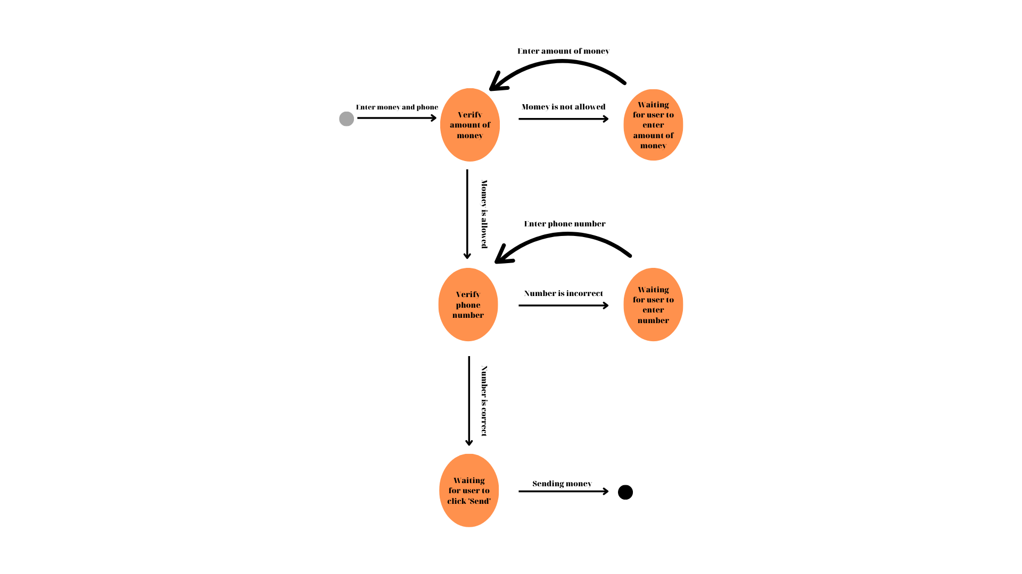

1)Verify that user will send money if he enters correct number and allowed amount of money in the first attempt.

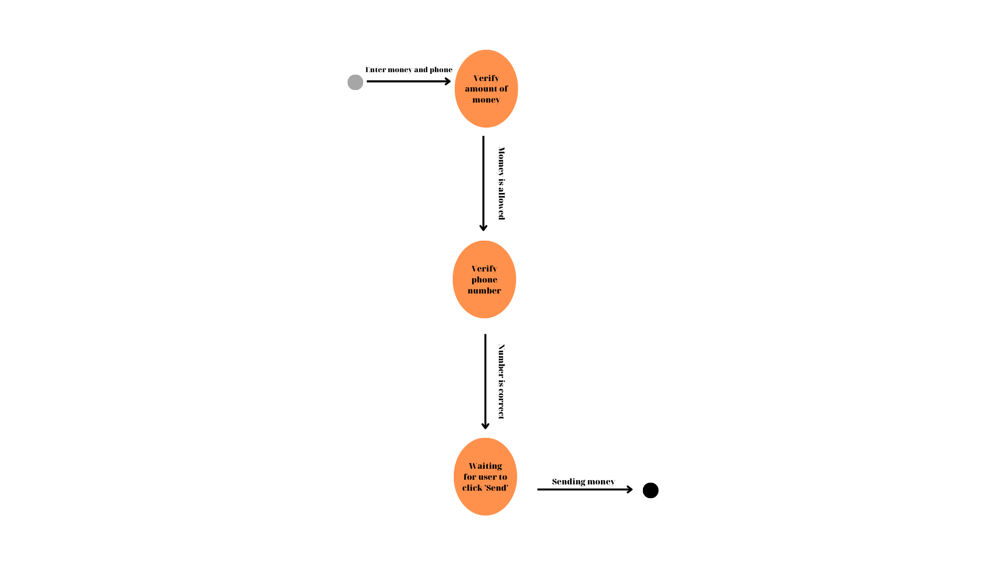

2)Verify that user will send money if he enters incorrect number in the first attempt and allowed amount of money.

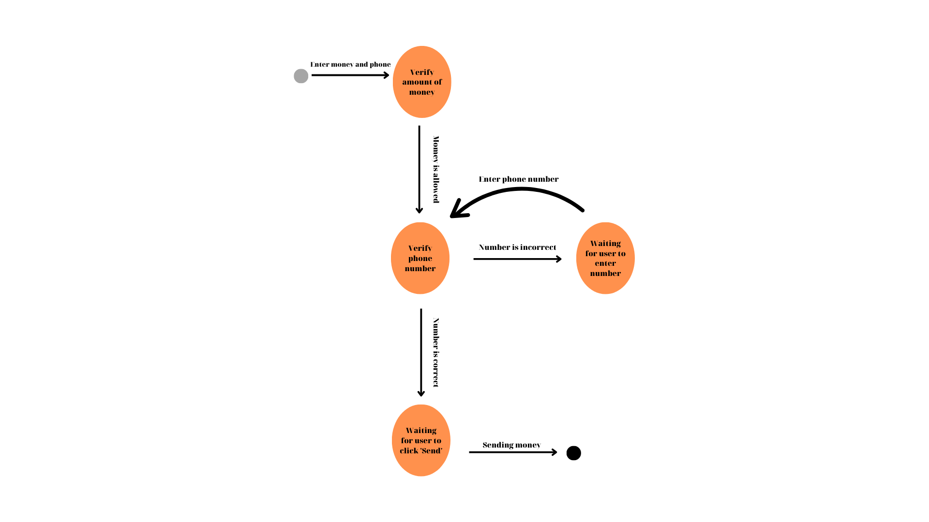

3) Verify that user will send money if he enters correct number and not allowed amount of money in the first attempt.

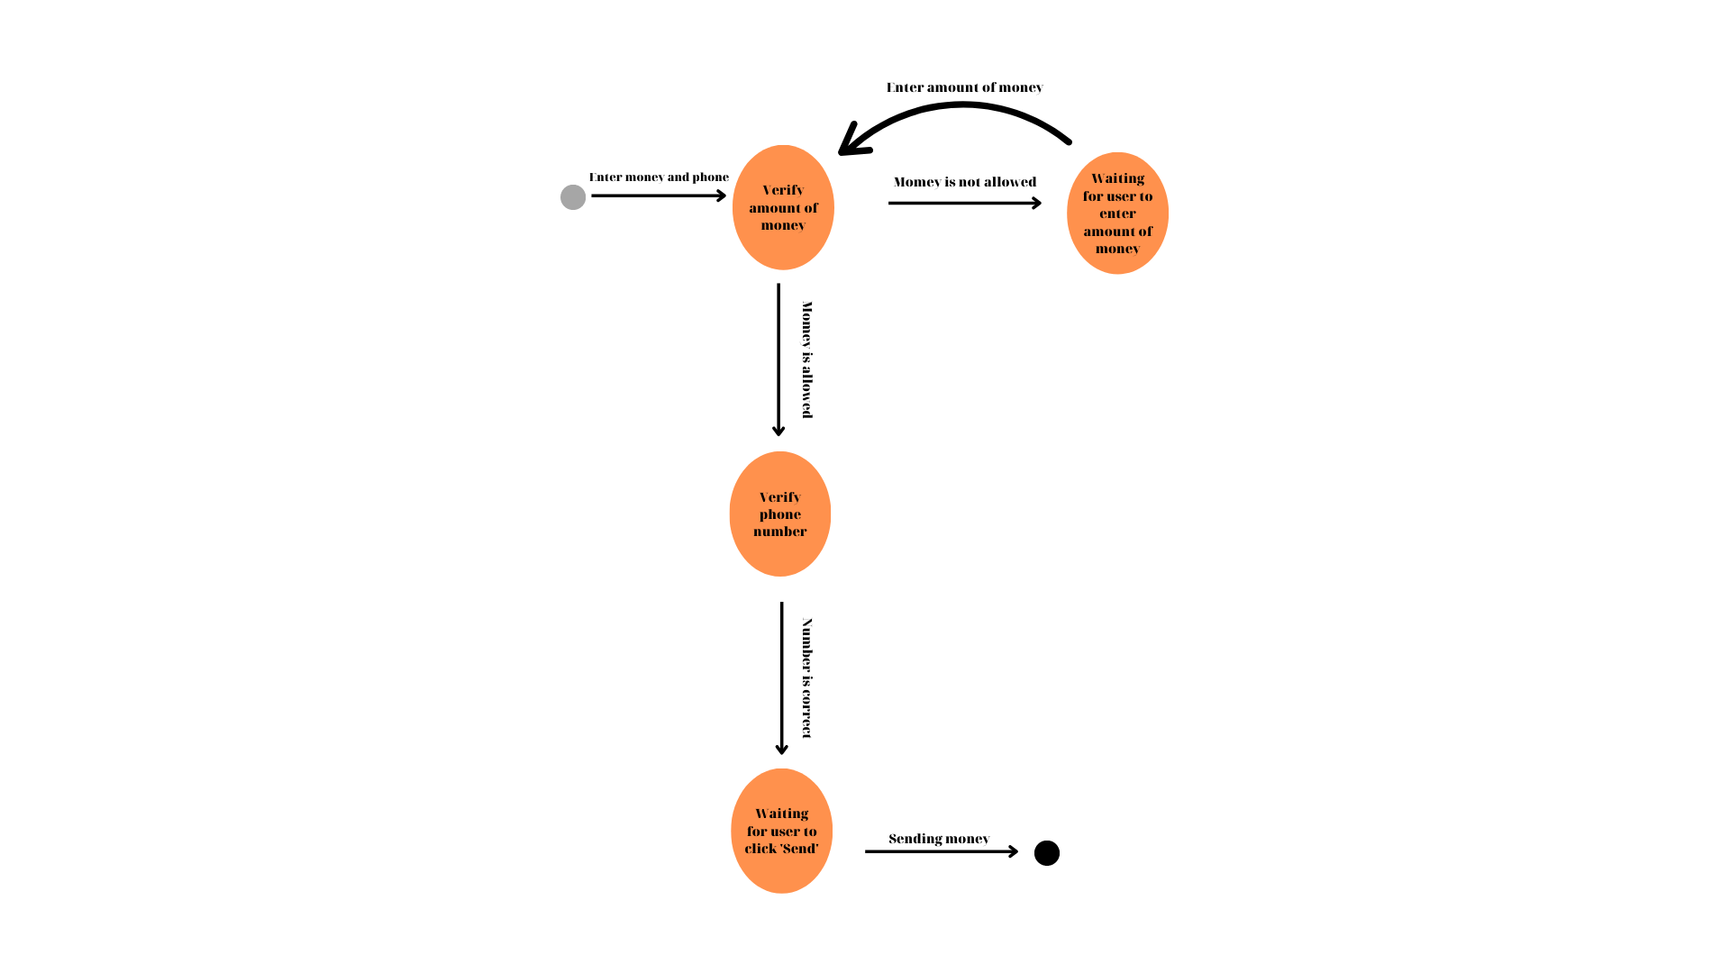

4) Verify that user will send money if he enters incorrect number and not allowed amount of money in the first attempt.

