Variant 4 – NataliaF

1. Equivalence partitioning and Boundary value analysis In a system designed for postal services' payment: Letters up to 100g are called as ‘light letters’. Postal rates for sending the light letters up to 10g are $25. The next 40g should be played by $35. Each next 25g up to 100g should be played by an extra $10.  
   Partitions should be designed for “grams”.
2. Build equivalence classes (partitions) based on given information
3. Stand Out boundary values
4. Cover requirements above by tests (write test cases’ names and objectives) based on equivalence partitioning and boundary value analysis

|  |  |  |  |  |  |  |
| --- | --- | --- | --- | --- | --- | --- |
| Weight, g | 0 | 1-9 | 10-49 | 50-74 | 75-99 | >=100 |
| Price, $ | Invalid | 25 | 35 | 45 | 55 | Invalid |
| EP | 0 | 5 | 30 | 63 | 87 | 150 |
| BVA | 0 | 1 9 | 10 49 | 50 74 | 75 99 | 100 |

|  |  |  |
| --- | --- | --- |
| **#** | **Condition** | **Expected Result** |
| 1 | Put value `0 g` into the “Weight” field | Error message appears "You have entered an incorrect value for the “Weight” field". |
| 2 | Put value `5 g` into the “Weight” field | Postal rates for sending is 25$. |
| 3 | Put value `30 g` into the “Weight” field | Postal rates for sending is 35$. |
| 4 | Put value `63 g` into the “Weight” field | Postal rates for sending is 45$. |
| 5 | Put value `87 g` into the “Weight” field | Postal rates for sending is 55$. |
| 6 | Put value `150 g` into the “Weight” field | Error message appears "You have entered an incorrect value for the “Weight” field". |

|  |  |  |
| --- | --- | --- |
| **#** | **Condition** | **Expected Result** |
| 1 | Put value `0 g` into the “Weight” field | Error message appears "You have entered an incorrect value for the “Weight” field". |
| 2 | Put value `1 g` into the “Weight” field | Postal rates for sending is 25$. |
| 3 | Put value `9 g` into the “Weight” field | Postal rates for sending is 25$. |
| 4 | Put value `10 g` into the “Weight” field | Postal rates for sending is 35$. |
| 5 | Put value `49 g` into the “Weight” field | Postal rates for sending is 35$. |
| 6 | Put value `50 g` into the “Weight” field | Postal rates for sending is 45$. |
| 7 | Put value `74 g` into the “Weight” field | Postal rates for sending is 45$. |
| 8 | Put value `75 g` into the “Weight” field | Postal rates for sending is 55$. |
| 9 | Put value `99 g` into the “Weight” field | Postal rates for sending is 55$. |
| 10 | Put value `100 g` into the “Weight” field | Error message appears "You have entered an incorrect value for the “Weight” field". |

|  |  |  |
| --- | --- | --- |
| # | Test Items | Test data |
| 1 | Verify that Postal rates for sending is 25$ if letters up to 10g. | 1. Any number from 1 to 9 (e.g. 5) 2. 1 3. 9 |
| 2 | Verify that Postal rates for sending is 35$ if letters from 10 to 50 g. | 1. Any number from 10 to 50 (e.g. 30) 2. 10 3. 49 |
| 3 | Verify that Postal rates for sending is 45$ if letters from 50 to 75 g. | 1. Any number from 50 to 75 (e.g. 63) 2. 50 3. 74 |
| 4 | Verify that Postal rates for sending is 55$ if letters from 75 to 100 g. | 1. Any number from 75 to 100 (e.g. 87) 2. 75 3. 99 |
| 5 | Verify that Error message appears "You have entered an incorrect value for the “Weight” field". | 1. Any number < 0 (e.g. -5) 2. 0 3. Any number > 100 (e.g. 150) 4. 100 5. Decimal number (e.g. 156.34) ???????????? 6. Decimal number (e.g. 34,98) 7. Alphabetic characters 8. Special characters |
| 6 | Verify that error message appears if client leaves ‘Weight’ field empty. |  |

1. Decision tables If you are a new customer of Apple store and you made a purchase on $500 and more, you will get a voucher on 10% discount for today’s purchase. If your purchase worth is less than $500, then you will get a voucher on 5% discount for today’s purchase. If you are a gold customer of Apple store, then you will have 30% discount on all store assortments.
2. Build decision table based on given information

|  |  |  |  |  |
| --- | --- | --- | --- | --- |
| Causes (inputs) | R1 | R2 | R3 | R4 |
| Is a purchase on $500 and more? | Y | Y | N | N |
| Are you a gold customer of Apple store? | Y | N | Y | N |
| Discount (%) | 30 | 10 | 30 | 5 |
| Message* |  |  |  |  |

|  |  |  |  |
| --- | --- | --- | --- |
| Causes (inputs) | R1/R4 | R2 | R4 |
| Is a purchase on $500 and more? | Y/N | Y | N |
| Is a purchase less than $500? | N/Y | N | Y |
| Are you a gold customer of Apple store? | Y | N | N |
| Discount (%) | 30 | 10 | 5 |
| Message* | + | + |  |

1. To open a visa you need to pass a list of steps in standard procedure. At first you need to get consultation or read some materials about documents which should be provided. Then you should prepare these documents according to templates and give them to tour agency for verification. If there are mistakes in the documents, they should be re-developed. If documents are prepared correctly, then you should pay $80 for consular fee and pass interview with consul. If embassy accepts documents and you passed interview successfully, then you will get visa. If not, then you will need to try again.

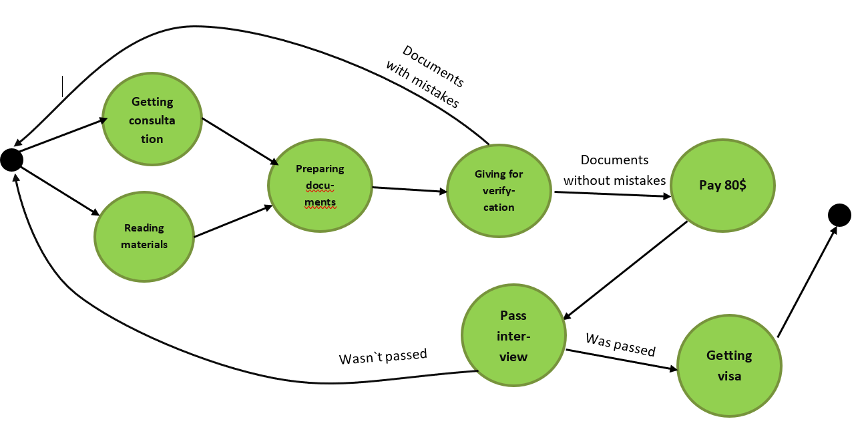

Documents with mistakes

Wasn`t passed

Was passed

Documents without mistakes