1. Suppose we have a discrete random variable X that can take on the values 1, 2, 3, and 4 with probabilities 0.1, 0.4, 0.3, and 0.2 respectively.
   * Write the probability mass function (PMF) for X.



* + Calculate the cumulative distribution function (CDF) for X.



1. Suppose we have a continuous random variable Y that follows a normal distribution with mean 10 and standard deviation 2.
   * Write the probability density function (PDF) for Y.



* + Calculate the probability that Y takes a value less than or equal to 12, i.e., P(Y ≤ 12).

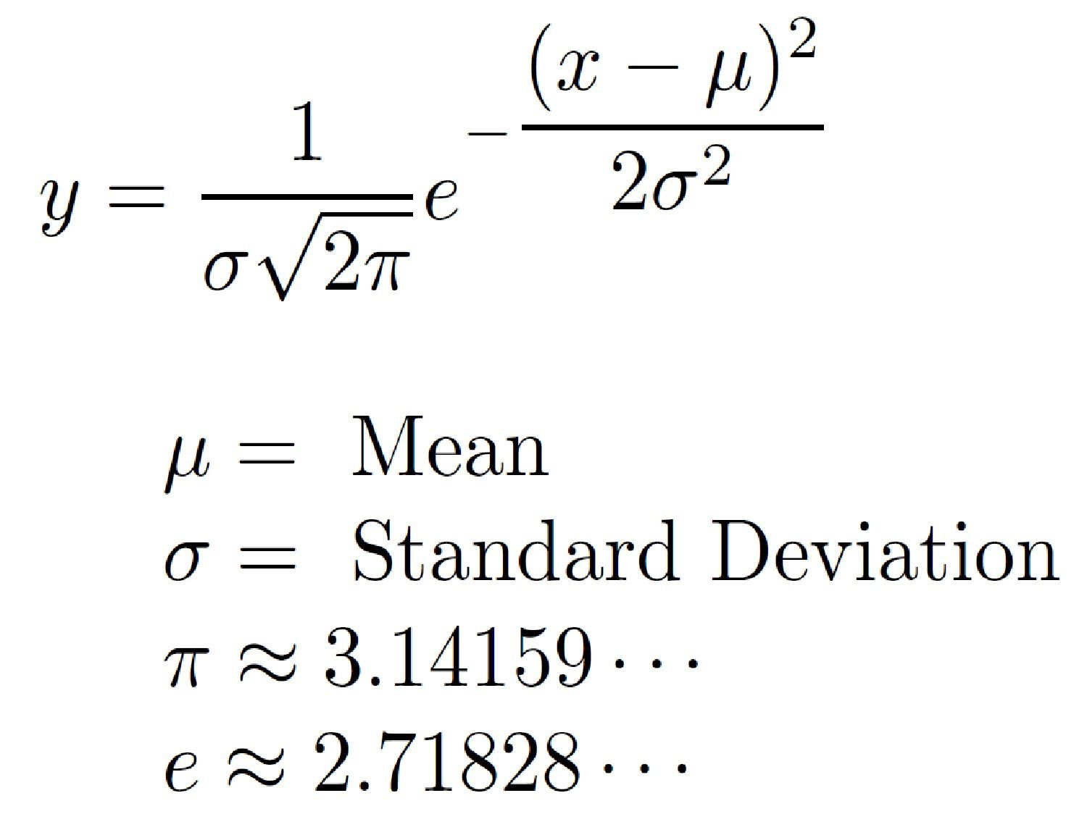

**SOLUTION:**



…where erf is the *error function*

1. Suppose a factory produces two types of smartphones, A and B. The factory produces 60% of type A and 40% of type B. Among the smartphones of type A, 10% are defective, while among the smartphones of type B, 5% are defective. A customer randomly buys one of these smartphones. What is the probability that the smartphone is defective?

Solution:

Let's define the events:

A: the smartphone is of type A

B: the smartphone is of type B

D: the smartphone is defective

We are looking for P(D), the probability that the smartphone is defective.

By the law of total probability, we can write:

P(D) = P(A)P(D|A) + P(B)P(D|B)

where P(A) = 0.6, P(B) = 0.4, P(D|A) = 0.1, and P(D|B) = 0.05.

Substituting these values, we get:

P(D) = 0.6 * 0.1 + 0.4 * 0.05 = 0.06 + 0.02 = 0.08

Therefore, the probability that the smartphone is defective is 0.08, or 8%.

1. Suppose a company has five departments: sales, marketing, finance, human resources, and IT. The company has 20 employees, and the distribution of employees across departments is as follows:

* Sales: 5 employees
* Marketing: 4 employees
* Finance: 3 employees
* Human resources: 6 employees
* IT: 2 employees

Suppose one of the employees is randomly selected. What is the probability that the selected employee works in the IT department, given that the employee works in the sales or marketing department?

Solution:

Let's define the events:

* S: the selected employee works in the sales or marketing department
* IT: the selected employee works in the IT department

We are looking for P(IT|S), the probability that the selected employee works in the IT department, given that the employee works in the sales or marketing department.

By Bayes' theorem, we can write:

P(IT|S) = P(S|IT)P(IT) / P(S)

We can calculate each of these probabilities as follows:

* P(S|IT) is the probability that the selected employee works in the sales or marketing department, given that the employee works in the IT department. Since there are only 2 employees in the IT department, and none of them are in the sales or marketing department, this probability is 0.
* P(IT) is the prior probability that the selected employee works in the IT department, which is 2/20 or 0.1.
* P(S) is the probability that the selected employee works in the sales or marketing department, which is (5+4)/20 or 0.45.

Substituting these values, we get:

P(IT|S) = 0 * 0.1 / 0.45 = 0

Therefore, the probability that the selected employee works in the IT department, given that the employee works in the sales or marketing department, is 0.

1. Suppose a detective is investigating a crime and has two possible suspects, A and B. The detective knows that the probability that suspect A committed the crime is 0.4, while the probability that suspect B committed the crime is 0.6. The detective also knows that if suspect A committed the crime, there is a 70% chance that there will be physical evidence linking him to the crime, and if suspect B committed the crime, there is a 90% chance that there will be physical evidence linking him to the crime. If physical evidence is found, what is the expected value of the probability that suspect A committed the crime?

Solution:

Let X be the random variable representing whether suspect A committed the crime or not (X = 1 if A committed the crime, X = 0 if B committed the crime). Let Y be the random variable representing whether physical evidence is found (Y = 1 if evidence is found, Y = 0 if no evidence is found).

The probability distribution for X is:

|  |  |
| --- | --- |
| X | P(X) |
| 0 | 0.6 |
| 1 | 0.4 |

The conditional probability distribution for Y given X is:

|  |  |  |
| --- | --- | --- |
| Y | P(Y/X=0) | P(Y/X=1) |
| 0 | 0.1 | 0.3 |
| 1 | 0.9 | 0.7 |

The probability that physical evidence is found is:

P(Y) = P(Y|X=0) * P(X=0) + P(Y|X=1) * P(X=1) = 0.1 * 0.6 + 0.7 * 0.4 = 0.34

The conditional probability that suspect A committed the crime given that physical evidence is found is:

P(X=1|Y=1) = P(Y=1|X=1) * P(X=1) / P(Y=1) = 0.7 * 0.4 / 0.34 = 0.82

The expected value of P(X=1|Y=1) is:

E(P(X=1|Y=1)) = 0.82

Therefore, if physical evidence is found, the expected value of the probability that suspect A committed the crime is 0.82. This result suggests that the detective should focus on suspect A as the more likely perpetrator of the crime, given the available evidence.

1. A police department is investigating a string of robberies in a neighborhood. The detectives believe that the robberies are being committed by one of three suspects, A, B, or C. The police have evidence that links each suspect to the robberies, but they do not have enough evidence to make an arrest. The police decide to use probability to determine which suspect is the most likely perpetrator. The following table shows the evidence against each suspect:

|  |  |
| --- | --- |
| Suspect | Probability of being guilty |
| A | 0.6 |
| B | 0.4 |
| C | 0.3 |

The police also have a list of witnesses who have seen the suspect near the scene of the crime. The following table shows the probability of each witness identifying the correct suspect:

|  |  |
| --- | --- |
| Witness | Probability of identifying the guilty suspect |
| 1 | 0.7 |
| 2 | 0.8 |
| 3 | 0.6 |

If witness 1 identified suspect A and witness 2 identified suspect B, what is the probability that suspect A is the guilty party?

Solution:

Let X be the random variable representing whether suspect A committed the crime or not (X = 1 if A committed the crime, X = 0 if B or C committed the crime). Let Y1 and Y2 be the random variables representing whether witness 1 and witness 2 identified the correct suspect, respectively (Y1 = 1 if A was identified correctly, Y1 = 0 otherwise; Y2 = 1 if B was identified correctly, Y2 = 0 otherwise).

The probability distribution for X is:

|  |  |
| --- | --- |
| X | P(X) |
| 0 | 0.6 |
| 1 | 0.4 |

The conditional probability distribution for Y1 and Y2 given X is:

|  |  |  |
| --- | --- | --- |
| Y1 | P(Y1|X=0) | P(Y1|X=1) |
| 0 | 0.7 | 0.3 |
| 1 | 0.3 | 0.7 |

|  |  |  |
| --- | --- | --- |
| Y2 | P(Y2|X=0) | P(Y2|X=1) |
| 0 | 0.8 | 0.2 |
| 1 | 0.2 | 0.8 |

The probability that witness 1 identified suspect A and witness 2 identified suspect B is:

P(Y1=1,Y2=1) = P(Y1=1|X=1) * P(Y2=1|X=0) * P(X=1) * P(X=0) = 0.7 * 0.8 * 0.4 * 0.6 = 0.1344

The probability that suspect A is the guilty party given this evidence is:

P(X=1|Y1=1,Y2=1) = P(Y1=1,Y2=1|X=1) * P(X=1) / P(Y1=1,Y2=1) = (0.7 * 0.2) * 0.4 / 0.1344 = 0.52

Therefore, the probability that suspect A is the guilty party given that witness 1 identified him and witness 2 identified suspect B is 0.52. This result suggests that suspect A is the most likely perpetrator of the robberies. However, more evidence would be needed to make an arrest and

1. A detective is investigating a crime where the victim was robbed at gunpoint in an alley. The victim was able to provide a description of the suspect, who is male and between 20 and 30 years old. The detective believes that the crime was committed by one of three suspects, A, B, or C, who match this description. The detective decides to use conditional probability to determine which suspect is the most likely perpetrator. The following information is available:
   * The probability of a male between 20 and 30 years old being the perpetrator is 0.4.
   * The probability that suspect A matches the description is 0.7.
   * The probability that suspect B matches the description is 0.5.
   * The probability that suspect C matches the description is 0.6.

If suspect A matches the description, what is the probability that he is the perpetrator?

Solution:

Let X be the event that suspect A is the perpetrator, and let M be the event that the perpetrator is male between 20 and 30 years old. We are given that P(M) = 0.4, P(A|M) = 0.7, P(B|M) = 0.5, and P(C|M) = 0.6.

By Bayes' theorem, we can calculate P(A|M) as:

P(A|M) = P(M|A) * P(A) / P(M)

We can calculate P(M|A) using the formula for conditional probability:

P(M|A) = P(A and M) / P(A)

We can calculate P(A and M) using the product rule:

P(A and M) = P(A|M) * P(M) = 0.7 * 0.4 = 0.28

We can calculate P(A) using the law of total probability:

P(A) = P(A|M) * P(M) + P(A|not M) * P(not M)

We know that P(A|not M) = 0, since we are given that the perpetrator is male between 20 and 30 years old.

Therefore,

P(A) = P(A|M) * P(M) = 0.7 * 0.4 = 0.28

Finally, we can calculate P(M) using the law of total probability:

P(M) = P(A and M) + P(B and M) + P(C and M)

We can calculate P(B and M) and P(C and M) using the same methods as above:

P(B and M) = P(B|M) * P(M) = 0.5 * 0.4 = 0.2

P(C and M) = P(C|M) * P(M) = 0.6 * 0.4 = 0.24

Therefore,

P(M) = P(A and M) + P(B and M) + P(C and M) = 0.28 + 0.2 + 0.24 = 0.72

Now we can use Bayes' theorem to calculate P(A|M):

P(A|M) = P(M|A) * P(A) / P(M) = (0.28 / 0.4) * 0.28 / 0.72 = 0.3889

Therefore, the probability that suspect A is the perpetrator given that he matches the description is approximately 0.3889. This result suggests that suspect A is the most likely perpetrator of the crime, but more evidence would be needed to make an arrest.

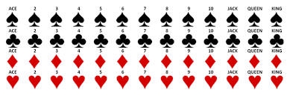

1. You have a standard deck of 52 cards. What is the probability of drawing a heart card, then a diamond card, and then a spade card, in that order, without replacement?

Solution:

* The probability of drawing a heart card on the first draw is 13/52, since there are 13 heart cards in the deck. After drawing a heart card, there are 51 cards left in the deck, including 12 diamond cards. The probability of drawing a diamond card on the second draw, given that a heart card was drawn on the first draw, is 12/51.
* After drawing a heart card and a diamond card, there are 50 cards left in the deck, including 13 spade cards. The probability of drawing a spade card on the third draw, given that a heart card and a diamond card were drawn on the first two draws, is 13/50.
* Therefore, the probability of drawing a heart card, then a diamond card, and then a spade card, in that order, without replacement is:

(13/52) * (12/51) * (13/50) = 0.0108

* The probability is approximately 0.0108, or about 1 in 92.5.

1. Suppose you have two decks of playing cards, one red and one blue. Each deck has 52 cards, with 13 cards of each suit (hearts, diamonds, clubs, and spades). You draw a card from the red deck, note the suit, and place the card back in the deck. Then you draw a card from the blue deck, note the suit, and place the card back in the deck. Are these events independent or dependent?

* What is the probability of drawing a heart from the red deck and a heart from the blue deck, in that order?
* What is the probability of drawing a heart from the red deck and a spade from the blue deck, in that order?

Solution:

* The events are independent, because drawing a heart from the red deck does not affect the composition of the blue deck, and vice versa. The probability of drawing a heart from the red deck is 13/52, and the probability of drawing a heart from the blue deck is also 13/52. Therefore, the probability of drawing a heart from the red deck and a heart from the blue deck, in that order, is:

P(heart, heart) = P(heart from red deck) * P(heart from blue deck) = (13/52) * (13/52) = 0.0625

The probability is approximately 0.0625, or about 1 in 16.

* The events are dependent, because drawing a heart from the red deck affects the composition of the blue deck. After drawing a heart from the red deck, there are 51 cardProbability For Single Eventss left in the deck, including 13 spades. Therefore, the probability of drawing a heart from the red deck and a spade from the blue deck, in that order, is:

P(heart, spade) = P(heart from red deck) * P(spade from blue deck | heart from red deck) = (13/52) * (13/51) = 0.05098

The probability is approximately 0.05098, or about 1 in 19.6.

1. In a poker game, the following options are commonly available:

* Bet: When it's your turn to act, you can choose to bet by placing chips into the pot. This is a show of strength and confidence in your hand.
* Call: If someone else has bet before you, you can choose to call by matching the amount of chips they have bet. This indicates that you are willing to continue playing the hand, but you do not necessarily have a strong hand.
* Fold: If you believe that your hand is not strong enough to continue playing, you can choose to fold. This means that you forfeit your cards and any chips you have already bet, and you are out of the hand.

|  |  |
| --- | --- |
| Probability For Single Events | Multiple Events |
| Probability with Combinations | Mutually Exclusive Events |
| Probability with Permutations | Non-Mutually Exclusive Events |
| Dependent Events | Intersection of Independent Events |
| Independent Events | Intersection of Dependent Events |
| Expected Value |  |

Please Check this link for more example:

<https://www.datacamp.com/tutorial/statistics-python-tutorial-probability-1>