

FLOWER SHOP

## Software Design Specification

#### – Hanoi, November 2022 –

**RECORD OF CHANGES**

|  |  |  |  |
| --- | --- | --- | --- |
| **Date** | **A* M, D** | **Name** | **Change Description** |
| 09/11/2022 | A | Trần Đình Hiếu | add form , screen, add class diagram |
| 09/11/2022 | M | Nguyễn Tường Phước | describe the functions of each screen |
| 09/11/2022 | D | Lê Quang Duy | delete database, edit database |
| 09/11/2022 | D | Lê Hoàng Dương | delete screen |
| 9/11/2022 | A | Đoàn Văn Đông | edit database, add class diagram |

*A - Added M - Modified D - Deleted

# Table of Contents

#### Contents

Table of Contents 3

1. Overview 7
   1. Code Packages 7
   2. Database Design 9
      1. Database Schema 9
      2. Table Description 10
2. Code Designs 10
   1. Homepage 11
      1. Class Diagram 11
      2. Class Specifications 11
      3. Screen 12
   2. Log in 13
      1. Class Diagram 13
      2. Class Specifications 13
      3. Screen 14
   3. Log out 14
      1. Class Diagram 14
      2. Class Specifications 14
      3. Screen 16
   4. Cart 17
      1. Class Diagram 17
      2. Class Specifications 17
      3. Screen 18
   5. Customer 19
      1. Class Diagram 19
      2. Class Specifications 20
      3. Screen 21
   6. Staff 22
      1. Class Diagram 22
      2. Class Specifications 22
      3. Screen 23
   7. Customers In Shop 23
      1. Class Diagram 23
      2. Class Specifications 23
      3. Screen 24
   8. Product Of Shop 25
      1. Class Diagram 25
      2. Class Specifications 26
      3. Screen 27
   9. Staff In Shop 28
      1. Class Diagram 28
      2. Class Specifications 28
      3. Screen 29
   10. List Bill 30
       1. Class Diagram 30
       2. Class Specifications 31
       3. Screen 32
   11. Add new Customer 34
       1. Class Diagram 34
       2. Class Specifications 34
       3. Screen 35
   12. Edit information of customer 36
       1. Class Diagram 36
       2. Class Specifications 36
       3. Screen 37
   13. Detail Customer 37
       1. Class Diagram 37
       2. Class Specifications 37
       3. Screen 38
   14. Delete Customer 39
       1. Class Diagram 39
       2. Class Specifications 39
       3. Screen 40
   15. Create Product 40
       1. Class Diagram 40
       2. Class Specifications 41
       3. Screen 41
   16. Edit Product 42
       1. Class Diagram 42
       2. Class Specifications 43
       3. Screen 44
   17. Delete Product 45
       1. Class Diagram 45
       2. Class Specifications 47
       3. Screen 48
   18. Create Staff 49
       1. Class Diagram 49
       2. Class Specifications 50
       3. Screen 50
   19. Edit Information staff 51
       1. Class Diagram 51
       2. Class Specifications 51
       3. Screen 52
   20. Delete Staff 52
       1. Class Diagram 52
       2. Class Specifications 52
       3. Screen 53
   21. Store 54
       1. Class Diagram 54
       2. Class Specifications 54
       3. Screen 55
   22. Create New Store 55
       1. Class Diagram 55
       2. Class Specifications 57
       3. Screen 57
   23. Edit Store 57
       1. Class Diagram 57
       2. Class Specifications 58
       3. Screen 59
   24. Detail Store 59
       1. Class Diagram 59
       2. Class Specifications 60
       3. Screen 61
   25. Delete Store 61
       1. Class Diagram 61
       2. Class Specifications 63
       3. Screen 64

71

# Overview

## 1 Introduction

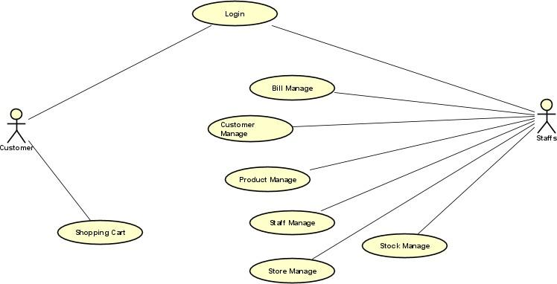

*UseCase*

In order to make the house, office become beautiful and lively, decorations play an important role. For office workers, flowers help them relieve stress. As for housewives, flowers are decorative objects that make the house more beautiful and poetic. Sometimes playing with flowers is also an art. From the love of flowers, we bring to a website that sells flowers, in order to help people choose the kind of flowers they need to find without having to go far, ensuring safety, variety of flowers, designs, scent and function.

### 2. Code Packages (vẽ )

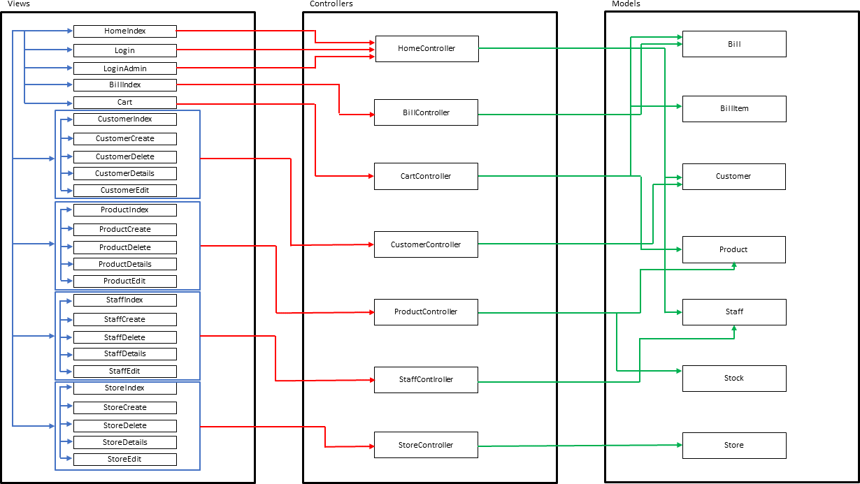

Figure 1.1.1: Code package

***Package descriptions & package class naming conventions***

|  |  |  |
| --- | --- | --- |
| **No** | **Package** | **Description** |
| 01 | view | This package used to contain html/css/js file, besides is assets with image, logo,…  *.jsp, *.css, *.js, … |
| 02 | controller | This package used to contain controller file. |
| 03 | model | This package used to contain model file. |

### Database Design

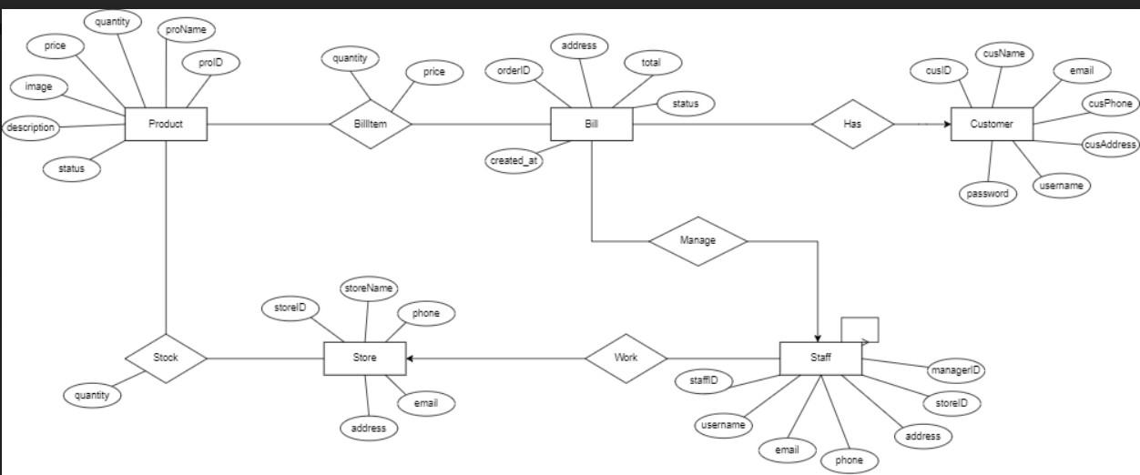

*ERD diagram*

* 1. ***Database Schema***

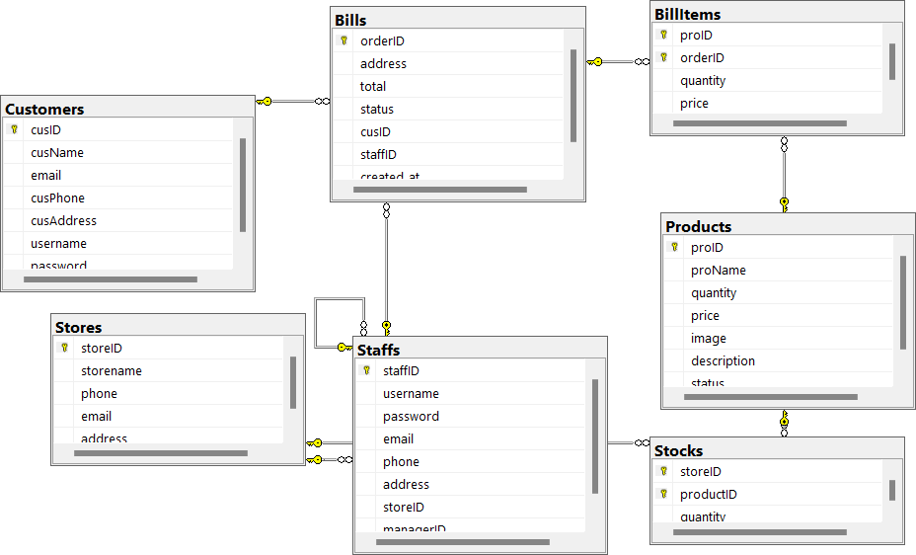

* 1. ***Table Description***

|  |  |  |
| --- | --- | --- |
| **No** | **Table** | **Description** |
| 01 | Customers | Save customer information |
| 02 | Bills | Display product information after being ordered, display bill, wait for confirmation |

|  |  |  |
| --- | --- | --- |
| 03 | BillItems | Products in the cart after being ordered |
| 04 | Store | Display information of stores, address and number of products |
| 05 | Staff | Managers of chain stores |
| 06 | Product | Information of product list |
| 07 | Stock | Number of products in stock |

# Code Designs

### Homepage

* 1. ***Class Diagram***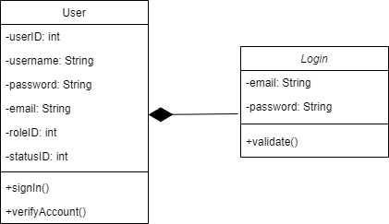

***Screen***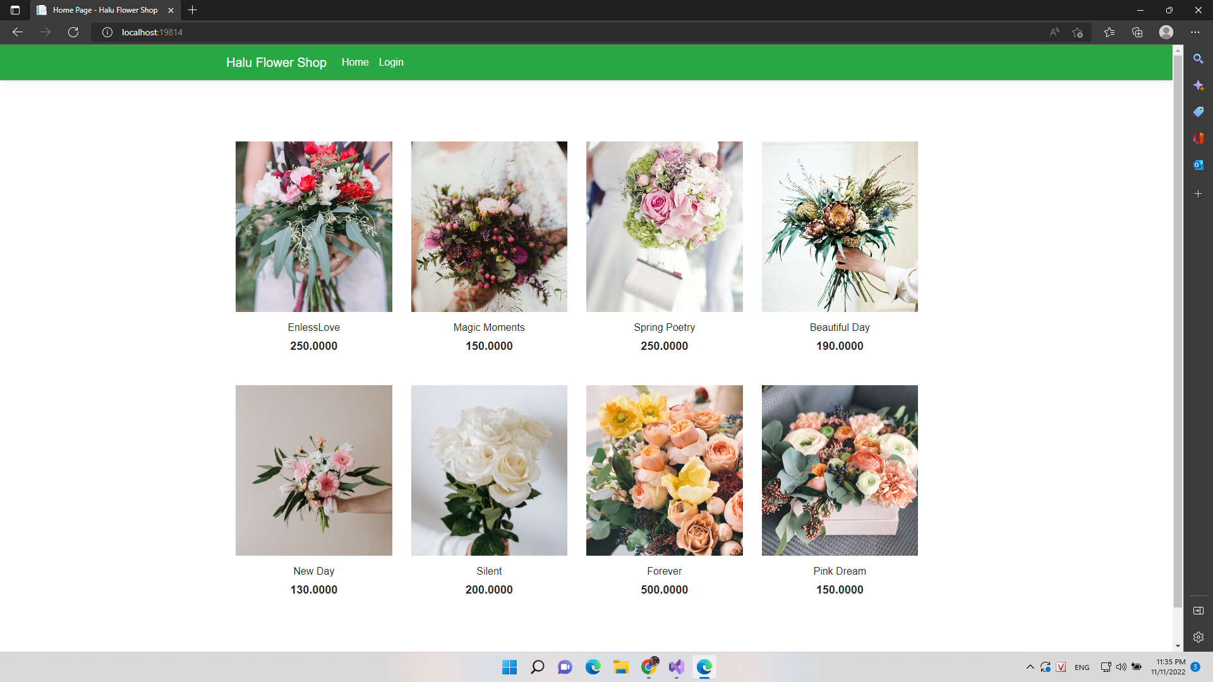

.

### Login

* 1. ***Class Diagram***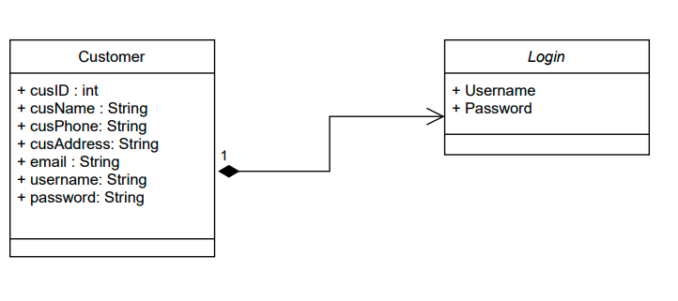

***Screen***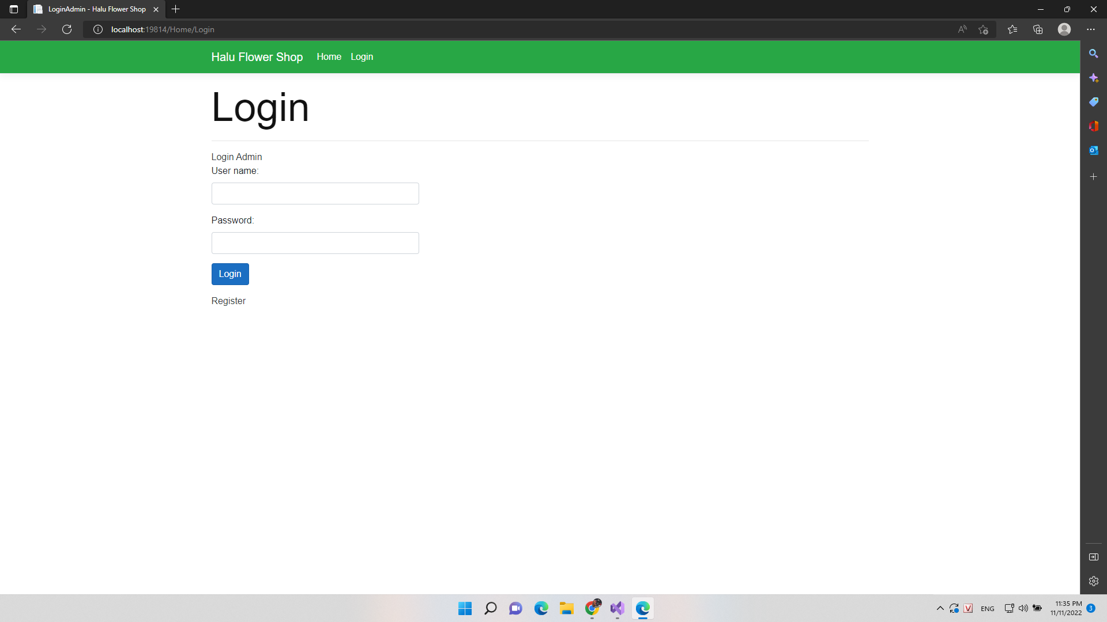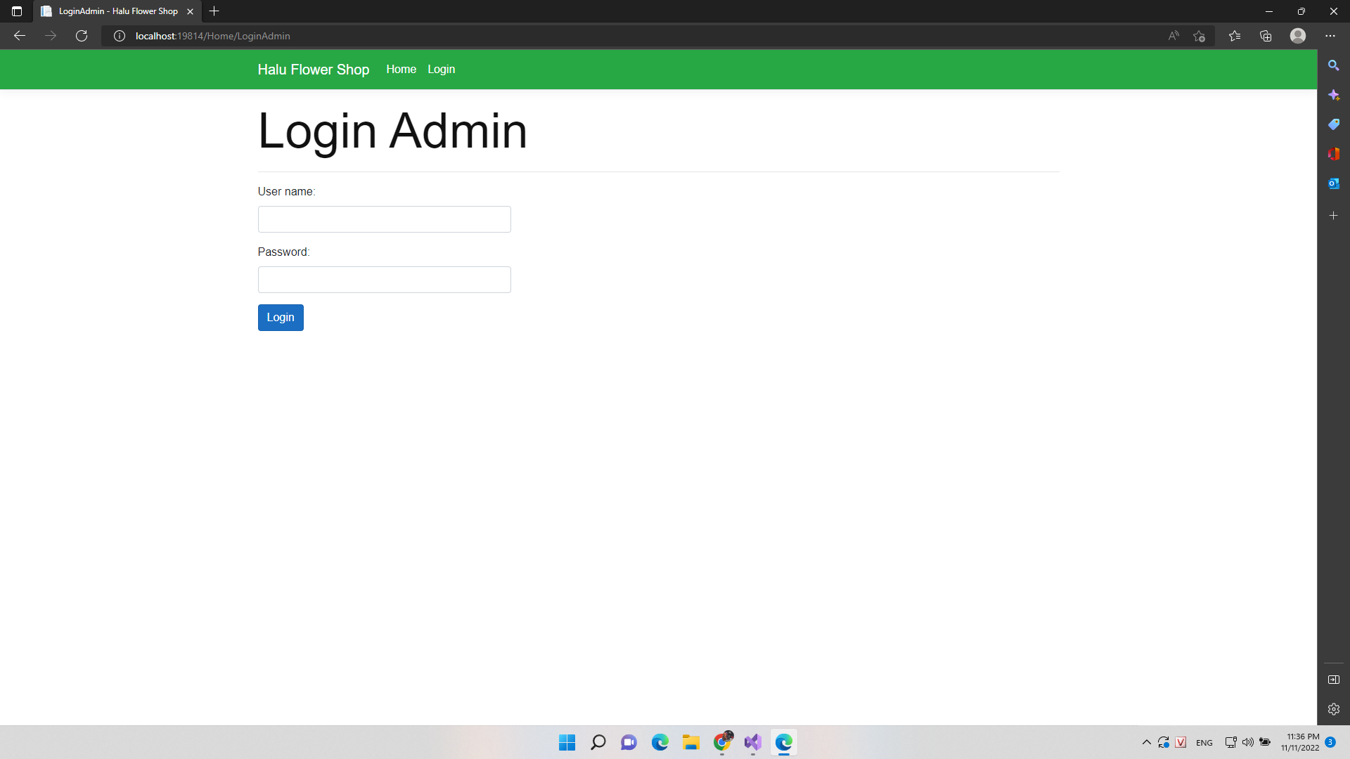

### Logout

***. Screen***

### Cart (Use for customer)

* 1. ***Class Diagram***

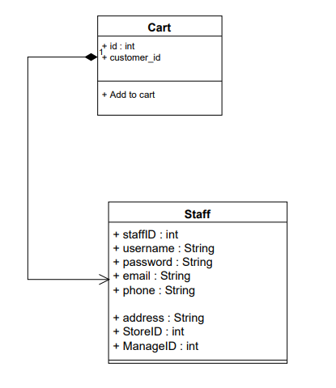

***Screen***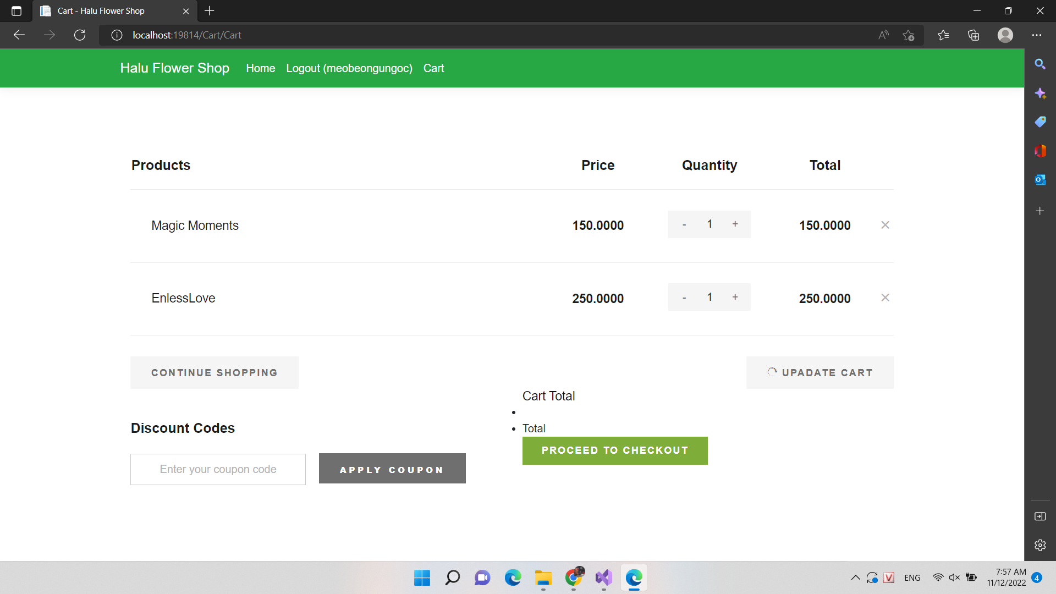

### Customer

* 1. ***Screen***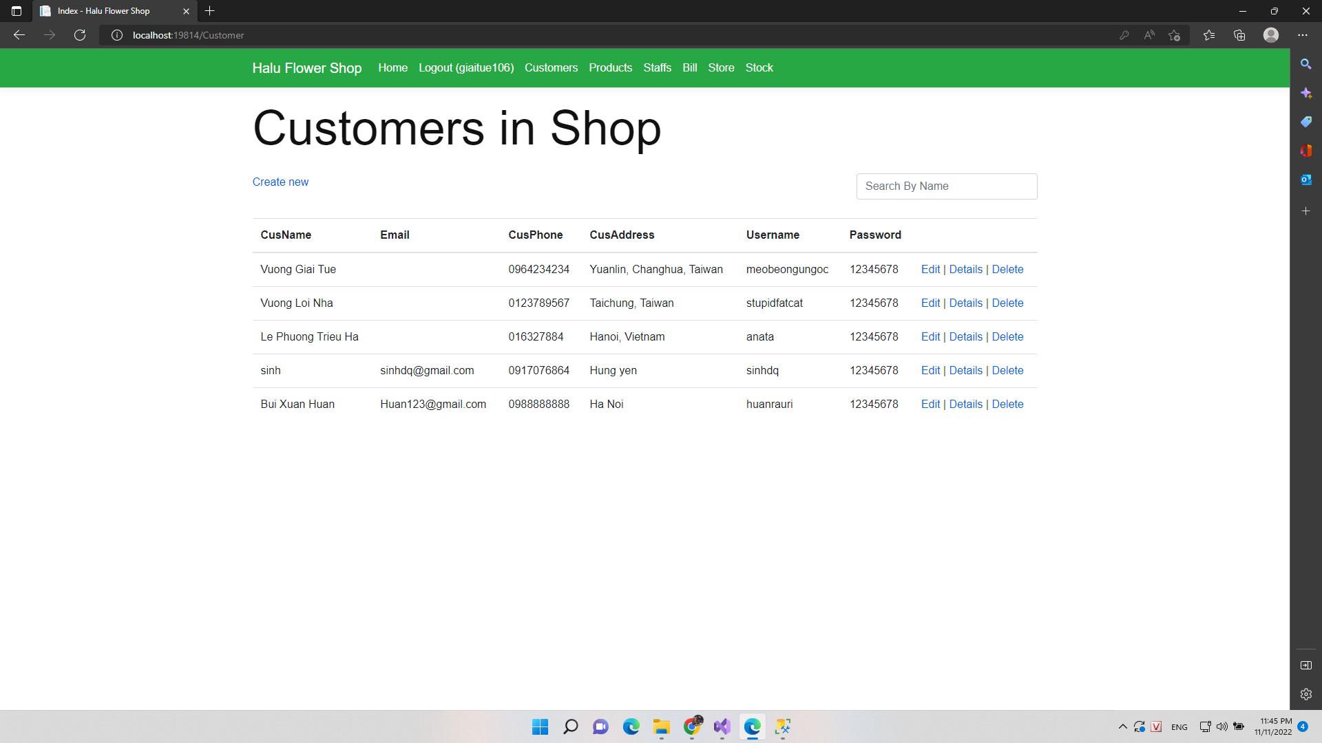

### Staff

* 1. ***Class Diagram***

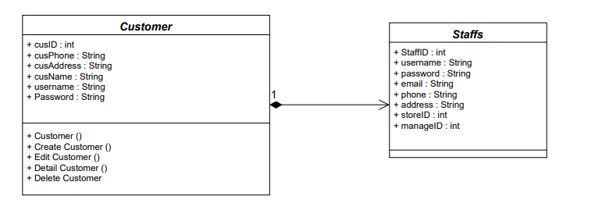

***Screen***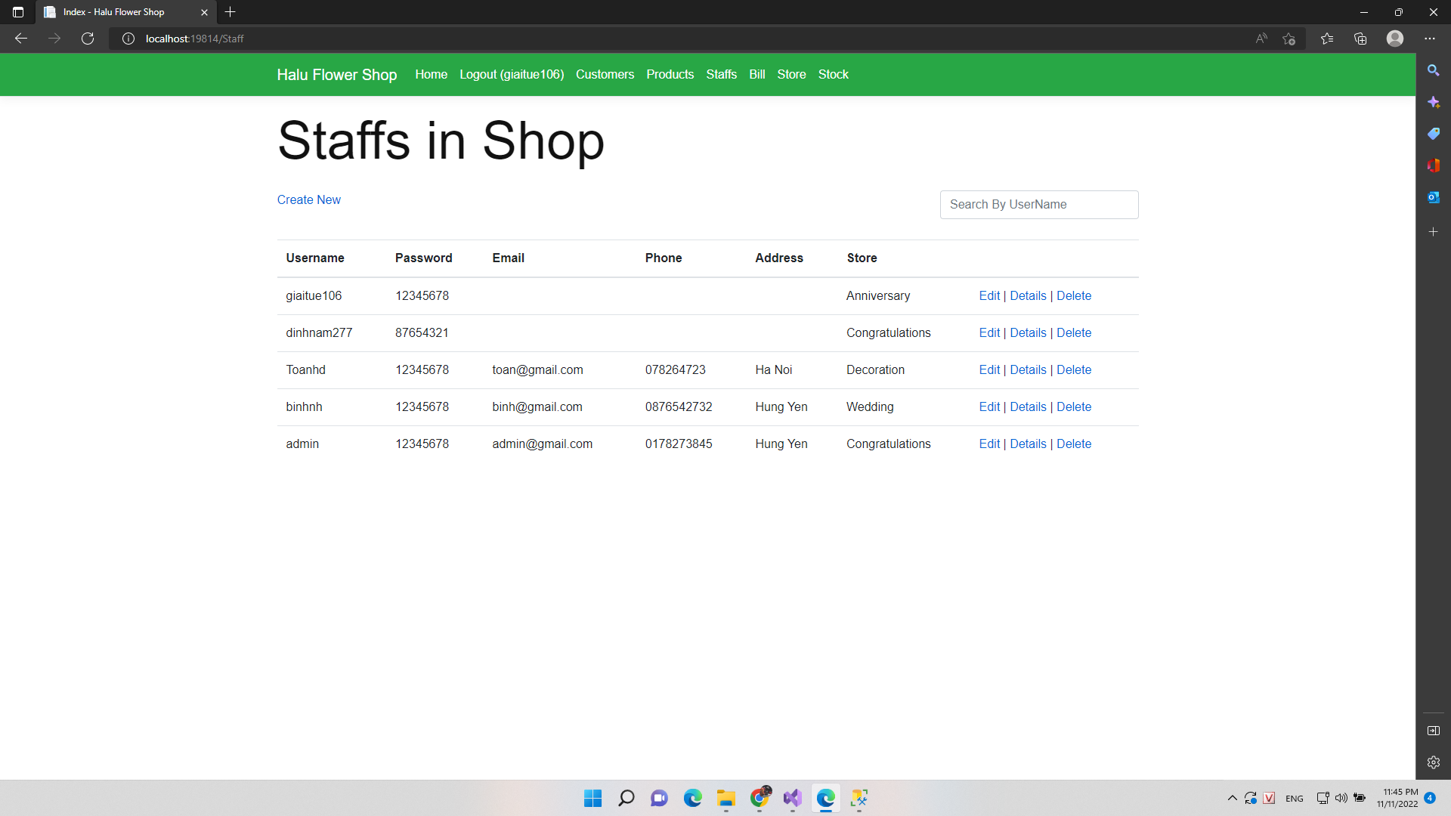

### Customer In Shop

***. Screen***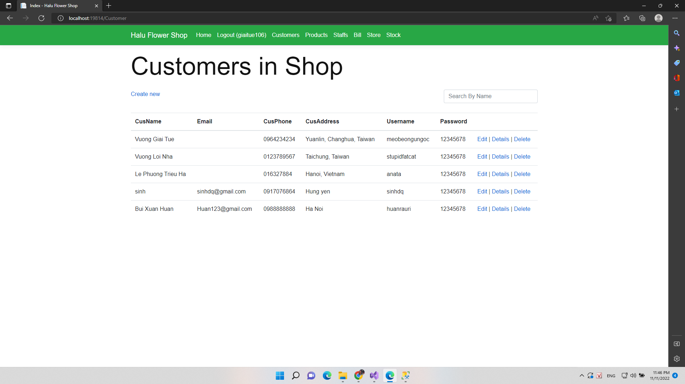

### Product Of Shop

***Screen***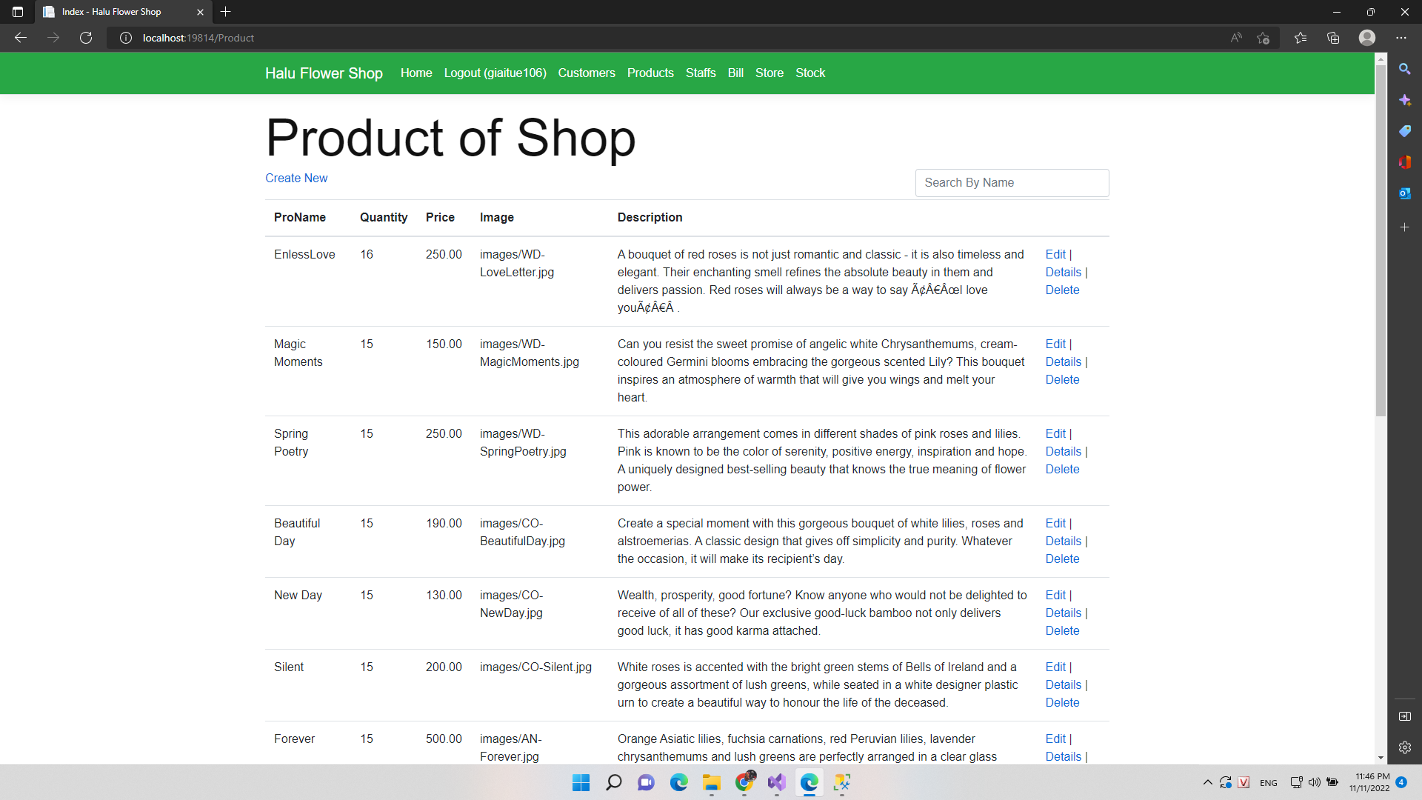

### List Bill

***c. Screen***

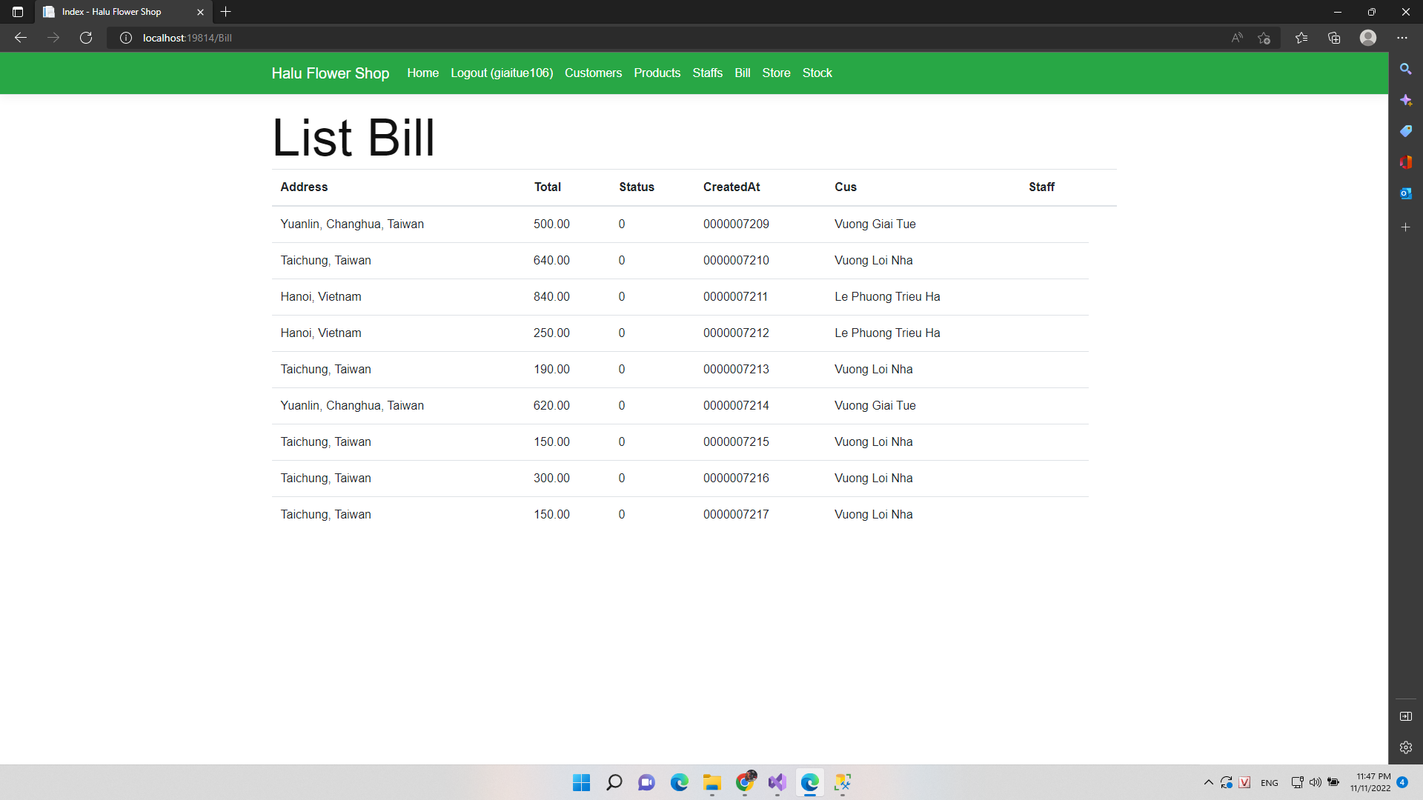

### Add New Customer

***. Screen***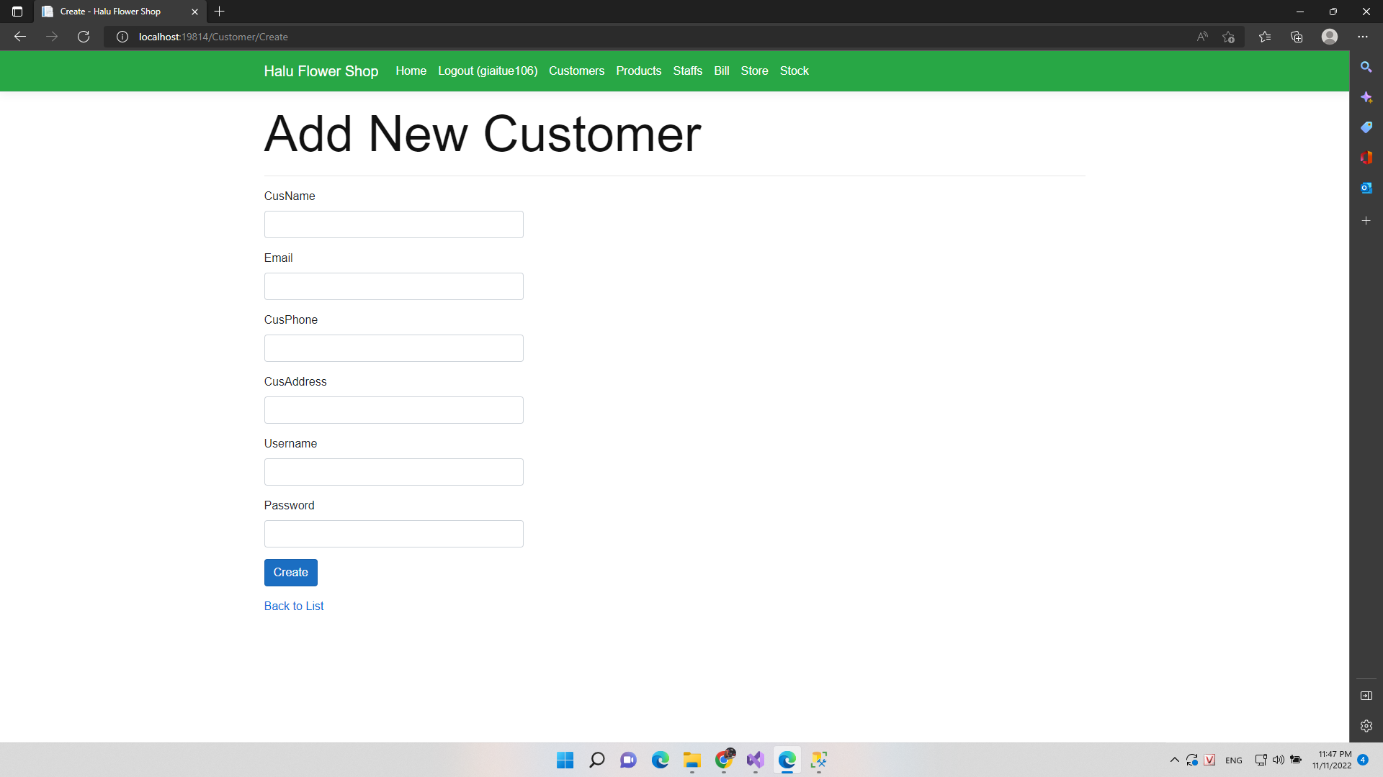

### Edit Information Of Customer

***. Screen***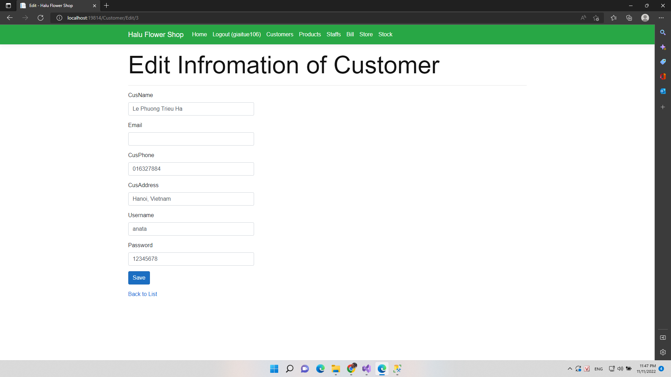

### Detail Customer

***. Screen***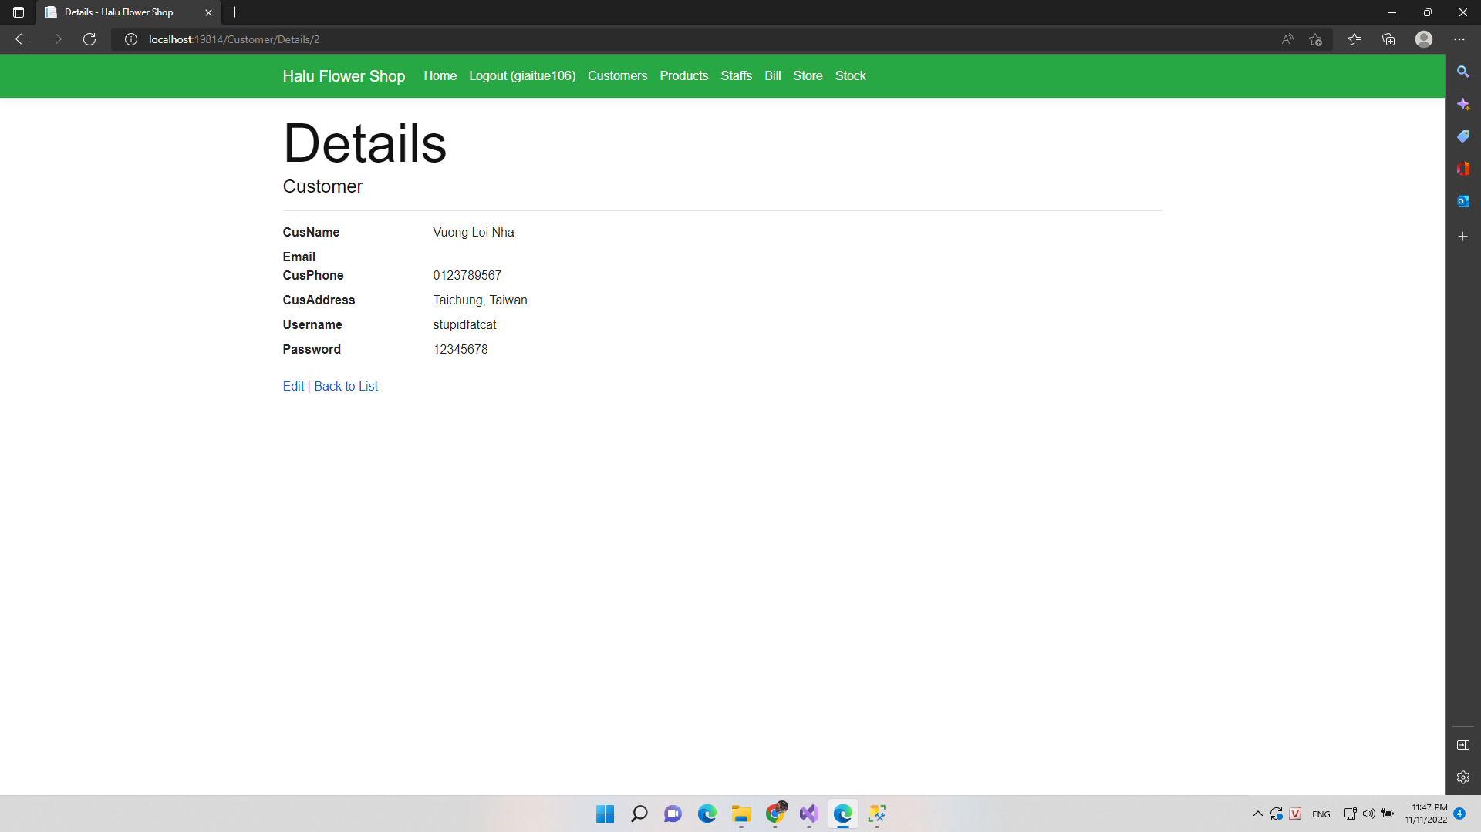

### Delete Customer

***. Screen***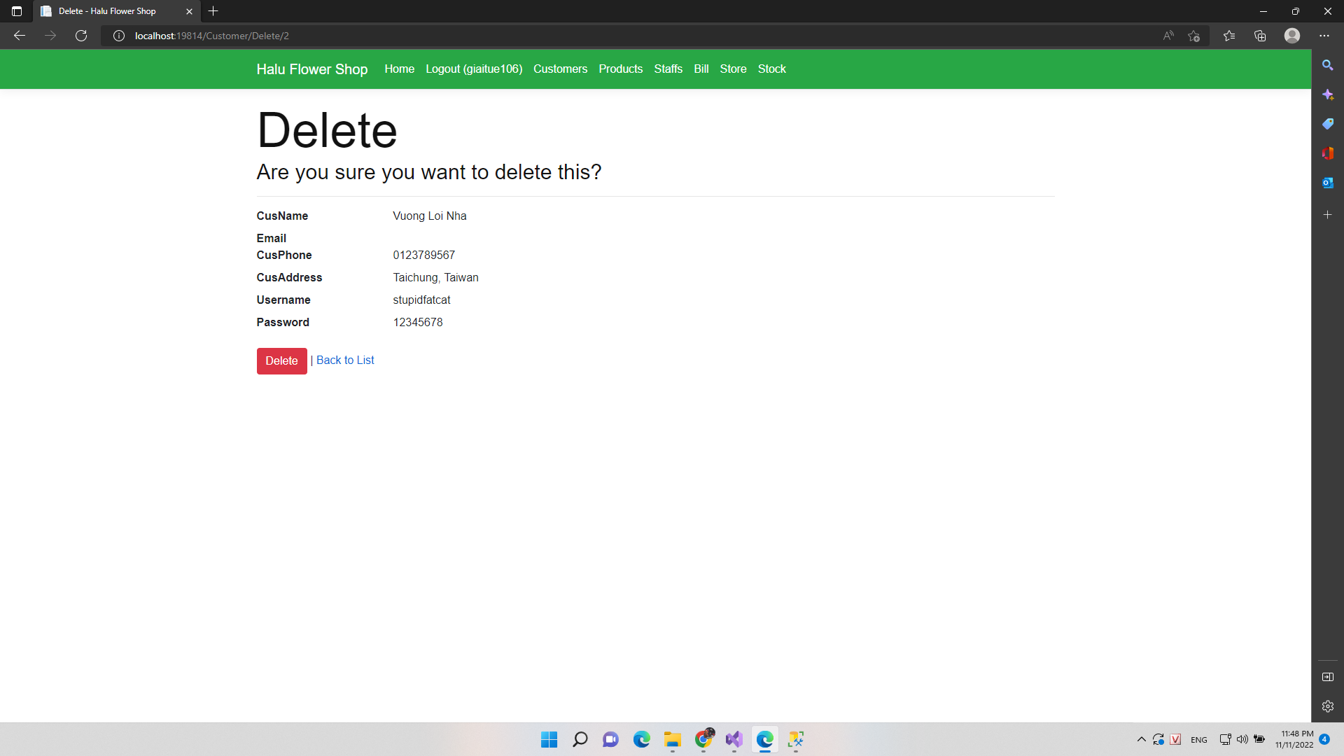

### Create Product

***. Screen***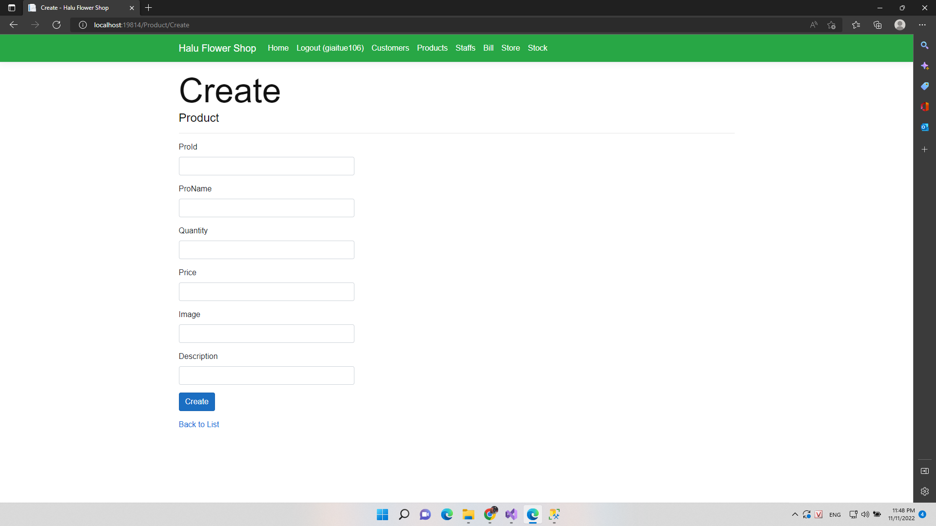

### Edit Product

***. Screen***

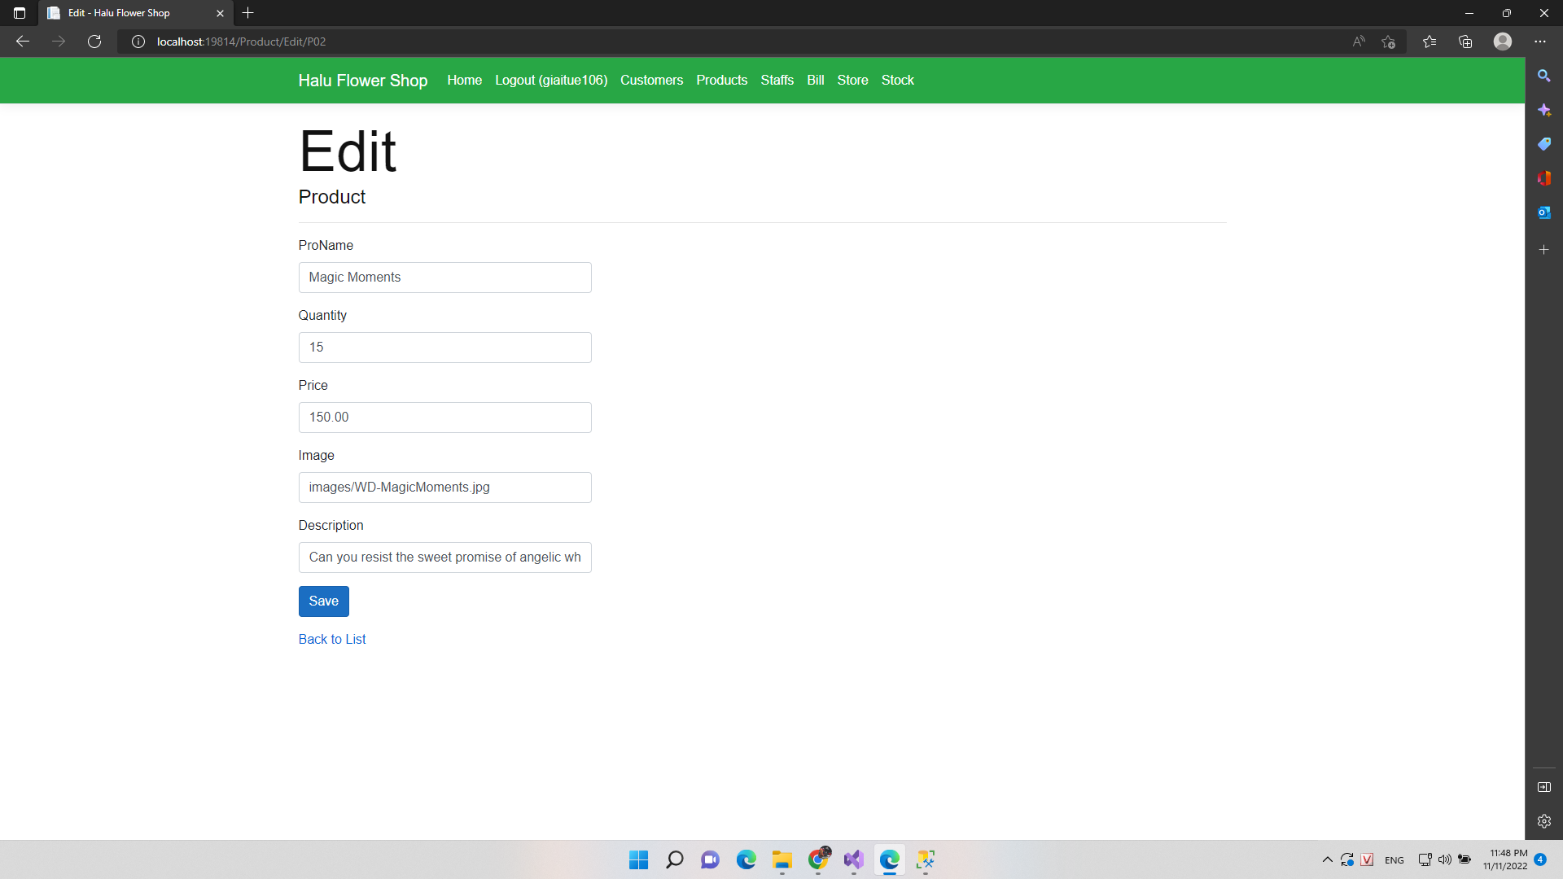

### Delete Product

***. Screen***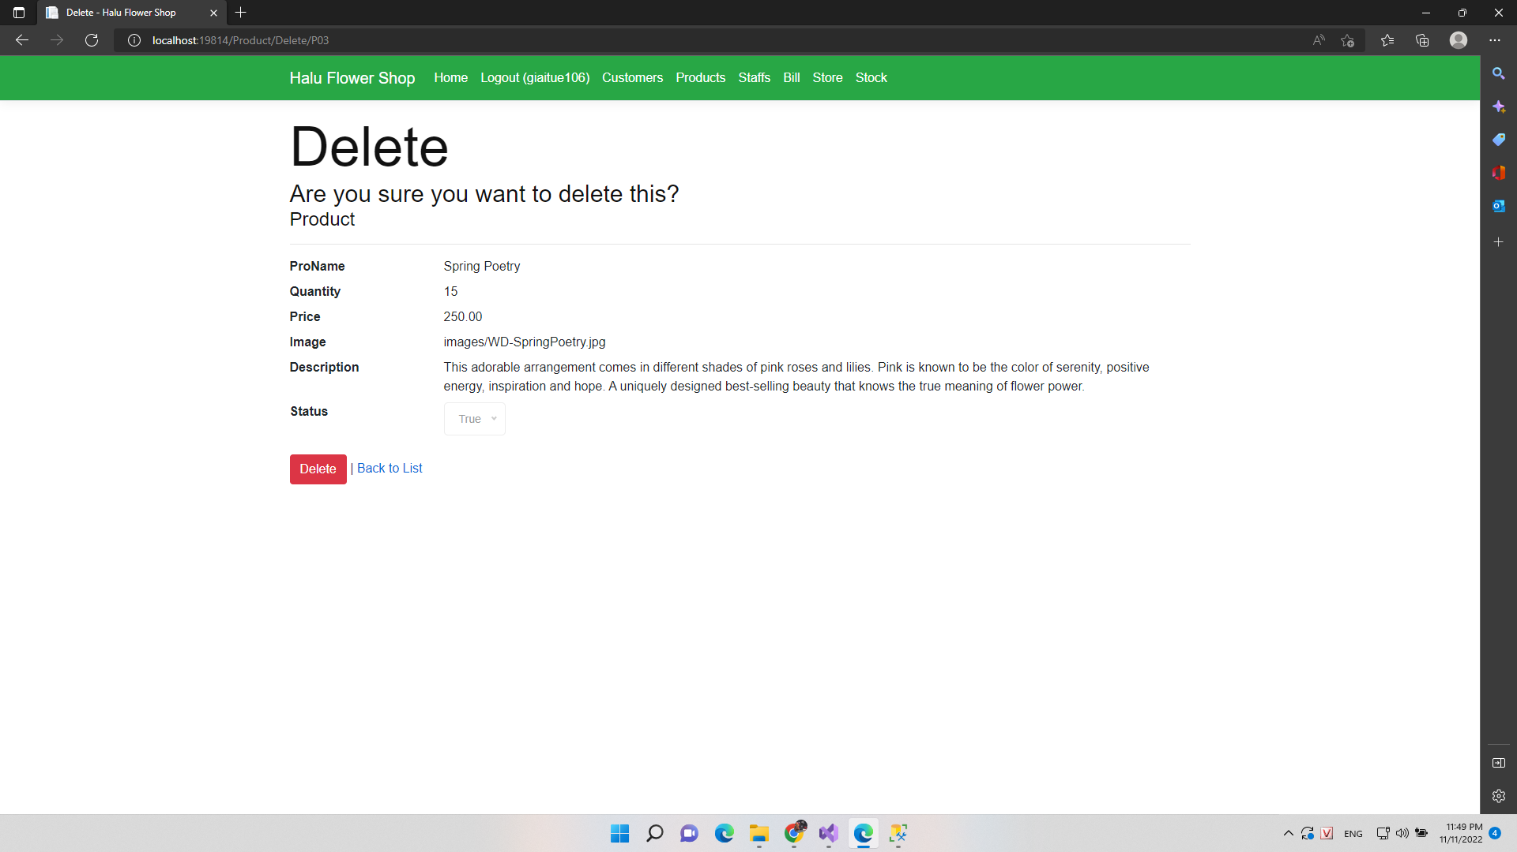

### Create New Staff

***Screen***

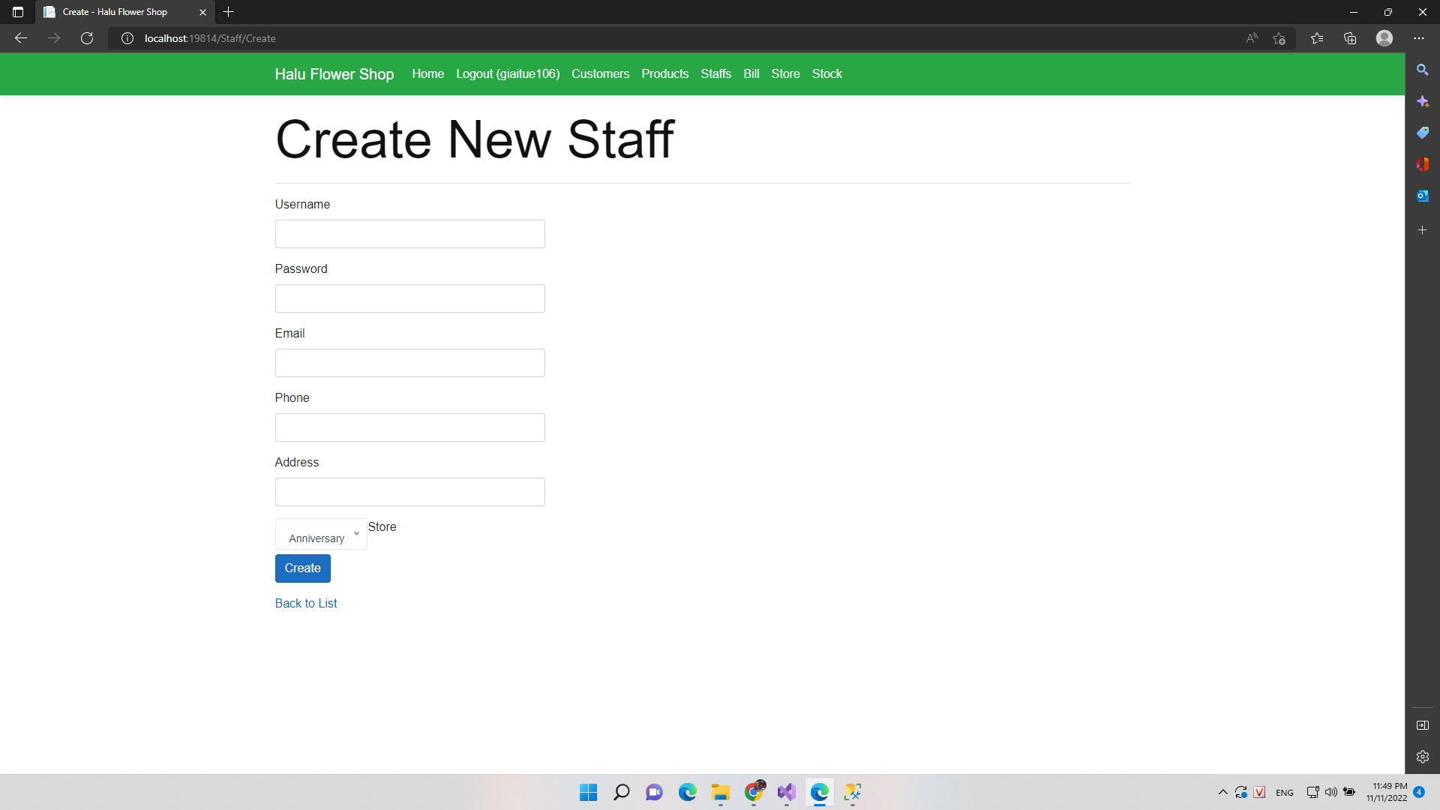

### Edit Information Staff

***. Screen***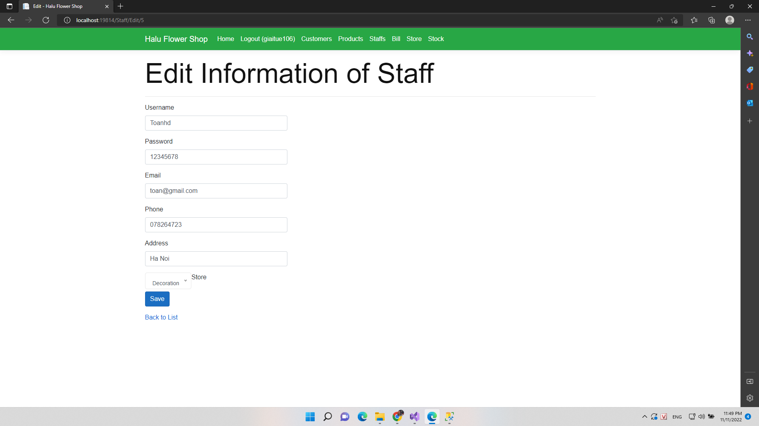

### Delete Staff

***. Screen***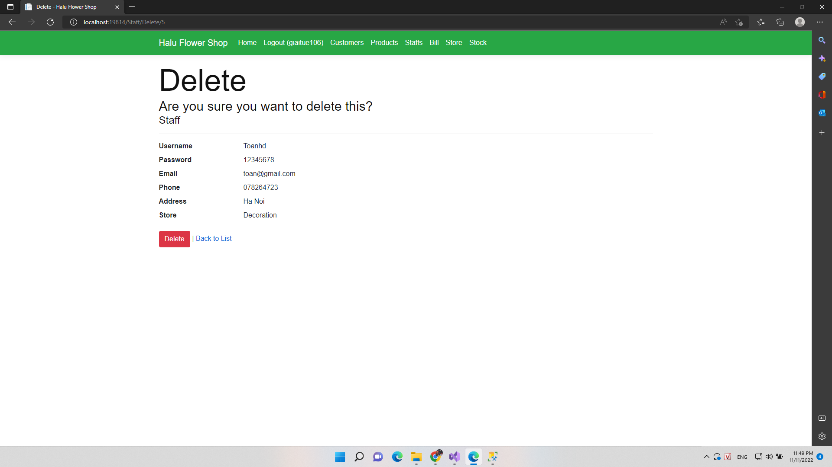

### Store

***a. Class Diagram***

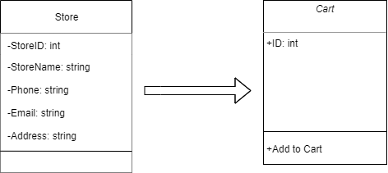

***. Screen***

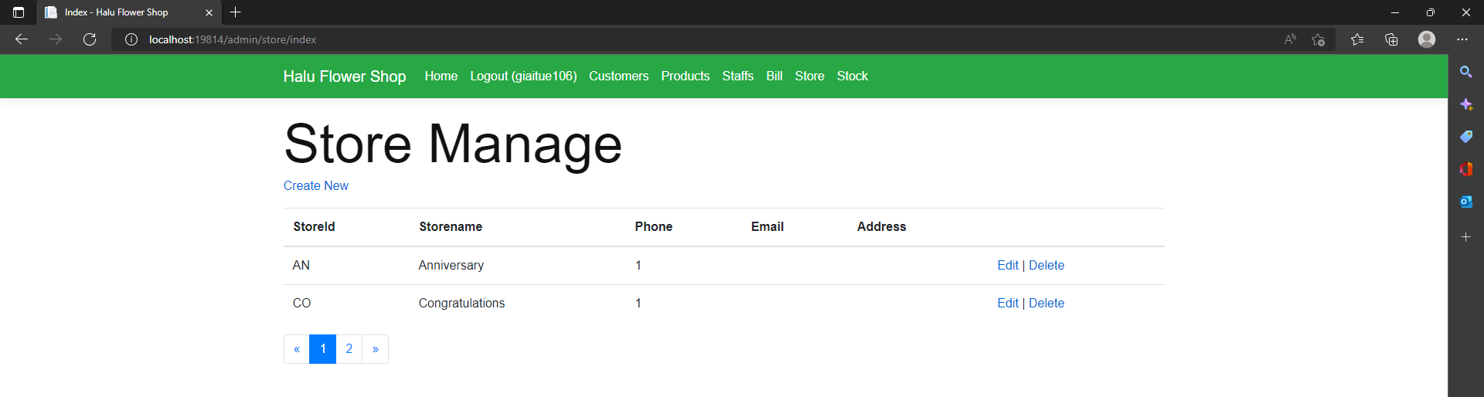



### Create New Store

***. Screen***

### Edit Store

1. ***Class Diagram***

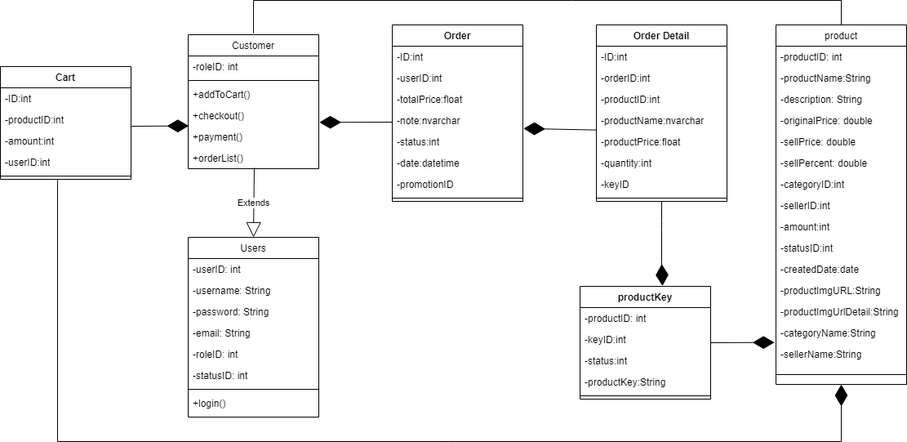

1. ***Class Specifications UsersClass***

***Class Methods***

|  |  |  |
| --- | --- | --- |
| **No** | **Method** | **Description** |
| *01* | *Login* | *Input correct username and password to login in to web* |

***Customer class***

***Class Methods***

|  |  |  |
| --- | --- | --- |
| **No** | **Method** | **Description** |

|  |  |  |
| --- | --- | --- |
| *01* | *addToCart* | *Add products to cart* |
| *02* | *checkOut* | *Check out cart* |
| *03* | *payMent* | *User pay for our order* |
| *04* | *orderList* | *Show list after order* |

1. ***Screen***

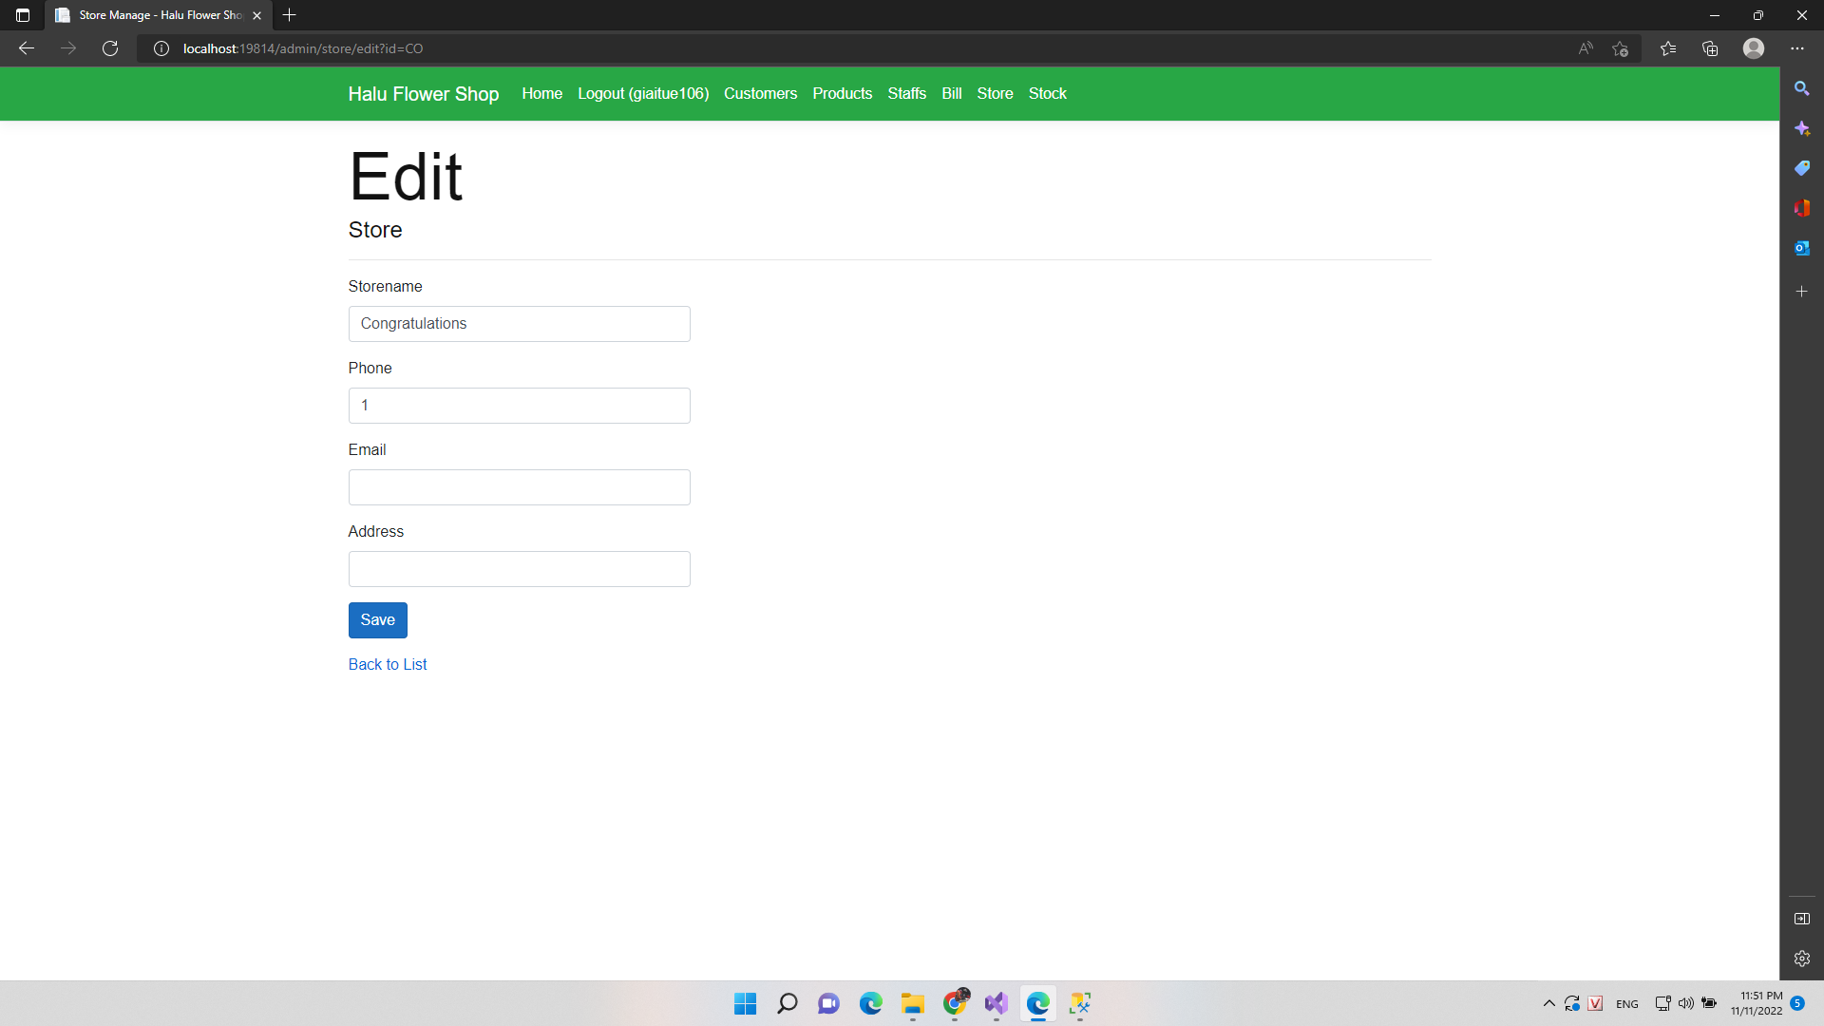

### Detail Store

1. ***Class Diagram***



1. ***Class Specifications UsersClass***

***Class Methods***

|  |  |  |
| --- | --- | --- |
| **No** | **Method** | **Description** |
| *01* | *Login* | *Input correct username and password to login in to web* |

***Customer class***

***Class Methods***

|  |  |  |
| --- | --- | --- |
| **No** | **Method** | **Description** |
| *01* | *addToCart* | *Add products to cart* |
| *02* | *checkOut* | *Check out cart* |
| *03* | *payMent* | *User pay for our order* |
| *04* | *orderList* | *Show list after order* |

1. ***Screen***

### Delete Store

1. ***Class Diagram***

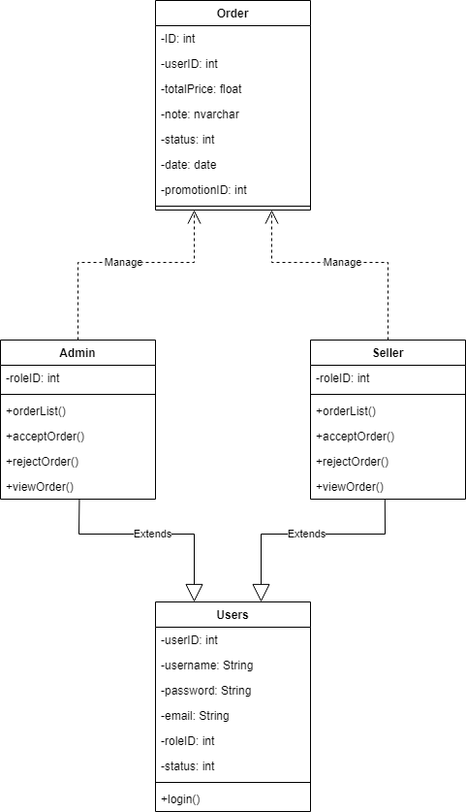

1. ***Class Specifications UsersClass***

***Class Methods***

|  |  |  |
| --- | --- | --- |
| **No** | **Method** | **Description** |
| *01* | *Login* | *Input correct username and password to login in to web* |

***Admin, Seller class***

***Class Methods***

|  |  |  |
| --- | --- | --- |
| **No** | **Method** | **Description** |
| *01* | *acceptOrder()* | *Accepted user order* |
| *02* | *rejectOrder()* | *Reject user order* |
| *03* | *viewOrder* | *Author view order detail of user* |
| *04* | *orderList* | *Show orders of users* |

1. ***Screen***