Section 1: Getting Started

This is a manual intended for users of the “AQBA” MATLAB program package. The program in the folder AQBA_v1 runs simulations corresponding to the full scale size model of the “AquaBuOY A” configuration. All the files for the AQBA code must be in the same directory.

Step 1: You must have MATLAB version 7.3.0 or later installed on your computer. The program may work for earlier versions but it is not guaranteed. The instructions following assume you have MATLAB installed on a Windows operating system on your computer. If not refer to MATLAB manual to install MATLAB.

Step 2: Opening MATLAB: There are two ways to open the MATLAB program on your Windows system. 1) One is to put the mouse cursor on the START menu (on the left hand corner of your Windows screen). Left click on the START button and then click on the MATLAB icon in the directory where you have MATLAB saved. 2) The other option is to have a shortcut to the MATLAB option on your Windows desktop and double click on the MATLAB icon to open MATLAB.

Overview of the Desktop
When you start MATLAB, it displays the MATLAB desktop, a set of tools (graphical user interfaces or GUIs) for managing files, variables, and applications associated with MATLAB.

Example of Desktop — Default Layout
The first time you start MATLAB, the desktop appears with the default layout, as shown in the following illustration. You can change the desktop arrangement to meet your
needs, including resizing, moving, and closing tools.

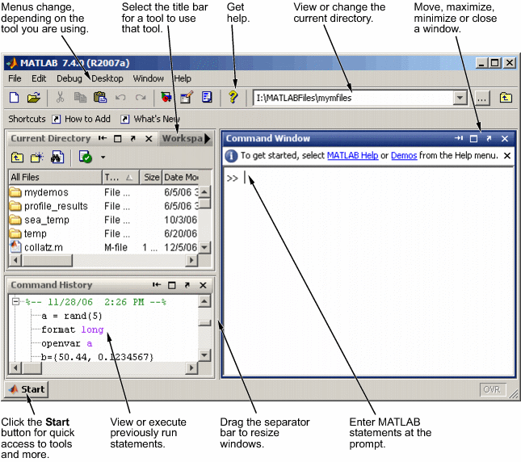

Now that you have MATLAB open we can move to the next step.

Step 3: Change the current directory to be the same directory where the AQBA program is. There are two ways you can do this.

1) The easiest way to do this is to click on the “view or change the current directory” list and select the AQBA_v1 directory.

2)Another way to do this is to use the change directory command “cd” at the location pointed by “Enter MATLAB statements at the prompt” as in the figure above. For example. On my computer the folder containing the program for AQBA is in a folder named “AQBA_v1”. The folder is on my desktop. My desktop is organized in my windows system in a folder under my name “abigail” and the folder “abigail” is inside a folder named “Documents and Settings”, and this folder is inside the “C” directory. For me to change the directory at the MATLAB prompt (which is pointed to above by the words: “Enter MATLAB statements at the prompt”) I have to type the change directory command at the prompt as follows:

>> cd 'C:\Documents and Settings\abigail\Desktop\AQBA_v1'

{Note that the entire directory name has to be in single quotes.}

Step 4: In this step we will learn to run a prepared simulation, and later in Step 5 we will look at how to change the inputs in the appropriate file for running different simulations.
To run the simulation that is prepared, at the MATLAB prompt type the word “driver”, as follows:

>>driver

After a few seconds two files will be created and saved. We will focus on the popup window containing figures that will appear after a few seconds which will display the following:
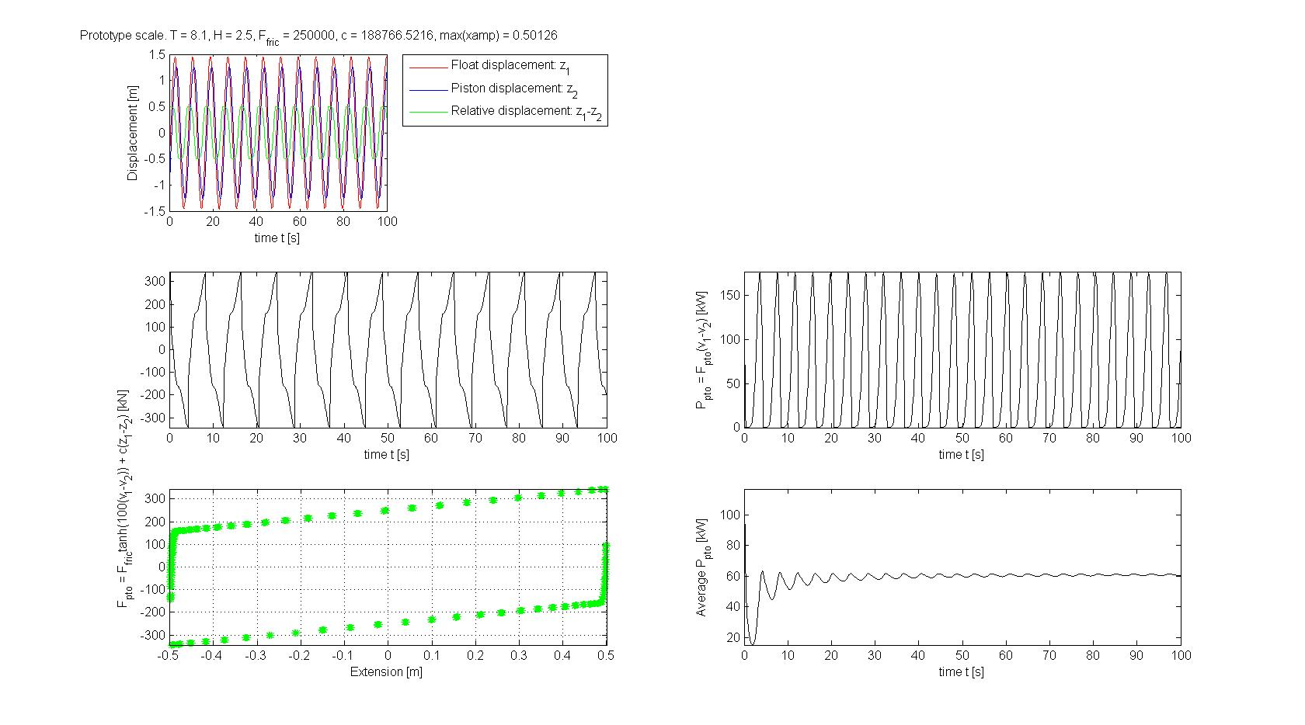

Step 5: looking at the results.
The are 5 figures to look at in the popup window, sample shown above. As well the following information to read from the title and labels:
1) In the title of the first figure it states that the simulations are:
“Prototype scale”. This means these figures correspond to the full size scale of the AquaBuOY model.
“T = 8.1” which corresponds to the wave period of the regular wave simulation.
“H = 2.5” which corresponds to the wave height of the regular wave simulation.
“Fric = 250000” which corresponds to the Culoumb damping in the simulation.
“c = 188766.5216” which corresponds to the stiffness of the PTO (power take off) in the simulation.
“max(xamp) = 0.50126” corresponds to the maximum excursion reached over the entire time period of the simulation, which in this case is 100 seconds.

2) In the legend next to the first figure are shown the three different labels corresponding to the solution graphs in the first figure on the top left hand side. These are: the displacement of the float, the displacement of the piston, and the relative displacement (=excursion =extension). The first graph shows these three displacements as a function of time in seconds.

3) Below the first graph are two graphs corresponding to the Force of the PTO. The graph right below the graph of the displacements is a graph of the Force in kN as a function of time. The graph below that is the same Force in kN as a function of extension (=relative displacement = excursion). The formula used to calculate this force is found on the y-axis label shared by these two graphs.

4) The graphs on the right side correspond to the power absorbed by the PTO. The first graph on the right hand side is a graph of the power in kW absorbed as a function of time in seconds (The formula used to calculate the power is found on the y-axis label of this graph.), and the graph below that is the average power in kW as a function of time in seconds (otherwise known as a running average).

Step 6: Looking at the results that are saved: a figure file and data file from the simulation above
In the directory where the program is found there will be two files replaced each time a simulation is run. These two files are: Plots.pdf and Data.txt
1) Plots.pdf is a PDF file containing the figures shown in the popup window displayed above. Opening the pdf file by double clicking on it will show you the identical graph as shown above.
2) Data.txt is a text file containing the inputs and outputs which correspond to the simulation that was run. Opening this text file with a text editor (preferably with WordPad or equivalent text editor) will result in the following information to be viewed:

-----------------------------------------------------------------------
INPUTS for Prototype scale model:

Regular Waves.
Wave Height H [m]: 2.50
Wave Period T [s]: 8.10
Float diameter [m]: 7.00
Tube inner diameter [m]: 4.70
Tube outer diameter [m]: 5.00
Tube length [m]: 30.00
Ffric [N]: 250000.00
PTO Spring Stiffness c [N/m]: 188766.52

OUTPUTS:

Peak Float Amplitude [m]: 1.455
Average Float Amplitude [m]: 0.890
Root Mean Square Float Amplitude [m]: 1.000

Peak Relative Amplitude |Float - Piston| [m]: 0.501
Average Relative Amplitude |Float - Piston| [m]: 0.383
Root Mean Square Relative Amplitude |Float - Piston| [m]: 0.410

Peak PTO Force [kN]: 344.16
Average PTO Force [kN]: 181.24
Root Mean Square PTO Force [kN]: 205.67

Peak Power [kW]: 176.80
Average Power [kW]: 60.43
Root Mean Sqare Power [kW]: 88.36

Peak Velocity of Float [m/s]: 1.018
Average Velocity of Float [m/s]: 0.719
Root Mean Square Velocity of Float [m/s]: 0.781

Peak Velocity of Piston [m/s]: 1.0211
Average Velocity of Piston [m/s]: 0.6248
Root Mean Square Velocity of Piston [m/s]: 0.7022
-----------------------------------------------------------------------

Section 2: Advanced instructions: changing inputs for different wave regime simulations

The simulation in the section “Getting started” is run by typing driver at the MATLAB prompt. The file driver.m is an “M-File Script”. Scripts are the simplest kind of M-file (MATLAB file) because they have no input or output arguments. They are useful for automating series of MATLAB commands, such as computations that you have to perform repeatedly from the command line. The sample file driver.m may be changed and called something else for example to run a different simulation, or the name may remain the same and only the inputs changed. The following are instructions on how to open the driver.m file and change inputs inside of it in order to run a different simulation.

Step 1: Opening the correct file
There are three options to open the driver file.
1) In the directory where all the program files are found, double click on the file with the name: “driver.m”. This will result in MATLAB’s internal editor to open the file.
2) At the MATLAB prompt type “edit driver.m” as follows:

>> edit driver.m
3) Use any text editor to open the file driver.m, edit as per the following instructions and save before running the simulation using MATLAB.

In any of the cases above the following will appear in the text editor that is used:
-----------------------------------------------------------------------------------------------------------
% A: is the wave height for regular waves
% T: is the wave period for regular waves
% Hs: is the significant wave height for irregular waves
% Tz: is the average wave period for irregular waves
% reg is parameter to choose if modeling regular or irregular waves,
% reg = 1 results in regular waves, otherwise the model is for
% irregular waves.
% linear is set to one if the linear damper equations are modeled,
% nonlinear if the nonlinear damping is modeled
% cd is the damping ratio if linear damping is modeled
% b2_in = Ffric friction between the float and the piston for
% non-linear damping.
% OR b2_in = b2 linear damping.
% c_in is the spring stiffness
% Cd is the fluid friction coefficient

clear all
close all

reg = 1;
H = 2.5;
A = H/2;
T = 8.1;
Hs = H; % doesn't matter for regular waves
Tz = T; % doesn't matter for regular waves
linear = 0;
cd = 1;
% This call to FPG.m is only called to get the hydrostatic stiffness,
% hence the inputs to this call do not matter.
[M1,M2,c,S,Aw,b2,D,rho,g,Dt_in,Dt_out,Lt,am_extra] = FPG(1,1,1,1);
b2_in = 250000;
c_in = .5*S;
Cd = 3;
AQBA(A,T,Hs,Tz,reg,linear,cd,b2_in,c_in,Cd,'Data.txt','Plots.pdf')

clear all
-----------------------------------------------------------------------------------------------------------

Step 2: Understanding what is inside the driver.m file

The percent symbol % is used to comment. Anything on the right hand side of the percent symbol % is a comment and is ignored by MATLAB. If the internal MATLAB editor opened the file the comments will appear in green, as above. The comments at the start of the file are describing the inputs to the AQBA program which is called in the driver.m file below the comments.

The inputs defined above are: A,T,Hs,Tz,reg,linear,cd,b2_in,c_in,Cd and each is explained in its corresponding comment line.

1) The first command in this file is “clear all”, this command simply clears any variables in the MATLAB workspace incase consecutive simulations are run.

2) The second command in this file is “close all”, this command simply closes any open figure files that may have been left open from previous simulations.

3) The next command is “reg = 1;”, this will be one of the inputs for using the AQBA.m program. The value of 1 indicates that it is to be a regular wave simulation. To make the simulation an irregular wave replace this command with “reg = 0;” and the results when the file driver.m is run will then correspond to an irregular wave simulation.

4) The next two command are: “H = 2.5;” and “A = H/2;”, the second of which is an input to the AQBA.m program. H is the wave height for a regular wave regime. A is the wave amplitude which is half of the wave height. This is only used if the simulation for regular waves is run (when reg = 1) as described in Step 3. If reg is assigned any value other than 1 the simulation will assume irregular waves and any value assigned to A will be ignored.

5) The next command is: “T = 8.1;”, this corresponds to the regular wave period. This is only used if the simulation for regular waves is run (when reg = 1) as described in Step 3.
If reg is assigned any value other than 1 the simulation will assume irregular waves and any value assigned to A will be ignored.

6) The next two command lines are:
Hs = H; % doesn't matter for regular waves
Tz = T; % doesn't matter for regular waves
These variables are also inputs, and were kept separate from the regular wave inputs (A,T) for future programming purposes. For the program as it stands these values are set to the same values as the regular wave inputs, thus one only need to change H and T from 4) and 5) in order to change these values automatically. If reg is assigned the value 1 the simulation will assume regular waves and any value assigned to Hs and Tz will be ignored.

7) The next command is “linear = 0;”, this is also an input to the program AQBA.m, this is telling the program that the non-linear damping is to be used. If the linear equations are to be modeled (refer to the Report on the mathematical model) then replace this command with the command “linear = 1”.

8) The next command is “cd = 1;” This is a variable that is only used when the linear damping model is used. In that case (referring to the Report on the mathematical model) the ratio coefficient of linear damping is assigned a value of 1. If one wants to run the linear damping model with a different damping ratio, say a ratio of 5 one replaces the command by: “cd =5”.

9) The next three lines are best ignored. These lines are:
% This call to FPG.m is only called to get the hydrostatic stiffness,
% hence the inputs to this call do not matter.
[M1,M2,c,S,Aw,b2,D,rho,g,Dt_in,Dt_out,Lt,am_extra] = FPG(1,1,1,1);

The first two commented lines are explaining that the only output used in the call to the function FPG.m is the hydrostatic stiffness, which is S which is used in this example in a command two lines below.

10) The next command is: “b2_in = 250000;” The variable input b2_in is used both for the linear damping and the nonlinear damping models. If the command in 7) is “linear = 0” then the variable b2_in corresponds to the nonlinear Friction coefficient (refer to the mathematical model report). If the command in 7) is “linear = 1” then the linear damping is used and b2_in corresponds to the linear damping coefficient.

11) The next command is: “c_in = .5*S;” This variable corresponds to the stiffness parameter. In this case it is set to 50% of the hydrostatic stiffness. To make this value for example 100% of the value of the hydrostatic stiffness, replace the command by:
“c_in = S;”.

12) The next command is “Cd = 3;”, this corresponds to assigning a fluid friction parameter value of 3. This value is found from lab tests for a particular scale by doing decay tests and adjusting the fluid friction coefficient to fit data accordingly. This parameter value was set for lab tests of a 1:50 scale model. This value is not realistically derived from a full scale model however, so it is suggested to fit adjust this parameter accordingly to fit results to the data from the buoy for a base case and then keep it the same for different wave regimes.

13) The next command line is: AQBA(A,T,Hs,Tz,reg,linear,cd,b2_in,c_in,Cd,'Data.txt','Plots.pdf')

This is the line where the program is called. The variables input were defined in the previous steps minus the last two inputs. The last two input variables to the AQBA.m program are the names of the data file and the name of the figure file that will be saved for the simulation. The data text file name is 'Data.txt' and the figure file name is 'Plots.pdf'. These file names can be changed for different simulations.

For example:
If you want to save the results from the particular simulation to files:
Data_May16.txt and Plots_May16.pdf the command would instead be:

AQBA(A,T,Hs,Tz,reg,linear,cd,b2_in,c_in,Cd,'Data_May16.txt','Plots_May16.pdf')

14) The next command is “clear all”, which clears any variables in the workspace.

Step 3: Second example driver.m file, change the inputs for a different wave regime corresponding to irregular waves:

Simulations for irregular waves are slow, mostly due to the amount of time steps required to compare results for a irregular waves, which requires 20 minutes worth of data, in this code there are 1200 time steps each step of one second so you will have to wait a little while before the figure file pops up for these simulations.

To run the non-linear damping (corresponding to the HP PTO characteristics) in an irregular sea, with a different wave regime, for example with significant wave height 2m and average wave period 7s, with the stiffness parameter set to 100% of the hydrostatic stiffness, and saving the results in the data and figure files “Data_irregular.txt” and “Plots_irregular.pdf” replace the corresponding variables in the driver.m file which will look as follows:
-----------------------------------------------------------------------------------------------------------
% A: is the wave height for regular waves
% T: is the wave period for regular waves
% Hs: is the significant wave height for irregular waves
% Tz: is the average wave period for irregular waves
% reg is parameter to choose if modeling regular or irregular waves,
% reg = 1 results in regular waves, otherwise the model is for
% irregular waves.
% linear is set to one if the linear damper equations are modeled,
% nonlinear if the nonlinear damping is modeled
% cd is the damping ratio if linear damping is modeled
% b2_in = Ffric friction between the float and the piston for
% non-linear damping.
% OR b2_in = b2 linear damping.
% c_in is the spring stiffness
% Cd is the fluid friction coefficient

clear all
close all

reg = 0;
H = 2;
A = H/2;
T = 7;
Hs = H; % doesn't matter for regular waves
Tz = T; % doesn't matter for regular waves
linear = 0;
cd = 1;
% This call to FPG.m is only called to get the hydrostatic stiffness,
% hence the inputs to this call do not matter.
[M1,M2,c,S,Aw,b2,D,rho,g,Dt_in,Dt_out,Lt,am_extra] = FPG(1,1,1,1);
b2_in = 250000;
c_in = S;
Cd = 3;
AQBA(A,T,Hs,Tz,reg,linear,cd,b2_in,c_in,Cd,'Data_irregular.txt','Plots_irregular.pdf')

clear all
-----------------------------------------------------------------------------------------------------------

Step 4) Once the changes above are made save the file, and follow the instructions from the beginning of Section 1.

