Shifts of the variables, demeaned regression

(Davidson and MacKinnon, 2004, p. 121, Ex. 3.22) Consider a linear regression model

for a dependent variable y t that has a sample mean of 17.21. Suppose that we create a new

variable yt∗ = yt +10 and run the same linear regression using yt∗  instead of yt as a regressand.

1. How are R2 and the estimate of the constant term related in the two regressions? What if we use yt∗ = yt − 10 instead?

***If we extract 10 from the mean, TSS will decrease => ratio RSS/TSS will increase and R2 will decrease.***

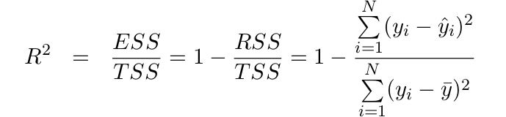

R2 modified = 1 - (2 / 2 ) < R2 initial

***Intercept will decrease by 10***

β̂ 0 = ȳ − β̂ 1 x̄

β̂ 0 modified = (ȳ - 10) − β̂ 1 x̄ = β̂ 0 - 10

2. What if we do the same with one or all of the regressors?

3. Consider a demeaned regression, i.e. center the regressors and the regressand to have zero mean. How does it influence the estimates?