Anti-Repost Tool for Cosplay Photos
app-operator (shell; the operator tool M-01 and M-02. A separate executable not distributed to Users)
Edition 1 (Draft) 2026-09-29 · Ishikawa Sou
Nagareyama Software Development Co., Ltd. (NRSD)
© 2026 Nagareyama Software Development Co., Ltd. (NRSD), Lead Developer: Ishikawa Sou (石川宗). Copyright in this document belongs to Nagareyama Software Development Co., Ltd. (NRSD). Rights in the third-party standards, software, commentaries on laws, and other materials referred to in this document belong to their respective holders. This is a translation of the Japanese original; where they differ, the Japanese original prevails.
Contents
Sections taken
Dependencies
Class diagram
Bridges (operations owned by this block)
Algorithms
Data design

Sections taken
- Chapter 1, 19 Operator tool (M-01 reference information, M-02 release signing, the form of the sources, carrying out from the offline PC)
- Read-only: Chapter 8, 3.4 (the form of the package; owned by core-ref), 3.5 (the rules of the main branch), Chapter 9, 4.3 (TUF metadata), 6.1 (release procedure), DD-9-4 (where keys are kept), Chapter 11, 7.1 (reference/, tools/).

Dependencies
- Lower blocks used: core-common, core-store (ZIP, AtomicFile), core-hash, core-net (fetching the IANA bootstrap; the M-01 PC only), core-ref (Writer::write_bundle, diff_bundle, iana_bootstrap_diff, budget_check, mark_errata, the BundleSigner trait, generation and verification of TUF metadata), core-render (checking the insertions in the sources).
- Dependency inversion: BundleSigner is defined by core-ref and implemented by this block with the hardware token (YubiKey PIV; the PIN at every signature).
- Outside: tauri-cli (tauri signer sign), git (signed commits and pull requests), the hardware token, USB (M-02 never goes on the network).
- Above: none. The screens are inside this block (a separate Tauri executable; identifier jp.nrsd.c2pa4cosplayer.operator).

Class diagram
- Workspace
  - +Path clone local copy of the Public Repository
  - +open(path) Workspace
  - +sources() Sources the YAML and Markdown in reference/src/
- Editor
  - +edit_table(file: Yaml, row_id, lang)
  - +edit_text(file: Markdown)
  - +validate() [Issue] missing fields, insertion names, alignment of the three languages
- BundleBuilder
  - +build(sources, version) RefBundle from the sources (YAML, Markdown) into core-ref's form. Diff, budget, correction marks, and writing out only call core-ref's Writer (B-229, B-310)
- IanaBootstrap
  - +fetch() Files core-net's Http::fetch. The diff is core-ref's Writer::iana_bootstrap_diff
- TokenSigner
  - +sign(bytes) (Sig, Attestation) the implementation of BundleSigner. Primary and spare tokens
  - +sign_targets(role: reference ｜ release, targets) Metadata
  - +sign_root(root) Metadata
- Publisher
  - +commit_and_pr(workspace, message) signed
  - +export_usb(items, dest) Path together with manifest-sha256.txt
- ReleaseSigner
  - +verify_hashes(artifacts, sums) Result
  - +sign_update(artifact, version) Sig tauri signer sign, the key encrypted with a passphrase
  - +make_app_tar_gz(app) Path
  - +make_update_json(artifacts, sigs, notes) Json the form of Chapter 9, 4.3
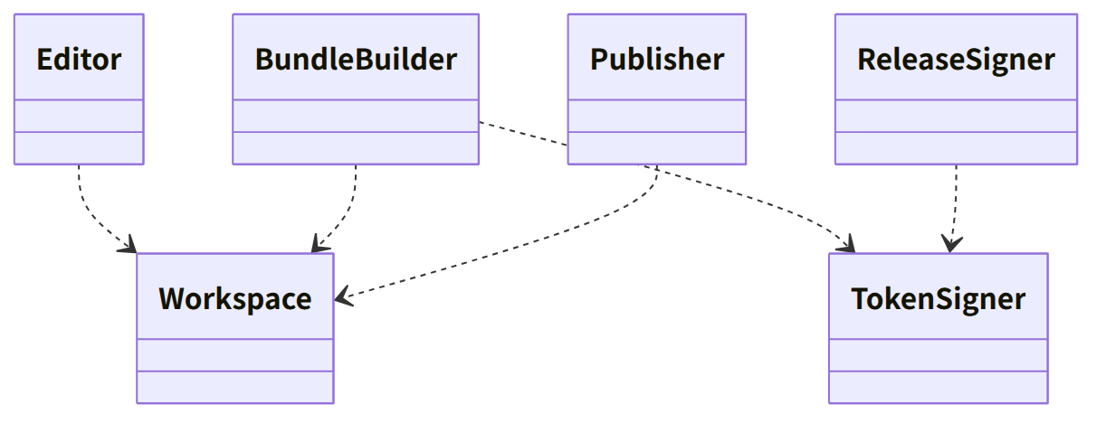
Figure：Class relationships（Class diagram）

Bridges (operations owned by this block)
No. | Operation | Counterpart | Origin
B-310 | TokenSigner::sign (the implementation of BundleSigner). M-01 calls core-ref's diff_bundle, iana_bootstrap_diff, budget_check, and the correction marks | core-ref | Chapter 8, 3.4
B-311 | ReleaseSigner (tauri signer sign --app-version, .app.tar.gz, the update manifest) | tauri-cli | Chapter 9, 4.3 and 6.1

Algorithms
- This block holds no algorithms. The form of the package and TUF verification are core-ref; hashes are core-hash.

Data design
Record or output | Form | Fields | Origin
reference/src/ (repository) | YAML (tables; one table per file, the row key is the number, ja:, zh:, en:), Markdown (long texts; one document, one language per file), native formats (the RDAP bootstrap, ClearURLs, VEX) | Chapter 1, 19 | Chapter 1, 19
Package reference/<version>/, latest.json, tuf/ | core-ref's form | Chapter 8, 3.4; Chapter 9, 4.3 | Chapter 8, 3.4
USB carry-out | The .sig of release/, the update manifest, targets.json, manifest-sha256.txt | Chapter 1, 19 | Chapter 1, 19
Settings on the operator's PC (under jp.nrsd.c2pa4cosplayer.operator) | JSON | Location of the clone, choice of token (primary or spare), location of the update signing key (a file encrypted with a passphrase) | Chapter 1, 19; Chapter 9, DD-9-4

